SDEC Integration Solution Design
Integration, managed file transfer and events for Create Thread, External User Document Upload and External User Submission
Version | 0.1
Status | Draft for design authority review
Date | 30 September 2026
Author | Integration Architect
Classification | To be set by the document owner

Document control

Version history
Version | Date | Author | Changes
0.1 | 30 September 2026 | Integration Architect | First draft consolidated from the J1, J2, J3 and NRS draft designs; proposed solution, API specifications and open item recommendations

Reviewers
Role | Review focus
SDEC solution architect | SDEC end-to-end design, Thread Manager behaviour
HIP integration architect | API Management and Event Management design
HIP MFT lead | File Transfer Manager, AV, S3 buckets
NRS service owner | NRS Submission and Attachment APIs, acceptance notification
eDMS service owner | eDMS upload document API
Communication Service owner | Send notification API
Security architect | Hashing, signing, authentication, pre-signed URLs

Related deliverables
- SDEC integration requirements workbook (sdec-integration-requirements.xlsx): requirements, API and event catalogues, step trace and open items.
- Consolidated journey diagram (sdec-consolidated-journeys.drawio) and consolidated interaction diagram (sdec-consolidated-interaction.drawio).
- API interaction diagrams on one canvas (sdec-api-interactions.drawio), the same diagrams as section 6.

Contents

1. Introduction

1.1 Purpose
This document sets out the integration requirements for the three SDEC journeys and the proposed solution that meets them. It covers every API, managed file transfer and event between SDEC, HIP, NRS, eDMS and the Communication Service, and gives an interaction diagram for each API.
It consolidates 49 requirements, 15 APIs, 13 events and commands, and 26 open items. Where the source designs leave a gap or disagree, this document logs an open item with an owner role and a recommendation rather than resolving it silently.

1.2 Scope

In scope
- Every interaction between SDEC front ends (MDTP), SDEC Thread Manager (HCP), HIP (API Management, Event Management, File Transfer Manager), NRS, eDMS and the Communication Service in the three journeys.
- Managed file transfer: direct upload, AV scan, quarantine, clean staging, transfers to NRS and eDMS, and deletion of staged files.
- Events and asynchronous commands between these systems, including their contracts and delivery rules.
- Non-functional integration requirements: correlation, contracts, delivery semantics, security, observability, limits, retention and volumetrics.

Out of scope
- Screen design and front-end behaviour, except where a front-end call is the start or end of an integration (front-end APIs are described for context only).
- Internal design of NRS, eDMS and the Communication Service beyond the interfaces they expose.
- Thread Manager internal data design beyond the states and records the integrations set.
- The separate File Upload sequence for Create Thread, which was not available; this design assumes it reuses Journey 2 (OI-04).

1.3 Sources
Code | Source design | Date | Coverage
J1 | Create Threads - DRAFT: sequence diagram (Draft) Create Thread - V4 | 29 Sep 2026 | Steps 1-49 (gaps in numbering), notes and assumptions
J2 | External User Document Upload - DRAFT: sequence diagram and interaction table | Undated draft | Steps 1-22 incl. error and success branches
J3 | (Draft) E2E Crystallisation flow: sequence diagram and interaction table | 18 Sep 2026 | Steps 1-42 plus A.1, A.2; Requirements for NRS
NRS | (Draft) NRS integration detail: HIP component view of J3 steps 11-24 | 18 Sep 2026 | Shows HIP API Management, Event Management and File Transfer Manager in every NRS interaction
Table 1: Source designs consolidated in this document

1.4 How to read this document
- Requirement IDs: INT (integration API), MFT (managed file transfer), EVT (event or command), NFR (non-functional). The same IDs are used in the workbook.
- Step references such as J3 step 18 point to the source sequence diagrams: J1 Create Thread, J2 External User Document Upload, J3 External User Submission.
- Rows marked Architect proposal are additions for review and are not in the source designs.
- Proposed endpoint paths and fields are indicative until the OpenAPI and AsyncAPI contracts are agreed (NFR-02).
- The thread owner inside the department is called the internal user.

1.5 Glossary
Term | Meaning
SDEC | The programme delivering threads, document requests and submissions between internal and external users.
MDTP | The platform hosting the SDEC front ends (Front-end Service internal and external).
HCP | The platform hosting SDEC Thread Manager and its Interaction and Document services.
HIP | The integration platform (iPaaS / MFT): API Management, Event Management and File Transfer Manager, with AV scanning and S3 buckets.
NRS | Non-repudiation service: stores signed submissions and attachments as evidence.
eDMS | Electronic document management system (Doxis): the records store for documents.
File collection | The set of files uploaded together; identified by a file collection id issued by File Transfer Manager.
Pre-signed URL | A time-limited URL that allows one upload to (or download from) one storage object without other credentials.
Clean staging | The HIP bucket holding files that passed AV scan and validation; the only source for onward transfers.
Crystallisation | The submission journey (J3) that fixes the external user's response as evidence in NRS and as a record in eDMS.
Command | An asynchronous message addressed to one consumer on a queue (for example request_file_transfer).
Event | An asynchronous notification that something happened, delivered to any subscriber (for example file_upload_succeeded).

2. Business and integration context

2.1 Journeys
Three journeys. NRS submission and eDMS ingestion run as parallel legs inside Journey 3; Journey 1 step 45 reuses the eDMS leg for thread attachments.
Journey | Actor | Trigger | Outcome | HIP involvement | Handoff
J1 Create Thread | Internal user (thread owner) | Internal user selects Create Thread in the workspace (already authenticated and authorised to create threads) | Thread in pending status with technical and business reference; attachments passed to eDMS; recipient notified (proposed) | File upload per attachment (separate File Upload sequence, pattern TBC); eDMS transfer at step 45; thread confirmation event (proposed) | Recipient (external user) is asked to provide documents: leads into J2
J2 External User Document Upload | External user | External user selects documents to upload against a thread interaction | Documents clean-staged in HIP (or quarantined); session, interaction and document state updated; user notified | File Transfer API, pre-signed URL generation, landing bucket, AV scan, quarantine, clean staging, upload outcome events | Clean-staged documents are referenced by the submission: leads into J3
J3 External User Submission (crystallisation) | External user; Internal user notified | External user clicks submit on the interaction response | Signed submission with attachments held by NRS (evidential) and ingested by eDMS; both users notified; staged files deleted | NRS Submission and Attachment APIs via API Management; file transfer request queue; transfers to NRS and eDMS; transfer, acceptance and deletion events | End of journey
Table 2: Journeys in scope

2.2 Consolidated journey view
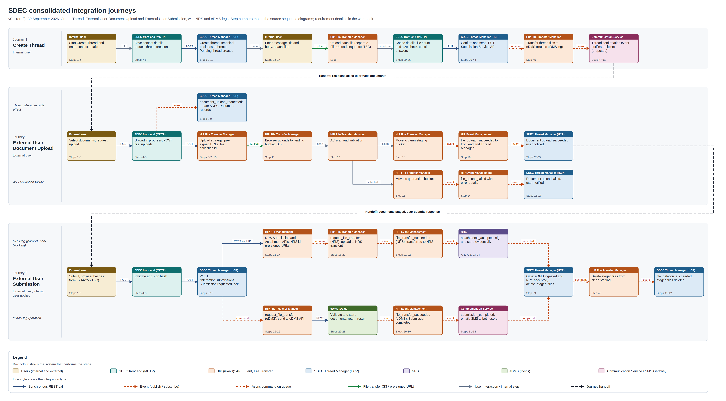
Figure 1: Consolidated journey view. Box colour shows the system; line style shows the integration type. Full size in sdec-consolidated-journeys.drawio.

3. Architecture principles
These principles shape the proposed solution and are the basis for the recommendations in section 11.
Principle | How it applies
HIP mediates every cross-platform integration | Calls and events that cross MDTP, HCP, HIP, NRS or eDMS boundaries pass through HIP API Management or Event Management, giving one security, throttling and observability model (OI-19, OI-20).
Thread Manager orchestrates; HIP executes | Thread Manager owns journey state and decides what happens next. File Transfer Manager moves files on command and reports outcomes; it holds no journey logic.
File content never passes through front ends or Thread Manager | Browsers upload directly to HIP storage with pre-signed URLs; onward transfers read from clean staging.
Asynchronous by default for long-running work | Upload scanning, NRS and eDMS transfers and deletion are asynchronous commands and events. Synchronous calls are short and return acknowledgements.
Configuration over construction | File Transfer Manager runs one generic transfer engine. NRS and eDMS are configuration rows (target type, endpoint, credentials, retry policy), not separate processes.
Contract first | Every API has an OpenAPI contract and every event or command an AsyncAPI contract before build. Contracts are versioned and owned.
Idempotent and traceable | Every request and message carries an idempotency key and a correlation id; consumers tolerate duplicates.
Independent legs | NRS and eDMS legs run in parallel and do not depend on each other; clean-up waits for both.
Table 3: Architecture principles

4. Integration requirements
Each requirement states what must be true, where it comes from, how it will be accepted, and which API in section 6 delivers it. Priority uses MoSCoW.

4.1 Integration (API) requirements
ID | Requirement | Source | Acceptance criteria | From / to | Delivered by | Priority, status
INT-01 | Create thread API  SDEC front end (internal) shall call the Thread Service API (POST) to create a thread entity record once contact details are captured. Thread Manager shall generate the technical and business-facing thread references together and set the thread to Pending thread created. The business reference is returned only at the confirmation step, not in the create response. | J1 steps 9, 10, 11, 12 | A valid create request returns 201 with a technical thread id and status PENDING within 2 seconds (p95); the business reference is stored but not returned; a repeated request with the same Idempotency-Key returns the original thread. | SDEC front end (internal) to SDEC Thread Manager | API-01 | Must, Draft
INT-02 | Submit thread API  SDEC front end (internal) shall submit the confirmed thread to Thread Manager via the Submission Service API (PUT). Thread Manager updates the thread and returns a submission response. | J1 steps 40, 41, 42, 43, 44 | A submit request for a PENDING thread returns 200 with status SUBMITTED and the business reference; a thread in any other state returns 409; the eDMS transfer command (EVT-07) is issued exactly once per submission. | SDEC front end (internal) to SDEC Thread Manager | API-04 | Must, Draft
INT-03 | Thread attachments to eDMS  On thread submission, Thread Manager shall initiate transfer of the thread's attached files to eDMS, reusing the eDMS ingestion leg of the submission journey (EVT-07, MFT-10, EVT-08). | J1 steps 45; J3 steps 25, 26, 29 | Every file attached to a submitted thread reaches eDMS with thread id and document id in its metadata, and Thread Manager records the eDMS document reference per file. | SDEC Thread Manager to eDMS (Doxis) | API-04, API-14 | Must, Handoff (outside J1 design scope)
INT-04 | File upload request (consumer side)  Front-end Service (external) shall request uploads through the HIP File Transfer API, passing document metadata and thread / interaction ids, and relay the returned pre-signed URLs to the browser. File content never passes through the front end. | J2 steps 5, 7, 10 | The front end never receives or proxies file content; for every requested file it relays one pre-signed URL set and the file collection id to the browser. | SDEC front end (external) to HIP File Transfer Manager | API-05, API-06 | Must, Draft
INT-05 | Submission initiation API  Front-end Service (external) shall call Thread Manager POST /interaction/submissions with submission content and signed hash. Thread Manager records Submission requested and returns a synchronous acknowledgement only; NRS and eDMS processing continues asynchronously. | J3 steps 6, 7, 8, 9 | Submission returns 202 Accepted with a submission id within 2 seconds (p95), before any NRS or eDMS call is made; repeated submissions with the same Idempotency-Key do not create a second submission. | SDEC front end (external) to SDEC Thread Manager | API-09, API-10 | Must, Draft
INT-06 | Submission content integrity  The browser shall hash the web form content (SHA-256 TBC). Front-end Service (external) validates the hash and signs it if not already signed. The signed hash travels with the payload to NRS. | J3 steps 2, 3, 4, 5, 11 | The hash algorithm and canonicalisation are documented; Front-end Service rejects a submission whose recomputed hash differs; NRS receives the signed hash unchanged. | Browser / SDEC front end (external) to NRS | API-09, API-11 | Must, Draft
INT-07 | NRS Submission API via HIP  Thread Manager shall call the NRS Submission API through HIP API Management with the signed interaction payload and attachment metadata / references. NRS persists the payload to transient storage and returns an NRS submission id, which Thread Manager stores. | J3 steps 11, 12, 13, 14; Requirements for NRS 1 | Thread Manager reaches the NRS Submission API only through HIP API Management; a successful call stores the NRS submission id against the interaction; transient failures are retried with the same idempotency key. | SDEC Thread Manager to NRS | API-11 | Must, Draft
INT-08 | NRS Attachment API via HIP  Thread Manager shall call the NRS Attachment API through HIP API Management with the NRS submission id and document metadata. NRS generates and returns pre-signed upload URLs to Thread Manager. | J3 steps 15, 16, 17; Requirements for NRS 1 | One pre-signed URL is returned per document with an expiry; Thread Manager passes the URLs to File Transfer Manager without altering them. | SDEC Thread Manager to NRS | API-12 | Must, Draft
INT-09 | NRS APIs published through iPaaS  NRS shall publish its Submission and Attachment APIs via HIP (iPaaS) API Management. | Requirements for NRS 1 | Both NRS APIs are listed in the HIP API catalogue with OpenAPI contracts, security policy and environments (test, pre-production, production). | NRS to HIP API Management | API-11, API-12 | Must, Requirement on NRS
INT-10 | NRS capacity for SDEC volumes  NRS shall enhance its APIs, services and underlying infrastructure to support SDEC projected transaction and attachment (document) volumes and attachment sizes. | Requirements for NRS 2 | NRS confirms in writing that its APIs and storage meet the SDEC volumetrics (NFR-08), including peak submissions per hour and maximum attachment size. | NRS to NRS | - | Must, Requirement on NRS
INT-11 | eDMS upload document API  eDMS shall expose an upload document API reachable from HIP File Transfer Manager, accepting documents, document metadata and transaction context, and returning success / failure and eDMS document references. | J3 steps 26, 27, 28 | eDMS returns a document reference for each successful upload and a structured error for each failure; the API is reachable from the HIP runtime in every environment. | HIP File Transfer Manager to eDMS (Doxis) | API-14 | Must, Draft
INT-12 | Notification request  Thread Manager shall call the Communication Service ('Send notification', endpoint TBC) to trigger email / SMS to the external user and email to the internal user through the SMS Gateway. Response status handling is covered by the communication design. | J3 steps 33, 37, 38 | One Send notification call triggers the email / SMS to the external user and the email to the internal user; Thread Manager receives a notification id; delivery failures are visible to support. | SDEC Thread Manager to Communication Service | API-15 | Must, Draft
INT-13 | Independent parallel NRS and eDMS legs  NRS submission and eDMS ingestion shall run in parallel and independently. NRS transfer status does not depend on eDMS, and Submission Completed does not depend on NRS succeeding. | J3 steps 11, 22, 25, 30 | Tests show Submission Completed set while NRS is unavailable, and NRS transfer completing while eDMS is unavailable; clean-up waits for both. | SDEC Thread Manager to NRS; eDMS | API-10, API-11 | Must, Draft
INT-14 | End-to-end document identity  Document identifiers shall be consistent from upload (J2) through NRS and eDMS, or the submission id shall be confirmed as the correlation key. | J3 steps 11, 26; J2 steps 9 | One document id, issued at upload, appears in SDEC_Document, NRS attachment metadata and eDMS document metadata for the same file. | All to All | - | Must, Open
Table 4: Integration (API) requirements

4.2 Managed file transfer requirements
ID | Requirement | Source | Acceptance criteria | From / to | Delivered by | Priority, status
MFT-01 | File Transfer API (provider)  HIP File Transfer Manager shall expose POST /file_uploads accepting document metadata (file names, types, sizes) and thread / interaction ids, and return a file collection id and pre-signed URLs. | J2 steps 5, 7 | POST /file_uploads returns 201 with a file collection id and one upload specification per file; invalid metadata returns 400, oversize 413, unsupported type 415. | SDEC front end (external) to HIP File Transfer Manager | API-06 | Must, Draft
MFT-02 | Upload strategy and pre-signed URLs  File Transfer Manager shall select single or multi-part upload per file from its size and generate time-limited pre-signed URLs scoped to the landing bucket. | J2 steps 6 | Files above the multi-part threshold receive part URLs; every URL is scoped to one object key and expires at the configured time. | HIP File Transfer Manager to HIP File Transfer Manager | API-06, API-07 | Must, Draft
MFT-03 | Landing bucket for direct upload  Browsers shall upload directly to a HIP landing bucket (AWS S3) using the pre-signed URLs. | J2 steps 11 | Uploaded objects land only in the landing bucket; the bucket blocks public access and accepts writes only through valid pre-signed URLs. | External user browser to HIP landing bucket | API-07 | Must, Draft
MFT-04 | AV scan and validation  File Transfer Manager shall scan and validate every uploaded file through the AV Service before it can be used downstream. | J2 steps 12 | No object leaves the landing bucket without a recorded AV verdict; scan errors are retried and then treated as failures, never as clean. | HIP File Transfer Manager to AV Service | API-08 | Must, Draft
MFT-05 | Quarantine  Files failing AV or validation shall be moved to a quarantine bucket (AWS S3) and never released downstream. | J2 steps 13 | Infected or invalid objects are in the quarantine bucket with the verdict recorded, and no transfer command can reference them. | HIP File Transfer Manager to Quarantine bucket | API-08 | Must, Draft
MFT-06 | Clean staging  Clean, valid files shall be moved to a clean staging bucket (AWS S3), which is the only source for onward transfers to NRS and eDMS. | J2 steps 18; J3 steps 19, 26 | Clean objects are in the clean staging bucket and are the only objects File Transfer Manager reads for NRS and eDMS transfers. | HIP File Transfer Manager to Clean staging bucket | API-08 | Must, Draft
MFT-07 | Upload outcome events  File Transfer Manager shall publish file_upload_succeeded or file_upload_failed (with error details) for each file collection, consumed by Front-end Service (external) and Thread Manager. | J2 steps 14, 19 | Exactly one outcome event per file collection (or per file, as agreed in the contract) is published within 60 seconds of the scan verdict. | HIP File Transfer Manager to SDEC front end (external); Thread Manager | API-08 | Must, Draft
MFT-08 | File transfer request queue  File Transfer Manager shall consume asynchronous commands from Thread Manager on a file transfer request queue: transfer to NRS, transfer to eDMS and delete staged files. Each command carries the file collection reference, target identifier(s) and transaction context. | J3 steps 18, 25, 39 | Commands are consumed from the request queue, processed idempotently by command id, and moved to a dead-letter queue after the retry limit. | SDEC Thread Manager to HIP File Transfer Manager | API-13 | Must, Draft
MFT-09 | Transfer to NRS transient storage  File Transfer Manager shall upload clean-staged files to NRS transient storage using the NRS-issued pre-signed URLs supplied in the command. | J3 steps 19, 20 | Every document in the command is uploaded to NRS using the URL supplied; an expired URL produces a failure outcome with reason URL_EXPIRED. | HIP File Transfer Manager to NRS transient storage | API-13 | Must, Draft
MFT-10 | Transfer to eDMS  File Transfer Manager shall send clean-staged files with document metadata and transaction context to the eDMS upload document API and handle the synchronous success / failure response. | J3 steps 26, 28; J1 steps 45 | Every document in the command is sent to eDMS with metadata and transaction context; the eDMS reference or error is captured per document. | HIP File Transfer Manager to eDMS (Doxis) | API-14 | Must, Draft
MFT-11 | Transfer outcome events  File Transfer Manager shall publish a transfer outcome event per target (NRS, eDMS) to Thread Manager: file_transfer_succeeded, and a failure outcome whose name and payload are to be agreed. | J3 steps 21, 29 | A success or failure outcome event is published for every transfer command, with target, document ids and, for failures, a reason and retryable flag. | HIP File Transfer Manager to SDEC Thread Manager | API-13, API-14 | Must, Draft
MFT-12 | Staged file deletion  File Transfer Manager shall delete staged files for a file collection on a delete_staged_files command and publish file_deletion_succeeded. | J3 steps 39, 40, 41 | On delete_staged_files all objects in the file collection are removed from clean staging and file_deletion_succeeded is published; deleting an already deleted collection is a no-op. | SDEC Thread Manager to HIP File Transfer Manager | - | Must, Draft
MFT-13 | File collection correlation  The file collection id issued at upload shall be the MFT correlation key for upload, transfer and deletion across J2 and J3. | J2 steps 7; J3 steps 18, 25, 39, 41 | The file collection id is present in every MFT API response, command, event and log entry for that collection. | HIP File Transfer Manager to All consumers | API-06 | Must, Draft
MFT-14 | Internal user file upload (Create Thread)  Files attached by the internal user when creating a thread shall be uploaded through the separate File Upload sequence and stored in S3. Assumed to reuse MFT-01 to MFT-07; to be confirmed. | J1 steps Loop, 23 | Files attached in Create Thread follow the same upload, scan and staging path and produce the same events as Journey 2. | Internal user browser to HIP File Transfer Manager | - | Must, To confirm
Table 5: Managed file transfer requirements

4.3 Event and command requirements
ID | Requirement | Source | Acceptance criteria | From / to | Delivered by | Priority, status
EVT-01 | document_upload_requested  Front-end Service (external) shall publish document_upload_requested after receiving pre-signed URLs. Thread Manager subscribes, updates the thread interaction status and creates SDEC Document records. | J2 steps 8, 9 | Thread Manager creates one SDEC Document record per file on receipt; duplicate delivery does not create duplicates. | SDEC front end (external) to SDEC Thread Manager | API-05 | Must, Draft
EVT-02 | file_upload_failed  File Transfer Manager shall publish file_upload_failed with document references and error details. Front-end Service (external) updates session state and notifies the user; Thread Manager records Document upload failed. | J2 steps 14, 15, 16, 17 | Front end shows the failure to the user and Thread Manager records Document upload failed with error details for each affected document. | HIP File Transfer Manager to SDEC front end (external); Thread Manager | API-08 | Must, Draft
EVT-03 | file_upload_succeeded  File Transfer Manager shall publish file_upload_succeeded with document references. Front-end Service (external) updates session state and notifies the user; Thread Manager records Document upload succeeded. | J2 steps 19, 20, 21, 22 | Front end shows success and Thread Manager records Document upload succeeded with document references. | HIP File Transfer Manager to SDEC front end (external); Thread Manager | API-08 | Must, Draft
EVT-04 | request_file_transfer (target NRS)  Thread Manager shall send an asynchronous Request File Transfer command for NRS with pre-signed URLs, file collection reference, target identifier(s) and transaction context. | J3 steps 18 | The command carries pre-signed URLs, file collection reference, target identifiers and transaction context, and validates against its AsyncAPI schema. | SDEC Thread Manager to HIP File Transfer Manager | API-12 | Must, Draft
EVT-05 | file_transfer_succeeded (NRS)  Thread Manager shall consume file_transfer_succeeded for the NRS target and record documents transferred to NRS, independent of eDMS status. | J3 steps 21, 22 | Thread Manager records documents transferred to NRS without waiting for, or changing, eDMS state. | HIP File Transfer Manager to SDEC Thread Manager | API-13 | Must, Draft
EVT-06 | attachments_accepted (NRS)  NRS shall notify SDEC asynchronously when a submission and its attachments are accepted (attachments_accepted via HIP Event Management). SDEC prefers an event; the NRS team has suggested polling. | J3 steps A.1, A.2, 23, 24; Requirements for NRS 3 | Thread Manager receives an acceptance notification for every NRS submission (event, or polling adapter if OI-16 decides so) and records NRS documents accepted. | NRS to SDEC Thread Manager | API-13 | Must, Open
EVT-07 | request_file_transfer (target eDMS)  Thread Manager shall send an asynchronous Request File Transfer command for eDMS with file collection reference, target identifier(s) and transaction context. | J3 steps 25; J1 steps 45 | The command carries file collection reference, target identifiers and transaction context and validates against its schema. | SDEC Thread Manager to HIP File Transfer Manager | API-04, API-14 | Must, Draft
EVT-08 | file_transfer_succeeded (eDMS)  Thread Manager shall consume file_transfer_succeeded for eDMS, with eDMS document references, and set Submission Completed (not dependent on NRS). | J3 steps 29, 30 | Thread Manager records Submission completed and the eDMS document references on receipt. | HIP File Transfer Manager to SDEC Thread Manager | API-14 | Must, Draft
EVT-09 | submission_completed  Thread Manager shall publish submission_completed (interaction status submitted). Front-end Service (external) notifies the external user; Front-end Service (internal) notifies the internal user. | J3 steps 31, 32, 34, 35, 36 | Both front ends receive submission_completed and notify their users; duplicates do not produce duplicate notifications. | SDEC Thread Manager to SDEC front end (external and internal) | - | Must, Draft
EVT-10 | delete_staged_files  Thread Manager shall send delete_staged_files only after both eDMS ingestion (EVT-08) and NRS acceptance (EVT-06) are confirmed. | J3 steps 39 | delete_staged_files is sent only when both eDMS ingestion and NRS acceptance are recorded; tests cover each arrival order. | SDEC Thread Manager to HIP File Transfer Manager | - | Must, Draft
EVT-11 | file_deletion_succeeded  File Transfer Manager shall publish file_deletion_succeeded (file collection id). Thread Manager updates document statuses to staged files deleted. | J3 steps 41, 42 | Thread Manager records staged files deleted for every document in the collection. | HIP File Transfer Manager to SDEC Thread Manager | - | Must, Draft
EVT-12 | thread_confirmed (proposed)  An event for thread confirmation shall be added that calls the search service in iPaaS, the email service and the internal outlook service, so the recipient is told a thread is awaiting them. | J1 design note (confirmation) | The recipient receives a notification after thread confirmation, and the event contract is agreed with the search, email and outlook service owners. | SDEC Thread Manager to Search service; email service; outlook service | API-04 | Should, Proposed
EVT-13 | Failure outcomes for transfer and deletion  Failure outcomes shall be defined for NRS transfer, eDMS transfer and staged file deletion (for example file_transfer_failed, file_deletion_failed), with Thread Manager state handling. | J3 steps 21, 29, 41 | Failure outcome events exist for NRS transfer, eDMS transfer and deletion, each driving a defined Thread Manager state and an operational alert. | HIP File Transfer Manager to SDEC Thread Manager | API-13 | Must, Proposed (proposal)
Table 6: Event and command requirements

4.4 Non-functional requirements
ID | Requirement | Source | Acceptance criteria | From / to | Delivered by | Priority, status
NFR-01 | Correlation identifiers  Thread id, interaction id, file collection id, NRS submission id and eDMS document references shall be propagated in every API header and event envelope and logged by HIP. | J2 steps 7; J3 steps 13, 29 | A single correlation id retrieves every log entry, API call and event for one submission across MDTP, HCP and HIP. | All to All | API-01 | Must, Proposed (proposal)
NFR-02 | Contracts  Every API shall have an OpenAPI contract and every event or command an AsyncAPI contract, versioned and owned, covering the attributes passed at each step. | J1 design note (attributes) | Every API and event in this document has a versioned OpenAPI or AsyncAPI contract in the HIP catalogue before build starts. | All to All | - | Must, Proposed (proposal)
NFR-03 | Delivery semantics  Events and commands shall be delivered at least once. Consumers (Thread Manager, front ends, File Transfer Manager) shall be idempotent on event id, with retry policy and dead-letter handling per queue. | J2 steps 8; J3 steps 18, 25, 39 | Duplicate delivery tests on each consumer show no duplicate side effects; each queue has a dead-letter queue with alerting. | All to All | - | Must, Proposed (proposal)
NFR-04 | Service authentication and URL security  Service-to-service authentication across MDTP, HCP, HIP, NRS and eDMS shall follow the external auth documentation. Pre-signed URLs shall be time-limited and scoped to one object. | J1 steps 8, 9; J2 steps 6; J3 steps 16 | All service calls use authenticated, encrypted channels; pre-signed URLs expire within the agreed time and cannot be reused for another object. | All to All | API-01 | Must, Proposed (proposal)
NFR-05 | Observability and audit  Every state transition listed on the Storage and States sheet shall be traceable end to end from a single correlation id. | J3 steps 7, 30, 42 | Dashboards show each submission's current state and history; alerts fire on failed transfers, dead-letter messages and staged files older than the agreed age. | All to All | - | Must, Proposed (proposal)
NFR-06 | File count and size limits  File count and size limits validated by the front end (J1 step 23) shall match MFT limits, including the AV scan ceiling (tracked gap G-15, about 250 MB) and the multi-part threshold. | J1 steps 23; J2 steps 6, 12 | Front end, File Transfer API and AV limits are configured from one agreed set of values and tested at the boundary. | SDEC front end to HIP File Transfer Manager | API-02 | Must, Proposed (proposal)
NFR-07 | Retention and orphan clean-up  Retention rules shall cover orphaned threads (user leaves mid-journey), quarantined files, and staged files where a leg never completes. | J1 design note (orphan); J2 steps 13; J3 steps 39 | Scheduled clean-up removes orphaned threads, expired quarantine objects and expired staging objects, each with an audit record. | SDEC Thread Manager to HIP File Transfer Manager | - | Must, Proposed (proposal)
NFR-08 | Volumetrics  SDEC shall publish projected transaction and attachment volumes and sizes for sizing of HIP, NRS and eDMS. | Requirements for NRS 2 | Volumetrics are published and signed off by SDEC, HIP, NRS and eDMS owners before performance testing. | SDEC to HIP; NRS; eDMS | - | Must, Proposed (proposal)
Table 7: Non-functional requirements

5. Proposed solution

5.1 Overview
SDEC front ends and Thread Manager keep journey behaviour and state. HIP provides the integration capabilities: API Management for every synchronous call across platforms, Event Management for events and commands, and File Transfer Manager for uploads, scanning, staging and transfers. NRS, eDMS and the Communication Service are reached only through HIP.
- Uploads: browsers get pre-signed URLs from the File Transfer API (through API Management), upload straight to the HIP landing bucket, and File Transfer Manager scans, quarantines or stages each file and publishes the outcome.
- Submission: Thread Manager acknowledges at once, then runs the NRS leg (Submission and Attachment APIs through API Management, then a transfer command) and the eDMS leg (a transfer command) in parallel.
- Transfers: one generic transfer engine in File Transfer Manager reads from clean staging and writes to a configured target; NRS and eDMS are configuration rows.
- Completion: eDMS success sets Submission completed and triggers notifications; clean-up waits for both eDMS ingestion and NRS acceptance.

5.2 Solution components
Component | Platform | Responsibility in this solution | Proposed realisation
HIP API Management | HIP | Publishes and secures APIs: File Transfer API, NRS Submission and Attachment APIs, Thread Manager APIs (if OI-19 confirms), Communication Service. Applies OAuth2, mTLS to back ends, schema validation, throttling and correlation id injection. | Boomi API Management gateway (proposed)
HIP Event Management | HIP | Topics for events and queues for commands, with dead-letter queues and replay. Carries every event and command in sections 7 and 6. | Boomi Event Streams or platform broker (OI-26)
HIP File Transfer Manager | HIP | File Transfer API, pre-signed URL issue, upload completion, AV scan orchestration, quarantine and clean staging, generic transfer engine for NRS and eDMS, deletion and outcome events. | Boomi Integration processes on the HIP runtime cluster, Amazon S3 connector, database tables for file collections (not the node-local cache)
AV Service | HIP | Scans each uploaded object and returns a verdict. | HIP AV capability (size ceiling tracked as G-15)
HIP S3 buckets | HIP | Landing, quarantine and clean staging buckets with encryption at rest, no public access and lifecycle rules. | AWS S3 with KMS encryption and bucket policies
Front-end Service (internal / external) | SDEC MDTP | User journeys, session state, hashing and signing (external), relaying pre-signed URLs, subscribing to outcome events. | SDEC
Thread Manager | SDEC HCP | Thread, interaction and document state; orchestration of NRS and eDMS legs; clean-up gate; notification requests. | SDEC (Interaction Service, Document Service)
NRS | External to SDEC | Submission and Attachment APIs, transient and evidential storage, acceptance notification. | NRS
eDMS (Doxis) | External to SDEC | Upload document API and document store. | eDMS
Communication Service / SMS Gateway | External to SDEC | Email and SMS notifications to external and internal users. | Communication Service
Table 8: Solution components

5.3 Integration patterns
Pattern | Where and why | Used by
Synchronous request via gateway | Short calls that need an immediate answer: create thread, submit thread, request upload, NRS submission and attachment, send notification. | API-01, 04, 06, 10, 11, 12, 15
Direct upload with pre-signed URL | Browsers upload straight to the landing bucket; HIP issues URLs scoped to one object with a short expiry. | API-07
Scan, quarantine, stage | Every upload is scanned before use; failures are quarantined, clean files staged. | API-08, MFT-04 to MFT-06
Asynchronous command | Thread Manager asks File Transfer Manager to transfer or delete; the command queue decouples them and supports retry and replay. | EVT-04, EVT-07, EVT-10
Publish / subscribe event | Outcomes are published once and consumed by every interested service. | EVT-01 to EVT-03, EVT-05, EVT-06, EVT-08, EVT-09, EVT-11
Orchestrated file transfer | One generic transfer engine reads from clean staging and writes to a configured target (pre-signed PUT for NRS, REST upload for eDMS). | API-13, API-14
Table 9: Integration patterns used

5.4 Cross-cutting conventions
- Headers on every API call: Authorization (OAuth2 bearer), X-Correlation-Id, Idempotency-Key on every POST and PUT that changes state.
- Errors use problem details (RFC 9457 style: type, title, status, detail, correlationId) so every consumer handles failures the same way.
- Identifiers: threadId, interactionId, submissionId, fileCollectionId and fileId are UUIDs issued once and never reused; fileId is the end-to-end document id (OI-13).
- Times are UTC ISO 8601. Hashes are SHA-256 hex unless OI-14 decides otherwise.
- Contracts are versioned in the path for APIs (/v1) and in the topic name for events (.v1).

6. API specifications and interaction diagrams
One subsection per API. Each gives the purpose, contract summary, processing, error handling, the requirements it delivers, related open items, and its interaction diagram. Step references in square brackets point to the source designs. Front-end APIs are included for context so each journey is complete end to end.
Figure 2: Legend for all interaction diagrams
ID | Name | Method and path | Consumer | Provider | Mediation | Scope
API-01 | Create thread | POST /threads (proposed; source: POST Thread Service API) | Front-end Service (internal) | Thread Manager (Thread Service) | HIP API Management (recommended, OI-19) | Integration (MDTP to HCP)
API-02 | Save thread details (front end) | PUT Thread Service API (front end) | Internal user browser | Front-end Service (internal) | None | Front end (context only)
API-03 | Change thread details (front end) | PUT Interaction API (front end) | Internal user browser | Front-end Service (internal) | None | Front end (context only)
API-04 | Submit thread | PUT /threads/{threadId}/submission (proposed; source: PUT Submission Service API) | Front-end Service (internal) | Thread Manager (Submission Service) | HIP API Management (recommended, OI-19) | Integration (MDTP to HCP)
API-05 | Request document upload (front end) | POST /document_uploads (source) | External user browser | Front-end Service (external) | None (front end calls API-06 through HIP) | Front end (context only)
API-06 | File Transfer API: request upload | POST /file_uploads (source) | Front-end Service (external and internal) | HIP File Transfer Manager | HIP API Management | Integration (MDTP to HIP)
API-07 | Direct upload with pre-signed URL | PUT {pre-signed URL}; completion: POST /file_uploads/{fileCollectionId}/files/{fileId}/complete (proposed) | User browser | HIP landing bucket (S3) | Pre-signed URL (no gateway) | Integration (browser to HIP)
API-08 | AV scan and staging | Internal call AV scan request (HIP capability) | HIP File Transfer Manager | AV Service | Internal to HIP | Integration (inside HIP)
API-09 | Submit interaction response (front end) | POST /interaction/submissions (source) | External user browser | Front-end Service (external) | None (front end calls API-10) | Front end (context only)
API-10 | Initiate submission (Thread Manager) | POST /interaction/submissions (source) | Front-end Service (external) | Thread Manager (Interaction and Document Service) | HIP API Management (recommended, OI-19) | Integration (MDTP to HCP)
API-11 | NRS Submission API | POST /submissions (NRS to confirm) | Thread Manager | NRS Submission service | HIP API Management | Integration (HCP to NRS via HIP)
API-12 | NRS Attachment API | POST /submissions/{nrsSubmissionId}/attachments (NRS to confirm) | Thread Manager | NRS Attachment Service | HIP API Management | Integration (HCP to NRS via HIP)
API-13 | Transfer to NRS transient storage | PUT {NRS pre-signed URL} | HIP File Transfer Manager | NRS transient storage | Pre-signed URL issued by NRS | Integration (HIP to NRS)
API-14 | eDMS upload document API | POST /documents (eDMS to confirm) | HIP File Transfer Manager | eDMS (Doxis) | HIP File Transfer Manager (REST target) | Integration (HIP to eDMS)
API-15 | Send notification | POST /notifications (TBC, source: 'Send notification') | Thread Manager | Communication Service / SMS Gateway | HIP API Management (TBC) | Integration (HCP to Communication Service)
Table 10: API summary

6.1 API-01 Create thread
Create the thread record once the internal user has entered the recipient's contact details, so a thread reference exists before files are attached.
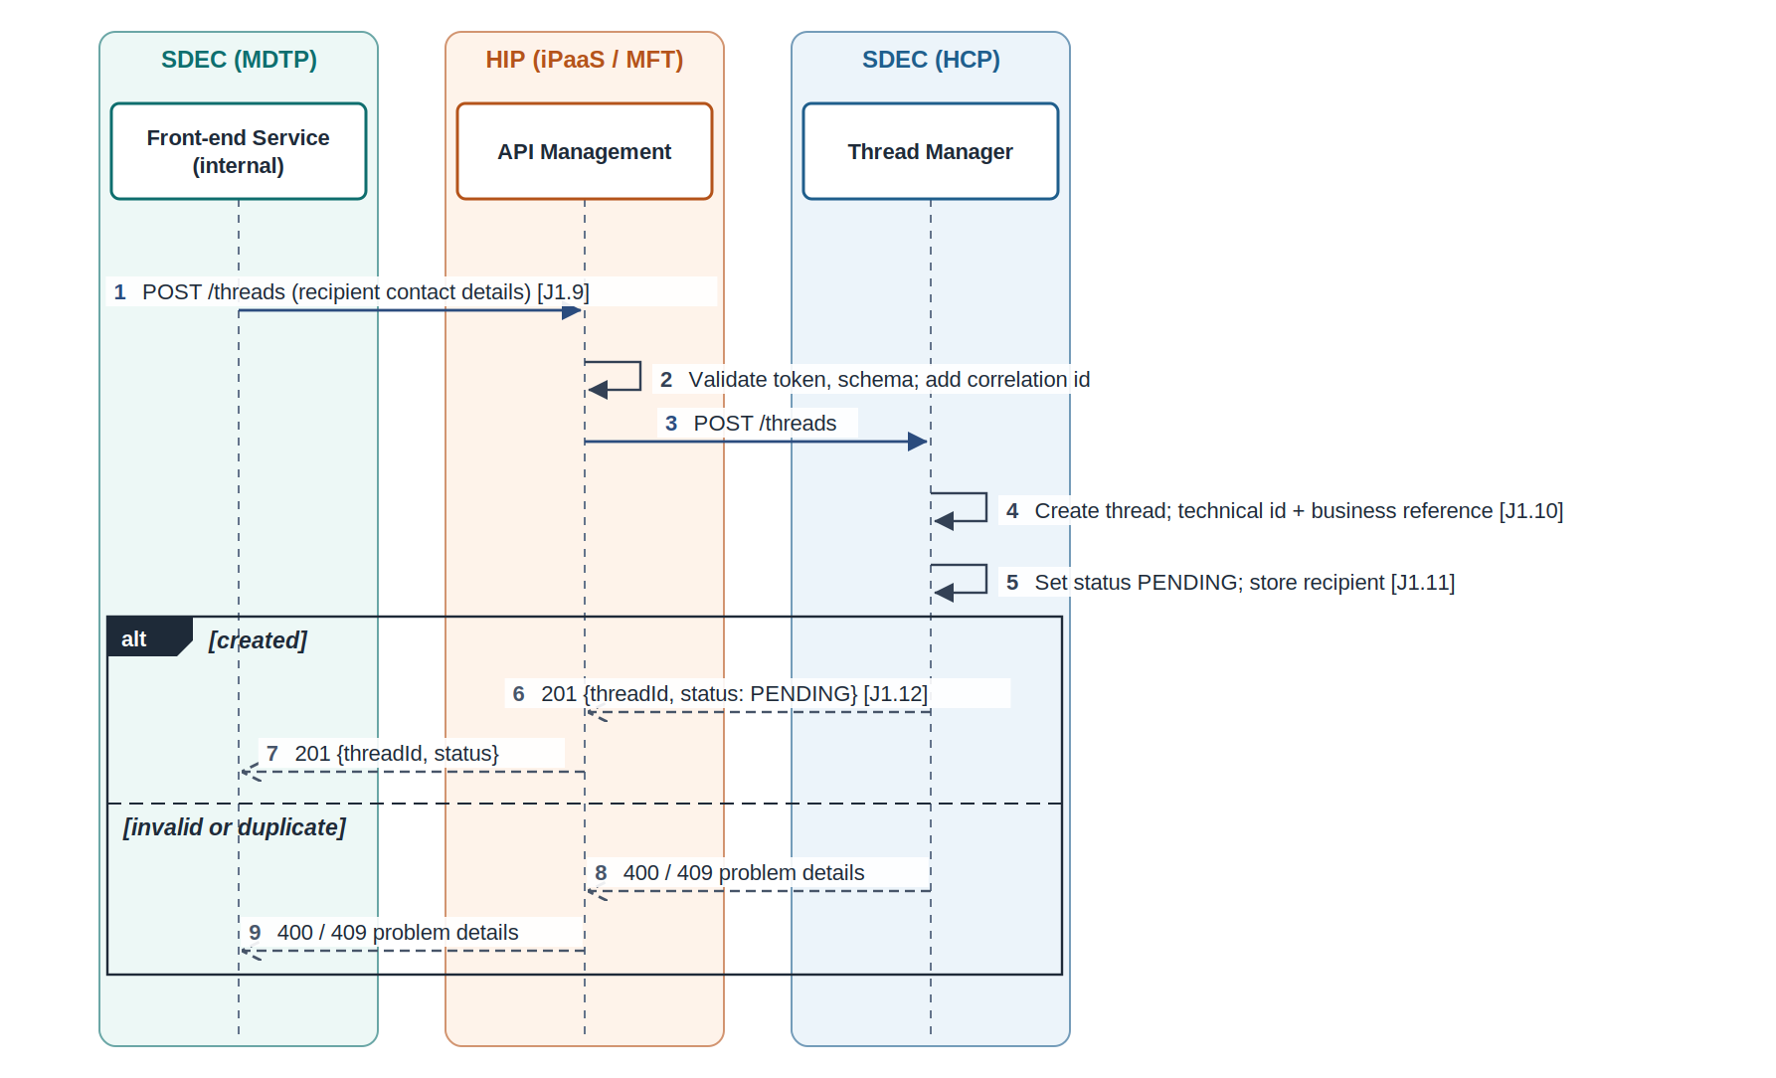
Figure 3: API-01 Create thread: interaction diagram

Attributes
Scope | Integration (MDTP to HCP)
Consumer | Front-end Service (internal)
Provider | Thread Manager (Thread Service)
Mediation | HIP API Management (recommended, OI-19)
Method and path | POST /threads (proposed; source: POST Thread Service API)
Pattern | Synchronous request / response
Requirements delivered | INT-01 Create thread API; NFR-01 Correlation identifiers; NFR-04 Service authentication and URL security
Open items | OI-01, OI-02, OI-06, OI-19

Request
Field | Type | Required | Notes
Idempotency-Key | header, UUID | Yes | Repeat-safe creation
X-Correlation-Id | header, UUID | Yes | Journey correlation
recipient.firstName / lastName | string | Yes | Contact details captured at J1 step 5
recipient.email / mobileNumber | string | Yes | For notifications
recipient.nino | string | Yes | Recipient identifier
createdBy | from token | Yes | Internal user identity (signed claim)

Response
Field | Type | Notes
threadId | UUID | Technical thread id
status | enum | PENDING
createdAt | timestamp | Creation time

Errors and handling
Code | Meaning | Handling
400 | Schema or field validation failure | Show field errors; no retry
401 / 403 | Caller or user not authorised | No retry
409 | Idempotency key reused with a different body | No retry
5xx / timeout | Thread Manager unavailable | Retry with the same Idempotency-Key, then show error

Processing
- API Management validates token and schema and adds the correlation id.
- Thread Manager creates the thread in Draft, generates the technical id and business reference together (OI-01), sets PENDING and stores the recipient (OI-06).
- The business reference is not returned here; it is returned by API-04.

Open items affecting this API
- OI-01: Technical versus business-facing thread reference. Note proposes generating both at step 10; the reference is returned only at confirmation (not steps 13-14).
- OI-02: Add API calls under steps 8 and 9 and align with external auth documentation; add generic pass and response call.
- OI-06: When recipient information is stored in HCP: at step 9 or after step 42.
- OI-19: Do SDEC MDTP to HCP calls (Thread Service, Submission Service, /interaction/submissions) route through HIP API Management or go direct?

6.2 API-02 Save thread details (front end)
Save message title, body and attachment list while the internal user builds the thread; details are cached in the front end until submission.
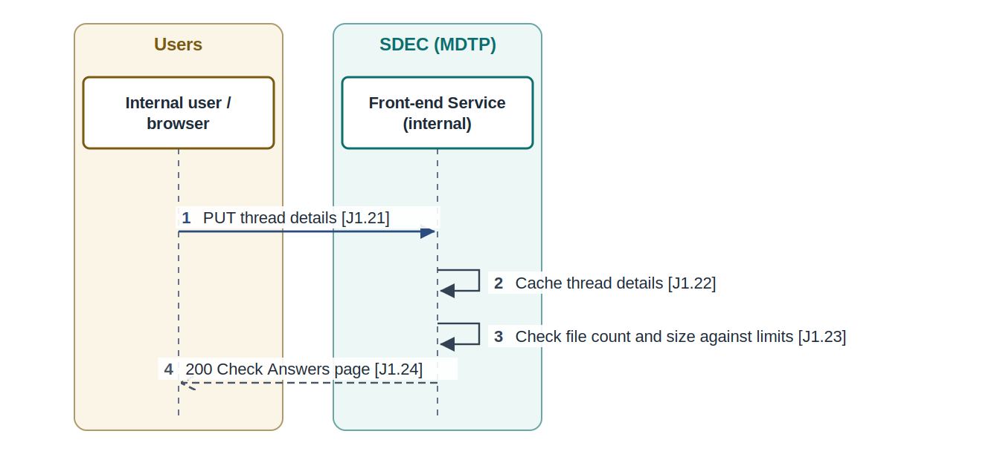
Figure 4: API-02 Save thread details (front end): interaction diagram

Attributes
Scope | Front end (context only)
Consumer | Internal user browser
Provider | Front-end Service (internal)
Mediation | None
Method and path | PUT Thread Service API (front end)
Pattern | Synchronous request / response
Requirements delivered | NFR-06 File count and size limits
Open items | OI-24

Request
Field | Type | Required | Notes
messageTitle / messageBody | string | Yes | J1 step 17
attachments[] | file ids | No | From the upload loop

Response
Field | Type | Notes
page | HTML | Check Answers page

Errors and handling
Code | Meaning | Handling
400 | Validation failure, including file count or size above limits (J1 step 23) | Show errors

Processing
- Front end caches the details (J1 step 22) and checks file count and size against the MFT limits (NFR-06).

Open items affecting this API
- OI-24: Source inconsistencies: table names SDEC_Interaction and SDEC_Thread_Interaction both used; step 28 marked 'Response to 25' (should be 26); steps 23-24 only on the diagram.

6.3 API-03 Change thread details (front end)
Save changes made from the Check Answers loop. The source design names this the Interaction API, while step 21 uses Thread Service API for the same action; one name should be agreed.
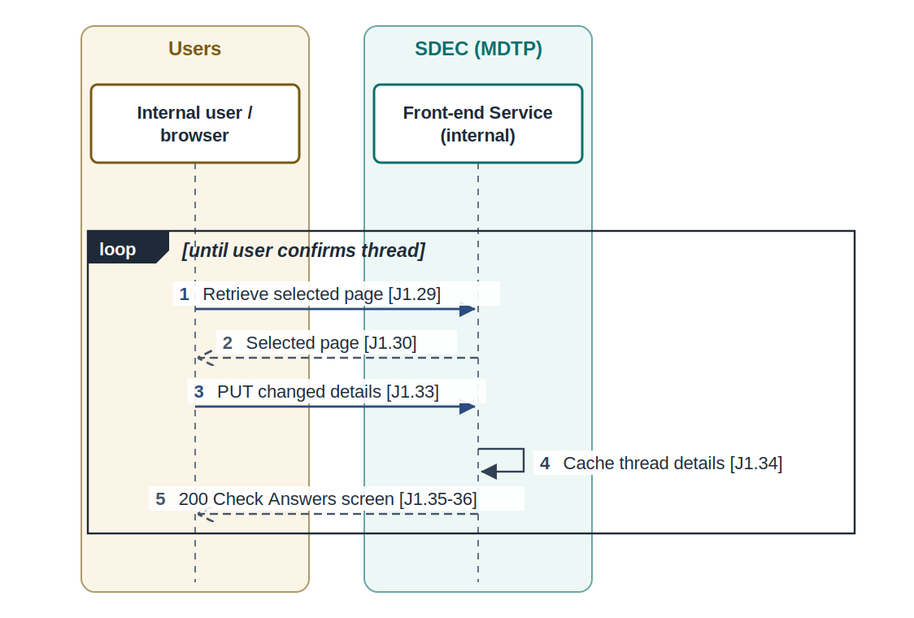
Figure 5: API-03 Change thread details (front end): interaction diagram

Attributes
Scope | Front end (context only)
Consumer | Internal user browser
Provider | Front-end Service (internal)
Mediation | None
Method and path | PUT Interaction API (front end)
Pattern | Synchronous request / response
Requirements delivered | Context only
Open items | OI-24

Request
Field | Type | Required | Notes
changed fields | various | Yes | Any page in the thread journey

Response
Field | Type | Notes
page | HTML | Check Answers screen

Errors and handling
Code | Meaning | Handling
400 | Validation failure | Show errors

Processing
- Front end caches the change (J1 step 34) and redisplays Check Answers.

Open items affecting this API
- OI-24: Source inconsistencies: table names SDEC_Interaction and SDEC_Thread_Interaction both used; step 28 marked 'Response to 25' (should be 26); steps 23-24 only on the diagram.

6.4 API-04 Submit thread
Confirm the thread, return the business reference for the confirmation page, and start the transfer of thread attachments to eDMS.
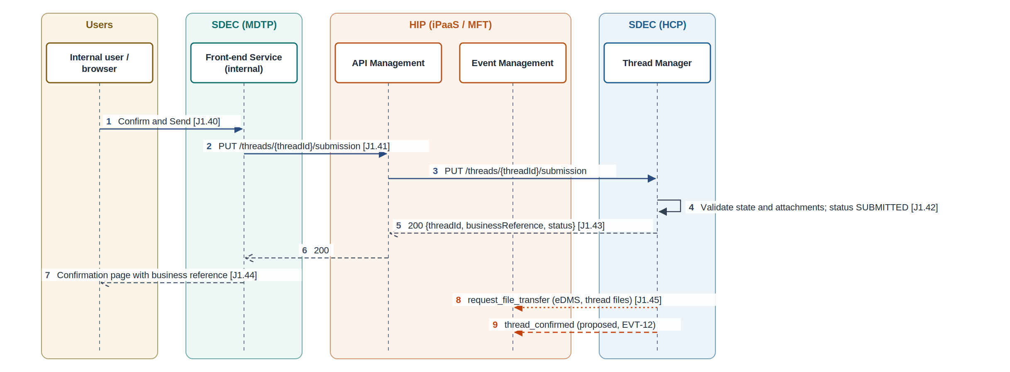
Figure 6: API-04 Submit thread: interaction diagram

Attributes
Scope | Integration (MDTP to HCP)
Consumer | Front-end Service (internal)
Provider | Thread Manager (Submission Service)
Mediation | HIP API Management (recommended, OI-19)
Method and path | PUT /threads/{threadId}/submission (proposed; source: PUT Submission Service API)
Pattern | Synchronous request / response, then asynchronous commands
Requirements delivered | INT-02 Submit thread API; INT-03 Thread attachments to eDMS; EVT-07 request_file_transfer (target eDMS); EVT-12 thread_confirmed (proposed)
Open items | OI-05, OI-08, OI-09, OI-19

Request
Field | Type | Required | Notes
Idempotency-Key / X-Correlation-Id | headers | Yes
messageTitle / messageBody | string | Yes | Cached thread details
responseDeadline | date | Yes | Shown to recipient
attachments[] | {fileCollectionId, fileId} | No | Clean-staged files
recipient | object | No | Only if changed since creation

Response
Field | Type | Notes
threadId | UUID
businessReference | string | Shown on confirmation page (OI-01)
status | enum | SUBMITTED

Errors and handling
Code | Meaning | Handling
404 | Thread not found | No retry
409 | Thread not in PENDING state | No retry; reload
422 | An attachment is not clean-staged | Ask user to re-upload
5xx / timeout | Unavailable | Retry with same key

Processing
- Thread Manager validates state and attachments, sets SUBMITTED (OI-08) and returns the business reference.
- Thread Manager then sends request_file_transfer (eDMS) for the attachments (EVT-07, J1 step 45) and publishes thread_confirmed (EVT-12, proposed) for the recipient notification.

Open items affecting this API
- OI-05: Correct endpoints for the iPaaS team and HCP team (steps 40-41).
- OI-08: Thread state after step 42 before the eDMS transfer at step 45.
- OI-09: Confirmation screen marked for removal; add thread confirmation event that calls search, email and outlook services.
- OI-19: Do SDEC MDTP to HCP calls (Thread Service, Submission Service, /interaction/submissions) route through HIP API Management or go direct?

6.5 API-05 Request document upload (front end)
Start an upload for the files the external user selected and return pre-signed URLs to the browser.
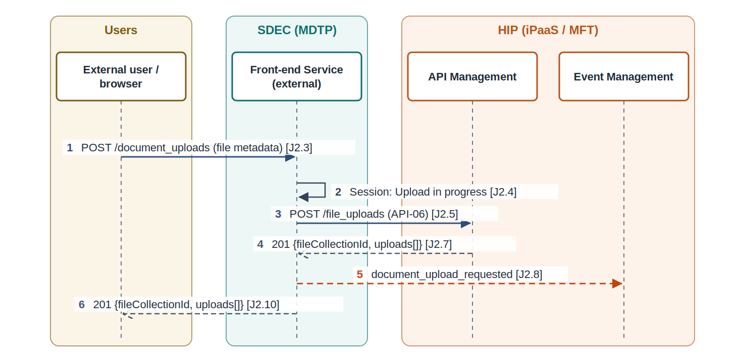
Figure 7: API-05 Request document upload (front end): interaction diagram

Attributes
Scope | Front end (context only)
Consumer | External user browser
Provider | Front-end Service (external)
Mediation | None (front end calls API-06 through HIP)
Method and path | POST /document_uploads (source)
Pattern | Synchronous request / response
Requirements delivered | INT-04 File upload request (consumer side); EVT-01 document_upload_requested
Open items | OI-20

Request
Field | Type | Required | Notes
files[] | {fileName, mediaType, sizeBytes} | Yes | From the user device (J2 steps 1-2)

Response
Field | Type | Notes
fileCollectionId | UUID
uploads[] | object | Pre-signed URL set per file (from API-06)

Errors and handling
Code | Meaning | Handling
400 / 413 / 415 | Passed through from API-06 | Show to user

Processing
- Front end sets session state Upload in progress, calls API-06, publishes document_upload_requested (EVT-01) and returns the URLs.

Open items affecting this API
- OI-20: Which events and commands use HIP Event Management versus an SDEC internal channel (for example document_upload_requested, submission_completed).

6.6 API-06 File Transfer API: request upload
Validate the files to be uploaded, choose single or multi-part upload, issue pre-signed URLs and create the file collection.
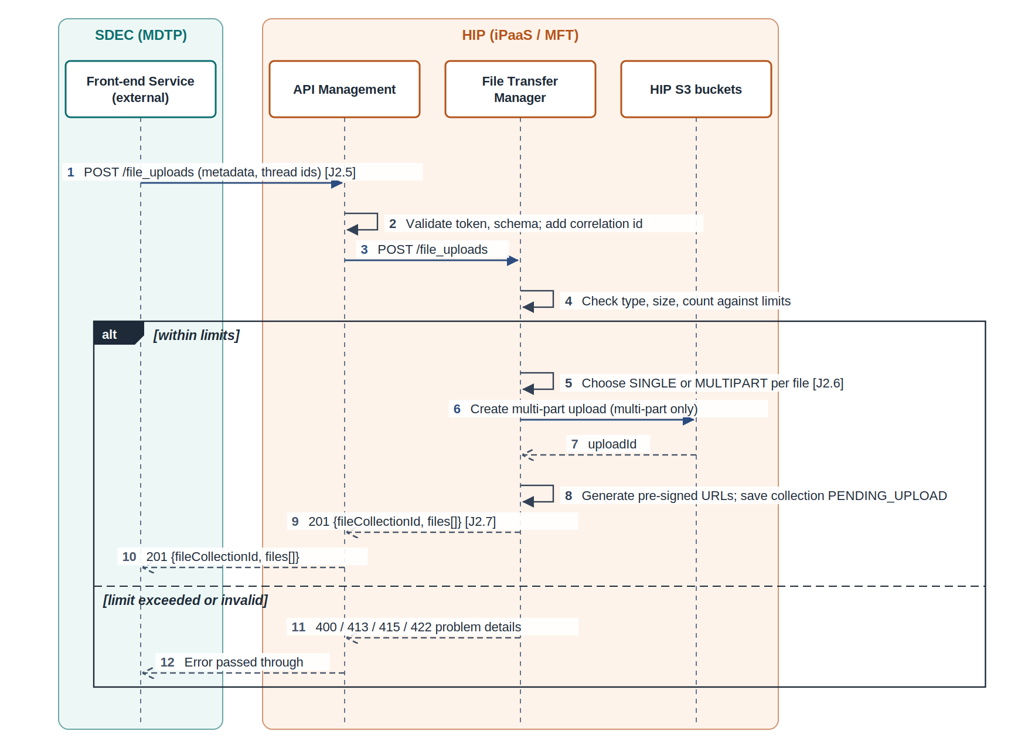
Figure 8: API-06 File Transfer API: request upload: interaction diagram

Attributes
Scope | Integration (MDTP to HIP)
Consumer | Front-end Service (external and internal)
Provider | HIP File Transfer Manager
Mediation | HIP API Management
Method and path | POST /file_uploads (source)
Pattern | Synchronous request / response
Requirements delivered | MFT-01 File Transfer API (provider); MFT-02 Upload strategy and pre-signed URLs; MFT-13 File collection correlation; INT-04 File upload request (consumer side)
Open items | OI-21, OI-22, OI-26

Request
Field | Type | Required | Notes
Idempotency-Key / X-Correlation-Id | headers | Yes
threadId / interactionId | UUID | Yes | Business context
uploadedBy | enum | Yes | INTERNAL or EXTERNAL
files[] | {clientFileRef, fileName, mediaType, sizeBytes} | Yes | One entry per file

Response
Field | Type | Notes
fileCollectionId | UUID | MFT correlation key (MFT-13)
files[].fileId | UUID | End-to-end document id (OI-13)
files[].strategy | enum | SINGLE or MULTIPART
files[].url / parts[] | URL(s) | Pre-signed PUT URL, or one URL per part with uploadId
files[].expiresAt | timestamp | URL expiry

Errors and handling
Code | Meaning | Handling
400 | Invalid metadata | No retry
413 | File above size limit | No retry
415 | Media type not allowed | No retry
422 | Too many files | No retry
5xx / timeout | HIP unavailable | Retry with same key

Processing
- Validate type, size and count against configured limits (NFR-06, OI-21).
- Choose strategy by size; for multi-part, create the multi-part upload in S3 to obtain an uploadId.
- Generate pre-signed URLs scoped to one object key in the landing bucket (OI-26 decides the mechanism).
- Persist the file collection and file records as PENDING_UPLOAD in the HIP database (not the node-local cache).

Open items affecting this API
- OI-21: Maximum file size and count versus AV scan ceiling (tracked gap G-15, about 250 MB) and multi-part threshold.
- OI-22: Microservice for steps 5-6 shown as 'TBC - iPaaS / MFT'. Confirm HIP owns the File Transfer API.
- OI-26: Technology choices inside HIP: event broker (Boomi Event Streams or the platform broker), pre-signed URL generation (Boomi script with AWS SDK or a small AWS Lambda), AV engine limits, and credential sourcing from enterprise secrets / PAM (tracked gap G-14).

6.7 API-07 Direct upload with pre-signed URL
Move file content from the browser to HIP storage without passing through SDEC services, and tell File Transfer Manager the upload is complete.
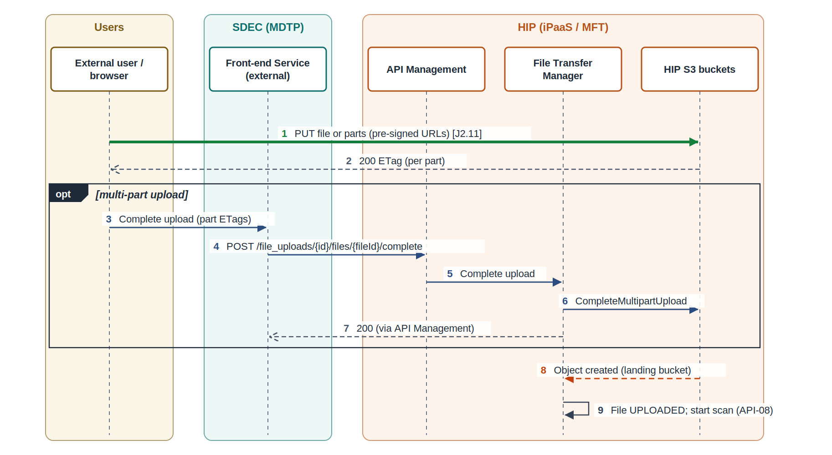
Figure 9: API-07 Direct upload with pre-signed URL: interaction diagram

Attributes
Scope | Integration (browser to HIP)
Consumer | User browser
Provider | HIP landing bucket (S3)
Mediation | Pre-signed URL (no gateway)
Method and path | PUT {pre-signed URL}; completion: POST /file_uploads/{fileCollectionId}/files/{fileId}/complete (proposed)
Pattern | Direct object upload, then storage event
Requirements delivered | MFT-03 Landing bucket for direct upload; MFT-02 Upload strategy and pre-signed URLs
Open items | OI-25

Request
Field | Type | Required | Notes
body | binary | Yes | File or part content
Content-Type | header | Yes | Must match the URL signature
parts[] {partNumber, eTag} | completion call | Multi-part only | From S3 part responses

Response
Field | Type | Notes
ETag | header | Per object or part
200 | completion | Multi-part upload completed

Errors and handling
Code | Meaning | Handling
403 | URL expired or signature mismatch | Request new URLs via API-05 / API-06
5xx | Storage error | Browser retries the part

Processing
- Browser PUTs the file (or each part) to the landing bucket.
- For multi-part, the browser (through its front end) calls the completion endpoint and File Transfer Manager completes the upload in S3 (OI-25).
- The S3 object-created notification tells File Transfer Manager the object exists; it sets UPLOADED and starts the scan (API-08).

Open items affecting this API
- OI-25: Upload completion is not in the source designs: how File Transfer Manager learns a direct browser upload has finished (single and multi-part), and who completes a multi-part upload.

6.8 API-08 AV scan and staging
Make sure no file is used downstream without a clean verdict; quarantine failures and stage clean files.
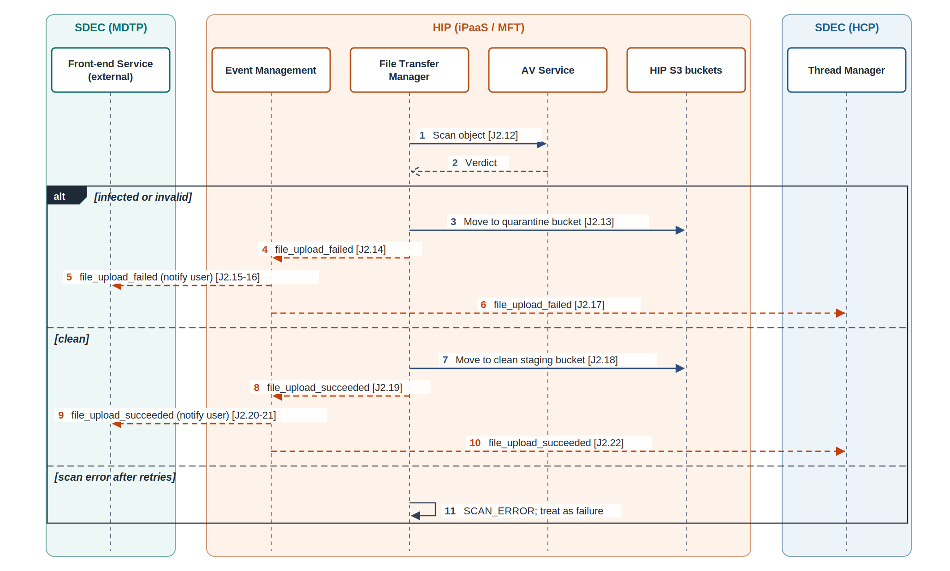
Figure 10: API-08 AV scan and staging: interaction diagram

Attributes
Scope | Integration (inside HIP)
Consumer | HIP File Transfer Manager
Provider | AV Service
Mediation | Internal to HIP
Method and path | Internal call AV scan request (HIP capability)
Pattern | Synchronous internal call, then events
Requirements delivered | MFT-04 AV scan and validation; MFT-05 Quarantine; MFT-06 Clean staging; MFT-07 Upload outcome events; EVT-02 file_upload_failed; EVT-03 file_upload_succeeded
Open items | OI-10, OI-21

Request
Field | Type | Required | Notes
bucket / objectKey | string | Yes | Landing object
fileId | UUID | Yes

Response
Field | Type | Notes
verdict | enum | CLEAN, INFECTED, INVALID or ERROR
engine / signature | string | Engine version and detection name

Errors and handling
Code | Meaning | Handling
ERROR | Scanner failure or file above scan ceiling (G-15) | Retry up to 3 times, then treat as failure; never as clean

Processing
- Scan every landing object (J2 step 12).
- Infected or invalid: move to quarantine, publish file_upload_failed (EVT-02).
- Clean: move to clean staging, publish file_upload_succeeded (EVT-03).
- Thread Manager and the front end consume the outcome (J2 steps 15-17, 20-22).

Open items affecting this API
- OI-10: Internal user or support notification on upload failure.
- OI-21: Maximum file size and count versus AV scan ceiling (tracked gap G-15, about 250 MB) and multi-part threshold.

6.9 API-09 Submit interaction response (front end)
Receive the external user's response with its browser hash, validate and sign it, and pass it to Thread Manager.
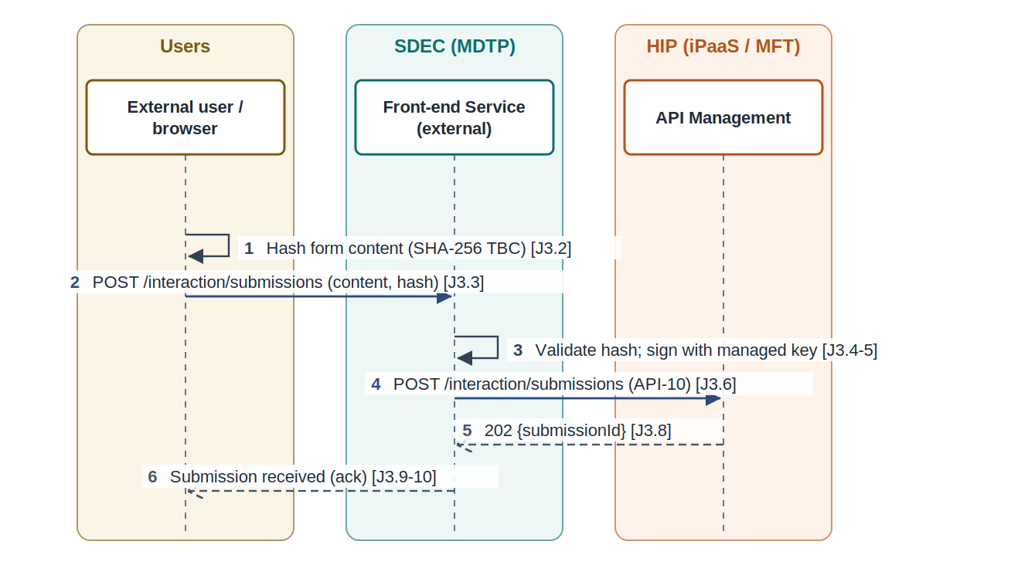
Figure 11: API-09 Submit interaction response (front end): interaction diagram

Attributes
Scope | Front end (context only)
Consumer | External user browser
Provider | Front-end Service (external)
Mediation | None (front end calls API-10)
Method and path | POST /interaction/submissions (source)
Pattern | Synchronous request / acknowledgement
Requirements delivered | INT-06 Submission content integrity; INT-05 Submission initiation API
Open items | OI-14

Request
Field | Type | Required | Notes
submissionContent | JSON | Yes | Form content
contentHash | {alg, value} | Yes | SHA-256 TBC (OI-14)

Response
Field | Type | Notes
submissionId / status |  | Acknowledgement only

Errors and handling
Code | Meaning | Handling
400 | Hash mismatch or invalid content | Show error

Processing
- Front end recomputes and validates the hash, signs it if not signed (J3 steps 4-5) and calls API-10.

Open items affecting this API
- OI-14: Hash algorithm (SHA-256 TBC) and where signing happens: browser or Front-end Service (external).

6.10 API-10 Initiate submission (Thread Manager)
Record the signed submission and start the parallel NRS and eDMS legs without making the user wait.
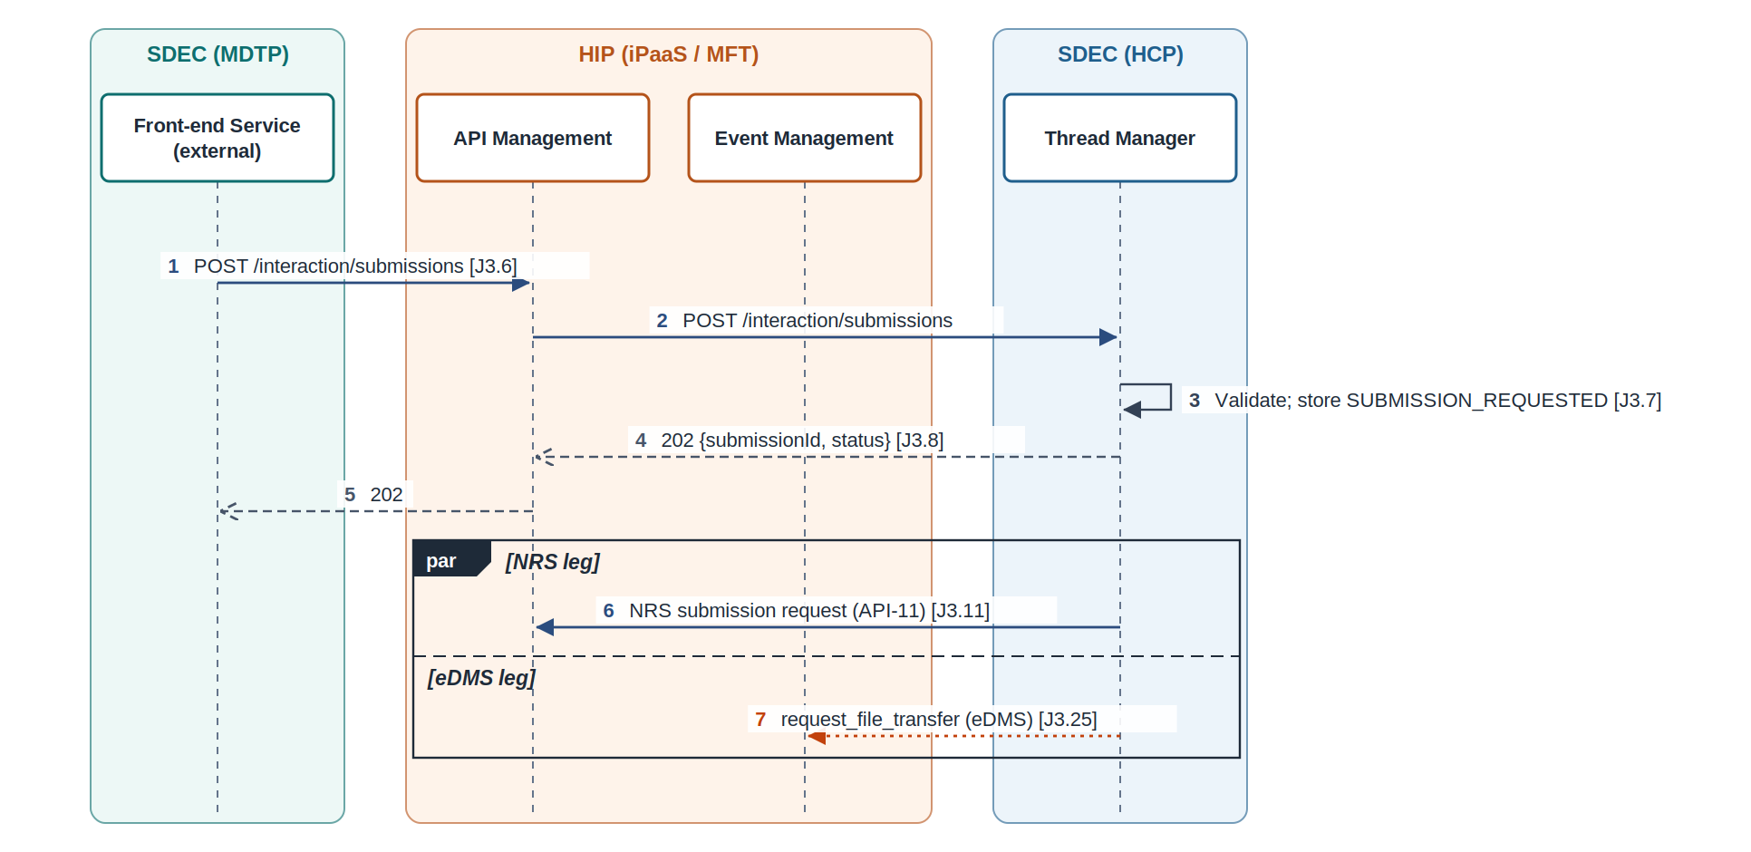
Figure 12: API-10 Initiate submission (Thread Manager): interaction diagram

Attributes
Scope | Integration (MDTP to HCP)
Consumer | Front-end Service (external)
Provider | Thread Manager (Interaction and Document Service)
Mediation | HIP API Management (recommended, OI-19)
Method and path | POST /interaction/submissions (source)
Pattern | Synchronous acknowledgement, asynchronous processing
Requirements delivered | INT-05 Submission initiation API; INT-13 Independent parallel NRS and eDMS legs
Open items | OI-12, OI-19

Request
Field | Type | Required | Notes
Idempotency-Key / X-Correlation-Id | headers | Yes
threadId / interactionId | UUID | Yes
submissionContent | JSON | Yes
contentHash | {alg, value} | Yes
signature | {alg, value, keyId} | Yes | Front-end signature
documents[] | fileId list | Yes | Clean-staged documents

Response
Field | Type | Notes
submissionId | UUID
status | enum | SUBMISSION_REQUESTED
receivedAt | timestamp

Errors and handling
Code | Meaning | Handling
400 | Invalid content or signature | No retry
409 | Already submitted | Return original
422 | Document not clean-staged | No retry
5xx / timeout | Unavailable | Retry with same key

Processing
- Thread Manager validates, stores SUBMISSION_REQUESTED (J3 step 7) and returns 202.
- In parallel: NRS leg (API-11, API-12, API-13) and eDMS leg (EVT-07, API-14).

Open items affecting this API
- OI-12: Is NRS dependent on a successful eDMS transfer? Avoid if possible; requires consistent document ids and browser hash / signing.
- OI-19: Do SDEC MDTP to HCP calls (Thread Service, Submission Service, /interaction/submissions) route through HIP API Management or go direct?

6.11 API-11 NRS Submission API
Lodge the signed interaction payload and attachment references with NRS and obtain an NRS submission id.
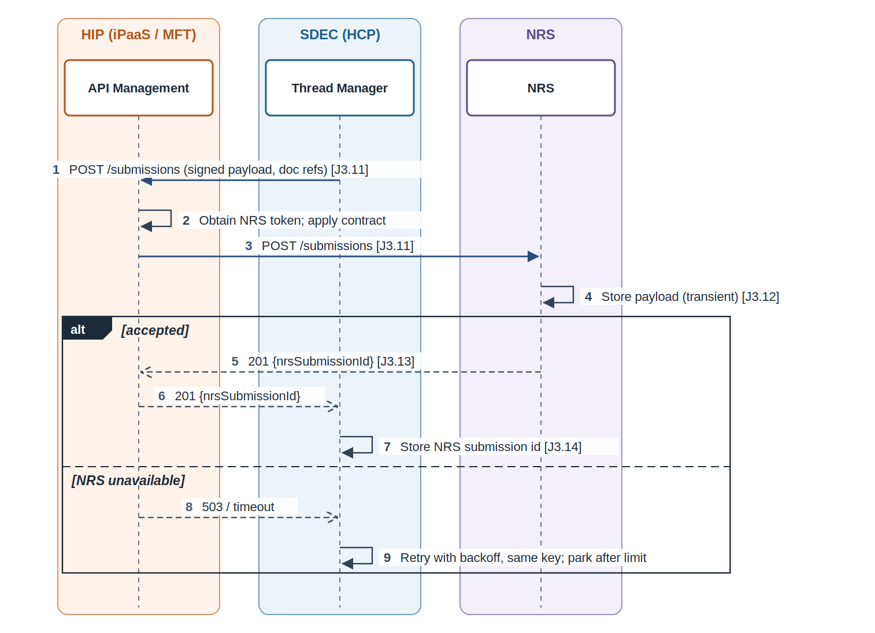
Figure 13: API-11 NRS Submission API: interaction diagram

Attributes
Scope | Integration (HCP to NRS via HIP)
Consumer | Thread Manager
Provider | NRS Submission service
Mediation | HIP API Management
Method and path | POST /submissions (NRS to confirm)
Pattern | Synchronous request / response
Requirements delivered | INT-07 NRS Submission API via HIP; INT-09 NRS APIs published through iPaaS; INT-06 Submission content integrity; INT-13 Independent parallel NRS and eDMS legs
Open items | OI-12, OI-13

Request
Field | Type | Required | Notes
Idempotency-Key / X-Correlation-Id | headers | Yes | Submission id as key
submissionId | UUID | Yes | SDEC submission id
payload | JSON | Yes | Signed interaction payload
payloadHash / signature | object | Yes | From API-10
attachments[] | {documentId, fileName, mediaType, sizeBytes, sha256} | Yes | Document references

Response
Field | Type | Notes
nrsSubmissionId | string | Stored by Thread Manager (J3 step 14)

Errors and handling
Code | Meaning | Handling
400 | Contract violation | No retry; alert
409 | Duplicate submission | Use returned id
5xx / timeout | NRS unavailable | Retry with backoff and same key; park after limit; eDMS leg continues

Processing
- API Management obtains the NRS token, calls NRS over mTLS and applies the contract.
- NRS stores the payload in transient storage (J3 step 12).

Open items affecting this API
- OI-12: Is NRS dependent on a successful eDMS transfer? Avoid if possible; requires consistent document ids and browser hash / signing.
- OI-13: Do we need end-to-end document ids, or can the submission id be used?

6.12 API-12 NRS Attachment API
Obtain pre-signed upload URLs from NRS for each document and hand them to File Transfer Manager.
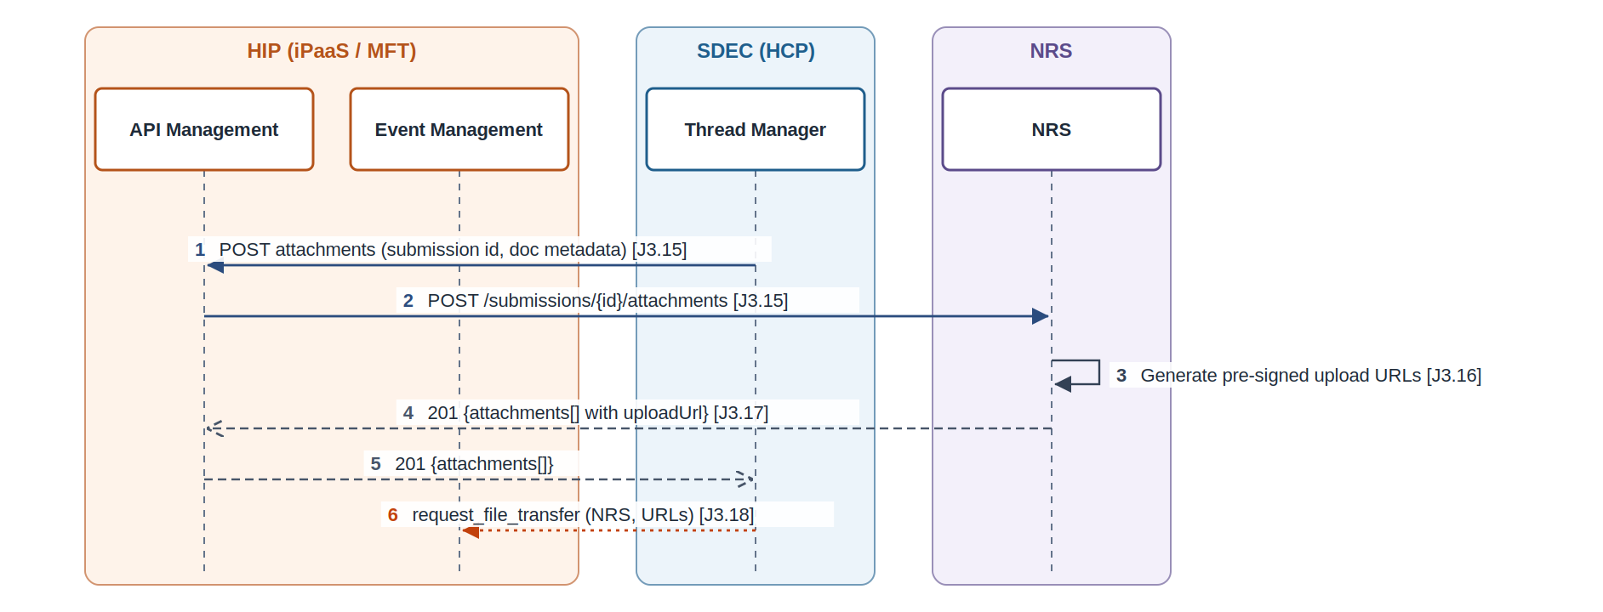
Figure 14: API-12 NRS Attachment API: interaction diagram

Attributes
Scope | Integration (HCP to NRS via HIP)
Consumer | Thread Manager
Provider | NRS Attachment Service
Mediation | HIP API Management
Method and path | POST /submissions/{nrsSubmissionId}/attachments (NRS to confirm)
Pattern | Synchronous request / response, then asynchronous command
Requirements delivered | INT-08 NRS Attachment API via HIP; INT-09 NRS APIs published through iPaaS; EVT-04 request_file_transfer (target NRS)
Open items | OI-15

Request
Field | Type | Required | Notes
nrsSubmissionId | path | Yes
attachments[] | {documentId, mediaType, sizeBytes, sha256} | Yes

Response
Field | Type | Notes
attachments[] | {documentId, uploadUrl, expiresAt} | One URL per document

Errors and handling
Code | Meaning | Handling
404 | Unknown NRS submission | Alert
5xx / timeout | NRS unavailable | Retry with backoff

Processing
- Thread Manager requests URLs (as suggested in the source, OI-15).
- Thread Manager sends request_file_transfer (NRS) with the URLs (EVT-04).

Open items affecting this API
- OI-15: Who obtains NRS pre-signed URLs: Thread Manager (suggested), File Transfer Manager, or Submission API returning them at step 13.

6.13 API-13 Transfer to NRS transient storage
Copy clean-staged documents to NRS transient storage and report the outcome to Thread Manager.
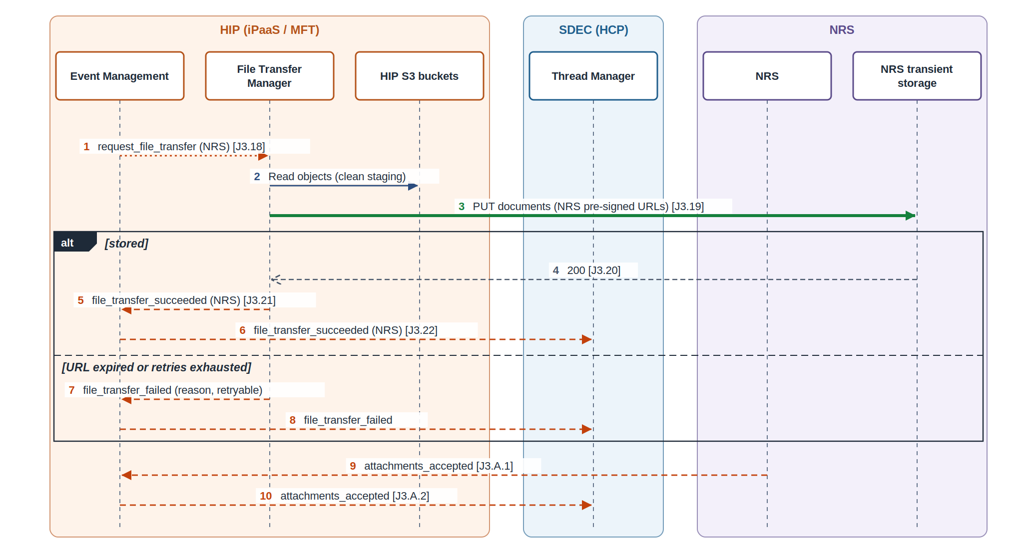
Figure 15: API-13 Transfer to NRS transient storage: interaction diagram

Attributes
Scope | Integration (HIP to NRS)
Consumer | HIP File Transfer Manager
Provider | NRS transient storage
Mediation | Pre-signed URL issued by NRS
Method and path | PUT {NRS pre-signed URL}
Pattern | Command-driven file transfer with outcome event
Requirements delivered | MFT-08 File transfer request queue; MFT-09 Transfer to NRS transient storage; MFT-11 Transfer outcome events; EVT-05 file_transfer_succeeded (NRS); EVT-06 attachments_accepted (NRS); EVT-13 Failure outcomes for transfer and deletion
Open items | OI-16, OI-18

Request
Field | Type | Required | Notes
body | binary | Yes | Read from clean staging
Content-Type / checksum | headers | As NRS requires

Response
Field | Type | Notes
200 |  | Stored

Errors and handling
Code | Meaning | Handling
403 | URL expired (URL_EXPIRED) | No retry; failure event; Thread Manager re-requests URLs via API-12
5xx / timeout | Storage error | Retry with backoff, then failure event

Processing
- The generic transfer engine consumes the command and applies the NRS_TRANSIENT target configuration.
- It publishes file_transfer_succeeded (NRS) or a failure outcome (EVT-05, EVT-13).
- NRS validates, signs and stores evidentially, then publishes attachments_accepted (EVT-06).

Open items affecting this API
- OI-16: NRS acceptance notification: asynchronous event (SDEC preference) or polling (NRS suggestion).
- OI-18: Failure paths for NRS and eDMS transfers are described as 'or has failed etc' only. Define failure events, retries and Thread Manager states.

6.14 API-14 eDMS upload document API
Ingest clean-staged documents into eDMS as records, for both submissions (J3) and thread attachments (J1 step 45).
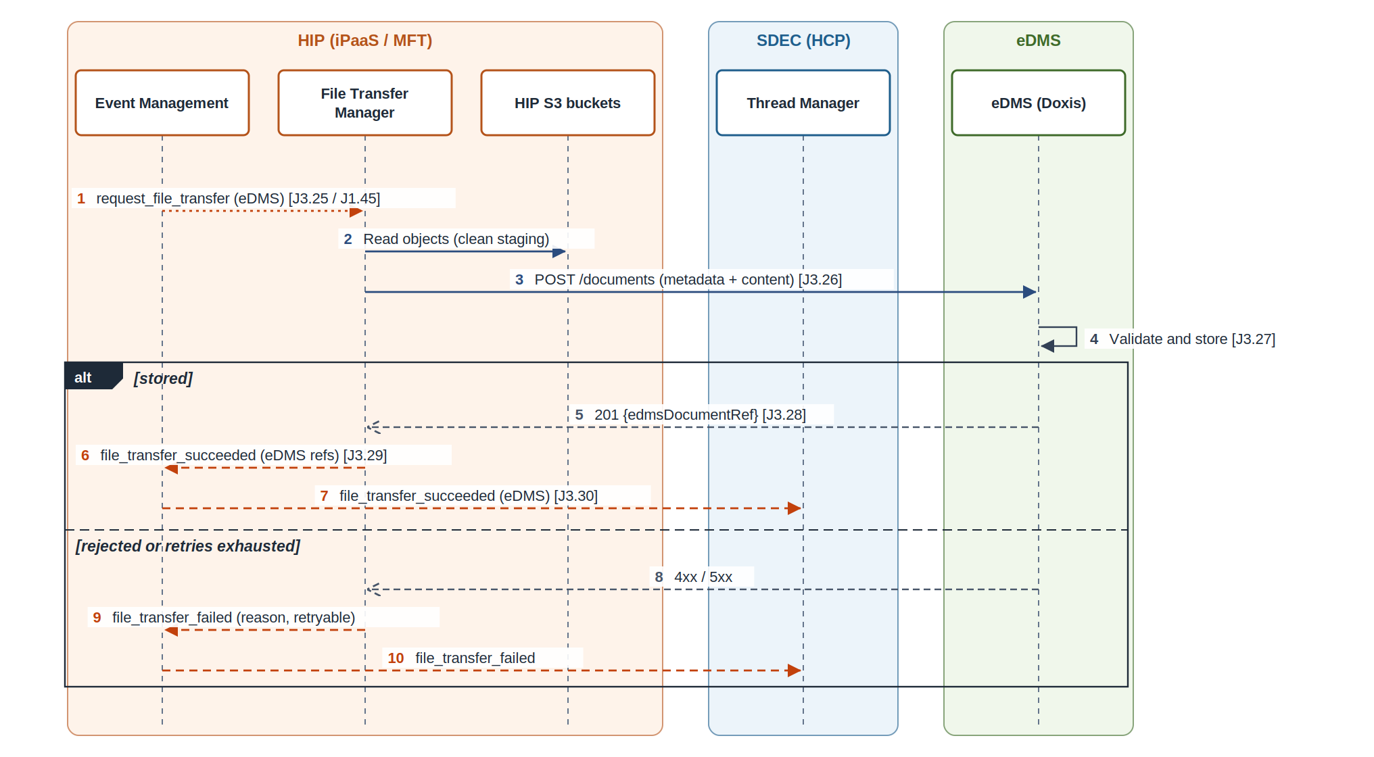
Figure 16: API-14 eDMS upload document API: interaction diagram

Attributes
Scope | Integration (HIP to eDMS)
Consumer | HIP File Transfer Manager
Provider | eDMS (Doxis)
Mediation | HIP File Transfer Manager (REST target)
Method and path | POST /documents (eDMS to confirm)
Pattern | Command-driven synchronous upload with outcome event
Requirements delivered | INT-11 eDMS upload document API; MFT-10 Transfer to eDMS; MFT-11 Transfer outcome events; EVT-07 request_file_transfer (target eDMS); EVT-08 file_transfer_succeeded (eDMS); INT-03 Thread attachments to eDMS
Open items | OI-18, OI-26

Request
Field | Type | Required | Notes
metadata.documentId | UUID | Yes | End-to-end document id
metadata.threadId / interactionId / submissionId | UUID | Yes | Transaction context
metadata.fileName / mediaType / sha256 | string | Yes
metadata.documentClass / retentionClass | string | TBC | Agreed with eDMS
content | binary (multipart/form-data) | Yes

Response
Field | Type | Notes
edmsDocumentRef | string | Stored by Thread Manager

Errors and handling
Code | Meaning | Handling
400 / 422 | Metadata or content rejected | No retry; failure event; alert
5xx / timeout | eDMS unavailable | Retry with backoff, then failure event

Processing
- The generic transfer engine applies the EDMS target configuration (endpoint and credentials from the secrets store).
- It publishes file_transfer_succeeded (eDMS) with references, or a failure outcome.
- Thread Manager sets Submission completed (J3 step 30), publishes submission_completed and requests notifications (API-15).

Open items affecting this API
- OI-18: Failure paths for NRS and eDMS transfers are described as 'or has failed etc' only. Define failure events, retries and Thread Manager states.
- OI-26: Technology choices inside HIP: event broker (Boomi Event Streams or the platform broker), pre-signed URL generation (Boomi script with AWS SDK or a small AWS Lambda), AV engine limits, and credential sourcing from enterprise secrets / PAM (tracked gap G-14).

6.15 API-15 Send notification
Tell the external user their submission is complete (email and / or SMS) and tell the internal thread owner a response has arrived (email).
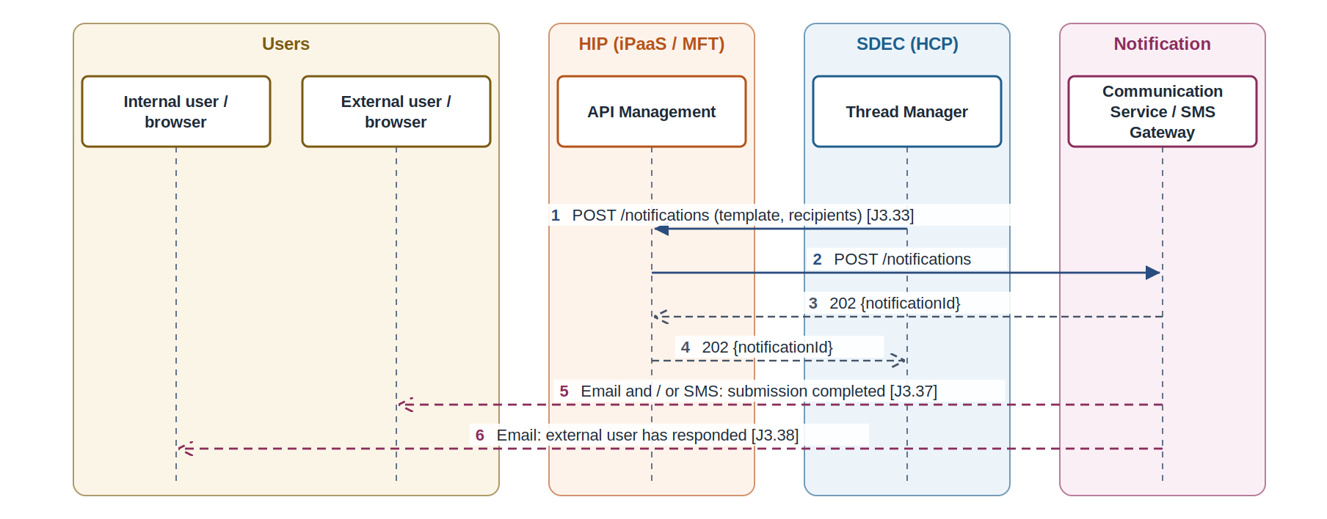
Figure 17: API-15 Send notification: interaction diagram

Attributes
Scope | Integration (HCP to Communication Service)
Consumer | Thread Manager
Provider | Communication Service / SMS Gateway
Mediation | HIP API Management (TBC)
Method and path | POST /notifications (TBC, source: 'Send notification')
Pattern | Synchronous acknowledgement, asynchronous delivery
Requirements delivered | INT-12 Notification request
Open items | OI-17

Request
Field | Type | Required | Notes
Idempotency-Key / X-Correlation-Id | headers | Yes
templateId | string | Yes | Per message type
recipients[] | {type, channel, address} | Yes | External user email / mobile, internal user email
personalisation | object | No | For example thread reference

Response
Field | Type | Notes
notificationId | UUID | For delivery status (OI-17)

Errors and handling
Code | Meaning | Handling
400 | Invalid template or address | No retry; alert
5xx / timeout | Unavailable | Retry with same key

Processing
- Thread Manager calls the service after Submission completed (J3 step 33).
- The SMS Gateway delivers email / SMS (J3 steps 37-38); delivery status handling is in the communication design.

Open items affecting this API
- OI-17: Communication Service endpoint ('Send notification') and response status handling, covered in the communication design.

7. Event and command design

7.1 Envelope
Every event and command uses one envelope so consumers can de-duplicate, trace and route without reading the payload.
Field | Type | Purpose
eventId | UUID | Unique per message; consumers de-duplicate on it.
eventType | string | For example file_upload_succeeded.
eventVersion | string | Contract version, for example 1.0.
occurredAt | timestamp (UTC) | When the fact happened.
source | string | Publishing service, for example hip.file-transfer-manager.
correlationId | UUID | Same value across all calls and events of one journey run.
threadId / interactionId | UUID | Business context.
fileCollectionId | UUID | Present on MFT messages.
data | object | Event-specific payload (see catalogue).
Table 11: Event and command envelope

7.2 Catalogue
ID | Name | Kind | Publisher | Subscribers | Topic or queue (proposed) | Steps | Payload | State change
EVT-01 | document_upload_requested | Event | Front-end Service (external) | Thread Manager | sdec.document-upload-requested.v1 | J2 8-9 | Thread / interaction state; document metadata | Interaction: Document upload requested; SDEC Document records created
EVT-02 | file_upload_failed | Event | HIP File Transfer Manager | Front-end Service (external); Thread Manager | hip.mft.file-upload-failed.v1 | J2 14-17 | Document references / metadata; error details | Session and interaction: Document upload failed
EVT-03 | file_upload_succeeded | Event | HIP File Transfer Manager | Front-end Service (external); Thread Manager | hip.mft.file-upload-succeeded.v1 | J2 19-22 | Document references / metadata | Session and interaction: Document upload succeeded
EVT-04 | request_file_transfer (NRS) | Command | Thread Manager | HIP File Transfer Manager | hip.mft.file-transfer-requests (queue) | J3 18 | Pre-signed URLs; file collection reference; target identifier(s); transaction context | None (triggers MFT-09)
EVT-05 | file_transfer_succeeded (NRS) | Event | HIP File Transfer Manager | Thread Manager | hip.mft.file-transfer-outcome.v1 | J3 21-22 | Success (failure outcome TBC) | Documents transferred to NRS
EVT-06 | attachments_accepted | Event | NRS | Thread Manager | nrs.attachments-accepted.v1 | J3 A.1-A.2 | Attachment acceptance status | NRS documents accepted
EVT-07 | request_file_transfer (eDMS) | Command | Thread Manager | HIP File Transfer Manager | hip.mft.file-transfer-requests (queue) | J3 25; J1 45 | File collection reference; target identifier(s); transaction context | None (triggers MFT-10)
EVT-08 | file_transfer_succeeded (eDMS) | Event | HIP File Transfer Manager | Thread Manager | hip.mft.file-transfer-outcome.v1 | J3 29-30 | Success; eDMS document references (failure outcome TBC) | Submission completed
EVT-09 | submission_completed | Event | Thread Manager | Front-end Service (external); Front-end Service (internal) | sdec.submission-completed.v1 | J3 31-32 | Interaction status: submitted | None (drives user notifications)
EVT-10 | delete_staged_files | Command | Thread Manager | HIP File Transfer Manager | hip.mft.file-transfer-requests (queue) | J3 39 | File collection id | None (triggers MFT-12)
EVT-11 | file_deletion_succeeded | Event | HIP File Transfer Manager | Thread Manager | hip.mft.file-deletion-outcome.v1 | J3 41-42 | File collection id | Document: staged files deleted
EVT-12 | thread_confirmed (proposed) | Event | Thread Manager | Search service (iPaaS); email service; outlook service (internal) | sdec.thread-confirmed.v1 | J1 note | TBC | TBC
EVT-13 | file_transfer_failed / file_deletion_failed (proposed) | Event | HIP File Transfer Manager | Thread Manager | hip.mft.file-transfer-outcome.v1 / file-deletion-outcome.v1 | J3 21, 29, 41 | Error details (TBC) | TBC
Table 12: Event and command catalogue

7.3 Delivery rules
- At-least-once delivery. Consumers de-duplicate on eventId and make side effects idempotent (NFR-03).
- Each subscriber has its own queue and dead-letter queue; failed messages are retried with backoff, then dead-lettered and alerted.
- Commands (request_file_transfer, delete_staged_files) go on one File Transfer Manager request queue; the command type and target select the behaviour.
- Ordering is not guaranteed across topics. Thread Manager's clean-up gate (EVT-10) checks recorded states, so eDMS and NRS outcomes may arrive in any order.
- Events that cross a platform boundary use HIP Event Management (OI-20).

8. Managed file transfer design

8.1 Storage
Store | Owner | Steps | Purpose | Retention
Landing bucket (AWS S3) | HIP File Transfer Manager | J2 11 | Receives browser uploads via pre-signed URLs | Until scanned
Quarantine bucket (AWS S3) | HIP File Transfer Manager | J2 13 | Infected or invalid files | TBC (NFR-07)
Clean staging bucket (AWS S3) | HIP File Transfer Manager | J2 18; J3 19, 26, 40 | Source for NRS and eDMS transfers | Until J3 step 40 deletion
NRS transient storage (AWS S3) | NRS | J3 12, 20 | Submission payload and attachments before signing | NRS owned
NRS evidential storage | NRS | J3 24 | Signed payload and attachments | NRS owned
eDMS document store | eDMS (Doxis) | J3 27; J1 45 | Records of submitted and thread documents | eDMS owned
Table 13: File storage locations

8.2 File lifecycle
State | Entered when | Next states
PENDING_UPLOAD | URLs issued (API-06) | UPLOADED, EXPIRED
UPLOADED | Object created in landing bucket (API-07) | SCANNING
SCANNING | Scan requested (API-08) | QUARANTINED, CLEAN_STAGED, SCAN_ERROR
QUARANTINED | Verdict infected or invalid | Deleted by quarantine retention
CLEAN_STAGED | Verdict clean, moved to clean staging | TRANSFERRING
TRANSFERRING | Transfer command received (NRS and / or eDMS) | TRANSFERRED, TRANSFER_FAILED
TRANSFERRED | Outcome recorded per target | DELETED
DELETED | delete_staged_files completed | End
Table 14: File states held by File Transfer Manager

8.3 Generic transfer engine
File Transfer Manager runs one transfer process. A command names the target; the target's configuration row supplies the method, endpoint, credentials and retry policy. Adding a target is a configuration change, not a new process.
Target | Type | Endpoint | Credentials | Retry policy
NRS_TRANSIENT | PRESIGNED_PUT | URL supplied in the command (from NRS Attachment API) | None beyond the URL | 3 attempts, exponential backoff; URL_EXPIRED is not retried (Thread Manager re-requests URLs)
EDMS | REST_UPLOAD | eDMS upload document API (per environment) | OAuth2 client credentials from the enterprise secrets store (G-14) | 3 attempts, exponential backoff on 5xx and timeout; 4xx not retried
Table 15: Transfer target configuration

8.4 Limits
Limit | Proposed value | Reference
Maximum file size | 200 MB proposed (below AV ceiling, G-15) | OI-21
Multi-part threshold | 100 MB proposed | OI-21
Maximum files per collection | To be agreed with SDEC (front end validates, J1 step 23) | NFR-06
Upload URL expiry | 15 minutes proposed | NFR-04
Staged file maximum age | To be agreed (alert before expiry) | OI-23
Quarantine retention | Per security policy | NFR-07
Table 16: File limits (to be confirmed)

9. Data and state model

9.1 SDEC records
Store | Owner | Steps | Purpose | Retention
SDEC_Thread_Interaction | SDEC Thread Manager | J2 9, 17, 22; J3 7 | Thread interaction status | SDEC owned
SDEC_Interaction | SDEC Thread Manager | J3 14, 22, A.2, 30 | Interaction state, NRS submission id (name differs from SDEC_Thread_Interaction) | SDEC owned
SDEC_Document | SDEC Thread Manager | J2 9, 17, 22; J3 7, 22, A.2, 30, 42 | Document records and status | SDEC owned
Session state | SDEC front end (external) | J2 4, 15, 20 | Upload session status | Session
Thread details cache | SDEC front end (internal) | J1 8, 22, 34 | Draft thread details before submission | Session
Thread record | SDEC Thread Manager | J1 9-11, 42 | Thread entity, technical and business references | SDEC owned
Table 17: SDEC records touched by the integrations

9.2 Status values
Entity | Status | Steps | Set by | Notes
Thread | Pending thread created | J1 11 | Thread Manager | Draft thread becomes pending
Thread | Thread details updated | J1 42 | Thread Manager | State name after submission TBC (OI-08)
Session | Upload in progress / Document upload requested | J2 4 | Front-end Service (external)
Interaction / document | Document upload requested | J2 9 | Thread Manager | SDEC Document records created
Session / interaction / document | Document upload failed | J2 15, 17 | Front end; Thread Manager | Error details kept
Session / interaction / document | Document upload succeeded | J2 20, 22 | Front end; Thread Manager | Document references kept
Interaction / document | Submission requested | J3 7 | Thread Manager | Signed hash stored
Interaction | NRS submission id recorded | J3 14 | Thread Manager
Interaction / document | Documents transferred to NRS | J3 22 | Thread Manager | Independent of eDMS
Interaction / document | NRS documents accepted | J3 A.2 | Thread Manager | Needed for clean-up gate
Interaction / document | Submission completed | J3 30 | Thread Manager | Not dependent on NRS
Document | Staged files deleted | J3 42 | Thread Manager | End state
Table 18: Status values set along the journeys

10. Non-functional design

10.1 Security
- Service calls authenticate with OAuth2 client credentials at HIP API Management; HIP calls back ends over mTLS; TLS 1.2 or higher everywhere.
- User identity is passed as a signed claim from the front end; Thread Manager authorises actions on threads by owner and recipient.
- Pre-signed URLs are scoped to one object, expire in 15 minutes (proposed) and are never logged in full.
- S3 buckets: KMS encryption, block public access, bucket policies limited to HIP roles, access logging.
- Submission content is hashed in the browser and signed by Front-end Service with a managed key (OI-14).
- Back-end credentials come from the enterprise secrets store; tracked gap G-14 covers PAM integration for HIP.

10.2 Resilience
- Every API accepts an Idempotency-Key header; every message has an eventId; consumers store processed ids for the replay window.
- Commands and events are delivered at least once, with retries and a dead-letter queue per consumer.
- NRS and eDMS legs are independent; a failure in one does not block the other (INT-13).
- Timeouts: 5 seconds for synchronous calls through API Management (proposed), with circuit breaking on repeated back-end failure.

10.3 Observability and audit
- A correlation id is created at the start of each journey run and carried in headers and event envelopes.
- HIP logs every API call, command and event with correlation id, file collection id and outcome; file content is never logged.
- Dashboards: submissions by state, transfer success rate per target, dead-letter depth, age of staged files.
- Alerts: transfer failures, dead-letter messages, staged files older than threshold, AV scan errors.

10.4 Performance and capacity
- Synchronous APIs: 2 seconds p95 (proposed) excluding upload time.
- Upload outcome event within 60 seconds of upload completion for files under the multi-part threshold (proposed).
- Volumetrics (submissions per hour at peak, files per submission, file size distribution) to be published by SDEC (NFR-08) and confirmed by NRS (INT-10).

10.5 Retention and clean-up
- Clean staging is emptied by delete_staged_files once both legs complete; a lifecycle rule removes anything older than the maximum age as a backstop.
- Quarantine retention follows security policy; landing objects not scanned within the timeout are scanned again or expired.
- Orphaned threads are purged by Thread Manager on an agreed schedule (OI-03).

11. Open items, decisions and recommendations
Each item has an owner role and a recommendation. Decisions are recorded in the Open Items sheet of the workbook.
ID | Journey | Item | Owner role | Related | Recommendation
OI-01 | J1 | Technical versus business-facing thread reference. Note proposes generating both at step 10; the reference is returned only at confirmation (not steps 13-14). | SDEC solution architect | INT-01 | Accept the note: Thread Manager generates both references at creation; the technical id is the integration key, the business reference is shown to users only at confirmation.
OI-02 | J1 | Add API calls under steps 8 and 9 and align with external auth documentation; add generic pass and response call. | SDEC MDTP tech lead | INT-01, NFR-04 | Front end calls carry an OAuth2 client-credentials token issued for HIP API Management plus the user's identity as a signed claim; align with the external auth documentation.
OI-03 | J1 | Orphaned threads when the user leaves the page: database-level clean-up microservice or retention policy change. | SDEC HCP tech lead | NFR-07 | Thread Manager runs a scheduled purge of threads left in Draft or Pending beyond an agreed age, issues delete_staged_files for their uploads, and the retention policy is updated to match.
OI-04 | J1 | File upload process for Create Thread needs more discussion; separate File Upload sequence not yet provided. Confirm it reuses the J2 pattern. | HIP MFT lead with SDEC solution architect | MFT-14 | Reuse the Journey 2 upload pattern (API-05 to API-08) with the internal front end as consumer, so one MFT capability serves both journeys.
OI-05 | J1 | Correct endpoints for the iPaaS team and HCP team (steps 40-41). | HIP integration architect | INT-02 | Use the endpoints in section 6 of this document as the baseline and confirm them with the iPaaS and HCP teams at design authority.
OI-06 | J1 | When recipient information is stored in HCP: at step 9 or after step 42. | SDEC solution architect | INT-01 | Store the recipient at thread creation (step 9) so notifications and clean-up have recipient context; update it at step 42 if changed.
OI-07 | All | Attributes passed between each sequence step (data contract per interaction). | SDEC solution architect with HIP integration architect | NFR-02 | Section 6 and 7 give indicative fields; publish them as OpenAPI and AsyncAPI contracts (NFR-02).
OI-08 | J1 | Thread state after step 42 before the eDMS transfer at step 45. | SDEC HCP tech lead | INT-03 | Define thread states SUBMITTED (after step 42), EDMS_TRANSFER_REQUESTED (after step 45) and EDMS_INGESTED (on success).
OI-09 | J1 | Confirmation screen marked for removal; add thread confirmation event that calls search, email and outlook services. | SDEC product owner | EVT-12 | Conflict with OI-01: the business reference is meant to be shown on the confirmation page. Keep a minimal confirmation page and add thread_confirmed for the recipient notification.
OI-10 | J2 | Internal user or support notification on upload failure. | SDEC product owner | EVT-02, MFT-07 | Send malware failures to a security / support subscriber; do not notify the internal user for routine validation failures.
OI-11 | J2 | Steps 1-2 interaction type shown as '?'. Confirm these are browser-local with no integration. | SDEC MDTP tech lead |  | Treat steps 1-2 as browser-local; no integration requirement.
OI-12 | J3 | Is NRS dependent on a successful eDMS transfer? Avoid if possible; requires consistent document ids and browser hash / signing. | NRS service owner with SDEC solution architect | INT-07, INT-13 | No dependency: both legs read independently from clean staging, using the same document ids issued at upload.
OI-13 | J3 | Do we need end-to-end document ids, or can the submission id be used? | SDEC solution architect | INT-14, MFT-13 | Use the file id issued by File Transfer Manager at upload as the end-to-end document id; carry the submission id alongside it.
OI-14 | J3 | Hash algorithm (SHA-256 TBC) and where signing happens: browser or Front-end Service (external). | Security architect | INT-06 | SHA-256 over canonicalised form content in the browser; Front-end Service signs server-side with a managed key (KMS / HSM) because browsers hold no signing keys.
OI-15 | J3 | Who obtains NRS pre-signed URLs: Thread Manager (suggested), File Transfer Manager, or Submission API returning them at step 13. | HIP integration architect with NRS service owner | INT-08, MFT-09 | Thread Manager requests the URLs, as suggested, because it orchestrates; File Transfer Manager only executes; an expired URL triggers a fresh request.
OI-16 | J3 | NRS acceptance notification: asynchronous event (SDEC preference) or polling (NRS suggestion). | NRS service owner | EVT-06 | Event via HIP Event Management. If NRS can only offer polling, HIP runs a polling adapter that publishes attachments_accepted, so the SDEC contract stays the same.
OI-17 | J3 | Communication Service endpoint ('Send notification') and response status handling, covered in the communication design. | Communication Service owner | INT-12 | Communication Service returns 202 with a notification id; delivery status comes back as an event defined in the communication design.
OI-18 | J3 | Failure paths for NRS and eDMS transfers are described as 'or has failed etc' only. Define failure events, retries and Thread Manager states. | HIP integration architect | MFT-11, EVT-13 | Define file_transfer_failed with target, reason and retryable flag; File Transfer Manager retries transient failures (for example 3 attempts with exponential backoff), then Thread Manager sets TRANSFER_FAILED and support can replay from the dead-letter queue.
OI-19 | All | Do SDEC MDTP to HCP calls (Thread Service, Submission Service, /interaction/submissions) route through HIP API Management or go direct? | HIP integration architect | INT-01, INT-02, INT-05 | Route MDTP to HCP calls through HIP API Management for one security, throttling and observability model; decision needed from the design authority.
OI-20 | All | Which events and commands use HIP Event Management versus an SDEC internal channel (for example document_upload_requested, submission_completed). | HIP integration architect | EVT-01, EVT-09, MFT-08 | Every event that crosses a platform boundary (MDTP, HCP, HIP, NRS) goes through HIP Event Management; events inside one platform may stay local.
OI-21 | All | Maximum file size and count versus AV scan ceiling (tracked gap G-15, about 250 MB) and multi-part threshold. | HIP MFT lead | MFT-02, MFT-04, NFR-06 | Until G-15 is resolved, cap files below the AV ceiling (for example 200 MB) and reject larger files at API-06 with 413; confirm the multi-part threshold (for example 100 MB).
OI-22 | J2 | Microservice for steps 5-6 shown as 'TBC - iPaaS / MFT'. Confirm HIP owns the File Transfer API. | HIP MFT lead | MFT-01, INT-04 | HIP owns the File Transfer API, implemented as a Boomi process behind HIP API Management.
OI-23 | J3 | Clean-up gate: what happens to staged files if NRS acceptance or eDMS ingestion never completes. | HIP MFT lead with SDEC HCP tech lead | EVT-10, MFT-12, NFR-07 | Keep staged files for an agreed maximum age; alert when a leg has not completed within its target time; on expiry delete with an audit record and set STAGED_FILES_EXPIRED.
OI-25 | J2 | Upload completion is not in the source designs: how File Transfer Manager learns a direct browser upload has finished (single and multi-part), and who completes a multi-part upload. | HIP MFT lead | MFT-02, MFT-03, MFT-04 | Use the S3 object-created notification on the landing bucket to start scanning; add POST /file_uploads/{fileCollectionId}/files/{fileId}/complete for multi-part completion.
OI-26 | All | Technology choices inside HIP: event broker (Boomi Event Streams or the platform broker), pre-signed URL generation (Boomi script with AWS SDK or a small AWS Lambda), AV engine limits, and credential sourcing from enterprise secrets / PAM (tracked gap G-14). | HIP platform architect | MFT-02, MFT-04, NFR-04 | Decide at HIP design authority; this document assumes Boomi Event Streams, a Boomi script for URL generation, and credentials from the enterprise secrets store once G-14 is closed.
OI-24 | J3 | Source inconsistencies: table names SDEC_Interaction and SDEC_Thread_Interaction both used; step 28 marked 'Response to 25' (should be 26); steps 23-24 only on the diagram. | SDEC solution architect |  | Correct the source designs: one table name, step 28 responds to step 26, and steps 23-24 added to the table.
Table 19: Open items and recommendations

12. Traceability
Requirement | Title | Source steps | Delivered by | Section
INT-01 | Create thread API | J1 steps 9, 10, 11, 12 | API-01 | 4.1
INT-02 | Submit thread API | J1 steps 40, 41, 42, 43, 44 | API-04 | 4.1
INT-03 | Thread attachments to eDMS | J1 steps 45; J3 steps 25, 26, 29 | API-04, API-14 | 4.1
INT-04 | File upload request (consumer side) | J2 steps 5, 7, 10 | API-05, API-06 | 4.1
INT-05 | Submission initiation API | J3 steps 6, 7, 8, 9 | API-09, API-10 | 4.1
INT-06 | Submission content integrity | J3 steps 2, 3, 4, 5, 11 | API-09, API-11 | 4.1
INT-07 | NRS Submission API via HIP | J3 steps 11, 12, 13, 14; Requirements for NRS 1 | API-11 | 4.1
INT-08 | NRS Attachment API via HIP | J3 steps 15, 16, 17; Requirements for NRS 1 | API-12 | 4.1
INT-09 | NRS APIs published through iPaaS | Requirements for NRS 1 | API-11, API-12 | 4.1
INT-10 | NRS capacity for SDEC volumes | Requirements for NRS 2 | - | 4.1
INT-11 | eDMS upload document API | J3 steps 26, 27, 28 | API-14 | 4.1
INT-12 | Notification request | J3 steps 33, 37, 38 | API-15 | 4.1
INT-13 | Independent parallel NRS and eDMS legs | J3 steps 11, 22, 25, 30 | API-10, API-11 | 4.1
INT-14 | End-to-end document identity | J3 steps 11, 26; J2 steps 9 | - | 4.1
MFT-01 | File Transfer API (provider) | J2 steps 5, 7 | API-06 | 4.2
MFT-02 | Upload strategy and pre-signed URLs | J2 steps 6 | API-06, API-07 | 4.2
MFT-03 | Landing bucket for direct upload | J2 steps 11 | API-07 | 4.2
MFT-04 | AV scan and validation | J2 steps 12 | API-08 | 4.2
MFT-05 | Quarantine | J2 steps 13 | API-08 | 4.2
MFT-06 | Clean staging | J2 steps 18; J3 steps 19, 26 | API-08 | 4.2
MFT-07 | Upload outcome events | J2 steps 14, 19 | API-08 | 4.2
MFT-08 | File transfer request queue | J3 steps 18, 25, 39 | API-13 | 4.2
MFT-09 | Transfer to NRS transient storage | J3 steps 19, 20 | API-13 | 4.2
MFT-10 | Transfer to eDMS | J3 steps 26, 28; J1 steps 45 | API-14 | 4.2
MFT-11 | Transfer outcome events | J3 steps 21, 29 | API-13, API-14 | 4.2
MFT-12 | Staged file deletion | J3 steps 39, 40, 41 | - | 4.2
MFT-13 | File collection correlation | J2 steps 7; J3 steps 18, 25, 39, 41 | API-06 | 4.2
MFT-14 | Internal user file upload (Create Thread) | J1 steps Loop, 23 | - | 4.2
EVT-01 | document_upload_requested | J2 steps 8, 9 | API-05 | 4.3
EVT-02 | file_upload_failed | J2 steps 14, 15, 16, 17 | API-08 | 4.3
EVT-03 | file_upload_succeeded | J2 steps 19, 20, 21, 22 | API-08 | 4.3
EVT-04 | request_file_transfer (target NRS) | J3 steps 18 | API-12 | 4.3
EVT-05 | file_transfer_succeeded (NRS) | J3 steps 21, 22 | API-13 | 4.3
EVT-06 | attachments_accepted (NRS) | J3 steps A.1, A.2, 23, 24; Requirements for NRS 3 | API-13 | 4.3
EVT-07 | request_file_transfer (target eDMS) | J3 steps 25; J1 steps 45 | API-04, API-14 | 4.3
EVT-08 | file_transfer_succeeded (eDMS) | J3 steps 29, 30 | API-14 | 4.3
EVT-09 | submission_completed | J3 steps 31, 32, 34, 35, 36 | - | 4.3
EVT-10 | delete_staged_files | J3 steps 39 | - | 4.3
EVT-11 | file_deletion_succeeded | J3 steps 41, 42 | - | 4.3
EVT-12 | thread_confirmed (proposed) | J1 design note (confirmation) | API-04 | 4.3
EVT-13 | Failure outcomes for transfer and deletion | J3 steps 21, 29, 41 | API-13 | 4.3
NFR-01 | Correlation identifiers | J2 steps 7; J3 steps 13, 29 | API-01 | 4.4
NFR-02 | Contracts | J1 design note (attributes) | - | 4.4
NFR-03 | Delivery semantics | J2 steps 8; J3 steps 18, 25, 39 | - | 4.4
NFR-04 | Service authentication and URL security | J1 steps 8, 9; J2 steps 6; J3 steps 16 | API-01 | 4.4
NFR-05 | Observability and audit | J3 steps 7, 30, 42 | - | 4.4
NFR-06 | File count and size limits | J1 steps 23; J2 steps 6, 12 | API-02 | 4.4
NFR-07 | Retention and orphan clean-up | J1 design note (orphan); J2 steps 13; J3 steps 39 | - | 4.4
NFR-08 | Volumetrics | Requirements for NRS 2 | - | 4.4
Table 20: Requirement traceability

Appendix A. Journey interaction diagrams
Each journey as a sequence, cut from the consolidated interaction diagram. These are overviews; open the SVG or draw.io files for full size.

A.1 Journey 1 Create Thread
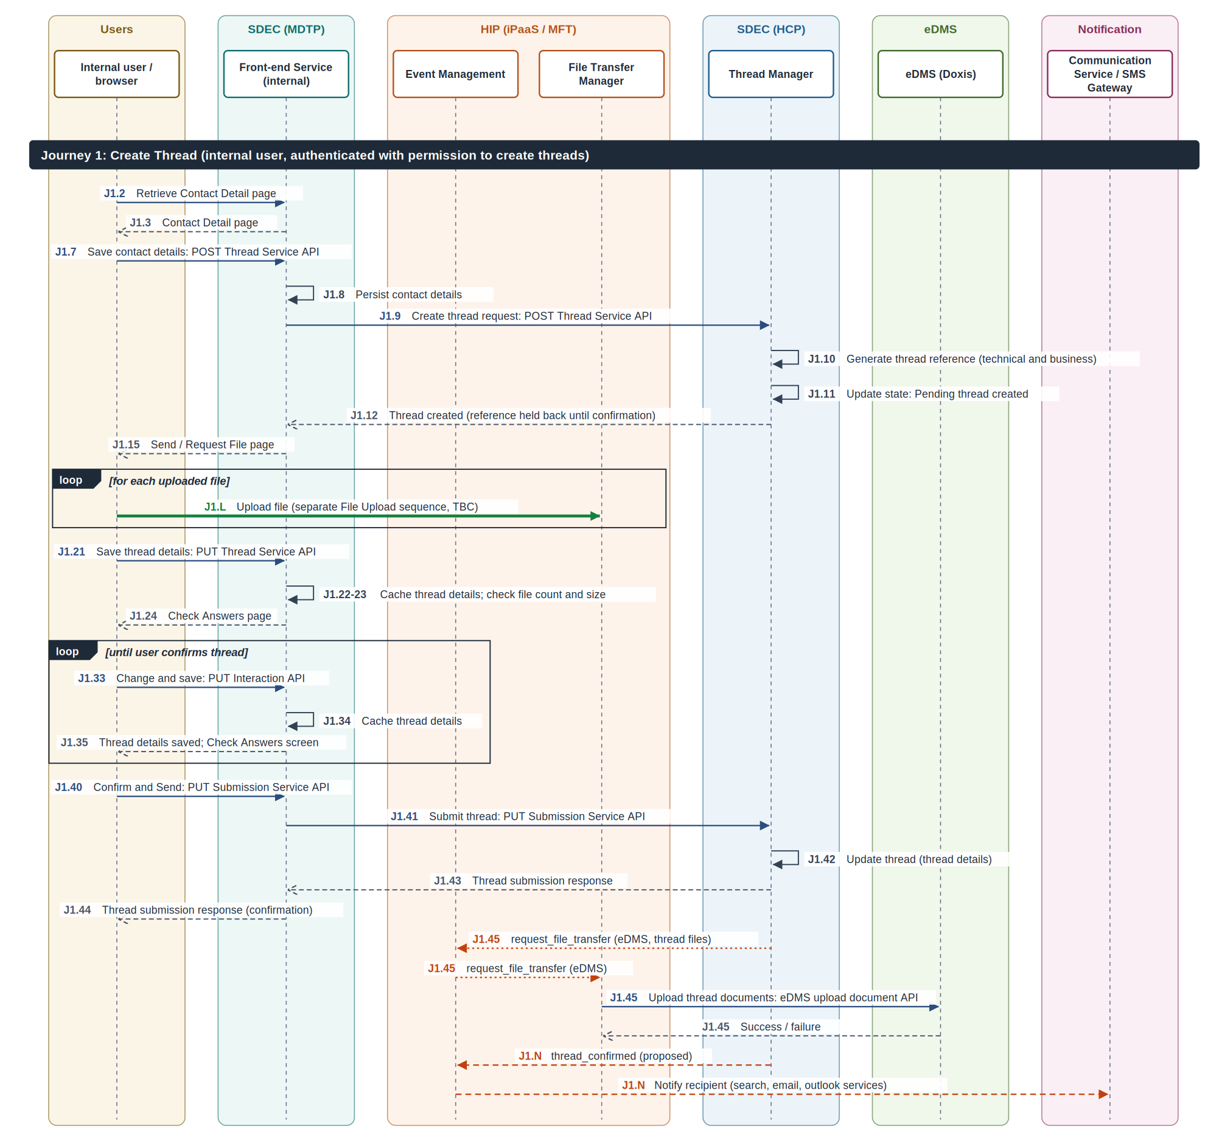
Figure 18: Journey 1 Create Thread: interaction

A.2 Journey 2 External User Document Upload
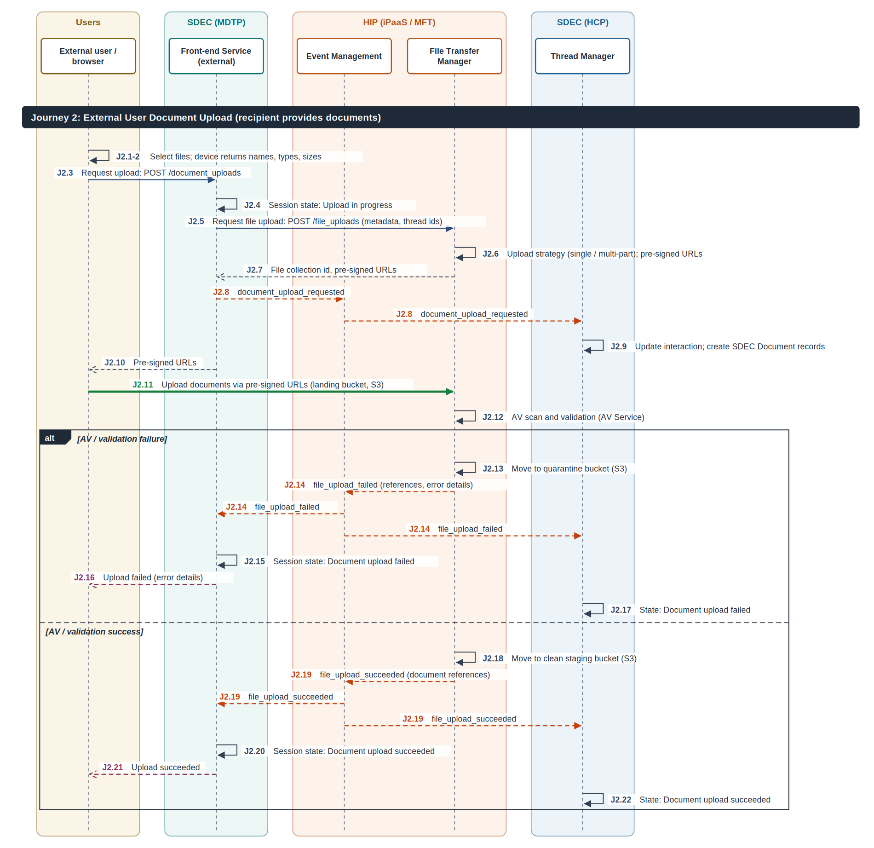
Figure 19: Journey 2 External User Document Upload: interaction

A.3 Journey 3 External User Submission
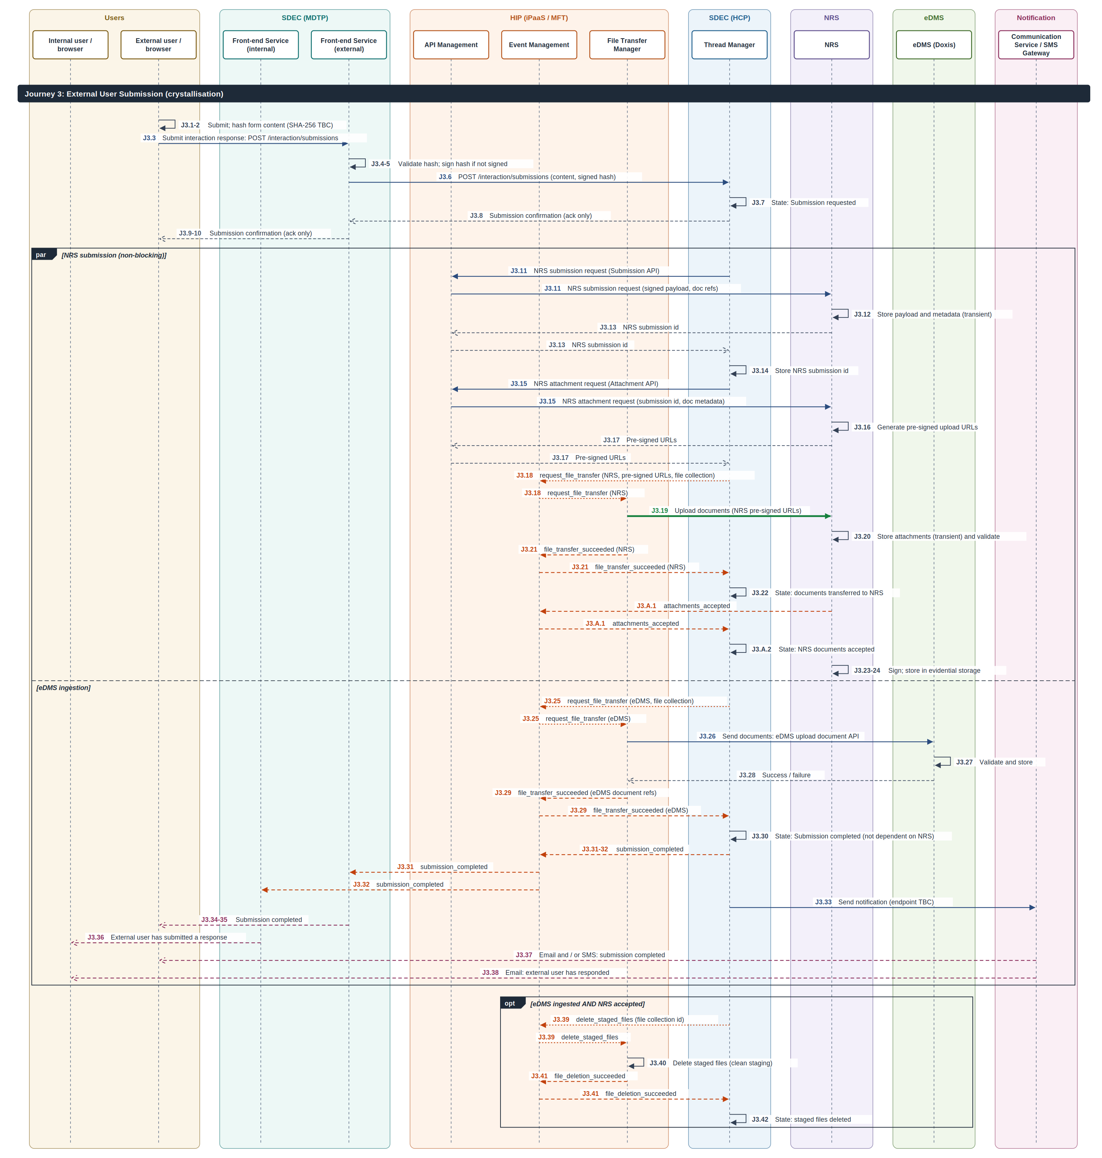
Figure 20: Journey 3 External User Submission: interaction

