Boomi MFT MVP Solution
Status | Draft v0.1 (draft), 22 October 2026. Concept note v0.2 under review; v0.3 redraft issued 20 October 2026
Page owner | Integration Architect
Environment | Non-production only
Parent page | Boomi MFT Platform: Overview, AFT and FS

1. Objective
Prove that Boomi MFT can run the four transfer directions the platform will need, across both trust boundaries, with the security, operability, delivery and audit controls a production service needs. The MVP uses synthetic or representative files in non-production. Its outputs are an evidence pack and an adoption recommendation.

2. Scope change
The earlier MVP candidate was a single live feed, ADR.040 (the quarterly Migrant Workers Scan): NPS to the ADR landing area, and ADR output to ONS. In October 2026 the MVP moved to four platform patterns with no live interface. Concept note v0.3 records this as a decision with a named owner (review finding F-01).

3. Transfer patterns
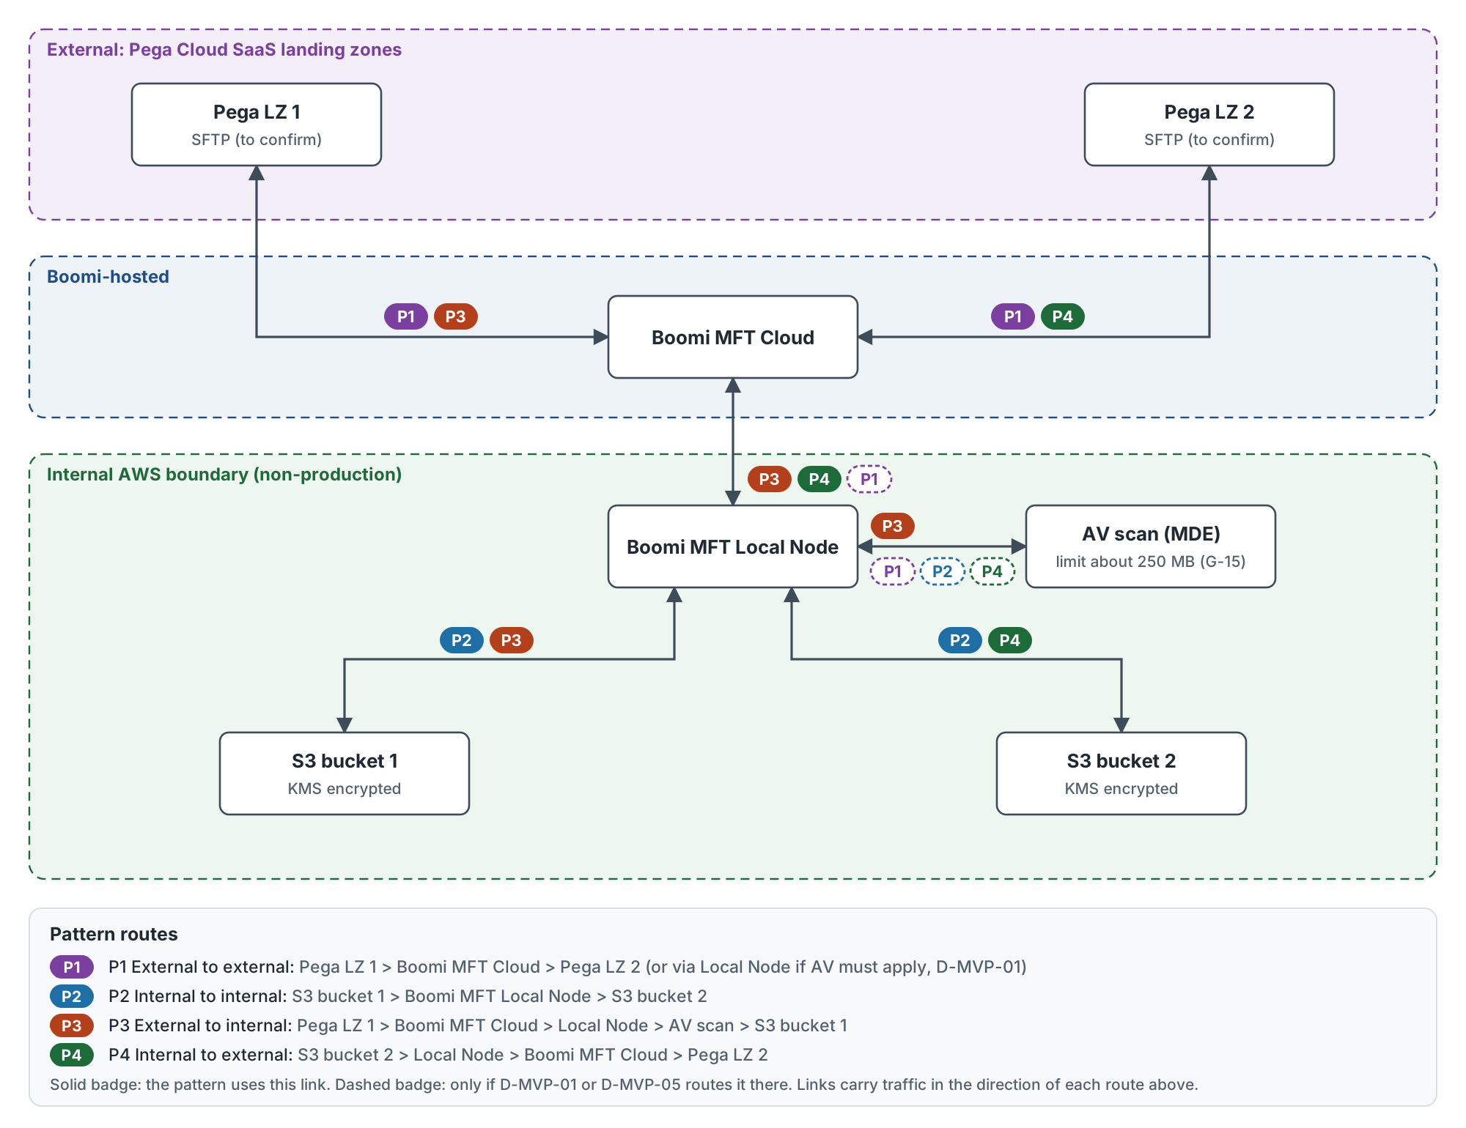
Figure 2. MVP transfer patterns and routes (source: boomi-mft-mvp-patterns.drawio)
Pattern | Direction | Route | Runtime | AV scanning
P1 | External to external | Pega LZ 1 > Boomi MFT Cloud > Pega LZ 2 | Cloud, or Local Node if AV must apply | Only if routed through the Local Node (D-MVP-01, D-MVP-05)
P2 | Internal to internal | S3 bucket 1 > Local Node > S3 bucket 2 | Local Node | Per policy (D-MVP-05)
P3 | External to internal | Pega LZ 1 > Boomi MFT Cloud > Local Node > AV scan > S3 bucket 1 | Cloud and Local Node | Mandatory before the file lands internally
P4 | Internal to external | S3 bucket 2 > Local Node > Boomi MFT Cloud > Pega LZ 2 | Local Node and Cloud | Per policy for outbound (D-MVP-05)

4. What the MVP will prove
Theme | Covers
Secure transfer | All four patterns, TLS on every leg, AV on the inbound route, SHA-256 match between source and target, encryption at rest
Operability | Scheduling, API trigger, alerting, retries, restart and replay, draft runbook
Repeatable delivery | Configuration promoted from dev to test with no manual re-keying (G-13)
Audit and governance | Audit record per transfer, evidence pack and sign-off

5. Scope

In scope
- The four patterns in non-production, using Pega Cloud SaaS landing zones and internal S3.
- Scheduled and API-triggered transfers.
- AV scanning on the inbound route, with negative-path tests.
- Alerting to the agreed channel (D-MVP-07).
- Security controls: TLS, credential storage, least-privilege IAM, encryption at rest.
- Configuration promotion from dev to test (D-MVP-06).
- Audit records, evidence pack, draft runbook and support walk-through.

Out of scope
- Live data and live interfaces, and production go-live.
- Performance and volume testing.
- High availability and disaster recovery failover.
- PGP payload encryption, unless D-MVP-10 brings it in.
- ServiceNow and Dynatrace integration; alerts go to email or Teams only.
- File Sharing (FS).

6. Success criteria
ID | Criterion
SC-1 | Each of the four patterns completes a scheduled and an API-triggered transfer, and the target SHA-256 matches the source.
SC-2 | Scheduled transfers run for at least five consecutive cycles per pattern with no manual intervention, and transfer history is visible end to end.
SC-3 | Non-arrival, transfer failure, AV detection and AV service failure each raise an alert to the agreed channel within the agreed time (target 15 minutes, D-MVP-07).
SC-4 | An infected, unscannable or oversize file is never delivered to any target.
SC-5 | Every transfer creates an audit record with source, destination, file name, size, SHA-256, start and end timestamps, outcome and correlation ID.
SC-6 | Configuration is promoted from dev to test through the agreed mechanism with no manual re-keying; rollback is demonstrated or the gap is recorded against G-13.
SC-7 | Security controls are evidenced: TLS 1.2 or higher on every leg, credentials held outside configuration (or the G-14 interim control recorded), least-privilege IAM on S3, encryption at rest.
SC-8 | The support team can restart a failed transfer, replay a transfer and investigate a quarantined file using the draft runbook, without platform team help.

7. Test approach
A pattern passes when its scheduled run and its API-triggered run both complete, the target SHA-256 equals the source, and the audit record is complete. Negative-path tests cover an EICAR test file, AV service unavailable, target unavailable, a file above the AV limit (G-15), a zero-byte file, a duplicate file and an invalid file name. The full test and evidence catalogue is published with the concept note review.

8. Decisions
ID | Decision required | Owner role
D-MVP-01 | Runtime that executes each pattern (Boomi MFT Cloud or Local Node) and where AV scanning happens for each. | Boomi Platform Owner with Security Architect
D-MVP-02 | Pega landing zone access method, accounts and keys, and confirmation that two distinct zones are available. | Pega Landing Zone Owner
D-MVP-03 | Internal S3 layout (two buckets or two prefixes), IAM roles and KMS keys for the Local Node. | AWS Platform Owner
D-MVP-04 | Credential storage for non-production: vault or PAM, or an interim control (G-14). | Security Architect
D-MVP-05 | AV policy per pattern, maximum test file size against the AV limit (G-15, about 250 MB) and the behaviour for oversize files. | Boomi Platform Owner with Security Architect
D-MVP-06 | Configuration promotion mechanism for dev to test and how rollback is evidenced (G-13). | Boomi Platform Owner
D-MVP-07 | Alert channel for the MVP (email or Teams versus ServiceNow) and the alert response target. | Service Management Lead
D-MVP-08 | Post-transfer handling of the source file (delete, archive or keep) and the retention period. | Integration Architect
D-MVP-09 | API trigger client and its authentication method. | Integration Architect
D-MVP-10 | Whether payload encryption (PGP) is in or out of MVP scope. | Security Architect
D-MVP-11 | Sign-off authority for the evidence pack and the forum that receives the adoption recommendation. | Design Authority Chair

9. Dependencies
ID | Dependency | Owner role
DEP-01 | Boomi MFT runtimes available in non-production: Boomi MFT Cloud tenant and internally hosted Local Node, with AV (MDE) enabled. | Boomi Platform Owner
DEP-02 | End-to-end connectivity: firewall and allow-list rules for Local Node to Boomi MFT Cloud, and Boomi egress IPs allow-listed on the Pega side. | Infrastructure Lead
DEP-03 | Two Pega landing zones with accounts and keys for Boomi. | Pega Landing Zone Owner
DEP-04 | Two S3 locations with IAM roles and KMS keys granted to the Local Node. | AWS Platform Owner
DEP-05 | Representative or synthetic test files agreed, with file naming rules and data classification confirmed, including whether the data may be held in external SaaS. | Integration Architect with Data Owner
DEP-06 | Credential storage arrangement agreed (D-MVP-04). | Security Architect
DEP-07 | Alert destination set up and reachable (D-MVP-07). | Service Management Lead
DEP-08 | Security approval to connect non-production to external SaaS. | Security Architect

10. Risks
ID | Risk | Impact / Likelihood | Mitigation | Owner role
R-MVP-01 | Firewall and allow-list lead times delay P3 and P4. | High / High | Raise change requests at note sign-off; test connectivity first. | Infrastructure Lead
R-MVP-02 | P1 routed through Boomi MFT Cloud bypasses internal AV; files above about 250 MB cannot be scanned (G-15). | High / Medium | Settle D-MVP-01 and D-MVP-05 before build; keep test files under the limit plus one oversize negative test. | Boomi Platform Owner
R-MVP-03 | No native CI/CD for MFT configuration (G-13), so SC-6 may not be met. | Medium / High | Agree the mechanism under D-MVP-06; record the gap if rollback cannot be shown. | Boomi Platform Owner
R-MVP-04 | No native PAM integration (G-14) leads to manual credential handling. | Medium / High | Interim controlled process with audit; record in the evidence pack. | Security Architect
R-MVP-05 | Pega landing zone access (two zones, accounts, keys) arrives late. | Medium / Medium | Confirm D-MVP-02 in week 0; P2 can start without it. | Pega Landing Zone Owner
R-MVP-06 | External SaaS may not accept representative data. | Medium / Medium | Default to synthetic files for P1, P3 and P4. | Integration Architect
R-MVP-07 | ServiceNow and Dynatrace are out of scope, so operational readiness is shown by email or Teams alerts only. | Low / High | State this limit in the recommendation. | Service Management Lead

11. Related proving work
Two connectivity proofs of concept run alongside the MVP. POC-1 is SaaS to SaaS (Quadient to Toxus). POC-2 moves files from a cloud SaaS into an internal landing zone. POC-2 is harder because it crosses the trust boundary: runtime placement and inbound firewall change lead time are on its critical path. G-14 and G-15 apply to both.

12. Proposed next steps
- Issue concept note v0.3 and record the scope change as a decision with an owner.
- Close D-MVP-01, D-MVP-02 and D-MVP-05 before build starts.
- Raise firewall and allow-list change requests at concept note sign-off.
- Start with P2, which has no Pega dependency, while Pega access is arranged.
- Collect evidence against SC-1 to SC-8 and present the recommendation to the forum named under D-MVP-11.

