Boomi MFT
Clustered deployment with load balancer
Solution architecture note | Version 1.0 | Draft for review

1 Document control
Item | Detail
Title | Boomi MFT clustered deployment with load balancer
Version | 1.0, draft for review
Status | Issued for Design Authority comment. Not approved for build.
Programme | HMRC enterprise iPaaS, Managed File Transfer capability
Related | MFT Solution Design Document v0.2  File Sharing capability architecture  Platform gap catalogue, entries G-13, G-14, G-15
Peer reviewers | Jatin, Patrick, Shijit, Sridhar
Open items | Sixteen design decisions in section 10, none currently has a named owner

2 Purpose
This note sets out the clustered deployment shape for the Boomi MFT runtime, where a load balancer sits in front of multiple runtime nodes rather than a single node carrying all transfer traffic. It records what was described, what has been added to make the shape coherent, and what still has to be decided before anyone commits to it.
It is deliberately a note rather than a design. Several load balancing behaviours that matter for file transfer protocols are not yet settled, and one of them, the target cloud platform, is contradictory in the source brief. Those are listed as decisions with owners to assign rather than resolved silently.

3 Architecture as described
The shape described is a straight left to right path:
- The MFT runtime, hosted on Boomi Managed Cloud Services, makes the call outbound.
- That call reaches a load balancer.
- The load balancer calls internally to the compute instances in the cloud infrastructure where the runtime nodes are present.
- The node then connects to the respective HOD endpoint.
Everything else in the diagram is a supporting element added to make that path deployable. Section 9 separates the two so the distinction is not lost.

4 Architecture diagram
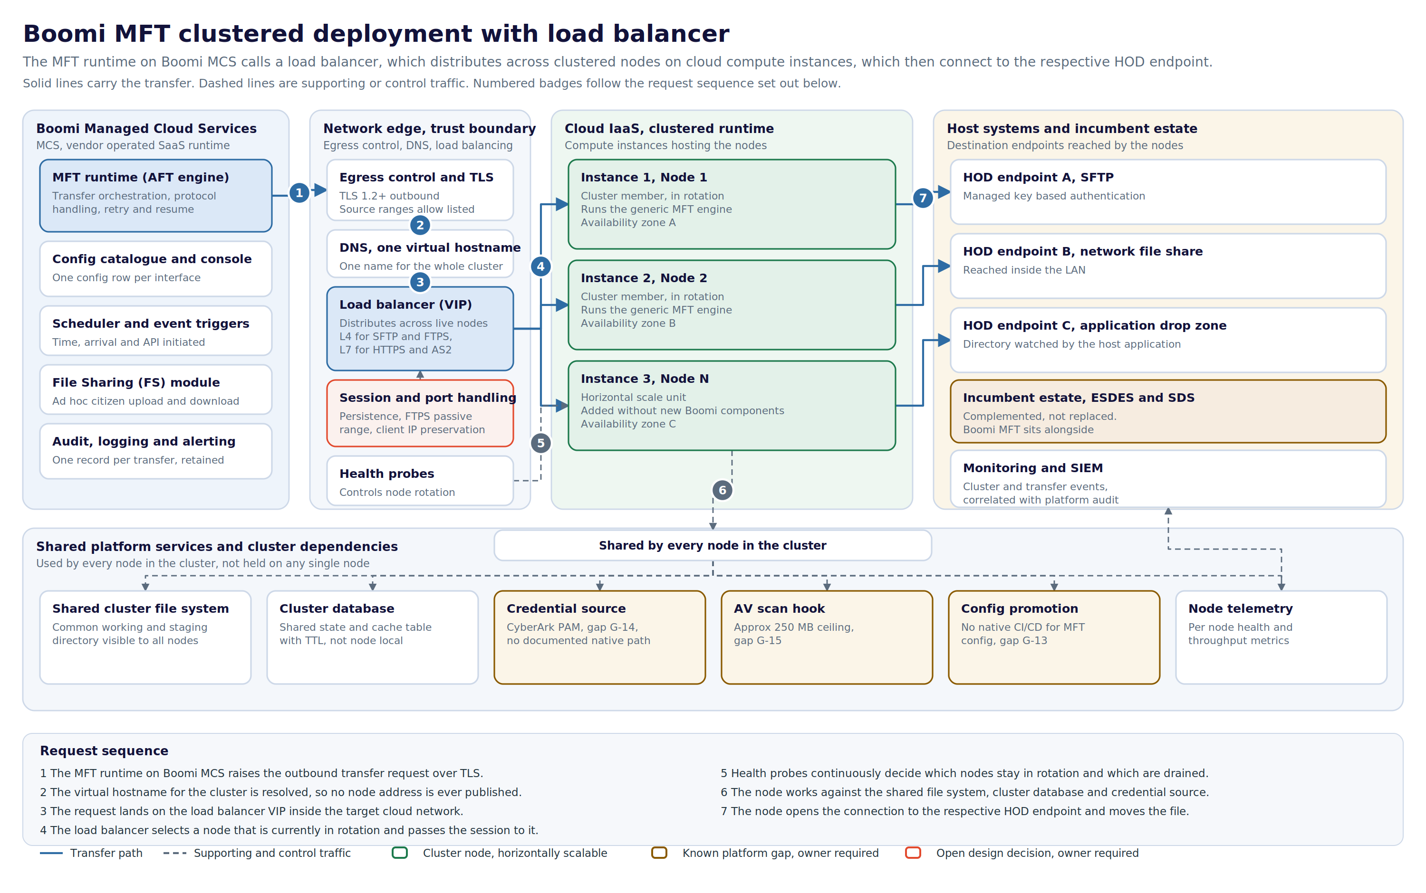
Figure 1. Clustered MFT deployment. Solid lines carry the transfer, dashed lines are supporting or control traffic. Amber boxes are known platform gaps, the red box is an open design decision.

5 Request sequence
- The MFT runtime on Boomi MCS raises the outbound transfer request over TLS.
- The virtual hostname for the cluster is resolved, so no individual node address is ever published.
- The request lands on the load balancer virtual IP inside the target cloud network.
- The load balancer selects a node currently in rotation and passes the session to it.
- Health probes continuously decide which nodes stay in rotation and which are drained.
- The node works against the shared file system, cluster database and credential source.
- The node opens the connection to the respective HOD endpoint and moves the file.

6 Component responsibilities
Component | Responsibility | Notes
MFT runtime on MCS | Transfer orchestration, protocol handling, retry and resume | Vendor operated. Not in the customer change control path.
Config catalogue | One configuration row per approved interface | Holds the config over construction principle. No new component per interface.
DNS virtual hostname | One name representing the whole cluster | Node addresses are never published, which is what makes nodes replaceable.
Load balancer | Distributes sessions across nodes in rotation | Layer and TLS posture are unresolved, see D-CL-03 and D-CL-04.
Health probes | Decide which nodes are in rotation | Probe depth is unresolved, see D-CL-08.
Cluster nodes | Execute the transfer, connect to the endpoint | Three shown illustratively. Actual count unresolved, see D-CL-11.
Shared file system | Common working and staging directory | Availability posture unresolved, see D-CL-09.
Cluster database | Shared state and cache with TTL | Required because the built in Cache shape is node local and unusable in a cluster.
Credential source | Supplies endpoint credentials to every node | No documented native PAM path, gap G-14.
AV scan hook | Scans content in transit | Approximately 250 MB ceiling, gap G-15.
Monitoring and SIEM | Correlates cluster and transfer events | Per node telemetry has to be distinguishable, or a failing node hides in the aggregate.

7 Load balancing considerations specific to file transfer
Load balancing HTTP traffic is well trodden. Load balancing file transfer protocols is not, and the differences are the part of this design most likely to be underestimated.

7.1 Protocol layer
SFTP and FTPS are not HTTP. An HTTP aware load balancer cannot proxy them, so those listeners have to operate at the transport layer. HTTPS and AS2 can be handled at the application layer. The practical consequence is that a single load balancer product may not serve every protocol in the catalogue, which affects cost and the operational model.

7.2 Multi channel protocols
FTPS negotiates a separate data channel. If that channel is balanced independently and lands on a different node from the control channel, the transfer fails. Session persistence has to be explicit, and the passive port range has to be agreed and opened consistently across the load balancer, the firewall and every node.

7.3 Identity and source address
Two things commonly break at this point. Client certificate identity is lost if the load balancer terminates TLS without forwarding it, which matters wherever mTLS is the authentication method. Separately, source IP allow listing at the far end stops working if the load balancer source NATs, because every session then appears to come from the load balancer.

7.4 Health checking
A node whose port is open but whose transfer engine is wedged will keep receiving sessions if the probe only tests the port. An application level probe is materially better, but it depends on the product exposing something meaningful to probe. If it does not, the compensating control is monitoring per node throughput and alerting on a node that stops completing transfers.

8 Cluster considerations
- Shared state cannot sit in the built in Cache shape, which is node local. A database backed cache table with TTL is the pattern that survives a clustered deployment.
- A single shared working directory reintroduces a single point of failure behind an otherwise resilient front end. Its availability posture needs stating.
- Spreading nodes across availability zones only helps if the shared file system and database are equally spread. A zone resilient front end over a single zone dependency is not zone resilient.
- Adding node N must remain a configuration and infrastructure action, not a Boomi build action. If adding a node requires new Boomi components, the config over construction principle has been broken.
- Configuration promotion has to land identically on every node. Partial promotion produces a cluster that behaves differently depending on which node answers, which is difficult to diagnose from the transfer logs alone.

9 What was described against what has been assumed
This separation matters. Only the first group came from the brief.

9.1 Described
- MFT runtime hosted on Boomi MCS.
- The runtime calls a load balancer.
- The load balancer calls internally to compute instances in the cloud infrastructure where the nodes are present.
- The node connects to the respective HOD.

9.2 Assumed, and requiring confirmation
- Three nodes. The count is illustrative and carries no capacity analysis.
- Availability zone spread across the nodes.
- A single DNS virtual hostname in front of the load balancer.
- A shared cluster file system and a shared cluster database.
- Credential sourcing, AV scanning and telemetry as cluster wide services.
- The protocol set of SFTP, FTPS, HTTPS and AS2, and the three endpoint styles shown.

10 Open design decisions
None of the following has a named owner. Each one is capable of changing the deployment shape, so each needs an owner and a date before this note becomes a design.
Ref | Decision | Why it matters | Owner
D-CL-01 | Target cloud platform is contradictory in the brief | The brief describes EC2 instances running in Azure infrastructure. EC2 is AWS compute; the Azure equivalent is Virtual Machines or a Virtual Machine Scale Set. The platform choice changes the load balancer product, the health probe model, the availability zone construct and the firewall change route. | To assign
D-CL-02 | Expansion and scope of HOD | HOD is used in the brief without expansion. The destination endpoints cannot be documented or security assessed until the term is confirmed and the endpoint inventory is named. | To assign
D-CL-03 | Load balancer layer, L4 against L7 | SFTP and FTPS are not HTTP, so an HTTP aware L7 load balancer cannot proxy them. HTTPS and AS2 can use L7. The likely outcome is two listener types, or two load balancer instances, which changes cost and the operational model. | To assign
D-CL-04 | TLS termination against passthrough at the load balancer | If the load balancer terminates TLS, client certificate identity used for mTLS is lost unless it is explicitly forwarded. If it passes through, the load balancer cannot inspect the session and health checking is limited to the transport layer. | To assign
D-CL-05 | Session persistence for multi channel protocols | FTPS opens a separate data channel. Without persistence back to the same node, the data channel can land on a different node and the transfer fails. SFTP is single channel and is not affected in the same way. | To assign
D-CL-06 | FTPS passive port range through the load balancer and firewall | A passive range has to be agreed, opened on the load balancer, and matched by NAT and firewall rules on every node. Left unagreed, this surfaces late as a firewall change with a long lead time. | To assign
D-CL-07 | Client IP preservation against source NAT | Host endpoints and partners frequently allow list by source IP. If the load balancer source NATs, the original client IP is lost. The alternatives are preserving client IP, forwarding it at L7 only, or publishing the egress address of the cluster as the allow listed value. | To assign
D-CL-08 | Health probe semantics | An open TCP port is not evidence that the MFT engine can accept a transfer. An application level probe is preferable but needs an endpoint that the product exposes. Without it, a node that is up but not functional stays in rotation. | To assign
D-CL-09 | Shared cluster file system availability | A single shared working directory becomes a single point of failure for the whole cluster and would undercut the value of load balancing. The availability posture of the share needs to be stated, not assumed. | To assign
D-CL-10 | Node drain behaviour for in flight transfers | What happens to a transfer already in progress when a node is taken out of rotation. Restart from zero against resume from checkpoint has a direct effect on large file transfer windows. | To assign
D-CL-11 | Cluster sizing and the trigger to add a node | Three nodes are shown as illustrative only. The metric that drives scaling, concurrent transfer count, throughput or queue depth, is not yet set, so capacity cannot be planned. | To assign
D-CL-12 | Config promotion across cluster nodes, gap G-13 | There is no native CI/CD path for MFT configuration promotion. In a clustered deployment this becomes sharper, because a promotion has to land consistently on every node or the cluster behaves inconsistently by node. | To assign
D-CL-13 | Credential sourcing from PAM, gap G-14 | There is no documented native path to source MFT credentials from CyberArk PAM. Every node in the cluster needs the same answer, and a per node manual credential is not acceptable at scale. | To assign
D-CL-14 | AV scan ceiling against large transfers, gap G-15 | The scan limit of approximately 250 MB via Windows MDE sits below plausible file sizes for a high volume transfer engine. The behaviour above the ceiling, block, bypass or quarantine, has to be a decision rather than a default. | To assign
D-CL-15 | Inbound firewall change lead time | Opening inbound paths to the load balancer and onward to the nodes is on the critical path, the same constraint already identified for POC-2. The lead time needs to be booked against a named date. | To assign
D-CL-16 | Certificate lifecycle for the cluster virtual hostname | One virtual hostname means one certificate whose expiry takes down every interface at once. Ownership of issuance, renewal and monitoring needs a name against it. | To assign

11 Cross programme tensions
These are recorded rather than resolved.

11.1 Clustered infrastructure against config over construction
A clustered runtime on customer managed compute is a build. The principle holds at the interface layer, where each approved interface is still a config row, but it does not hold for the platform underneath it. The risk is that the platform build quietly grows until adding an interface starts requiring infrastructure work again. Worth an explicit statement of where the config boundary sits.

11.2 Overlap with the incumbent estate
The nodes in this design reach host endpoints directly. ESDES already performs administered, secure and auditable file transfer to parts of that estate. Boomi MFT complements rather than replaces it, which has been confirmed previously, but at the point where both can reach the same endpoint the routing rule between them needs to be written down. Otherwise the choice gets made per interface by whoever builds it.

11.3 Prove it before you promise it
The load balancing behaviours in section 7 are the items most likely to fail in a way that only shows up under real protocol traffic. A short proving exercise against one SFTP endpoint and one FTPS endpoint through the load balancer would retire most of the uncertainty in D-CL-03 to D-CL-08. Committing a delivery date for clustered MFT before that has run would be promising ahead of proof.

12 Next actions
Action | Depends on | Owner
Confirm the target cloud platform and correct the brief | D-CL-01 | To assign
Confirm the expansion and endpoint inventory for HOD | D-CL-02 | To assign
Decide load balancer layer, TLS posture and persistence | D-CL-03 to D-CL-05 | To assign
Agree the FTPS passive range and raise the firewall change | D-CL-06, D-CL-15 | To assign
Settle client IP handling with the endpoint owners | D-CL-07 | To assign
Define the health probe and the compensating monitoring | D-CL-08 | To assign
State the availability posture of the shared file system and database | D-CL-09 | To assign
Run a proving exercise for SFTP and FTPS through the load balancer | Section 11.3 | To assign

End of document.

