OFFICIAL
Boomi MFT MVP, Two-week delivery plan
Candidate: ADR.040 Migrant Workers Scan, internal and external in one feed
Build window: Monday 28 September to Friday 9 October 2026
v0.3 | Draft for approval | 8 September 2026 | Integration Architecture | Integration Catalogue Programme

1. Goal
Prove that Boomi MFT can carry a real scheduled file transfer across both trust boundaries, as configuration rather than as a new build, inside a two-week window.
 | What we prove
Leg A | Internal to internal. Supplier file into the ADR landing area, replacing UTM.
Leg B | Internal to external. ADR output area direct to ONS, removing the Insecure IF server hop.
The point | One generic engine, two configuration rows, zero bespoke components. If that holds, onboarding the rest of the estate is configuration work, not development work.

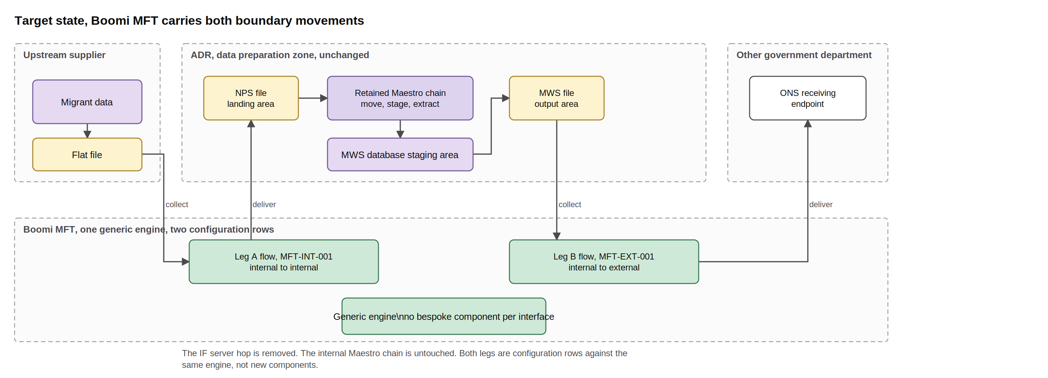
The two legs. Leg A replaces UTM into the ADR landing area. Leg B goes direct to ONS and removes the insecure hop. The internal Maestro chain is unchanged.

2. The plan
Ten working days. Configuration is the only development, and it is two days. Everything either side of it is discovery, proving and handover.
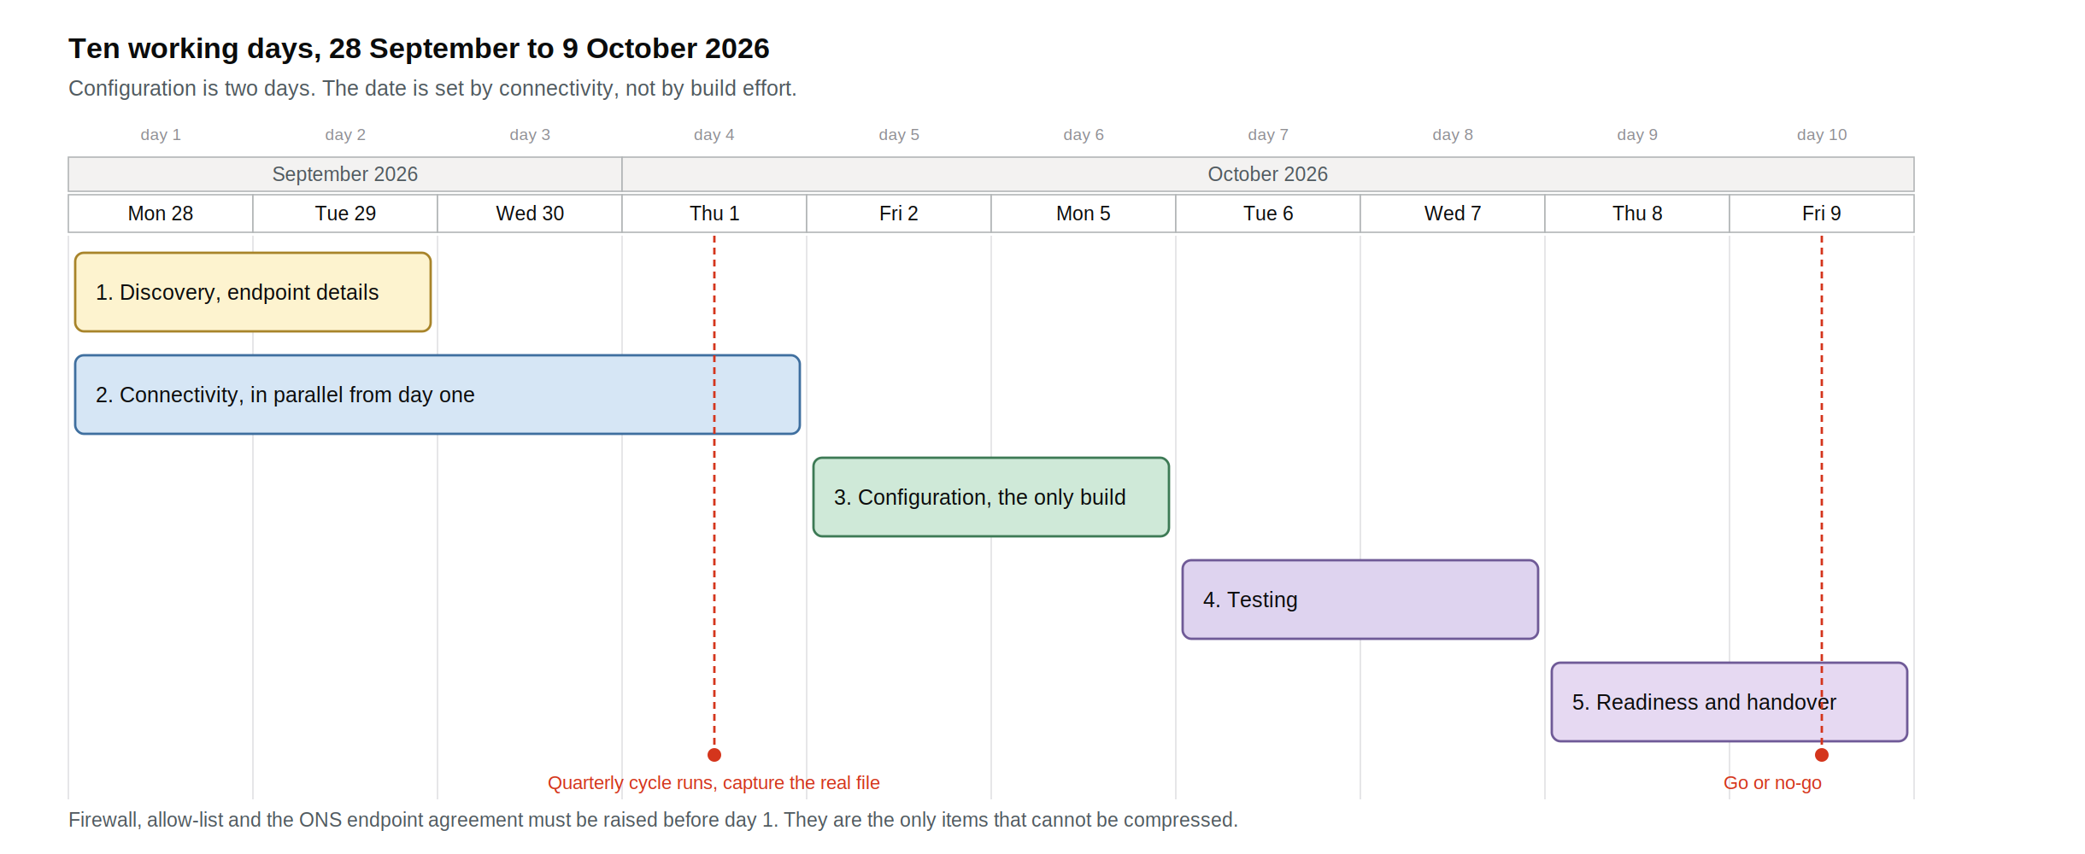

Phase | Days | What happens | Done when
1. Discovery | Day 1 to 2, 28 to 29 Sep | Capture the endpoint details in section 3 for both legs. Nothing else. No process mapping, no workshops. | Every cell in the endpoint table is filled
2. Connectivity | Day 1 to 4, 28 Sep to 1 Oct | Runs in parallel from day one. Firewall and allow-list changes, credentials, host keys, and a reachability test in both directions. | A test file moves end to end on both paths, manually
3. Configuration | Day 5 to 6, 2 and 5 Oct | Build MFT-INT-001 and MFT-EXT-001 as configuration rows on the generic engine. Schedule, file mask, archive, quarantine, alerts. | Both rows built, engine gap log empty
4. Testing | Day 7 to 8, 6 and 7 Oct | Happy path, file absent, late arrival, duplicate, oversized, scan failure, destination unavailable, credential rejection. Reconcile against the incumbent. | All cases evidenced, output byte identical
5. Readiness | Day 9 to 10, 8 and 9 Oct | Runbook, alerts and escalation. Walk Service Operations through one live failure and recovery. Prove and time the rollback. | Operations sign the handover, go or no-go issued

The 1 October quarterly cycle falls inside the window. Observe it on the incumbent path on day 4 and use the real file characteristics for testing. That is a free piece of realism, so do not miss it.

3. Endpoint details required
This is the whole of discovery. Incomplete answers here are the only thing that reliably derails a file transfer build, so treat this table as the gate into day 3. Send it out now, ahead of the window.
What we need | Leg A, source, NPS | Leg A, target, ADR landing | Leg B, source, ADR output | Leg B, target, ONS
Host and port
Protocol, SFTP, FTPS, S3 or share
Directory path
File name or mask
Credential type and who issues it
Host key or certificate
Firewall change needed, which direction
Source IP the far side must allow
Archive path
Quarantine path
Acknowledgement expected
Named contact

Known already: the feed is quarterly on the first day of January, April, July and October, one file per cycle, and the file is the Migrant Worker Scan extract. Everything else in the table is open.

4. Dependencies
Two of these decide the start date. The rest are ordinary.
Dependency | Owner | Needed by | Why it matters
Endpoint details, all four columns in section 3 | Feed and system owners | Before day 1 | Discovery is two days only because this arrives complete. If it does not, day 1 becomes chasing, and the window slips
Firewall and allow-list changes, both legs | Network security | Raise now | The one item that cannot be compressed by working harder. Standard lead time is longer than the build itself, so it must be raised before the window opens
ONS agreement to receive from a new sending endpoint | Cross-department liaison | Raise now | Leg B cannot be proven without it. If it is not in place, leg A still delivers inside the window and leg B follows
ADR to Data Lake migration position | Data Lake programme | Before day 5 | See section 5
Credentials and host keys | Security architecture | Day 3 | Needed for the connectivity test, not for the build
Runtime placement approval | Platform engineering | Day 3 | Where the MFT runtime sits for each leg
Representative or synthetic test file | Feed owner, ADR | Day 6 | Testing needs a file with production structure, not production data
Service Operations availability, half a day | Service Operations | Day 9 | The handover walkthrough is what turns a demo into an accepted service
Incumbent path stays live throughout | Incumbent service owner | Day 1 | The MVP runs alongside, it does not cut over

5. The ADR to Data Lake migration
The ADR legacy warehouse is being migrated to the Data Lake, and both of this MVP's touchpoints sit inside that scope: the NPS file landing area on leg A and the MWS file output area on leg B. Three things need an answer before configuration starts on day 5.
Question | Why it changes what we build
Are the NPS landing area and the MWS output area in scope of the migration, and when do they move? | If they move during or shortly after the MVP, we configure against an endpoint with a known end date. That is acceptable, but it must be a decision rather than a surprise
Should leg A land into the Data Lake target rather than the current landing area? | If the Data Lake landing zone already exists, building straight to it avoids a rebuild. If it does not, build to the current area and re-point later
Does the Maestro job chain survive the migration, or is it replaced by Data Lake ingestion? | The MVP assumes the internal chain is untouched. If it is being replaced, leg A's handover point changes

This dependency is an argument for the MVP rather than against it. Under config over construction, re-pointing a transfer at a migrated endpoint is editing one row, not rebuilding an interface. If the platform behaves as designed, the Data Lake migration makes it more useful, not less. That is worth proving here.

6. Success criteria
Ref | Met when
SC-1 | Leg A delivers into the ADR landing area, byte identical, three consecutive runs
SC-2 | Leg B delivers to ONS, acknowledged, three consecutive runs
SC-3 | Both legs are configuration rows on one engine, zero bespoke components
SC-4 | The existing Maestro chain runs unchanged after Boomi delivers
SC-5 | The Insecure IF server hop is absent from the leg B path
SC-6 | Non-arrival, transfer failure and scan failure each raise an alert to a named queue, evidenced in test
SC-7 | One audit record per transfer: source, destination, size, checksum, timestamps, outcome
SC-8 | Service Operations signs the handover after a live failure and recovery walkthrough
SC-9 | Rollback to the incumbent path executed and timed at least once
SC-10 | Build effort recorded in hours, separated from time spent waiting on dependencies

SC-3 is the one that matters. Everything else can be fixed. If two similar transfers cannot both be delivered as configuration on one engine, the platform's economics do not hold and the answer is no-go.

7. What could move the date
Risk | What we do about it
Firewall change is not complete by day 4 | Raise it now, before the window opens. If it lands late, connectivity slides and everything after it slides with it. This is the single most likely cause of a miss
ONS endpoint is not agreed in time | Split the result. Deliver leg A inside the window and report it. Leg B follows within days of the external path opening, because the build is already done
Endpoint details arrive incomplete | Day 1 and 2 become chasing. Send the section 3 table out now and treat a complete return as the trigger to open the window
Data Lake migration answers are unclear at day 5 | Build to the current endpoints and record the re-point as a one-row change. Do not pause the build waiting for the migration plan
No production-like test environment | Test on the real path with a synthetic file. Say so plainly in the evidence rather than claiming coverage we do not have

Configuration is two days. The date is set by connectivity, not by build effort. Start the firewall and ONS requests now and the window holds.

