INTELLIGRATOR
Managed File Transfer on Boomi
Product Overview · July 2026
A self-service portal that turns requesting a Managed File Transfer interface
into a five-minute conversation — and an approved request into a live,
running interface with no manual build.

1. Purpose & Scope
This document describes Intelligrator's Managed File Transfer (MFT) capability — what it does, who it's for, and how it's built.

Not in scope
This document does not cover Intelligrator's API management or asynchronous/event-driven integration capabilities — those are addressed separately. It also assumes standard platform foundations — sign-on, account administration, and general portal navigation — as a given baseline, rather than describing them here. The focus throughout is MFT, and MFT alone.

Built on Boomi
Intelligrator achieves its vision by combining three Boomi capabilities: Boomi Integration (iPaaS), the process engine that performs every file transfer; Boomi Managed File Transfer, for secure, governed file movement at scale; and Boomi Companion, Boomi's AI-assisted development capability, which accelerates how the platform team builds, tests, deploys, and diagnoses the integrations underneath Intelligrator itself.

2. Product Vision
For integration teams and business requesters who need file transfer interfaces built reliably and fast, Intelligrator replaces a multi-week engineering request with a five-minute conversation and an automatic build — turning managed file transfer from something you wait on into something you simply ask for.
Every connection is proven before a request is submitted. Every interface is named and checked for duplicates automatically. Every approval leads straight to a live, deployed interface — with nothing built by hand.

3. Key Highlights & Features
- Prove it before you submit — source and destination connections, and their folders, are tested live in the wizard, not discovered as a failure after delivery.
- No duplicate interfaces — every request is checked against existing interfaces automatically, before anything is built twice.
- Consistent naming, automatically — Intelligrator suggests the interface name for you, following a standard convention.
- Zero manual build — approval triggers automatic provisioning on Boomi; the interface is live in minutes, not weeks.
- Full visibility, always — requesters track their request end to end; nobody has to email to ask ‘what's the status?’
- Governed, not gatekept — a human approver still decides, but every piece of evidence they need is already on the screen.

4. Who Uses Intelligrator
Three roles cover the full MFT lifecycle:
Role | What they do
Standard User | Requests an MFT interface through the wizard, tests connections, and tracks the request through to a live interface — no technical Boomi knowledge required.
MFT Admin | Reviews every request in the queue — with connection evidence and duplicate checks already attached — and approves or denies it.
Platform Engineer | Maintains the underlying Boomi engine, and steps in only when something needs deeper investigation — most requests never need them at all.

5. Request Flow
How a standard user's request becomes a live, running interface:
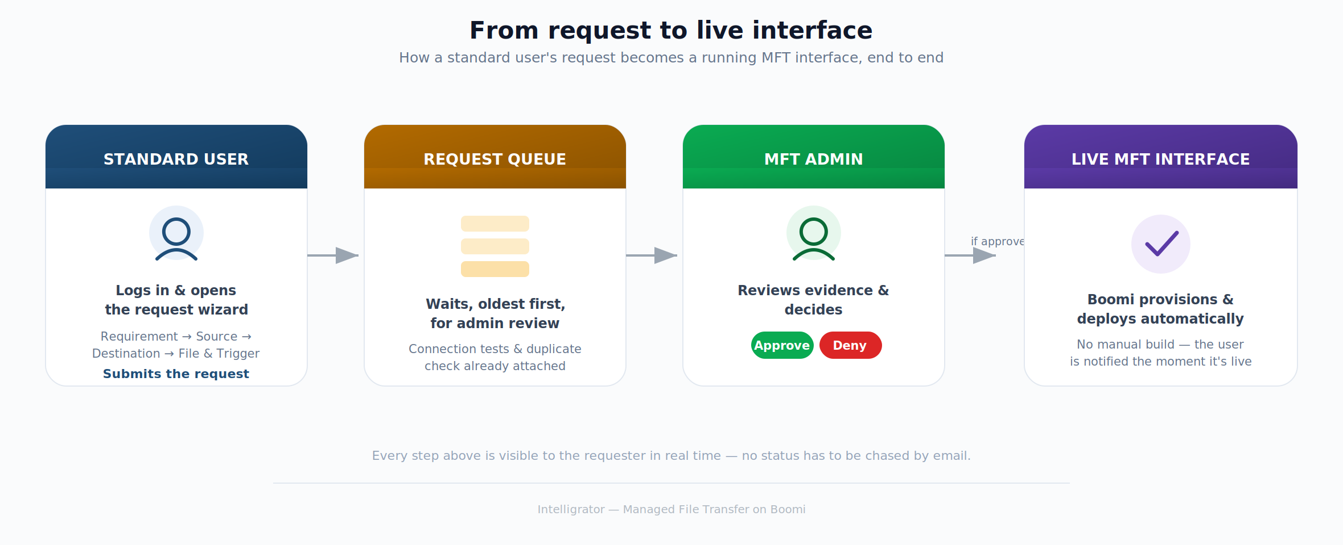

6. End-to-End Journey

Standard User — the request wizard
Log in → Requirement details → Source details → Destination details → File & trigger → Summary & submit
Step | What happens
Log in | The user signs in and lands on a simple dashboard of their own requests.
Requirement details | Purpose, business value, and a point of contact — the ‘why’ behind the request.
Source details | Where the file comes from — tested live, with the folder confirmed to exist, before moving on.
Destination details | Where the file needs to go — tested the same way.
File & trigger | What the file looks like, and when the transfer should run.
Summary & submit | A plain-English recap of everything entered, then one click to submit into the queue.

MFT Admin — review to production
Log in → Open the queue → Approve or deny → Interface goes live
Step | What happens
Log in | The admin signs in to a queue of everything awaiting a decision.
Open the queue | Every request already carries its connection-test results and duplicate-check outcome — no chasing for information.
Approve or deny | One decision, with a comment if it's a denial. The requester is notified immediately either way.
Interface goes live | An approval is all it takes — Boomi provisions and deploys the MFT interface automatically, with no manual build.

7. How It Works — Technical Approach
Intelligrator's automation is built on two complementary Boomi capabilities.

Boomi Integration (iPaaS)
A single, reusable process on Boomi's runtime performs the transfer itself: it picks up the file from the source, validates it, delivers it to the destination, and carries out any follow-up action such as archiving the original. Every approved request becomes a configuration entry for this one process, rather than a new process being built each time — which is what makes ‘no manual build’ possible.

Boomi Managed File Transfer
For interfaces that call for it, Boomi's own native Managed File Transfer product provides a governed, secure channel for the transfer — with built-in retry, guaranteed delivery, and encryption at every stage.

Boomi MFT's two applications
Application | What it's for
Automated File Transfer (AFT) | System-to-system, scheduled file transfer — this is the application Intelligrator's MFT interfaces use.
File Sharing (FS) | Person-to-person file sharing and collaboration — a different use case, not part of this capability.

Connecting Boomi Integration to Boomi MFT
A Boomi process interacts with Boomi MFT through a dedicated connector, using two operations:
Operation | What it does
Get | Picks up a file that's waiting to be collected.
Create | Drops a file off for delivery.
The result: a requester never sees any of this — they see a wizard, a queue, and a live interface. Everything above happens automatically, the moment a request is approved.

8. User Stories

Standard User
US-01 [MUST] As a standard user, I want to log in and see my own requests so that I always know where things stand without asking anyone.
US-02 [MUST] As a standard user, I want to describe the purpose and business value of my request so that the admin has the context to approve it quickly.
US-03 [MUST] As a standard user, I want to test my source and destination connections before submitting so that I know the interface will work before anyone builds it.
US-04 [MUST] As a standard user, I want to be warned if a similar interface already exists so that I don't accidentally request a duplicate.
US-05 [MUST] As a standard user, I want a plain-English summary before I submit so that I can catch mistakes before they go to review.
US-06 [MUST] As a standard user, I want to track my request through every stage so that I know the moment it's approved and live.

MFT Admin
US-07 [MUST] As an MFT admin, I want a single queue of everything awaiting my decision so that nothing gets missed.
US-08 [MUST] As an MFT admin, I want connection-test results and duplicate checks already attached to each request so that I can decide without chasing anyone for information.
US-09 [MUST] As an MFT admin, I want to approve or deny with a comment so that the requester understands the outcome.
US-10 [MUST] As an MFT admin, I want approval to trigger automatic provisioning so that I never have to ask engineering to build anything by hand.

Platform Engineer
US-11 [SHOULD] As a platform engineer, I want to be alerted only when automatic provisioning fails so that my time goes to genuine exceptions, not routine builds.
US-12 [SHOULD] As a platform engineer, I want clear diagnostics on any failed provisioning so that I can resolve it quickly and keep the queue moving.

