Boomi Managed File Transfer
Minimum Viable Product (MVP) | Executive Concept Note
MVP proposition: prove that Boomi MFT can operate as a secure, repeatable and production-ready managed file transfer service for HMRC, not simply that it can move a file.
Version 0.3 (suggested redraft), 20 October 2026. Scope changed from a single live feed to four platform transfer patterns in non-production.

1. Objective
Establish Boomi MFT in non-production and demonstrate four transfer patterns covering both directions across the internal and external boundary, measured against the success criteria in section 6.

2. Chosen use case
MVP scope | Non-production environment; four platform transfer patterns; no live interface
Purpose | Validate Boomi MFT platform capabilities and re-usable patterns
External landing zones | Pega Cloud SaaS: Pega LZ 1 and Pega LZ 2 (access method to confirm, D-MVP-02)
Internal landing zones | Internal HMRC AWS: S3 bucket 1 and S3 bucket 2 (D-MVP-03)
Runtimes | Boomi MFT Cloud and Boomi MFT Local Node; allocation per pattern under D-MVP-01
Data | Synthetic or representative non-production files; classification confirmed (DEP-05)

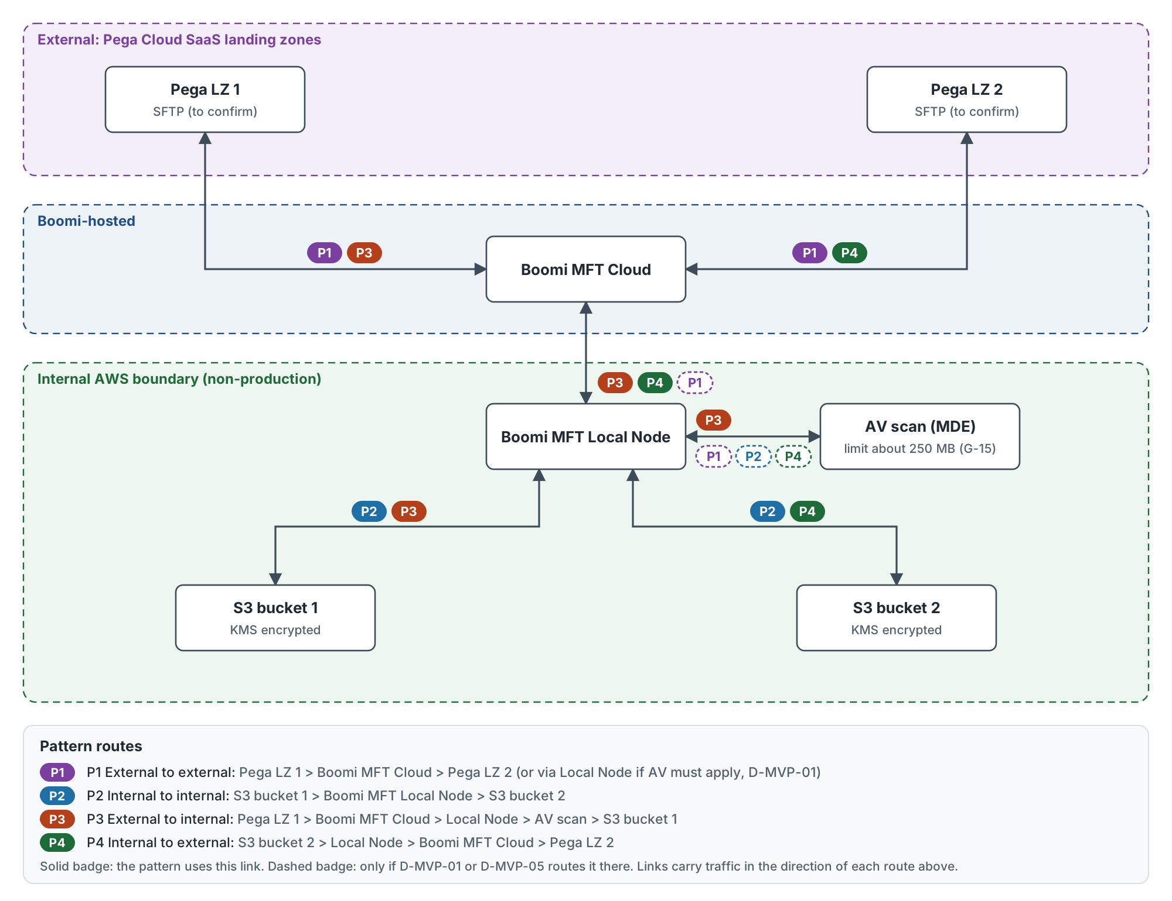
Figure 1. Four MVP patterns and the route each takes through Boomi.
MVP transfer patterns
ID | Pattern | Source to target | AV scanning
P1 | External to external | Pega LZ 1 to Pega LZ 2 | Only if routed through the Local Node (D-MVP-01, D-MVP-05)
P2 | Internal to internal | S3 bucket 1 to S3 bucket 2 | Per policy (D-MVP-05)
P3 | External to internal | Pega LZ 1 to S3 bucket 1 | Mandatory before the file lands internally
P4 | Internal to external | S3 bucket 2 to Pega LZ 2 | Per policy for outbound (D-MVP-05)

3. What the MVP will prove
Secure transfer  Internal and external movement in both directions, TLS on every leg, credentials held outside configuration, AV scanning before release. | Operability  Scheduling without manual intervention, monitoring, alerting on non-arrival, failure and AV events, restart and replay.
Repeatable delivery  Patterns configured once and promoted dev to test; re-usable for future onboarding. | Audit and governance  An auditable record per transfer: source, destination, size, SHA-256, timestamps, outcome.

4. Scope boundaries
IN SCOPE | OUT OF SCOPE FOR THE MVP
- All four transfer patterns (P1 to P4)  - Scheduled and API-triggered transfer  - Configuration, scheduling and promotion from dev to test  - Security controls: TLS, credentials, IAM, encryption at rest, AV scanning  - Monitoring, audit records and alerts  - Negative-path testing (see test catalogue)  - Draft runbook and support walk-through | - Live or production data, and production go-live  - Enterprise-wide migration and multiple business feeds  - Transformation of file content  - Performance, volume and soak testing  - HA and DR failover testing  - Payload encryption (PGP), unless brought in by D-MVP-10  - Full ServiceNow or Dynatrace integration, unless essential to show operational readiness

5. Critical dependencies and decisions
Dependencies
ID | Dependency | Owner role
DEP-01 | Boomi MFT runtimes available in non-production: Boomi MFT Cloud tenant and internally hosted Local Node, with AV (MDE) enabled. | Boomi Platform Owner
DEP-02 | End-to-end connectivity: firewall and allow-list rules for Local Node to Boomi MFT Cloud, and Boomi egress IPs allow-listed on the Pega side. | Infrastructure Lead
DEP-03 | Two Pega landing zones with accounts and keys for Boomi. | Pega Landing Zone Owner
DEP-04 | Two S3 locations with IAM roles and KMS keys granted to the Local Node. | AWS Platform Owner
DEP-05 | Representative or synthetic test files agreed, with file naming rules and data classification confirmed (including whether the data may be held in external SaaS). | Integration Architect with Data Owner
DEP-06 | Credential storage arrangement agreed (D-MVP-04). | Security Architect
DEP-07 | Alert destination set up and reachable (D-MVP-07). | Service Management Lead
DEP-08 | Security approval to connect non-production to external SaaS. | Security Architect

Decisions required before build
ID | Decision | Owner role
D-MVP-01 | Runtime that executes each pattern (Boomi MFT Cloud or Local Node) and where AV scanning happens for each. | Boomi Platform Owner with Security Architect
D-MVP-02 | Pega landing zone access method, accounts and keys, and confirmation that two distinct zones are available. | Pega Landing Zone Owner
D-MVP-03 | Internal S3 layout (two buckets or two prefixes), IAM roles and KMS keys for the Local Node. | AWS Platform Owner
D-MVP-04 | Credential storage for non-production: vault or PAM, or an interim control (G-14). | Security Architect
D-MVP-05 | AV policy per pattern, maximum test file size against the AV limit (G-15, about 250 MB) and the behaviour for oversize files. | Boomi Platform Owner with Security Architect
D-MVP-06 | Configuration promotion mechanism for dev to test and how rollback is evidenced (G-13). | Boomi Platform Owner
D-MVP-07 | Alert channel for the MVP (email or Teams versus ServiceNow) and the alert response target. | Service Management Lead
D-MVP-08 | Post-transfer handling of the source file (delete, archive or keep) and the retention period. | Integration Architect
D-MVP-09 | API trigger client and its authentication method. | Integration Architect
D-MVP-10 | Whether payload encryption (PGP) is in or out of MVP scope. | Security Architect
D-MVP-11 | Sign-off authority for the evidence pack and the forum that receives the adoption recommendation. | Design Authority Chair

6. Success criteria
# | The MVP is successful when...
SC-1 | Each of the four patterns completes a scheduled and an API-triggered transfer, and the target SHA-256 matches the source.
SC-2 | Scheduled transfers run for at least five consecutive cycles per pattern with no manual intervention, and transfer history is visible end to end.
SC-3 | Non-arrival, transfer failure, AV detection and AV service failure each raise an alert to the agreed channel within the agreed time (target 15 minutes, D-MVP-07).
SC-4 | An infected, unscannable or oversize file is never delivered to any target.
SC-5 | Every transfer creates an audit record with source, destination, file name, size, SHA-256, start and end timestamps, outcome and correlation ID.
SC-6 | Configuration is promoted from dev to test through the agreed mechanism with no manual re-keying; rollback is demonstrated or the gap is recorded against G-13.
SC-7 | Security controls are evidenced: TLS 1.2 or higher on every leg, credentials held outside configuration (or the G-14 interim control recorded), least-privilege IAM on S3, encryption at rest.
SC-8 | The support team can restart a failed transfer, replay a transfer and investigate a quarantined file using the draft runbook, without platform team help.
Targets (five runs, 15 minutes) are proposed and confirmed under D-MVP-07. Each criterion maps to tests in the test and evidence catalogue.

7. Definition of done
The MVP is complete when SC-1 to SC-8 are met, or any unmet criterion has an accepted gap with an owner; the evidence pack (test results, audit extract, alert evidence, configuration export, runbook walk-through record) is signed off by the Boomi Platform Owner, Security Architect and Service Management Lead; and an adoption recommendation, including the position on G-13 (configuration promotion), G-14 (credential sourcing) and G-15 (AV size limit), is presented to the Design Authority.

8. Indicative timeline
When | Stage | Exit
Week 0 | Readiness | Decisions D-MVP-01 to 05 closed, connectivity tested, accounts and test files in place.
Week 1 | Build and positive tests | Configure four patterns, schedules and API trigger; run SC-1, SC-2, SC-5.
Week 2 | Negative and operational tests | Run negative catalogue, alerts, promotion and security checks; SC-3, SC-4, SC-6, SC-7, SC-8.
Week 3 | Evidence and recommendation | Assemble evidence pack, sign-off, adoption recommendation to Design Authority.

9. Key risks
ID | Risk | I / L | Mitigation | Owner role
R-MVP-01 | Firewall and allow-list lead times delay P3 and P4. | High / High | Raise change requests at note sign-off; test connectivity first. | Infrastructure Lead
R-MVP-02 | P1 routed through Boomi MFT Cloud bypasses internal AV; files above about 250 MB cannot be scanned (G-15). | High / Medium | Settle D-MVP-01 and D-MVP-05 before build; keep test files under the limit plus one oversize negative test. | Boomi Platform Owner
R-MVP-03 | No native CI/CD for MFT configuration (G-13), so SC-6 may not be met. | Medium / High | Agree the mechanism under D-MVP-06; record the gap if rollback cannot be shown. | Boomi Platform Owner
R-MVP-04 | No native PAM integration (G-14) leads to manual credential handling. | Medium / High | Interim controlled process with audit; record in the evidence pack. | Security Architect
R-MVP-05 | Pega landing zone access (two zones, accounts, keys) arrives late. | Medium / Medium | Confirm D-MVP-02 in week 0; P2 can start without it. | Pega Landing Zone Owner
R-MVP-06 | External SaaS may not accept representative data. | Medium / Medium | Default to synthetic files for P1, P3 and P4. | Integration Architect
R-MVP-07 | ServiceNow and Dynatrace are out of scope, so operational readiness is shown by email or Teams alerts only. | Low / High | State this limit in the recommendation. | Service Management Lead

