Boomi MFT Platform: Overview, AFT and FS
Status | Draft v0.2 (draft), 22 October 2026
Page owner | Integration Architect
Audience | Architects, Boomi platform team, delivery teams, security and service management
Child page | Boomi MFT MVP Solution
Change history | v0.1: sections 1 to 5 and gaps, principles, references. v0.2: adds section 6 (instances and environments), 7 (roles and access) and 8 (naming conventions)

1. Purpose
This page describes the Boomi Managed File Transfer (MFT) platform: its two applications, Automated File Transfer (AFT) and File Sharing (FS), the runtime that keeps internal transfers inside our network, how the platform is deployed on the programme, how environments and instances are organised, the roles and access given to product teams, the naming conventions, and the gaps and decisions that shape its use. The MVP is described on the child page, Boomi MFT MVP Solution.

2. Platform at a glance
Boomi MFT is a cloud-native managed file transfer service within the Boomi Enterprise Platform. It came from Boomi's acquisition of Thru Inc., announced in May 2025, so some screens, URLs and install paths still carry the Thru name. Boomi hosts the control plane, the portal and persistent file storage. We host the MFT Node runtime inside our network wherever files must stay internal.
On the programme, Boomi MFT complements the incumbent file-transfer estate (ESDES and SDS). It is not a like-for-like replacement. New and migrated transfers are onboarded by configuration, not by building a new component for each interface.
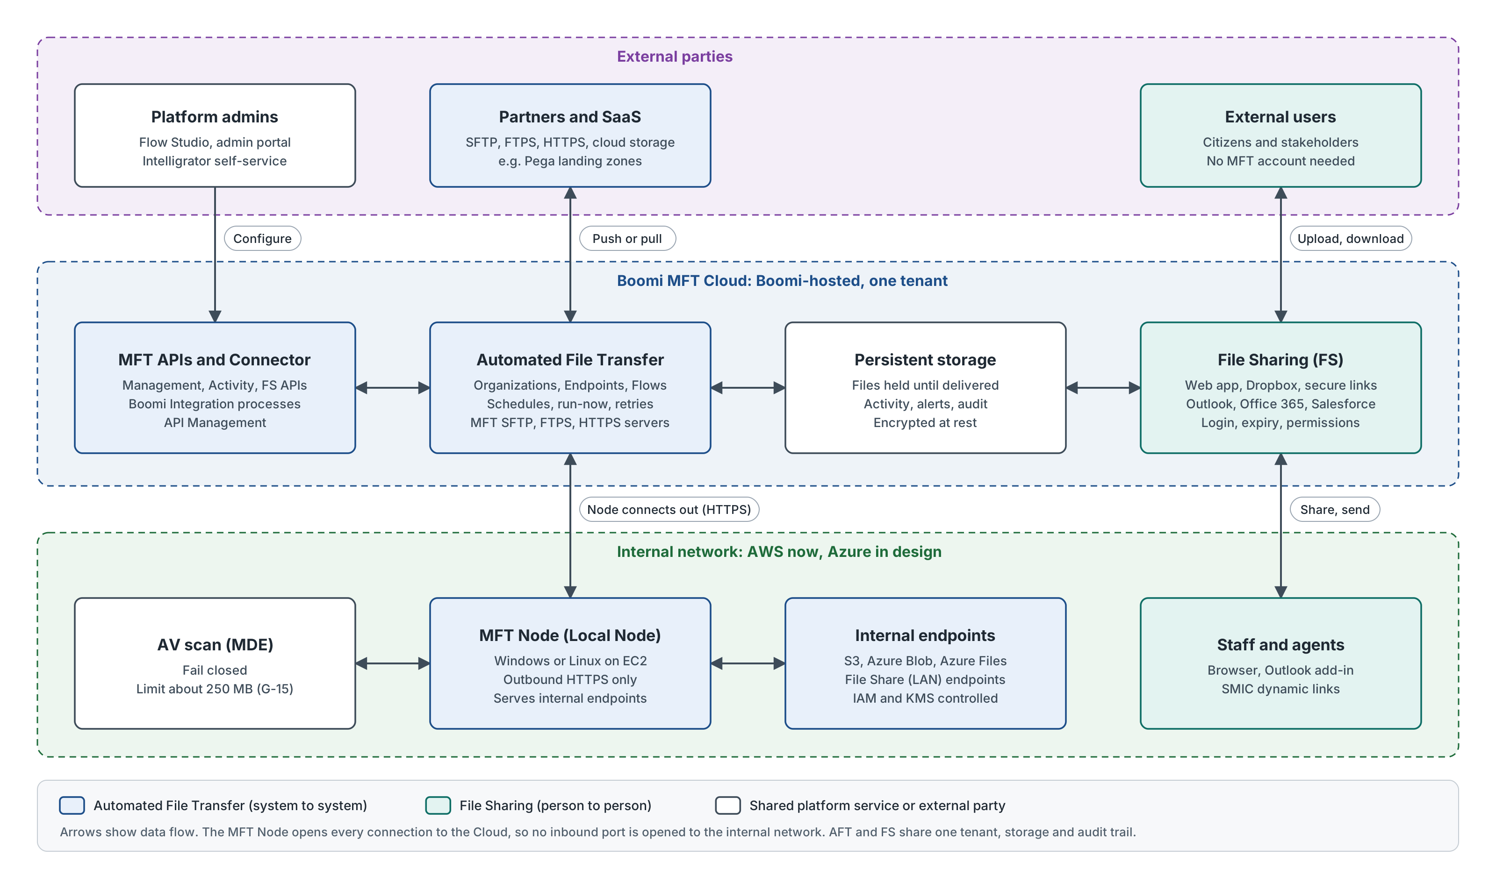
Figure 1. Boomi MFT platform components, trust zones and data flows (source: boomi-mft-platform.drawio)

2.1 Building blocks
Component | What it is | Where it runs | Notes
Boomi MFT Cloud | Control plane, admin portal, Flow Studio, activity tracking, alerting and persistent file storage | Boomi-hosted | Files are held until delivered, which underpins guaranteed delivery and automatic retries.
Automated File Transfer (AFT) | System-to-system transfers built from Organizations, Endpoints and Flows | Boomi MFT Cloud, with the MFT Node for internal endpoints | Scheduled or API-triggered. See section 3.
File Sharing (FS) | Person-to-person sharing: web app, secure links, MFT Dropbox, Outlook, Office 365 and Salesforce add-ins | Boomi MFT Cloud | See section 4.
MFT Node (Local Node) | Runtime agent installed on Windows or Linux inside our network | Our AWS estate (EC2); Azure in design | Outbound HTTPS only, token authenticated, orchestrated by the Cloud. See section 5.
MFT Server endpoints | SFTP, FTPS (explicit mode only) and HTTPS servers hosted by MFT for partners | Boomi MFT Cloud | A partner needs an MFT user to connect.
MFT APIs | Management, Activity and File Sharing APIs | Boomi MFT Cloud | Used for run-now triggers, status queries and self-service provisioning.
MFT Connector | Boomi Integration connector that sends and receives files inside integration processes | Boomi Integration runtime | A re-architected next-generation connector is on the Boomi Q3 2026 roadmap.

3. Automated File Transfer (AFT)
AFT is managed file transfer as a service for system-to-system exchange. Boomi describes it with a postal model: participants drop off and pick up files, and the Flow decides where each file goes. Internal teams and systems use the same Flows to reach each other's endpoints.

3.1 Concepts
Concept | Meaning | Use on the programme
Organization | A participant in file exchange: the enterprise, a partner, an internal team or a system. Once granted access, an Organization manages its own users and reusable endpoints. | One Organization per business area or partner, created through the onboarding process.
Endpoint | A source or target location. External endpoints: MFT connects out to a server with supplied credentials. MFT Server endpoints: MFT is the server and the partner logs in with an MFT user. | Endpoints are configuration rows. Credentials are held on the endpoint (gap G-14).
Flow | The file exchange process. Organizations subscribe by attaching source and target Flow Endpoints, with path mapping and settings. | A small set of generic Flows per transfer type, not one build per interface.
Flow Studio | Browser tool to design Flows, attach Flow Endpoints and send a test file. | Platform team and approved administrators.
Activity and Alerts | Activity screen and Activity API show the status of each transfer. The Alerts dashboard shows failed transfers to both enterprise and partner administrators. | Feeds operational monitoring and the MVP evidence pack.

3.2 Endpoint types
Endpoint type | Typical use
MFT SFTP Server | Partner pushes or pulls files over SFTP to a server hosted by MFT
MFT FTPS Server | As above over FTPS; explicit mode only
MFT HTTPS | Upload and download over HTTPS
External SFTP Server | MFT connects to a partner or SaaS SFTP server, for example a Pega landing zone
External FTPS Server | MFT connects to a partner FTPS server
File Share / MFT Node | Local folders and LAN shares reached through an MFT Node (not the File Sharing application)
Amazon S3 | S3 buckets; internal buckets are reached through the MFT Node in our design
Azure Blob | Azure Blob containers
Azure Files | Azure file shares
Google Cloud Storage | GCS buckets
SharePoint | SharePoint document libraries
Managed File Transfer Connector | Hand-off to and from Boomi Integration processes
MFT File Sharing | Hand-off between AFT Flows and File Sharing folders

New endpoint types can be requested through Boomi Support.

3.3 Key capabilities
- Triggering: schedules on source Flow Endpoints (four frequency options), or an API call that runs a Flow Endpoint now when an upstream event says files are ready.
- Guaranteed delivery: files persist in MFT storage until delivered, Flow state survives retries, and failed transfers retry automatically.
- Fan-out: a Flow can have many subscribers. If one subscriber or endpoint is disabled, the Flow still runs for the others.
- Hybrid execution: external endpoints can be served by the Cloud or by an MFT Node (Node Direct). With Node Direct, connections start from the Node's IP addresses, so partners must allow-list those.
- Concurrency: transfer concurrency is set per Flow Endpoint and the Node follows that setting.
- Visibility: Activity screen and API, alert emails per Node and per Flow, and audit history.
- Integration: the MFT Connector and APIs let Boomi Integration processes and API Management start or consume transfers.
Operational caution: when an Organization endpoint changes (for example a password or key rotation), the change must be carried to every Flow that uses it. Plan credential rotation with this in mind (G-14).

3.4 Roadmap items to confirm
These items are on the Boomi Q3 2026 product roadmap. They are not assumed in our design until Boomi confirms them for our tenant.
Roadmap item | Relevance to the programme
AV scanning on the Windows MFT runtime using Microsoft Defender, holding each file until a passed, quarantined or error result is reported to the control plane | Could replace the custom MDE scan step and report AV status centrally. Does not by itself remove the size limit (G-15).
External command on the MFT runtime after download from the Cloud and before delivery to the target | Hook for checksum checks, decryption or local processing.
Endpoint metadata tags (for example data class or encryption) carried into the Activity API, screens and logs | Supports data classification reporting and audit.
Next-generation MFT Connector | Affects Boomi Integration processes that move files.

4. File Sharing (FS)
FS is the person-to-person side of Boomi MFT: a managed, virtualised file system for sharing large files with internal teams and external parties, with the policy controls and audit that email attachments and consumer file-sharing tools lack.

4.1 Capabilities
Capability | Description
Web application | Browse, upload, download and share files and folders from any browser, including mobile browsers. Access is set per folder and per member.
Secure send | Send files or folders of any size as a link. Policies can require the recipient to log in, set link expiry and confirm delivery.
MFT Dropbox | A link that lets people without an MFT account upload files into a user's Dropbox folder. The owner gets an email when files arrive. The URL can be customised.
Outlook add-in | Send large attachments as secure links from Outlook. The side panel uploads, downloads and files emails into MFT folders. Installs MFT Explorer for desktop access.
Office 365 add-in | Open, edit and save Word, Excel and PowerPoint files held in MFT.
Salesforce add-in | Send files from Salesforce securely. Needs an API-enabled Salesforce org (Enterprise edition or above).
Mobile | iOS app to open and edit files.
FS APIs and AFT hand-off | FS APIs support automation. The MFT File Sharing endpoint type lets AFT Flows pick up from or drop into FS folders.

4.2 AFT and FS compared
Aspect | Automated File Transfer (AFT) | File Sharing (FS)
Purpose | System-to-system, repeatable transfers | Person-to-person, ad hoc sharing
Users | Platform team, partner and system administrators | Staff, agents, citizens, external stakeholders
Trigger | Schedule, API run-now, file arrival | A user sends, shares or uploads
Interfaces | Flow Studio, protocol endpoints, Activity API, MFT Connector | Web app, Dropbox links, Outlook, Office 365, Salesforce, mobile, FS APIs
Controls | Endpoint credentials, Flow settings, retries, alerts | Login on download, link expiry, folder permissions, notifications
Example | Scheduled feed from an internal S3 bucket to a partner SFTP server | A citizen uploads evidence through a Dropbox link

Naming trap: the AFT "File Share" endpoint type is a LAN network share reached through an MFT Node. It is unrelated to the File Sharing (FS) application. Write "File Share endpoint" and "File Sharing (FS)" in full in all material.

4.3 FS on the programme
The FS capability design covers two use cases: citizens uploading and downloading through MFT Dropbox links, and agents creating dynamic links from within SMIC. FS is not part of the MVP. Six decisions are open and need named owners before FS is offered to users.
ID | Decision required | Proposed owner role
D-FS-01 | Dropbox posture for citizens: public link, or protected by registration or login | Security Architect
D-FS-02 | Dynamic link policy for agents: who can create links, expiry, login requirement and download limits | Service Owner with Security Architect
D-FS-03 | AV scan ceiling for citizen uploads and the behaviour for files above it (G-15) | Boomi Platform Owner with Security Architect
D-FS-04 | Treatment of the absence of native DLP on the citizen channel | Security Architect
D-FS-05 | Retention and data protection lifecycle for shared files and links, covered by the DPIA | Data Protection Officer
D-FS-06 | Standard terminology for FS features in user-facing and design material | Integration Architect

5. Deployment on the programme
Area | Position
Environments and instances | Four environments (dev, test, pre-prod, prod), each a separate site with its own vanity DNS name (CNAME to the Boomi MFT host), each hosting three instances. See section 6.
Runtime | MFT Node on EC2 in the internal AWS estate for internal endpoints (S3, file shares). A clustered Node layer across three availability zones, on AWS with EFS and on Azure with Azure Files, behind a load balancer, is in design.
Connectivity | The Node connects out to the Cloud over HTTPS with token authentication and pulls its configuration by polling. Nothing is opened inbound to the internal network. Partner and SaaS allow-lists must include Boomi Cloud egress IPs, or Node IPs where Node Direct is used.
Protocols at the edge | SFTP and FTPS cannot be proxied by HTTP-aware load balancers. FTPS needs multi-channel persistence, TLS termination loses client identity, and source NAT breaks IP allow-lists. Run a proving exercise before committing delivery dates.
Antivirus | Windows MDE scan on the internal route, limit about 250 MB (G-15). Files above the limit need an explicit design and are never released unscanned.
Node operations | The Node caches files locally; Boomi guidance allows up to 1 TB for high volumes or large files. It checks for updates every 15 minutes. Deleting a Node in the portal uninstalls it at its next check. Windows installs run as a scheduled task; Linux uses systemd or crontab.
Onboarding | Intelligrator self-service portal: an approved request becomes a configuration row consumed by one generic engine, not a new build per interface.
Current consumer | SDEC uses MFT transient storage for document upload through presigned URLs, with platform enhancements for document status and delete (SDEC-MFT-API-01 to 03).

6. Instances and environments
Boomi MFT separates work at four levels: site, instance, organization, and the endpoints, users and machine users inside an organization. The programme runs four environments. Each environment is its own site with its own base URL, and each site hosts the same three instances: Tax, Borders and Trade, and Valuation Office. That gives 12 instances in total, all built to the same pattern.
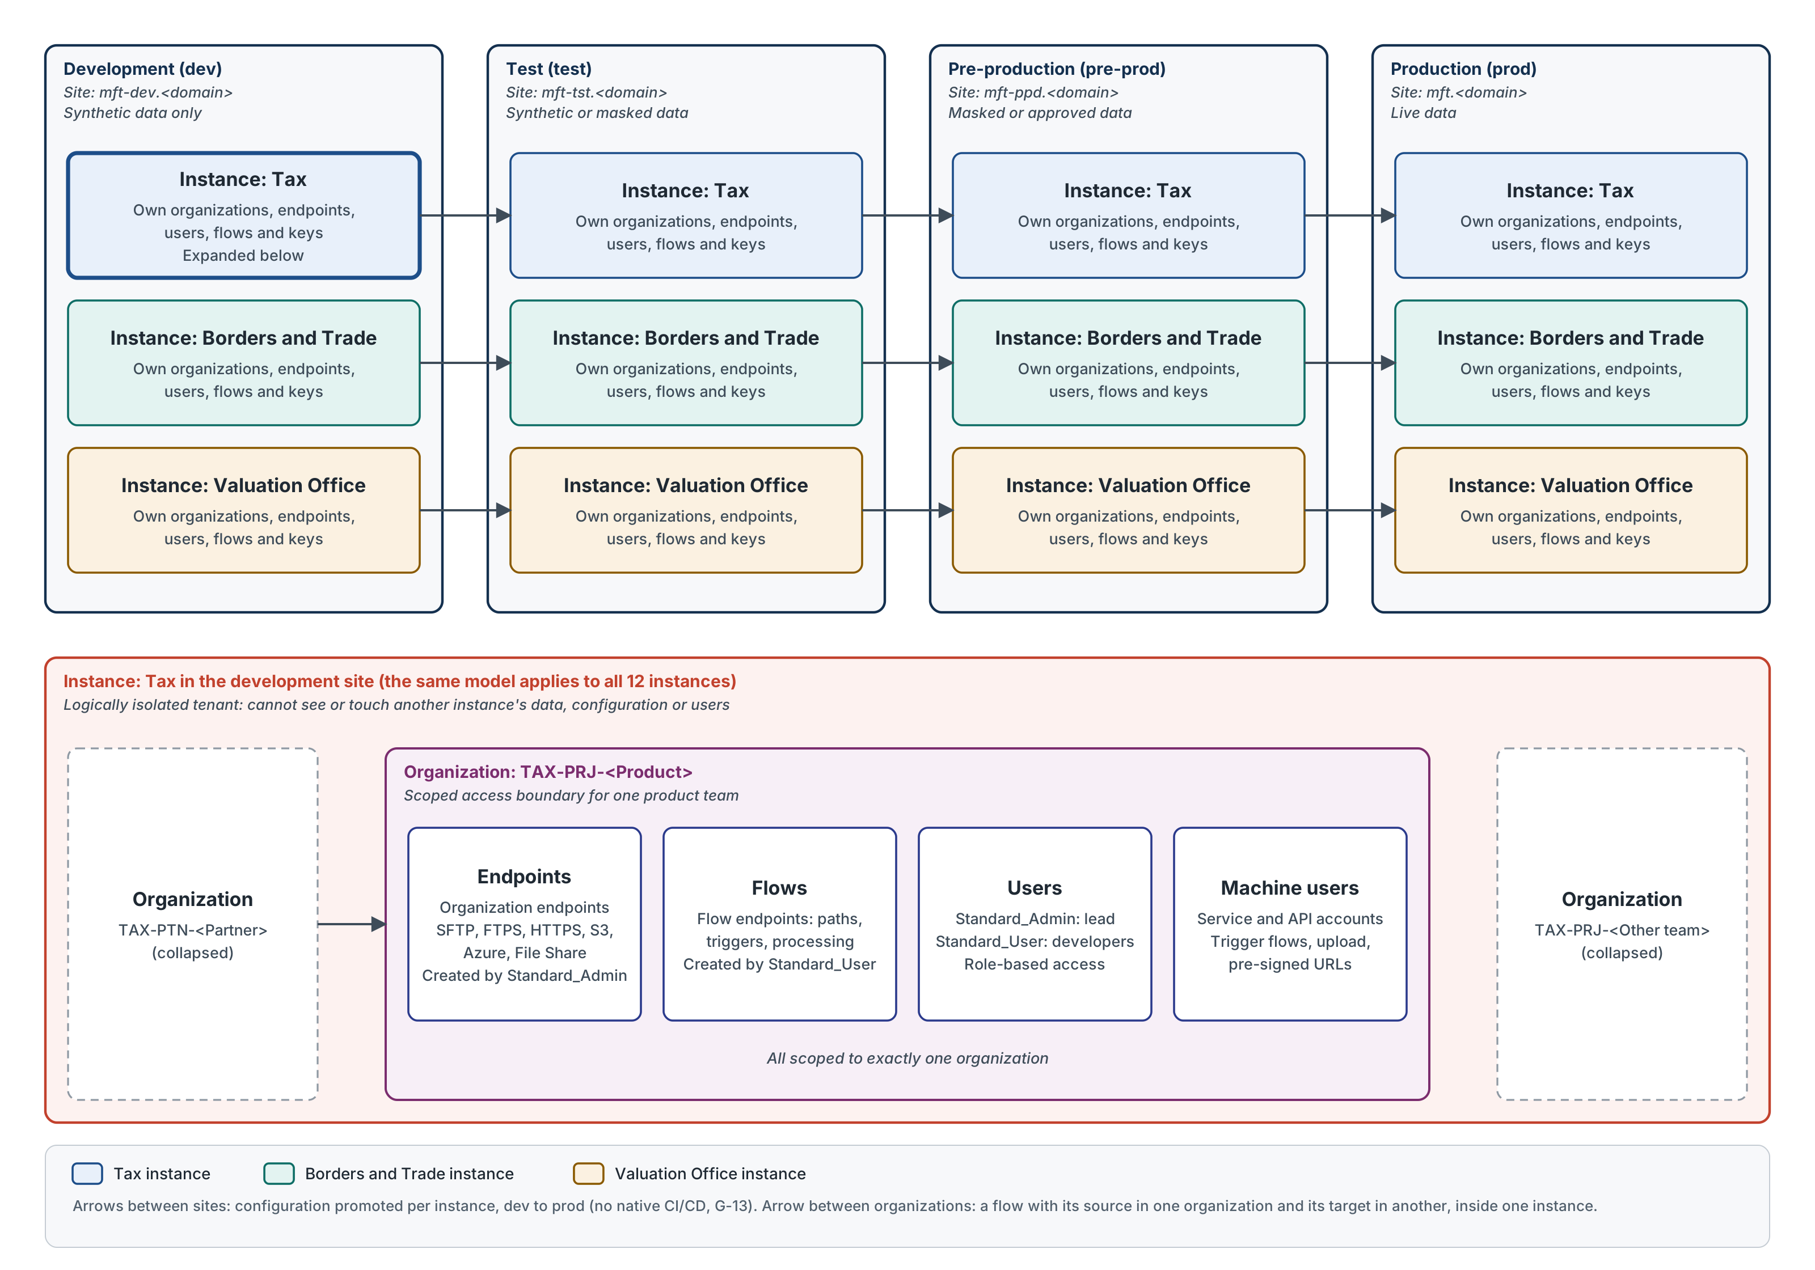
Figure 3. Environments, instances and the isolation model inside one instance (source: boomi-mft-environments-instances.drawio)

6.1 How Boomi MFT separates work
Level | What it is | On the programme
Site | One regional deployment, addressed by a single base URL. A site can host one or many instances. | One site per environment: dev, test, pre-prod and prod.
Instance | A logically isolated tenant. It cannot see or touch another instance's data, configuration or users. | Three instances in every site: Tax, Borders and Trade, Valuation Office.
Organization | An entity inside an instance, such as a business unit, product team or trading partner. It owns its own connections, flows and keys. | One organization per product team or partner, created by the iPaaS team (section 7).
Endpoints, users and machine users | An organization's connection points, human accounts and service accounts. Each is scoped to that organization only. | Endpoints are created by the team's Standard_Admin, flows by its Standard_User (section 7).

6.2 Environments
Environment | Site base URL (proposed) | Purpose | Data allowed | How configuration changes
Development (dev) | mft-dev.<domain> | Build and unit test flows. Product teams self-serve. | Synthetic only | Built by the product team's Standard_Admin and Standard_User
Test (test) | mft-tst.<domain> | System and integration testing, partner connectivity tests | Synthetic or masked | Promoted from dev; fixes are made in dev and promoted again
Pre-production (pre-prod) | mft-ppd.<domain> | Production-like rehearsal: operational acceptance, release rehearsal, volume checks | Masked or approved production-like data (D-ENV-04) | Promotion only
Production (prod) | mft.<domain> | Live transfers | Live | Promotion only, under change control

Base URLs are a proposed pattern. Where vanity DNS names are already allocated, those names are used and this table is updated to match.

6.3 Instances
Instance | Code used in names | Covers
Tax | TAX | File transfers for tax services, their product teams and partners
Borders and Trade | BDT | File transfers for customs, borders and trade services, their product teams and partners
Valuation Office | VOA | File transfers for property valuation services, their product teams and partners

6.4 Rules
- Each instance is set up the same way in every environment: the same organizations, endpoint names and flow names, with environment-specific values (hosts, paths, credentials). Promotion then changes values, not names.
- No flow crosses an instance boundary. A transfer between business areas in different instances goes through a location both can reach, with a flow in each instance (D-ENV-01).
- Live data only in prod. Dev and test use synthetic data; pre-prod data follows D-ENV-04.
- MFT Nodes are created under an organization and are separate in each environment. A dev Node never serves test, pre-prod or prod. Whether one Node can serve several organizations or instances is to be confirmed with Boomi (D-ENV-02).
- The iPaaS team administers all 12 instances. Product teams get access only to their own organization, set per environment (section 7.6).
- Configuration moves dev, then test, then pre-prod, then prod. There is no native CI/CD for MFT configuration (G-13), so the promotion method is a decision (D-ENV-03; D-MVP-06 covers the MVP).

6.5 Decisions
ID | Decision required | Proposed owner role
D-ENV-01 | Pattern for a transfer between business areas held in different instances | Integration Architect
D-ENV-02 | MFT Node scope (per organization, instance or environment), count and sizing | Boomi Platform Owner
D-ENV-03 | Configuration promotion mechanism and rollback for the service (G-13) | Boomi Platform Owner
D-ENV-04 | Data allowed in pre-prod: masked, or approved production-like | Data Protection Officer with Security Architect

7. Roles and access
Product and development teams build their own transfers under a controlled self-service model. Creating a flow is straightforward. The control point is the type and level of access each team gets, which this section sets out. It follows Approach B from the role design note: each product team is given an organization and works inside it.

7.1 Self-service context
Three transfer patterns are in scope for self-service: internal to internal (within our estate), internal to external (to trusted or untrusted external parties), and external to internal (from trusted or untrusted external parties). The MVP also tests external to external. Flows are built using one of four mechanisms, chosen by use case.
Mechanism | How it works | Notes
1. Scheduled flow | An AFT flow with a schedule picks up files from a location at a set time or within a time window | Default choice
2. API-triggered flow | An AFT flow started by an API call | Many current transfers are API triggered. Confirm a schedule is not enough before using this (D-RA-07).
3. API upload | An API call carries the file and triggers a flow that drops it at a set location | Packaged as a Boomi Integration template for developers
4. Pre-signed URL | A REST endpoint returns pre-signed URLs so digital applications can upload citizen documents to a set location | Supported through an iFrame component in FS and AFT, injected into the digital front end. A pre-signed URL that can be called by API has been requested from Boomi.

For faster delivery, the API interactions in mechanisms 2 to 4 are packaged as templates in Boomi Integration that developers reuse.

7.2 What teams create
Object | Holds | Created by
Organization endpoint | Server and connection details: protocol or connector type, host (IP) and port, username and password or key | Standard_Admin
Flow endpoint | How a flow uses an organization endpoint: pickup or drop-off directory, trigger details, processing such as encryption and AV scan | Standard_User, as part of a flow
Flow | The transfer from source to one or more targets, using the organization's endpoints and properties | Standard_User

7.3 Approach B: one organization per product team
The iPaaS team creates an organization for each product team, named after the product or project, in each instance and environment the team uses. Inside it the team creates endpoints (following the naming conventions in section 8), creates flows and reuses its endpoints across its flows. Teams cannot create organizations. Further organizations are created by the iPaaS team when needed. Access to another team's organization is restricted and granted only on a need basis.
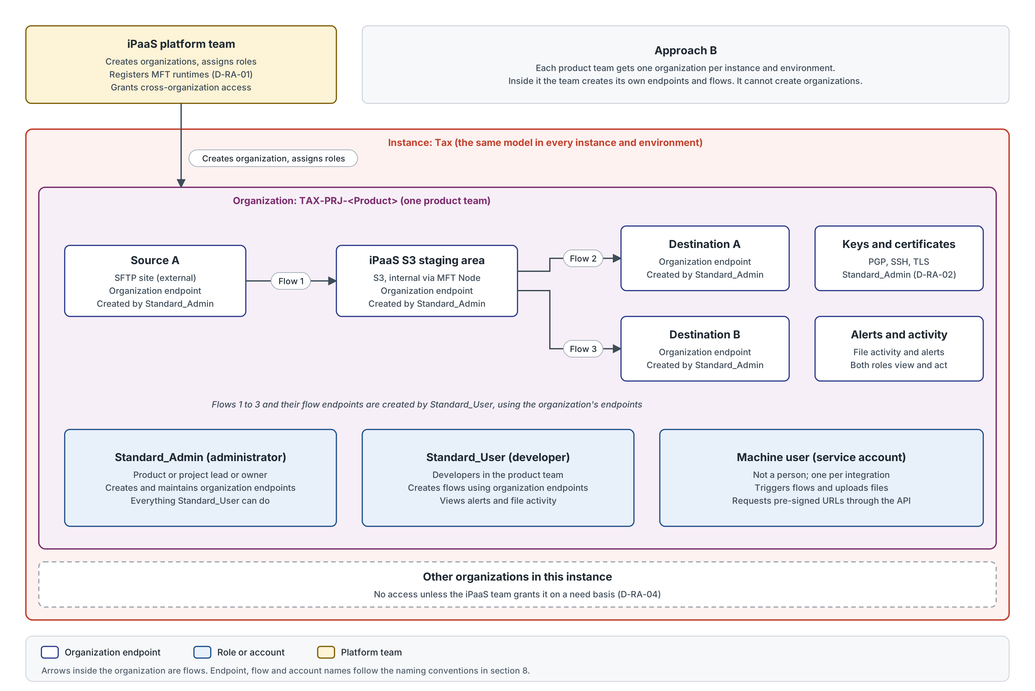
Figure 4. Approach B: a product team organization with its endpoints, flows and roles (source: boomi-mft-roles-approach-b.drawio)
Assessment of Approach B | Detail
Strength | Easy to set up with existing Boomi roles or custom permissions
Strength | Teams move quickly: they own their endpoints and flows end to end
Strength | Simpler delivery pipeline, because teams can update their own endpoints
Limitation | Less central control over endpoint quality and reuse, so naming conventions and periodic review matter
Limitation | Configuration promotion still has no native CI/CD (G-13); a simpler pipeline does not remove that gap (D-ENV-03)

7.4 Role types
Each product team gets two role types in its organization: administrators (Standard_Admin) and developers (Standard_User). The iPaaS team holds platform administration. Machine users are accounts, not roles.
Role | Assigned to | Can | Cannot
iPaaS platform admin | iPaaS team | Create organizations, assign roles, register MFT runtimes, grant cross-organization access, view all activity | Build product team flows (by convention)
Standard_Admin (administrator) | Lead or owner of the project or product | View its assigned organization, create and change organization endpoints, and everything Standard_User can do | Create organizations; see other organizations unless granted
Standard_User (developer) | Developers in the product team | Create flows using the organization's endpoints and properties, view alerts and file activity | Create organization endpoints or organizations
Machine user (account) | One service or API account per integration | Trigger flows, upload files, request pre-signed URLs through the API | Sign in to the portal

7.5 Permission matrix
As set out in the role design note, with the iPaaS column added. The comments flag where this page proposes a change.
Category | Standard_User (developer) | Standard_Admin (administrator) | iPaaS platform admin | Comments
Create organization | No | No | Yes | Only iPaaS admins create organizations
Create organization endpoint | No | Yes | Yes | Only Standard_Admin in the product team
Create PGP, SSH keys and certificates | Yes | Yes | Yes | Proposed: Standard_Admin only (D-RA-02)
Create MFT runtimes | Yes | Yes | Yes | Proposed: iPaaS team only (D-RA-01)
Create flows (using organization endpoints and properties) | Yes | Yes | Yes
Alerts | Yes | Yes | Yes
File activity | Yes | Yes | Yes
View other organizations | On request | On request | Yes | Granted by the iPaaS team on a need basis (D-RA-04)

7.6 Access by environment (proposed)
Role | dev | test | pre-prod | prod
Standard_User (developer) | Build | View; run tests | View | View alerts and file activity
Standard_Admin (administrator) | Build | Set endpoint values for test | Set endpoint values, by change | Set endpoint values, by change; view
iPaaS platform admin | Full | Full | Full | Full, under change control

From test onwards, flows and endpoints arrive by promotion, not by hand. Only environment-specific values, such as hosts and credentials, are set in each environment (D-RA-03).

7.7 Decisions
ID | Decision required | Proposed owner role
D-RA-01 | MFT runtimes: the role note lets both product roles create them. A runtime needs a server, network placement and firewall rules in the internal estate. Proposal: only the iPaaS team creates and registers runtimes, and product teams select an existing runtime on their endpoints. | Boomi Platform Owner
D-RA-02 | Keys and certificates: the role note lets Standard_User create them. Proposal: Standard_Admin only, under the key management process, with the creation date in the name for rotation (G-14). | Security Architect
D-RA-03 | Access by environment as in section 7.6 | Service Owner with Boomi Platform Owner
D-RA-04 | Cross-organization access on a need basis: request, approval, time limit and review | Boomi Platform Owner
D-RA-05 | Confirm that standard Boomi roles or custom permissions can limit a user to one organization inside an instance, as Approach B assumes | Boomi Platform Owner with Boomi
D-RA-06 | Joiners, movers and leavers, sign-in through corporate SSO, and quarterly access review for each organization | Service Owner
D-RA-07 | When an API-triggered flow (mechanism 2) is justified over a schedule | Integration Architect

8. Naming conventions (proposed)

8.1 Rules
- Names are the same in every environment. The environment comes from the site, so promoted configuration needs no renaming. Only MFT Nodes, hosts and access groups carry an environment code.
- Segments go in a fixed order, separated by hyphens. Codes are upper case; the purpose segment is PascalCase. Directory paths, Node names and machine users are lower case.
- Letters, digits and hyphens only, with no spaces. Keep names under 64 characters; confirm Boomi field limits (D-NC-02).
- No personal names in object names. Use team, system or partner names.
- Existing objects keep their names. The convention applies to new objects.

8.2 Codes
Code set | Values
Environment | DEV, TST, PPD, PRD
Instance | TAX (Tax), BDT (Borders and Trade), VOA (Valuation Office)
Organization type | PRJ (product or project team), PTN (external partner), SYS (internal system that owns a landing area), PLT (iPaaS platform)
Pattern | I2I (internal to internal), I2E (internal to external), E2I (external to internal), E2E (external to external)
Endpoint type | SFTP, FTPS, HTTPS, S3, BLOB (Azure Blob), AZF (Azure Files), GCS, SPO (SharePoint), FSH (File Share via MFT Node), CON (MFT Connector), FS (File Sharing)
Flow endpoint role | SRC (source), TGT (target)
Key type | PGP, SSH, TLS

8.3 Object names
Object | Pattern | Example
Site base URL | mft-{env}.<domain>; prod is mft.<domain> | mft-dev.<domain>
Instance | Business area name | Tax
Organization | {INST}-{ORGTYPE}-{Name} | TAX-PRJ-SDEC; TAX-PTN-ONS
Organization endpoint | {ORG}-{TYPE}-{System} | TAX-PRJ-SDEC-S3-Staging
Flow | {INST}-{PATTERN}-{Source}-{Target}-{Purpose} | TAX-I2E-ADR-ONS-MigrantWorkersScan
Flow endpoint | {Organization endpoint}-{SRC|TGT} | TAX-PRJ-SDEC-S3-Staging-TGT
Directory path | /{inst}/{org}/{purpose}/{in|out|archive|error} | /tax/prj-sdec/evidence-upload/in
File name (new interfaces) | {Source}_{Target}_{FileType}_{YYYYMMDDThhmmssZ}[_{seq}].{ext} | NPS_ADR_MWS_20261022T020000Z_001.csv
MFT Node | {env}-{inst}-node-{zone}-{nn} | prd-tax-node-az1-01
Machine user | svc-{inst}-{org}-{purpose} | svc-tax-sdec-api-trigger
Human user | Corporate SSO identity; no shared accounts | Corporate email address
Access group | MFT-{ENV}-{ORG}-{ADMIN|DEV} | MFT-PRD-TAX-PRJ-SDEC-ADMIN
Key or certificate | {ORG}-{KEYTYPE}-{Purpose}-{YYYYMM} | TAX-PTN-ONS-PGP-Public-202610
Alert recipient list | mft-{inst}-{org}-alerts@<domain> | mft-tax-sdec-alerts@<domain>
Endpoint tags (when available) | dataclass, owner, pattern, catalogue-id | dataclass=official; pattern=I2E

The access group pattern maps to the two role types: the ADMIN group is assigned Standard_Admin and the DEV group Standard_User on that organization.

8.4 Worked example (illustrative)
MVP pattern P3, external to internal, named as if it sat in the Tax instance in dev.
Item | Name
Partner organization | TAX-PTN-PEGA
Partner endpoint | TAX-PTN-PEGA-SFTP-LZ1
Product team organization | TAX-PRJ-MFTMVP
Internal endpoint | TAX-PRJ-MFTMVP-S3-Bucket1
Flow | TAX-E2I-PEGALZ1-Bucket1-MvpPattern3
Flow endpoints | TAX-PTN-PEGA-SFTP-LZ1-SRC; TAX-PRJ-MFTMVP-S3-Bucket1-TGT
Target path | /tax/prj-mftmvp/pattern3/in
MFT Node | dev-tax-node-az1-01
Machine user | svc-tax-mftmvp-api-trigger
Access groups | MFT-DEV-TAX-PRJ-MFTMVP-ADMIN; MFT-DEV-TAX-PRJ-MFTMVP-DEV

8.5 Decisions
ID | Decision required | Proposed owner role
D-NC-01 | Agree the naming convention and the instance and organization type codes | Integration Architect with Boomi Platform Owner
D-NC-02 | Confirm Boomi field length and character limits for each object type | Boomi Platform Owner

9. Gaps and security baseline
ID | Gap | Impact | Treatment | Owner role
G-13 | No native CI/CD pipeline for MFT configuration | Configuration rows are data, outside standard build and rollback | Agree the promotion mechanism and evidence rollback (D-MVP-06) | Boomi Platform Owner
G-14 | No documented native route to source MFT credentials from enterprise PAM (CyberArk) | Manual credential handling | Interim controlled process with audit (D-MVP-04) | Security Architect
G-15 | AV scan limit about 250 MB via Windows MDE | Large files cannot be scanned on the current route | Large-file design or a size cap; fail closed | Boomi Platform Owner
FS gap | No native DLP on the FS citizen channel | Sensitive content could be shared without inspection | Decision D-FS-04 | Security Architect

9.1 Security baseline for every transfer
- TLS 1.2 minimum (1.3 preferred) on every leg; no plaintext FTP.
- Credentials held outside configuration where the platform allows, with the G-14 interim control recorded where it does not.
- Least-privilege IAM roles and KMS keys on S3 locations used by the Node; encryption at rest throughout.
- AV scan before any inbound file lands internally. A scanner fault fails closed and the file is not delivered.
- An audit record per transfer: source, target, file name, size, SHA-256, start and end time, outcome and correlation ID.

10. Design principles
Principle | What it means for MFT
Config over construction | A new transfer is a configuration row on a generic Flow, never a new component per interface.
Prove it before you promise it | Capabilities and dates are committed only after proving work, with decisions owned by named roles.
Visibility as a feature | Activity, alerting and audit are requirements, not extras.
Surface tensions | Overlaps with the incumbent estate and other programmes are logged as decisions with owners, not resolved silently.

11. References
- Boomi MFT overview: https://help.boomi.com/docs/Atomsphere/Integration/MFT/boomi_mft
- Automated File Transfer: https://help.boomi.com/docs/Atomsphere/Integration/MFT/AutomatedFileTransfer/aft
- AFT endpoint types: https://help.boomi.com/docs/Atomsphere/Integration/MFT/AutomatedFileTransfer/user-guide/organizations/endpoint-types/
- MFT Nodes: https://help.boomi.com/docs/Atomsphere/Integration/MFT/AutomatedFileTransfer/user-guide/organizations/mftnodes/
- MFT Node runtime: https://help.boomi.com/docs/Atomsphere/Integration/MFT/AutomatedFileTransfer/user-guide/mft-node-runtime/
- File Sharing user guide: https://help.boomi.com/docs/Atomsphere/Integration/MFT/FileSharing/FileSharingUserGuide/file-sharing-user-guide
- File Sharing administration guide: https://help.boomi.com/docs/Atomsphere/Integration/MFT/FileSharing/AdministrationGuide/administration-guide
- Boomi product roadmap, Q3 2026: https://boomi.com/ja/blog/boomi-product-roadmap-q3-2026-everything-you-want-to-know/

