**Create Service using SEGW and SICF with CRUD Operations**

*CRUD( Create, Edit, Delete, Update)*

Contents

1. Create Service in SEGW 2

2. Create DATA Model (Import DDIC or Manual) 3

3. Redefine Methods of Created Model to suit desired Behavior 8

4. Testing 10

4.4. Get Set Item (All entries) TODO: Show use of the ff: $select, $top, $filter, $paginate, etc 12

4.5. Get Individual (Read) 13

4.6. Create Entry (Create) 14

4.7. Delete 16

4.8. Update 17

5. TODO Items 18

1. Create Service in SEGW

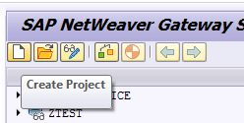

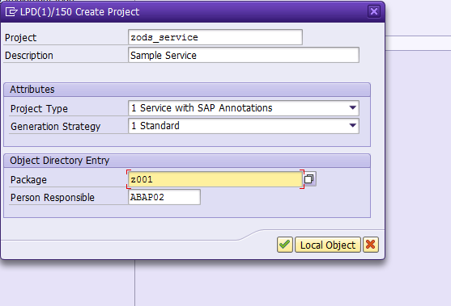

1. Create DATA Model (Import DDIC or Manual)

* Entity
* Entity Properties
* Entity Sets

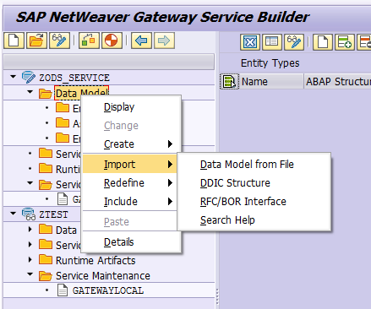

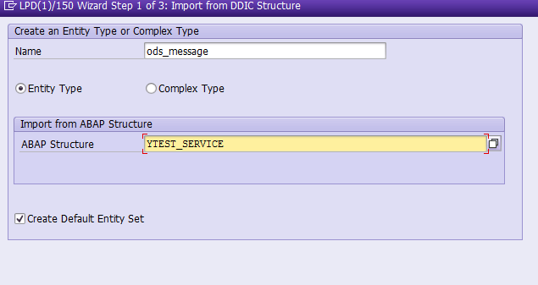

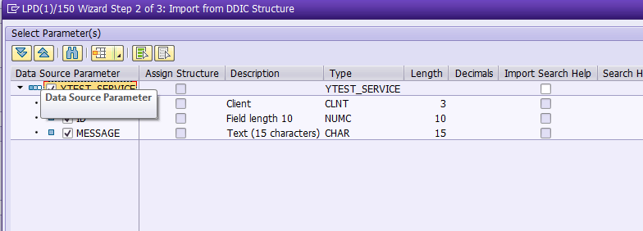

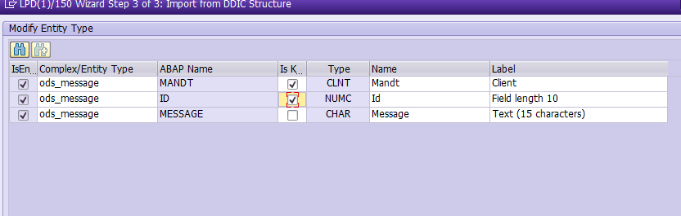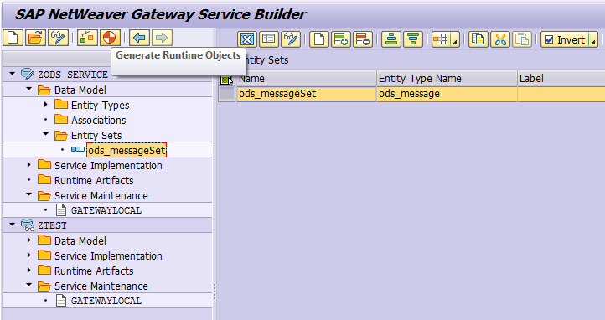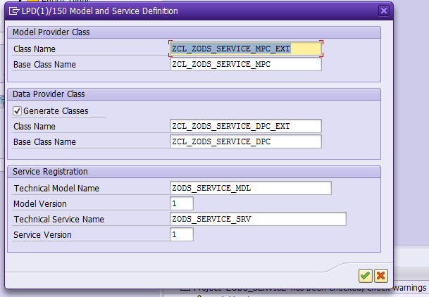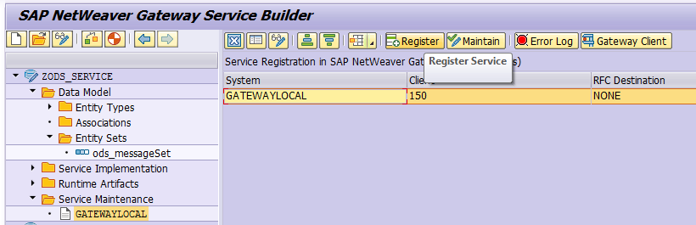

TODO: Show How to Configure SAP Gateway (GATEWAYLOCAL)  
https://blogs.sap.com/2013/05/14/quick-starter-configuration-guide-sap-gateway/

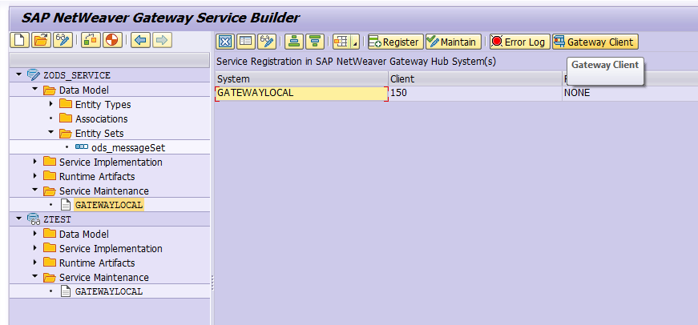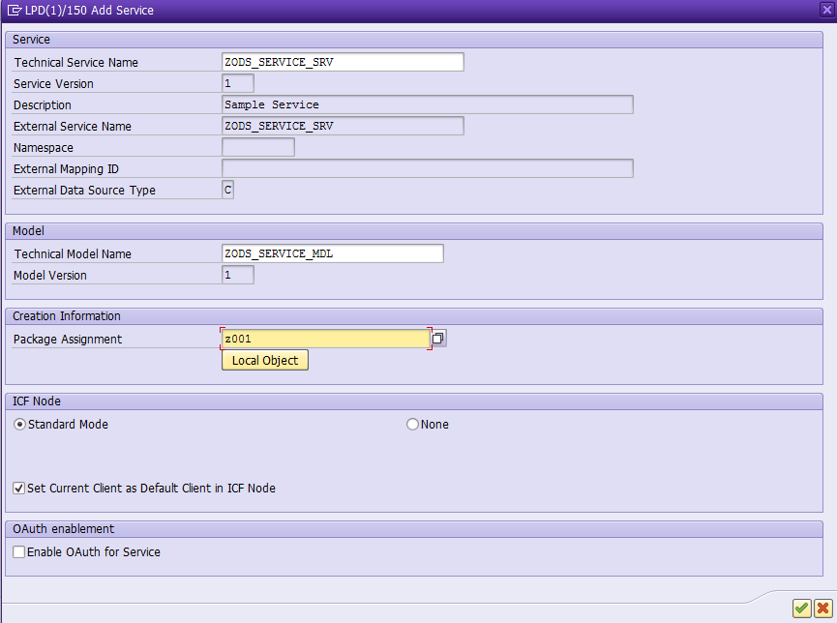

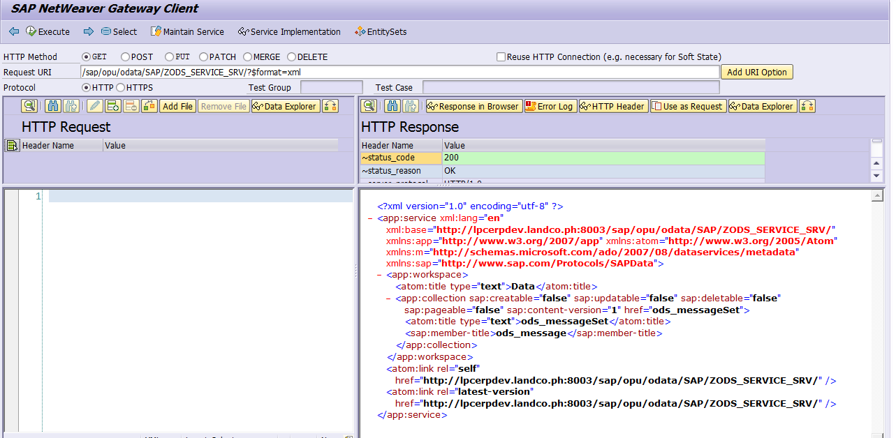

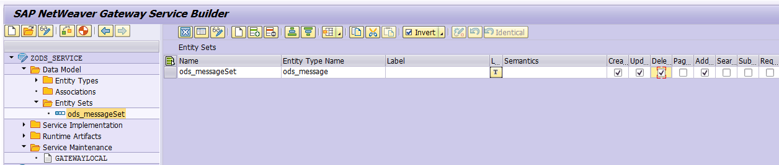



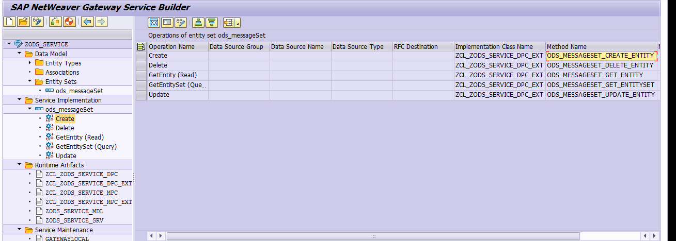

1. Redefine Methods of Created Model to suit desired Behavior

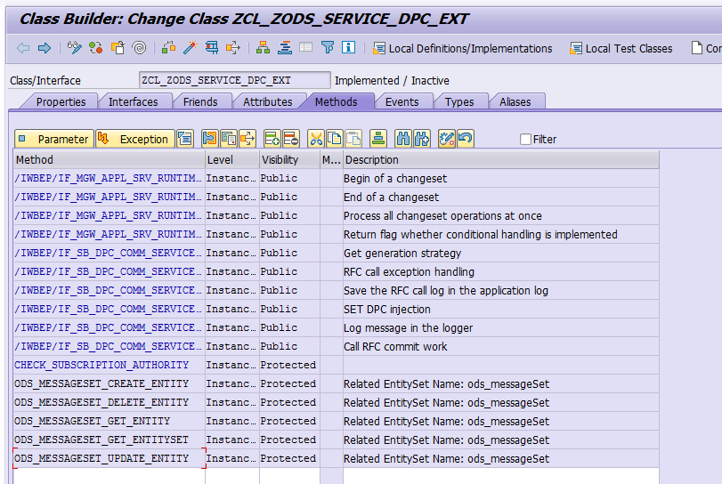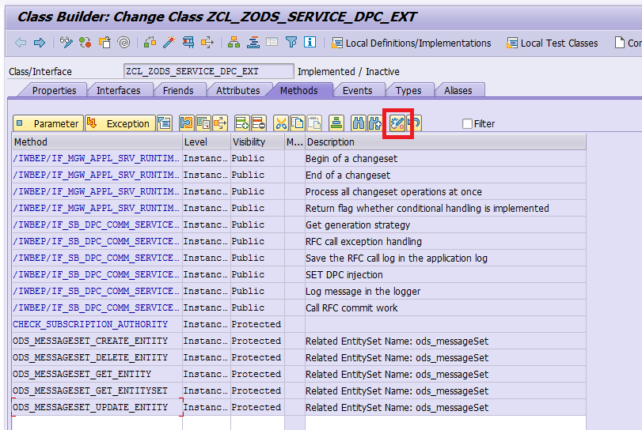

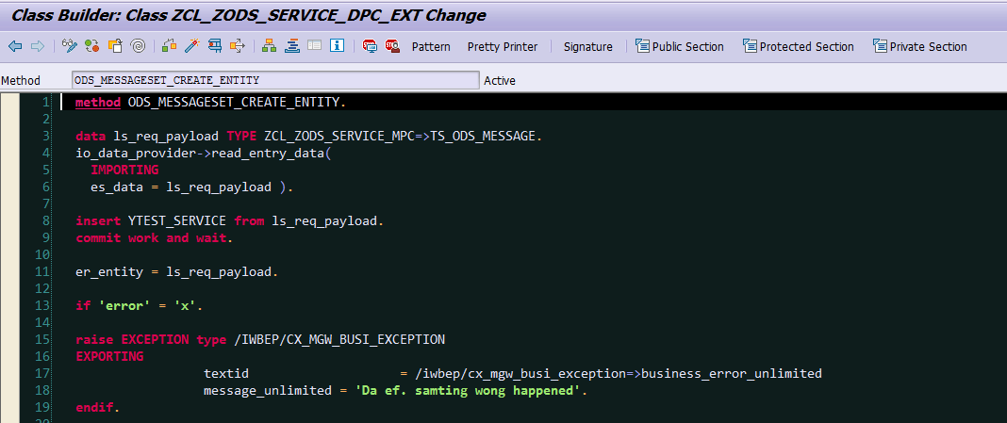

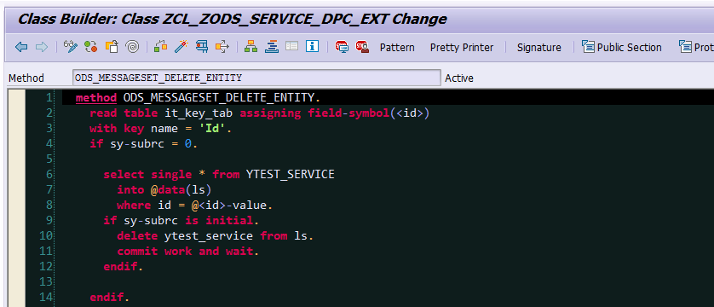

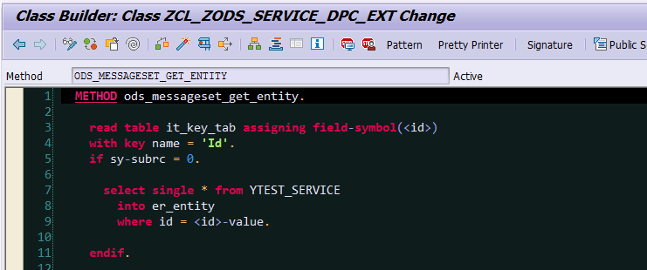

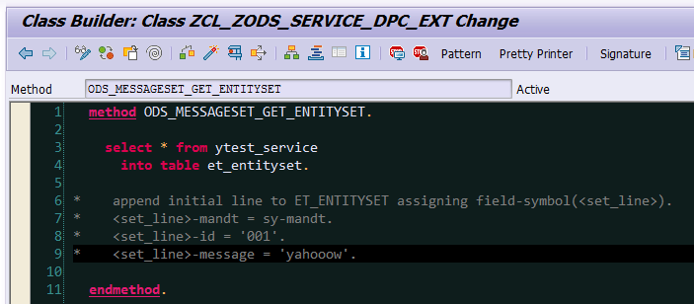

1. Testing

SE16N – Data to be used for sampling/testing

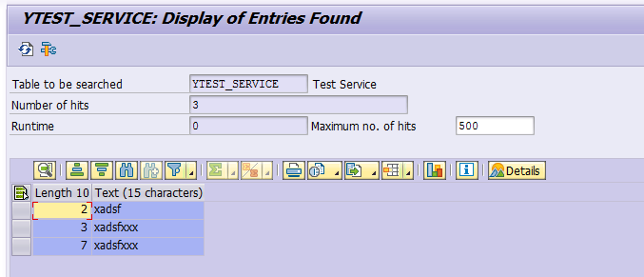



* 1. Get Set Item (All entries)  
     TODO: Show use of the ff:  
     $select, $top, $filter, $paginate, etc

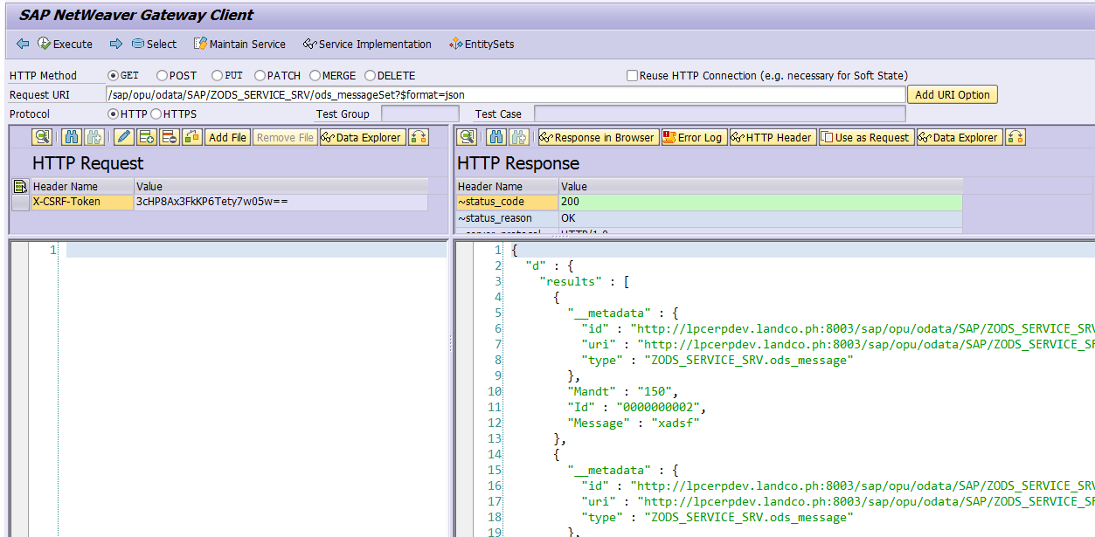

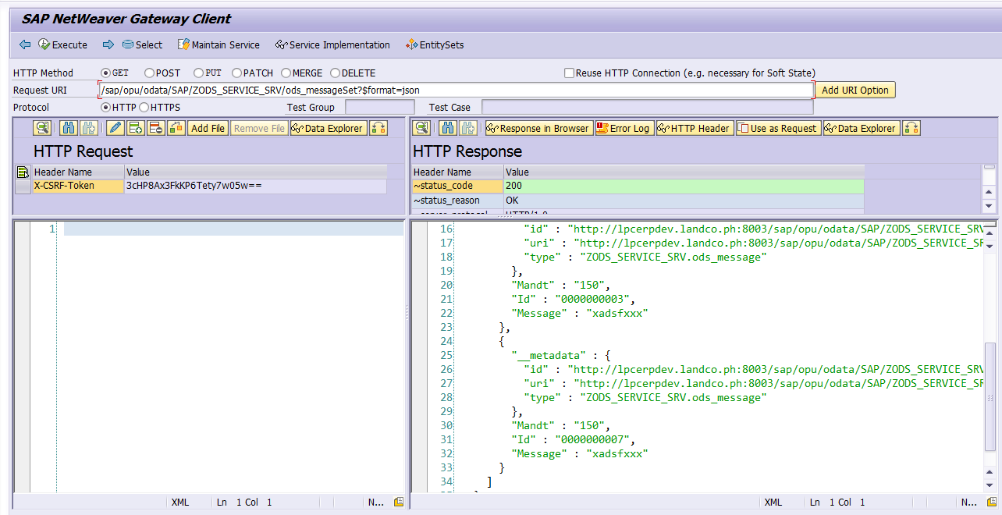

* 1. Get Individual (Read)

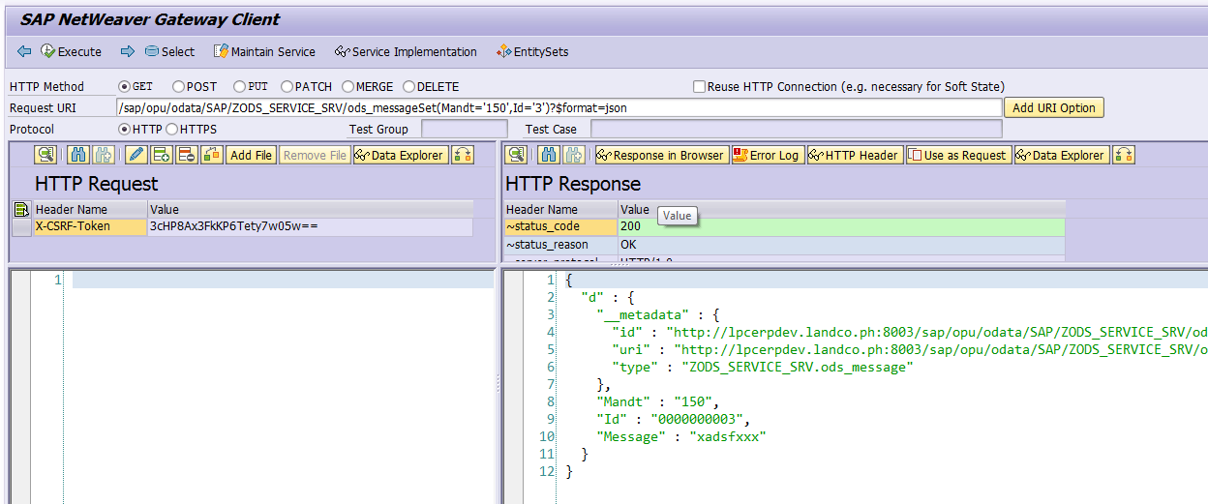

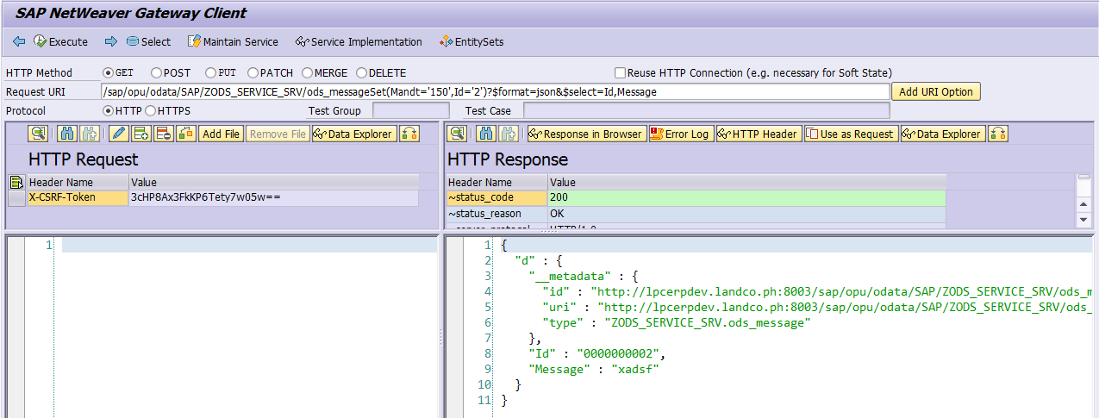

* 1. Create Entry (Create)

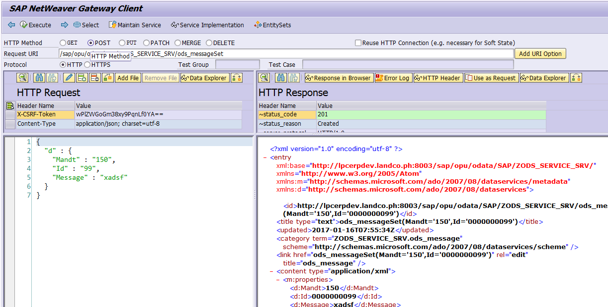 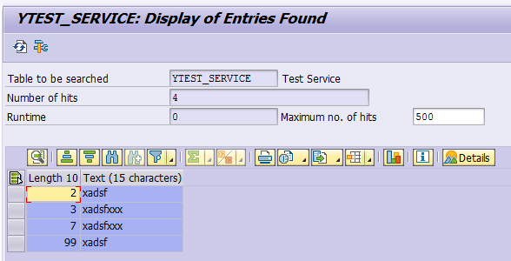 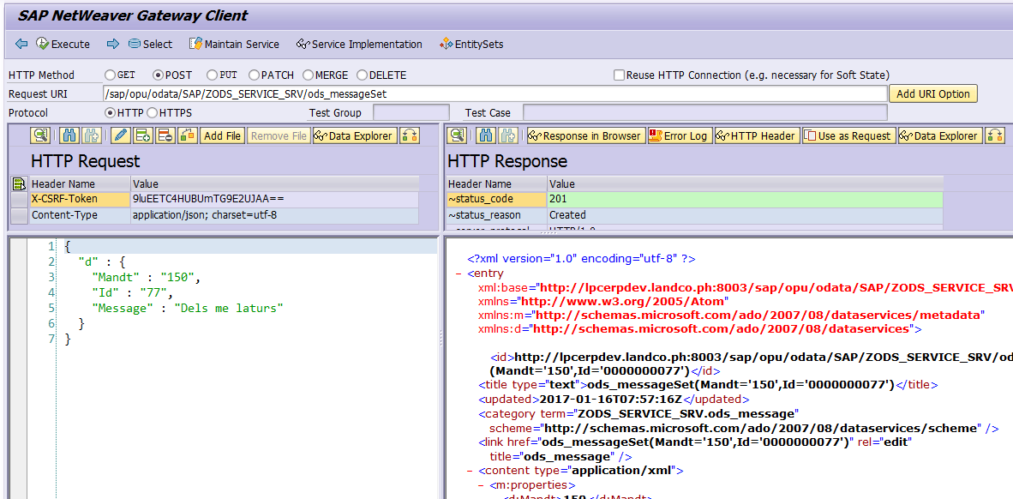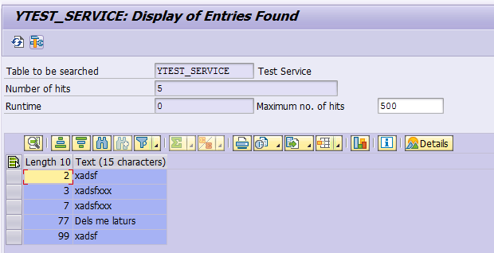

* 1. Delete

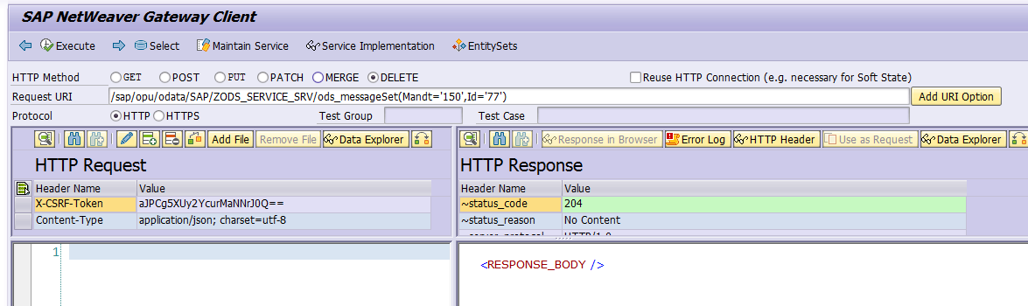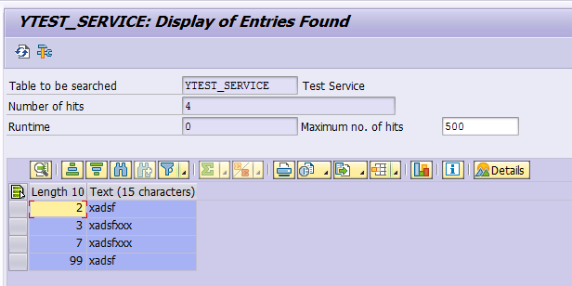

* 1. Update

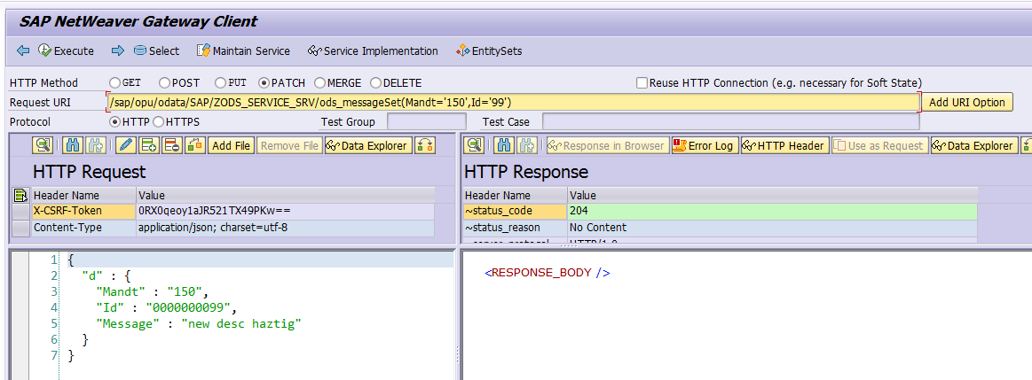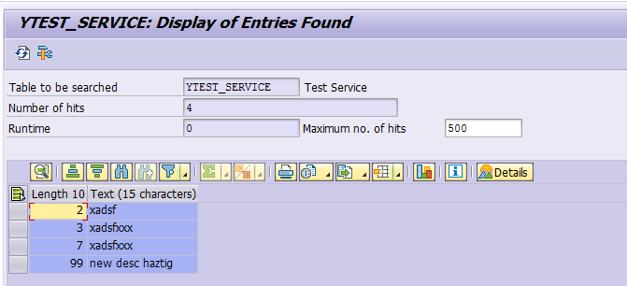

1. TODO Items

> Testing outside the Gateway SAP Client

- Browser

- Postman/Curl

> Error Handling

> Authentication

- Standard

- Using HTTP header fields for automatic login

- sap-user, sap-password, sap-client

> SSL/HTTPS/Encryption

> Debugging

> Service Creation for a BAPI