Data Analytics for Business Strategy
Marketing Analytics for a Family-Managed Construction Business
Residential flat sales and warehouse leasing: synthetic-data study, data preparation, descriptive and diagnostic analytics, Streamlit dashboard and strategy

1. Business context and objective

The family-managed business (FMB) takes over the land, builds residential apartment complexes and leases warehouse complexes to third-party logistics (3PL) companies and other enterprises, while selling the apartments to individual buyers. Construction and land are the strength of the family, marketing so far is informal (referrals, brokers, some spend on portal, hoardings). Owners are looking to expand the business on the marketing end.
Business objective: increase conversion of lead to sale / lead to lease (flats/warehouses) and lower marketing cost per acquisition by identifying which leads to bookings and which doesn't.

Business questions the data must answer
- What information does the business need to be answered?
- Identify the channels that attract buyers and tenants versus volume alone. (channel ROI)
- What makes the difference between a bookable lead and a non-bookable lead? (diagnostics: speed, site visits, affordability, finance, seasonality)
- Do project, price positioning, unit type or customer demographics matter?
- In the warehouse context, what is the value of the access of decision makers, proposals and rent positioning?
- Where to invest the next dollar of marketing and sales?

Techniques applied and why
Step | Technique | Why it is used on this data
1 | Synthetic data generation (4 linked tables) | The FMB has no clean CRM history. Generating data from the business process shows which columns are needed and lets the analysis be checked against known ground truth.
2 | Cleaning and transformation (10 marks) | CRM data is messy (mixed date formats, label variants, duplicates, typos, missing values). Models and correlations are unreliable without fixing this.
3a | Descriptive analytics | Answers what happened: KPIs, distributions, funnel, trends, channel and project performance.
3b | Diagnostic analytics | Answers why: Spearman correlation (mixed types, skewed data), chi-square / Mann-Whitney / Kruskal-Wallis tests (is a difference real?), drill-downs and a logistic-regression driver model (which factor matters after controlling for others).
3c | Streamlit dashboard | Lets the sales and marketing team filter, explore and repeat the analysis without code.
4 | Strategy formulation | Converts the findings into budget, process and calendar decisions with measurable targets.

2. Step 1: Synthetic data generation

2.1 Why synthetic data, and how it was designed
Since there is no existing lead-level history for the FMB, a synthetic history was created from the business process itself (script 01_generate_synthetic_data.py, seed 42, reproducible). The numbers aren't the point; the point is to find out what columns a real CRM has to capture and why, and whether relationships can be recovered through analytics that really drive the business. The diagnostic results in Section 5 can be checked against the generating rules since they are known.
Table | Rows (raw) | What it represents | Key columns
residential_leads_raw | 3,248 | Flat-buyer leads, Jan 2024 to Dec 2025, 8 projects, 8 channels | channel, project, unit type, income, budget, response time, follow-ups, site visits, loan pre-approval, cost, converted, booking value, days to close
warehouse_leads_raw | 1,120 | B2B leasing enquiries, 4 warehouse parks, 7 channels | client type, area required, lease term, quoted rent, response time, decision-maker reached, proposal sent, negotiation rounds, converted, lease value
campaign_performance_raw | 365 | Monthly spend, impressions, clicks, leads and conversions per channel | spend, impressions, clicks, leads_reported, conversions_reported
projects_master | 12 | Project attributes | price/sqft or rent/sqft, zone, amenities, distance to metro/highway, dock doors
market_conditions | 24 | External factors | home-loan rate, festive index

2.2 Business logic embedded in the data
All the drivers below were provided with a realistic direction to create something meaningful to analyze. Overall conversion was roughly 12.5% (flats) and 15% (warehouses) for real-estate funnels..
- Flats: Faster response, more visits to the site, budget above price, festive months and proximity increase conversion, higher interest rates and long distance decrease conversion – flats. High intent leads are referral or walk-in, lower intent but costlier or bulkier leads are Meta Ads, portals, and hoardings.
- Warehouses: Sending a proposal to the decision-maker, reaching the 3PL clients, faster response and renting at or below market level raise conversion rates at Warehouses; the same is true for Referral and Broker channels, but not so for Cold Calling and SEO.
- Costs: Every channel will have different costs per lead (e.g. Walk-in: 1,000; Hoardings: 10,000 currency units) and the overhead for the agency in the campaign table.
- Seasonality: lead volume and conversion are increased during the festive season (October – November).
- Realistic mess: On purpose realistic mess has been injected so that Step 2 has real work: mixed date formats, label variants, duplicates, impossible values, x100 typos, missing values and 'NA' strings.

2.3 Validity of the synthetic data
Descriptive checks confirm that the data is consistent with a real portfolio: average closing period is approximately 48 days; average booking value by book is constant, approximately 6.5 million currency units; average sales share and lead share differ by channel as in real markets, average 12.81% overall. All embedded drivers were recovered in the correct direction with statistical significance (Section 5) and the variables intended to have no effect (age) did not have an effect. That's the proof that the synthetic data validates the strategy that is being diagnosed.
Note on limits: the effects were designed in and the findings indicate that the method works and what a real CRM would need to record. Prior to making major budget decisions, the size of the effects needs to be re-estimated using the real data from the FMB.

3. Step 2: Data cleaning and transformation (10 marks)
Script 02_data_cleaning_transformation.py will perform all of the actions below and create a log (tables/cleaning_log.csv) to remember what was done, making the work repeatable. Rationale: dirty labels divide one channel into multiple channels which can affect overall counts, negative or impossible values will affect averages, unscaled or text variables cannot be used in correlation or models.

3.1 Cleaning actions and evidence
Table | Problem found | Treatment | Records
residential | Exact duplicate lead rows (CRM double entry) | Dropped duplicates | 48
residential | Duplicate lead_id after exact-dup removal | Kept first occurrence | 0
residential | Inconsistent channel labels (case, spaces, underscores) | Mapped to 8 canonical channels | 431
residential | Occupation lower-case variants | Standardised casing | 141
residential | 3 mixed date formats stored as text | Parsed to datetime64 | 3200
residential | Target stored as Yes/Y/No/N/1/0 | Converted to binary 0/1 | 3200
residential | 'NA' text inside numeric site_visits column | Coerced to numeric NaN (imputed below) | 51
residential | Negative response time (sign entry error) | Took absolute value | 15
residential | Impossible ages (0, 5, 17, 130, 150, 212) | Set to NaN then imputed | 6
residential | Budget typo outliers (x100) - ratio to price > 8 | Divided by 100 (verified plausible after fix) | 13
residential | Missing age | Imputed median by occupation | 141
residential | Missing annual_income | Imputed median by occupation | 198
residential | Missing response_time_hrs | Imputed median by channel | 97
residential | Missing distance_from_site_km | Imputed median by overall | 62
residential | Missing site_visits | Imputed median by channel | 51
residential | Missing occupation | Imputed mode | 105
residential | Extreme values in response_time_hrs | Winsorised at 1st/99th percentile | 32
residential | Extreme values in distance_from_site_km | Winsorised at 1st/99th percentile | 55
residential | Extreme values in annual_income | Winsorised at 1st/99th percentile | 64
warehouse | Exact duplicate lead rows | Dropped duplicates | 20
warehouse | Inconsistent channel labels | Mapped to 7 canonical channels | 146
warehouse | 2 mixed date formats stored as text | Parsed to datetime64 | 1100
warehouse | Negative response time | Took absolute value | 8
warehouse | Area outliers (x50 typo, > 300,000 sqft requirement) | Divided by 50 | 5
warehouse | Missing area_required_sqft | Imputed median by client_type | 29
warehouse | Missing response_time_hrs | Imputed median by channel | 39
warehouse | Missing quoted_rent_per_sqft | Imputed median by project_id | 14
warehouse | Missing client_type | Imputed mode | 37
warehouse | Extreme values in response_time_hrs | Winsorised 1st/99th pct | 11
warehouse | Extreme values in area_required_sqft | Winsorised 1st/99th pct | 22
campaign | Duplicate monthly records | Dropped duplicates | 6
campaign | Inconsistent channel labels | Mapped to canonical | 46
campaign | Missing spend (finance feed gap) | Imputed = channel-median cost-per-lead x leads | 12
campaign | Impressions/clicks blank for offline channels | Left as NaN (not applicable, not an error) | 215

Why these treatments: Duplicates were removed from the count; text labels were mapped to canonical lists – each channel represents one category; dates were parsed from three formats; the target was converted from Yes/Y/No/N/1/0 to binary; impossible ages (0, 5, 17, 130, 150, 212) were treated as missing; missing numerics were imputed with the group median (e.g. income by occupation, response time by channel) rather than a single global value to preserve group differences; extreme values in variables with skewed distributions were winsorised at the 1st/99th percentile without being removed to keep the sample size.
Missing values before and after (residential): age (residential): 135 to 0, occupation: 108 to 0, annual income: 200 to 0, distance: 64 to 0, response time: 100 to 0, site visits: 51 to 0. The value of booking and days-to-close will be left as blank fields for non-converted leads on purpose, as there is no booking. For offline (hoardings, referrals, brokers) impressions and clicks are blank.

3.2 Transformation and feature engineering
- Joins: The attributes of projects (price per sqft, amenities, distance to metro) and the monthly market conditions (loan rate, festive index) were enriched onto the leads.
- Date features: month, quarter, weekday, festive-season flag (October and November).
- Business features: budget-to-price ratio, affordability band, response-time bucket (<2h, 2-6h, 6-24h, >24h), age group, income quartile, local-lead flag (within 5 km), visited-site flag, digital-channel flag, net revenue after marketing cost.
- Warehouse features: rent gap to market, area as a percentage of park, size band, long lease flag, annual rent potential.
- Campaign KPIs: click-through rate, cost per lead, lead-to-sale %, cost per conversion.
- Model-ready file: The model-ready file contains the following three categorical variables one-hot encoded, and 11 numerics z-score standardised: residential_model_ready.csv.
Result: residential 3,248 – 3,200 (48 duplicate rows removed), warehouse 1,120 – 1,100 (50 duplicate rows removed), campaign 365 – 359 (8 duplicate rows removed); no missing values for analysis variables.

4. Step 3a: Descriptive analytics (what happened?)
Rationale: Question "Why?" cannot be asked without having a picture of volume, conversion, cost and revenue. KPIs and the figures below were generated with Script 03_eda_descriptive_diagnostic.py, which are interactive in the dashboard.

4.1 Headline KPIs
KPI | Residential flats | Warehouse leasing
Leads | 3,200 | 1,100
Conversions | 410 bookings | 164 leases
Lead-to-conversion rate | 12.81% | 14.91%
Marketing cost per conversion (CAC) | 49,538 | 75,523
Total marketing cost | 20,310,426 | 12,385,786
Total booked value / lease value | 2,679,261,000 | 8,951,370,000
Average value per deal | 6,534,783 | 54,581,524
Average days to close (flats) | 48.5 | -
Values are in generic currency units. Marketing cost is a very small share of deal value, so the question is not whether marketing pays but whether money and effort are allocated to the leads that convert.
Distributions and funnel (figures in the figures folder): response time, income and distance are right-skewed (about one in three leads waits over 6 hours), which is why rank-based statistics were chosen. About 80% of leads visit a site at least once, so the leak is between first and repeat visit, not lead and first visit.
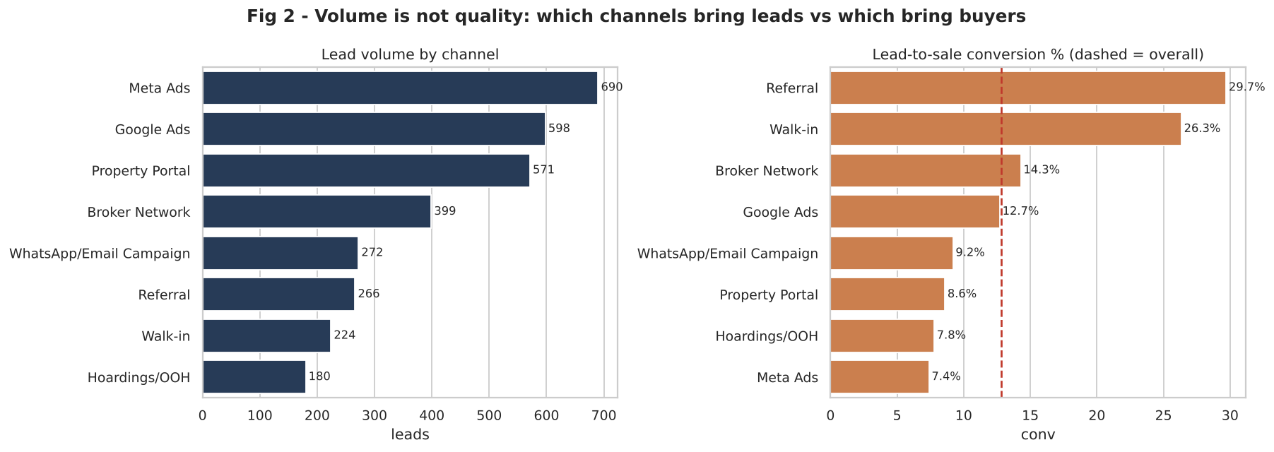
Figure 1: Lead volume versus conversion by channel
What it shows: Left: how many leads each channel produces. Right: how many of those leads become bookings, against the overall rate (dashed).
Insight: Volume is not quality. Meta Ads is the largest source (690 leads, 21.6% of all leads) yet converts only 7.4%, while Referral (29.7%) and Walk-in (26.3%) convert about twice the average from far fewer leads.
Business action: Judge channels on bookings and cost per booking, not on lead counts.
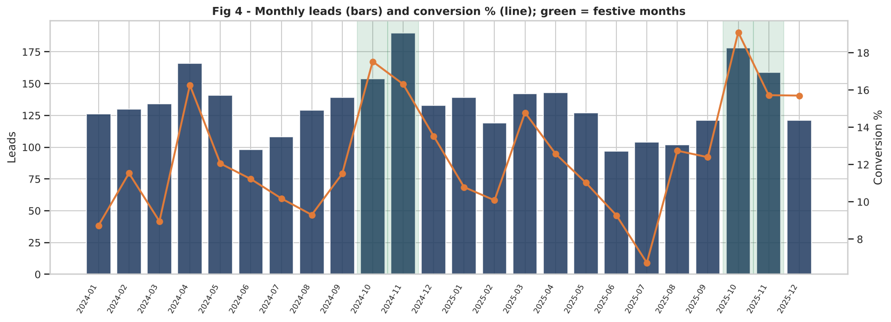
Figure 2: Monthly leads and conversion (green = festive months)
What it shows: Lead volume (bars) and conversion % (line) by month across 2024 and 2025, festive months shaded.
Insight: Both volume and conversion rise in October and November: conversion is 17.18% in festive months versus 11.63% otherwise, a relative lift of about 48%. Festive months hold about 21% of leads.
Business action: Plan launches, offers and extra sales staff for September to November; avoid spending the same in the June to August trough.
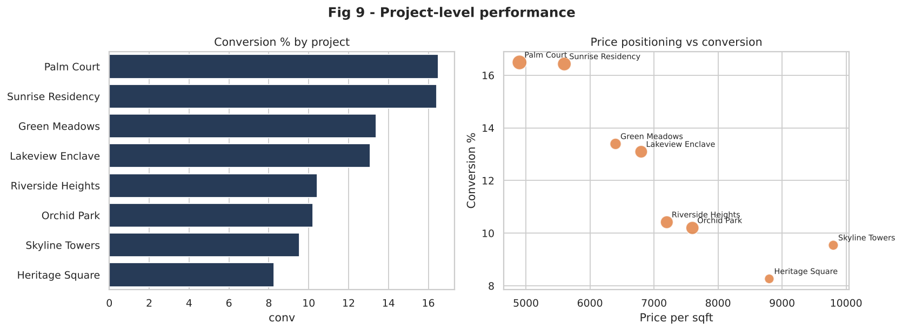
Figure 3: Project-level conversion and price positioning
What it shows: Conversion by project (left) and price per sqft versus conversion (right), bubble = lead volume.
Insight: Lower-priced projects convert better, and the 1BHK unit type converts best (19.1% versus 9.5% for 3BHK). Premium central projects attract fewer, harder leads. Differences by project are driven mostly by affordability and distance rather than by marketing alone.
Business action: Match channel mix to project price: referral and broker for premium projects, digital for value projects.
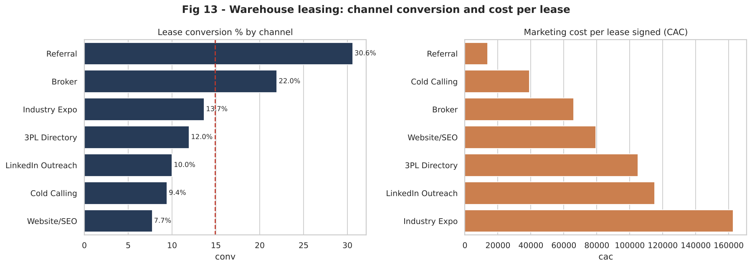
Figure 4: Warehouse conversion and cost per lease by channel
What it shows: Lease conversion % (left) and marketing cost per lease signed (right) for the seven warehouse channels.
Insight: Referral converts at 30.6% at about 13,700 per lease; Broker converts 22.0%. Industry Expo is the most expensive route at about 162,800 per lease and only 13.7% conversion; Website/SEO is the weakest at 7.7%.
Business action: Treat brokers and referrals as the core B2B engine; use expos selectively for brand and large-account access.
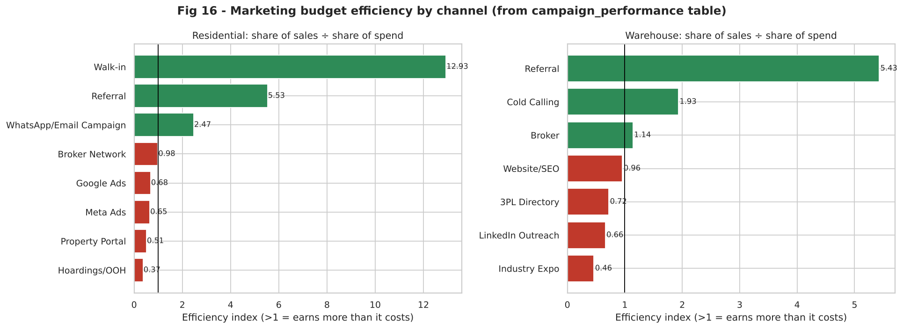
Figure 5: Budget efficiency by channel (share of sales divided by share of spend)
What it shows: From the campaign table: a channel scores above 1 if it delivers a larger share of sales than the share of budget it consumes.
Insight: Walk-in (12.9), Referral (5.5) and WhatsApp/Email nurture (2.5) are strongly efficient for flats; Hoardings (0.37) and Property Portals (0.51) destroy value. For warehouses Referral (5.4) and Cold Calling (1.9, low cost) beat expected, while Industry Expo (0.46) and LinkedIn (0.66) lag.
Business action: This index is the simplest rule for the monthly budget review: move money from channels below 1 toward channels above 1, within capacity limits.

5. Step 3b: Diagnostic analytics (why did it happen?)
Rationale: descriptive charts show differences but cannot tell whether they are real or caused by something else. Diagnostics combine correlation (strength and direction), hypothesis tests (is it statistically real?), drill-downs (where does it come from?) and a multivariable model (does it hold after controlling for other factors?).

5.1 Correlation analysis
Why Spearman: several variables are skewed or ordinal (response time, site visits, income) and the target is binary, so rank correlation is more reliable than Pearson.
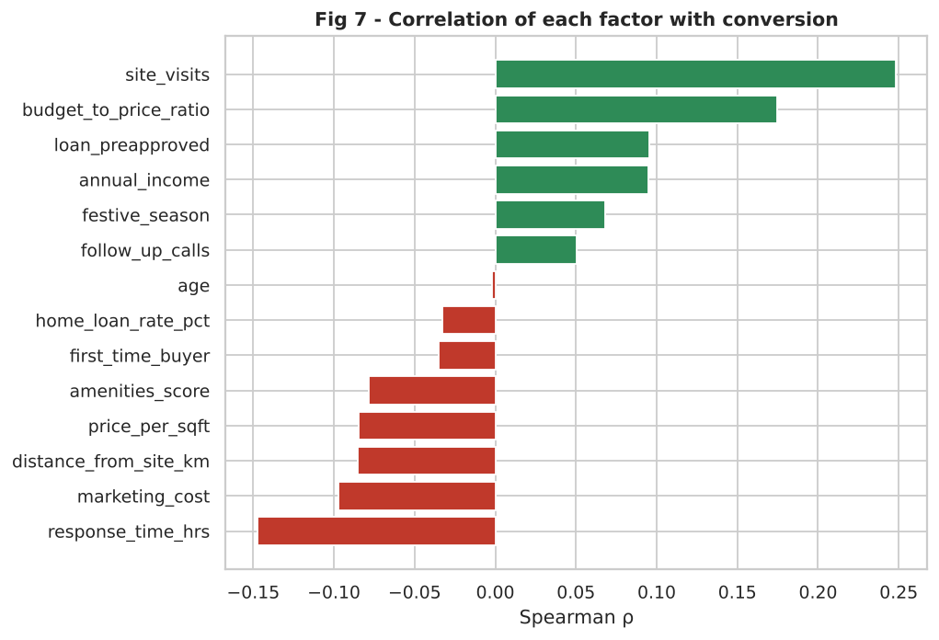
Figure 6: Correlation of each factor with conversion
What it shows: Pairwise rank correlation between all numeric factors, and each factor's correlation with booking.
Insight: Site visits (+0.25) and budget-to-price ratio (+0.18) are the strongest positive correlates; response time is the strongest negative one (-0.15), followed by marketing cost (-0.10), distance and price. Age and interest rate are near zero. Correlations are modest because conversion is a rare binary outcome, which is why tests and a model are needed next. Marketing cost per lead correlates negatively with conversion: expensive leads are not better leads.
Business action: Prioritise levers that are controllable: visit scheduling, response time and qualification.

5.2 Drill-down on the key drivers
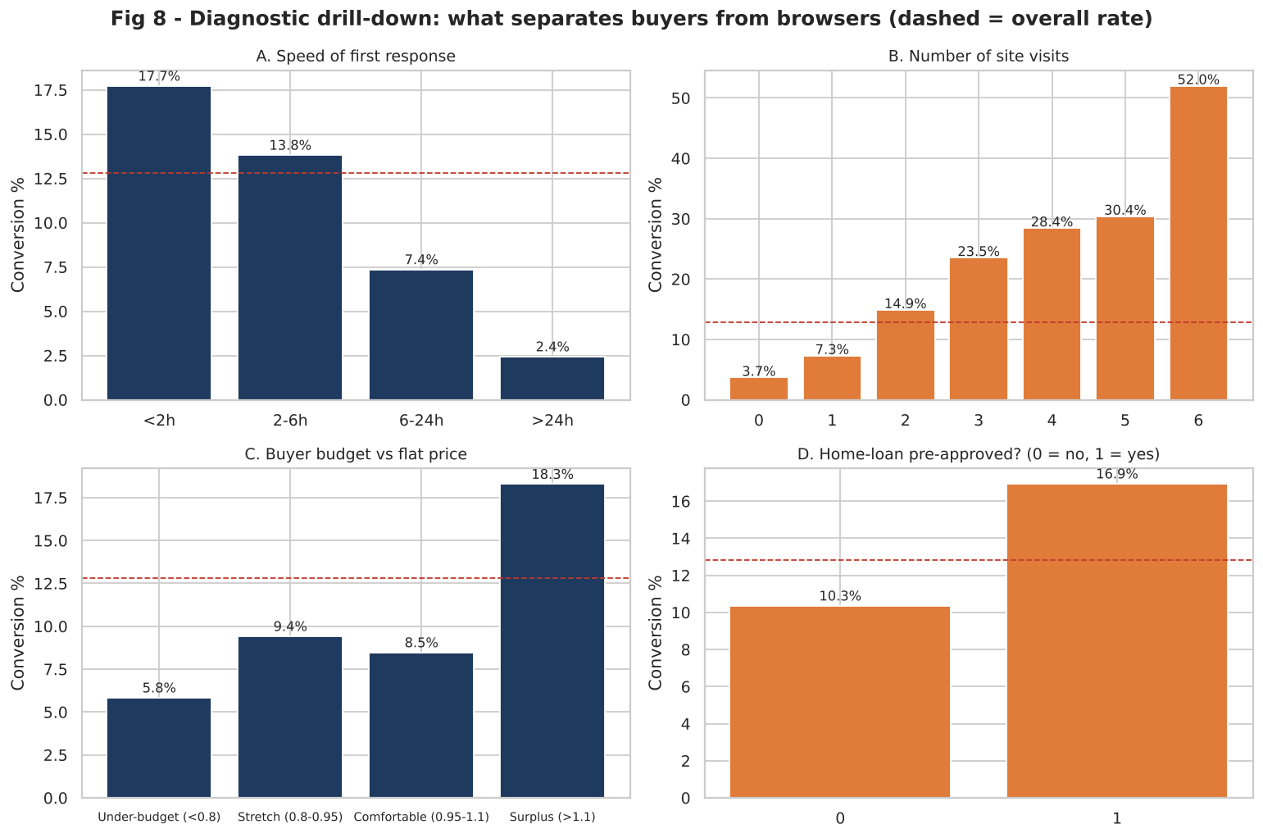
Figure 7: What separates buyers from browsers
What it shows: Conversion rate across four controllable factors.
Insight: (A) Response time: 17.73% when answered in under 2 hours, falling to 2.44% after 24 hours, a seven-fold gap. (B) Site visits: 3.68% with no visit, 23.53% with three visits and above 50% at six. (C) Affordability: leads whose budget exceeds the price convert at 18.3% versus 5.85% for under-budget leads. (D) Loan pre-approval adds about 6.6 points (16.93% versus 10.34%).
Business action: Service-level target: first response within 2 hours; at least two site visits per qualified lead; early budget and loan check; connect leads to bank partners at first contact.
Other results: the monthly link between loan rate and conversion is negative but not significant (rho = -0.337, p = 0.1072), so rate effects cannot be confirmed on 24 months. Age has no effect (p = 0.91); income does (top quartile 16.9% vs 8.5%), reflecting affordability. Demographic targeting therefore matters less than behaviour.
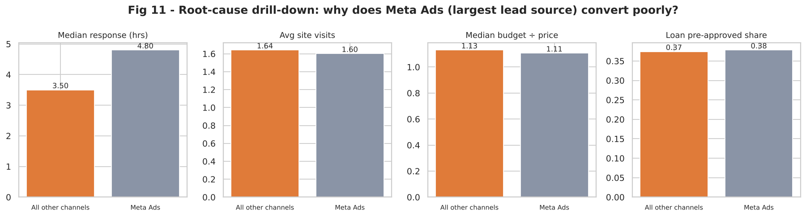
Figure 8: Root-cause drill-down: why does Meta Ads convert poorly?
What it shows: Meta leads versus all other leads on response time, site visits, budget ratio and loan status.
Insight: Meta leads get a slower median response (4.8 hours versus 3.5) but are otherwise similar in budget, visits and finance. So the weakness is not explained by lead affordability; it is mostly lower purchase intent of the channel plus slower follow-up. This is a useful negative finding: simply improving targeting on budget will not fix it.
Business action: Cap Meta spend, speed up its follow-up (automated WhatsApp reply within minutes) and re-test with a retargeting audience.

5.3 Hypothesis tests (residential)
Chi-square tests are used for categorical factors against a binary outcome; Mann-Whitney U for numeric factors between buyers and non-buyers (no normality assumed); Kruskal-Wallis for days-to-close across channels. Significance level alpha = 0.05; effect size is reported so that large samples do not make trivial differences look important.
ID | Hypothesis | Test | p-value | Effect / note | Decision
H1 | Conversion differs by channel | Chi-square | 5.2e-27 | Cramer's V=0.21 | Reject H0
H2 | Buyers got faster first response | Mann-Whitney U | 8.2e-17 | median buyers=2.30 vs non=4.10 | Reject H0
H3 | Site visit vs conversion | Chi-square | 9.0e-15 | Cramer's V=0.14 | Reject H0
H4 | Loan pre-approval vs conversion | Chi-square | 9.3e-8 | Cramer's V=0.09 | Reject H0
H5 | Higher budget-to-price ratio among buyers | Mann-Whitney U | 4.8e-23 | median buyers=1.52 vs non=1.08 | Reject H0
H6 | Festive season vs conversion | Chi-square | 1.6e-4 | Cramer's V=0.07 | Reject H0
H7 | Local lead (<=5km) vs conversion | Chi-square | 9.4e-4 | Cramer's V=0.06 | Reject H0
H8 | First-time buyer vs conversion | Chi-square | 0.052 | Cramer's V=0.03 | Fail to reject
H9 | Unit type (BHK) vs conversion | Chi-square | 1.0e-6 | Cramer's V=0.10 | Reject H0
H10 | Age difference buyers vs non-buyers | Mann-Whitney U | 0.909 | median buyers=38.00 vs non=38.00 | Fail to reject
H11 | Income difference buyers vs non-buyers | Mann-Whitney U | 8.0e-8 | median buyers=1748000 vs non=1567000 | Reject H0
H12 | Days-to-close differs by channel | Kruskal-Wallis | 0.382 |  | Fail to reject

Reading the table: channel, response speed, site visits, loan pre-approval, budget ratio, festive season, proximity, unit type and income all have a significant relationship with booking. Age, first-time-buyer status (borderline, p = 0.052) and days-to-close by channel do not. The strongest effects by effect size are channel (Cramer's V 0.21) and site visits (0.14).

5.4 Driver model and accuracy validation
Why logistic regression: the outcome is binary and the business needs an interpretable answer to 'which factors matter after controlling for the others', not a black box. Features were standardised so coefficients are comparable; channels are expressed against Google Ads. Data were split 75/25 (stratified), trained on 2,400 leads and tested on 800 unseen leads.
Metric (hold-out set) | Value | Meaning
ROC-AUC | 0.771 | Ranks buyers above non-buyers 77% of the time (0.5 = random)
Accuracy | 0.73 | Share of leads classified correctly (class-balanced model)
Recall (buyers caught) | 0.667 | 68 of 102 actual buyers flagged as high-potential
Precision | 0.272 | Low because only 12.8% of leads buy; flagged group is 2.1x richer in buyers than average
Confusion matrix [TN FP / FN TP] | [[516,182],[34,68]] | 516 / 182 / 34 / 68

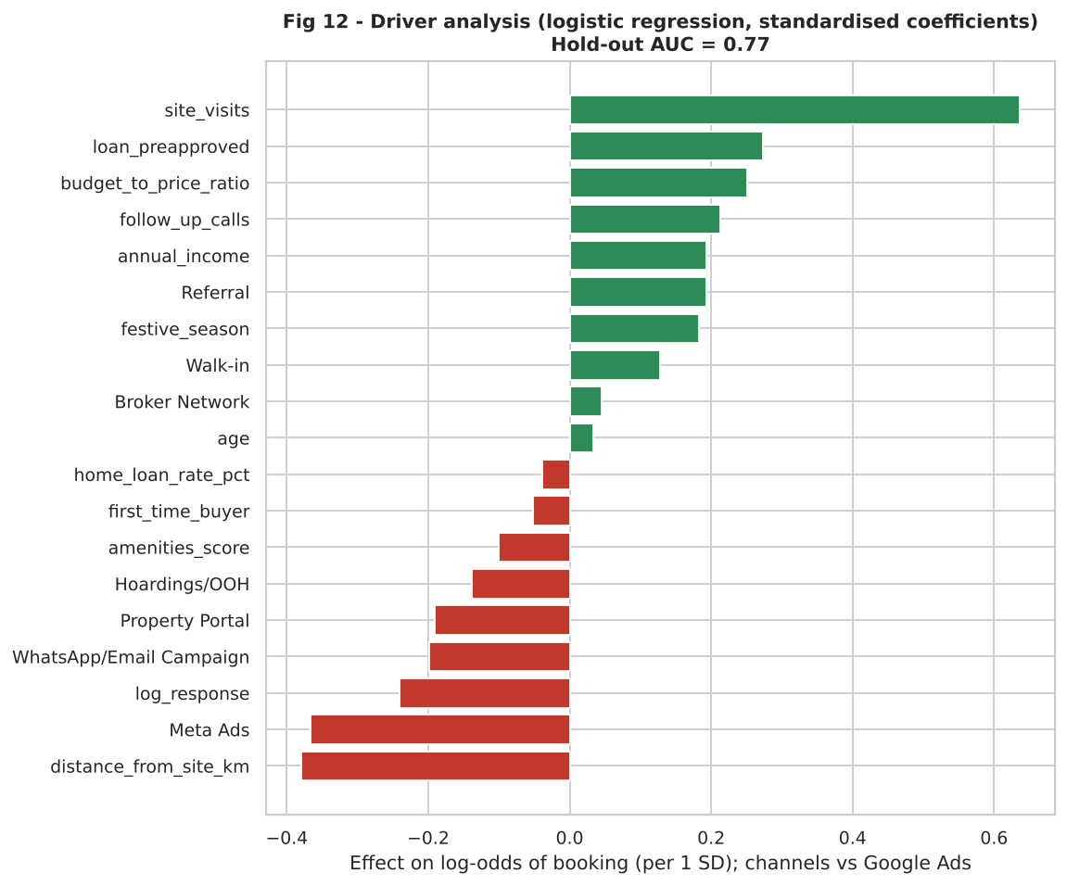
Figure 9: Driver analysis (standardised logistic coefficients)
What it shows: The effect of each factor on the log-odds of booking while holding the others constant.
Insight: Site visits is the largest positive driver (odds x1.89 per standard deviation), followed by loan pre-approval (x1.31), budget ratio (x1.29), follow-up calls (x1.24) and festive season (x1.20). Negative drivers are distance from site (x0.68), Meta Ads (x0.69) and slower response (x0.79). This agrees with the correlation and test results and with the logic built into the data, which is the validation that the diagnostics recover real structure.
Business action: Use the model to score new leads so sales effort goes first to high-probability leads (lead prioritisation).
Honest reading of accuracy: an AUC of 0.77 is useful for ranking leads, not for deciding single cases with certainty. A random forest or gradient boosting model could add a little accuracy, but would reduce interpretability, which matters more at this stage.

5.5 Warehouse diagnostics
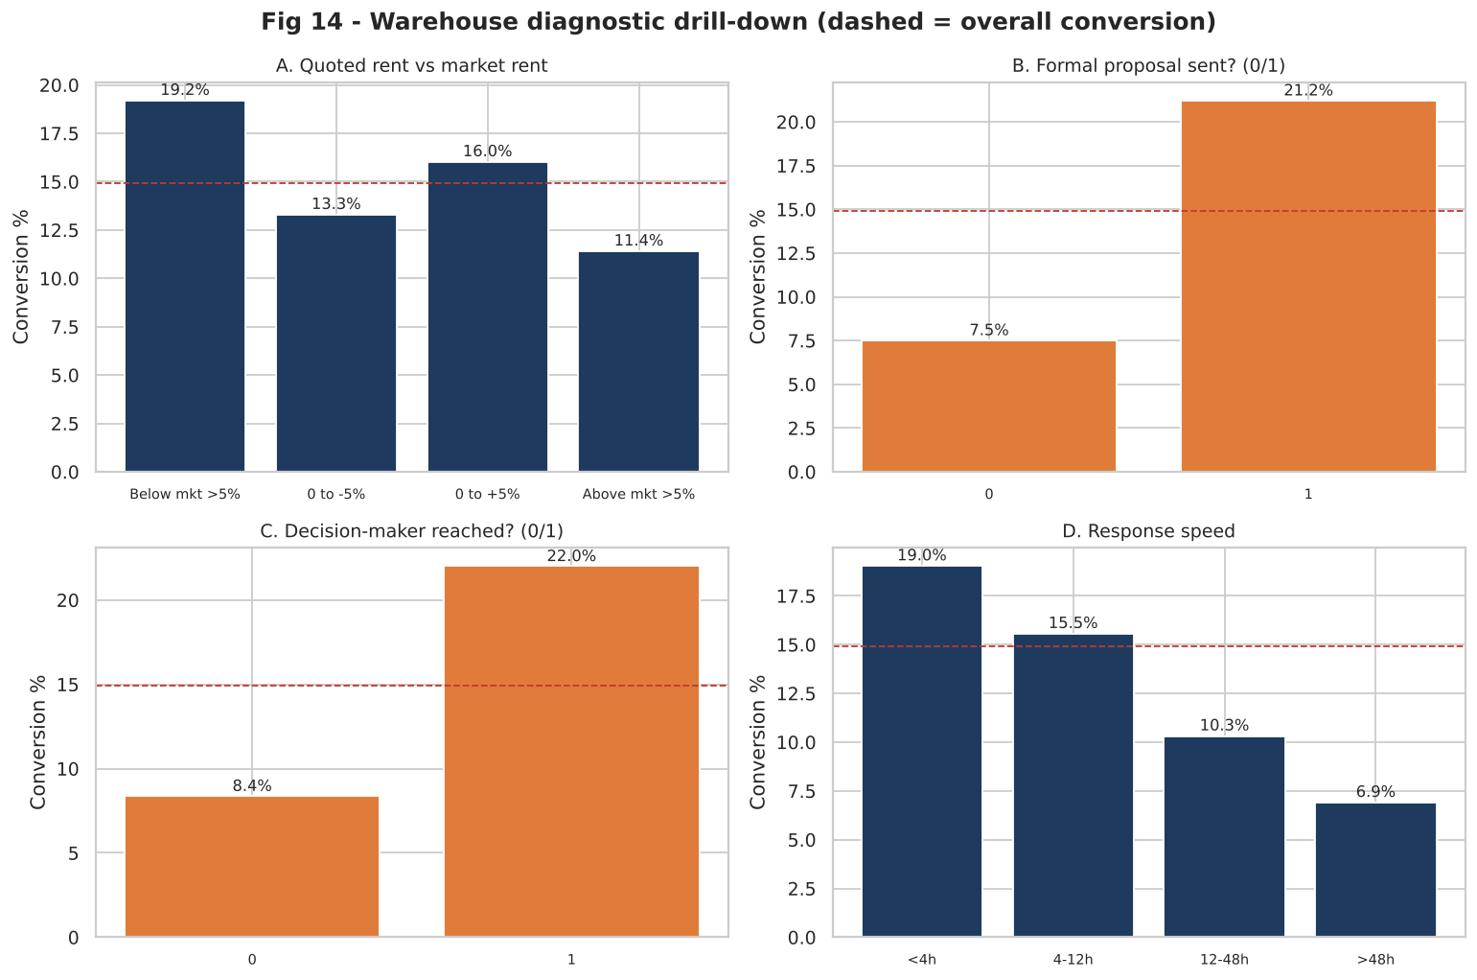
Figure 10: Warehouse diagnostic drill-down
What it shows: Lease conversion by rent positioning, proposal status, decision-maker contact and response speed.
Insight: Proposal sent: 21.21% versus 7.51% without. Decision-maker reached: 22.01% versus 8.38%. Response under 4 hours converts 19.02% versus 6.9% after 48 hours. Rent more than 5% above market converts 11.4% versus 19.19% when more than 5% below. About 52% of warehouse leads never reach a decision-maker and about 33% wait more than 12 hours for a response.
Business action: Make 'reach the decision-maker and issue a proposal within a week' a standard stage gate; keep quoted rent within plus or minus 5% of market unless a strategic tenant justifies a discount.

Channel, client type (3PL converts 19.0% versus 10.7% to 13.2% for others), proposal, decision-maker contact, rent gap and response speed are significant. Lease term (3 to 9 years) and number of negotiation rounds are not, so long leases are not harder to close and extended negotiation is not a signal of failure.

6. Streamlit dashboard
The 04_streamlit_dashboard.py file makes it possible to use the analysis without having to write any code, which is what the FMB team will do. It parses the cleaned files and provides filters on the side (date range, channel, project) and six tabs:
- Overview: KPI cards for flats and warehouses and the monthly lead/conversion trend.
- Channels and ROI: conversion, cost per booking, share of leads versus share of sales and the campaign efficiency index.
- Why do leads convert?: Select any reason and view the conversion by level using the chi-square p-value, Cramer's V and the Meta Ads drill-down.
- Warehouse leasing: channel type and client type performance, factor selector.
- Correlation explorer: Pearson/Spearman heatmap with an interactive scatter plot of any leads converted.
- Data quality and insights: the cleaning log and the recommended actions.
To run: pip install streamlit pandas numpy matplotlib seaborn scipy; streamlit run 04_streamlit_dashboard.py from the project folder. The streamlit code did not successfully install in the build environment, and so the dashboard code was syntax checked, but not executed here, it is best to open it once before submitting for the screens and take screenshots for the viva.

7. Business strategy formulated from the analysis

7.1 Strategic diagnosis
Marketing isn't the problem, it's the issue of leads being distributed incorrectly and being ignored. Referral, Walk in and WhatsApp/Email nurture bookings make up about 40% while spending ~7%, and Property Portals and Hoardings and Meta Ads spend about 52% and produce about 28% of bookings. In each channel, leads convert better when responded to within a short period of time, followed by multiple visits to the site and qualification on budget/funding. The gap for warehouses is in the decision makers and disciplining the proposal.

7.2 Recommendations with measurable targets
# | Action | Evidence | Target / KPI
1 | Response SLA: first contact under 2 hours (flats) and 4 hours (warehouses), with auto-reply on WhatsApp and a lead-routing rule | 17.7% vs 2.4% conversion (flats); 19.0% vs 6.9% (warehouses) | Median response under 2h; share of leads answered after 24h below 5%
2 | Site-visit programme: schedule a first visit within 3 days and a second visit with a loan/finance desk on site | 3.7% (0 visits) to 23.5% (3 visits); strongest model driver | Average visits per qualified lead from 1.6 to 2.5
3 | Shift budget: reduce Hoardings and Property Portals; cap Meta; scale referral rewards, walk-in events and WhatsApp/Email nurture | Efficiency index 0.37 / 0.51 versus 5.5 / 12.9 / 2.5 | Cost per booking down 20% at same sales; referral share of leads from 8% to 15%
4 | Qualify early: budget range and loan status in the first call; tie up with 2 to 3 banks for pre-approval camps | Surplus budget 18.3% vs 5.8%; pre-approved 16.9% vs 10.3% | Pre-approved share of leads from 37% to 55%
5 | Festive calendar: concentrate launches, offers and sales staff in Sep to Nov | 17.2% vs 11.6% conversion | Festive-quarter bookings plus 25%
6 | Warehouse playbook: decision-maker mapping, proposal within one week, rent within plus or minus 5% of market, 3PL focus, broker partnership programme | Proposal 21.2% vs 7.5%; decision-maker 22.0% vs 8.4%; 3PL 19.0% | Proposal rate from about 50% to 75% of qualified leads; decision-maker contact above 70%
7 | Lead scoring: use the logistic model to rank new leads and assign senior sales staff to the top 30% | AUC 0.77; 68 of 102 buyers caught | Lift in conversion of top-scored leads at least 2x

7.3 How to validate the strategy in practice
- Run the changes as an A/B pilot – run the changes on two projects and leave the other two as control for one quarter, and then compare conversion by chi-square test
- Re-calibrate the driver model using actual CRM information on a monthly basis and remove the recommendation when its effect size drops.
- Monitor dashboard KPIs like conversion, cost per booking, response time, visits per lead, efficiency index per channel.

What-if (illustrative): If a 10% increase of flat marketing spend is directed to channels with an efficiency greater than 0.6 (Referral, Walk-in, Nurture), it would be expected that bookings would go up, but the returns are likely to slow as the Referral, Walk-in, Nurture channels are scaled, so the change should be incremental and re-measured, not assumed linear.

8. Limitations
- The data is synthetic, direction of effects has been designed in, absolute magnitudes as for example the 7-fold response-time effect have to be re-estimated in real data before being quoted externally.
- The Pilot test in 7.3 creates causality, not the association (observational real world data).
- The campaign table covers 24 months, so seasonal and interest-rate conclusions rest on few data points (the rate effect is not significant).
- Logistic regression assumes additive effects rather than interactions (channel x response time, for example) which might be investigated using tree-based models.
- No taxation, brokerage commission or discounting on any other currency beyond any booking discount generated.

9. Conclusion
A real and synthetic dataset was created from the FMB's own business process, followed by cleaning, transforming and analysing the data using descriptive and diagnostic techniques. The analysis reveals that demography is not the big driver of conversion, while controllable process variables (speed, site visits, qualification, channel mix) account for about 70 per cent, and approximately 50 per cent of the flat marketing budget rests on low-efficiency channels. With 7 measurable actions, a marketing plan dashboard to keep track of them, and a lead-scoring model that it can test and optimize using real CRM data, the family business has a marketing plan of its own.
The files contained in the pack are: 01_generate_synthetic_data.py, 02_data_cleaning_transformation.py, 03_eda_descriptive_diagnostic.py, 04_streamlit_dashboard.py, data/raw, data/clean, figures, tables (including cleaning_log.csv and results.json), and README.md.

