ZAMBIA UNIVERSITY COLLEGE OF TECHNOLOGY
SCHOOL OF INFORMATION AND COMMUNICATION TECHNOLOGY
DEPARTMENT OF INFORMATION TECHNOLOGY

PASSWORD MANAGER WITH ZERO-KNOWLEDGE ENCRYPTION
A FINAL-YEAR PROJECT REPORT
BY
NANKOLOLWE RITAH — 2410802
KABASO KELVIN — 2410780
CHANDA CHANDA — 2410902
Submitted in partial fulfilment of the requirements for the award of the
Bachelor of Information Technology
Ndola, Zambia
2026

DECLARATION AND DEDICATION
We declare that this report is our original work and has not been submitted to another institution for an academic award. Sources used in the study are acknowledged in the text and reference list. The software evidence reported here was obtained from the submitted project repository and from tests executed specifically for this report.
We dedicate this work to our families, lecturers, classmates, and everyone who encouraged us to pursue secure and responsible information-technology solutions.
Student: Nankololwe Ritah Signature: ____________________ Date: ____________________
Student: Kabaso Kelvin Signature: ____________________ Date: ____________________
Student: Chanda Chanda Signature: ____________________ Date: ____________________

NOTICE OF COPYRIGHT
Copyright © 2026 Nankololwe Ritah, Kabaso Kelvin, and Chanda Chanda. No part of this report may be reproduced, stored, or transmitted for commercial purposes without the authors' and institution's permission, except for fair academic use with acknowledgement.

CERTIFICATE OF APPROVAL
This report has been submitted with the approval of the project supervisor and the Department of Information Technology, Zambia University College of Technology.
Supervisor: ______________________________
Signature: _______________________________ Date: ____________________
Head of Department: ______________________
Signature: _______________________________ Date: ____________________

ACKNOWLEDGEMENT
We thank our lecturers and project supervisor for guidance on research, software design, and academic presentation. We also thank our classmates and families for their practical support during implementation and testing. Finally, we acknowledge the authors and maintainers of Electron, React, Node.js, SQLite, and the standards and research publications that informed the security analysis.

ABSTRACT
Password reuse, weak credential storage, and phishing make personal account management difficult. This project implemented a cross-platform desktop password vault in Electron and React. The application derives a 256-bit session key from a master password with PBKDF2-HMAC-SHA-256, a random 16-byte salt, and 600,000 iterations. Individual vault entries are serialized to JSON and protected with AES-256-GCM using a fresh 12-byte initialization vector; the SQLite database stores only the resulting ciphertext package and non-secret derivation metadata. The renderer interacts with the main process through a preload bridge while context isolation is enabled and Node integration is disabled.
Evaluation combined source-code inspection, five automated cryptographic tests, a production renderer build, a synthetic end-to-end vault smoke test, and direct interface capture. All five repository tests passed in 380.9273 ms, the Vite build completed in 4.69 seconds, and the smoke test confirmed wrong-password rejection, lock enforcement, authenticated-tamper rejection through the underlying test suite, master-password rotation, encrypted export/import, and absence of two known plaintext secrets from stored entry blobs. The study therefore demonstrates a credible local encrypted-vault prototype. It does not establish a formal zero-knowledge protocol: there is no server, the unlocked renderer displays plaintext, and memory, IPC, packaging, operating-system hardening, accessibility, usability, and cross-platform validation remain incomplete. The report recommends mandatory export passphrases, main-process password validation, IPC sender checks, a strict Content Security Policy, sandboxing, secure memory and clipboard controls, migration to a memory-hard KDF where practical, broader tests, and measured user evaluation.
Keywords: password manager; PBKDF2; AES-256-GCM; Electron; React; SQLite; authenticated encryption; local-first security.

LIST OF ACRONYMS
Acronym | Meaning
AES | Advanced Encryption Standard
API | Application Programming Interface
CSP | Content Security Policy
DB | Database
GCM | Galois/Counter Mode
IPC | Inter-Process Communication
IV | Initialization Vector
KDF | Key Derivation Function
PBKDF2 | Password-Based Key Derivation Function 2
RNG | Random Number Generator
SQL | Structured Query Language
STRIDE | Spoofing, Tampering, Repudiation, Information Disclosure, Denial of Service, Elevation of Privilege
UI | User Interface
WAL | Write-Ahead Logging
XSS | Cross-Site Scripting

TABLE OF CONTENTS
CHAPTER ONE: INTRODUCTION
1.1 Background
1.2 Problem Statement
1.3 Aim
1.4 Specific Objectives
1.5 Research Questions
1.6 Significance of the Study
1.7 Scope and Delimitations
1.8 Operational Definitions
1.9 Chapter Summary
CHAPTER TWO: LITERATURE REVIEW
2.1 Password Management and Human Factors
2.2 Password-Based Key Derivation
2.3 AES-256-GCM Authenticated Encryption
2.4 Cryptographic Randomness and Password Generation
2.5 Electron Security Architecture
2.6 Local Storage, Locking, and Memory
2.7 Related Password Managers
2.8 Threat Modelling and Secure Development
2.9 Conceptual Framework
2.10 Literature Gap and Chapter Summary
CHAPTER THREE: RESEARCH METHODOLOGY AND SYSTEM DESIGN
3.1 Research Design
3.2 Development Approach
3.3 Functional Requirements
3.4 Non-Functional Requirements
3.5 System Architecture
3.6 Database Design
3.7 Detailed Cryptographic Design
3.8 User Interaction and Sequence Design
3.9 Threat Model and Security Controls
3.10 Evaluation Procedure
3.11 Validity, Ethics, and Data Handling
3.12 Chapter Summary
CHAPTER FOUR: IMPLEMENTATION, RESULTS, AND DISCUSSION
4.1 Implementation Overview
4.2 First-Run Vault Creation
4.3 Vault Workspace and Entry Management
4.4 Entry Form and Password Generator
4.5 Settings, Locking, Rotation, and Backup
4.6 Automated Test Results
4.7 Production Build Result
4.8 Synthetic Vault Smoke-Test Result
4.9 Security Configuration Findings
4.10 Objective Evaluation
4.11 Answers to the Research Questions
4.11.1 Research Question One
4.11.2 Research Question Two
4.11.3 Research Question Three
4.12 Discussion
4.13 Chapter Summary
CHAPTER FIVE: CONCLUSIONS AND RECOMMENDATIONS
5.1 Summary of the Study
5.2 Conclusions by Objective
5.2.1 Objective One
5.2.2 Objective Two
5.2.3 Objective Three
5.3 Overall Conclusion
5.4 Immediate Security Recommendations
5.5 Functional and Quality Recommendations
5.6 Proposed Evaluation Programme
5.7 Proposed Future Architecture
5.8 Final Statement
REFERENCES
APPENDIX A: EXECUTED COMMANDS AND RESULTS
APPENDIX B: REQUIREMENTS TRACEABILITY MATRIX
APPENDIX C: SOURCE-INSPECTION CHECKLIST
APPENDIX D: RECOMMENDED SECURITY ACCEPTANCE TESTS

LIST OF FIGURES
Figure 1.1: System context and local trust boundary0
Figure 2.1: Implemented key-derivation and authenticated-encryption flow0
Figure 2.2: Electron process and privilege architecture0
Figure 2.3: Logical data model and encryption boundary0
Figure 2.4: STRIDE-oriented threat surface for the prototype0
Figure 3.1: Implemented logical architecture0
Figure 3.2: SQLite tables and protected fields0
Figure 3.3: Unlock request and verification sequence0
Figure 3.4: STRIDE threat analysis0
Figure 4.1: First-run master-password creation screen0
Figure 4.2: Populated vault and search workspace0
Figure 4.3: Credential entry form and generator controls0
Figure 4.4: Security settings, rotation, and backup interface0
Figure 4.5: Executed automated-test result0
Figure 4.6: Executed Vite production-build result0
Figure 4.7: Synthetic end-to-end vault smoke-test result0

LIST OF TABLES
Table 1.1: Project scope and delimitations0
Table 1.2: Operational definitions0
Table 2.1: Related-system comparison0
Table 2.2: Conceptual input–process–output framework0
Table 3.1: Functional requirements and implementation status0
Table 3.2: Non-functional requirements and evaluation measures0
Table 3.3: Implemented cryptographic parameters0
Table 3.4: Threats, controls, and residual risk0
Table 4.1: Implemented layers and source modules0
Table 4.2: Repository automated-test outcomes0
Table 4.3: Synthetic vault scenario results0
Table 4.4: Security configuration findings0
Table 4.5: Objective achievement matrix0
Table 5.1: Immediate security-hardening roadmap0
Table 5.2: Functional and quality recommendations0
Table A.1: Verification execution summary0
Table B.1: Research and requirement traceability0
Table C.1: Repository inspection checklist0

CHAPTER ONE: INTRODUCTION
This chapter establishes the password-management problem, the motivation for local authenticated encryption, the official objectives and research questions, the project scope, and the criteria used to judge the implemented prototype.

1.1 Background
Passwords remain a common authentication secret even though users must manage many accounts with different policies and risk levels. Human memory does not scale well to long, unique credentials. The predictable response is reuse, minor variation, recording in insecure locations, or choosing memorable phrases that may be easier to guess. Password managers address this usability-security tension by placing randomly generated credentials in a protected vault and asking the user to remember one master secret [1]–[3].
A password manager concentrates value as well as reducing risk. If the vault is copied, an attacker can perform offline guesses against the master password; if the application is compromised while unlocked, plaintext credentials can be observed; and if the product integrates cloud synchronisation, mistakes in key management or authentication can expose many users simultaneously [4]–[7]. A defensible design therefore needs a deliberately expensive password-based key derivation function, authenticated encryption, fresh randomness, a narrow attack surface, safe update practices, and evidence that the implementation actually enforces its stated controls.
The submitted project follows a local-first desktop model. A React renderer supplies the user interface; a preload script exposes selected methods; Electron's main process owns window, clipboard, timer, file-dialog, and IPC behaviour; and a vault service performs key derivation, encryption, decryption, and SQLite access. The design avoids an application server. That choice reduces exposure to remote data breaches, but it does not eliminate local malware, renderer compromise, memory disclosure, weak master passwords, insecure backups, or supply-chain risks.
The phrase zero-knowledge encryption is used in the project title to express the intention that no server should receive plaintext or the master key. In cryptography, however, zero knowledge can refer to formal proof systems with precise simulation properties. This prototype implements neither a remote server nor a zero-knowledge proof protocol. The report therefore uses the more exact description local client-side authenticated encryption and treats the project title as an architectural goal rather than a proven formal property.
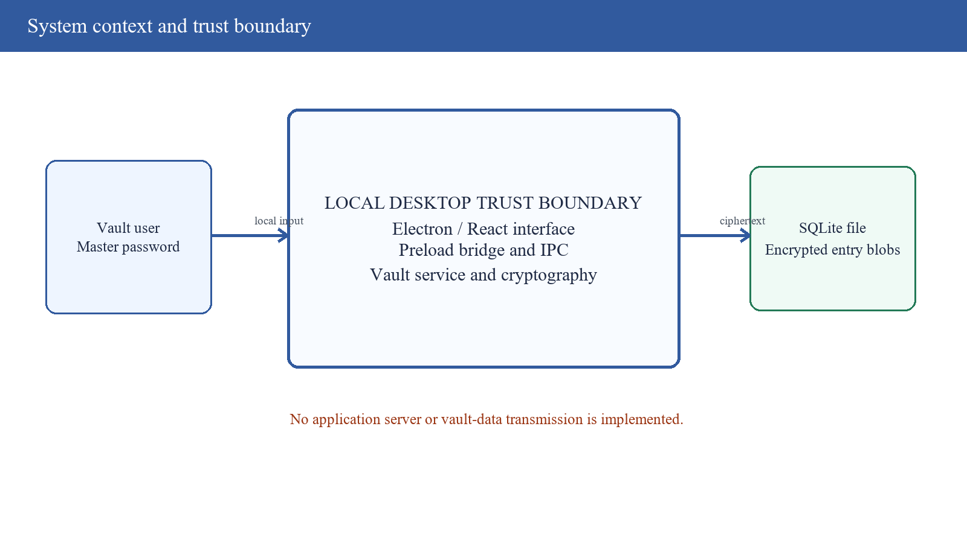
Figure 1.1: System context and local trust boundary

1.2 Problem Statement
Users need a practical way to store unique credentials without leaving reusable plaintext in ordinary files or sending secrets to an untrusted service. Existing manual approaches—browser notes, spreadsheets, notebooks, repeated passwords, or unencrypted exports—can expose multiple accounts when one device or service is compromised. The central technical problem is to convert one master password into an encryption key that is costly to guess, protect each vault record against disclosure and undetected modification, and present the result in a usable desktop application.
The problem is not solved by selecting cryptographic algorithm names alone. PBKDF2 must use a unique salt, a defined pseudorandom function, a suitable iteration count, and a derived-key length appropriate for AES-256. GCM requires unique nonces for a given key and verification of its authentication tag. The desktop boundary must prevent the renderer from directly accessing Node capabilities, validate IPC messages, restrict external content, and respond safely to locking, clipboard, export, import, and password-rotation events [8]–[15].
The project proposal also creates an evidence problem: some planned features and evaluation activities are broader than the repository implementation. A final report must not convert intentions into results. It must distinguish implemented functionality, executed verification, limitations discovered by inspection, and future recommendations. This report addresses that need through traceability from each objective and research question to source modules and observable tests.

1.3 Aim
The aim of the project is to design, implement, and evaluate a cross-platform desktop password manager that derives encryption keys from a master password and protects locally stored vault entries with authenticated client-side encryption.

1.4 Specific Objectives
1. To implement a PBKDF2-based key derivation module generating session encryption keys from a master password to prevent brute-force attacks.
2. To design and implement a client-side AES-256 encryption engine ensuring all vault entries are encrypted before leaving the user's device.
3. To build a cross-platform desktop password vault using Electron and React with zero server-side plaintext exposure, validated through security testing.

1.5 Research Questions
1. How can a PBKDF2 key derivation module be developed to generate session-specific encryption keys that resist brute-force attacks?
2. How can a client-side AES-256 encryption engine be implemented to ensure vault entries are encrypted on the device before any transmission?
3. How can a cross-platform desktop password vault built with Electron and React achieve zero server-side plaintext exposure, as validated through security testing?

1.6 Significance of the Study
The project demonstrates how established primitives can be combined in a small desktop system that students can inspect end to end. It makes the security boundary visible: the master password enters the renderer, the main process derives a session key, the vault encrypts entry JSON, and SQLite persists the ciphertext package. This is more educationally valuable than treating encryption as an opaque database option because the data transformations, parameters, and failure modes can be tested directly.
For users, the prototype offers local credential organization, search, secure random password generation, clipboard clearing, explicit locking, password change, and encrypted backup import/export. For the institution, it provides a concrete case study in secure software development, threat modelling, cryptographic API use, evidence-based reporting, and the difference between a working demonstration and production assurance.
The study is also relevant to privacy and data-protection practice in Zambia. Credentials are personal security data whose compromise can enable access to other personal information. The Zambia Data Protection Act establishes duties around security safeguards and accountability [36]. Although a personal local vault is not automatically a data-controller system, the same principles of confidentiality, minimisation, controlled access, and breach prevention support the design.

1.7 Scope and Delimitations
Included in the implemented scope | Outside the implemented or evaluated scope
Electron desktop shell and React interface | Mobile application and browser extension
Local SQLite vault with per-entry AES-256-GCM | Cloud synchronisation and server-side storage
PBKDF2-HMAC-SHA-256 at 600,000 iterations | Argon2id migration and adaptive benchmarking
Create, read, update, delete, search, copy | Credential autofill and browser integration
Random password generation | Implemented visual password-strength meter
Locking, timed auto-lock control, password change | Persisted auto-lock preference and OS idle integration
Encrypted JSON export/import | Recovery service, account sharing, or versioned backup format
Windows execution evidence | Measured macOS/Linux compatibility, signing, notarisation

Table 1.1: Project scope and delimitations

1.8 Operational Definitions
Term | Meaning in this report
Client-side encryption | Encryption performed by the desktop application before persistent storage or any potential transfer.
Session key | The 32-byte AES key derived after a successful unlock and retained by the main-process vault object until lock.
Zero server-side plaintext exposure | No project server exists and no vault transmission path is implemented; therefore the server side cannot observe application plaintext in the tested architecture.
Authenticated encryption | AES-GCM confidentiality plus integrity verification using an authentication tag.
Verified | Observed in code and confirmed by an executed test or build.
Partial | A relevant component exists, but the objective's full assurance or evaluation requirement is not demonstrated.

Table 1.2: Operational definitions

1.9 Chapter Summary
The project addresses the need for a usable local vault backed by deliberately expensive password-based key derivation and authenticated encryption. Its contribution is a functioning, inspectable prototype; its principal limitation is that a local encrypted database does not by itself prove comprehensive endpoint security or formal zero knowledge. Chapter Two examines the standards, prior research, related products, and conceptual framework that inform this judgement.

CHAPTER TWO: LITERATURE REVIEW
This chapter reviews password-manager usability, password-based key derivation, authenticated encryption, randomness, desktop application isolation, storage, related products, and the legal and secure-development context. Primary standards and official technical sources are favoured over marketing claims.

2.1 Password Management and Human Factors
Bonneau et al. showed that web passwords persist because they combine deployability and usability properties that many stronger schemes do not simultaneously achieve [1]. That persistence creates a practical burden: users are expected to choose and recall many distinct secrets even though memory and attention are limited. A manager changes the task from memorising every credential to protecting one master password and using generated credentials for individual services.
Usability remains part of the security model. Pearman et al. found that people use password managers in varied and sometimes partial ways, including browser storage, manual copying, and selective adoption [5]. Lyastani et al. demonstrated that managers can improve password strength but may also create new failure modes around autofill, migration, and trust [6]. These studies support clear lock state, understandable error messages, safe export behaviour, and password generation that communicates its policy.
A master password is not equivalent to a random 256-bit key. Its effective resistance depends on user choice, attacker knowledge, and KDF cost. Minimum length is only one control; breached-password screening, rate limits for online authentication, user education, and recovery design also matter [2], [3]. In a local vault, database theft converts the problem into offline guessing, so the KDF work factor and password entropy become decisive.
Concentrating credentials in a vault increases the consequence of compromise. Security analyses of commercial managers have identified flaws in bookmarklets, extensions, origin checking, local storage, and memory behaviour [4], [7]. The appropriate conclusion is not that managers are useless, but that their attack surface must be analysed across locked storage, unlock, active use, clipboard, backups, updates, and integration points.

2.2 Password-Based Key Derivation
PBKDF2 is specified in PKCS #5 and NIST SP 800-132 [16], [17]. It repeatedly applies a pseudorandom function to a password and salt, producing a derived key of the requested length. The salt does not need to be secret; it prevents identical passwords from producing identical keys across vaults and prevents useful precomputation against a universal salt. The iteration count increases the cost of each guess for both legitimate users and attackers.
The implementation uses PBKDF2-HMAC-SHA-256, a 16-byte random salt, 600,000 iterations, and a 32-byte output. This matches the OWASP Password Storage Cheat Sheet's PBKDF2-HMAC-SHA-256 work-factor guidance available at the time of review [18]. The exact value is not permanent. Hardware improves, operating environments vary, and an interactive desktop application must balance delay against resistance. The parameter should be versioned and periodically re-benchmarked.
Modern guidance generally prefers memory-hard KDFs such as Argon2id where compatible libraries and deployment constraints permit [19]. Argon2id makes large-scale guessing more expensive by requiring both computation and memory. PBKDF2 remains widely implemented and defensible when required, but its CPU-oriented cost is especially amenable to GPU/ASIC acceleration. The prototype should therefore document PBKDF2 as a compatibility choice and plan a versioned migration path rather than implying that a fixed iteration count prevents brute force absolutely.
The repository calls `pbkdf2Sync` in Electron's main process. The measured derivation time was approximately 481.63 ms on the review machine. This is substantial enough to slow guesses but also blocks the main event loop during derivation. A production version should benchmark target hardware, use an asynchronous API or worker when appropriate, record a KDF version beside the salt, and re-encrypt or rewrap on successful unlock when parameters become obsolete.
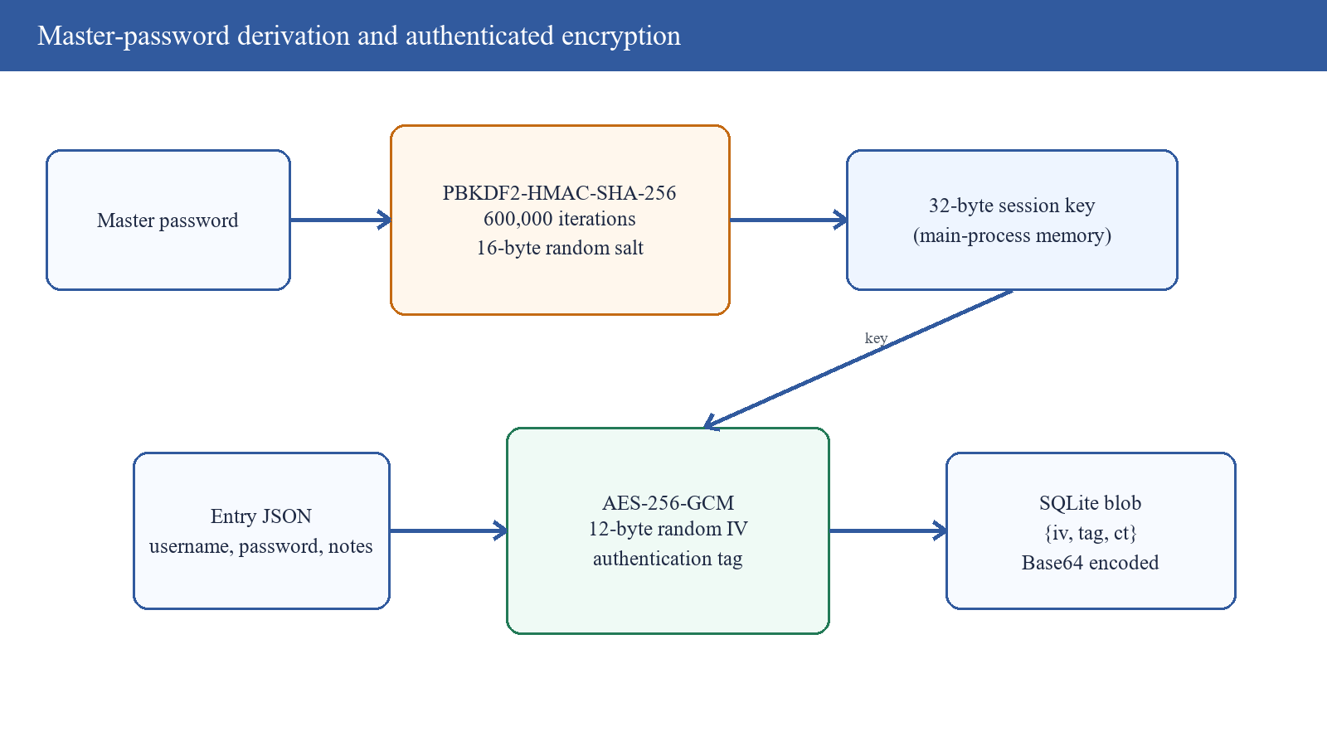
Figure 2.1: Implemented key-derivation and authenticated-encryption flow

2.3 AES-256-GCM Authenticated Encryption
AES is a standard block cipher with 128-bit blocks and key sizes of 128, 192, or 256 bits [20]. A block cipher mode determines how it protects data longer than one block. GCM combines counter-mode encryption with a polynomial authentication function, producing ciphertext and an authentication tag [21]. Successful decryption therefore provides confidentiality and evidence that the protected ciphertext and associated data have not been modified under the key.
Nonce uniqueness is essential. Repeating an IV with the same GCM key can reveal relationships between plaintexts and undermine authentication. NIST recommends a 96-bit IV for efficient standard processing [21]. The implementation generates a fresh 12-byte IV with Node's cryptographic random source for each encryption operation and stores it beside the authentication tag and ciphertext. Random generation makes collision improbable at the project's scale, but large or long-lived systems should enforce volume limits and explicit key-rotation policy.
Authenticated decryption must reject invalid tags before plaintext is trusted. The automated tests confirm that modified ciphertext triggers failure. Node's current API guidance also recommends explicitly constraining expected GCM tag length when decrypting because non-default short tags have security implications [22]. The current code obtains the normal tag from encryption but does not specify `authTagLength` on decryption. Setting and validating 16 bytes would make the contract explicit.
The encrypted object contains base64 encodings of IV, tag, and ciphertext. Base64 is transport encoding, not encryption. Security derives from AES-GCM and key secrecy. The record currently does not authenticate external metadata such as the SQLite row identifier and timestamp as additional authenticated data. A versioned envelope that binds schema version, entry identity, and relevant metadata would reduce ambiguity and substitution risks during future format evolution.

2.4 Cryptographic Randomness and Password Generation
Cryptographic salts, IVs, and generated passwords require an unpredictable random source. NIST DRBG guidance describes mechanisms and entropy requirements for random-bit generation [23]. Node's `crypto.randomBytes` uses the operating system's cryptographic source, and `crypto.randomInt` avoids modulo bias when sampling an integer range [22]. These APIs are appropriate for the prototype's salt, IV, and character selection.
The generator builds a pool from selected uppercase, lowercase, numeric, and symbol sets and independently samples characters. This produces unpredictable selections from the pool but does not guarantee at least one character from every enabled category. Consequently, a request with all categories selected can occasionally yield a password missing one category. The UI also lacks the strength meter promised in the presentation. A revised generator should first choose one character from each required category, fill the remainder uniformly, cryptographically shuffle the result, and report length and estimated search space without presenting entropy estimates as guarantees about user-specific resistance.

2.5 Electron Security Architecture
Electron combines Chromium's renderer model with a privileged Node.js main process. Its security guidance recommends loading only secure content, disabling Node integration for remote content, enabling context isolation and sandboxing, using a restrictive CSP, validating IPC senders, limiting navigation and new windows, avoiding uncontrolled external URL opening, exposing narrow bridge methods, keeping Electron current, and evaluating fuses [10]–[15]. These are system controls, not optional style preferences, because a renderer injection can otherwise become local-code execution.
The project enables `contextIsolation` and disables `nodeIntegration`, and its preload exposes named vault operations instead of raw `ipcRenderer`. These are meaningful strengths. However, no explicit sandbox preference or CSP was found, and IPC handlers do not validate their sender or arguments. The lock callback forwards Electron's event object directly into the renderer callback, a pattern the IPC guidance cautions against because it can expose more capability than intended [13].
The React CSS imports Google Fonts from a remote URL. No credential payload is sent by that stylesheet code, but the request contradicts a strict offline claim, introduces an external dependency and metadata disclosure, and expands the network surface. Bundling fonts locally or using system fonts, then enforcing `default-src 'self'` with carefully chosen directives, would better align behaviour with the local-only architecture.
Electron version maintenance also matters. The repository pins Electron 31.1.0. The report does not infer vulnerability solely from the version number, but official guidance recommends staying on a supported current release [10]. Production distribution should include dependency review, integrity-locked installation, code signing, automatic-update validation, platform notarisation where required, and a release process aligned with the NIST Secure Software Development Framework [34].
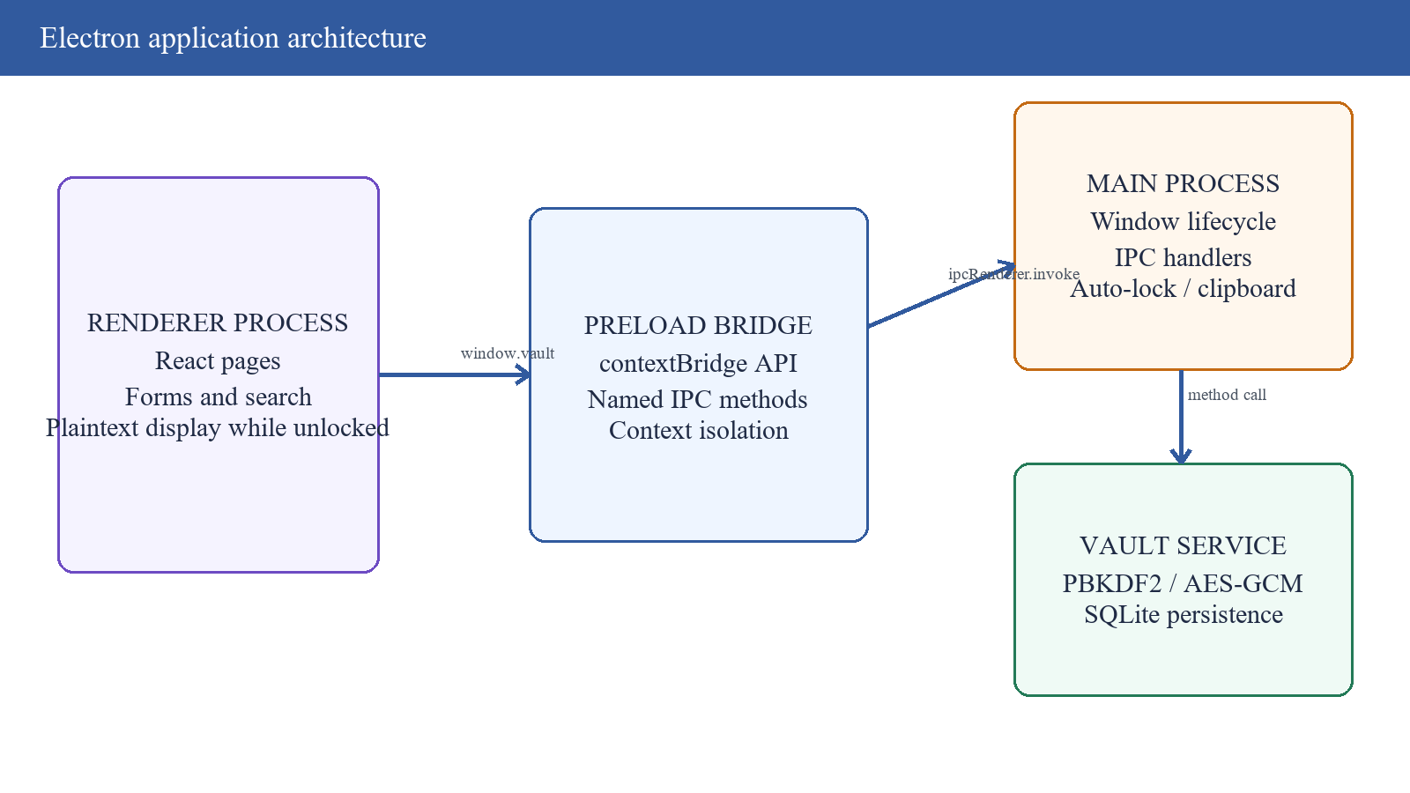
Figure 2.2: Electron process and privilege architecture

2.6 Local Storage, Locking, and Memory
SQLite provides a compact transactional database suitable for local desktop applications. Write-ahead logging permits readers and writers to operate with improved concurrency by appending changes to a WAL file before checkpointing [24]. The project uses `better-sqlite3` and enables WAL mode [25]. The database itself is not SQLCipher-encrypted. Instead, the `entries.blob` value is individually encrypted, while salt, iteration count, verifier, IDs, and timestamps remain visible.
Per-entry encryption provides a clear boundary and supports selective operations after unlock. It also means analysts must include the database, WAL, shared-memory file, backups, temporary files, and exported JSON when assessing residual data. The synthetic smoke test searched known plaintext secrets in the stored entry blobs and did not find them. That narrow result is useful but cannot prove absence from free pages, journals, memory dumps, operating-system swap, crash reports, screenshots, or clipboard history.
The `lock()` method clears the application's reference to the derived key. JavaScript strings and Buffers are managed by the runtime, and dropping a reference is not proof of immediate physical erasure. CWE-316 describes cleartext sensitive data in memory as a weakness [38]. A hardened design should minimise plaintext lifetime, avoid unnecessary copies, overwrite mutable buffers where possible, clear rendered values and clipboard contents, consider OS-provided credential protection, and test memory behaviour on target operating systems.
The clipboard is automatically cleared after 30 seconds, which reduces persistence but does not control clipboard managers, remote-desktop capture, or other local processes. The auto-lock timer is configurable during a session but its value is not persisted. A production design should use OS idle events where available, lock on suspend/session change, persist safe preferences, clear pending timers, and communicate exactly what lock does and does not protect.
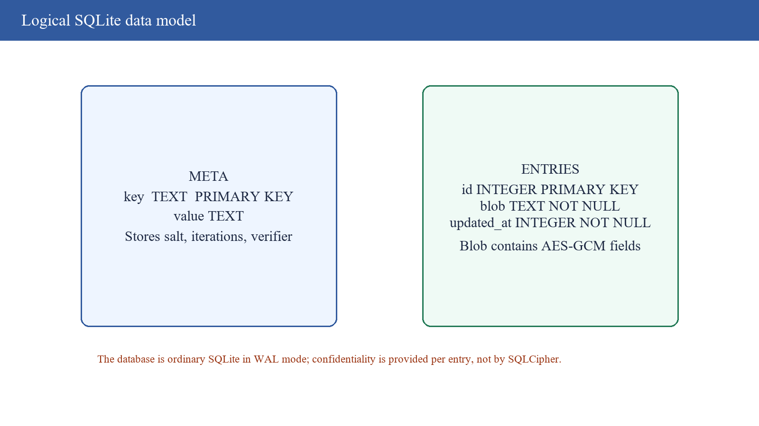
Figure 2.3: Logical data model and encryption boundary

2.7 Related Password Managers
System | General model | Design lesson for this project
KeePass | Local encrypted database | Local-first storage can be transparent and portable, but database/OS protection and safe plugins remain important [41].
Bitwarden | Open-source clients with optional hosted synchronisation | Documented key derivation, encrypted sync, and independent review illustrate the value of a public security architecture [42].
1Password | Encrypted hosted vault with account secret and master password | Adding a high-entropy device/account secret can reduce exposure to weak human passwords after server-data theft [43].
LastPass | Hosted vault service | Public incident disclosures show why backups, metadata, KDF parameters, and user communication must be included in the threat model [44].
This prototype | Local Electron/React vault; no server | Reduced remote exposure and simpler deployment, with unresolved endpoint, memory, IPC, backup, update, and cross-platform assurance.

Table 2.1: Related-system comparison
The comparison is architectural rather than a feature ranking. Mature managers include years of compatibility, import formats, recovery choices, platform integration, audits, operational monitoring, and incident response that are outside this student prototype. Conversely, the project's small local codebase is easier to inspect and demonstrates the core transformation from a password to an authenticated encrypted record.
The most transferable lesson is that security documentation must define trust boundaries and recovery assumptions. A local-only vault transfers responsibility to the device owner and backup process. A hosted vault introduces authentication, account recovery, synchronisation, and server compromise. Neither model is inherently risk free; each requires evidence that its implementation and operational controls match its claims.

2.8 Threat Modelling and Secure Development
STRIDE provides a practical vocabulary for examining spoofing, tampering, repudiation, information disclosure, denial of service, and elevation of privilege [33]. Applied here, spoofing concerns weak master-password acceptance; tampering concerns database and import manipulation; repudiation concerns the absence of audit records; disclosure concerns memory, clipboard, backups, CSS requests, and screenshots; denial of service concerns oversized imports and synchronous KDF work; elevation concerns IPC abuse and renderer compromise.
A threat model is useful only when connected to requirements and verification. NIST SSDF recommends preparing the organisation, protecting software, producing well-secured software, and responding to vulnerabilities [34]. OWASP ASVS supplies testable application-security requirements, though some web-server controls do not directly apply to a local desktop vault [35]. The project should derive desktop-specific acceptance tests rather than cite these frameworks generically.
Product quality also includes reliability, performance efficiency, usability, maintainability, portability, and compatibility in addition to security [31]. Accessibility guidance such as WCAG 2.2 is web-oriented but relevant to Electron renderers for keyboard access, focus visibility, labels, contrast, error identification, and zoom [32]. These quality dimensions inform the evaluation framework in Chapter Three.
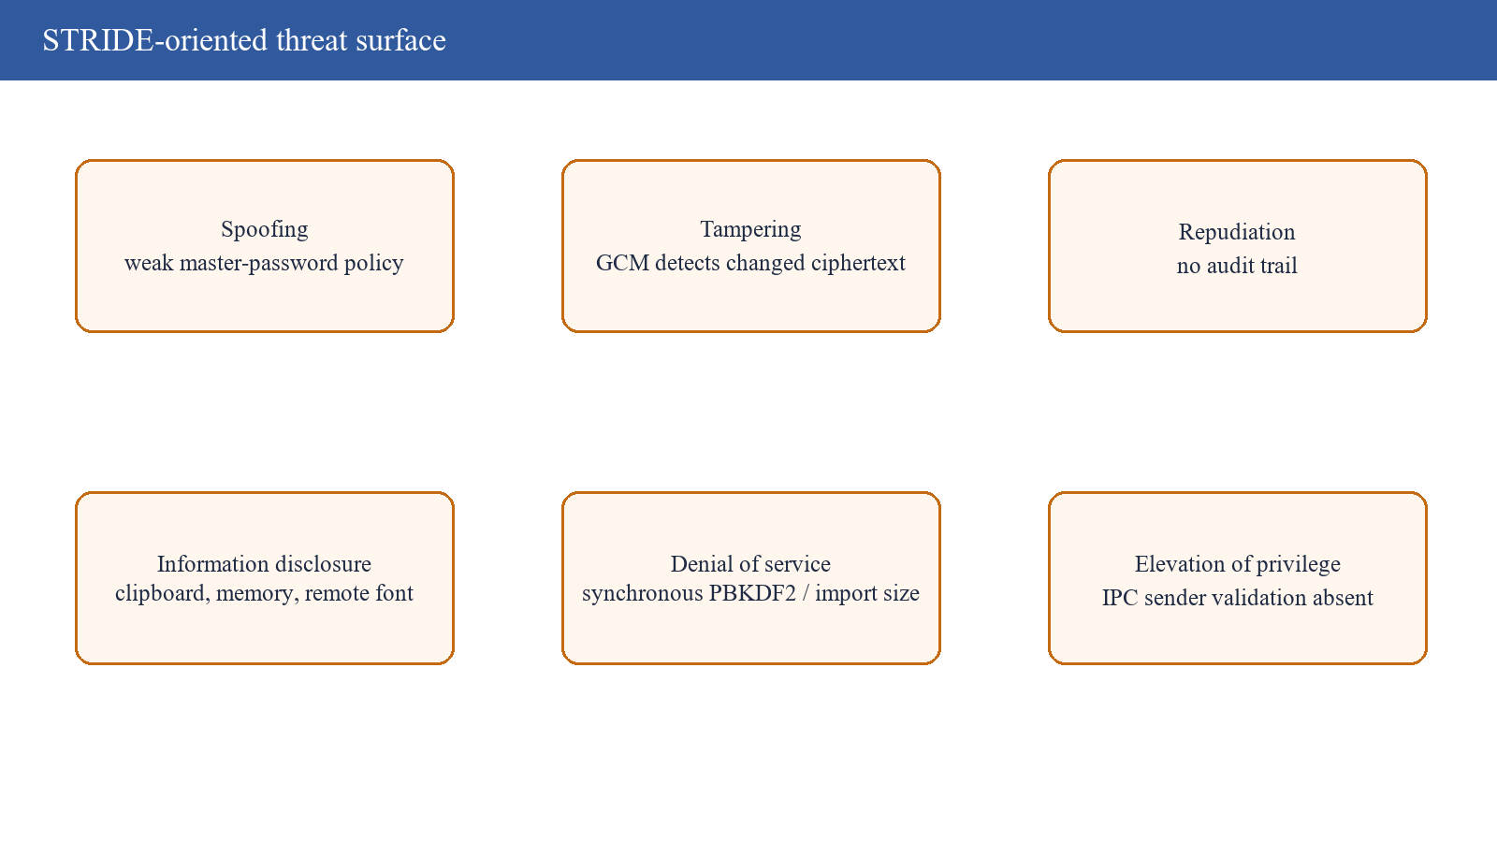
Figure 2.4: STRIDE-oriented threat surface for the prototype

2.9 Conceptual Framework
Input | Mechanism | Immediate output | Evaluation concern
Master password + random salt | PBKDF2-HMAC-SHA-256 | 32-byte session key | Guess cost, parameter version, latency
Entry JSON + key + random IV | AES-256-GCM | Ciphertext + tag | Confidentiality, tamper rejection, IV uniqueness
Renderer action | Preload bridge and IPC | Vault-service request | Privilege boundary, validation, CSP
Encrypted record | SQLite/WAL persistence | Local vault | Artifacts, backups, durability, lifecycle
Implemented controls | Tests, build, smoke scenario | Evidence | Coverage, reproducibility, unsupported claims

Table 2.2: Conceptual input–process–output framework

2.10 Literature Gap and Chapter Summary
The literature explains cryptographic primitives, password usability, desktop isolation, and known manager failures, but a student project still needs to translate them into a bounded implementation and honest evaluation. The repository's distinctive value is not a new cipher; it is the integration of established controls in a transparent local application. The research gap addressed is therefore applied: how closely does a compact Electron implementation conform to the security properties implied by its objectives, and what remains before those properties can be claimed responsibly?
The review supports PBKDF2 as an implemented compatibility KDF while favouring a future Argon2id migration, AES-GCM with unique 96-bit IVs and explicit tag validation, a minimal Electron bridge with layered isolation, and evidence across storage, memory, interface, export, packaging, and usability. Chapter Three converts these findings into the research and system-development method.

CHAPTER THREE: RESEARCH METHODOLOGY AND SYSTEM DESIGN
This chapter describes the evidence-centred case-study method, requirements analysis, development process, architecture, data design, cryptographic workflow, threat model, and test procedure used to evaluate the submitted implementation.

3.1 Research Design
The study used an implementation-centred design-science case study. The artefact is the Electron password manager; the evaluation question is whether its observable design and behaviour support the official objectives and research questions. This method is appropriate because the core contribution is a working system and because security claims can be checked against source code, repeatable execution, and established standards rather than inferred from participant opinion alone.
Evidence was triangulated from six sources: the proposal and repaired presentation for intended scope; the repository for implemented behaviour; automated tests for selected cryptographic properties; the production build for deployable renderer syntax and bundling; a synthetic vault scenario for persistence and lifecycle behaviour; and interface captures for user-visible implementation. External standards and peer-reviewed literature supplied criteria, not proof that the project met those criteria.
The proposal mentioned interviews, surveys, and broader security testing. No participant dataset, ethics record, questionnaire results, raw security-tool output, or cross-platform execution record was found. These activities are therefore not reported as completed. The methodology distinguishes documentary intention from executed evidence to protect the validity of the conclusions.

3.2 Development Approach
The project structure is consistent with an iterative Agile approach: the user interface, main process, preload bridge, vault service, and tests are separate modules that can be developed incrementally [30]. Security-critical choices were concentrated in `crypto.js` and `vault.js`, allowing focused test cases. However, no sprint records, issue history, or retrospective evidence accompanied the repository, so the report describes the approach as inferred modular iteration rather than claiming measured Agile process performance.
A security-first iteration should begin with assets and threats, define abuse cases, implement the smallest control, add a negative test, and review the trust boundary before expanding features. For this project, the natural increments are initialise/unlock; encrypted CRUD; lock/clipboard; password generation; master-password rotation; and backup import/export. Each increment should include error behaviour and migration rules, not only the successful UI path.

3.3 Functional Requirements
ID | Requirement | Repository status
FR-01 | Create a vault using a master password | Implemented
FR-02 | Unlock only with the correct master password | Implemented; automated/smoke evidence
FR-03 | Create, list, search, update, and delete entries | Implemented; UI/source evidence
FR-04 | Encrypt every persisted vault entry | Implemented; blob inspection on synthetic entries
FR-05 | Generate random passwords with selected categories | Implemented; no category guarantee/strength meter
FR-06 | Copy values and clear clipboard automatically | Implemented; 30-second timer
FR-07 | Lock explicitly and after configured inactivity | Implemented during session; preference not persisted
FR-08 | Change master password and re-encrypt entries | Implemented; smoke evidence
FR-09 | Export and import an encrypted backup | Implemented; unsafe empty-passphrase default
FR-10 | Operate across supported desktop platforms | Electron design supports it; only Windows executed

Table 3.1: Functional requirements and implementation status

3.4 Non-Functional Requirements
Quality | Requirement | Measure used or required
Security | No plaintext vault records at rest; tamper/wrong-password rejection | Automated crypto tests and synthetic blob scan
Performance | Unlock delay tolerable on target devices | Single-machine derivation timing; broader benchmark required
Usability | Clear create, unlock, vault, entry, and settings flows | UI inspection; participant study required
Reliability | Transactions preserve the vault during rotation/import | Smoke path passed; interruption/fault injection absent
Portability | Electron/React application builds for major desktops | Renderer build passed on Windows; packaging matrix absent
Maintainability | Crypto, vault, bridge, and views remain modular | Source-structure review and testability
Accessibility | Keyboard, labels, focus, contrast, zoom | Not formally audited

Table 3.2: Non-functional requirements and evaluation measures

3.5 System Architecture
The renderer is responsible for presentation and transient user interaction. It calls methods on `window.vault` rather than importing database or cryptography modules. The preload bridge maps those methods to named IPC channels. The main process owns privileged Electron functionality and delegates vault operations to the vault service. This separation is appropriate because renderer content is comparatively exposed to injection and should not possess direct Node access.
The vault service maintains one database connection and an in-memory derived key reference. Before unlock, methods that require plaintext reject access. On successful password verification, the key reference permits entry decryption. Locking removes the reference. This state model is simple and auditable, though it needs stronger treatment of key lifetime, renderer plaintext, suspend events, multiple windows, and application crashes.
There is no network API, user account, authentication server, administrator role, or remote database in the repository. Statements about server-side zero knowledge must therefore be read as an absence-of-server property. A future synchronisation feature would fundamentally change the threat model and require authenticated clients, record versioning, conflict resolution, encrypted metadata policy, recovery design, transport security, and protocol review.

Figure 3.1: Implemented logical architecture

3.6 Database Design
The database contains `meta` and `entries` tables. `meta` maps keys to values and stores the KDF salt, iteration count, and encrypted verifier. `entries` stores an integer identifier, encrypted blob, and update timestamp. Entry fields are not individually queryable while locked; search therefore occurs after decryption in the application. This is a reasonable confidentiality trade-off for a small local vault.
The verifier is an AES-GCM encryption of a fixed value under the derived key. Unlock derives a candidate key and attempts to decrypt the verifier. This avoids storing a password hash separately but means the verifier is itself an offline-guessing target, as any encrypted vault must provide some way to recognise a correct guess. Security therefore rests on master-password quality and KDF cost, not on hiding the verification mechanism.
During master-password change, the application decrypts entries with the current key, derives a new key using a new salt, and rewrites encrypted records in a transaction. Transactional use is important because partial re-encryption could make the vault unrecoverable. Future versions should test forced termination, full disks, corrupted rows, and rollback, and should keep a recoverable backup or journal strategy before destructive format migration.

Figure 3.2: SQLite tables and protected fields

3.7 Detailed Cryptographic Design
Parameter | Implemented value | Rationale and limitation
KDF | PBKDF2-HMAC-SHA-256 | Standard and available; not memory hard
Iterations | 600,000 | Matches cited OWASP guidance; should be benchmarked/versioned
Salt | 16 random bytes | Unique per vault; stored in metadata
Derived key | 32 bytes | AES-256 key length
Cipher | AES-256-GCM | Authenticated confidentiality
IV | 12 random bytes per encryption | NIST-recommended GCM length; collision policy not explicit
Tag | Node-generated GCM tag | Tamper rejection tested; expected 16-byte length should be explicit
Envelope | JSON with base64 iv/tag/ct | Portable but unversioned; metadata not bound as AAD

Table 3.3: Implemented cryptographic parameters
Initialisation generates a salt and derives the first key. It then creates the encrypted verifier and stores the iteration count. Unlock reads those metadata values, derives a candidate key, and accepts it only if authenticated verifier decryption yields the expected constant. Entry encryption serialises the complete record, generates a new IV, encrypts, and stores the three ciphertext-envelope fields. Entry decryption reconstructs the cipher, assigns the authentication tag, decrypts, and parses JSON.
The design achieves key separation only at the level of a unique IV per entry; the same derived key encrypts the verifier, entries, and exported material in their relevant contexts. A more extensible design could derive subkeys with a labelled HKDF step after the master KDF, separating verifier, vault-entry, export, and metadata authentication purposes. That is a recommendation, not an implemented feature.

3.8 User Interaction and Sequence Design
On first launch, the user creates and confirms a master password. On later launches, the unlock page submits the master password through the preload API. The vault service reads KDF metadata, derives and verifies the key, and returns success or an error. After unlock, the React application requests decrypted entries for display and supports search and editing. Plaintext necessarily exists in the renderer during active use; renderer isolation therefore remains a critical security control.
The application sends a lock notification so the renderer can return to the locked state. The preload listener should transform the event into plain data and return an unsubscribe function, rather than exposing the Electron event object. All IPC calls should validate types, lengths, IDs, file paths, and the sender frame before privileged work. These checks are especially important because renderer validation can be bypassed by injected code.
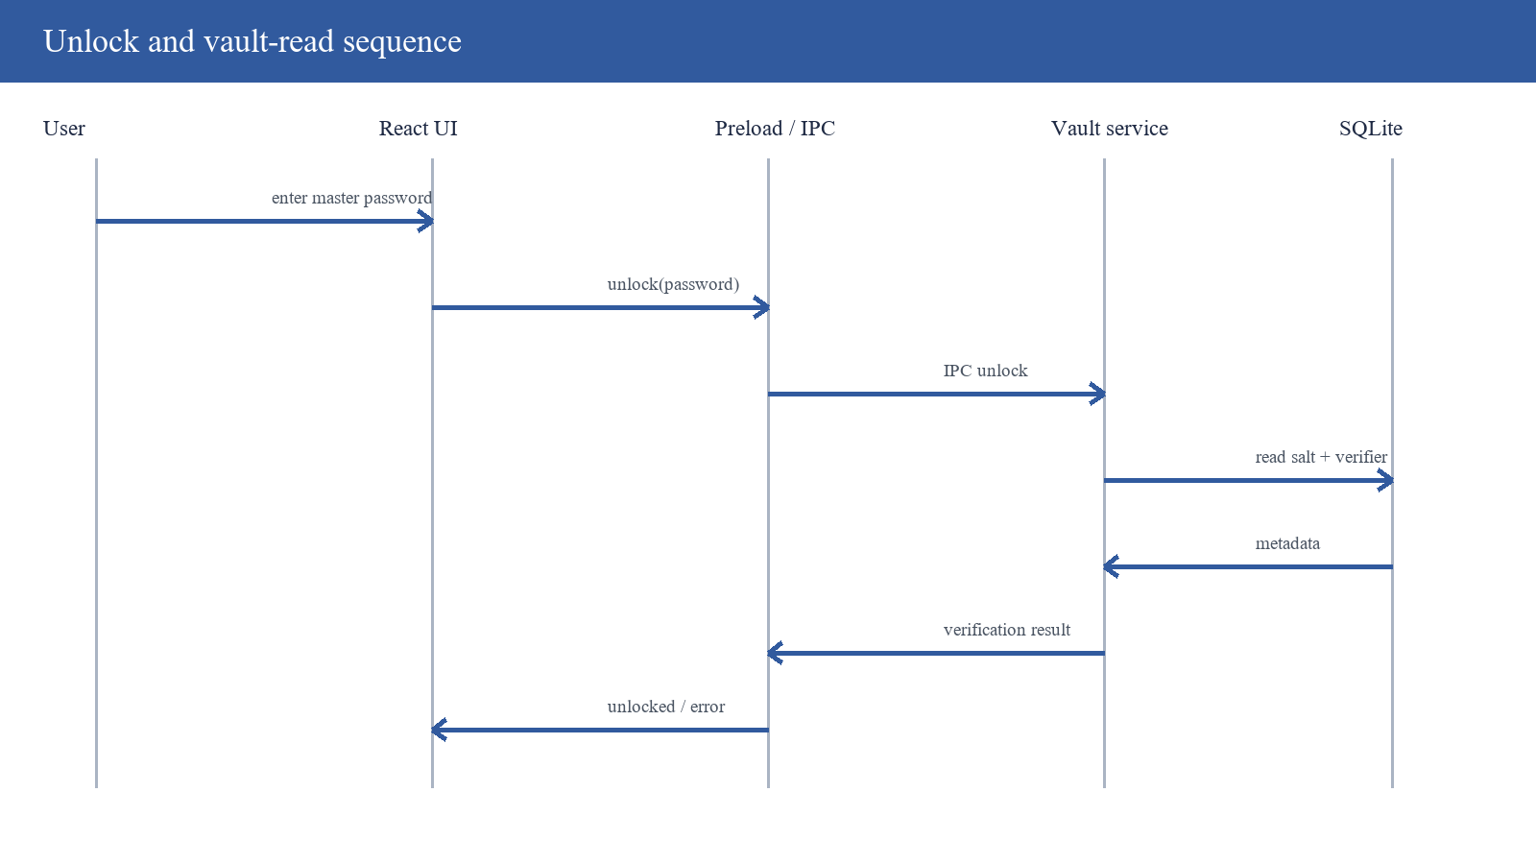
Figure 3.3: Unlock request and verification sequence

3.9 Threat Model and Security Controls
Threat | Existing control | Residual risk / required control
Offline master-password guessing | 600k PBKDF2, random salt | Weak passwords; add main-process policy, breached-list checks, Argon2id migration
Ciphertext tampering | AES-GCM tag; rejection test | Bind record metadata and envelope version as AAD
Renderer compromise | Context isolation; Node integration disabled | Add sandbox, CSP, navigation controls, sender/argument validation
Local memory disclosure | Explicit lock drops key reference | Minimise/overwrite buffers; test dumps, swap, suspend and crash behaviour
Clipboard exposure | Automatic clear after 30 seconds | Clipboard managers/other processes; configurable shorter window and direct typing
Backup disclosure | Encrypted export | No mandatory passphrase; default `changeme` when empty must be removed
Malicious import | Authenticated decryption | Validate size/schema/version; deduplicate; treat paths/data as untrusted
Supply-chain/update compromise | Lockfile and modular dependencies | Supported Electron, audit, signing, verified updater and SBOM

Table 3.4: Threats, controls, and residual risk

Figure 3.4: STRIDE threat analysis

3.10 Evaluation Procedure
1. Inspect the proposal, presentation, source tree, dependency manifest, renderer, preload, main-process, cryptographic, persistence, and test modules.
2. Execute the repository's `node:test` suite with the bundled compatible runtime and record pass/fail counts and duration.
3. Build the renderer with Vite in production mode and record modules, sizes, duration, and warnings.
4. Run a synthetic vault scenario under the project's Electron-compatible native-module ABI: initialise, add entries, scan stored blobs for known plaintext, lock, test wrong/correct passwords, rotate the master password, export, and import.
5. Launch the real Electron/React interface against a temporary database and capture first-run, populated-vault, entry-form, and settings states.
6. Compare evidence with the official objectives, research questions, NIST, OWASP, Electron, Node, SQLite, accessibility, and secure-development guidance.
7. Classify each conclusion as achieved, partially achieved, not implemented, or not evaluated; avoid treating absence of a failing test as proof of complete security.

3.11 Validity, Ethics, and Data Handling
Construct validity was improved by defining terms such as zero server-side exposure and verified before evaluation. Internal validity was improved by using synthetic entries with recognisable sentinel secrets and by testing lock, wrong-password, rotation, and import behaviour in sequence. Reproducibility is supported by recording parameters, commands, tool outputs, and implementation paths. External validity remains limited because one Windows host was used and no participant or adversarial penetration study was conducted.
No real credentials or participant personal data were used. Screenshots contain synthetic demonstration entries, and temporary databases are retained only in the isolated report work area. The report avoids publishing actual secrets or representing a teaching prototype as production-ready. If future usability research involves people, the team should obtain institutional approval, informed consent, data-minimisation arrangements, and a plan for secure deletion.

3.12 Chapter Summary
The method evaluates the artefact through traceable documentary, code, execution, and interface evidence. It defines functional and non-functional requirements, documents the actual local architecture, identifies trust-boundary risks, and explicitly limits the conclusions to the tested Windows environment and synthetic data. Chapter Four reports the results.

CHAPTER FOUR: IMPLEMENTATION, RESULTS, AND DISCUSSION
This chapter presents the implemented interface and modules, executed test and build results, the synthetic vault scenario, objective traceability, and an evidence-based discussion of security strengths and limitations.

4.1 Implementation Overview
Layer | Principal files | Responsibility
Electron main | src/main/index.js | Window, IPC, timers, clipboard, file dialogs
Cryptography | src/main/crypto.js | PBKDF2, AES-GCM, verifier, random passwords
Vault/persistence | src/main/vault.js | Schema, state, CRUD, rotation, export/import
Preload | src/preload/index.js | Context-isolated renderer API
Renderer | src/renderer/** | Initialise, unlock, vault, entry form, settings
Tests | tests/crypto.test.js | Five cryptographic and generator checks

Table 4.1: Implemented layers and source modules
The application starts a 1024×720 BrowserWindow, loads the renderer, and enables context isolation while disabling Node integration. It selects a database within Electron's application data directory. The main process registers IPC handlers for status, initialise, unlock, list, save, delete, copy, generate, settings, password change, export, import, and lock-related behaviour. The preload translates these channels into a method-oriented API.
The React application presents three principal states: initial vault creation, unlock, and the populated vault workspace. Entries can be searched and edited. Settings include master-password change, auto-lock selection, export, and import. The implementation is cohesive enough for a demonstration, although several controls depend on renderer-side validation and the settings are not all persisted.

4.2 First-Run Vault Creation
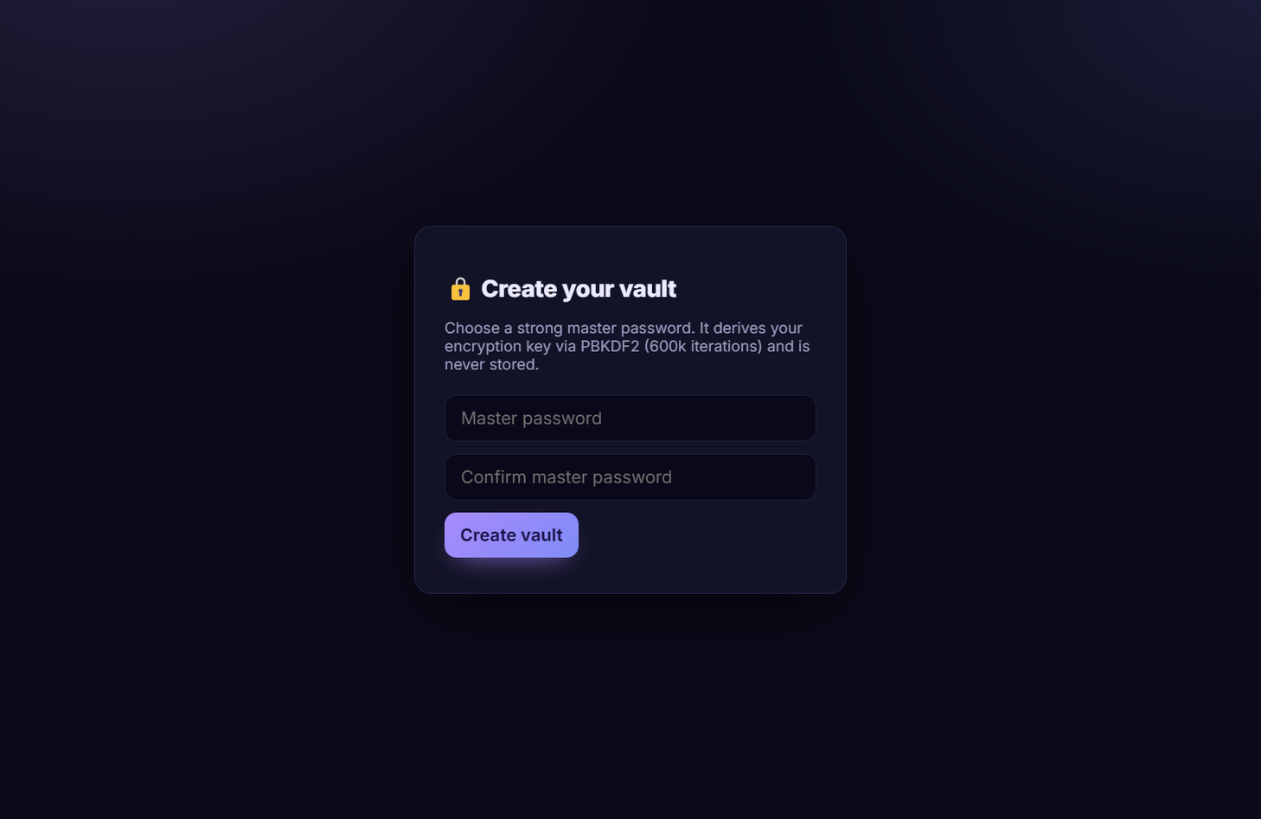
Figure 4.1: First-run master-password creation screen
The first-run screen explains that encryption is local and asks for a master password and confirmation. Renderer validation enforces a minimum of eight characters and equality before invoking initialisation. The interface is visually clear and does not expose unrelated privileged controls.
The minimum is not enforced in the main-process vault API. Injected renderer code or a future alternate client could bypass the check and initialise with a weak or empty password. Because the master password is the root of offline-guess resistance, validation belongs at the privileged boundary as well as in the UI. Eight characters is also a low assurance threshold for an offline encrypted vault; a longer passphrase policy and strength feedback are preferable [2], [18].

4.3 Vault Workspace and Entry Management
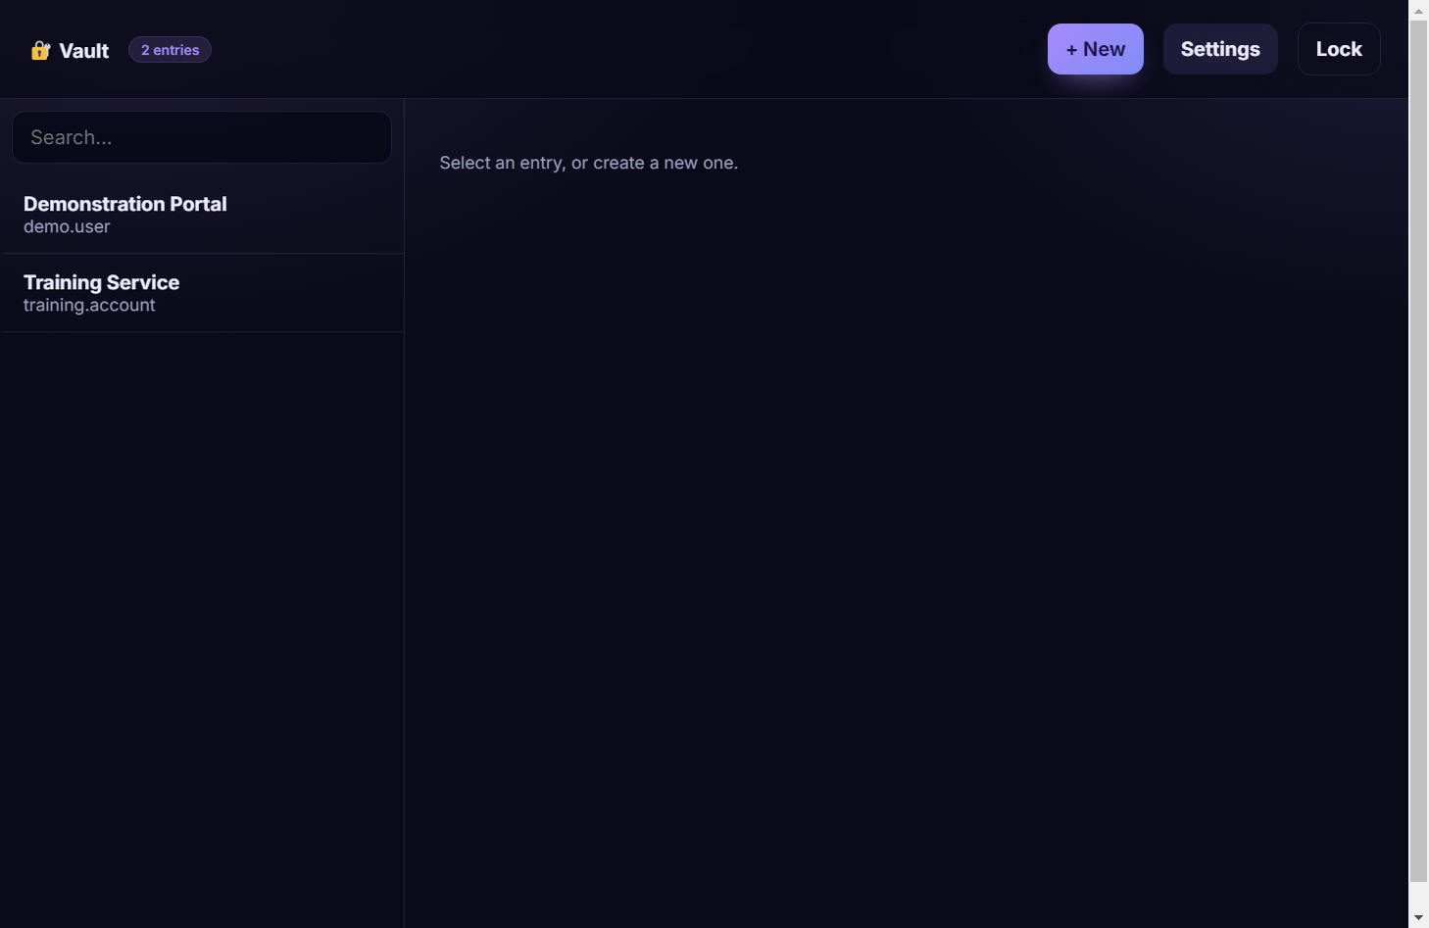
Figure 4.2: Populated vault and search workspace
The workspace displays synthetic credential entries after unlock and provides search, add, edit, copy, settings, and lock controls. Search occurs over decrypted entry objects, which avoids plaintext indexes in SQLite. Copy actions are routed to the main process, where a timer clears the clipboard after 30 seconds.
Displaying usernames and passwords necessarily places plaintext in renderer memory. Context isolation reduces but does not eliminate risk from renderer injection, extensions, Chromium vulnerabilities, screen capture, accessibility APIs, or local malware. The interface should mask password values by default, use explicit reveal with a short timeout, minimise DOM residency, and lock or hide sensitive content when the window loses trust-relevant state.

4.4 Entry Form and Password Generator
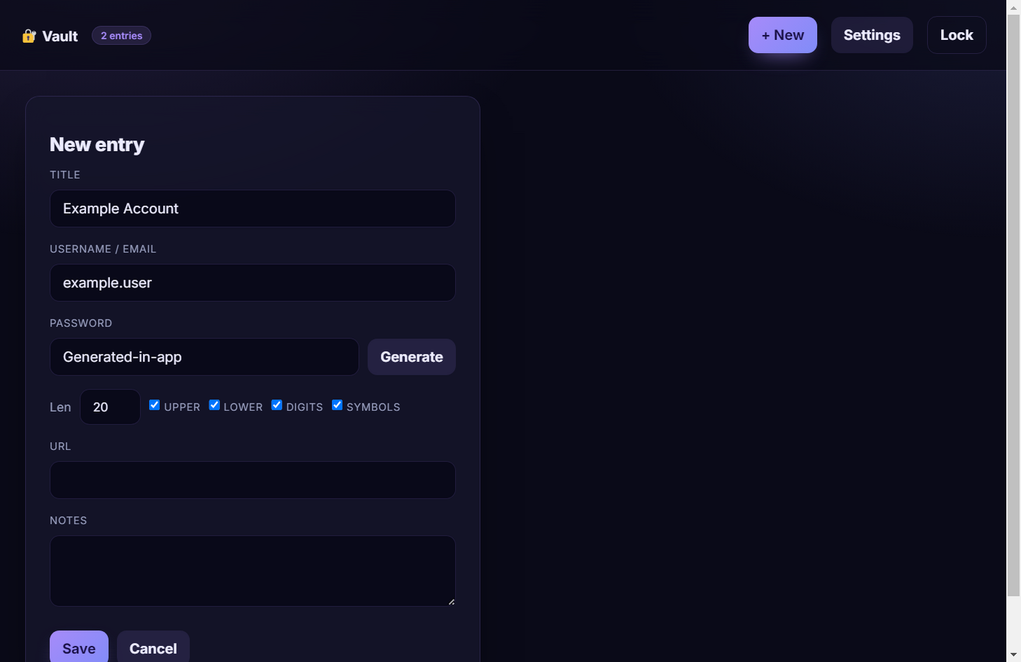
Figure 4.3: Credential entry form and generator controls
The entry form collects title, username, password, website, and notes and offers a password-generation action. The cryptographic generator uses `randomInt`, which is preferable to `Math.random` for secrets. Users can select character categories and length through the settings exposed by the application.
Two gaps affect the stated scope. First, no password-strength meter is implemented even though the presentation lists one. Second, pooling selected categories does not guarantee representation from each category. These are functional limitations rather than failures of the random source. A corrected generator and tested strength indicator should be added without retaining generated values in logs or analytics.

4.5 Settings, Locking, Rotation, and Backup
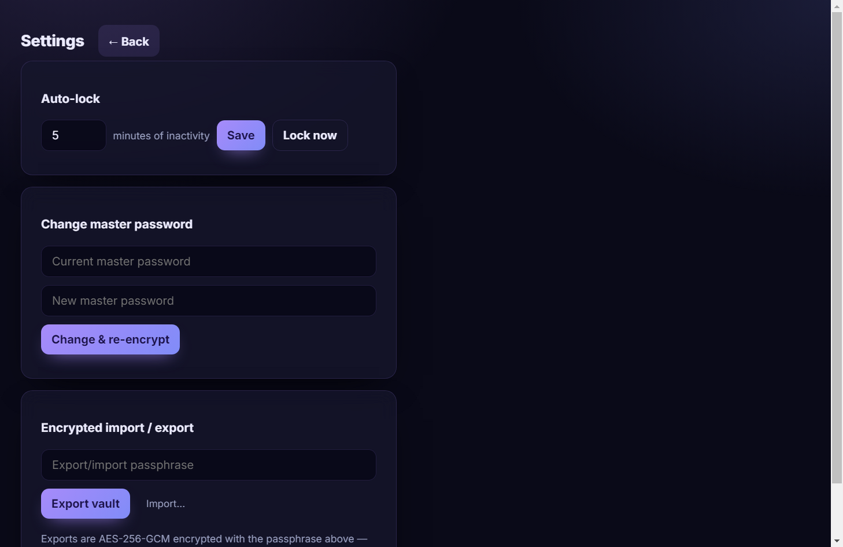
Figure 4.4: Security settings, rotation, and backup interface
The settings view exposes auto-lock timing, master-password change, and encrypted export/import. Password rotation passed in the synthetic smoke test: the old password was rejected and the new password accepted after re-encryption. This is a significant functional result because it exercises derivation, decryption, transaction handling, re-encryption, metadata replacement, and later unlock.
The change-password path does not enforce confirmation or minimum length at the privileged boundary. The most serious backup issue is that an empty export/import passphrase silently becomes `changeme`. Users can therefore believe they created a protected backup while receiving a widely guessable default. The application should require an explicit non-empty high-quality passphrase, confirm it on export, version and authenticate the envelope, show recovery consequences, and never substitute a known fallback.
Import decrypts records but performs limited schema and size validation, assigns new local IDs, and can create duplicates. A malicious or accidentally huge file could cause resource problems. A safer process would validate a versioned top-level structure, cap bytes and record counts, validate every field, preview additions and conflicts, and perform the operation transactionally after explicit confirmation.

4.6 Automated Test Results
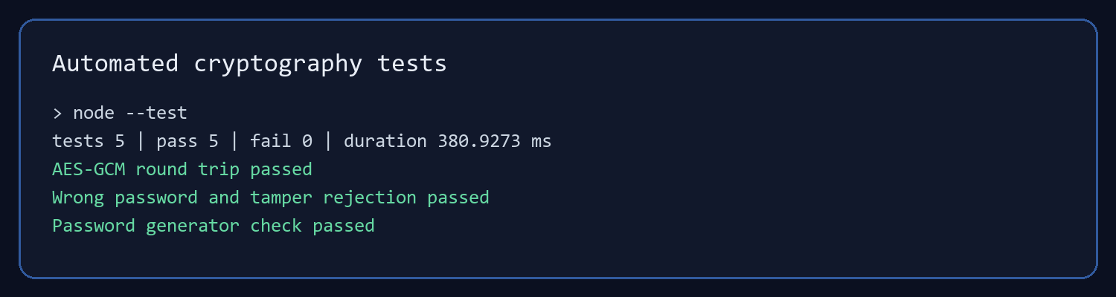
Figure 4.5: Executed automated-test result
Test concern | Observed result | Interpretation
AES-GCM round trip | Passed | Correct key reconstructs original test value
Wrong-password derivation/verifier | Passed | Incorrect master password is rejected
Verifier behaviour | Passed | Fixed verification payload can be authenticated
Ciphertext tampering | Passed | Modified protected data fails authenticated decryption
Password generator | Passed | Expected length/allowed-set property tested

Table 4.2: Repository automated-test outcomes
The direct `node --test` execution completed five tests with five passes, no failures, and a total duration of 380.9273 ms. The tests provide credible evidence for basic primitive integration and negative behaviour. In particular, tamper rejection demonstrates a key reason for choosing authenticated encryption instead of unauthenticated AES modes.
Coverage is narrow. There are no automated tests for database transactions, lock-state access, IPC validation, renderer flows, clipboard clearing, auto-lock, master-password rotation, import/export validation, crash recovery, accessibility, or package installation. The smoke scenario supplements several of these paths but is not part of the repository suite. A production claim would require much broader unit, integration, UI, property, fuzz, and adversarial testing.

4.7 Production Build Result
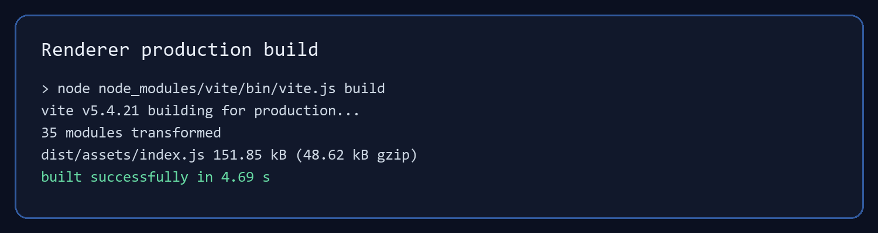
Figure 4.6: Executed Vite production-build result
The renderer production build succeeded with Vite 5.4.21. It transformed 35 modules and produced approximately 151.85 kB of JavaScript (48.62 kB gzip), 3.06 kB of CSS (1.29 kB gzip), and a small HTML shell in 4.69 seconds. The result confirms that the renderer source is syntactically and bundler compatible in the tested environment.
A renderer build is not the same as a signed desktop release. No executed Electron packaging, installer, macOS notarisation, Linux package, update-signature, or clean-machine installation evidence was available. The build emitted a Vite warning about the deprecated CJS Node API; the configuration should be modernised during dependency maintenance.

4.8 Synthetic Vault Smoke-Test Result
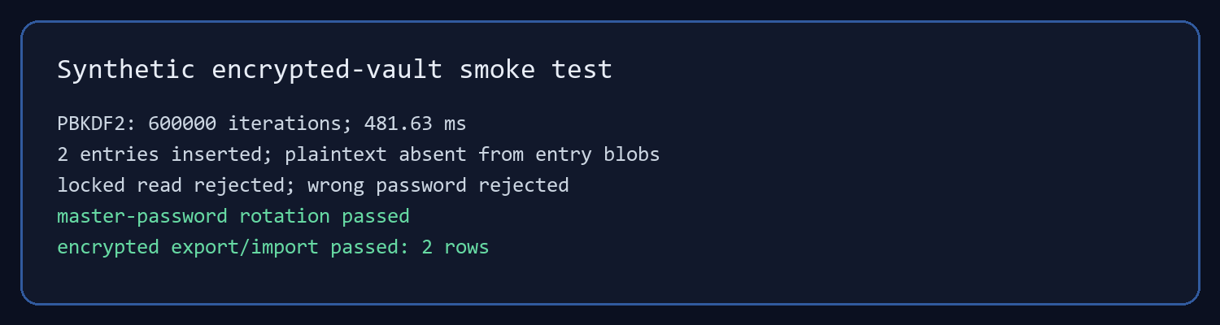
Figure 4.7: Synthetic end-to-end vault smoke-test result
Check | Result
Configured iterations | 600,000
Measured derivation on review host | 481.63 ms
Synthetic entries inserted / encrypted rows | 2 / 2
Known plaintext absent from entry blobs | True
Read while locked rejected | True
Wrong password rejected | True
Correct password accepted | True
Old password rejected after rotation | True
New password accepted after rotation | True
Encrypted export produced | True
Imported records | 2

Table 4.3: Synthetic vault scenario results
The scenario used only synthetic demonstration values and a temporary database. Because `better-sqlite3` is a native module compiled for Electron's Node ABI, the smoke script ran through the project's Electron binary in `ELECTRON_RUN_AS_NODE` mode. This is an environmental compatibility detail, not a test failure.
The plaintext scan was deliberately narrow: it checked the stored entry blob text for two known secrets. Passing supports the claim that the application does not place those entry JSON values directly in the `entries` table. It does not establish whole-disk forensic absence. SQLite WAL pages, deleted records, backups, virtual memory, crash dumps, UI memory, and clipboard systems require separate investigation.

4.9 Security Configuration Findings
Finding | Evidence | Assessment
Context isolation enabled | BrowserWindow webPreferences | Implemented strength
Node integration disabled | BrowserWindow webPreferences | Implemented strength
Narrow preload API | Method-per-channel contextBridge | Implemented strength; lock event wrapper should be safer
No explicit renderer sandbox | Main-process configuration | High-priority hardening gap
No CSP in HTML | Renderer index/source | High-priority injection mitigation gap
No IPC sender/argument validation | IPC handler inspection | High-priority privilege-boundary gap
Remote Google Fonts import | Renderer CSS | Contradicts strict offline model; remove/bundle
Default backup passphrase | Export/import implementation | Critical usability-security defect
Key reference removed on lock | Vault state | Useful but not proof of memory erasure
No secret logging observed | Source inspection | Positive; runtime/third-party logging still untested

Table 4.4: Security configuration findings

4.10 Objective Evaluation
Objective | Evidence | Judgement
1 — PBKDF2 session key | PBKDF2-HMAC-SHA-256, 600k, random salt, 32-byte key; tests and 481.63 ms measurement | Achieved as an implementation; ‘prevent’ brute force is too absolute and resistance is not benchmarked across attackers
2 — client-side AES-256 | AES-256-GCM per record, fresh 12-byte IV, tag, tamper test, blob scan | Substantially achieved for local persistence; there is no transmission path and whole-device plaintext absence is unproven
3 — cross-platform Electron/React vault | Working Electron/React UI, production renderer build, no server, security tests | Partially achieved: only Windows executed; security suite is narrow; zero knowledge is architectural wording, not formal proof

Table 4.5: Objective achievement matrix

4.11 Answers to the Research Questions

4.11.1 Research Question One
A PBKDF2 module can derive a session key by combining the master password with a unique random salt, HMAC-SHA-256, a deliberately high and versioned work factor, and a 32-byte output. The project implements this pattern at 600,000 iterations and verifies the result through an authenticated encrypted constant. It resists guessing by increasing the cost per attempt, but it cannot prevent brute force against a weak password. Resistance should be measured on representative hardware and improved over time, preferably through a memory-hard Argon2id migration.

4.11.2 Research Question Two
A client-side AES-256 engine can protect each entry by serialising it, generating a new 96-bit IV, encrypting with AES-256-GCM, retaining the authentication tag, and persisting only a versioned encoded envelope. The implementation performs these core steps, and the tamper test plus synthetic blob scan support them. The current application has no vault transmission feature, so the phrase before any transmission is satisfied only vacuously; a future sync feature would need protocol-level verification.

4.11.3 Research Question Three
Electron and React can implement a cross-platform local vault by keeping privileged cryptography and storage in the main process, exposing a narrow context-isolated bridge, disabling renderer Node integration, and storing authenticated ciphertext in SQLite. The submitted vault demonstrates that architecture and has no server-side plaintext because it has no server. Full validation requires macOS/Linux execution, sandbox/CSP/IPC hardening, broader negative tests, packaging assurance, memory analysis, accessibility checks, and user evaluation.

4.12 Discussion
The strongest result is internal consistency across the core cryptographic path. Source inspection shows standard primitives and appropriate sizes; automated tests show correct round trips and rejection; and the synthetic database contains ciphertext envelopes rather than the two known plaintext secrets. This is stronger evidence than a proposal claim alone and supports the project as a successful educational prototype.
The most important gap is the difference between encrypted storage and secure application operation. While unlocked, secrets exist in the renderer and main process. The clipboard intentionally exposes a value to the operating system. Import/export accepts files chosen by the user. The renderer lacks an explicit CSP and sandbox, IPC trust is not validated, and a remote font request remains. These are normal areas for hardening, but they prevent a claim of complete zero-knowledge security.
The default backup passphrase deserves immediate correction because it creates a mismatch between user expectation and cryptographic reality. AES-GCM can be perfectly implemented and still provide little practical protection if its key derives from the public word `changeme`. This finding illustrates a broader principle from the literature: security is a system property connecting user choices, API boundaries, cryptography, storage, and recovery.
The project also needs assurance proportional to its portability claim. Electron makes source portability plausible, but native modules, file paths, keychain integration, packaging, signing, permissions, window behaviour, and suspend/resume differ by operating system. Only a test matrix can convert cross-platform intent into evidence. The same applies to usability: a coherent screenshot is not a participant study.

4.13 Chapter Summary
The application implements the intended local vault and its core cryptographic tests pass. The renderer builds, the UI is operational, and a synthetic scenario confirms important lock, rotation, persistence, and backup behaviours. The objectives are achieved at prototype level but only partially at assurance level. Chapter Five presents the conclusions and prioritised recommendations.

CHAPTER FIVE: CONCLUSIONS AND RECOMMENDATIONS
This chapter synthesises the study, states its contribution and limitations, concludes against each objective and research question, and provides a staged roadmap from demonstrable prototype to a more defensible release.

5.1 Summary of the Study
The study examined a password manager implemented with Electron, React, Node.js cryptography, and SQLite. Its official goals were PBKDF2-based session-key derivation, client-side AES-256 encryption, and a cross-platform desktop vault with no server-side plaintext. Evaluation combined exact requirement recovery from the presentation, source inspection, five automated tests, a production renderer build, a synthetic encrypted-vault scenario, real interface capture, and comparison with standards and literature.
The core pipeline is technically coherent. A random salt and 600,000 PBKDF2-HMAC-SHA-256 iterations produce a 32-byte key. AES-256-GCM protects each serialised entry with a fresh 12-byte IV and authentication tag. SQLite stores encoded ciphertext packages. The application isolates renderer context, disables Node integration, provides CRUD and search, generates passwords, clears copied secrets after a delay, changes the master password, and imports/exports encrypted backups.
Executed evidence supported these functions but also bounded them. Five tests passed and the renderer built successfully. The smoke scenario passed lock, password, rotation, encrypted persistence, and import/export checks. Only Windows was executed; no formal penetration, memory, accessibility, participant, packaging, or cross-platform study was available. Several hardening and policy gaps were found in source.

5.2 Conclusions by Objective

5.2.1 Objective One
The PBKDF2 module is implemented and functioning. It uses an appropriate salt size, SHA-256 PRF, a cited 600,000-iteration work factor, and a 256-bit output. It increases offline guess cost but does not prevent brute force absolutely. The objective is achieved as a software-delivery objective and only partially achieved as an empirical security claim because attacker-cost benchmarks, password-quality enforcement, parameter migration, and memory-hard alternatives were not evaluated.

5.2.2 Objective Two
The AES-256 encryption engine is implemented as AES-GCM and protects persisted entry JSON before it reaches SQLite. Automated tamper rejection and the synthetic plaintext scan support the result. The objective is substantially achieved for local storage. Its transmission wording cannot be meaningfully stress-tested because no transmission exists, and the study does not establish absence of plaintext from process memory, clipboard, swap, logs, or forensic disk artefacts.

5.2.3 Objective Three
A working Electron/React desktop vault exists and, because it has no application server, exposes no application plaintext to a project server. The renderer production build and live interface demonstrate the artefact. The cross-platform and security-validation parts are partial: only one operating system was run and the test suite does not cover the complete trust boundary. The term zero knowledge should be qualified as local client-side encryption unless a formal protocol and server threat model are later implemented.

5.3 Overall Conclusion
The project succeeds as a final-year prototype that demonstrates practical password-based key derivation, authenticated record encryption, encrypted local persistence, and a usable desktop workflow. The implementation uses sound primitive choices and includes meaningful negative tests. It provides an understandable basis for teaching secure desktop architecture and for further development.
It is not yet suitable for storing high-value real credentials without hardening. The highest-risk gaps are the known default export passphrase, absent privileged password policy, missing CSP and explicit sandbox, unvalidated IPC sender and arguments, exposed lock event object, unversioned import/export format, remote font dependency, incomplete memory/clipboard assurance, and untested packaging. Correcting these gaps should precede new features such as synchronisation or autofill.

5.4 Immediate Security Recommendations
Priority | Recommendation | Acceptance evidence
P0 | Remove the `changeme` backup fallback; require and confirm a strong explicit export passphrase | Empty/weak values rejected in main process; negative backup tests
P0 | Validate minimum password policy and confirmation in privileged initialisation/change paths | Direct IPC tests cannot bypass policy
P0 | Add strict CSP, explicit renderer sandbox, navigation/window restrictions, IPC sender and argument validation | Electron checklist review and malicious-renderer integration tests
P0 | Wrap lock events as plain data and return listener cleanup | Preload tests show no Electron event exposure or listener leak
P1 | Version the encrypted envelope; require 16-byte GCM tag; bind version/record identity as AAD | Format test vectors, corruption/substitution tests, migration test
P1 | Bundle fonts locally and remove unneeded network access | Offline run with CSP; no external requests
P1 | Minimise plaintext/key lifetime and test memory, suspend, crash, clipboard, and swap behaviour | Documented platform-specific memory/clipboard test report
P1 | Move KDF work off the main event loop and benchmark/version parameters | Latency/guess-cost matrix on low, medium, high hardware

Table 5.1: Immediate security-hardening roadmap

5.5 Functional and Quality Recommendations
Area | Recommendation | Reason
Password generation | Guarantee every selected category, cryptographically shuffle, add tested strength feedback | Meets stated scope and avoids misleading category selection
Auto-lock | Persist preference; respond to OS idle, sleep, lock, and focus events | Improves predictable secret lifetime
Import | Validate size, schema, types, version and conflicts; preview and transact | Reduces corruption and denial-of-service risk
Recovery | Document no-recovery consequence; offer user-controlled verified backups | Prevents false expectations and permanent accidental loss
Accessibility | Audit keyboard order, focus, labels, contrast, zoom and announcements | Makes the security workflow usable for more users
Portability | Build/test Windows, macOS and Linux matrices with native module checks | Converts framework capability into project evidence
Release | Use supported Electron, audit dependencies, produce SBOM, sign installers and updates | Protects the software supply chain
Testing | Add vault, IPC, UI, fuzz, fault-injection, property and regression suites | Raises assurance beyond primitive unit tests

Table 5.2: Functional and quality recommendations

5.6 Proposed Evaluation Programme
The next evaluation should begin with deterministic test vectors for KDF and encryption envelopes, property-based generation/decryption tests, malformed import fuzzing, transaction interruption, concurrency, and database corruption. IPC tests should invoke privileged handlers from unexpected frames and with invalid types, lengths, paths, IDs, and payload sizes. UI automation should cover create, unlock, wrong password, CRUD, copy, lock, idle lock, password rotation, backup, cancellation, and error recovery.
Performance testing should record KDF latency on representative low-end and high-end Windows, macOS, and Linux devices; vault open/list/search time at increasing entry counts; memory use while locked and unlocked; import/export throughput; and UI responsiveness during derivation. Security testing should inspect CSP, sandbox status, navigation, external requests, package fuses, update signatures, dependency vulnerabilities, file permissions, WAL artefacts, crash dumps, and clipboard behaviour.
A usability study should use a reviewed protocol and synthetic credentials. Participants could complete initialisation, generate and save an entry, retrieve and copy a password, interpret lock state, change the master password, export a backup, and explain recovery implications. Measures should include task completion, errors, time, System Usability Scale or another validated instrument, comprehension of backup security, and accessibility observations. No such participant results should be claimed until ethics and data-handling requirements are satisfied.

5.7 Proposed Future Architecture
A hardened local version should retain the small privilege boundary but move derivation into an asynchronous worker, derive labelled subkeys, authenticate a versioned envelope, and store settings safely. OS keychain integration could optionally protect a high-entropy wrapping key for convenience, provided the report explains how this changes the threat model and master-password semantics. Sensitive renderer components should receive only the minimum plaintext required for the current view.
If synchronisation is added, it should be designed as a separate protocol rather than attaching uploads to the current database format. The server should store authenticated encrypted records and minimal metadata; clients should authenticate independently of the vault key; conflicts should be versioned; device enrolment and revocation should be explicit; and recovery should not silently weaken encryption. Independent review and protocol test vectors should precede deployment.
Future research could compare PBKDF2 and Argon2id across local hardware, study passphrase-policy comprehension among university users, measure ciphertext-envelope migration reliability, examine JavaScript/Electron secret persistence in memory, and evaluate whether local-only or synchronised models better fit users with intermittent connectivity and shared-device constraints in Zambia.

5.8 Final Statement
Security claims are strongest when they are narrow, testable, and connected to evidence. This project can justifiably claim a functioning local encrypted password-vault prototype with PBKDF2 and AES-256-GCM. It should not yet claim formal zero knowledge, complete plaintext absence, comprehensive brute-force prevention, or verified cross-platform production readiness. With the P0 and P1 controls implemented and the proposed evaluation completed, the artefact would have a credible path toward a substantially stronger desktop security tool.

REFERENCES
[1] J. Bonneau, C. Herley, P. C. van Oorschot, and F. Stajano, ‘The quest to replace passwords: A framework for comparative evaluation of web authentication schemes,’ in 2012 IEEE Symposium on Security and Privacy, 2012, pp. 553–567, doi: 10.1109/SP.2012.44.
[2] National Institute of Standards and Technology, Digital Identity Guidelines: Authentication and Authenticator Management, NIST SP 800-63B-4, 2025. [Online]. Available: https://pages.nist.gov/800-63-4/sp800-63b.html
[3] National Institute of Standards and Technology, ‘Frequently Asked Questions—Passwords and password managers.’ [Online]. Available: https://www.nist.gov/itl/applied-cybersecurity/tig/back-basics-multi-factor-authentication
[4] Z. Li, W. He, D. Akhawe, and D. Song, ‘The emperor's new password manager: Security analysis of web-based password managers,’ in 23rd USENIX Security Symposium, 2014, pp. 465–479.
[5] S. Pearman et al., ‘Let's go in for a closer look: Observing passwords in their natural habitat,’ in 2017 ACM SIGSAC Conference on Computer and Communications Security, 2017, pp. 295–310, doi: 10.1145/3133956.3133973.
[6] S. G. Lyastani, M. Schilling, S. Fahl, M. Backes, and S. Bugiel, ‘Better managed than memorized? Studying the impact of managers on password strength and reuse,’ in 27th USENIX Security Symposium, 2018, pp. 203–220.
[7] S. Oesch and S. Ruoti, ‘That was then, this is now: A security evaluation of password generation, storage, and autofill in browser-based password managers,’ in 29th USENIX Security Symposium, 2020, pp. 2165–2182.
[8] MITRE, ‘CWE-312: Cleartext storage of sensitive information.’ [Online]. Available: https://cwe.mitre.org/data/definitions/312.html
[9] OWASP Foundation, ‘Cryptographic Storage Cheat Sheet.’ [Online]. Available: https://cheatsheetseries.owasp.org/cheatsheets/Cryptographic_Storage_Cheat_Sheet.html
[10] Electron, ‘Security.’ [Online]. Available: https://www.electronjs.org/docs/latest/tutorial/security
[11] Electron, ‘Context isolation.’ [Online]. Available: https://www.electronjs.org/docs/latest/tutorial/context-isolation
[12] Electron, ‘Process sandboxing.’ [Online]. Available: https://www.electronjs.org/docs/latest/tutorial/sandbox
[13] Electron, ‘Inter-process communication.’ [Online]. Available: https://www.electronjs.org/docs/latest/tutorial/ipc
[14] Electron, ‘Process model.’ [Online]. Available: https://www.electronjs.org/docs/latest/tutorial/process-model
[15] Electron, ‘contextBridge.’ [Online]. Available: https://www.electronjs.org/docs/latest/api/context-bridge
[16] B. Kaliski, PKCS #5: Password-Based Cryptography Specification Version 2.0, RFC 2898, Sep. 2000, doi: 10.17487/RFC2898.
[17] National Institute of Standards and Technology, Recommendation for Password-Based Key Derivation: Part 1: Storage Applications, NIST SP 800-132, Dec. 2010, doi: 10.6028/NIST.SP.800-132.
[18] OWASP Foundation, ‘Password Storage Cheat Sheet.’ [Online]. Available: https://cheatsheetseries.owasp.org/cheatsheets/Password_Storage_Cheat_Sheet.html
[19] A. Biryukov, D. Dinu, D. Khovratovich, and S. Josefsson, Argon2 Memory-Hard Function for Password Hashing and Proof-of-Work Applications, RFC 9106, Sep. 2021, doi: 10.17487/RFC9106.
[20] National Institute of Standards and Technology, Advanced Encryption Standard (AES), FIPS PUB 197-upd1, May 2023, doi: 10.6028/NIST.FIPS.197-upd1.
[21] M. Dworkin, Recommendation for Block Cipher Modes of Operation: Galois/Counter Mode (GCM) and GMAC, NIST SP 800-38D, Nov. 2007, doi: 10.6028/NIST.SP.800-38D.
[22] OpenJS Foundation, ‘Node.js cryptography documentation.’ [Online]. Available: https://nodejs.org/api/crypto.html
[23] E. Barker and J. Kelsey, Recommendation for Random Number Generation Using Deterministic Random Bit Generators, NIST SP 800-90A Rev. 1, June 2015, doi: 10.6028/NIST.SP.800-90Ar1.
[24] SQLite, ‘Write-ahead logging.’ [Online]. Available: https://www.sqlite.org/wal.html
[25] J. Wise, ‘better-sqlite3.’ [Online]. Available: https://github.com/WiseLibs/better-sqlite3
[26] Meta Open Source, ‘React documentation.’ [Online]. Available: https://react.dev/learn
[27] Vite Team, ‘Vite guide.’ [Online]. Available: https://vite.dev/guide/
[28] OpenJS Foundation, ‘Node.js test runner.’ [Online]. Available: https://nodejs.org/api/test.html
[29] OpenJS Foundation, ‘Node.js buffer documentation.’ [Online]. Available: https://nodejs.org/api/buffer.html
[30] K. Beck et al., ‘Manifesto for Agile Software Development,’ 2001. [Online]. Available: https://agilemanifesto.org/
[31] ISO/IEC, ISO/IEC 25010:2023 Systems and Software Engineering—Systems and Software Quality Requirements and Evaluation (SQuaRE)—Product Quality Model, 2023.
[32] World Wide Web Consortium, Web Content Accessibility Guidelines (WCAG) 2.2, W3C Recommendation, Oct. 2023. [Online]. Available: https://www.w3.org/TR/WCAG22/
[33] Microsoft, ‘The STRIDE threat model.’ [Online]. Available: https://learn.microsoft.com/azure/security/develop/threat-modeling-tool-threats
[34] M. Souppaya, K. Scarfone, and D. Dodson, Secure Software Development Framework (SSDF) Version 1.1, NIST SP 800-218, Feb. 2022, doi: 10.6028/NIST.SP.800-218.
[35] OWASP Foundation, Application Security Verification Standard 4.0.3, 2021. [Online]. Available: https://owasp.org/www-project-application-security-verification-standard/
[36] Government of Zambia, Data Protection Act, No. 3 of 2021. [Online]. Available: https://www.dataprotection.gov.zm/wp-content/uploads/2024/06/Act-No.-3-The-Data-Protection-Act-2021_0-2.pdf
[37] National Institute of Standards and Technology, Security and Privacy Controls for Information Systems and Organizations, NIST SP 800-53 Rev. 5, Sep. 2020, doi: 10.6028/NIST.SP.800-53r5.
[38] MITRE, ‘CWE-316: Cleartext storage of sensitive information in memory.’ [Online]. Available: https://cwe.mitre.org/data/definitions/316.html
[39] National Institute of Standards and Technology, Recommendation for Key Management: Part 1—General, NIST SP 800-57 Part 1 Rev. 5, May 2020, doi: 10.6028/NIST.SP.800-57pt1r5.
[40] National Institute of Standards and Technology, Guide to Storage Encryption Technologies for End User Devices, NIST SP 800-111, Nov. 2007, doi: 10.6028/NIST.SP.800-111.
[41] D. Reichl, ‘KeePass Password Safe—Security.’ [Online]. Available: https://keepass.info/help/base/security.html
[42] Bitwarden, ‘Security whitepaper.’ [Online]. Available: https://bitwarden.com/help/bitwarden-security-white-paper/
[43] 1Password, ‘1Password security design white paper.’ [Online]. Available: https://1passwordstatic.com/files/security/1password-white-paper.pdf
[44] LastPass, ‘Notice of recent security incident,’ 2022. [Online]. Available: https://blog.lastpass.com/posts/notice-of-recent-security-incident
[45] OWASP Foundation, ‘Content Security Policy Cheat Sheet.’ [Online]. Available: https://cheatsheetseries.owasp.org/cheatsheets/Content_Security_Policy_Cheat_Sheet.html
[46] OWASP Foundation, ‘Threat Modeling Cheat Sheet.’ [Online]. Available: https://cheatsheetseries.owasp.org/cheatsheets/Threat_Modeling_Cheat_Sheet.html

APPENDIX A: EXECUTED COMMANDS AND RESULTS
Operation | Command / runtime | Result
Automated tests | Bundled Node: `node --test` | 5 tests passed; 0 failed; 380.9273 ms
Renderer build | Bundled Node invoking Vite 5.4.21 | 35 modules; built in 4.69 s
Vault smoke | Electron binary with ELECTRON_RUN_AS_NODE=1 | All 11 reported checks passed
UI capture | Actual Electron application, temporary vault | Four clean synthetic screenshots

Table A.1: Verification execution summary
The package-manager test command itself could not be used in the read-only source directory because the package manager attempted to create temporary installation state and received an operating-system permission error. The underlying repository test runner was therefore invoked directly with the bundled Node executable. This environment issue is not counted as an application test failure.
A system Node runtime could not load the project's `better-sqlite3` binary because it was compiled for Electron's Node ABI. The smoke script was then executed with the repository's Electron runtime in Node mode, matching the native module. This produced the results reported in Chapter Four without rebuilding or modifying the student's dependency tree.

APPENDIX B: REQUIREMENTS TRACEABILITY MATRIX
Research item | Implementation | Evidence | Status
Objective 1 / RQ1 | crypto.js deriveKey and verifier | Source; automated tests; 481.63 ms timing | Achieved / bounded
Objective 2 / RQ2 | AES-GCM entry envelope and SQLite blob | Source; tamper test; synthetic blob scan | Substantially achieved
Objective 3 / RQ3 | Electron/React UI and local-only vault | Build; screenshots; source security review | Partial assurance
CRUD/search | vault.js and renderer pages | Source and live interface | Implemented
Master rotation | transactional re-encryption | Synthetic smoke scenario | Implemented
Encrypted backup | export/import methods | Smoke scenario and source review | Implemented with P0 defect
Cross-platform | Electron framework | No non-Windows execution | Not validated
Strength meter | No corresponding component | Source/UI inspection | Not implemented

Table B.1: Research and requirement traceability

APPENDIX C: SOURCE-INSPECTION CHECKLIST
Area | Inspected item | Key observation
Dependencies | package.json / lockfile | Electron, React, Vite, better-sqlite3; lockfile present
Main process | window and IPC registration | Context isolation on; Node integration off; CSP/sandbox/sender checks absent
Cryptography | KDF, AES-GCM, random generator | Appropriate primitives and sizes; explicit tag contract/migration needed
Persistence | schema, CRUD, rotation, backup | Per-entry encryption; ordinary SQLite/WAL; unsafe empty backup passphrase
Preload | contextBridge API | Narrow calls; lock callback should not expose raw event
Renderer | pages and CSS | Complete core workflow; remote font and missing strength meter
Tests | tests/crypto.test.js | Five passing primitive-level checks; broad integration coverage absent
Documentation | README, proposal, presentation | Useful intent; several claims require qualification against code

Table C.1: Repository inspection checklist

APPENDIX D: RECOMMENDED SECURITY ACCEPTANCE TESTS
1. Attempt initialisation and password change through IPC with empty, short, oversized, non-string, and malformed inputs; verify rejection in the main process.
2. Modify IV, tag, ciphertext, version, record ID, and authenticated metadata independently; every unsupported or unauthenticated envelope must fail closed.
3. Invoke each IPC channel from an unexpected frame or origin and verify sender rejection; fuzz numeric IDs, file paths, payload sizes, and object prototypes.
4. Run the renderer offline under a restrictive CSP and confirm there are no remote requests, inline-script violations, or broken functional paths.
5. Inspect process memory, page file/swap, crash dumps, SQLite/WAL/free pages, temporary export files, and clipboard history before unlock, while unlocked, after lock, after rotation, and after exit.
6. Interrupt master-password rotation and import at multiple transaction stages; confirm the original vault remains recoverable and no mixed-key state is committed.
7. Build, install, launch, suspend, resume, update, and uninstall signed packages on supported Windows, macOS, and Linux versions, including native SQLite compatibility.
8. Use automated accessibility tooling and keyboard-only/manual checks for labels, focus order, visible focus, error announcements, contrast, scaling, and screen-reader output.
9. Measure KDF latency and memory cost across representative hardware; select and version parameters that preserve usability while maximising offline-guess cost.
10. Conduct reviewed usability testing with synthetic accounts and explicit recovery tasks; report participant counts, protocol, limitations, and raw aggregate measures.

