BASM - HW 1

Jason Tang 102034038

1. Load the exam data

exam <-read.table("c:/Users/tsunh/Desktop/exam_results.txt", header=TRUE)  
exam

## scores  
## 1 79  
## 2 52  
## 3 89  
## 4 58  
## 5 65  
## 6 82  
## 7 67  
## 8 48  
## 9 71  
## 10 51  
## 11 18  
## 12 65  
## 13 91  
## 14 74  
## 15 77  
## 16 54  
## 17 100  
## 18 84  
## 19 70  
## 20 60  
## 21 49  
## 22 54  
## 23 84  
## 24 94  
## 25 68  
## 26 65  
## 27 57  
## 28 80  
## 29 82  
## 30 67  
## 31 69  
## 32 61  
## 33 90  
## 34 95  
## 35 71  
## 36 72  
## 37 10  
## 38 57  
## 39 70  
## 40 75  
## 41 75  
## 42 76  
## 43 52  
## 44 88  
## 45 59  
## 46 65  
## 47 57  
## 48 75  
## 49 53  
## 50 67

#Use head() to see just few rows  
head(exam)

## scores  
## 1 79  
## 2 52  
## 3 89  
## 4 58  
## 5 65  
## 6 82

1. What is the 5th element in the original list of correct grades?

exam$scores[5]

## [1] 65

1. What is the fifth lowest grade?

sort(exam$scores)[5] #the fifth lowest grade

## [1] 51

1. Extract the five lowest grades together

sort(exam$scores)[1:5]

## [1] 10 18 48 49 51

1. Get the five highest scores by first sorting exam$scores in decreasing order.

sort(exam$scores,decreasing = T)[1:5]

## [1] 100 95 94 91 90

1. What is the standard deviation of scores? (guess or google the standard deviation command)

sd(exam$scores) # the standard deviation of scores

## [1] 17.23826

1. Make a new variable called scores_diff, with the difference between each grade and the mean grade

scores_dif <- exam$scores -mean(exam$scores)  
scores_dif

## [1] 11.16 -15.84 21.16 -9.84 -2.84 14.16 -0.84 -19.84 3.16 -16.84  
## [11] -49.84 -2.84 23.16 6.16 9.16 -13.84 32.16 16.16 2.16 -7.84  
## [21] -18.84 -13.84 16.16 26.16 0.16 -2.84 -10.84 12.16 14.16 -0.84  
## [31] 1.16 -6.84 22.16 27.16 3.16 4.16 -57.84 -10.84 2.16 7.16  
## [41] 7.16 8.16 -15.84 20.16 -8.84 -2.84 -10.84 7.16 -14.84 -0.84

1. What is the average difference between each grade and the mean of all grades?

mean(scores_dif) # It might be close zero since we just centralized the data

## [1] -3.410741e-15

1. Visualize the data as we did in class: histogram, density plot, boxplot+stripchart

hist(exam$scores,main="Histogram of Scores")

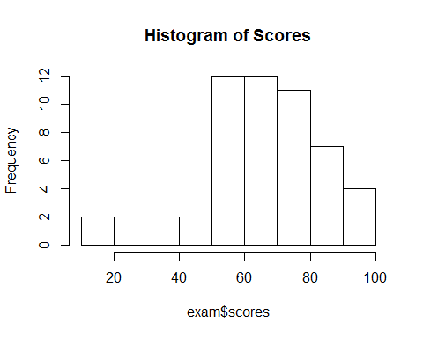

plot(density(exam$scores),main="Density plot of Scores")

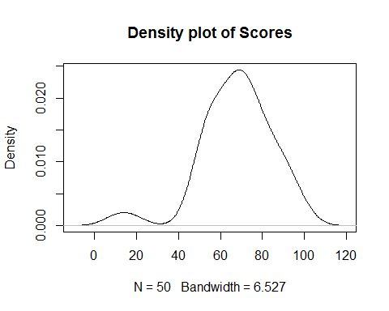

boxplot(exam$scores, horizontal = TRUE)  
stripchart(exam$scores, method = "stack", add = TRUE)

