HW15

Question 1) Create a PLS path model using SmartPLS, with the following characteristics:

a).Create a PLS path model using SmartPLS, with the following characteristics:

1. Measurement of constructs by items
2. Trust in website (TRUST): reflective construct with items TRST1-4
3. Perceived security of website (SEC): reflective construct with items PSEC1-4
4. Reputation of website (REP): formative construct with items PREP1-4
5. Investment in website (INV): reflective construct with PINV1-3
6. Perception of policy (POL): reflective construct with items PPSS1-3
7. Familiarity with website (FAML): single-item construct measured by FAML1
8. Interaction between REP and POL (use orthogonalized product terms)
9. Structural paths between constructs (shown as causal models -- note direction of arrows):
10. **SEC ← REP + INV + POL + FAML + REP.POL**
11. **TRUST ← SEC**

**My scratch of the SEM.**

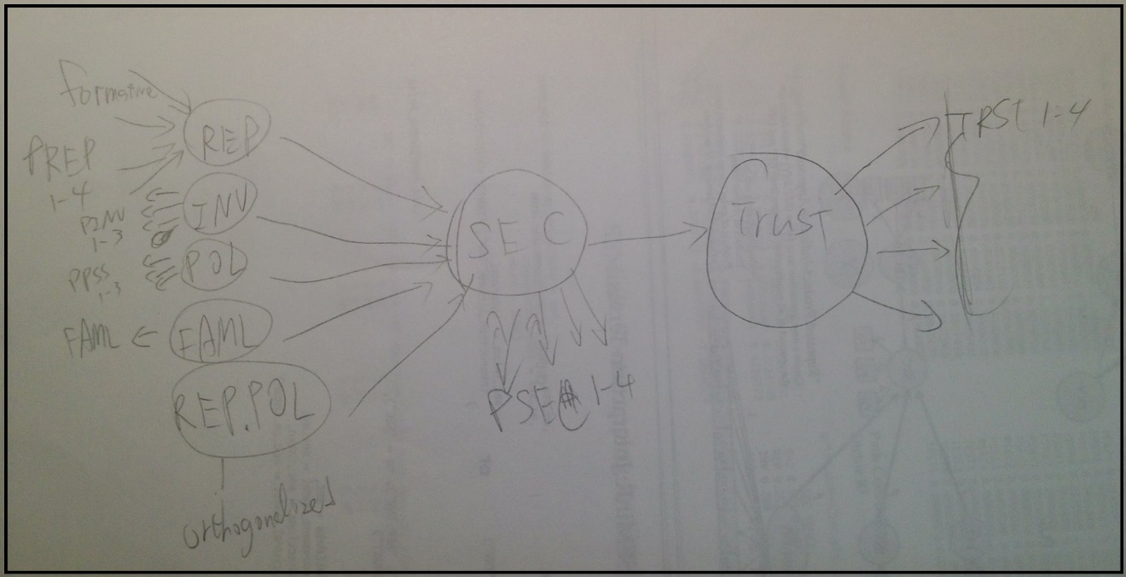

library(seminr)

##   
## Attaching package: 'seminr'

## The following object is masked from 'package:base':  
##   
## structure

sec = read.csv("security_data.csv")  
  
# Measurement Model   
sec_mm <- measure(  
 form("REP",multi_items("PREP",1:4)),  
 reflect("INV", multi_items("PINV",1:3)),  
 reflect("POL", multi_items("PPSS",1:3)),  
 reflect("FAML","FAML1"),  
 reflect("TRUST", multi_items("TRST", 1:4)),  
 reflect("SEC",multi_items("PSEC",1:4))  
)  
  
#interaction term  
sec_intxn <- interact(  
 interaction_ortho("REP","POL")  
)  
  
#Structural Model  
sec_sm <- structure(  
 paths(from = c("REP","INV","POL","FAML","REP.POL"), to = "SEC"),  
 paths(from = "SEC", to = "TRUST")  
)  
  
#run PLS  
  
sec_pls <- estimate_model(data = sec,  
 measurement_model = sec_mm,  
 structural_model = sec_sm,  
 interactions = sec_intxn)

## Generating the plsm model

b). Show us the following results in table of figure formats:

1. Loadings of reflective factors / Weights of formative factors

sec_pls$outer_loadings

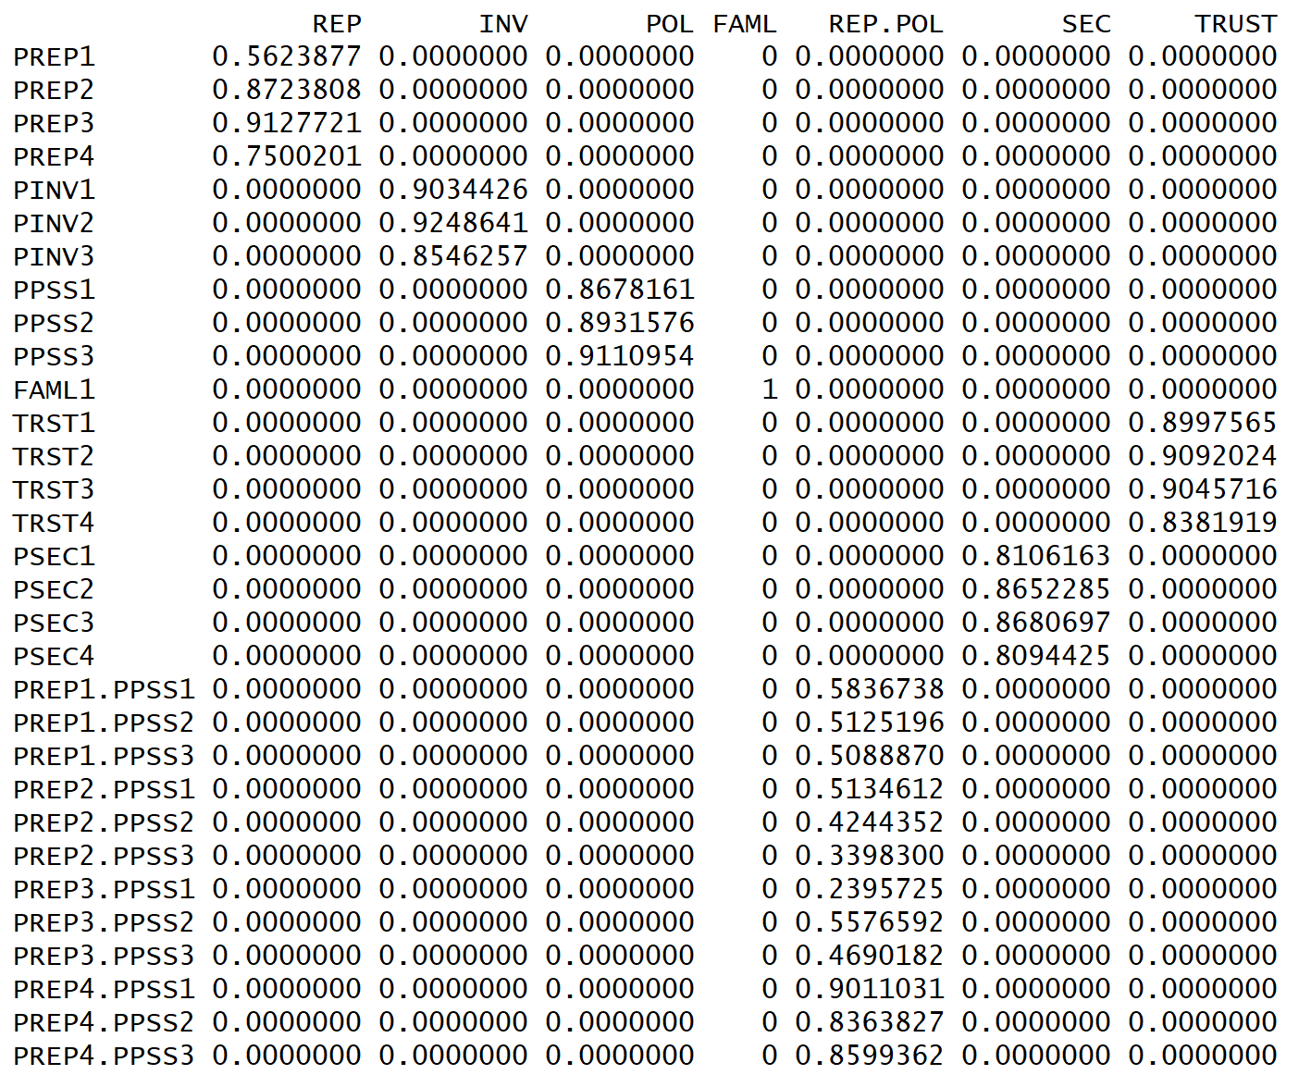

sec_pls$outer_weights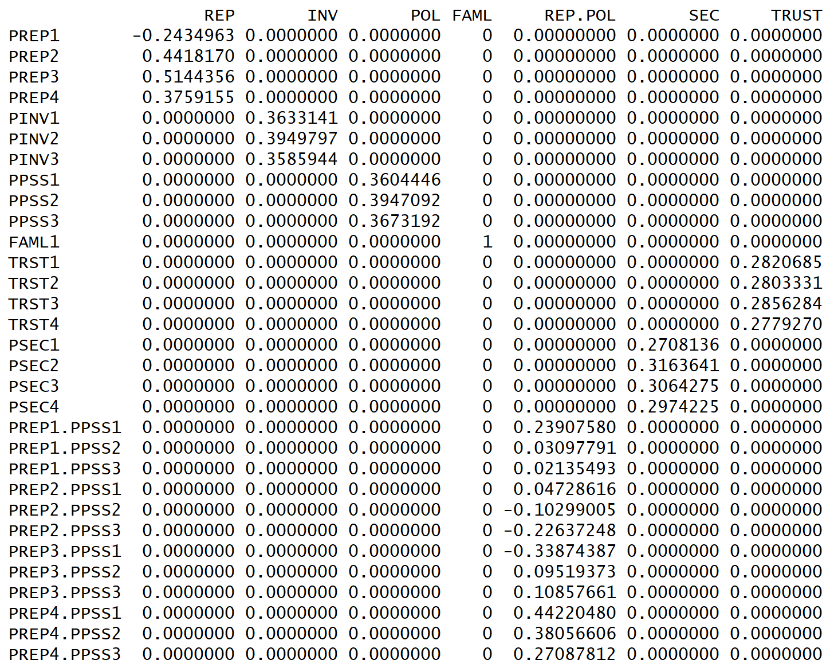

1. Regression coefficients of paths between factors

print_paths(sec_pls)

## SEC TRUST  
## R^2 0.44 0.37  
## REP 0.30 .  
## INV 0.17 .  
## POL 0.32 .  
## FAML 0.01 .  
## REP.POL -0.11 .  
## SEC . 0.61

1. Bootstrapped path coefficients: t-values, p-values (are any paths not significant at p=5% ?)

boot_pls <- bootstrap_model(data = sec,  
 measurement_model = sec_mm,  
 structural_model = sec_sm,  
 interactions = sec_intxn,  
 nboot = 1000)

## Bootstrapping model using simplePLS...

print_paths(boot_pls)

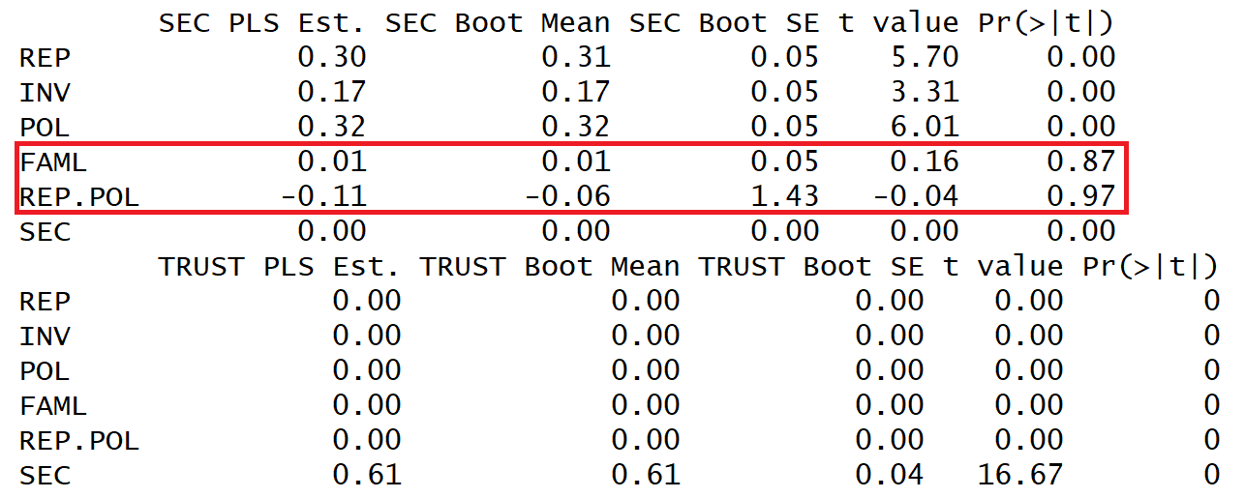

From the above table, we can find out that **FAML** and **REP.POL** are insignificant paths.