HW5

Question 1) Let’s compare the mean load times of Alentus versus HostMonster using their two samples (see class notes on difference of means between two samples; data in page_loads.csv)

page_loads <- read.csv("c:/Users/tsunh/Desktop/schoolwork/BASM/page_loads.csv")  
alentus <- page_loads$Alentus  
hostmonster <- page_loads$HostMonster

a)Use a boxplot to remove the major outliers of Alentus’ load times. Then, use the appropriate form of the t.test function to test the difference between the mean of Alentus and the mean of HostMonster load times (assume the samples come from populations with different variances). From the output of t.test:

plot(density(alentus), lwd=2, col='blue', main="Page load times at Atlentus")

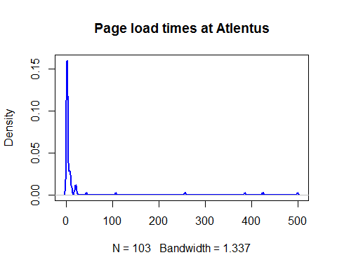

boxplot(alentus, horizontal = TRUE)

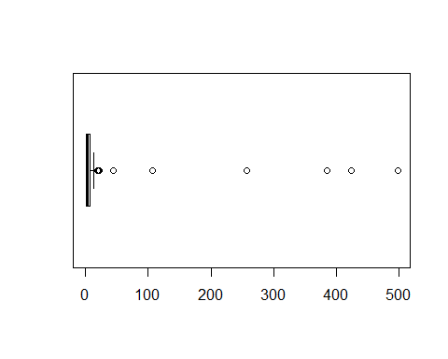

su <- summary(alentus)  
su

## Min. 1st Qu. Median Mean 3rd Qu. Max.   
## 0.41 1.55 2.24 20.65 6.58 498.20

Q1 <- su["1st Qu."]  
Q3 <- su["3rd Qu."]  
IQR <- Q3 - Q1  
  
#get rid of outlier; use filter function from dplyr package  
library(dplyr)

##   
## Attaching package: 'dplyr'

## The following objects are masked from 'package:stats':  
##   
## filter, lag

## The following objects are masked from 'package:base':  
##   
## intersect, setdiff, setequal, union

alentus_cleaned <- page_loads %>%   
 filter(Alentus > Q1-1.5*IQR & Alentus < Q3+1.5*IQR) %>%   
 select(Alentus)   
alentus_cleaned <- alentus_cleaned$Alentus  
  
#omit na in hostmonster  
hostmonster_cleaned <- na.omit(hostmonster)  
mean_hostmonster <- mean(hostmonster_cleaned)  
  
#t test  
alentus_t_cutoff <- abs(qt(0.025, df=length(alentus_cleaned)-1))  
alentus_t_cutoff

## [1] 1.986675

mean_diff <- mean(alentus_cleaned)- mean_hostmonster  
t.test(hostmonster_cleaned, alentus_cleaned, alternative="two.sided")

##   
## Welch Two Sample t-test  
##   
## data: hostmonster_cleaned and alentus_cleaned  
## t = -1.9876, df = 132.39, p-value = 0.04892  
## alternative hypothesis: true difference in means is not equal to 0  
## 95 percent confidence interval:  
## -1.306392097 -0.003159185  
## sample estimates:  
## mean of x mean of y   
## 2.522917 3.177692

1. What is the null and alternative hypotheses in this case?

Here we are going to test the **difference** between the mean of Alentus and the mean of HostMonster load times,2.522917. Therefor, our hypotheses are shown below:

Let $μ_{0}=mean of alentus$ and $μ_{1}=mean of hostmonster$

$H_{null}:μ_{0}−μ_{1}=0$

$H_{alt}:μ_{0}−μ_{1}≠0$

1. What is the 95% CI of the difference of the two providers’ means?

The 95% CI of the difference of the two providers’ means is -1.306392097 to -0.003159185, which 0 is not included.

1. Based on the 95% CI, the t-value, and the p-value, would you reject the null hypothesis or not?
2. The 95% CI didn't include zero.
3. The t-value is greater than the t cutoff. |1.9876| > 1.986675
4. The p-value is smaller than significance level. 0.04892 < 0.05

Therefore, I would like to reject the null hypothesis and claim that those means are different!

b)Let’s try this using bootstrapping: Estimate bootstrapped alternative values of t using the same t.test function as above to compare bootstrapped samples of both providers; Estimate bootstrapped null values of t by using the t.test function above to compare bootstrapped values of Alentus against the original Alentus sample; also estimate the difference between means of both bootstrapped samples.

set.seed(38)  
bootstrap_null_alt <- function(sample0, hyp_mean) {  
 resample <- sample(sample0, length(sample0), replace=TRUE)  
 resample_se <- sd(resample) / sqrt(length(resample))  
 mean_diff <- mean(resample)-hyp_mean  
 t_stat_alt <- (mean(resample) - hyp_mean) / resample_se  
 t_stat_null <- (mean(resample) - mean(sample0)) / resample_se  
 return(c(t_stat_alt, t_stat_null,mean_diff))  
}  
boot_t_stats <- replicate(2000, bootstrap_null_alt(alentus_cleaned, mean_hostmonster))  
t_alt <- boot_t_stats[1,]  
t_null <- boot_t_stats[2,]  
mean_diff <- boot_t_stats[3,]

1. What is the bootstrapped 95% CI of the difference of means?

ci_95 <- quantile(mean_diff, probs=c(0.025, 0.975))  
ci_95

## 2.5% 97.5%   
## 0.1155284 1.2503086

The bootstrapped 95% CI of the difference of means is (0.1155284,1.2503086). Note that the interval doesn't include zero!

1. Plot a distribution of the bootstrapped null t-values and bootstrapped alternative t-values, adding vertical lines for the 95% CI of the alternative distribution (adjust x- and y- axis limits accordingly).

plot(density(t_alt), xlim=c(-6,6), lwd=2,main="Alternative and Null Distributions of t", col="cornflowerblue")  
abline(v=mean(t_alt), col="cornflowerblue")  
lines(density(t_null), lty="dashed")  
ci_95 <- quantile(t_null, probs=c(0.025, 0.975))  
abline(v=ci_95, lty="dotted")  
legend(-6,0.4,c("Null","Alternative"),lty = c(2,1),lwd=c(1,2),col = c("black","cornflowerblue"))

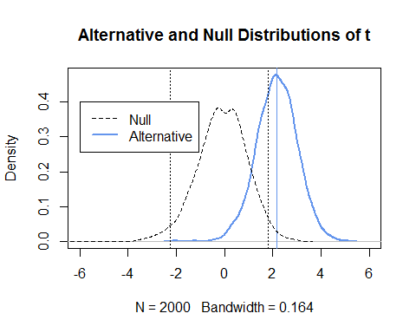

1. Based on these bootstrapped results, should we reject the null hypothesis?

Our alternative t-values largely lie outside the 95% CI of the null t-distribution. Therefore, we should reject the null hypothesis.

Question 2) Here, we really don’t know what test statistic to use to compare medians of two samples, so let’s just bootstrap the confidence interval:

CLAIM: Alentus claims that, with its major outliers removed, its median load time is in fact significantly smaller than the median load time of HostMonster (with 95% confidence)!

$H_{null}:Median_{Alentus}=Median_{Hostermonster}$

$H_{alt}:Median_{Alentus}<Median_{Hostermonster}$

1. First, confirm that the median load time of Alentus (without outliers) is smaller than for HostMonster.

median(alentus_cleaned) < median(hostmonster_cleaned)

## [1] TRUE

1. Bootstrap the difference between the median of Alentus (without major outliers) and the median for HostMonster; Also bootstrap the ‘null’ difference (compare the median of bootstrapped samples of Alentus against the median of the original Alentus sample).

set.seed(38)  
bootstrap_median_null_alt <- function(sample0, hyp_median) {  
 resample <- sample(sample0, length(sample0), replace=TRUE)  
 median_diff <- median(resample)-hyp_median  
 t_stat_alt <- (median(resample) - hyp_median)   
 t_stat_null <- (median(resample) - median(sample0))  
 return(c(t_stat_alt, t_stat_null,median_diff))  
}  
boot_t_stats <- replicate(2000, bootstrap_median_null_alt(alentus_cleaned, median(hostmonster_cleaned)))  
median_alt <- boot_t_stats[1,]  
median_null <- boot_t_stats[2,]  
median_diff <- boot_t_stats[3,]

1. What is the average difference between medians of the two service providers?

mean(median_diff)

## [1] -0.21008

1. What is the 95% CI of the difference between the medians of the two service providers? (consider this time, where the 5% ‘rejection zone’ of the distribution of differences will be: will it be on both sides or only on one side?)

ci_95 <- quantile(median_diff,probs = c(0.5))  
ci_95

## 50%   
## -0.21

1. Plot the distributions of the bootstrapped alternative and null differences between medians and use a vertical dashed lines to show us the 5% ‘rejection zone’

plot(density(median_alt), xlim=c(-1,1), lwd=2,main="Alternative and Null Distributions of diff_median", col="cornflowerblue")  
abline(v=mean(median_alt), col="cornflowerblue")  
lines(density(median_null), lty="dashed")  
ci_95 <- quantile(median_null, probs=c(0.05))  
abline(v=ci_95, lty="dotted")  
legend(0.45,2,c("Null","Alternative"),lty = c(2,1),lwd=c(1,2),col = c("black","cornflowerblue")  
 ,cex = 0.7)

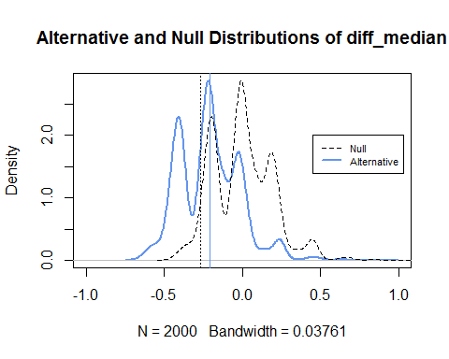

1. Does the 95% CI bootstrapped difference of medians suggest that the median of Alentus load times (without outliers) is significantly smaller than the median load times of HostMonster?

From the above plot, we can find out that the average of median-difference lies in the 95% CI instead of rejection zone. Therefore, we are not going to reject the null hypothesis; that is, the median of Alentus load time is not significantly smaller than that of HostMonster.

Question 3) Let's take a look back at some data from a marketing survey of mobile users.

#load data  
survey <- read.csv("c:/Users/tsunh/Desktop/schoolwork/BASM/Data_0630.txt", sep="\t", header = TRUE)  
#get column we are interested in   
iphone <- survey[survey$X.current_phone.==1,]$X.Brand_Identification.1.  
samsung <- survey[survey$X.current_phone.==2,]$X.Brand_Identification.1.

We find that the means of identification scores between users of the two phone brands are very similar. So we wish to test whether one brand’s **variance** of identification scores is higher than the other brand’s variance of identification scores.

1. What is the null and alternative hypotheses in this case?(Start by identifying which brand has the higher variance)

var(iphone)-var(samsung)

## [1] 0.3480833

After checking whose variance might be bigger, we determine to test whether iphone's variance of identification scores is higher than that of samsung's. The the null and alternative hypotheses in this case would be:

$H_{null}:{Var}_{iphone}={Var}_{samsung}$

$H_{alt}:{Var}_{iphone}>{Var}_{samsung}$

1. Let’s try traditional statistical methods first
2. What is the F-statistic of the ratio of variances?

f_value = var(iphone)/var(samsung)  
f_value

## [1] 1.136295

1. What is the cut-off value of F, such that we want to reject the 5% most extreme F-values? (this is another way of saying we want 95% confidence) Use the qf() function in R to determine the cutoff.

qf(p=0.95, df1 = length(iphone)-1, df2 = length(samsung)-1)

## [1] 1.369645

1. Can we reject the null hypothesis?

According to the tranditional statistics, we should not reject the null hypothesis. Also, we can use *var.test* function.

var.test(iphone,samsung,alternative = "greater")

##   
## F test to compare two variances  
##   
## data: iphone and samsung  
## F = 1.1363, num df = 108, denom df = 112, p-value = 0.2516  
## alternative hypothesis: true ratio of variances is greater than 1  
## 95 percent confidence interval:  
## 0.8296279 Inf  
## sample estimates:  
## ratio of variances   
## 1.136295

Note that the p-value is 0.2516 which is greater than 0.05, so we are not going to reject the null hpothesis. The two variance should be the same accordingly.

1. Let’s try bootstrapping this time:

# function for bootstrapping f distribution  
set.seed(38)  
var_phone_test <- function(larger_var_sample,smaller_var_sample){  
 resample_larger_var <- sample(larger_var_sample,length(larger_var_sample),replace = T)  
 resample_smaller_var <- sample(smaller_var_sample,length(smaller_var_sample),replace = T)  
 f_alt <- var(resample_larger_var) / var(resample_smaller_var)  
 f_null <- var(resample_larger_var) / var(larger_var_sample)  
 return(c(f_alt,f_null))  
}

1. Create bootstrapped values of the F-statistic, for both null and alternative hypotheses.

f_stats <- replicate(5000,var_phone_test(iphone,samsung))  
f_alts <- f_stats[1,]  
f_nulls <- f_stats[2,]

1. What is the 95% cutoff value according to the bootstrapped null values of F?

quantile(f_nulls,probs = 0.95)

## 95%   
## 1.185212

1. What is the median bootstrapped F-value for the alternative hypothesis?

median(f_alts)

## [1] 1.127677

1. Plot a visualization of the null and alternative distributions of the bootstrapped F-statistic, with vertical lines at the cutoff value of F nulls, and at median F-values for the alternative.

plot(density(f_alts),col="cornflowerblue",ylim = c(0,4),xlim=c(0,2.5),main="Null and Alt Distributions of F", lwd = 2)  
lines(density(f_nulls),col="coral3",lwd=2,lty="dotted")  
  
abline(v=quantile(f_nulls,probs=0.95),col="coral3")  
abline(v=median(f_alts),lty="dotted",col="cornflowerblue")  
legend(1.5,3,c("Null","95% CI of Null","Alt","Median of Alt"),  
 lty=c(2,1,1,2),  
 col = c("coral3","coral3","cornflowerblue","cornflowerblue"),  
 lwd = c(2,2,2,2),  
 cex=0.7)

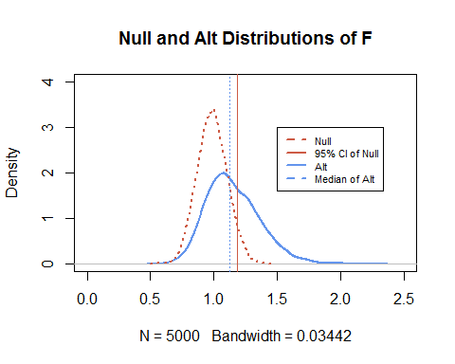

1. What do the bootstrap results suggest about the null hypothesis?

The boostrap results suggest that we should not reject the null hypothesis since the median of alternative distribution lies into the 95% CI of the null distribution. Therefore, there's no significant difference between the variances.