Previous Page | | | Next Page

The SGSCATTER Procedure

Overview
The SGSCATTER procedure creates a paneled graph of scatter plots for multiple combinations of variables, depending on the plot statement that you use. You can use options to overlay fit plots and ellipses on your scatter plots.
The SGSCATTER procedure can create many different types of paneled graphs. The following table shows some of the types of graphs that you can create:
Examples of Graphs that Can Be Generated by the SGSCATTER Procedure
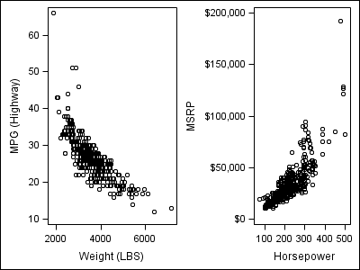 | The following code creates a paneled graph of scatter plots:  proc sgscatter data=sashelp.cars;  plot mpg_highway*weight msrp*horsepower;  run;
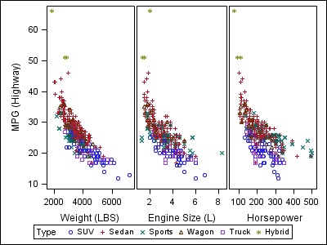 | The following code creates a paneled graph of scatter plots with shared axes:  proc sgscatter data=sashelp.cars;  compare y=mpg_highway  x=(weight enginesize horsepower )  / group=type;  run;
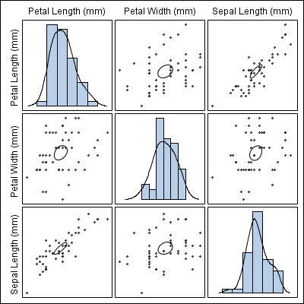 | The following code creates a scatter plot matrix with prediction ellipses and a diagonal with histograms and density plots:  proc sgscatter data=sashelp.iris  (where=(species eq "Virginica"));  matrix petallength petalwidth sepallength  / ellipse=(type=mean)  diagonal=(histogram kernel);  run;
Note: The graphs that you create with the SGSCATTER procedure can have many individual graph cells. As the number of cells increases, the overall graph size does not automatically increase. To increase the graph size, use the HEIGHT= and WIDTH= options of the ODS GRAPHICS statement.

