Exploratory Data Analysis Report
Student Name: Nguyen Van Tuan Kiet (ID 104772099)
Class Number: COS40007
Date: 04 October 2026
Dataset: Concrete Compressive Strength Data Set (supplied concrete_data.csv)
Github Repository: https://github.com/odmiefnf/COS40007

GenAI Declaration
OpenAI Codex assisted with dataset research, analysis design, code generation, debugging, visualisations, interpretation drafts and report preparation. Statistics were computed from the downloaded CSV. Student verification and revision are pending. This assistance exceeds the narrower support uses listed in the task; acceptance must be checked with the tutor. Independent student authorship is not claimed.

1. Dataset Overview
The selected Concrete Compressive Strength dataset contains laboratory observations of concrete mixtures. Each row records seven ingredient quantities, test age and measured strength. These predictors are relevant to civil and materials engineering because composition and hydration maturity affect the performance of concrete. The Kaggle mirror credits I-Cheng Yeh and the original UCI dataset (https://doi.org/10.24432/C5PK67).
Item | Result
Rows | 1,030 raw; 1,005 after exact full-row deduplication
Columns | 9 original: 8 predictors and 1 target
Target | Concrete compressive strength (float64, MPa)
Primary problem | Regression
Supplemental classes | Three equal-frequency ordered strength bands
Target summary | Cleaned mean 35.250; median 33.800; SD 16.285; range 2.33-82.60 MPa

Three relative strength bands use equal-frequency boundaries at 26.823333 and 41.05 MPa. The lower band includes the first boundary; the middle band includes the second. Counts are 335 Lower strength, 338 Middle strength and 332 Higher strength observations. Ties prevent exactly equal groups. These are dataset-relative bands, not standard concrete grades or 28-day design strengths. The continuous target is retained for regression and interpretation.
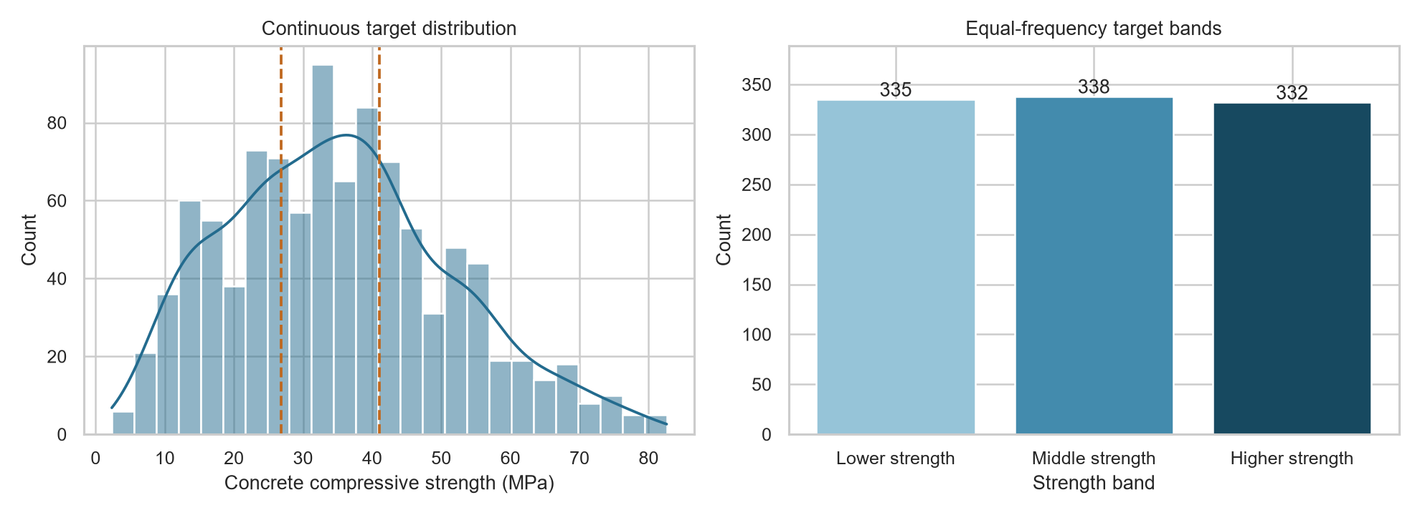
Figure 1. Continuous compressive strength is mildly right-skewed; the three quantile bands are approximately balanced.

2. Data Quality Assessment
The raw dataset has no missing cells in any of its nine columns. The uniform missingness heatmap in the notebook confirms complete observations. Zero slag, fly ash and superplasticizer quantities mean the ingredient is absent, so they are preserved rather than imputed. The fine_aggregate header contains trailing whitespace; only header text was normalised.
Column | Missing | Percent
Cement | 0 | 0.00%
Blast furnace slag | 0 | 0.00%
Fly ash | 0 | 0.00%
Water | 0 | 0.00%
Superplasticizer | 0 | 0.00%
Coarse aggregate | 0 | 0.00%
Fine aggregate | 0 | 0.00%
Age | 0 | 0.00%
Compressive strength | 0 | 0.00%
All columns | 0 | 0.00%

- Duplicates: 25 identical full rows were removed on a copy, leaving 1,005 analysis rows. The original CSV is preserved. Without experiment IDs, repeated laboratory observations cannot be conclusively classified as errors.
- Outliers: the IQR rule flags 59 age values, 15 water values, 10 superplasticizer values, 8 strengths, 5 fine-aggregate values and 2 slag values. These counts overlap across 94 observations. All flagged observations are retained because unusual recipes and long-duration tests can be legitimate.
- Repeated inputs: 13 predictor vectors beyond their first occurrence have differing strength outcomes and remain in the analysis. They may reflect experimental variation or unrecorded test conditions.
Preparation removed exact full-row repetitions and normalised column names without imputing, scaling, winsorising or deleting IQR flags. All numerical cells are finite; no negative ingredient quantities, nonpositive ages, fractional ages or nonpositive strengths were found. The mean strength changes from 35.818 MPa in the raw table to 35.250 MPa after deduplication; the notebook reports correlation sensitivity to this choice.

3. Key Findings from Univariate Analysis
Age is strongly right-skewed (skewness 3.254), with 419 observations at 28 days, or 41.69% of the cleaned sample. Slag, fly ash and superplasticizer have substantial masses at zero: 46.77%, 53.83% and 37.61%, respectively. Cement is moderately right-skewed (0.565); superplasticizer has a right tail (0.981). These distributions support retaining structural zeros and considering nonlinear age effects.
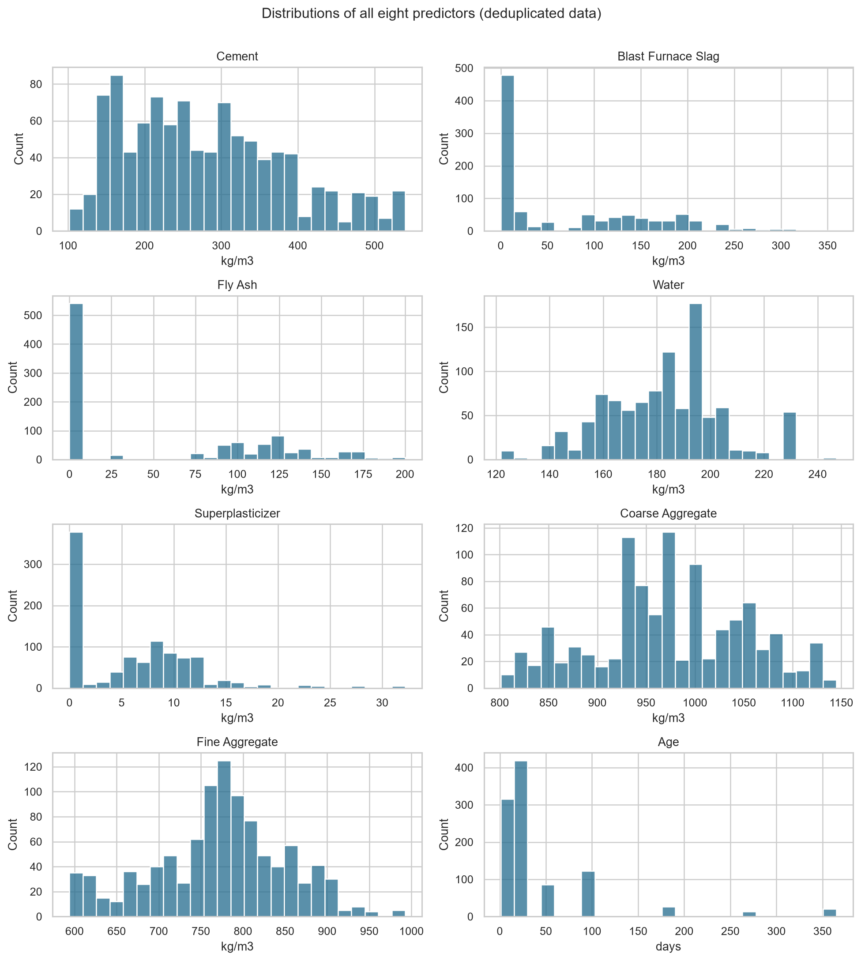
Figure 2. All eight numerical predictor distributions; the notebook also includes complete summaries and boxplots for all nine numerical variables.
Water has near-zero skewness (0.034), coarse aggregate is roughly symmetric (-0.065) and fine aggregate has mild left asymmetry (-0.252). Repeated recipe values and irregular histogram shapes mean that symmetry alone does not establish normality. All predictors are numerical; no categorical encoding is needed for the original inputs.

4. Key Findings from Multivariate Analysis
Feature | Correlation with strength
Cement | 0.4883
Superplasticizer | 0.3442
Age | 0.3374

Cement has the strongest original linear association with strength (r = 0.4883), followed by superplasticizer (0.3442) and age (0.3374). These are marginal Pearson associations ranked by absolute magnitude, not independent effects. Age has a larger Spearman coefficient (0.6054), suggesting an important monotonic component that a linear summary can obscure. The notebook pairplot shows age bands and variation among mixtures at the same test age.
Predictor A | Predictor B | Absolute correlation
Water | Superplasticizer | 0.6469
Water | Fine aggregate | 0.4449
Fly ash | Superplasticizer | 0.4142
Cement | Fly ash | 0.3856

No original predictor pair reaches |r| >= 0.80; the strongest pair is water and superplasticizer (-0.6469). Pairwise screening does not rule out joint multicollinearity: VIF values are 7.449 for cement, 7.263 for slag, 6.972 for fine aggregate, 6.838 for water and 6.085 for fly ash. Ingredient substitution and fixed-volume recipe structure can create redundancy, so linear coefficients require care and regularisation.
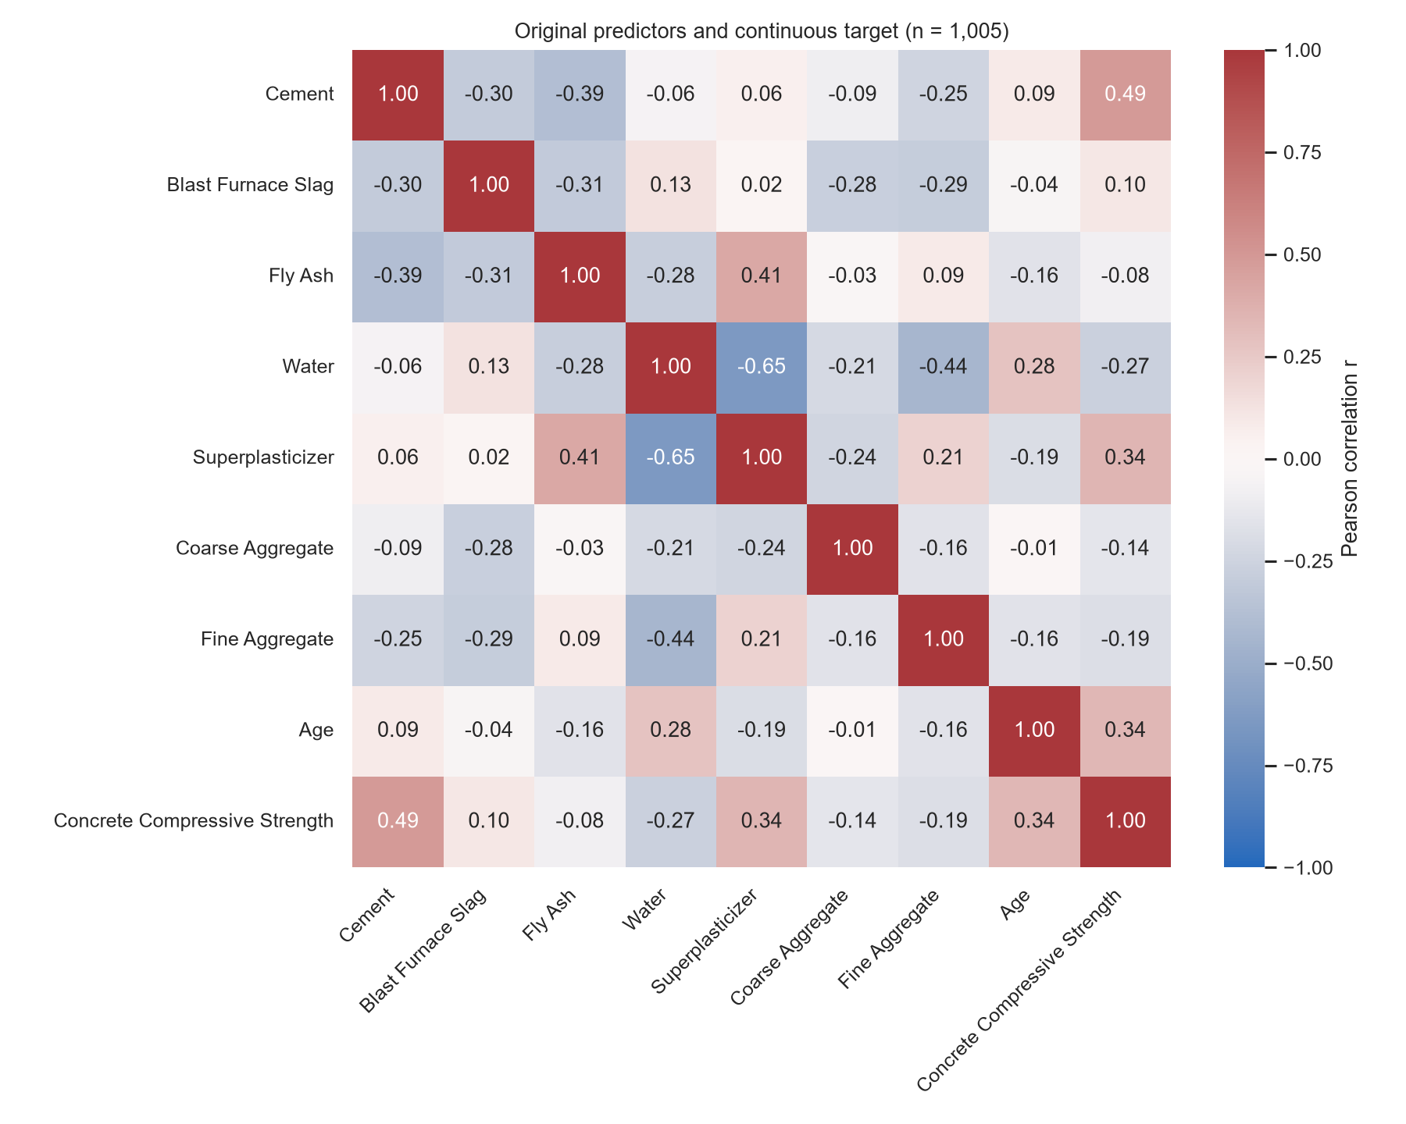
Figure 3. Pearson correlation matrix for all eight original predictors and the continuous strength target.

5. Initial Insights for Modelling
- Promising predictors: cement, age, superplasticizer and water. Retain slag and fly ash initially because interactions and substitution can hide useful information from marginal correlations.
- Preprocessing: preserve meaningful ingredient zeros; consider log1p(age), binder content and water-to-binder ratio. No imputation is currently required, and target-derived columns must never become predictors.
- Scaling: fit scaling on training data for ridge or logistic models; tree-based models normally do not require it. The original predictors do not need categorical encoding.
- Feature selection: compare regularised predictors and engineering ratios through validation; avoid interpreting correlated mixture components as independent causal effects.
- Candidate models: a mean baseline and ridge regression, followed by random forest or gradient boosting. For the three-class alternative, consider a majority baseline, multinomial logistic regression or an ordinal classifier.
No predictive model is trained for this assessment. Future regression evaluation should use MAE and RMSE in MPa; classification should use macro-F1 and a confusion matrix. Group recipe compositions across test ages within the same fold to limit leakage. Fit scaling, selection and any class boundaries on training data only, and audit errors by age and strength range.

6. Engineering Interpretation
The positive age association is consistent with strength development during hydration under adequate curing. Lower water demand and the use of superplasticizer can support workable mixtures without increasing water content. These qualitative interpretations are consistent with American Cement Association guidance on water-cement ratio and curing (https://www.cement.org/cement-concrete/applications-of-cement/). The observed coefficients do not establish causation.
Mean strength is not strictly increasing across age groups: the 56-day group averages 50.715 MPa and the 90-day group 40.480 MPa. Different mixtures occur in these groups, so this is not evidence of weakening over time. The derived water-to-binder ratio has r = -0.6108 with strength, motivating a feature candidate without proving a prediction improvement. The small negative fly-ash coefficient (-0.0806) likewise does not show that fly ash always reduces strength.
Potentially important missing information includes curing temperature and moisture, cement and supplementary-material chemistry, aggregate grading, air content, compaction, specimen geometry and batch/laboratory IDs. Binder is defined here as cement plus slag plus fly ash for exploration; this does not assume equal chemical reactivity. Nonlinear and regularised models are reasonable candidates, subject to independent validation.

7. Challenges Encountered
- Correcting a trailing-space header without altering any measurements.
- Distinguishing meaningful zero ingredient quantities from missing data.
- Handling exact repetitions while retaining differing outcomes for identical recorded inputs.
- Interpreting long-age and unusual-recipe IQR flags without deleting valid experiments.
- Detecting joint ingredient multicollinearity that pairwise screening alone misses.
- Defining balanced relative classes while preserving the continuous engineering outcome and avoiding causal claims.

8. Reflection Questions
Poor quality could reduce model reliability through unit errors, repeated observations overweighting particular recipes, deletion of valid old-age tests or missing experimental conditions. Different strengths for the same recorded inputs show that the predictors do not fully explain the outcome. Controls should include traceable cleaning, duplicate sensitivity analysis, batch-aware validation and tests on independent laboratory data.
Laboratory mixes and uneven test ages may not represent current Vietnamese materials, climate or construction practice. Missing provenance prevents a reliable coverage audit. A future model could overestimate strength and support unsafe screening decisions, or underestimate it and increase material use and cost. Responsible use requires uncertainty reporting, checks by age and mix range, local validation, qualified review and laboratory confirmation. Strength alone cannot establish carbon impact. AI assistance must be honestly declared and independently reviewed.

9. Next Steps
- Obtain experiment and batch provenance, define the intended use and create a leakage-safe grouped evaluation protocol.
- Compare a baseline and ridge regression with random forest and gradient boosting; inspect errors by age, composition and strength range.
- Evaluate log-age and water-to-binder features, assess redundancy and compare regression with the ordered three-class alternative.
- Check sensitivity to exact duplicate removal and outlier policies, then validate on independent local materials and test conditions.

10. GenAI Declaration
OpenAI Codex assisted with dataset research, analysis design, code generation, debugging, visualisations, interpretation drafts and report preparation. Statistics were computed from the downloaded CSV. Student verification and revision are pending. This assistance exceeds the narrower support uses listed in the task; acceptance must be checked with the tutor. Independent student authorship is not claimed.
The accompanying notebook contains the full executable evidence: loading and outputs, missingness, duplicate examples, boxplots for all numerical variables, target classes, all predictor distributions, Pearson and Spearman correlations, VIF, a pairplot, age comparisons, the engineering ratio exploration and detailed interpretations. The raw CSV is embedded for standalone use. Code was previously rerun in a fresh process; the repository link above is the submission destination. Canvas submission has not been performed.

