**Problem understanding:**

Every year there is 53k number of accidents on the British roads out of which 44% is severe. Hospital directors that plan resources may want to predict risk and severity of accidents on streets to help people that were victims of car accidents. Heads of police departments want to know how to protect citizens and patrol the streets so to limit dangerous behaviour on the streets. Aim of this project is to predict the severity of road accidents so to limit the number of incidences on the way and optimize resources to protect victims. To understand what influence the severity of the accident we may want to look at things like: weather conditions, light conditions, road conditions or place location.

**Data source:**

To this project I have used data from British department of transportation on car accidents that happened in years 2010 to 2018 <https://data.gov.uk/dataset/cb7ae6f0-4be6-4935-9277-47e5ce24a11f/road-safety-data> The raw data is made of two files: vehicle details and accident circumstances. Vehicle details include facts such as: vehicle type, junction location, sex or age band age of driver, vehicle propulsion code and more. Accident circumstances include facts such as: police force division that attended the accident, road type, speed limit, weather conditions, urban or rural area and more. For full details on columns included please refer to the appendix.

Looking at the data I have noticed that the accident with maximum number of vehicles was not on the same data as accident with maximum number of casualities. The maximum number of casualities recorded during car accident was 93 on date 20/10/2014 and the maximum number of vehicles recorded during car accident was 67 on date 05/09/2013. I found information on the second accident in the press so it will allow me to validate the accuracy of the data.

**Data Cleaning:**

The data comes from multiple years, each year in separate csv file. Comparing columns across years we see that Age_of_Driver and Vehicle_IMD_Decile are not in all files across the years so we remove the variables in files that the columns exists, that’s to uniform the data. We normalize the column names across the files. Files from the same category: vehicle details or accident details we append on top of each other to have one dataset for each year and then we join together both complete files on accident index column. To better understand the data types and what columns say about the incident I recode the data using variable lookup file provided. Some of variables are in too granular level so that the ratio across different options is too big. For this reason some columns are changed to Yes|No type columns such as: Vehicle_Leaving_Carriageway, Hit_Object_off_Carriageway, Carriageway_Hazards and more. Finally we have 37 columns of type string, 11 of type float and 5 of type integer making a total of 53 columns and nearly 3mlns observations.

Some of the missing values are left blank, some are recorded as -1 and some are recorded as unclassified or else. To better understand the missing values I calculate proportion of all missing values cases per column. For some columns such as Was_Vehicle_Left_Hand_Drive?, Propulsion_Code, 2nd_Road_Class, Junction_Control, Age_of_Vehicle I imput missing values by the most popular option. Time column I imput using forwardfill as I noticed that the data is in chronical order. For column Age_Band_of_Driver the missing values I change on Unknown. I noticed that the data has some records for driver in the age 1-5, 5-10, 10-15 since this is illegal to drive in this age and that doesn’t make sense I simply make this as unknown as well. For columns such as Engine_Capacity(CC) or Driver_Home_Area_Type the missing values I imput using mode grouping by Vehicle_Type or Accident_Severity. Since I want to visualise the data on a map with accident severity but I don’t need the columns Longitude and Latitude in the general data I create temporary data set with Accident_Index, Accident_Severity, Longitude and Latitude and I remove those two geographical columns from the main dataset. In total, in the initial cleaning stage, I have removed 10 columns either because the number of missing values was more than 50% or because they would not give good insights. For example, Location_Easting_OSGR and Location_Northing_OSGR are geographical variables. We already stored the longitude and latitude and in the main data we have column Police_Force that gives information what area of Britain the Police_Force operate in. Local_Authority_(District), 1st_Road_Number, 2nd_Road_Number are too granular. We don’t have information on LSOA_of_Accident_Location or Driver_IMD_Decile to know what does it mean.

I have noticed that for each vehicle taking part in the accident there is separate record so all columns with small proportion of missing values first I tried to get the missing values from the accident index as they were taking part in the same accident. In total I managed to get 84% of the total data cleaned.

The first view on data type shows that there are 26 columns as float, 22 columns as integer and 5 columns as string. However, that’s not true as categorical data is coded in numbers. After recoding we find out that 37 columns are strings, 11 are floats and 5 are integers.

**Big accidents examples:**

**04/11/2011**

I decided to have a close look at 2 accidents. One from 4th of November 2011 with 34 number of vehicles taking part in the accident and another from 5th of September 2013 wth 67 vehicles. That’s to validate the data, how accurate the accidents were recorded and to understand columns better.

On 4th of November 2011, Friday 8:23pm was mass of crashed vehicles described by emergency worker as “the worst road traffic collision anoyone can remember”. 7 fatal victims, 51 injured and 34 cars taking part in this collision close to junction 25 of the M5’s northbound carriageway. Drivers reported a white wall of fog. People said that smoke from fireworks at the rugby club next to the motorway might have contributed to the poor visibility. There was also huge fireworks display that could distract the drivers. Cars that were driving slow managed to escape but cars speeding up with 60-70mph were just colliding one onto another. 3 lorries collide including one full of deodorants and cans. People were trapped in their vehicles and were screaming. <https://www.youtube.com/watch?v=1ZdsxShKJe0>

The data shows only 5 fatal casualities so 5 reported on the scene and 2 passed in the hospital. We learn that the Local_Authority_(District) is Taunton Deane. That was on Motorway, dual carriageway with speed limit 70. Not on junction or not junction within 20 meters. No pedestrians involved. In the data it was reported as daylight, which can't be true as that was November after 8pm. Weather condition from report as 9: Unknown but we know from press and reports that was fog, 100% humidity and dark outside, Road_Surface_Conditions: reported as 1 - dry That is not true as it was fog with humidity 100%. 6 Goods vehicles 7.5 tonnes mgw and over, 1 Van / Goods 3.5 tonnes mgw or under and rest normal cars

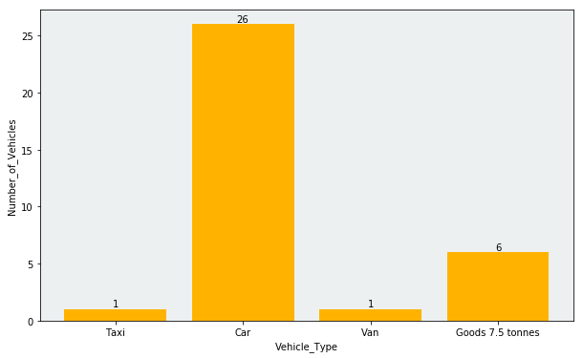

7. 4 female drivers and rest male drivers.

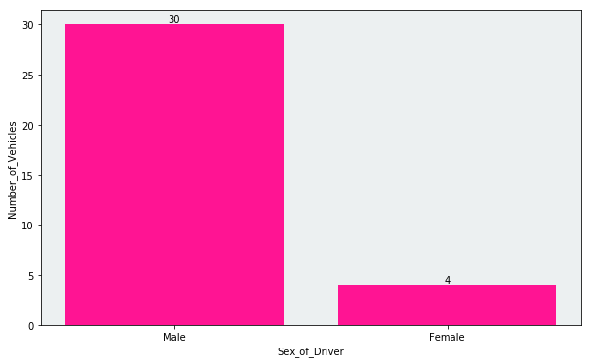

After this accident analytics we can identify that:

1. Important the severity is from 1 - 3 with 1 the highest

2. As that's interesting during data exploration this level is too granular and we won't include Local_Authority_(District) for our model

3. We can notice that we have multiple records for each accident as the details for vehicles are specific for particular vehicle.

4. We can remove the 1st_Road_Number and 2nd_Road_Number as does not say something relevant for the model

**05/09/2013**:

Another big accident: Carmageddon recorded on Thursday. Hundred car pile-up on foggy Sheppey crossing bridge on A249 in Kent at 7.15am. The crash happened as parts of Kent, Essex and parts of London suffered from some areas of dense, patchy fog between 4am and 8.30am. It was forecasted to be mostly dry, sunny and very warm over central, southern and eastern England once the early fog had cleared. After incident there was a call for a safety review on the A249 Sheppey Crossing to look at the speed limit, lack of matrix warning signs and lighting.’ Gordon Henderson, Conservative MP for Sittingbourne and Sheppey, said:‘I have had concerns in the past, particularly about the level of lighting on the bridge.’

Eight people seriously injured and another 200 with minor injuries - 33 people taken to hospital but no fatalities after the incident. A fleet of 30 ambulances and other response vehicles treated some casualties at the roadside. Firefighters used hydraulic cutting equipment to free those who were trapped. Stranded motorists sit on road for up to eight hours in 30C heat but left area by 3pm. The four-lane bridge was shut in both directions. Bridge reopened at 5.30pm. AA chief sayed crash may have been caused by 'stupid driving' - specifically tailgating and not using fog lights.: [More informtaion you can find in the Guardian article](https://www.dailymail.co.uk/news/article-2412099/Sheppey-crash-chaos-Kent-200-injured-100-vehicle-pile-up.html)

Data shows 67 vehicles and 70 casualities out of which 2 are serious, 33 taken to hospital rest were injured but not hospitalisation needed. Similarly like the previous one it was on dual carriageway with speed limit 70. Light conditions was recorded as daylight, weather conditions: Fog or mist. Road surface: dry.In the accident took part: 1 Taxi, 15 Vans, 1 Goods 7.5 tonnes rest cars:

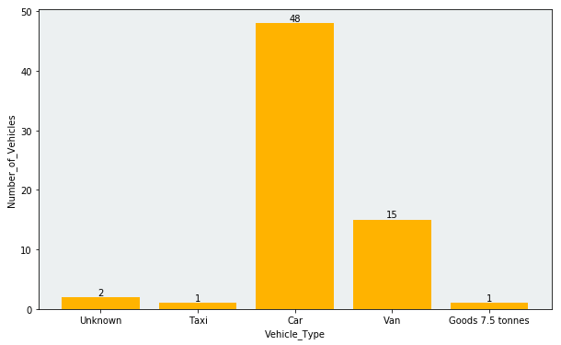

45 male + 22 female drivers:

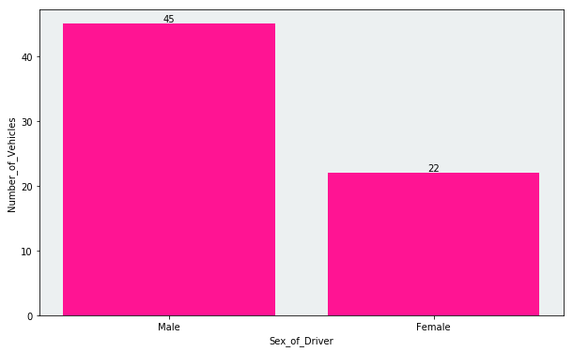

3 drivers in age 16 - 20, 8 in Age 21 - 25, 14 in age 26 - 36, 14 in age 36 - 45, 17 in age 46 - 55 and 10 in age 56 - 65

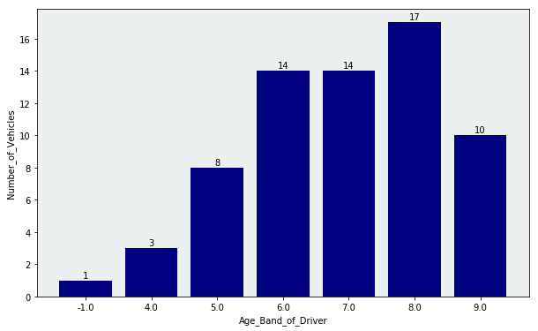

**Missing values imputation:**

The only columns that don’t have missing values are: Accident_Index, Police_Force, Accident_Severity, Number_of_Vehicles, Number_of_Casualties, Date, Day_of_Week, Time, Local_Authority_(Highway), 1st_Road_Class, Was_Vehicle_Left_Hand_Drive?, Propulsion_Code,

I have imputed missing numbers by most popular option in columns: Was_Vehicle_Left_Hand_Drive?, Propulsion_Code, 2nd_Road_Class, Junction_Control, Vehicle_Type,

For column Age_Band_of_Drvier I filled missing values with Unknown,

In Time column since I know don’t data comes in chronological order I filled missing values with forward fill.

Engine_Capacity_(CC) I filled with most popular option by vehicle type, driver home area type by accident severity.

**Imbalanced dataset:**

Data imbalance usually reflects an unequal distribution of classes within a dataset, for us it is Accidents severity. On British road majority of accidents is not sever but we are interested in the sever accidents. We want to see how different things impact severity of accidents. To remove this problem we need to normalize the data. To do that first we shuffle randomly the dataset then we separate sever and non severe classes and take the sizes of samples for each class. We finally concatenate the data sets together.

In the dataset we have variables that are unique for each car taking part in the accident such as age of vehicle or journey purpose of driver and we have columns that are uniform for all such as weather or road conditions.

The distribution of vehicle types shows that majority of accidents with motorcyles are severe where majority of cars ccidents are non severe.

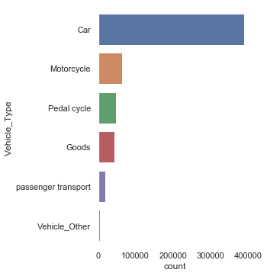 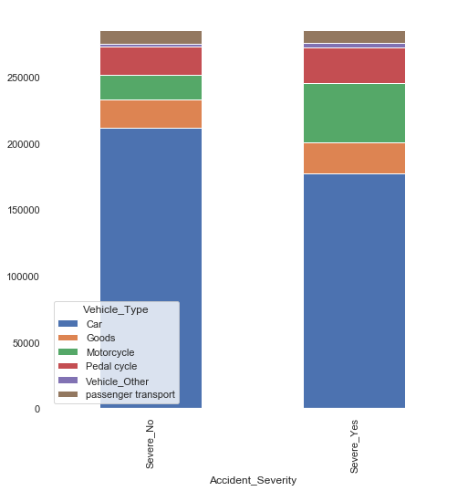

We can see that Towing and articulation distribution is not balanced, majority of the accidents had no Towing. I would recommend to remove this variable:

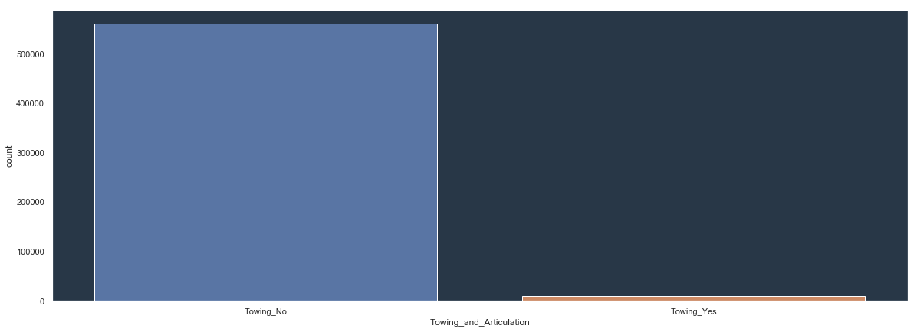

Majority of accidents are with vehicle going ahead other but accidents when turning left are more severe than those were turning right.

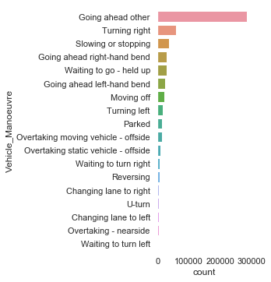 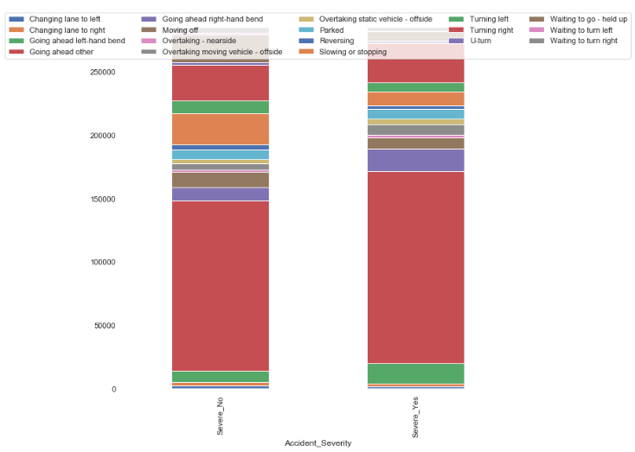

Majority of accidents did not hit object in carriage way and we can’t really see big difference in distribution between sever and non severe.

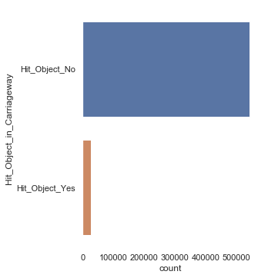 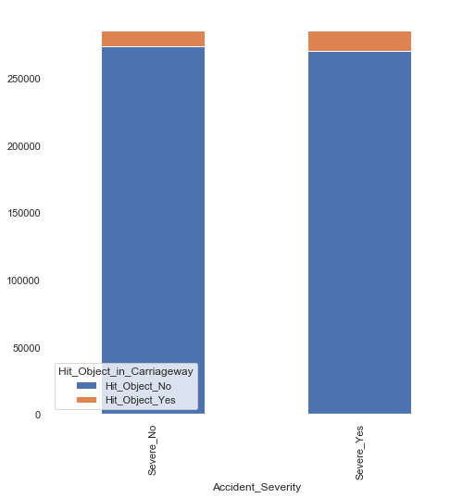

Majority of accidents were when vehicle was not leaving carriageway but more cases when it happened was with severe accidents rather than not.

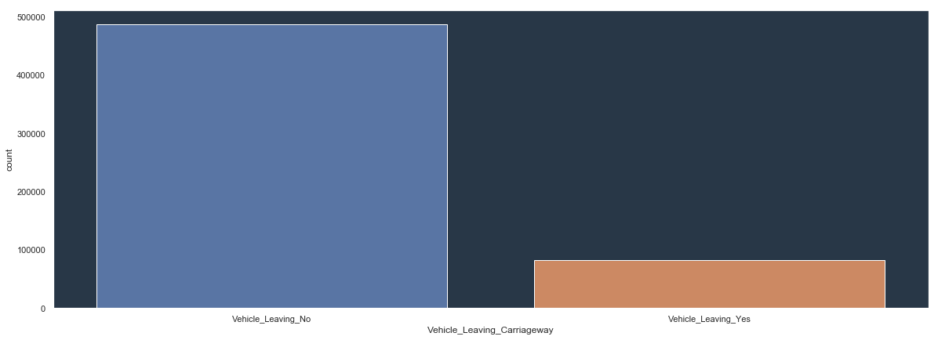

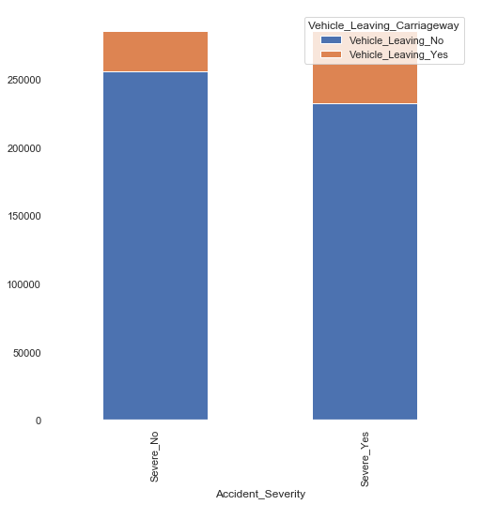

Majority of accidents did not hit objects off carriageway and we do not see big different in distribution between those when the accident was severe or not

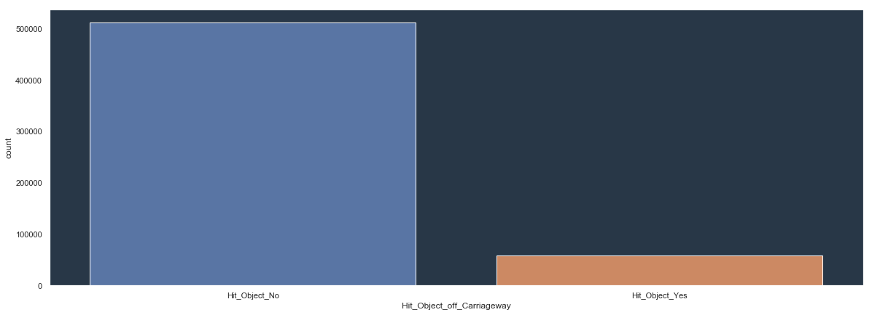



Majority of incidence 1st point of impact was front and more often the accident is severe when it hits in front in comparison to when it hits at the back.

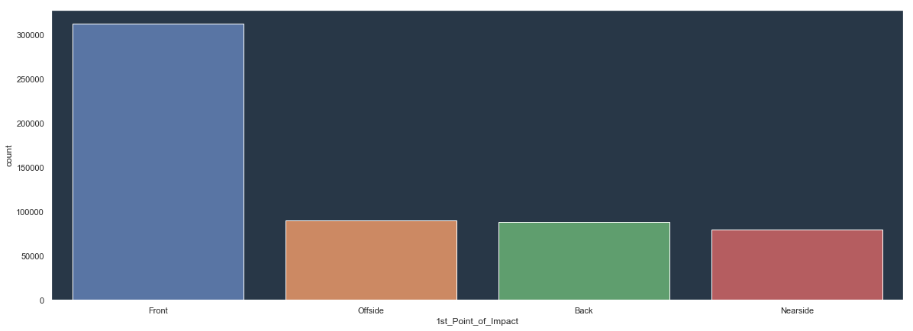

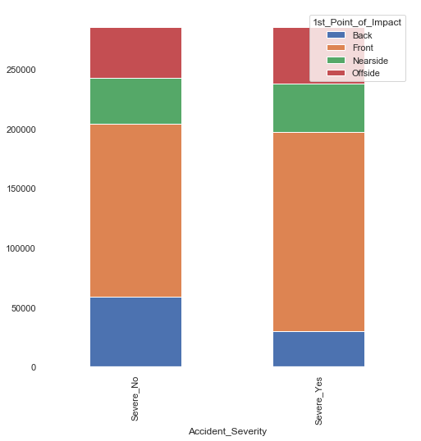

Majority of accidents where not left hand drive and I would remove the variable as the proportion is too big.

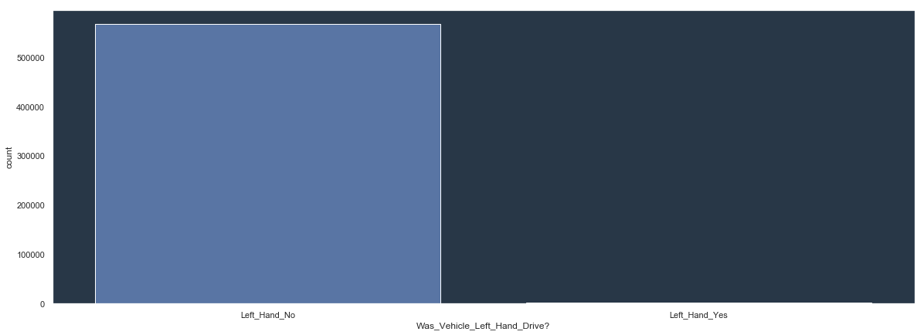

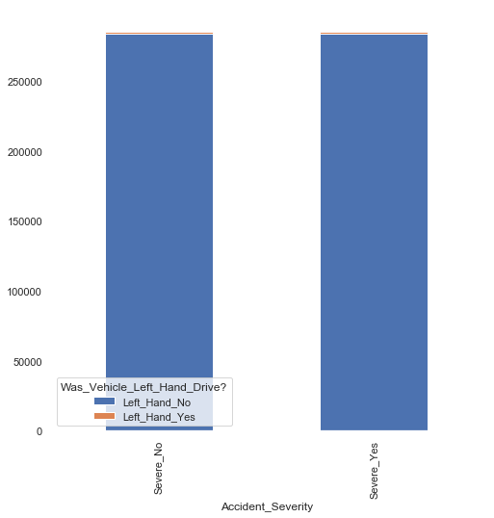

Majority of records are with unknown journey purpose and we don’t really see a difference in distribution

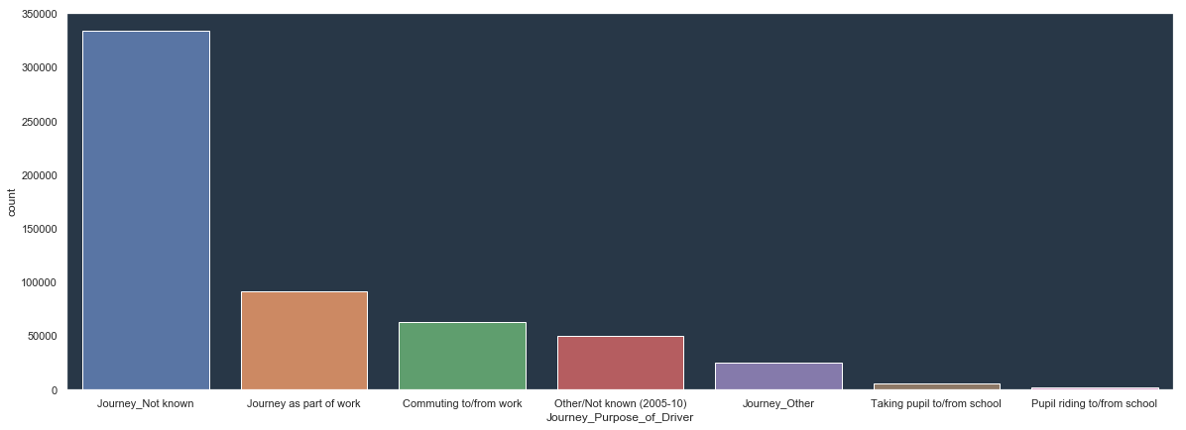

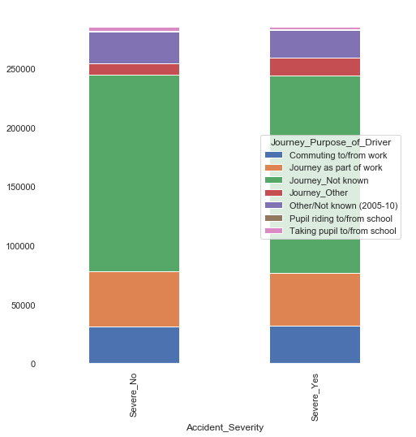

Majority of Accident records are with men and accidents when men is a driver are more severe when it’s women.

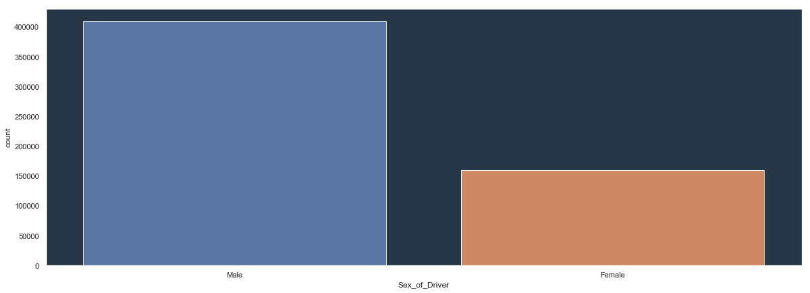

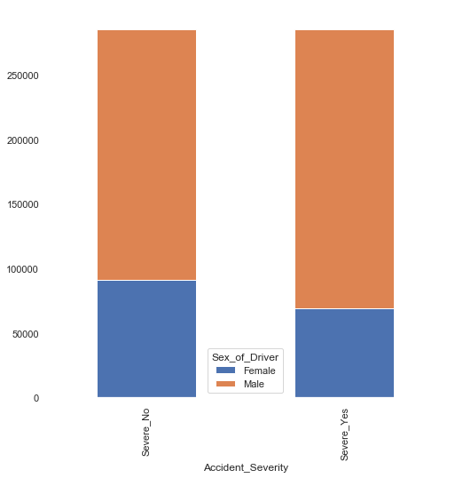

Majority of drivers are in age 26 – 35 but we don’t see big difference in distribution

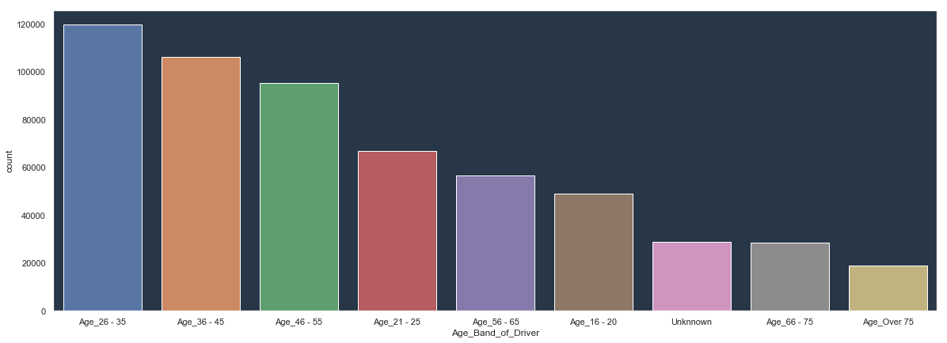

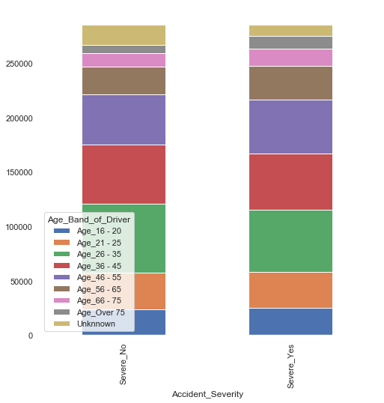

Majority of cars on British Roads are Petrol and we don’t see difference in distribution between severe and non severe accidents for the type of fuel.

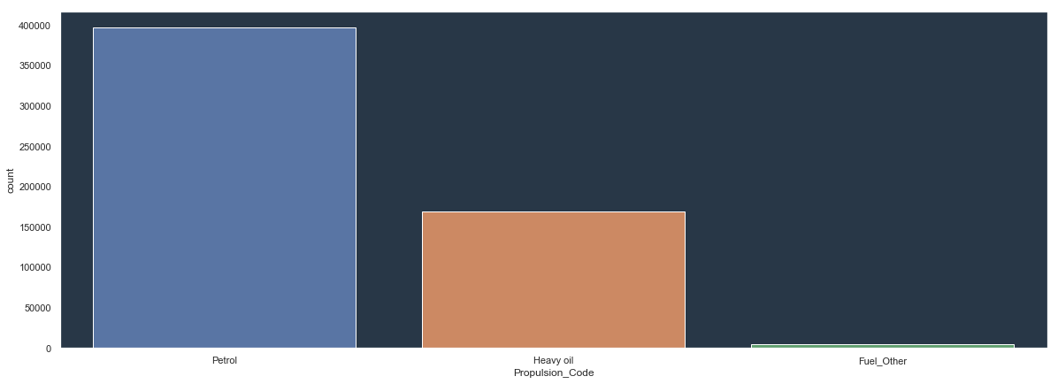

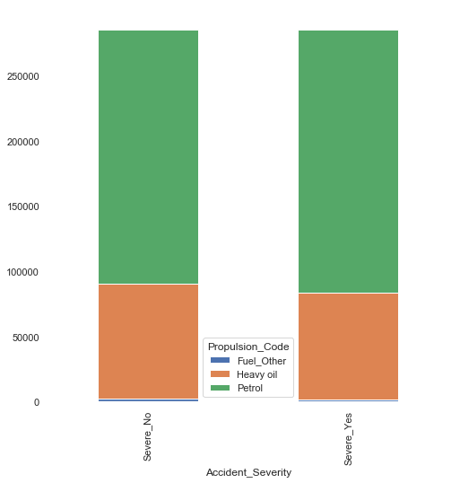

Majority of accidents are with drivers from 1 Home Area type. We don’t have information what does it mean so we remove this variable later.

Majority of accidents are when there was no skidding and more severe accidents are when there is skidding rather than not.

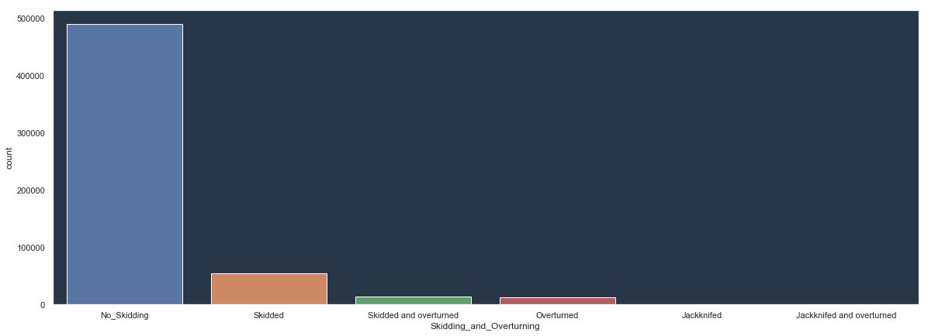

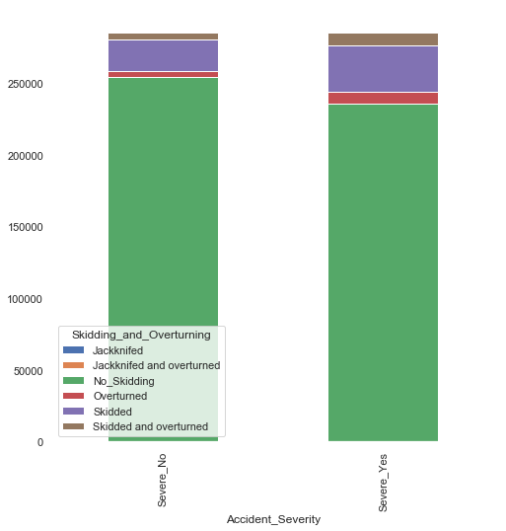

After that data is reduced by taking one observation per accident. The variables unique for individual cars are pivoted so that accident index is a row and different levels of the categorical variable becomes columns for the data. For the columns that are unique for the accident but all vehicles got the same observation e.g. speed limit on the road or weather condition duplicates are removed. So that out of 570,644 observations data is reduced to 474,174 Variable Time is first transformed on categorical: early morning, morning, afternoon, evening, night and then pivoted. Similarly Vehicle Age is transformed to new_car, average_car, old_car, antique_car. Due to grouping we need to normalized the dataset again so that to have equal number of severe and non severe cases of accidents.

The majority of data comes from Metropolitan Police district but majority of accidents from there are not severe

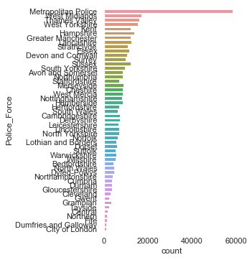 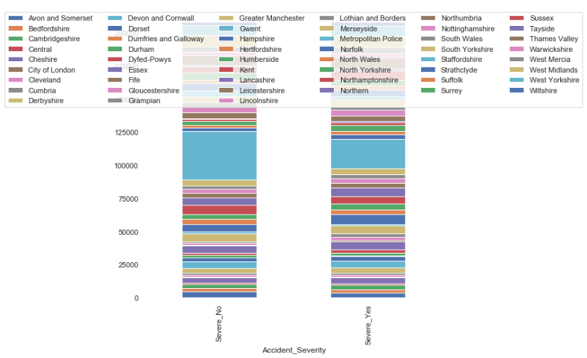

The biggest number of accidents recorded on Friday when Sunday is the safest day to travel

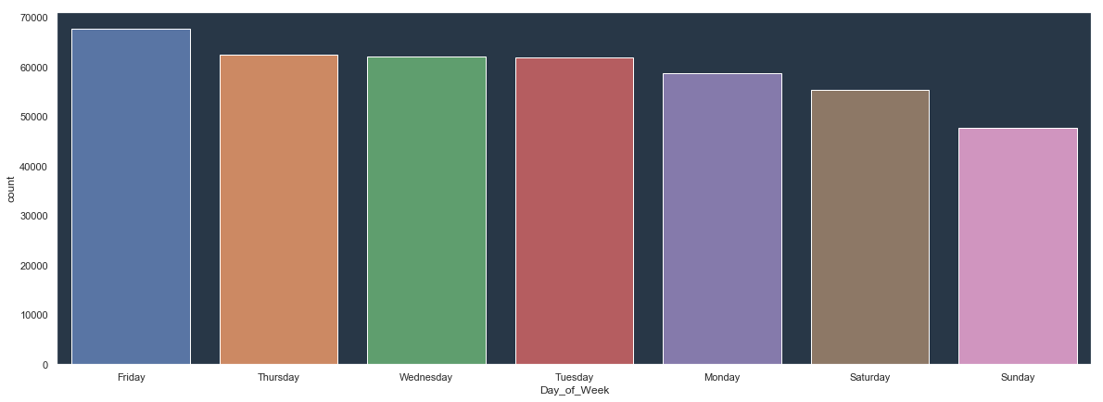

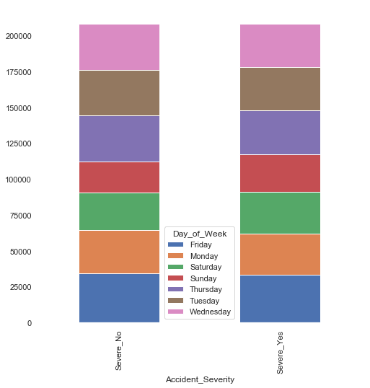

The most popular Road Type in Britain is Single Carriageway. Majority of accidents on roundabouts and dual carriageways are not severe.

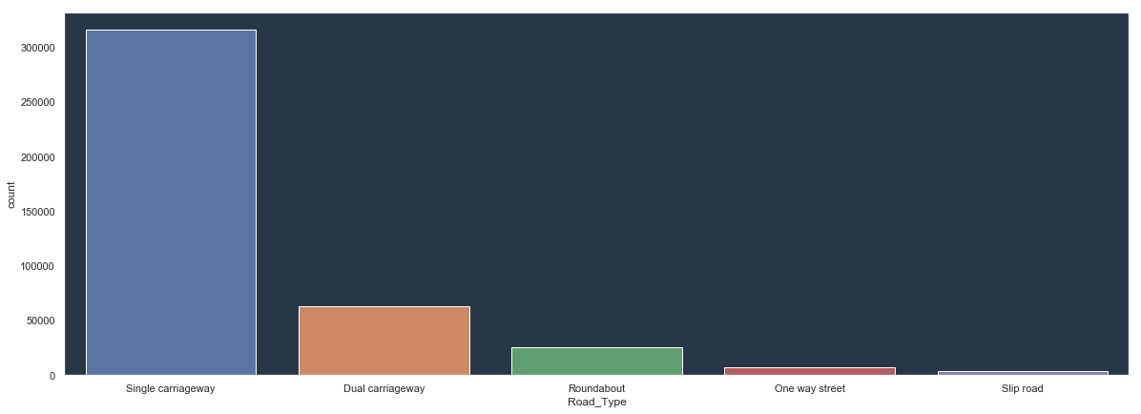

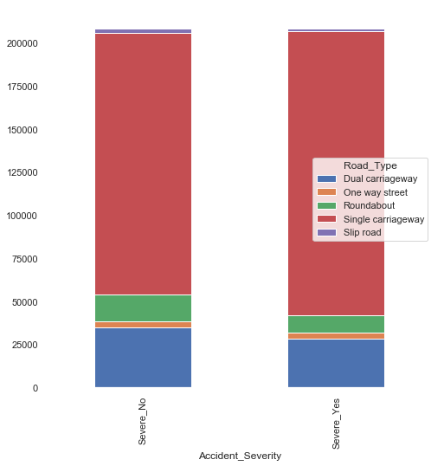

Majority of roads are with speed limit 30 where 2 times more accidents on roads with speed limit 60 is severe than not.

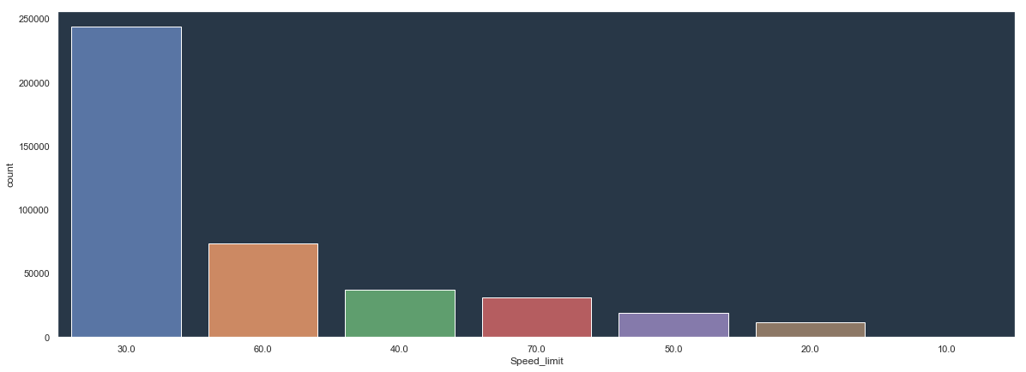

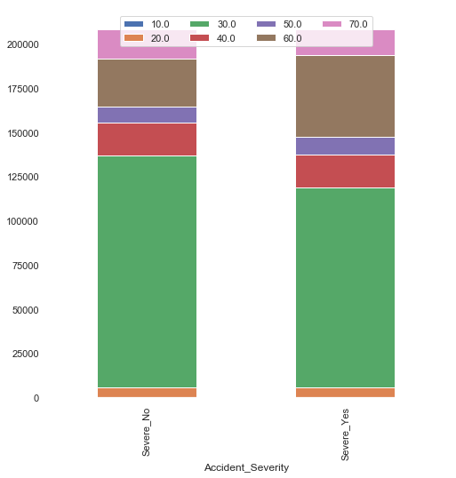

Majority of accidents happened not on junction or 20 miles away from there and on T or staggered junctions. And again 2 times more accidents that happened on roundabouts are not severe.

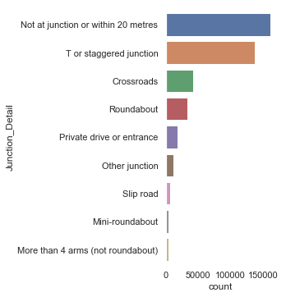

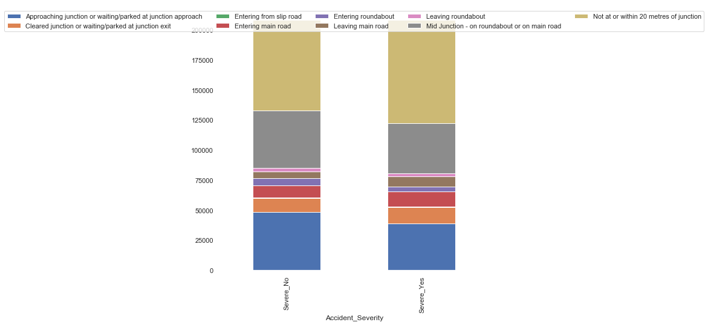

Nearly all cases are classified as Junction Control other. I would recommend removing this variables from the model

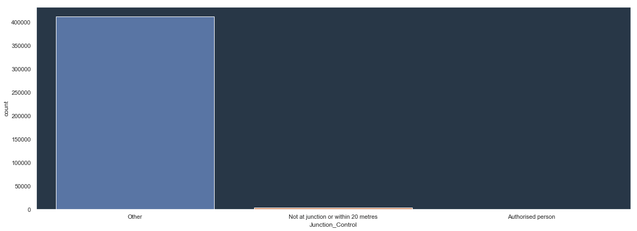

Majority of Roads has 2nd Road Class Unclassified. And 2 times more accidents on raods category A are not severe.

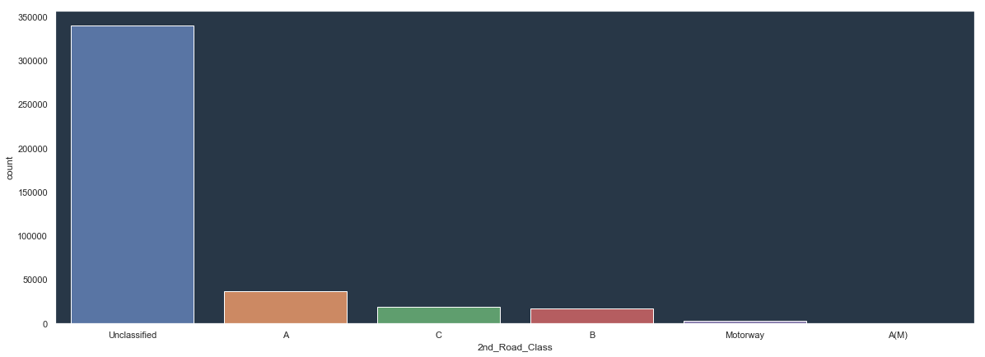

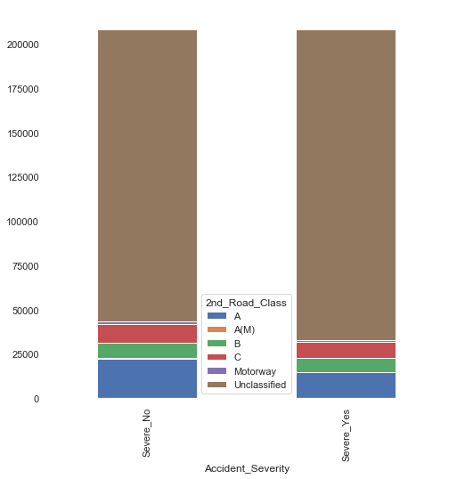

Nearly all of the cases has not Pedestrian_Crossing-Human_Control I would recommend to remove this variable

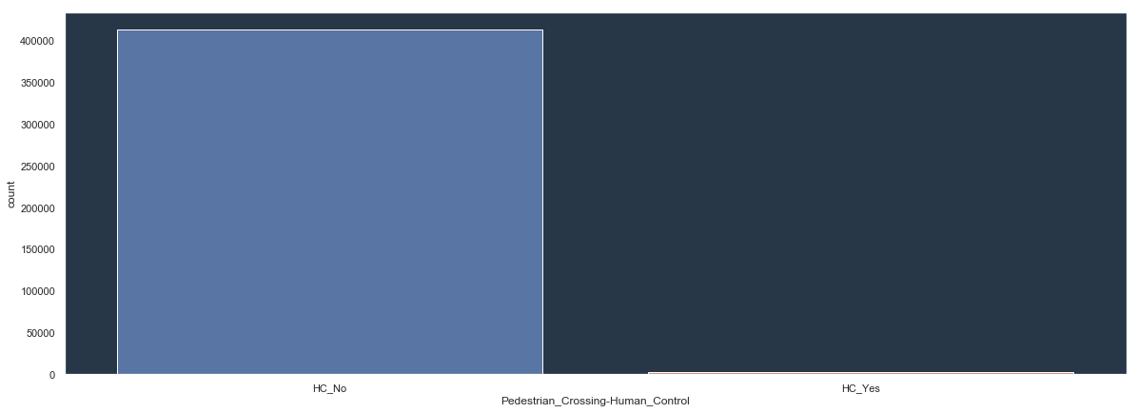

Majority of cases has not Pedestrian_Crossing-Physical_Facilities but less accidents that do have it are severe:

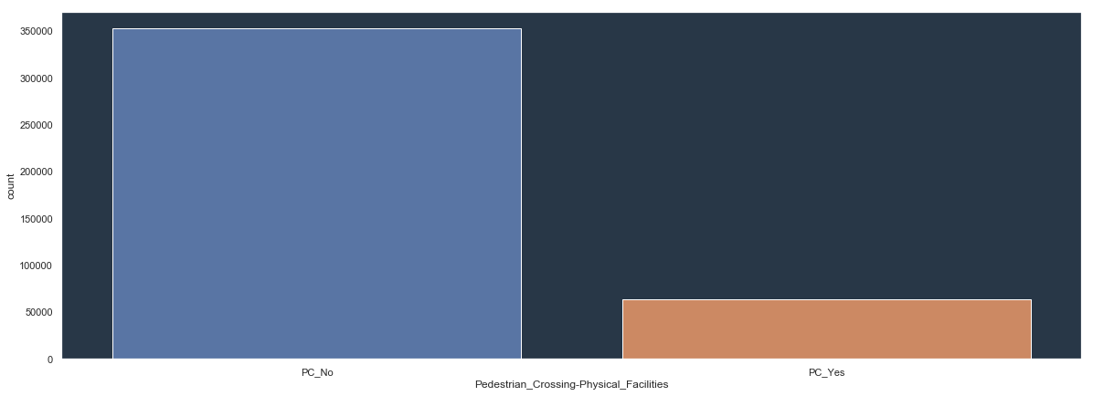

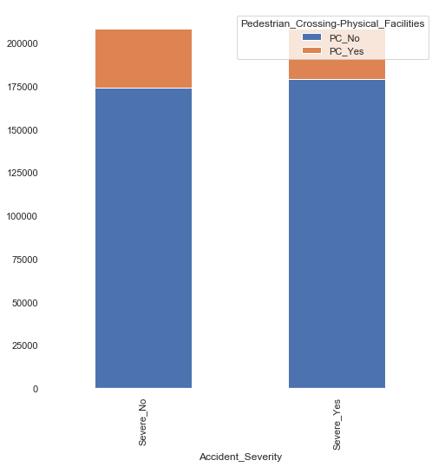

Majority of cases happened when was daylight but two times more accidents where severe when there was darkness – no lightning

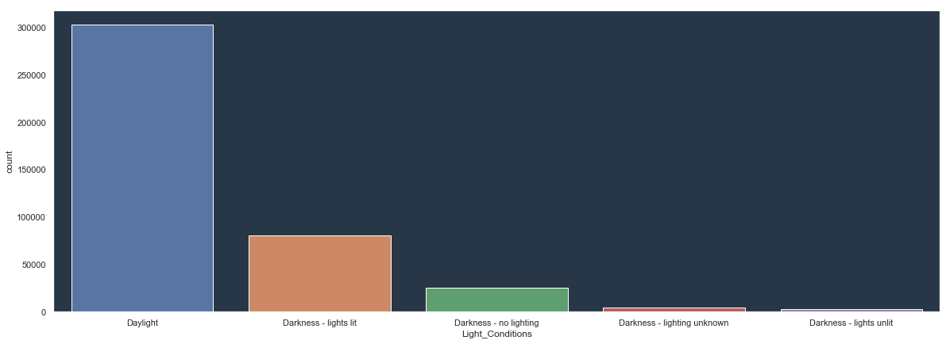

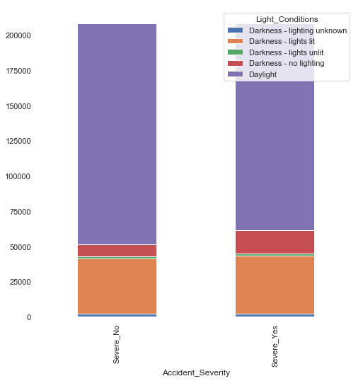

Majority of accidents were when there was good weather with no high winds

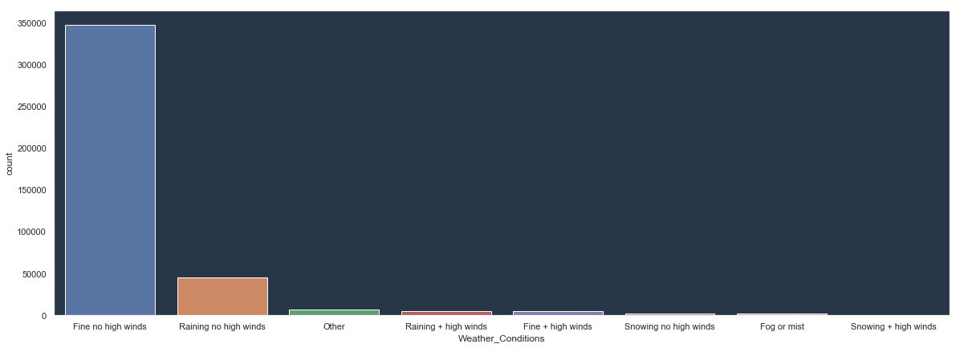

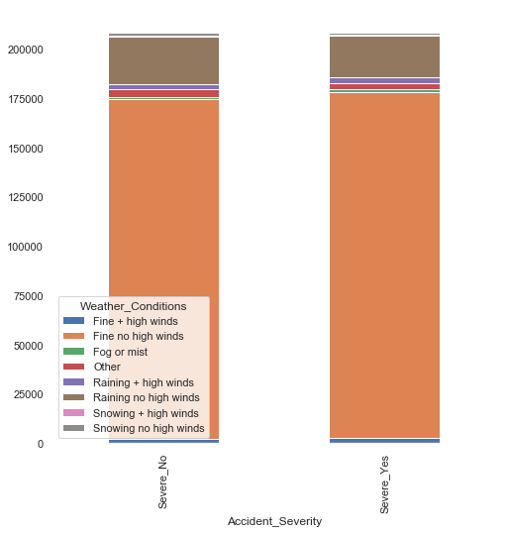

Majority of cases when there was Dry Road surface

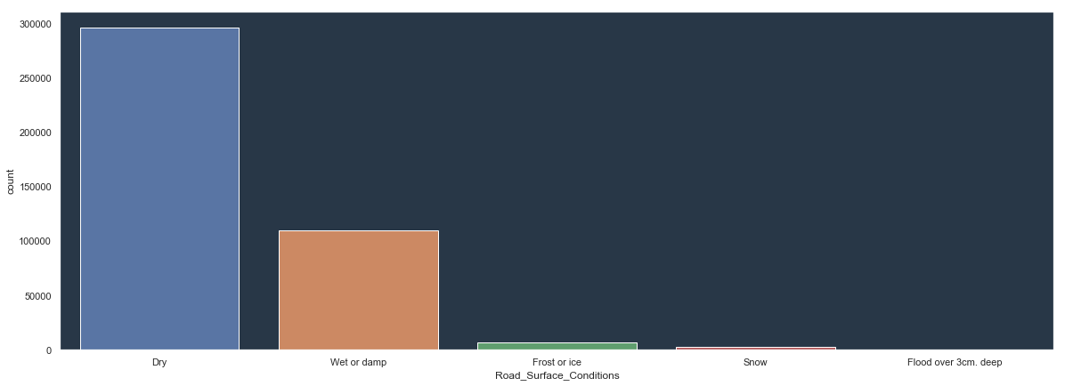

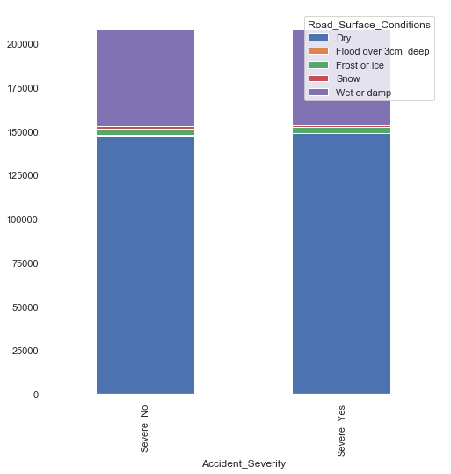

Nearly all accidents didn’t have special control on road side. I would recommend to remove this variable

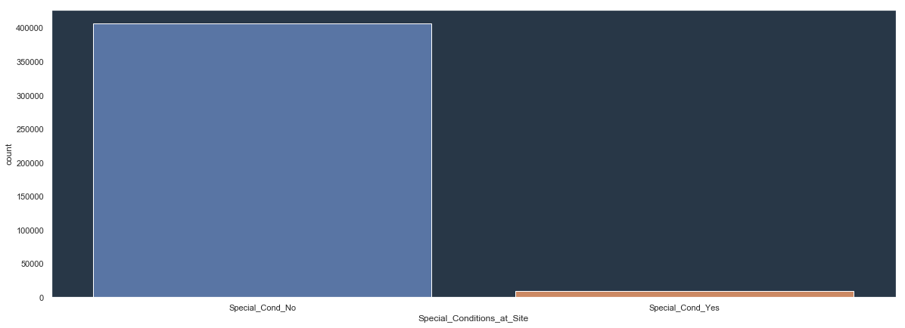

Nearly all cases didn’t have carriage hazards. I would recommend to remove this variable

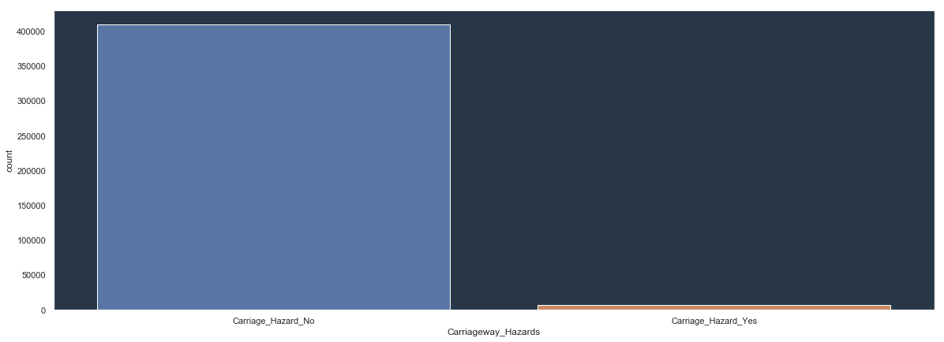

Majority of cases happened on Urban areas but more cases are severe when it happens on rural rather than not.

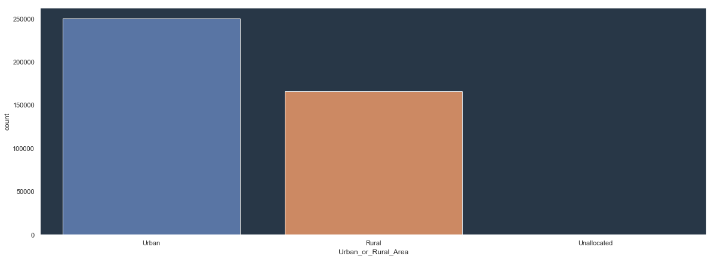

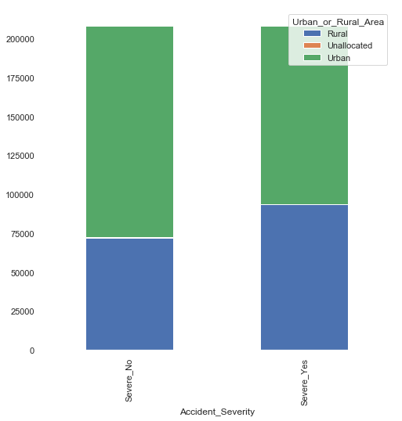

For majority of cases did attend police officer

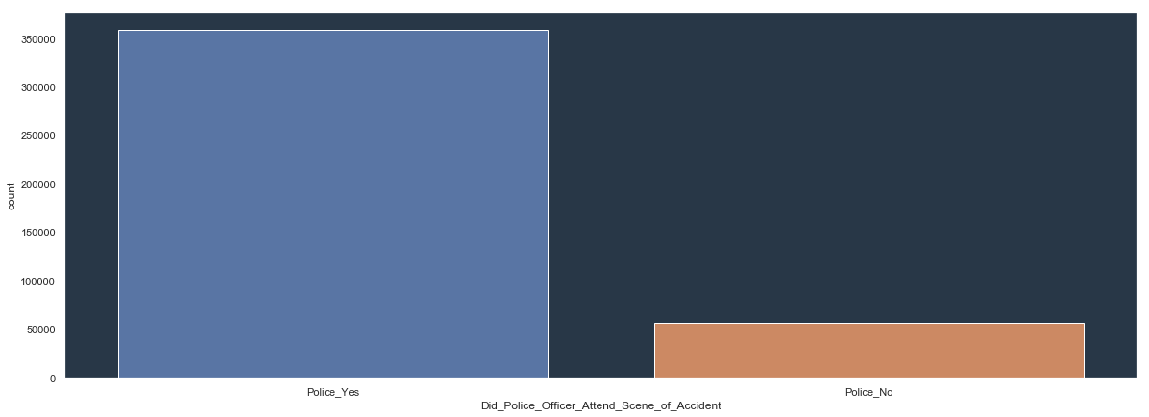

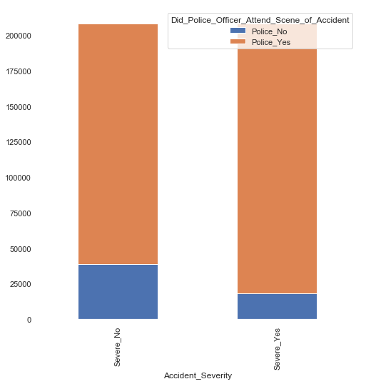

Majority of cases didn’t have restricted line. I would recommend to remove this variable

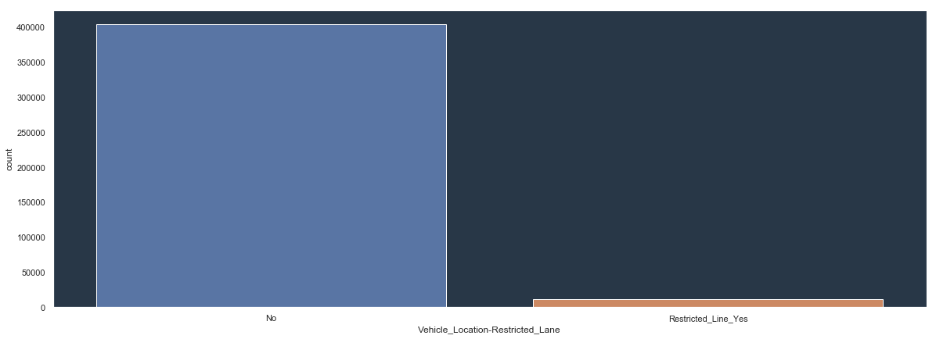

Majority of cases has 1st road class A

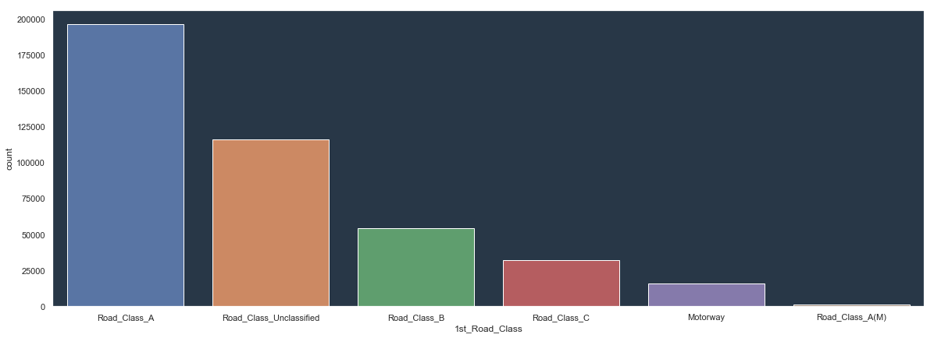

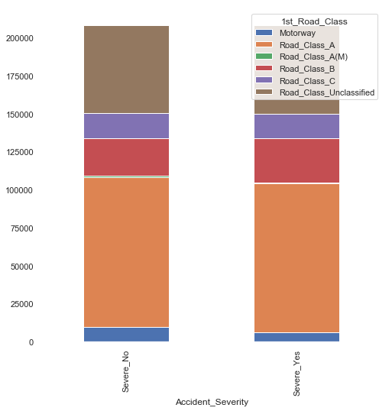

Summary of the most interesting points:

* Majority of accidents are with vehicle going ahead other but accidents when turning left are more severe than those were turning right.
* Majority of accidents were when vehicle was not leaving carriageway but more cases when it happened was with severe accidents rather than not.
* Majority of incidence 1st point of impact was front and more often the accident is severe when it hits in front in comparison to when it hits at the back.
* Majority of Accident records are with men and accidents when men is a driver are more severe when it’s women.
* Majority of accidents are when there was no skidding and more severe accidents are when there is skidding rather than not.
* The majority of data comes from Metropolitan Police district but majority of accidents from there are not severe
* The biggest number of accidents recorded on Friday when Sunday is the safest day to travel
* The most popular Road Type in Britain is Single Carriageway. Majority of accidents on roundabouts and dual carriageways are not severe.
* Majority of roads are with speed limit 30 where 2 times more accidents on roads with speed limit 60 is severe than not.
* Majority of accidents happened not on junction or 20 miles away from there and on T or staggered junctions. And again 2 times more accidents that happened on roundabouts are not severe.
* Majority of Roads has 2nd Road Class Unclassified. And 2 times more accidents on raods category A are not severe.
* Majority of cases happened when was daylight but two times more accidents where severe when there was darkness – no lightning
* Majority of accidents were when there was good weather with no high winds
* Majority of cases when there was Dry Road surface
* Majority of cases happened on Urban areas but more cases are severe when it happens on rural rather than not.