LABORATORIYA ISHI №4
Mavzu: PHP orqali MySQL ma’lumotlar bazasiga ulanish

1. Ishning maqsadi
- Tayyor MySQL bazaga PHP orqali ulanish
- SELECT so‘rovlarini bajarish
- INNER JOIN orqali bir nechta jadval ma’lumotlarini chiqarish
- MySQLi (procedural, OOP) va PDO usullarini taqqoslash
- Ular orasidagi farqlarni amaliy ko‘rsatish

2. Nazariy qism
PHP orqali MySQL bilan ishlashning 3 asosiy usuli mavjud:
- MySQLi (Procedural)
- MySQLi (Object-Oriented)
- PDO (PHP Data Objects)


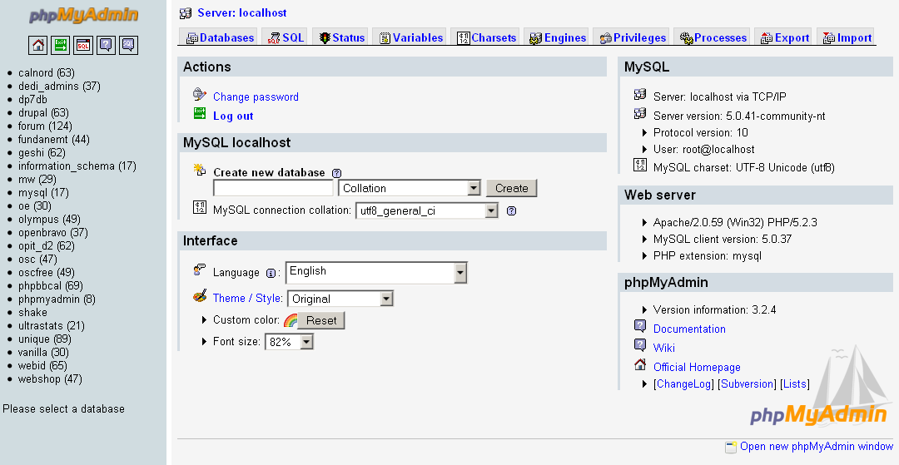

3. Amaliy baza (tayyor database)
Database: db_universitet
3 ta jadval:
fakultetlar
- id (PK)
- nomi
talabalar
- id (PK)
- ism
- kurs
- fakultet_id (FK)
fanlar
- id (PK)
- fan_nomi
- kredit
- talaba_id (FK)

4. Oddiy SELECT so‘rovi
SELECT * FROM talabalar;

5. JOIN so‘rovi
SELECT
talabalar.ism,
talabalar.kurs,
fakultetlar.nomi AS fakultet,
fanlar.fan_nomi
FROM talabalar
INNER JOIN fakultetlar ON talabalar.fakultet_id = fakultetlar.id
INNER JOIN fanlar ON talabalar.id = fanlar.talaba_id;

6. PHP orqali ulanish usullari
6.1 MySQLi – Procedural usul
<?php
$conn = mysqli_connect("localhost", "root", "", "db_universitet");
if (!$conn) {
die("Ulanish xatoligi: " . mysqli_connect_error());
}
$sql = "SELECT * FROM talabalar";
$result = mysqli_query($conn, $sql);
while ($row = mysqli_fetch_assoc($result)) {
echo $row['ism'] . " - " . $row['kurs'] . "<br>";
}
mysqli_close($conn);
?>
Xususiyatlari:
- Oddiy
- Faqat MySQL bilan ishlaydi
- Xavfsizlik PDO ga qaraganda pastroq
6.2 MySQLi – Object Oriented usul
<?php
$conn = new mysqli("localhost", "root", "", "db_universitet");
if ($conn->connect_error) {
die("Xatolik: " . $conn->connect_error);
}
$sql = "SELECT * FROM talabalar";
$result = $conn->query($sql);
while ($row = $result->fetch_assoc()) {
echo $row['ism'] . "<br>";
}
$conn->close();
?>
Xususiyatlari:
- OOP yondashuv
- Professionalroq
- Katta loyihalar uchun qulay
6.3 PDO usuli (Tavsiya etiladi)
<?php
try {
$conn = new PDO("mysql:host=localhost;dbname=db_universitet", "root", "");
$conn->setAttribute(PDO::ATTR_ERRMODE, PDO::ERRMODE_EXCEPTION);
$sql = "SELECT * FROM talabalar";
$stmt = $conn->query($sql);
while ($row = $stmt->fetch(PDO::FETCH_ASSOC)) {
echo $row['ism'] . "<br>";
}
} catch(PDOException $e) {
echo "Xatolik: " . $e->getMessage();
}
?>
Xususiyatlari:
- Turli DB lar bilan ishlaydi (MySQL, PostgreSQL, Oracle)
- Eng xavfsiz
- Prepared Statement kuchli
- try-catch bilan ishlaydi

7. PDO orqali JOIN misoli
<?php
try {
$conn = new PDO("mysql:host=localhost;dbname=db_universitet", "root", "");
$conn->setAttribute(PDO::ATTR_ERRMODE, PDO::ERRMODE_EXCEPTION);
$sql = "SELECT
talabalar.ism,
talabalar.kurs,
fakultetlar.nomi AS fakultet,
fanlar.fan_nomi
FROM talabalar
INNER JOIN fakultetlar
ON talabalar.fakultet_id = fakultetlar.id
INNER JOIN fanlar
ON talabalar.id = fanlar.talaba_id";
$stmt = $conn->query($sql);
echo "<table border='1'>";
echo "<tr><th>Ism</th><th>Kurs</th><th>Fakultet</th><th>Fan</th></tr>";
while ($row = $stmt->fetch(PDO::FETCH_ASSOC)) {
echo "<tr>
<td>{$row['ism']}</td>
<td>{$row['kurs']}</td>
<td>{$row['fakultet']}</td>
<td>{$row['fan_nomi']}</td>
</tr>";
}
echo "</table>";
} catch(PDOException $e) {
echo "Xatolik: " . $e->getMessage();
}
?>

8. Usullarni taqqoslash
Xususiyat | MySQLi Procedural | MySQLi OOP | PDO
DB turi | Faqat MySQL | Faqat MySQL | Ko‘p DB
Xavfsizlik | O‘rtacha | Yaxshi | Eng yaxshi
try-catch | Yo‘q | Yo‘q | Bor
Prepared | Bor | Bor | Juda kuchli
Professional | O‘rtacha | Yaxshi | Eng yaxshi

9. Natija
Laboratoriya ishida:
- Tayyor MySQL bazaga ulanish amalga oshirildi
- SELECT so‘rovi bajarildi
- INNER JOIN ishlatildi
- 3 xil PHP usuli taqqoslandi
- PDO eng tavsiya etiladigan usul ekanligi ko‘rsatildi
Topshiriqlar:

12-IT kompaniya tizimi
Database: db_itcompany

Jadvallar:
xodimlar
- id
- ism
- lavozim
loyihalar
- id
- nomi
- boshlanish_sana
vazifalar
- id
- loyiha_id (FK)
- xodim_id (FK)
- vazifa_nomi

Bog‘lanish:
- vazifalar.loyiha_id → loyihalar.id
- vazifalar.xodim_id → xodimlar.id

JOIN vazifa:
Xodim + Loyiha + Vazifa nomi chiqarish.

Talaba nima qiladi?
- PDO ulanish
- 3 jadvalni vazifalar orqali bog‘laydi
- JOIN query yozadi
- Jadval ko‘rinishida chiqaradi

<?php
$host = 'localhost';
$db = 'db_itcompany';
$user = 'root';
$pass = '';
$charset = 'utf8';

$dsn = "mysql:host=$host;dbname=$db;charset=$charset";

try {
$pdo = new PDO($dsn, $user, $pass);
$pdo->setAttribute(PDO::ATTR_ERRMODE, PDO::ERRMODE_EXCEPTION);

$sql = "SELECT
xodimlar.ism,
xodimlar.lavozim,
loyihalar.nomi AS loyiha_nomi,
vazifalar.vazifa_nomi
FROM vazifalar
JOIN xodimlar ON vazifalar.xodim_id = xodimlar.id
JOIN loyihalar ON vazifalar.loyiha_id = loyihalar.id";

$stmt = $pdo->query($sql);
$rows = $stmt->fetchAll(PDO::FETCH_ASSOC);

} catch (PDOException $e) {
die("Xatolik: " . $e->getMessage());
}
?>

<!DOCTYPE html>
<html>
<head>
<meta charset="UTF-8">
<title>IT Company</title>
<style>
table {
border-collapse: collapse;
width: 80%;
margin: 30px auto;
}
th, td {
border: 1px solid #000;
padding: 10px;
text-align: center;
}
th {
background: #f2f2f2;
}
</style>
</head>
<body>

<h2 style="text-align:center;">IT Company - Vazifalar ro'yxati</h2>

<table>
<tr>
<th>Xodim</th>
<th>Lavozim</th>
<th>Loyiha</th>
<th>Vazifa</th>
</tr>

<?php foreach ($rows as $row): ?>
<tr>
<td><?= htmlspecialchars($row['ism']) ?></td>
<td><?= htmlspecialchars($row['lavozim']) ?></td>
<td><?= htmlspecialchars($row['loyiha_nomi']) ?></td>
<td><?= htmlspecialchars($row['vazifa_nomi']) ?></td>
</tr>
<?php endforeach; ?>

</table>

</body>
</html>
