6-Lobaratoriya.PHP orqali CRUD (Create, Read, Update, Delete) amallarini bajarish

Ishdan maqsad
- PHP va MySQL yordamida ma’lumotlar bazasi bilan ishlashni o‘rganish
- CRUD (Create, Read, Update, Delete) amallarini amalda bajarish
- HTML forma orqali ma’lumotlarni kiritish va qayta ishlash
- Ma’lumotlar bazasidagi yozuvlarni chiqarish, tahrirlash va o‘chirish

Kerakli dasturiy vositalar
- XAMPP / OpenServer / Denwer
- PHP 7.x yoki yuqori
- MySQL
- Brauzer (Chrome, Edge va h.k.)
- Kod muharriri (VS Code, Sublime va boshqalar)

Nazariy qism
CRUD tushunchasi
CRUD – bu ma’lumotlar bazasida bajariladigan 4 asosiy amal:
Amal | Tavsif
Create | Yangi ma’lumot qo‘shish
Read | Ma’lumotlarni o‘qish (ko‘rish)
Update | Ma’lumotni tahrirlash
Delete | Ma’lumotni o‘chirish

1-qadam: Ma’lumotlar bazasini yaratish
phpMyAdmin orqali quyidagi SQL so‘rovni bajaring:
CREATE DATABASE talaba_db;
USE talaba_db;
CREATE TABLE talabalar (
id INT AUTO_INCREMENT PRIMARY KEY,
ism VARCHAR(50) NOT NULL,
familiya VARCHAR(50) NOT NULL,
yosh INT NOT NULL
);

2-qadam: Loyihaning fayl tuzilmasi
crud/
│
├── db.php
├── index.php
├── add.php
├── edit.php
├── delete.php

3-qadam: Ma’lumotlar bazasiga ulanish (db.php)
<?php
$conn = new mysqli("localhost", "root", "", "talaba_db");
if ($conn->connect_error) {
die("Ulanishda xatolik: " . $conn->connect_error);
}
?>

4-qadam: CREATE – Ma’lumot qo‘shish (add.php)
<?php
include 'db.php';
if(isset($_POST['submit'])){
$ism = $_POST['ism'];
$familiya = $_POST['familiya'];
$yosh = $_POST['yosh'];
$sql = "INSERT INTO talabalar (ism, familiya, yosh)
VALUES ('$ism', '$familiya', '$yosh')";
$conn->query($sql);
header("Location: index.php");
}
?>
<form method="POST">
Ism: <input type="text" name="ism"><br>
Familiya: <input type="text" name="familiya"><br>
Yosh: <input type="number" name="yosh"><br>
<button type="submit" name="submit">Saqlash</button>
</form>

5-qadam: READ – Ma’lumotlarni chiqarish (index.php)
<?php include 'db.php'; ?>
<a href="add.php">Yangi talaba qo‘shish</a>
<table border="1">
<tr>
<th>ID</th>
<th>Ism</th>
<th>Familiya</th>
<th>Yosh</th>
<th>Amallar</th>
</tr>
<?php
$result = $conn->query("SELECT * FROM talabalar");
while($row = $result->fetch_assoc()){
echo "<tr>
<td>{$row['id']}</td>
<td>{$row['ism']}</td>
<td>{$row['familiya']}</td>
<td>{$row['yosh']}</td>
<td>
<a href='edit.php?id={$row['id']}'>Tahrirlash</a>
<a href='delete.php?id={$row['id']}'>O‘chirish</a>
</td>
</tr>";
}
?>
</table>

6-qadam: UPDATE – Ma’lumotni tahrirlash (edit.php)
<?php
include 'db.php';
$id = $_GET['id'];
$result = $conn->query("SELECT * FROM talabalar WHERE id=$id");
$row = $result->fetch_assoc();
if(isset($_POST['update'])){
$ism = $_POST['ism'];
$familiya = $_POST['familiya'];
$yosh = $_POST['yosh'];
$conn->query("UPDATE talabalar
SET ism='$ism', familiya='$familiya', yosh='$yosh'
WHERE id=$id");
header("Location: index.php");
}
?>
<form method="POST">
Ism: <input type="text" name="ism" value="<?php echo $row['ism']; ?>"><br>
Familiya: <input type="text" name="familiya" value="<?php echo $row['familiya']; ?>"><br>
Yosh: <input type="number" name="yosh" value="<?php echo $row['yosh']; ?>"><br>
<button type="submit" name="update">Yangilash</button>
</form>

7-qadam: DELETE – Ma’lumotni o‘chirish (delete.php)
<?php
include 'db.php';
$id = $_GET['id'];
$conn->query("DELETE FROM talabalar WHERE id=$id");
header("Location: index.php");
?>

Topshiriqlar:
12.TOPSHIRIQ: “Qurilish Loyiha”
Database: construction_project_db
Jadval: site_projects
Ustunlar:
- project_id
- project_title
- contractor_name
- budget_amount
- start_schedule
- end_schedule
- project_status
- location_area
kod qismi:
add_colums.php
<?php
include 'db.php';

if(isset($_POST['add_column'])){

$count = (int)$_POST['column_count'];

for($i = 1; $i <= $count; $i++){
$column_name = "extra_column_" . time() . "_" . $i;

mysqli_query($conn, "ALTER TABLE site_projects
ADD $column_name VARCHAR(255) NULL");
}
header("Location: index.php");
}
?>

add.php
<?php
include 'db.php';

if(isset($_POST['submit'])){

$title = $_POST['project_title'];
$contractor = $_POST['contractor_name'];
$budget = $_POST['budget_amount'];
$start = $_POST['start_schedule'];
$end = $_POST['end_schedule'];
$status = $_POST['project_status'];
$location = $_POST['location_area'];

mysqli_query($conn, "INSERT INTO site_projects
(project_title, contractor_name, budget_amount, start_schedule, end_schedule, project_status, location_area)
VALUES ('$title','$contractor','$budget','$start','$end','$status','$location')");

$project_id = mysqli_insert_id($conn);

if(!empty($_POST['extra_data'])){
foreach($_POST['extra_data'] as $value){
mysqli_query($conn, "INSERT INTO project_extra_data
(project_id, extra_value)
VALUES ($project_id, '$value')");
}
}

header("Location: index.php");
}
?>

<!DOCTYPE html>
<html>
<head>
<title>Yangi Loyiha</title>
<link rel="stylesheet" href="style.css">
</head>
<body>
<div class="container">
<h1>➕ Yangi Loyiha</h1>

<form method="POST">

<input type="text" name="project_title" placeholder="Loyiha nomi" required>
<input type="text" name="contractor_name" placeholder="Pudratchi nomi" required>
<input type="number" name="budget_amount" placeholder="Byudjet" required>
<input type="date" name="start_schedule" required>
<input type="date" name="end_schedule" required>
<input type="text" name="project_status" placeholder="Status" required>
<input type="text" name="location_area" placeholder="Hudud" required>

<label>Qo‘shimcha maydon soni:</label>
<select id="extraCount" onchange="generateFields()">
<option value="0">0</option>
<option value="1">1</option>
<option value="2">2</option>
<option value="3">3</option>
</select>

<div id="extraFields"></div>

<button type="submit" name="submit" class="add-btn">Saqlash</button>

</form>
</div>

<script>
function generateFields() {
let count = document.getElementById("extraCount").value;
let container = document.getElementById("extraFields");
container.innerHTML = "";

for (let i = 1; i <= count; i++) {
container.innerHTML +=
`<input type="text" name="extra_data[]"
placeholder="Qo‘shimcha ma'lumot ${i}" required>`;
}
}
</script>

</body>
</html>

db.php
<?php
$host = "localhost";
$user = "root";
$password = "";
$database = "construction_project_db";
$conn = mysqli_connect($host, $user, $password, $database);
if (!$conn) {
die("Ulanishda xatolik: " . mysqli_connect_error());
}
?>
delete.php
<?php
include 'db.php';
$id = $_GET['id'];

mysqli_query($conn, "DELETE FROM site_projects WHERE project_id=$id");
header("Location: index.php");
?>

edit.php
<?php
include 'db.php';
$id = $_GET['id'];

$data = mysqli_fetch_assoc(mysqli_query($conn,
"SELECT * FROM site_projects WHERE project_id=$id"));

if(isset($_POST['update'])){
mysqli_query($conn, "UPDATE site_projects SET
project_title='$_POST[project_title]',
contractor_name='$_POST[contractor_name]',
budget_amount='$_POST[budget_amount]',
start_schedule='$_POST[start_schedule]',
end_schedule='$_POST[end_schedule]',
project_status='$_POST[project_status]',
location_area='$_POST[location_area]'
WHERE project_id=$id");

header("Location: index.php");
}
?>

<!DOCTYPE html>
<html>
<head>
<title>Edit Loyiha</title>
<link rel="stylesheet" href="style.css">
</head>
<body>
<div class="container">
<h1>✏ Loyiha Tahrirlash</h1>
<form method="POST">
<input type="text" name="project_title" value="<?= $data['project_title'] ?>" required>
<input type="text" name="contractor_name" value="<?= $data['contractor_name'] ?>" required>
<input type="number" name="budget_amount" value="<?= $data['budget_amount'] ?>" required>
<input type="date" name="start_schedule" value="<?= $data['start_schedule'] ?>" required>
<input type="date" name="end_schedule" value="<?= $data['end_schedule'] ?>" required>
<input type="text" name="project_status" value="<?= $data['project_status'] ?>" required>
<input type="text" name="location_area" value="<?= $data['location_area'] ?>" required>
<button type="submit" name="update" class="edit-btn">Yangilash</button>
</form>
</div>
</body>
</html>

Index.php
<?php
include 'db.php';

if(isset($_POST['save_multiple'])){

foreach($_POST['projects'] as $project){

$title = $project['project_title'];
$contractor = $project['contractor_name'];
$budget = $project['budget_amount'];
$start = $project['start_schedule'];
$end = $project['end_schedule'];
$status = $project['project_status'];
$location = $project['location_area'];

if($title != ""){
mysqli_query($conn, "INSERT INTO site_projects
(project_title, contractor_name, budget_amount, start_schedule, end_schedule, project_status, location_area)
VALUES
('$title','$contractor','$budget','$start','$end','$status','$location')");
}
}

header("Location: index.php");
}
?>
<!DOCTYPE html>
<html>
<head>
<title>Qurilish Loyihalari</title>
<link rel="stylesheet" href="style.css">
</head>
<body>

<div class="container">
<h1>🏗 Qurilish Loyihalari</h1>

<label>Nechta yangi qator qo‘shilsin:</label>
<select id="rowCount" onchange="addRows()">
<option value="0">0</option>
<option value="1">1</option>
<option value="2">2</option>
<option value="3">3</option>
<option value="4">4</option>
</select>

<form method="POST">

<table id="projectTable">
<tr>
<th>ID</th>
<th>Nomi</th>
<th>Pudratchi</th>
<th>Byudjet</th>
<th>Boshlanish</th>
<th>Tugash</th>
<th>Status</th>
<th>Hudud</th>
<th>Amallar</th>
</tr>

<?php
$result = mysqli_query($conn, "SELECT * FROM site_projects");
while($row = mysqli_fetch_assoc($result)){
?>
<tr>
<td><?= $row['project_id'] ?></td>
<td><?= $row['project_title'] ?></td>
<td><?= $row['contractor_name'] ?></td>
<td>$<?= $row['budget_amount'] ?></td>
<td><?= $row['start_schedule'] ?></td>
<td><?= $row['end_schedule'] ?></td>
<td><?= $row['project_status'] ?></td>
<td><?= $row['location_area'] ?></td>
<td>
<a href="delete.php?id=<?= $row['project_id'] ?>" class="btn delete-btn">Delete</a>
</td>
</tr>
<?php } ?>

</table>

<div id="newRows"></div>

<br>
<button type="submit" name="save_multiple" class="add-btn">
Saqlash
</button>

</form>
</div>

<script>
function addRows() {

let count = document.getElementById("rowCount").value;
let container = document.getElementById("newRows");
container.innerHTML = "";

for(let i=0; i<count; i++){

container.innerHTML += `
<table style="margin-top:15px;">
<tr>
<td>Yangi</td>
<td><input type="text" name="projects[${i}][project_title]" placeholder="Loyiha nomi"></td>
<td><input type="text" name="projects[${i}][contractor_name]" placeholder="Pudratchi"></td>
<td><input type="number" name="projects[${i}][budget_amount]" placeholder="Byudjet"></td>
<td><input type="date" name="projects[${i}][start_schedule]"></td>
<td><input type="date" name="projects[${i}][end_schedule]"></td>
<td><input type="text" name="projects[${i}][project_status]" placeholder="Status"></td>
<td><input type="text" name="projects[${i}][location_area]" placeholder="Hudud"></td>
</tr>
</table>
`;
}
}
</script>

</body>
</html>

Style.css
body {
font-family: 'Segoe UI', sans-serif;
background: linear-gradient(135deg, #ff9ecf, #ff4da6);
margin: 0;
padding: 0;
color: white;
}

.container {
width: 90%;
margin: 40px auto;
background: rgba(255, 255, 255, 0.15);
padding: 30px;
border-radius: 20px;
backdrop-filter: blur(15px);
box-shadow: 0 8px 25px rgba(0,0,0,0.2);
}

h1 {
text-align: center;
font-size: 32px;
letter-spacing: 2px;
}

table {
width: 100%;
border-collapse: collapse;
margin-top: 20px;
background: white;
color: #444;
border-radius: 15px;
overflow: hidden;
box-shadow: 0 5px 20px rgba(0,0,0,0.15);
}

table th, table td {
padding: 14px;
text-align: center;
}

table th {
background: linear-gradient(90deg, #ff4da6, #ff1493);
color: white;
font-size: 16px;
}

table tr:nth-child(even) {
background: #ffe6f2;
}

table tr:hover {
background: #ffd6eb;
transition: 0.3s;
}

button, .btn {
padding: 10px 18px;
border: none;
border-radius: 25px;
cursor: pointer;
text-decoration: none;
font-weight: bold;
transition: 0.3s ease;
}

.add-btn {
background: linear-gradient(45deg, #ff66b2, #ff1493);
color: white;
}

.edit-btn {
background: linear-gradient(45deg, #ff99cc, #ff4da6);
color: white;
}

.delete-btn {
background: linear-gradient(45deg, #ff3366, #cc0066);
color: white;
}

button:hover, .btn:hover {
transform: scale(1.08);
box-shadow: 0 5px 15px rgba(0,0,0,0.3);
}

form input, form select {
width: 100%;
padding: 12px;
margin: 10px 0;
border-radius: 12px;
border: none;
outline: none;
}

form input:focus, form select:focus {
box-shadow: 0 0 10px #ff66b2;
}

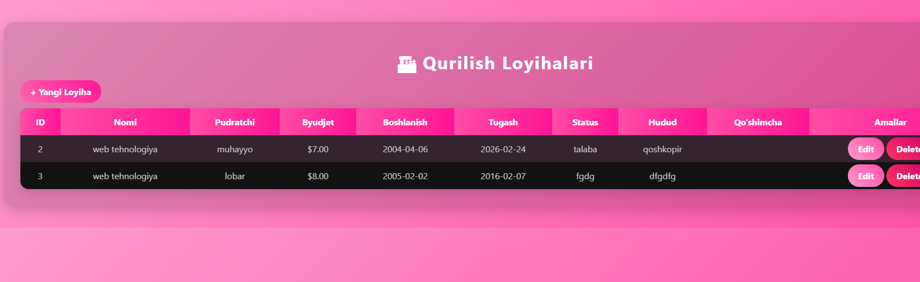
Yangi loyihani yaratish
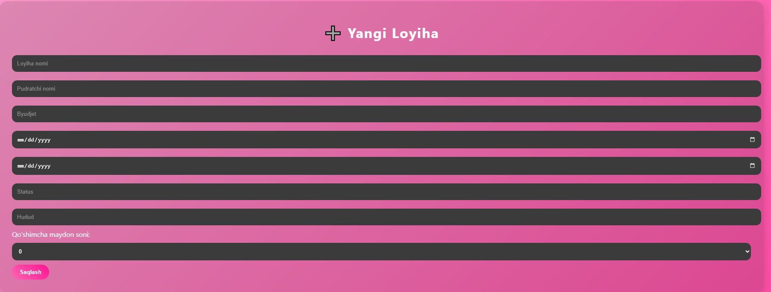
Edit yani tahrirlashni bosganda o’gartirish malumotlarni
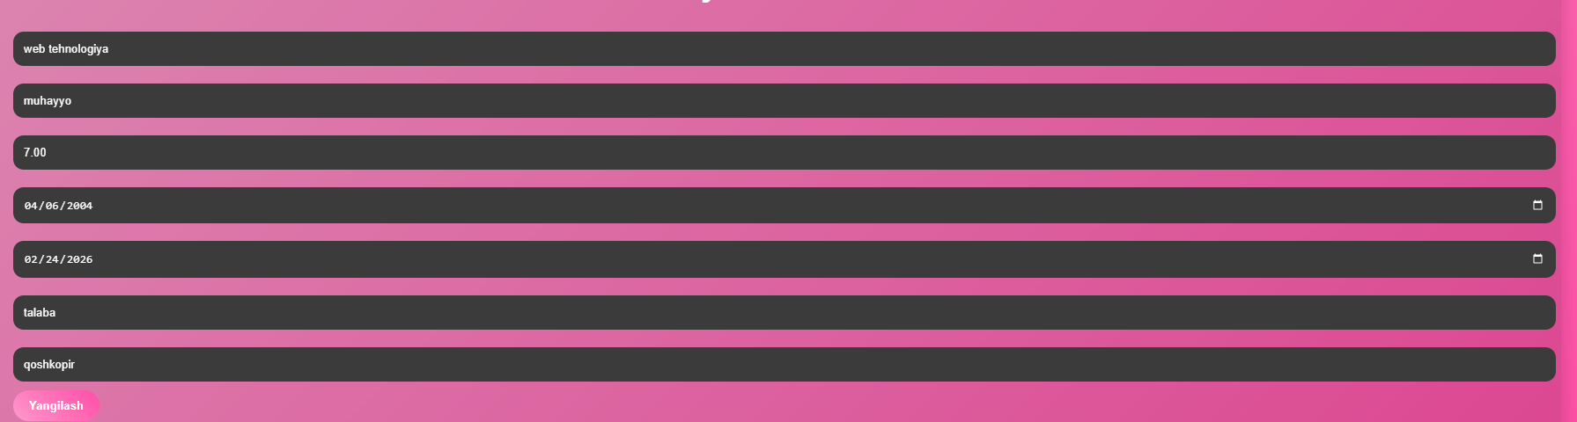
Deletni bosganda ustunni o’chiradi
