Obed Dominguez

AIT 642 / COSC 603

Software Testing and Maintenance

Spring 2016

Project 1 task 3

Task 3 for Project 1

Screenshot of Git course completed

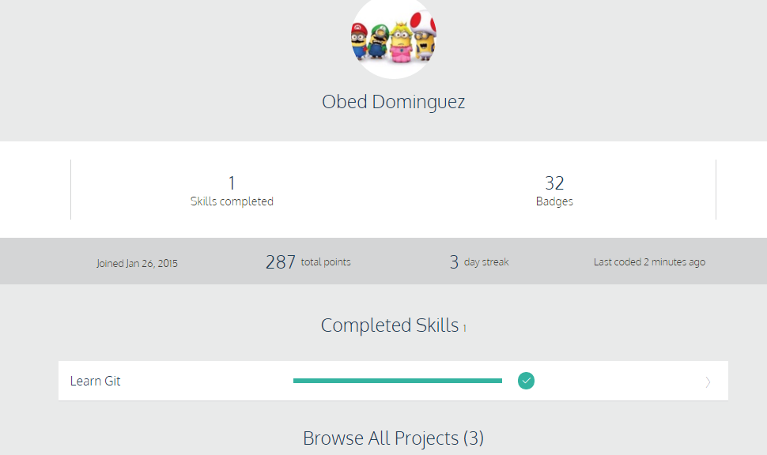

For this task I completed the Git course from Code Academy and learned the general idea of how a version control system works. The provided tutorials for how GitHub works were somewhat helpful, but I searched for additional video tutorials on how to use GitHub. Having the general understanding of how a version control system works is helpful, but I really got to learned it once I started directly working with GitHub. To get better practice for this task, I created a practice repository to play around and learn how GitHub Desktop and GitHub.com interacted with each other.