ODONG FREDRICK ARNOLDS | BU/UP/2025/1557
OKELLO INNOCENT | BU/UP/2025/2135
KERE FRANCIS | BU/UP/2025/5145
ALUM PROSSY FRANCIS | BU/UP/2025/1533
ADONG VIVIAN | BU/UP/2025/1530

1. Newton-Raphson Method

Problem
Find a root of f(x) = x³ − 2x − 5 starting from x0 = 2, correct to 4 decimal places (tol = 0.0001).

Formula
x(n+1) = x(n) − f(x(n)) / f'(x(n)), where f'(x) = 3x² − 2

Solution (iteration table)
I | x0 | f(x0) | f'(x0) | x1 | |x1 − x0|
1 | 2.000000 | −1.000000 | 10.000000 | 2.100000 | 0.100000
2 | 2.100000 | 0.061000 | 11.230000 | 2.094568 | 0.005432
3 | 2.094568 | 0.000186 | 11.161647 | 2.094551 | 0.000017

The error after iteration 3 is 0.000017, which is below 0.0001, so we stop. Root ≈ 2.0946 (more precisely 2.09455).

1.1 Pseudocode using a FOR loop
START
READ x0, tol, N
FOR i = 1 TO N DO
x1 ← x0 − f(x0) / f'(x0)
IF |x1 − x0| < tol THEN
PRINT 'Root =', x1, 'Iterations =', i
STOP
END IF
x0 ← x1
END FOR
PRINT 'No convergence in N iterations'
END

1.2 Pseudocode using a WHILE loop
START
READ x0, tol, N
i ← 1
error ← 1
WHILE error > tol AND i ≤ N DO
x1 ← x0 − f(x0) / f'(x0)
error ← |x1 − x0|
x0 ← x1
i ← i + 1
END WHILE
PRINT 'Root =', x0, 'Iterations =', i − 1
END

1.3 Flowchart: Newton-Raphson with a FOR loop
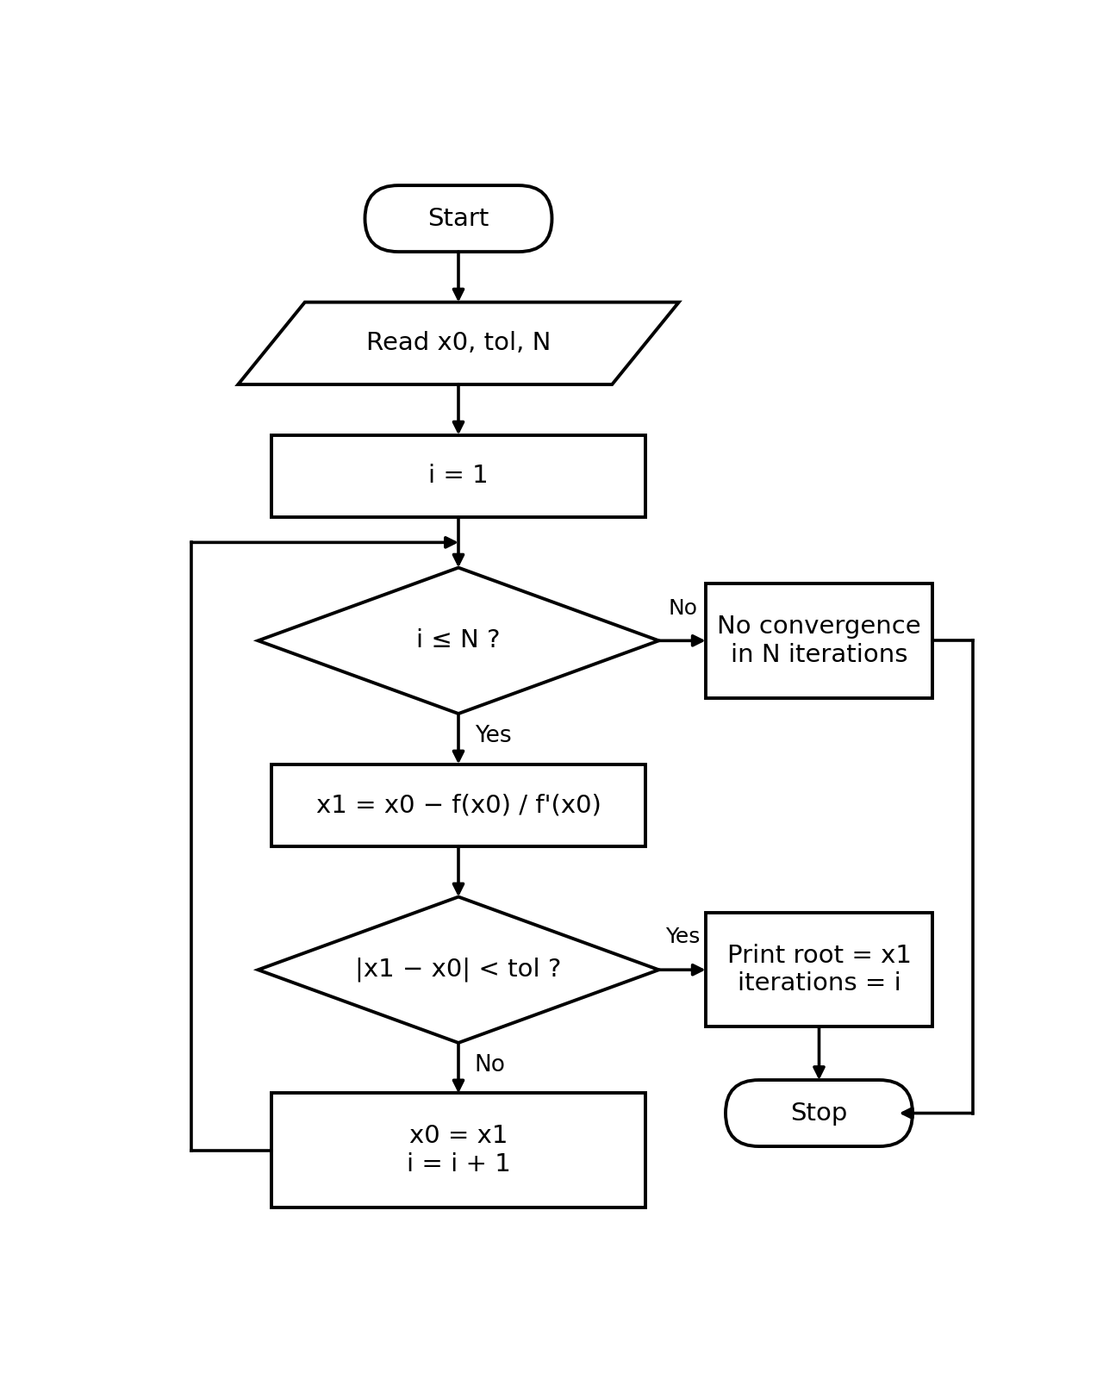

1.4 Flowchart: Newton-Raphson with a WHILE loop
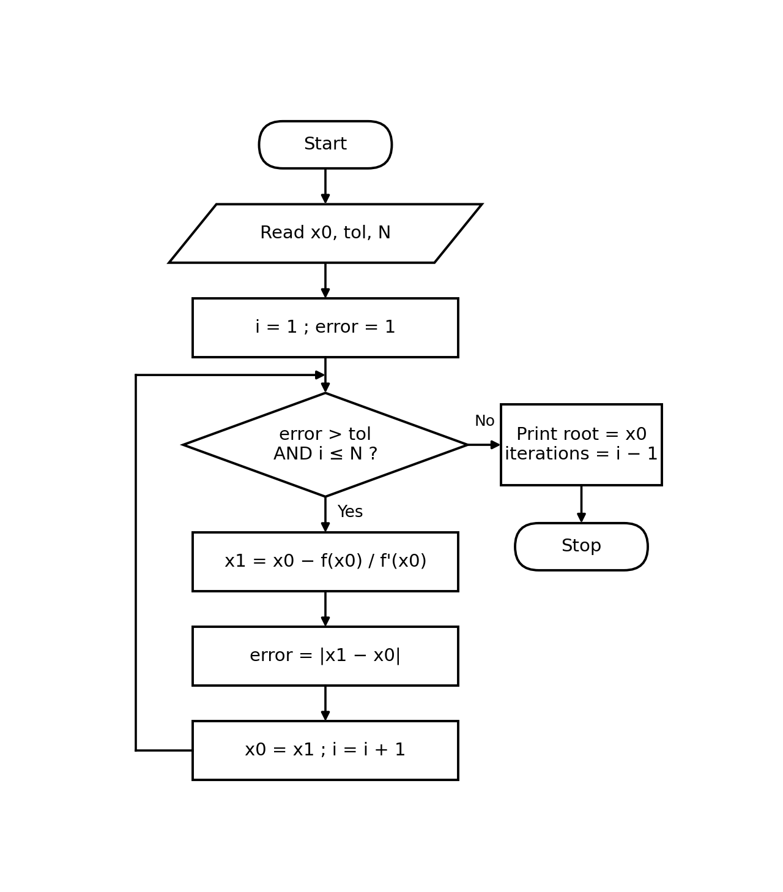

2. Secant Method

Problem
Find a root of f(x) = cos(x) − x using the two starting values x0 = 0.5 and x1 = 1, correct to 4 decimal places (tol = 0.0001). Angles are in radians.

Formula
x2 = x1 − f(x1)·(x1 − x0) / (f(x1) − f(x0))
.

Solution (iteration table)
I | x0 | x1 | f(x0) | f(x1) | x2 | |x2 − x1|
1 | 0.500000 | 1.000000 | 0.377583 | −0.459698 | 0.725482 | 0.274518
2 | 1.000000 | 0.725482 | −0.459698 | 0.022698 | 0.738399 | 0.012917
3 | 0.725482 | 0.738399 | 0.022698 | 0.001149 | 0.739087 | 0.000689
4 | 0.738399 | 0.739087 | 0.001149 | −0.000003 | 0.739085 | 0.000002

2.1 Pseudocode using a FOR loop
START
READ x0, x1, tol, N
FOR i = 1 TO N DO
f0 ← f(x0); f1 ← f(x1)
x2 ← x1 − f1· (x1 − x0) / (f1 − f0)
IF |x2 − x1| < tol THEN
PRINT 'Root =', x2, 'Iterations =', i
STOP
END IF
x0 ← x1; x1 ← x2
END FOR
PRINT 'No convergence in N iterations'
END

2.2 Pseudocode using a WHILE loop
START
READ x0, x1, tol, N
i ← 1
error ← 1
WHILE error > tol AND i ≤ N DO
f0 ← f(x0); f1 ← f(x1)
x2 ← x1 − f1· (x1 − x0) / (f1 − f0)
error ← |x2 − x1|
x0 ← x1; x1 ← x2
i ← i + 1
END WHILE
PRINT 'Root =', x1, 'Iterations =', i − 1
END

2.3 Flowchart: Secant with a FOR loop
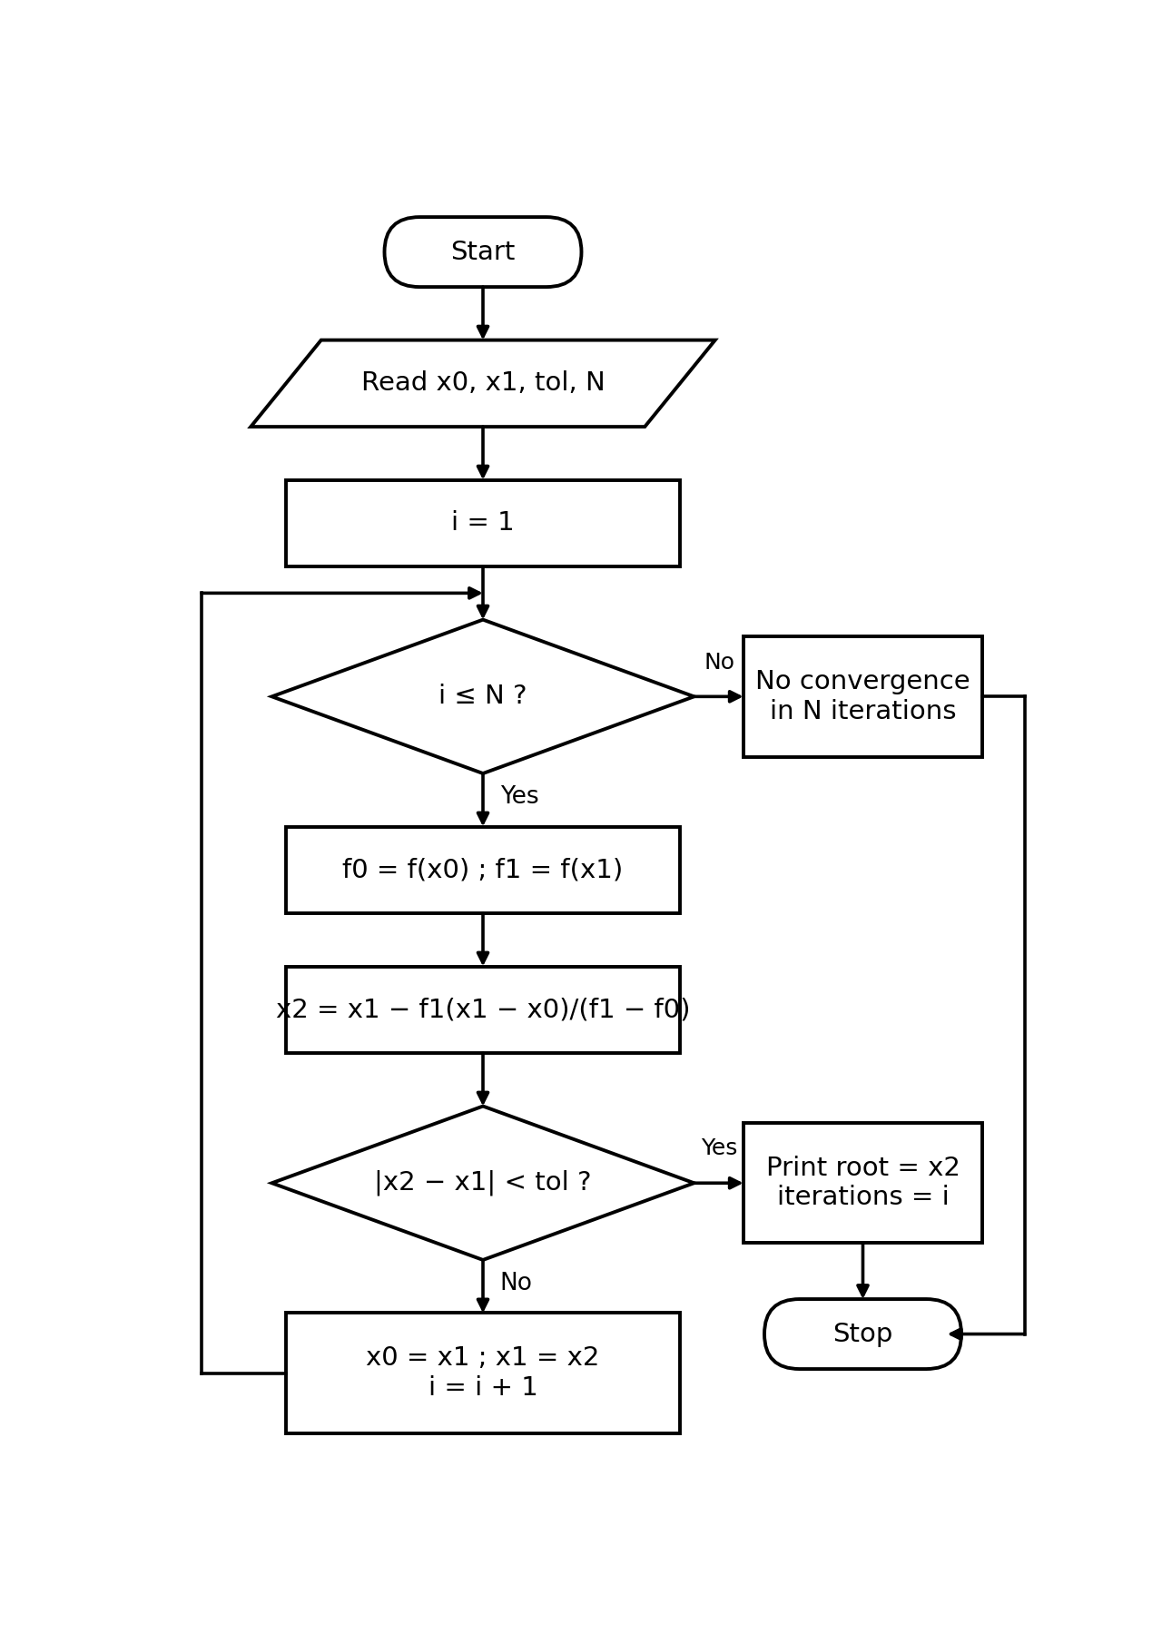

2.4 Flowchart: Secant with a WHILE loop
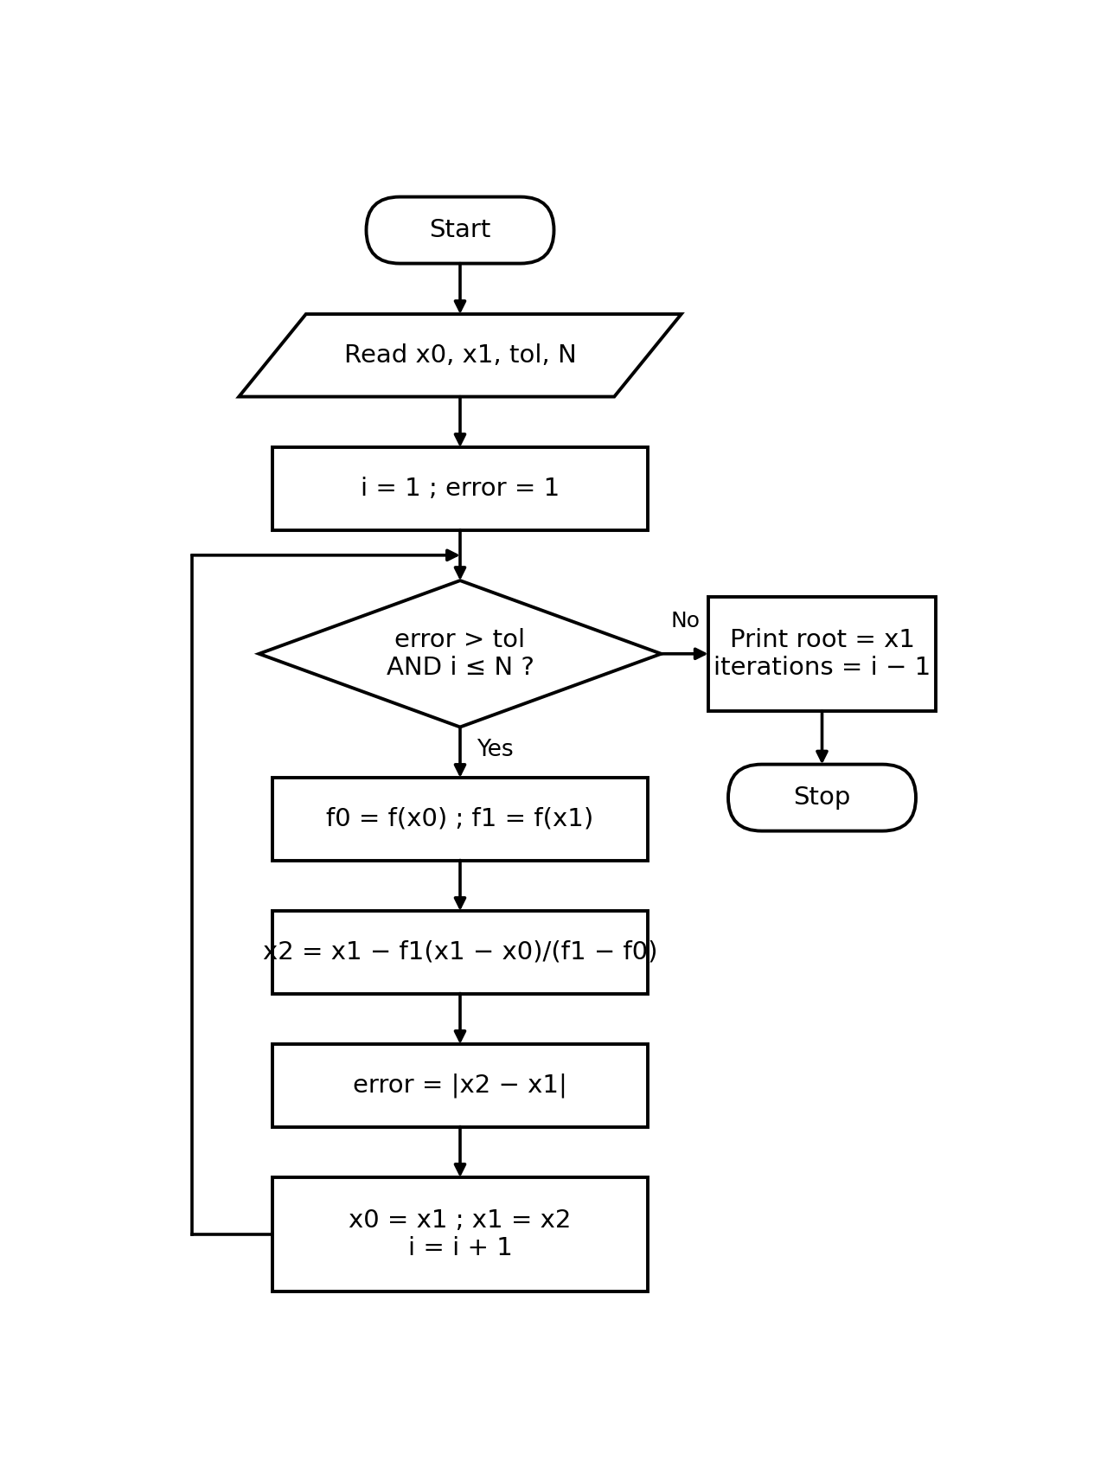

3. Runge-Kutta Method (4th order)

Problem
Solve dy/dx = x + y with y(0) = 1, using step size h = 0.1, and find y(0.2). (Exact answer: y = 2eˣ − x − 1, so y (0.2) = 1.242806.)

Formula
k1 = h·f (x, y); k2 = h·f (x + h/2, y + k1/2); k3 = h·f (x + h/2, y + k2/2); k4 = h·f (x + h, y + k3); y(new) = y + (k1 + 2k2 + 2k3 + k4)/6

Solution (iteration table)
Step | x | y | k1 | k2 | k3 | k4 | y(new)
1 | 0.0 | 1.000000 | 0.100000 | 0.110000 | 0.110500 | 0.121050 | 1.110342
2 | 0.1 | 1.110342 | 0.121034 | 0.132086 | 0.132638 | 0.144298 | 1.242805

After two steps, y(0.2) ≈ 1.242805. The exact value is 1.242806, so the error is only about 0.000001.

3.1 Pseudocode using a FOR loop
START
READ x0, y0, h, n
x ← x0; y ← y0
FOR i = 1 TO n DO
k1 ← h·f (x, y)
k2 ← h·f (x + h/2, y + k1/2)
k3 ← h·f (x + h/2, y + k2/2)
k4 ← h·f (x + h, y + k3)
y ← y + (k1 + 2k2 + 2k3 + k4) / 6
x ← x + h
END FOR
PRINT 'x =', x, 'y =', y
END

3.2 Pseudocode using a WHILE loop
START
READ x0, y0, h, xn
x ← x0; y ← y0
WHILE x < xn DO
k1 ← h·f (x, y)
k2 ← h·f (x + h/2, y + k1/2)
k3 ← h·f (x + h/2, y + k2/2)
k4 ← h·f (x + h, y + k3)
y ← y + (k1 + 2k2 + 2k3 + k4) / 6
x ← x + h
END WHILE
PRINT 'x =', x, 'y =', y
END

3.3 Flowchart: Runge-Kutta with a FOR loop
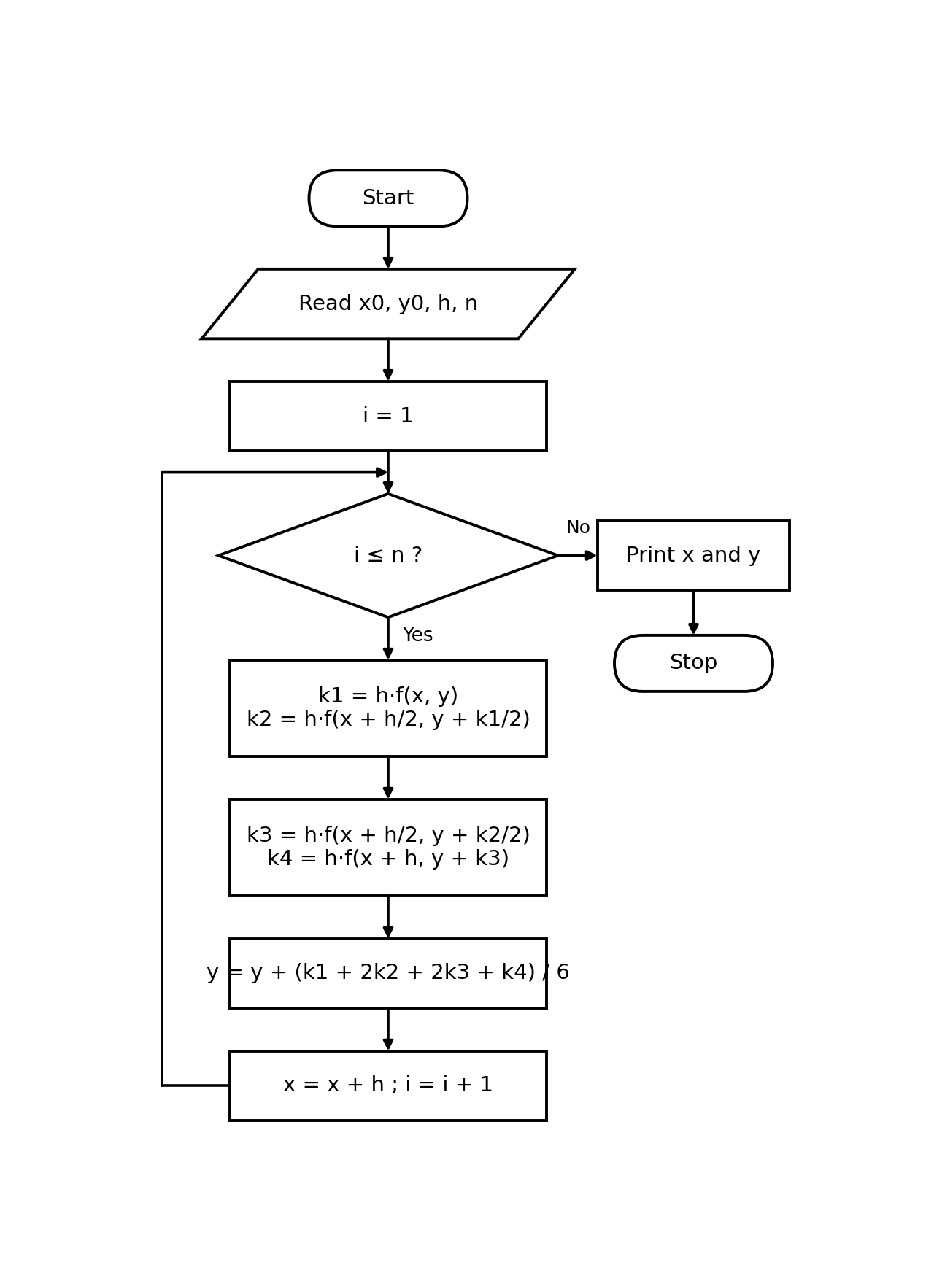

3.4 Flowchart: Runge-Kutta with a WHILE loop


