Homework 5

OMER OZEREN

March 02, 2019

Table of Contents

1. Create a **.CSV** file (or optionally, a **MySQL** database!) that includes all of the information above.  
   You’re encouraged to use a “wide” structure similar to how the information appears above, so that you can practice tidying and transformations as described below.
2. Read the information from your **.CSV** file into **R**, and use **tidyr** and **dplyr** as needed to tidy and transform your data.
3. Perform analysis to compare the arrival delays for the two airlines.
4. Your code should be in an R Markdown file, posted to rpubs.com, and should include narrative descriptions of your data cleanup work, analysis, and conclusions. Please include in your homework submission:

The URL to the **.Rmd** file in your GitHub repository and The URL for your **rpubs.com** web page.

## Library definition

library(stringr)  
library(tidyr)  
library(dplyr)  
library(knitr)  
library(ggplot2)

## (1) Read information from **.CSV** file into R.

For simplicity and reproducibility reasons, I have posted this file on my GitHub repository as follows:

**GitHub URL**

url <- "https://raw.githubusercontent.com/omerozeren/DATA607/master/HMW_5/airlines.csv"

raw_data <- read.csv(url, header=FALSE, sep=",", stringsAsFactors=FALSE)  
raw_data <- data.frame(raw_data)  
raw_data

## V1 V2 V3 V4 V5 V6 V7  
## 1 Los Angeles Phoenix San Diego San Francisco Seatle  
## 2 ALASKA on time 497 221 212 503 1841  
## 3 delayed 62 12 20 102 305  
## 4   
## 5 AM WEST on time 694 4840 383 320 201  
## 6 delayed 117 415 65 129 61

## (2) Renaming Column headers

# Adding "Missing" titles from original file onto the Row #1  
raw_data$V1[1] <- "Airline"  
raw_data$V2[1] <- "Status"  
# Assigning all the values from the row #1 as the Column Headers  
names(raw_data) <- raw_data[1,]  
# Need to eliminate Row #1 in order to keep data consistency.  
raw_data <-raw_data[-c(1), ]

Table displaying correct column titles.

|  |  |  |  |  |  |  |  |
| --- | --- | --- | --- | --- | --- | --- | --- |
|  | Airline | Status | Los Angeles | Phoenix | San Diego | San Francisco | Seatle |
| 2 | ALASKA | on time | 497 | 221 | 212 | 503 | 1841 |
| 3 |  | delayed | 62 | 12 | 20 | 102 | 305 |
| 4 |  |  |  |  |  |  |  |
| 5 | AM WEST | on time | 694 | 4840 | 383 | 320 | 201 |
| 6 |  | delayed | 117 | 415 | 65 | 129 | 61 |

## (3) Eliminating Empty rows with **“NA”** values

For this, I have to transform our data as follows:

## 'data.frame': 5 obs. of 7 variables:  
## $ Airline : chr "ALASKA" "" "" "AM WEST" ...  
## $ Status : chr "on time" "delayed" "" "on time" ...  
## $ Los Angeles : chr "497" "62" "" "694" ...  
## $ Phoenix : chr "221" "12" "" "4840" ...  
## $ San Diego : chr "212" "20" "" "383" ...  
## $ San Francisco: chr "503" "102" "" "320" ...  
## $ Seatle : chr "1841" "305" "" "201" ...

Procedure to transform values into integers

for (i in 3:dim(raw_data)[2]){  
 raw_data[,i] <- as.integer(raw_data[,i])  
}

Preview of data after transformation

## 'data.frame': 5 obs. of 7 variables:  
## $ Airline : chr "ALASKA" "" "" "AM WEST" ...  
## $ Status : chr "on time" "delayed" "" "on time" ...  
## $ Los Angeles : int 497 62 NA 694 117  
## $ Phoenix : int 221 12 NA 4840 415  
## $ San Diego : int 212 20 NA 383 65  
## $ San Francisco: int 503 102 NA 320 129  
## $ Seatle : int 1841 305 NA 201 61

Procedure to eliminate all the **NA** lines from our original file by employing **drop_na()**

raw_data <- raw_data %>% drop_na()

|  |  |  |  |  |  |  |  |
| --- | --- | --- | --- | --- | --- | --- | --- |
|  | Airline | Status | Los Angeles | Phoenix | San Diego | San Francisco | Seatle |
| 2 | ALASKA | on time | 497 | 221 | 212 | 503 | 1841 |
| 3 |  | delayed | 62 | 12 | 20 | 102 | 305 |
| 5 | AM WEST | on time | 694 | 4840 | 383 | 320 | 201 |
| 6 |  | delayed | 117 | 415 | 65 | 129 | 61 |

## (4) Adding missing Airline name to “delayed” row

for (i in 1:dim(raw_data)[1]){  
 if (i %% 2 == 0){  
 raw_data$Airline[i] <- raw_data$Airline[i-1]  
 }  
}

Final completed table in order to start employing **tidy** transformations for further analysis.

|  |  |  |  |  |  |  |  |
| --- | --- | --- | --- | --- | --- | --- | --- |
|  | Airline | Status | Los Angeles | Phoenix | San Diego | San Francisco | Seatle |
| 2 | ALASKA | on time | 497 | 221 | 212 | 503 | 1841 |
| 3 | ALASKA | delayed | 62 | 12 | 20 | 102 | 305 |
| 5 | AM WEST | on time | 694 | 4840 | 383 | 320 | 201 |
| 6 | AM WEST | delayed | 117 | 415 | 65 | 129 | 61 |

## (5) Analysis

**First:** we need to transform our table by employing **gather()** from **tidyr** library.

# Tidy table by having 4 variables (Airline, Status, City, number of flights)  
flight <- gather(raw_data, City, Flight_Count, 3:7)

|  |  |  |  |
| --- | --- | --- | --- |
| Airline | Status | City | Flight_Count |
| ALASKA | on time | Los Angeles | 497 |
| ALASKA | delayed | Los Angeles | 62 |
| AM WEST | on time | Los Angeles | 694 |
| AM WEST | delayed | Los Angeles | 117 |
| ALASKA | on time | Phoenix | 221 |
| ALASKA | delayed | Phoenix | 12 |
| AM WEST | on time | Phoenix | 4840 |
| AM WEST | delayed | Phoenix | 415 |
| ALASKA | on time | San Diego | 212 |
| ALASKA | delayed | San Diego | 20 |
| AM WEST | on time | San Diego | 383 |
| AM WEST | delayed | San Diego | 65 |
| ALASKA | on time | San Francisco | 503 |
| ALASKA | delayed | San Francisco | 102 |
| AM WEST | on time | San Francisco | 320 |
| AM WEST | delayed | San Francisco | 129 |
| ALASKA | on time | Seatle | 1841 |
| ALASKA | delayed | Seatle | 305 |
| AM WEST | on time | Seatle | 201 |
| AM WEST | delayed | Seatle | 61 |

# grouping by flights  
total_A <- flight %>% group_by(Airline) %>% summarise(Total_Flights = sum(Flight_Count))  
kable(total_A)

|  |  |
| --- | --- |
| Airline | Total_Flights |
| ALASKA | 3775 |
| AM WEST | 7225 |

#### (a) Flights Status by airlines

# Total of flights from each airline that were on time  
on_time_airline <- flight %>% group_by(Airline) %>% filter(Status == 'on time') %>% summarise(Flights_On_Time = sum(Flight_Count))  
kable(on_time_airline)

|  |  |
| --- | --- |
| Airline | Flights_On_Time |
| ALASKA | 3274 |
| AM WEST | 6438 |

# Total of flights from each airline that were delayed.  
delayed_airline <- flight %>% group_by(Airline) %>% filter(Status == 'delayed') %>% summarise(Flights_Delayed = sum(Flight_Count))  
kable(delayed_airline)

|  |  |
| --- | --- |
| Airline | Flights_Delayed |
| ALASKA | 501 |
| AM WEST | 787 |

**Combine delayed and on_time data sets**

# Now will combine all the data set information (including new columns) into data.frame flights.summary  
flights_summary_airline <- cbind(on_time_airline, Flights_Delayed = delayed_airline$Flights_Delayed, Total_Flights = total_A$Total_Flights)  
flights_summary_airline <- flights_summary_airline %>% mutate(Percent_On_Time_airline = Flights_On_Time/Total_Flights, Percent_Delayed_airline = Flights_Delayed/Total_Flights)  
  
kable(flights_summary_airline)

|  |  |  |  |  |  |
| --- | --- | --- | --- | --- | --- |
| Airline | Flights_On_Time | Flights_Delayed | Total_Flights | Percent_On_Time_airline | Percent_Delayed_airline |
| ALASKA | 3274 | 501 | 3775 | 0.8672848 | 0.1327152 |
| AM WEST | 6438 | 787 | 7225 | 0.8910727 | 0.1089273 |

Overall, it appears that AM_West seems to be doing slightly a better job of staying on time. And not to mention, AM West flew more flights than Alaska.

Now I will create two data.frames where one is Alaska Airlines, and the other is AM_West Airlines.

Alaska <- flight %>% filter(Airline == 'ALASKA')  
AM_West <- flight %>% filter(Airline == 'AM WEST')

**Plot:**

my.plot <- barplot(flights_summary_airline$Total_Flights, main="Flights by Airline", xlab="Airline", names.arg=flights_summary_airline$Airline, axes=FALSE, ylim = c(0, max(flights_summary_airline$Total_Flights)+1000))  
# Placing values on top of bars  
text(my.plot, flights_summary_airline$Total_Flights, labels = flights_summary_airline$Total_Flights, pos = 3)

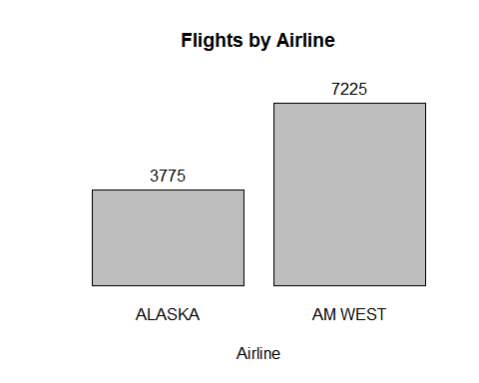

#### (b) Flight Status by City

**grouping by flights**

total_C <- flight %>% group_by(City) %>% summarise(Total_Flights = sum(Flight_Count))  
kable(total_C)

|  |  |
| --- | --- |
| City | Total_Flights |
| Los Angeles | 1370 |
| Phoenix | 5488 |
| San Diego | 680 |
| San Francisco | 1054 |
| Seatle | 2408 |

# Total of flights from each airline that were on time  
on_time_city <- flight %>% group_by(City) %>% filter(Status == 'on time') %>% summarise(Flights_On_Time = sum(Flight_Count))  
kable(on_time_city)

|  |  |
| --- | --- |
| City | Flights_On_Time |
| Los Angeles | 1191 |
| Phoenix | 5061 |
| San Diego | 595 |
| San Francisco | 823 |
| Seatle | 2042 |

# Total of flights from each airline that were delayed.  
delayed_city <- flight %>% group_by(City) %>% filter(Status == 'delayed') %>% summarise(Flights_Delayed = sum(Flight_Count))  
kable(delayed_city)

|  |  |
| --- | --- |
| City | Flights_Delayed |
| Los Angeles | 179 |
| Phoenix | 427 |
| San Diego | 85 |
| San Francisco | 231 |
| Seatle | 366 |

**Now will combine all the data set information (including new columns) into data.frame flights.summary**

flights_summary_city<- cbind(on_time_city, Flights_Delayed = delayed_city$Flights_Delayed, Total_Flights = total_C$Total_Flights)  
flights_summary_city <- flights_summary_city %>% mutate(Percent_On_Time_city = Flights_On_Time/Total_Flights, Percent_Delayed_city = Flights_Delayed/Total_Flights)  
  
kable(flights_summary_city)

|  |  |  |  |  |  |
| --- | --- | --- | --- | --- | --- |
| City | Flights_On_Time | Flights_Delayed | Total_Flights | Percent_On_Time_city | Percent_Delayed_city |
| Los Angeles | 1191 | 179 | 1370 | 0.8693431 | 0.1306569 |
| Phoenix | 5061 | 427 | 5488 | 0.9221939 | 0.0778061 |
| San Diego | 595 | 85 | 680 | 0.8750000 | 0.1250000 |
| San Francisco | 823 | 231 | 1054 | 0.7808349 | 0.2191651 |
| Seatle | 2042 | 366 | 2408 | 0.8480066 | 0.1519934 |

**Plot:**

my.plot <- barplot(flights_summary_city$Total_Flights, main="Flights by Airline", xlab="Airline", names.arg=flights_summary_city$City, axes=FALSE, ylim = c(0, max(flights_summary_city$Total_Flights)+1000))  
# Placing values on top of bars  
text(my.plot, flights_summary_city$Total_Flights, labels = flights_summary_city$Total_Flights, pos = 3)

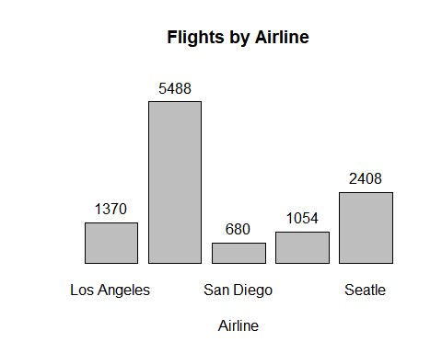

ggplot(flights_summary_city, aes(x = City, y = Percent_On_Time_city)) + geom_point(alpha = 0.5, size = 5, color = 'blue') + labs(title ="cities on time ratio", x = "City", y = "Flights_On_Time_Percent")

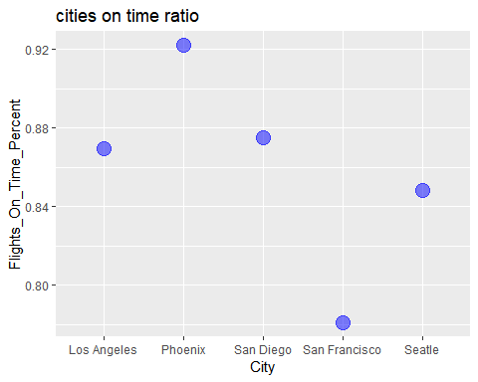

ggplot(flights_summary_city, aes(x = City, y = Percent_Delayed_city)) + geom_point(alpha = 0.5, size = 5, color = 'blue') + labs(title ="cities delayed ratio", x = "City", y = "Percent_Delayed")

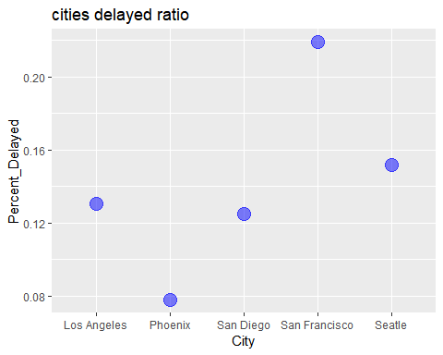

#### (c) Joining tables with horizontal probabilities

spread_data <- flight %>% spread(Status, `Flight_Count`)

main_table <- spread_data %>% subset(select=c(Airline, City))  
airline_table <- flights_summary_airline %>% subset(select=c(Airline, Percent_Delayed_airline,Percent_On_Time_airline))  
city_table <- flights_summary_city %>% subset(select=c(City, Percent_Delayed_city,Percent_On_Time_city))  
main_table <- main_table %>% inner_join(airline_table, by="Airline" )  
main_table <- main_table %>% inner_join(city_table, by="City" )  
kable(main_table)

|  |  |  |  |  |  |
| --- | --- | --- | --- | --- | --- |
| Airline | City | Percent_Delayed_airline | Percent_On_Time_airline | Percent_Delayed_city | Percent_On_Time_city |
| ALASKA | Los Angeles | 0.1327152 | 0.8672848 | 0.1306569 | 0.8693431 |
| ALASKA | Phoenix | 0.1327152 | 0.8672848 | 0.0778061 | 0.9221939 |
| ALASKA | San Diego | 0.1327152 | 0.8672848 | 0.1250000 | 0.8750000 |
| ALASKA | San Francisco | 0.1327152 | 0.8672848 | 0.2191651 | 0.7808349 |
| ALASKA | Seatle | 0.1327152 | 0.8672848 | 0.1519934 | 0.8480066 |
| AM WEST | Los Angeles | 0.1089273 | 0.8910727 | 0.1306569 | 0.8693431 |
| AM WEST | Phoenix | 0.1089273 | 0.8910727 | 0.0778061 | 0.9221939 |
| AM WEST | San Diego | 0.1089273 | 0.8910727 | 0.1250000 | 0.8750000 |
| AM WEST | San Francisco | 0.1089273 | 0.8910727 | 0.2191651 | 0.7808349 |
| AM WEST | Seatle | 0.1089273 | 0.8910727 | 0.1519934 | 0.8480066 |