PROJECT 2

OMER OZEREN

March 09, 2019

Table of Contents

Choose any of the three wide datasets identified in the week 6 discussion items. (You may choose your own) Read the information from your csv into R and use tidyR and dplyr as needed to transform the data. Perform the analysis requested in the discussion item.

Load Libraries:

library(RCurl)  
library(stringr)  
library(tidyr)  
library(dplyr)  
library(ggplot2)  
library(psych)  
library(knitr)

### GINI

Measuring the wealth distribution between the people in each country has been something economists have been measuring for many years. In the GINI index, a higher GINI coefficient signifies inequality in wealth distribution, with 1 being complete inequality and 0 being complete equality.

The World Bank has been maintaining this data.

<http://databank.worldbank.org/data/reports.aspx?source=2&series=SI.POV.GINI&country=#>

Import dataset from a .csv file.

#### Data

GINI.rawfile <- read.csv("https://raw.githubusercontent.com/omerozeren/DATA607/master/PROJECT_2/GINI.csv", header = TRUE)  
head(GINI.rawfile)

## Series.Name Series.Code Country.Name Country.Code  
## 1 GINI index (World Bank estimate) SI.POV.GINI Afghanistan AFG  
## 2 GINI index (World Bank estimate) SI.POV.GINI Albania ALB  
## 3 GINI index (World Bank estimate) SI.POV.GINI Algeria DZA  
## 4 GINI index (World Bank estimate) SI.POV.GINI American Samoa ASM  
## 5 GINI index (World Bank estimate) SI.POV.GINI Andorra AND  
## 6 GINI index (World Bank estimate) SI.POV.GINI Angola AGO  
## X1990..YR1990. X2000..YR2000. X2009..YR2009. X2010..YR2010.  
## 1 .. .. .. ..  
## 2 .. .. .. ..  
## 3 .. .. .. ..  
## 4 .. .. .. ..  
## 5 .. .. .. ..  
## 6 .. 52 .. ..  
## X2011..YR2011. X2012..YR2012. X2013..YR2013. X2014..YR2014.  
## 1 .. .. .. ..  
## 2 .. 29 .. ..  
## 3 27.6 .. .. ..  
## 4 .. .. .. ..  
## 5 .. .. .. ..  
## 6 .. .. .. ..  
## X2015..YR2015. X2016..YR2016. X2017..YR2017. X2018..YR2018.  
## 1 .. .. .. ..  
## 2 .. .. .. ..  
## 3 .. .. .. ..  
## 4 .. .. .. ..  
## 5 .. .. .. ..  
## 6 .. .. .. ..

I notice that from the original data frame, there are columns: 1990, 2000, 2009, 2010, 2011, 2012, 2013, 2014, 2015, 2016,2017,2018. I will use the gather() function from dplyr to ‘tidy’ up the data.

#### Untidy Data

#First, will rename the columns so that it is easier to read.  
colnames(GINI.rawfile) <- c("Series.Name", "Series.Code", "Country.Name", "Country.Code", 1990, 2000, 2009, 2010, 2011, 2012, 2013, 2014, 2015, 2016,2017,2018)  
# Then will replace ".." with NA  
GINI.rawfile[GINI.rawfile == '..'] <- NA  
# Next will gather the data and then eliminate the columns "Series.Name" and "Series.Code"  
GINI <- GINI.rawfile %>% gather(Year, GINI_Index, c(5:16), na.rm = TRUE) %>% group_by(Country.Name) %>% select(-c(Series.Name, Series.Code)) %>% arrange(Country.Name)  
# must convert them into numbers so that we can perform calculations and statistical analysis.   
GINI <- transform(GINI, GINI_Index = as.numeric(GINI_Index))  
head(GINI)

## Country.Name Country.Code Year GINI_Index  
## 1 1990 NA  
## 2 1990 NA  
## 3 1990 NA  
## 4 1990 NA  
## 5 1990 NA  
## 6 2000 NA

GINI is now formatted into a ‘tidy’ format that can now be utilized for analysis.

According to the threat, an analysis that could be performed is the trend in the GINI coefficient for each country (or continent) or the average of the GINI coefficient.

Let’s demonstrate the trend for the countries GINI coefficient scores.

#### Subset Data

GINI.subset <- GINI %>% filter(Country.Name %in% c('United States', 'Vietnam', 'Spain', 'United Kingdom', 'Turkmenistan', 'Russian Federation', 'Portugal', 'Mexico', 'China'))  
ggplot(GINI.subset, aes(x = Year, y = GINI_Index)) + geom_jitter(width = 0.5, height = 0.5, aes(color = as.factor(Country.Name))) + geom_line(aes(group = Country.Name), lty = 2, color = "blue") + labs(title = "Subset of Countries", x = "Year", y = "GINI Index")

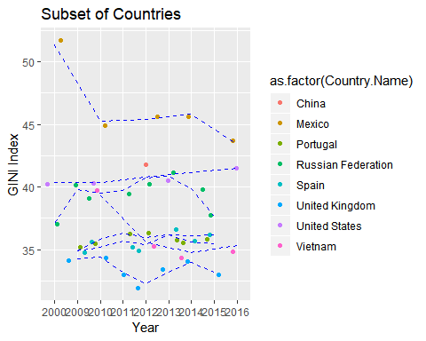

#### Entire countries trend

ggplot(GINI, aes(x = Year, y = GINI_Index)) + geom_jitter(width = 0.5, height = 0.5, aes(color = as.factor(Country.Name))) + geom_line(aes(group = Country.Name), lty = 2, color = "purple") + labs(title = "Entire Countries", x = "Year", y = "GINI Index") + theme(legend.position = "none")

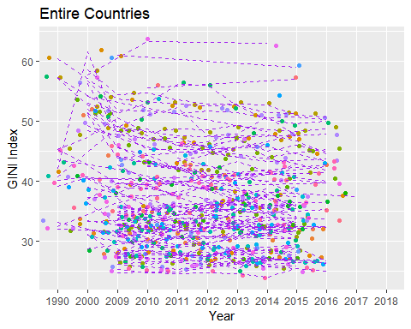

#### Ranked average GINI Index

# find the max and min of the country's GINI index by dplyr   
par(mfrow = c(1,2))  
GINI.avg.per.country.order <- GINI %>% group_by(Country.Name) %>% summarise(AVG_GINI = mean(GINI_Index)) %>% arrange(AVG_GINI)  
head(GINI.avg.per.country.order)

## # A tibble: 6 x 2  
## Country.Name AVG_GINI  
## <fct> <dbl>  
## 1 Ukraine 24.8  
## 2 Slovenia 25.4  
## 3 Czech Republic 26.2  
## 4 Norway 26.2  
## 5 Slovak Republic 26.8  
## 6 Iceland 27.0

GINI.avg.per.country.order.max <- GINI.avg.per.country.order %>% arrange(desc(AVG_GINI))  
head(GINI.avg.per.country.order.max)

## # A tibble: 6 x 2  
## Country.Name AVG_GINI  
## <fct> <dbl>  
## 1 South Africa 61.4  
## 2 Botswana 60.5  
## 3 Namibia 60.0  
## 4 Zambia 56.4  
## 5 Lesotho 54.2  
## 6 Mozambique 54

Interestingly, the top 6 counties with the worst GINI indices (higher the number, and hence, worse the inequality) are all in Africa, while the most of the top 6 countries with the best GINI indices are all in Eastern Europe.

GINI.avg.per.country <- GINI %>% group_by(Country.Name) %>% summarise(AVG_GINI = mean(GINI_Index))  
GINI.avg.per.country

## # A tibble: 148 x 2  
## Country.Name AVG_GINI  
## <fct> <dbl>  
## 1 "" NA   
## 2 Albania 29   
## 3 Algeria 27.6  
## 4 Angola 52   
## 5 Argentina 43.3  
## 6 Armenia 30.5  
## 7 Australia 34.7  
## 8 Austria 30.7  
## 9 Bangladesh 32.6  
## 10 Belarus 27.6  
## # ... with 138 more rows

#### Summary

GINI.stat <- describe(GINI.avg.per.country$AVG_GINI)  
GINI.qq <- summary(GINI.avg.per.country$AVG_GINI)  
GINI.stat

## vars n mean sd median trimmed mad min max range skew kurtosis  
## X1 1 147 38.43 7.95 37.5 37.87 7.56 24.81 61.4 36.59 0.62 -0.06  
## se  
## X1 0.66

GINI.qq

## Min. 1st Qu. Median Mean 3rd Qu. Max. NA's   
## 24.81 32.72 37.50 38.43 43.10 61.40 1

hist(GINI.avg.per.country$AVG_GINI, prob = TRUE, main = "GINI Average per Country", xlab = "GINI Index")  
x <- seq(20, 70, length = 10000)  
y <- dnorm(x, mean = GINI.stat$mean, sd = GINI.stat$sd)  
lines(x, y, type = 'l', lwd = 2, col = 'blue')

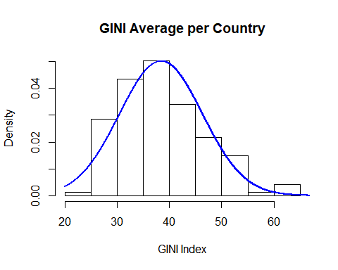

qqnorm(GINI.avg.per.country$AVG_GINI)  
qqline(GINI.avg.per.country$AVG_GINI)

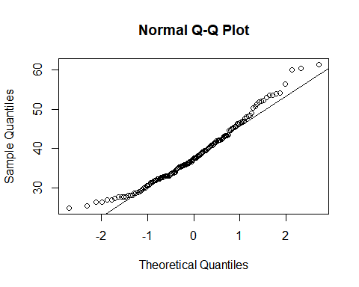

# Let's find the GINI mean index value for United States  
United_States.GINI <- GINI.avg.per.country[GINI.avg.per.country$Country.Name == 'United States', 'AVG_GINI']  
paste0("United_States Average GINI index: ", round(United_States.GINI, 2))

## [1] "United_States Average GINI index: 40.83"

# Calculate the z-score and percentile.  
world.mean <- mean(GINI.avg.per.country$AVG_GINI,na.rm = T)  
United_States.Z <- (United_States.GINI - world.mean)/GINI.stat$sd  
United_States.prob <- pnorm(United_States.Z$AVG_GINI, mean = 0, sd = 1)  
paste("United States is", round(United_States.Z$AVG_GINI,2), "standard deviations away from the mean and is", round(United_States.prob, 2) * 100, "percentile.")

## [1] "United States is 0.3 standard deviations away from the mean and is 62 percentile."

SUMMARY : The United Sates has balance out the wealth and equality . The United States is far only 0.3 standard deviation from world mean “GINI SCORE” and it is on 62 percentile.

### POPULATION

This data shows changes in population by counties from 1960 to 2017. Here I’m going to define that there have been population shifts and I want to highlight some of them in my analysis in a very easy to read visualization.

The World Bank has been maintaining this data.

<https://data.worldbank.org/indicator/sp.pop.totl>

Import dataset from a .csv file.

#### Data

population<- read.csv("https://raw.githubusercontent.com/omerozeren/DATA607/master/PROJECT_2/populationbycountry.csv", header = TRUE)  
population[1:15, 1:5]

## Country.Name X1960 X1961 X1962 X1963  
## 1 Aruba 54211 55438 56225 56695  
## 2 Afghanistan 8996351 9166764 9345868 9533954  
## 3 Angola 5643182 5753024 5866061 5980417  
## 4 Albania 1608800 1659800 1711319 1762621  
## 5 Andorra 13411 14375 15370 16412  
## 6 Arab World 92490932 95044497 97682294 100411076  
## 7 United Arab Emirates 92634 101078 112472 125566  
## 8 Argentina 20619075 20953077 21287682 21621840  
## 9 Armenia 1874120 1941491 2009526 2077575  
## 10 American Samoa 20013 20486 21117 21882  
## 11 Antigua and Barbuda 55339 56144 57144 58294  
## 12 Australia 10276477 10483000 10742000 10950000  
## 13 Austria 7047539 7086299 7129864 7175811  
## 14 Azerbaijan 3895396 4030320 4171425 4315128  
## 15 Burundi 2786106 2839666 2893669 2949926

I want to remove Country.Names that actually not country such as

-North America -Central & South America -Antarctica -Eurasia -Middle East -Asia & Oceania -World -Africa -Europe -Former Czechoslovakia -Former Serbia and Montenegro -Former Yugoslavia -East -Hawaiian Trade Zone -U.S. Pacific Islands -Wake Island -Former U.S.S.R.

kable(head(population$Country.Name,10))

|  |
| --- |
| x |
| Aruba |
| Afghanistan |
| Angola |
| Albania |
| Andorra |
| Arab World |
| United Arab Emirates |
| Argentina |
| Armenia |
| American Samoa |

Make a vector that lists all the countries that could not be classified by country

remove<- c('North America',  
 'Central & South America',  
 'Antarctica',   
 'Eurasia',   
 'Middle East',   
 'Asia & Oceania',   
 'World', 'Africa', 'Europe',   
 'Former Czechoslovakia',  
 'Former Serbia and Montenegro',  
 'Former Yugoslavia',   
 'East', 'Hawaiian Trade Zone',  
 'U.S. Pacific Islands', 'Wake Island', 'Former U.S.S.R.',  
 'IDA & IBRD total','Low & middle income',  
'Middle income','IBRD only','Early-demographic dividend','Upper middle income','Lower middle income',',Late-demographic dividend',  
'South Asia','South Asia (IDA & IBRD)','OECD members','High income','Post-demographic dividend','IDA total','IDA only',  
'Least developed countries: UN classification','Pre-demographic dividend','Latin America & Caribbean','Latin America & the Caribbean (IDA & IBRD countries)','Heavily indebted poor countries (HIPC)',  
'Low income','Latin America & Caribbean (excluding high income)','Euro area','IDA blend','Fragile and conflict affected situations','Late-demographic dividend',  
'Latin America & the Caribbean (IDA & IBRD countries)','Heavily indebted poor countries (HIPC)','Latin America & the Caribbean (IDA & IBRD countries)','Heavily indebted poor countries (HIPC)')  
df <- population[ !grepl(paste(remove, collapse="|"), population$Country.Name),]  
df <- data.frame(df)  
head(df)

## Country.Name X1960 X1961 X1962 X1963 X1964 X1965  
## 1 Aruba 54211 55438 56225 56695 57032 57360  
## 2 Afghanistan 8996351 9166764 9345868 9533954 9731361 9938414  
## 3 Angola 5643182 5753024 5866061 5980417 6093321 6203299  
## 4 Albania 1608800 1659800 1711319 1762621 1814135 1864791  
## 5 Andorra 13411 14375 15370 16412 17469 18549  
## 7 United Arab Emirates 92634 101078 112472 125566 138529 150362  
## X1966 X1967 X1968 X1969 X1970 X1971 X1972 X1973  
## 1 57715 58055 58386 58726 59063 59440 59840 60243  
## 2 10152331 10372630 10604346 10854428 11126123 11417825 11721940 12027822  
## 3 6309770 6414995 6523791 6642632 6776381 6927269 7094834 7277960  
## 4 1914573 1965598 2022272 2081695 2135479 2187853 2243126 2296752  
## 5 19647 20758 21890 23058 24276 25559 26892 28232  
## 7 160481 170283 183194 203820 235499 278808 332760 397174  
## X1974 X1975 X1976 X1977 X1978 X1979 X1980 X1981  
## 1 60528 60657 60586 60366 60103 59980 60096 60567  
## 2 12321541 12590286 12840299 13067538 13237734 13306695 13248370 13053954  
## 3 7474338 7682479 7900997 8130988 8376147 8641521 8929900 9244507  
## 4 2350124 2404831 2458526 2513546 2566266 2617832 2671997 2726056  
## 5 29520 30705 31777 32771 33737 34818 36067 37500  
## 7 471364 554324 646943 748117 852262 952040 1042384 1120900  
## X1982 X1983 X1984 X1985 X1986 X1987 X1988 X1989  
## 1 61345 62201 62836 63026 62644 61833 61079 61032  
## 2 12749645 12389269 12047115 11783050 11601041 11502761 11540888 11777609  
## 3 9582156 9931562 10277321 10609042 10921037 11218268 11513968 11827237  
## 4 2784278 2843960 2904429 2964762 3022635 3083605 3142336 3227943  
## 5 39114 40867 42706 44600 46517 48455 50434 52448  
## 7 1189545 1253060 1318478 1391052 1472218 1560718 1655849 1756043  
## X1990 X1991 X1992 X1993 X1994 X1995 X1996 X1997  
## 1 62149 64622 68235 72504 76700 80324 83200 85451  
## 2 12249114 12993657 13981231 15095099 16172719 17099541 17822884 18381605  
## 3 12171441 12553446 12968345 13403734 13841301 14268994 14682284 15088981  
## 4 3286542 3266790 3247039 3227287 3207536 3187784 3168033 3148281  
## 5 54509 56671 58888 60971 62677 63850 64360 64327  
## 7 1860174 1970026 2086639 2207405 2328686 2448820 2571020 2700010  
## X1998 X1999 X2000 X2001 X2002 X2003 X2004 X2005  
## 1 87277 89005 90853 92898 94992 97017 98737 100031  
## 2 18863999 19403676 20093756 20966463 21979923 23064851 24118979 25070798  
## 3 15504318 15949766 16440924 16983266 17572649 18203369 18865716 19552542  
## 4 3128530 3108778 3089027 3060173 3051010 3039616 3026939 3011487  
## 5 64142 64370 65390 67341 70049 73182 76244 78867  
## 7 2838145 2988162 3154925 3326032 3507232 3741932 4087931 4579562  
## X2006 X2007 X2008 X2009 X2010 X2011 X2012 X2013  
## 1 100832 101220 101353 101453 101669 102053 102577 103187  
## 2 25893450 26616792 27294031 28004331 28803167 29708599 30696958 31731688  
## 3 20262399 20997687 21759420 22549547 23369131 24218565 25096150 25998340  
## 4 2992547 2970017 2947314 2927519 2913021 2905195 2900401 2895092  
## 5 80991 82683 83861 84462 84449 83751 82431 80788  
## 7 5242032 6044067 6894278 7666393 8270684 8672475 8900453 9006263  
## X2014 X2015 X2016 X2017  
## 1 103795 104341 104822 105264  
## 2 32758020 33736494 34656032 35530081  
## 3 26920466 27859305 28813463 29784193  
## 4 2889104 2880703 2876101 2873457  
## 5 79223 78014 77281 76965  
## 7 9070867 9154302 9269612 9400145

I need to clean all of my year columns have an X in front of the name. We can use some regular expression to clean the column names.

#remove the x  
names(df) <- gsub(x = names(df), pattern = "\\X", replacement = "")   
names(df)

## [1] "Country.Name" "1960" "1961" "1962"   
## [5] "1963" "1964" "1965" "1966"   
## [9] "1967" "1968" "1969" "1970"   
## [13] "1971" "1972" "1973" "1974"   
## [17] "1975" "1976" "1977" "1978"   
## [21] "1979" "1980" "1981" "1982"   
## [25] "1983" "1984" "1985" "1986"   
## [29] "1987" "1988" "1989" "1990"   
## [33] "1991" "1992" "1993" "1994"   
## [37] "1995" "1996" "1997" "1998"   
## [41] "1999" "2000" "2001" "2002"   
## [45] "2003" "2004" "2005" "2006"   
## [49] "2007" "2008" "2009" "2010"   
## [53] "2011" "2012" "2013" "2014"   
## [57] "2015" "2016" "2017"

head(df, 2)

## Country.Name 1960 1961 1962 1963 1964 1965 1966  
## 1 Aruba 54211 55438 56225 56695 57032 57360 57715  
## 2 Afghanistan 8996351 9166764 9345868 9533954 9731361 9938414 10152331  
## 1967 1968 1969 1970 1971 1972 1973 1974  
## 1 58055 58386 58726 59063 59440 59840 60243 60528  
## 2 10372630 10604346 10854428 11126123 11417825 11721940 12027822 12321541  
## 1975 1976 1977 1978 1979 1980 1981 1982  
## 1 60657 60586 60366 60103 59980 60096 60567 61345  
## 2 12590286 12840299 13067538 13237734 13306695 13248370 13053954 12749645  
## 1983 1984 1985 1986 1987 1988 1989 1990  
## 1 62201 62836 63026 62644 61833 61079 61032 62149  
## 2 12389269 12047115 11783050 11601041 11502761 11540888 11777609 12249114  
## 1991 1992 1993 1994 1995 1996 1997 1998  
## 1 64622 68235 72504 76700 80324 83200 85451 87277  
## 2 12993657 13981231 15095099 16172719 17099541 17822884 18381605 18863999  
## 1999 2000 2001 2002 2003 2004 2005 2006  
## 1 89005 90853 92898 94992 97017 98737 100031 100832  
## 2 19403676 20093756 20966463 21979923 23064851 24118979 25070798 25893450  
## 2007 2008 2009 2010 2011 2012 2013 2014  
## 1 101220 101353 101453 101669 102053 102577 103187 103795  
## 2 26616792 27294031 28004331 28803167 29708599 30696958 31731688 32758020  
## 2015 2016 2017  
## 1 104341 104822 105264  
## 2 33736494 34656032 35530081

#Lets gather by key value pairs and create a new data frame   
total_pop <- df %>% gather(data=df, Population, "1960":"2017")  
head(total_pop, 10)

## Country.Name . Population  
## 1 Aruba 1960 54211  
## 2 Afghanistan 1960 8996351  
## 3 Angola 1960 5643182  
## 4 Albania 1960 1608800  
## 5 Andorra 1960 13411  
## 6 United Arab Emirates 1960 92634  
## 7 Argentina 1960 20619075  
## 8 Armenia 1960 1874120  
## 9 American Samoa 1960 20013  
## 10 Antigua and Barbuda 1960 55339

tail(total_pop, 10)

## Country.Name . Population  
## 12867 Venezuela, RB 2017 31977065  
## 12868 British Virgin Islands 2017 31196  
## 12869 Virgin Islands (U.S.) 2017 107268  
## 12870 Vietnam 2017 95540800  
## 12871 Vanuatu 2017 276244  
## 12872 Samoa 2017 196440  
## 12873 Kosovo 2017 1830700  
## 12874 Yemen, Rep. 2017 28250420  
## 12875 Zambia 2017 17094130  
## 12876 Zimbabwe 2017 16529904

I need to rename the year column

colnames(total_pop)[colnames(total_pop)=="."]<-"Year"  
names(total_pop)

## [1] "Country.Name" "Year" "Population"

removing the Na rows

total_pop<-na.omit(total_pop)  
head(total_pop)

## Country.Name Year Population  
## 1 Aruba 1960 54211  
## 2 Afghanistan 1960 8996351  
## 3 Angola 1960 5643182  
## 4 Albania 1960 1608800  
## 5 Andorra 1960 13411  
## 6 United Arab Emirates 1960 92634

#### Subset Population

In subset population data, I choose Turkey to see how population is look like.

Creating Subset

df.Turkey<-subset(total_pop, Country.Name=='Turkey', select=c(Country.Name, Year, Population))  
head(df.Turkey, 30)

## Country.Name Year Population  
## 204 Turkey 1960 27472331  
## 426 Turkey 1961 28146893  
## 648 Turkey 1962 28832805  
## 870 Turkey 1963 29531342  
## 1092 Turkey 1964 30244232  
## 1314 Turkey 1965 30972965  
## 1536 Turkey 1966 31717477  
## 1758 Turkey 1967 32477961  
## 1980 Turkey 1968 33256432  
## 2202 Turkey 1969 34055361  
## 2424 Turkey 1970 34876267  
## 2646 Turkey 1971 35720568  
## 2868 Turkey 1972 36587225  
## 3090 Turkey 1973 37472298  
## 3312 Turkey 1974 38370241  
## 3534 Turkey 1975 39277211  
## 3756 Turkey 1976 40189511  
## 3978 Turkey 1977 41108248  
## 4200 Turkey 1978 42039935  
## 4422 Turkey 1979 42993991  
## 4644 Turkey 1980 43975921  
## 4866 Turkey 1981 44988356  
## 5088 Turkey 1982 46025357  
## 5310 Turkey 1983 47073422  
## 5532 Turkey 1984 48114105  
## 5754 Turkey 1985 49133883  
## 5976 Turkey 1986 50128489  
## 6198 Turkey 1987 51100878  
## 6420 Turkey 1988 52053704  
## 6642 Turkey 1989 52992429

#Visualize the population  
ggplot(data=df.Turkey, aes(x=Year, y=Population, group=1)) +  
 geom_line(arrow = arrow())+  
 geom_point()+  
 theme(axis.text.x = element_text(angle = 90, hjust = 1))+  
 labs( x="Year", y="Turkey population (In Millions)")

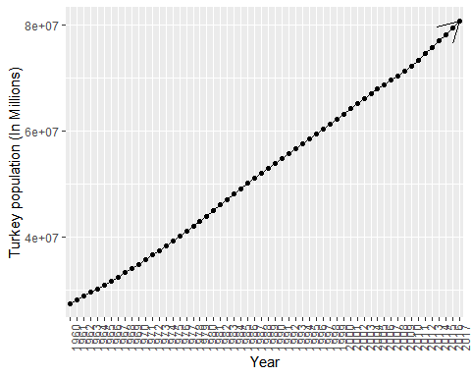

#### Entire country Population

#Visualize the population  
ggplot(data=total_pop, aes(x=Year, y=Population, group=1)) +  
 geom_line(arrow = arrow())+  
 geom_point()+  
 theme(axis.text.x = element_text(angle = 90, hjust = 1))+  
 labs( x="Year", y="World population (In Millions)")

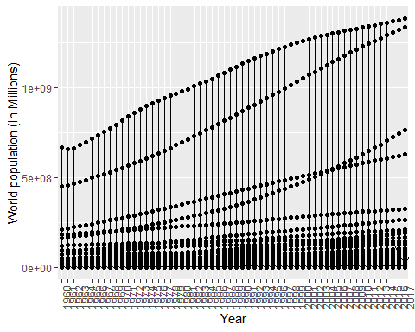

#### Untidy Data

# find the max and min of the country's Population index by dplyr   
par(mfrow = c(1,2))  
POP.avg.per.country.order <- total_pop %>% group_by(Year) %>% group_by(Country.Name) %>% summarise(AVG_POP = mean(Population,na.rm=TRUE))%>% arrange(AVG_POP)  
head(POP.avg.per.country.order)

## # A tibble: 6 x 2  
## Country.Name AVG_POP  
## <fct> <dbl>  
## 1 Nauru 8568.  
## 2 Tuvalu 8745   
## 3 Turks and Caicos Islands 15170.  
## 4 Palau 15479.  
## 5 British Virgin Islands 16759.  
## 6 St. Martin (French part) 19246.

POP.avg.per.country.order.max <- POP.avg.per.country.order %>% arrange(desc(AVG_POP))  
head(POP.avg.per.country.order.max)

## # A tibble: 6 x 2  
## Country.Name AVG_POP  
## <fct> <dbl>  
## 1 China 1077271293.  
## 2 India 861643130.  
## 3 Latin America & the Caribbean (IDA & IBRD countries) 417789480.  
## 4 Heavily indebted poor countries (HIPC) 384511872.  
## 5 United States 251274672.  
## 6 Indonesia 174988161.

#### Summary

POP.stat <- describe(POP.avg.per.country.order.max$AVG_POP)  
POP.qq <- summary(POP.avg.per.country.order.max$AVG_POP)  
(POP.stat)

## vars n mean sd median trimmed mad min max  
## X1 1 221 27063439 102588210 4269193 8335631 6179046 8567.5 1077271293  
## range skew kurtosis se  
## X1 1077262726 7.81 68.28 6900830

POP.qq

## Min. 1st Qu. Median Mean 3rd Qu. Max.   
## 8.568e+03 5.217e+05 4.269e+06 2.706e+07 1.473e+07 1.077e+09

hist(POP.avg.per.country.order.max$AVG_POP, prob = TRUE, main = "Average Population per Country", xlab = "AVG POP")  
y <- dnorm(x, mean = POP.stat$mean, sd = POP.stat$sd)  
lines(x, y, type = 'l', lwd = 2, col = 'blue')

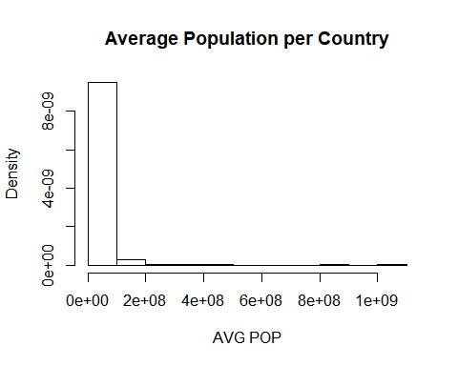

The summary table shows that the average min population is 8567.5 and average maximum poulation is 422187266. The country that has maximun average population is China and second is India so on.

### LOTTERY

The New York State Government keeps track of all the drawn winning numbers. This database contains information from June 2014 to March 2019.

Defination : Each game costs $2. Players choose (or have the terminal select the numbers, which is known as “quick pick” in Maryland, New Jersey, New York, Pennsylvania, and Tennessee; and “easy pick” in Virginia) 5 of 60 numbers in the main field, and 1 of 4 (hence the game’s name) green “Cash Ball” numbers in a second field. Matching all six numbers wins, or shares (“split-prize liability”).

Source Defination : <https://en.wikipedia.org/wiki/New_York_Lottery>

Data Source : <https://data.ny.gov/Government-Finance/Lottery-Cash-4-Life-Winning-Numbers-Beginning-2014/kwxv-fwze>

#### Data

# Reading the .csv file from my github page  
lottery <- read.csv("https://raw.githubusercontent.com/omerozeren/DATA607/master/PROJECT_2/LOTTERY.csv", header = TRUE)  
# This shows the first 6 rows of this data.frame  
head(lottery)

## Draw.Date Winning.Numbers Cash.Ball  
## 1 3/7/2019 07 14 20 38 58 1  
## 2 3/4/2019 06 09 45 49 55 4  
## 3 2/28/2019 03 15 18 21 35 2  
## 4 2/25/2019 18 24 42 55 58 3  
## 5 2/21/2019 03 04 34 38 39 2  
## 6 2/18/2019 01 37 39 48 54 4

#### Untidy Data

# We will separate all the winning numbers and create separate columns i.e. in row 1, Ball 1: 09, Ball 2: 36, Ball 3: 44, Ball 4: 53, Ball 5: 59  
lottery.separated <- unlist(str_extract_all(lottery$Winning.Numbers, "(\\d)."))  
lottery.separated <- as.numeric(lottery.separated)  
lottery2 <- matrix(lottery.separated, ncol = 5, byrow = TRUE)  
lottery2 <- as.data.frame(lottery2)  
lottery.untidy <- data.frame(lottery$Draw.Date, lottery2, lottery$Cash.Ball)  
colnames(lottery.untidy) <- c("Draw.Date", 1, 2, 3, 4, 5, "Cash.Ball")  
# As you can see, this separated all the numbers into its own fields  
head(lottery.untidy)

## Draw.Date 1 2 3 4 5 Cash.Ball  
## 1 3/7/2019 7 14 20 38 58 1  
## 2 3/4/2019 6 9 45 49 55 4  
## 3 2/28/2019 3 15 18 21 35 2  
## 4 2/25/2019 18 24 42 55 58 3  
## 5 2/21/2019 3 4 34 38 39 2  
## 6 2/18/2019 1 37 39 48 54 4

So now we have created an untidy data frame with all of the Cash 4 Life Winning Numbers. We will now utilize dplyr and tidyr to ‘tidy’ up the data.

lottery.tidy <- lottery.untidy %>% gather(BallOrder, Number, 2:6) %>% select(-Cash.Ball)  
head(lottery.tidy)

## Draw.Date BallOrder Number  
## 1 3/7/2019 1 7  
## 2 3/4/2019 1 6  
## 3 2/28/2019 1 3  
## 4 2/25/2019 1 18  
## 5 2/21/2019 1 3  
## 6 2/18/2019 1 1

Next, I would liket to see 1. What is the most frequent ball to show up? 2. What is the least frequent ball to show up?

hist(lottery.tidy$Number, breaks = 60, main = "Number Drawn", xlab = "Ball Number", ylim = c(0,40), col = 'lightblue')

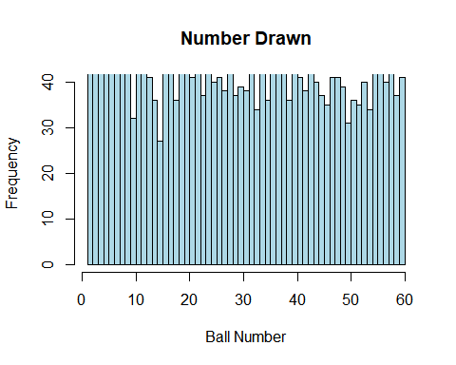

Ball.Num <- as.numeric(lottery.tidy$Number)  
Ball.Num <- as.data.frame(table(Ball.Num))  
head(Ball.Num)

## Ball.Num Freq  
## 1 1 41  
## 2 2 36  
## 3 3 42  
## 4 4 52  
## 5 5 47  
## 6 6 43

Now with the frequency calculated for each number of ball. Let’s find out some more information about these ball numbers.

Freq.Drawn <- Ball.Num %>% arrange(desc(Freq))  
Freq.Drawn

## Ball.Num Freq  
## 1 4 52  
## 2 55 52  
## 3 8 49  
## 4 24 49  
## 5 38 49  
## 6 11 48  
## 7 28 48  
## 8 37 48  
## 9 40 48  
## 10 43 48  
## 11 5 47  
## 12 20 47  
## 13 9 46  
## 14 12 45  
## 15 56 45  
## 16 7 44  
## 17 17 44  
## 18 58 44  
## 19 6 43  
## 20 19 43  
## 21 22 43  
## 22 32 43  
## 23 3 42  
## 24 16 42  
## 25 34 42  
## 26 36 42  
## 27 1 41  
## 28 13 41  
## 29 21 41  
## 30 26 41  
## 31 41 41  
## 32 47 41  
## 33 48 41  
## 34 60 41  
## 35 25 40  
## 36 44 40  
## 37 53 40  
## 38 57 40  
## 39 30 39  
## 40 49 39  
## 41 27 38  
## 42 31 38  
## 43 42 38  
## 44 23 37  
## 45 29 37  
## 46 45 37  
## 47 59 37  
## 48 2 36  
## 49 14 36  
## 50 18 36  
## 51 35 36  
## 52 39 36  
## 53 51 36  
## 54 46 35  
## 55 52 35  
## 56 33 34  
## 57 54 34  
## 58 10 32  
## 59 50 31  
## 60 15 27

paste("The Most Drawn Ball is: ", Freq.Drawn$Ball.Num[1])

## [1] "The Most Drawn Ball is: 4"

paste("The Least Drawn Ball is: ", Freq.Drawn$Ball.Num[length(Freq.Drawn$Ball.Num)])

## [1] "The Least Drawn Ball is: 15"

Ball.stat <- Freq.Drawn %>% summarise(Mean= mean(Freq))  
Ball.stat <- as.numeric(Ball.stat)  
paste("A number was drawn on average: ", Ball.stat)

## [1] "A number was drawn on average: 41.0833333333333"

#### Summary

So at least from the histogram, the majority of the numbers appear to be drawn fairly evenly. But as you can see, ball 4 comes very often and ball 15 does not over the course of the 3 years.

I’ll make a null and alternative hypothesis. Utilizing the 2 tailed p value test (using alpha = 0.05), we will determine if there is a statistical anomaly.

The null hypothesis is that the number 4 and 15 are variance and are not statistical outliers.

The alternative hypothesis is that the NY State Lottery system is rigged and weighs number 4 and 15 differently from the rest of the numbers.

# Calculating the standard deviation, which we will use to calculate the Z-score  
Ball.sd <- sd(Freq.Drawn$Freq)  
# The Z-score is obtained and coverted into a two-taled p value Z.4.p  
Z.4 <- (60 - Ball.stat)/Ball.sd  
Z.4 <- pnorm(Z.4, mean = 0, sd = 1)  
Z.4.p <- (1 - Z.4) * 2  
# Again, the same process takes place here, except that this time, it is for ball 42  
Z.15 <- (9 - Ball.stat)/Ball.sd  
Z.15 <- pnorm(Z.15, mean = 0, sd = 1)  
Z.15.p <- (Z.15) * 2  
paste("The P-value for Ball 4: ", Z.4.p)

## [1] "The P-value for Ball 4: 0.000354100249031708"

paste("The P-value for Ball 15: ", Z.15.p)

## [1] "The P-value for Ball 15: 1.37443761802246e-09"

Both these values are less than alpha = 0.05, thus making them statistically significant. Now does this actually mean that the NYS Lottery System is rigged? The numbers make a strong case for rejecting the null hypothesis.

Even though the p-values suggest that we reject the null hypothesis, we have to remember that this lottery has only been played 494 times since June 2014.That truelly means that our analysis is based on only 494 data points so conclusion might not be accurate.