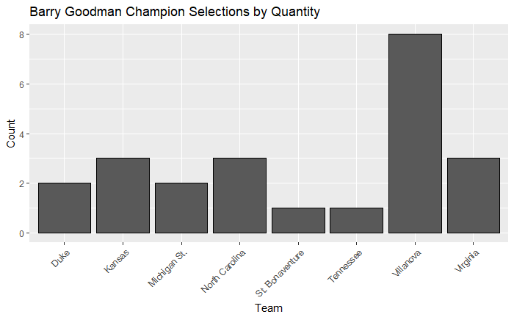

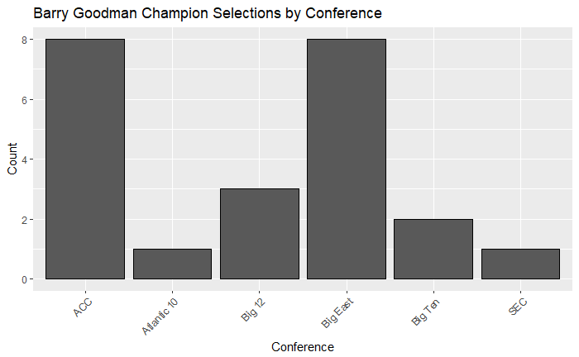

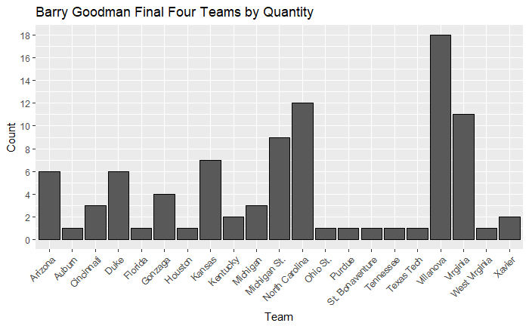

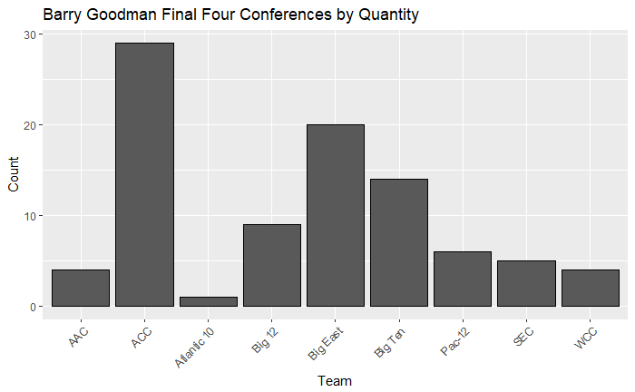

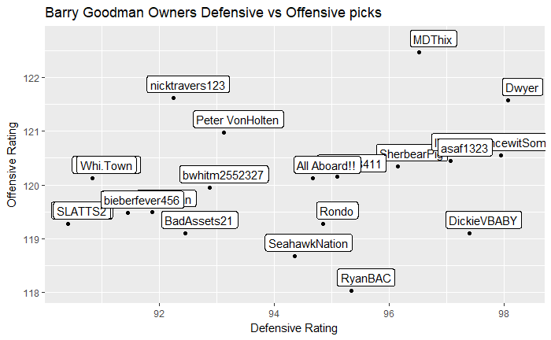

Riskiest

# 1. IWannaDancewitSomeBonnies

# 2. RyanBAC

# 3. DickieVBABY

## Graph 7: Top Three Safest Brackets (The Mike Porter Trophy)

```{r}

# 1. Whi. Town, Mike Porter

# T2. nicktravers123, Nick Travers

# T2. BallRulesAll, Big Er

