# 

* Top Three Riskiest Brackets:

1. IWannaDancewitSomeBonnies
2. RyanBAC
3. DickieVBABY

* Top Three Safest Brackets (The Mike Porter Award):

1. Whi. Town, Mike Porter

T2. nicktravers123, Nick Travers

T2. BallRulesAll, Big Er

* Most Selected Champions

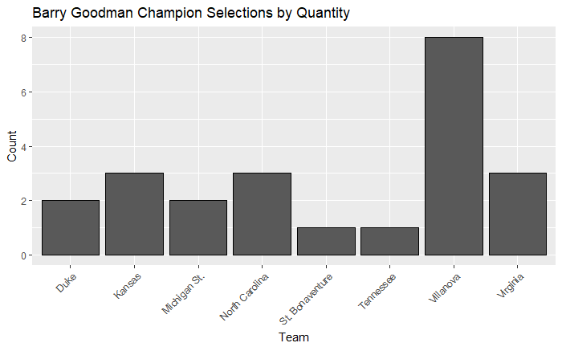

* Most Selected Champions by Conference

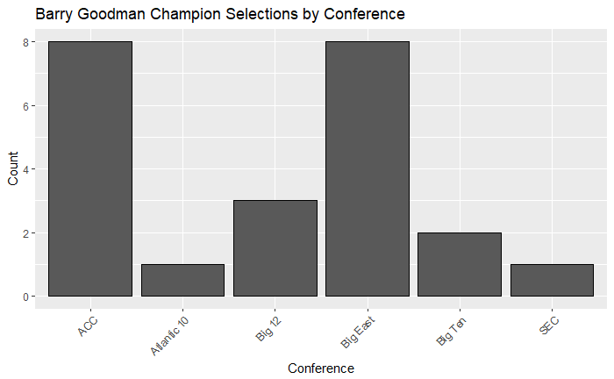

* Most Selected Final Four Teams

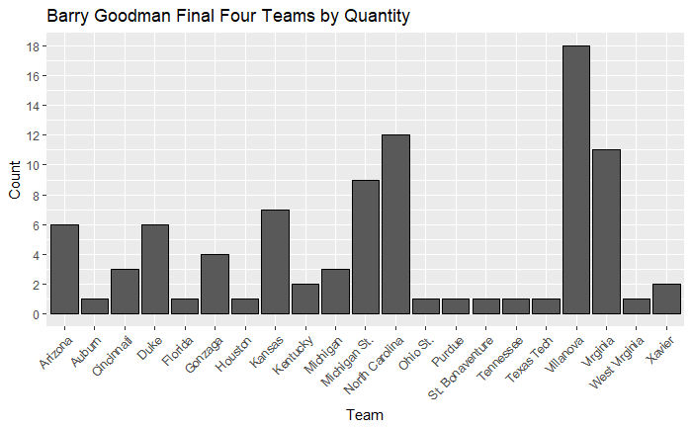

* Most Selected Final Four Conferences

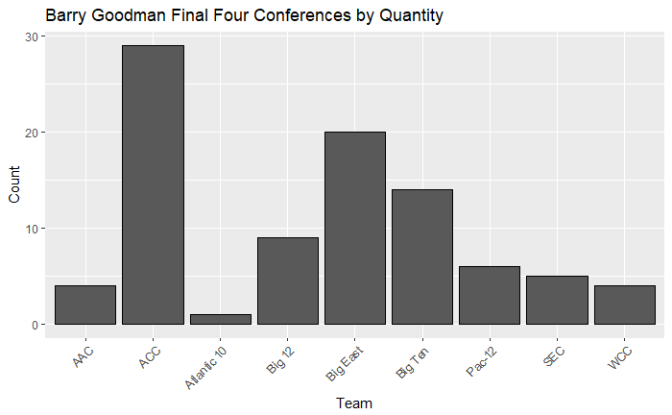

* Owners’ Weight Placed on Defense vs. Offense
  + Ref: nicktravers123 is all about scoring, DickiVBABY is about lockdown D

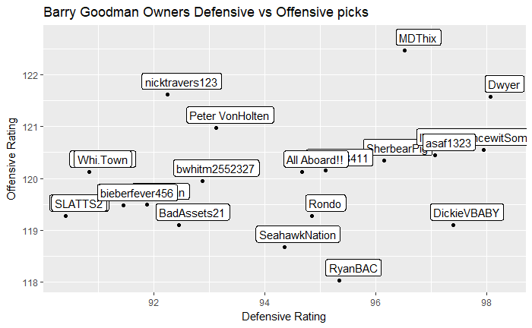

* Owners’ Weight Placed on Strength of Schedule
  + Ref: Lone Starr values wins, MDThix values top 25 wins

