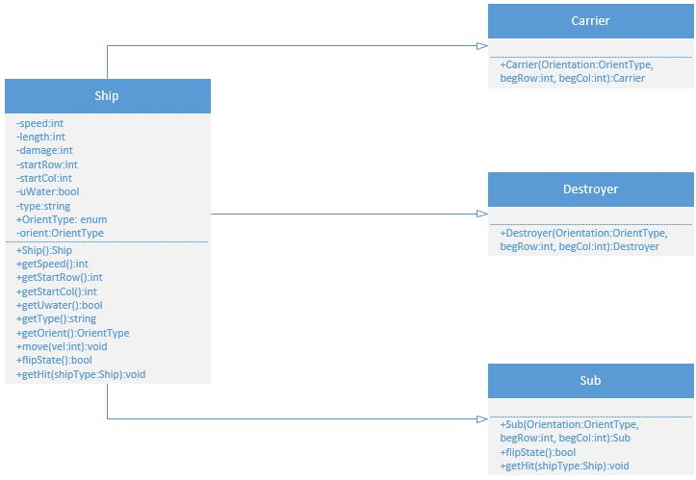Peter O’Donohue

Doctor Bruce Elenbogen

CIS 200

20th, July 2017

Program Three Class Diagram