Installation Guidline For SugarCRM:

Purpose:

This Module Import SugarCRM "Users", "Accounts", "Contacts", "Employees",
“Leads”,”Opportunities”,”'Meetings”, “calls”, “Cases”, “Emails and History”, “Project”,
Project Tasks, “Bugs”, “Document” into OpenERP.

How to Use Module:
    - Install Module “import_sugarcrm”.
    - Now Run wizard From “Sales=>Import=>Import SugarCRM” .
    - Enter SugarSoap Api url through which you can connect with Sugar Soap method.
Enter Username and Password which you have given During Your SugarCRM Configuration.it should be Admin Which have The Sugar administrator (default name admin) has administrative privileges. So you have necessary accessrights to create or delete record of SugarCRM.
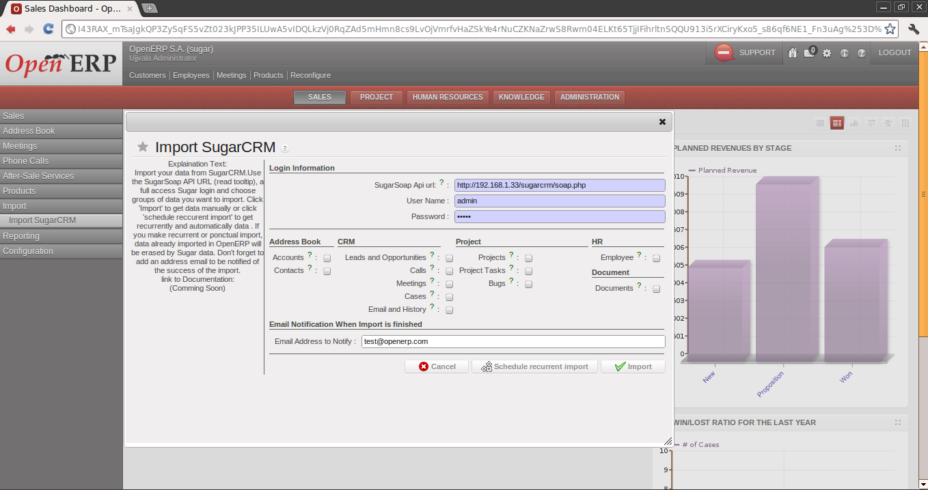

    - And Select List of Module to Import:
      - Address Book:
        - Accounts: Account's Field are selected, Account Module Data of Sugarcrm Imported as Partners in OpenERP.
        - Contacts: Contact Data of Sugarcrm Imported into Partner Addresses of OpenERP.
      - CRM:
        - Leads And Opportunities: Leads and Opportunities of SugarCRM are imported as Lead and Opportunity in OpenERP.
        - Meetings: SugarCRM's Meetings and Meeting Tasks are imported as Meeting in Openerp.
        - Calls: SugarCRM Calls are imported as Phonecalls in OpenERP.
        - Cases: SugarCRM Cases data imported as Claims in OpenERP.
      - Project:
        - Project: SugarCRM Projects are imported as Projects in OpenERP
        - Project Tasks: SugarCRM Project Tasks are imported as Tasks OpenERP project.task object.
        - Bugs: SugarCRM Bugs are imported as Project Issues in OpenERP.
      - HR:
        - Employee: SugarCRM Employees are imported as OpenERP employees.
          - If you delete imported employees and import them again, you may raise an error. To solve the problem : delete corresponding Ressource also
      - Document:
        - Document: SugarCRM Documents are imported in OpenERP as Attachment.
        - Emails And Notes: SugarCRM Notes are imported as Attachments in OpenERP and Emails are imported as Messages in OpenERP. Both are linked with their parent object
    - Email notification
When the import process is finished, a notification is send to the email address specified in the field “Email address to notify”. This Email contain information of start time and Finished time of Import. Also contain How many record were Imported from which table and with some warning or not also.
    - Import
Import” button that will start process in backgroung
    - Schedule a recurrent
If User want to call Import Process through Scheduler ,by Clicking “Create Recurrent Import” you can create scheduler, which will run import process at specified interval.

MultiInstance Management Field :
There is a multi instance management field, but the user has to be member of group no one to see it. MultiInstance name will be used to separate import from multiple SugarCRM login instance.come from different server.

