pre-requirenments :
OpenERP-Requirenmants :
1.python2.4, and pythob2.4-dev
2.postgres-7.4 or postgres-8.1
3.SOAP for python – ZSI-2.0-rc3.tar.gz

Sugar-Requirenmants :
1.web-server
2.php5,
3.xml-rpc for php

Installation Of SugarCRM:

1.Install The MySQL Database Server using: sudo apt-get install mysql-server mysql-client
2.Install The Apache Webserver And PHP,xml-rpc for php:
sudo apt-get install apache2 apache2-doc apache2-mpm-prefork apache2-utils libexpat1 libapache2-mod-php5 php5-common php5-gd php5-idn php-pear php5-imap php5-mcrypt php5-mhash php5-mysql php5-sqlite php5-xmlrpc php5-xsl php5-curl
3.Now You can download SugarCRM Community Edition: http://www.sugarcrm.com/crm/download/sugar-suite.html
-We will Install SugarCRM in Apache's default vhost (document root /var/www) in
the directory /var/www/sugarcrm.
-So Unzip that and Move it using mv * /var/www/sugarcrm/
-Give permission using: chown -R www-data:www-data /var/www/sugarcrm
Now Use the Sugar Setup Wizard after copying the Sugar files into your web root. The Sugar Setup Wizard islocated at http://<yourServer>/<yourSugarDirectory>/install.php.
For example: http://localhost/Sugar-Full_6.2.0/install.php and follow sugarcrm configuaration wizard steps. Which is given in this Guidline link: http://www.sugarcrm.com/crm/support/documentation/SugarCommunityEdition/6.2/-docs-Application_Guides-Sugar_Community_Edition_Application_Guide_6.2.0GA-Sugar_Install_Upgrade.html#1182572

Enter the necessary information and click Send Registration to register your Sugar instance with SugarCRM; or click No Thanks to skip registration.

The Sugar login page displays on the screen. You can now log into Sugar with the Sugar admin name and password that you specified during installation. Here is Image:
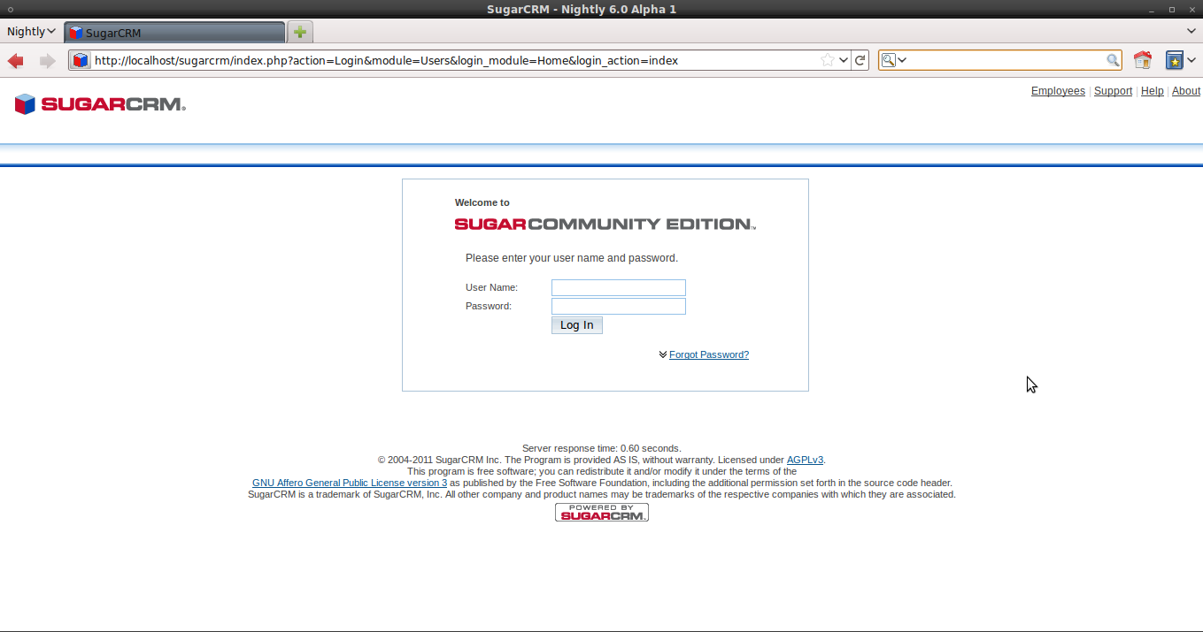
Soap Api:
1.To integrate SugarCRM with third party applications .Uses the SugarCRM SOAP API.
2.SugarCRM SOAP API for authenticating a user by connecting to SugarCRM SOAP service.
3.You can connect to sugar soap using http. you need to configure your webserver to accept
http request. So your URL would be your own sugar installation and append
/soap.php to the URL,you will see Information For various method to get SugarCRM Module data plus a link to the WSDL.
Example of Soap Api: https://<yourinstance-name>/sugarcrm/soap.php

