eg_product_restriction_on_user

discription: this app will restrict multiple product for particular user.

1. Select one or multiple products in Restrict Products and then tick Product Restriction boolean.

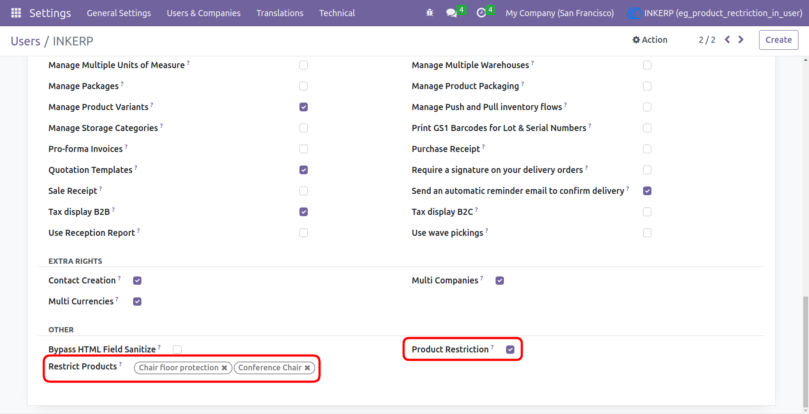
2.Here you can seethat restricted products is disappear in products. (to visiable the restricted products untick the product restriction boolean)

