

MyBox: Easy Tools Set
Development Guide

Author: Mara
Version: 2.1
2020-08-27

Contents
1 About MyBox 4
1.1 Resource Addresses 4
1.2 Documents 5
2 Source Codes 6
2.1 Develoment Resources 6
2.1.1 Softwares need download 6
2.1.2 Dependencies download automatically by Maven 6
2.1.3 Thirdparty codes referred directly 6
2.1.4 Icons 8
2.2 Build jar package by Maven 9
2.2.1 Build on win 9
2.2.2 Build on linux 10
2.2.3 Build on mac 10
2.2.4 Build package without Javafx 10
2.3 Scripts for self-contain package 11
2.3.1 Tool “jpackage” 11
2.3.2 Make exe package for windows 11
2.3.3 Make executable package on linux 12
2.3.4 Make dmg on mac 13
3 Coding with Netbeans 14
3.1 Config Derby 14
3.1.1 Add Derby Drivers 14
3.1.2 Start/Connect to Derby as emdedded mode 15
3.1.3 Connect to derby in client mode 17
3.2 Manage project 18
3.2.1 Switch configration profile 18
3.2.2 Quick debug 18
3.2.3 Build package with all dependencies 18
3.3 Find and download codes 19
3.4 Exceptions 21
3.4.1 Remove modules 21
3.4.2 OS broken 21
3.4.3 Editor instead of JavaFX Scene Builder is opened when double click fxml 21
4 Coding JavaFx 22
4.1 Offical Guides 22
4.2 Configure of latest JavaFx 22
4.3 Interface in CSS style 22
4.4 Javafx Experts 22
4.5 Exchange data between interfaces 22
4.6 Limit text field 22
4.7 Enable/Disable HiDPI 22
4.8 Resolution of Control' snapshot 22
4.9 Set controller for fxml dynamically 25
4.10 Update legend in chart dynamically 25
4.11 Danger of “setAlwaysOnTop” 25
4.12 Ghost data in TableView/ListView 26
4.13 Listen events in embedded page 26
4.14 Refresh ListView 27
4.15 Submit updates when lose focus for Editable Cell 27
4.16 Items in one sentence 27
5 Image Manufacture 29
5.1 Java Image I/O Technology 29
5.2 Image Meta Data 29
5.3 Multiple Frames Image File 29
5.4 Tiff/Tif file 29
5.5 Animated Gif 29
5.6 Big Image 30
5.7 Image Sampling 30
5.8 Image Grayscale 31
5.9 Color Distance 31
5.10 How to get sepia image 31
5.11 Image Blending 31
5.12 Convolution 31
5.13 Flood-Fill 31
5.14 Image Size 32
5.15 Image quantization 32
5.16 Filters 33
6 Media 34
6.1 ffmpeg 34
7 Coding in Java 35
7.1 Data precision 35
7.2 Charset and encoding 35
7.3 Problems 35
7.3.1 “cannot access class … because module ... does not export ...” 35
7.3.2 “xxx uses unchecked or unsafe operations.” 36
7.4 Items in one sentence 37

About MyBox

Resource Addresses
This is GUI(Graphic User Interface) program developed in JavaFx, whose target is to provide simple and easy tools . It is free and open sources, and its main page is following:
https://github.com/Mararsh/MyBox
Source codes, compilered packages, and documents are under Releases directory:
https://github.com/Mararsh/MyBox/releases
Welcome to submit software requirements and problem reports online:
https://github.com/Mararsh/MyBox/issues
Cloud storage:
https://pan.baidu.com/s/1fWMRzym_jh075OCX0D8y8A#list/path=%2F

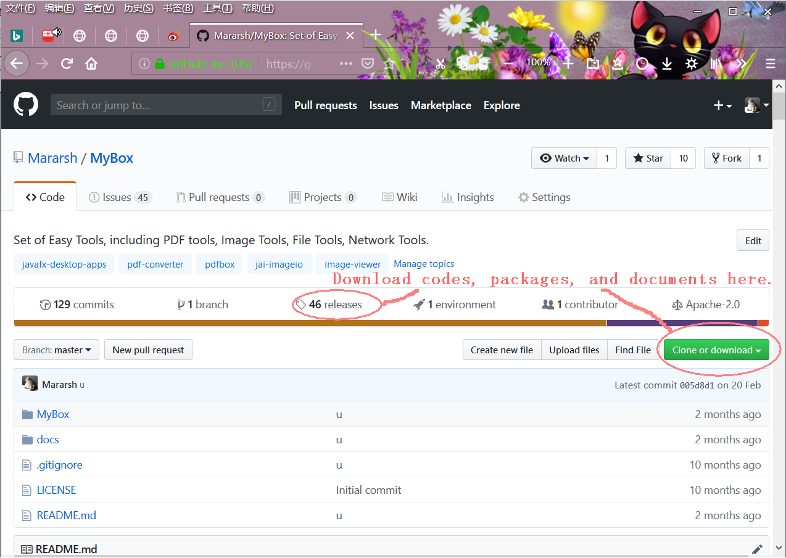

Documents
This document introduces some summaries about MyBox development. It can be download from following address:
https://mararsh.github.io/MyBox_documents/en/MyBox-DevGuide-2.1-en.pdf

User Guides of MyBox include:
“MyBox User Guide – Overview”
https://github.com/Mararsh/MyBox/releases/download/v5.0/MyBox-UserGuide-5.0-Overview-en.pdf
“MyBox User Guide – PDF Tools”
https://github.com/Mararsh/MyBox/releases/download/v5.0/MyBox-UserGuide-5.0-PdfTools-en.pdf
“MyBox User Guide – Image Tools”
https://github.com/Mararsh/MyBox/releases/download/v5.0/MyBox-UserGuide-5.0-ImageTools-en.pdf
“MyBox User Guide – Desktop Tools”
https://github.com/Mararsh/MyBox/releases/download/v5.0/MyBox-UserGuide-5.0-DesktopTools-en.pdf
“MyBox User Guide – Network Tools”
https://github.com/Mararsh/MyBox/releases/download/v5.0/MyBox-UserGuide-5.0-NetworkTools-en.pdf

Source Codes

Develoment Resources
Both development and execution of MyBox depend only on open sources.
Current MyBox is based on Java 14.0.1 + openjfx 14.0.1 + derby 10.15.1.3 + NetBean 12.0.

Softwares need download
To develop MyBox, following need be download:
Java 14.0.1 or higer (either Oracle JDK or openJDK)
https://www.oracle.com/technetwork/java/javase/downloads/index.html
http://openjdk.java.net/
NetBean 12.0 or higher
https://netbeans.org/
https://netbeans.apache.org/download/index.html
JavaFX Scene Builder 2.0
https://www.oracle.com/technetwork/java/javafxscenebuilder-1x-archive-2199384.html
Maven
http://maven.apache.org/index.html

Dependencies download automatically by Maven
MyBox depends on following too, but developers need not download them and Maven will fetch them automatically when sources are built:
JavaFx (It is not included in Java since Java 11, so JavaFx is added in project as dependencies)

Thirdparty codes referred directly
Following codes are copied as class files under source directory “MyBox\src\main\java\thridparty\”.
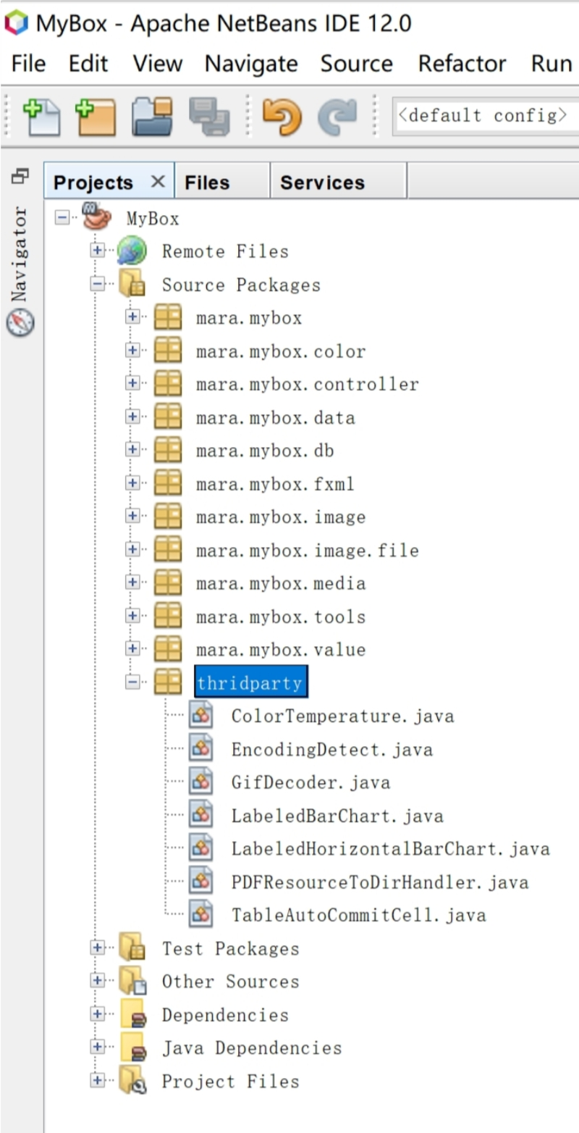

Icons
Following website shares their resources with all of open sources projects:
https://icons8.com/icons/set/home

MyBox includes 5 sets of icons in different colors in which light-blue icons are download from above website and icons in other 4 colors are generated automatically by method “makeIcons()” of file “MainMenuController.java”.
Icons | How to get | Color values
light-blue | download | #4788c7 #dff0fe
red | Reduce 215 of hue based on light-blue icons | #c94d58 #feb6be
pink | Increase 151 of red based on light-blue icons | #de88c7 #ffdcfe
blue | Increase 50% of saturation based on light-blue icons | #0066cc #92cbfe
orange | Reduce 171 of hue based on light-blue icons | #c8754b #fecdb6

To get function “Make Icon”:
1) Edit source file “MainMenu.fxml”, and uncommet following line:
<MenuItem mnemonicParsing="false" onAction="#makeIcons" text="%MakeIcons" />
2) Build MyBox
3) Run MyBox, and menu “Help”. Select “Make Icon”.

Build jar package by Maven
Project file “pom.xml” defines different profiles for different platforms, so package can be built against specified platform.

Build on win
Under root directory of MyBox source codes, execute following command: (Default profile is win)
mvn clean
mvn package

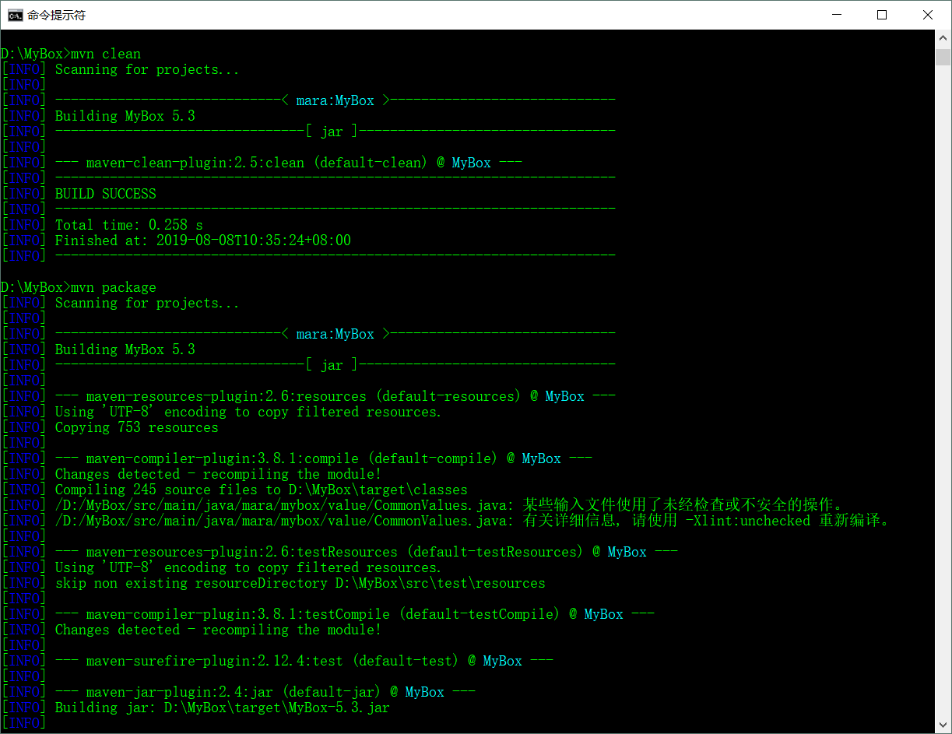

Build on linux
Make sure JAVA_HOME is defined as jdk13.0.1, like “/usr/java/openjdk-13.0.1”
Under root directory of MyBox source codes, execute following command:
mvn clean
mvn -P linux package

Build on mac
Make sure JAVA_HOME is defined as jdk13.0.1, like “/usr/java/openjdk-13.0.1”
Under root directory of MyBox source codes, execute following command:
mvn clean
mvn -P mac package

Build package without Javafx
If user's env has openjfx 12.0.1 or higher installed, package without javafx can be built for them. The advantage is that the package is smaller, and the disadvantages are that javafx should be installed and that extra configuration is need for javafx.
Looks disadvantages are more, so no such package is made now.

Scripts for self-contain package
Self-contain package is that can run without extra requirements like Java env.

Tool “jpackage”
Jdk 14.0.1 includes the tool jpackage:
https://docs.oracle.com/en/java/javase/14/docs/specs/man/jpackage.html

Make exe package for windows
1) Unpack source files under any path:
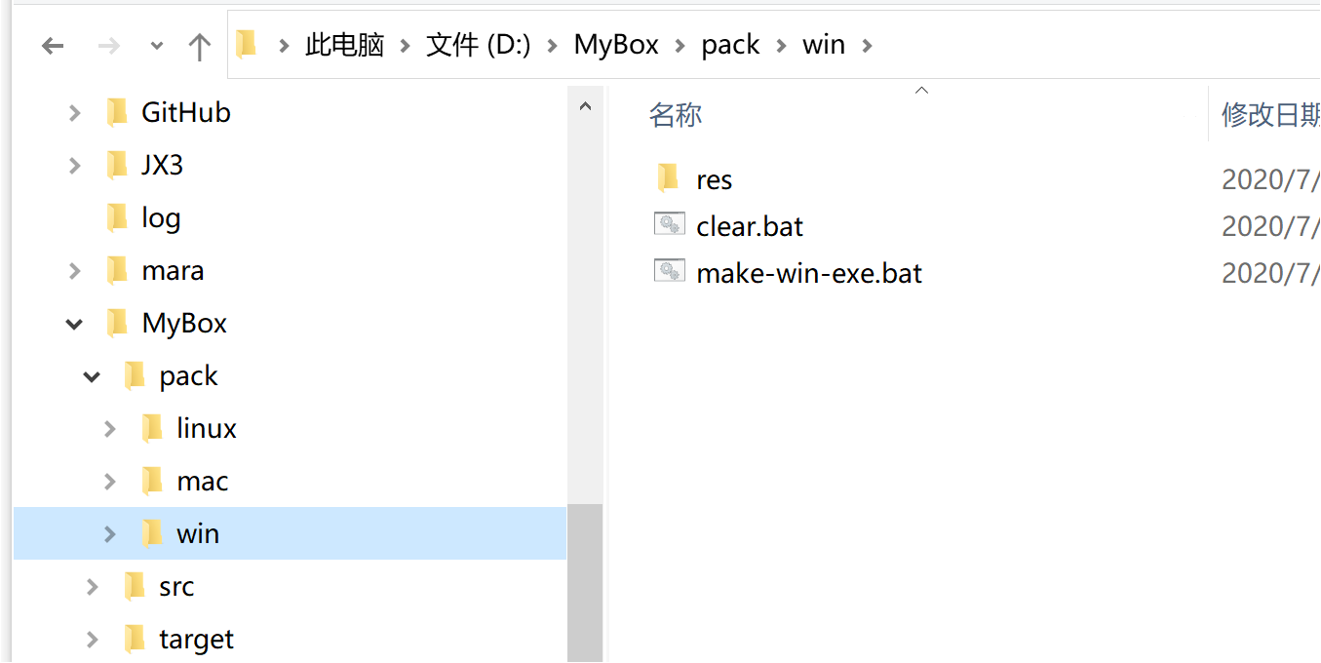
2) Edit script “MyBox\pack\win\make-win-exe.bat” and set parameters as your env:
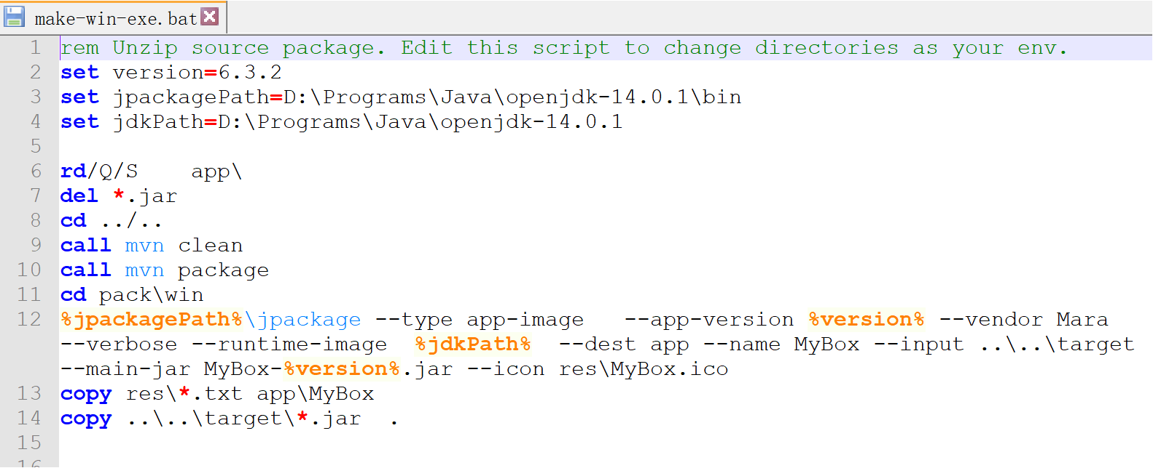
3) Execute script “MyBox\pack\win\make-win-exe.bat”. Geneated lanucher is “MyBox\pack\win\app\MyBox\MyBox.exe”.

Make executable package on linux
1) Unpack source files under any path:

2) Edit script “MyBox/pack/linux/make-linux-bin.sh”, and set parameters as your env:

3) Open a terminal window and enter path “MyBox/pack/linux”
4) Execute script “MyBox/pack/linux/make-linux-bin.sh”. Geneated lanucher is “MyBox/pack/linux/app/MyBox/bin/MyBox”.

Make dmg on mac
1）将源码包解包到任意可写目录下：

2) Edit script “MyBox/pack/mac/make-mac-dmg.sh”, and set parameters as your env:

3) Open a terminal window and enter path “MyBox/pack/mac”
4) Execute script “MyBox/pack/linux/make-mac-dmg.sh”. Geneated lanucher is “MyBox/pack/linux/app/MyBox-$version.dmg”.

File “MyBox/pack/mac/res/generate-mac-icns.sh” can help to make icns automatically.

Coding with Netbeans

Config Derby

Add Derby Drivers
Find file “Derbytools.jar” in Derby installation package and use Netbeans “Services” - “Databases” - “Drivers” to add 2 Derby JDBC drivers “Client Driver” and “Embeded Driver”, like following graph:

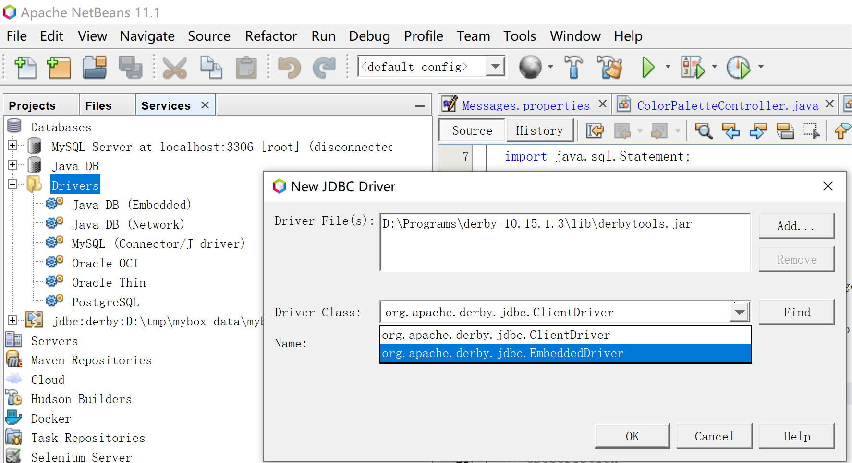

Start/Connect to Derby as emdedded mode
Notice: Only one application can accesse derby in this mode. NetBeans can not visit derby when other JVM or application has connected it. And others can not visit derby when NetBeans has connected it.
When MyBox is not started, developer can use this mode to start derby and check data.
Before debug MyBox, make sure connection in embedded mode has been closed to avoid MyBox fails to visit db.

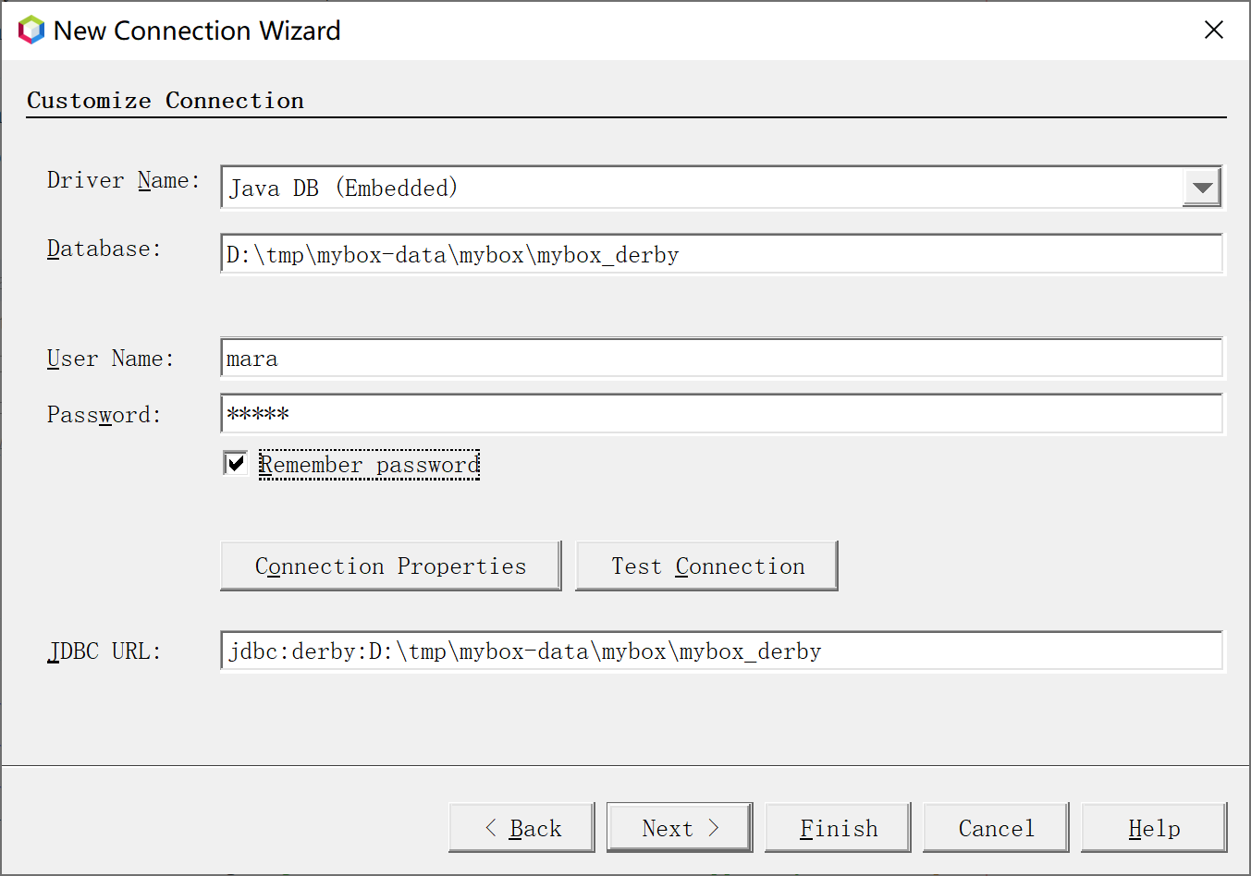

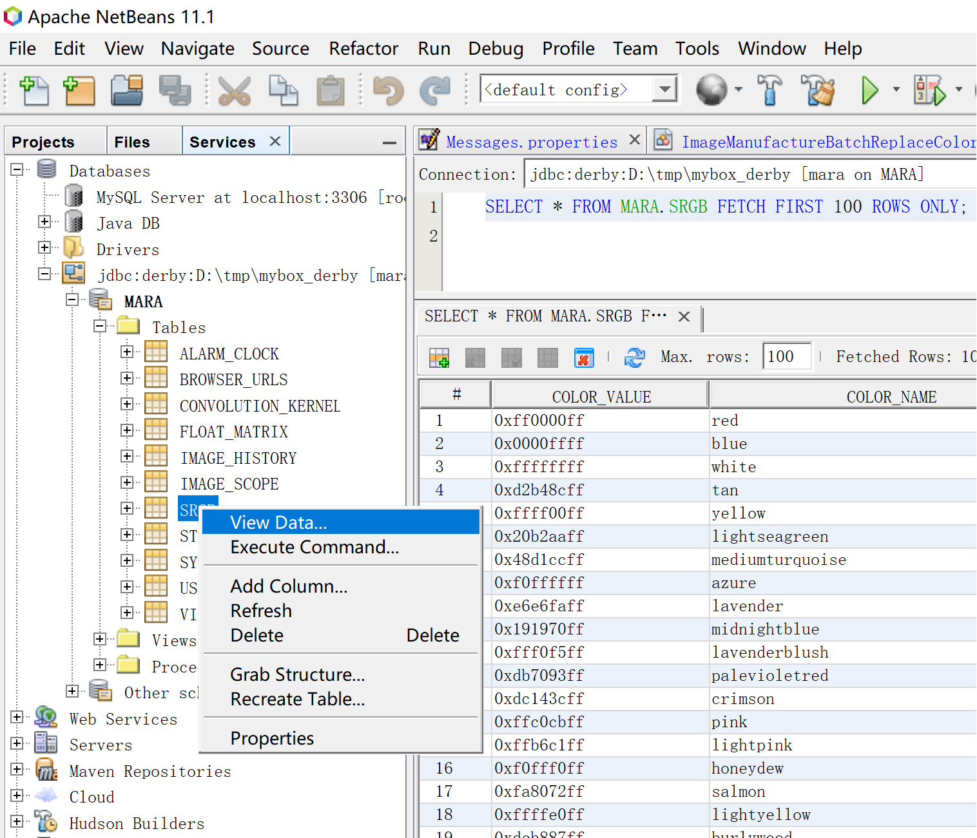

Connect to derby in client mode
When Derby has been started in network(server) mode, NetBeans can connect to it by client mode.
Developer can use this mode to check data when MyBox has been started.

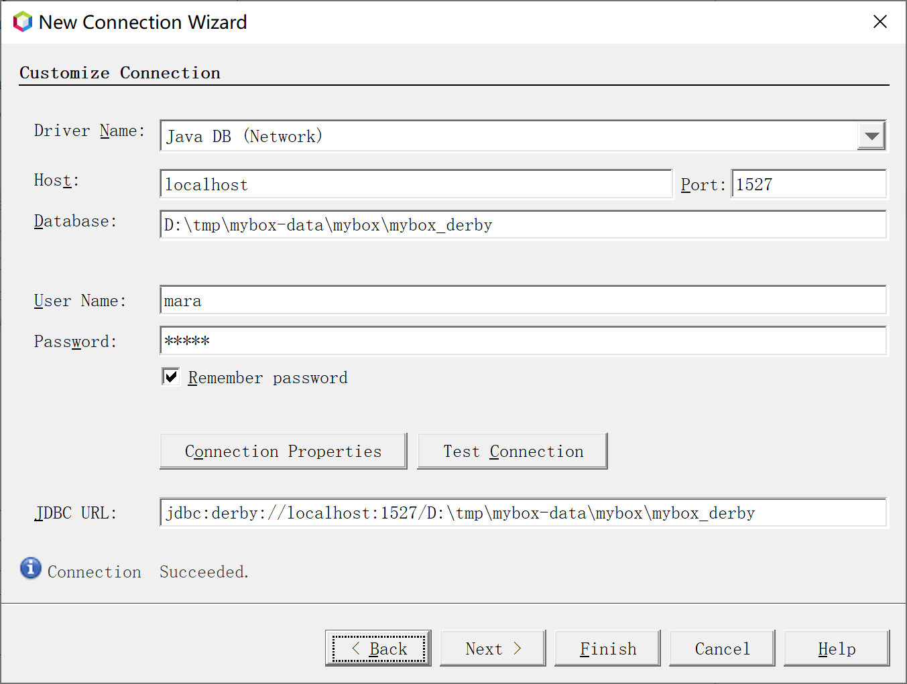

Manage project

Switch configration profile
Project files “nbactions*.xml” are netbeans configration profiles for different maven profiles(different platforms). They can be switch easily in netbeans to build package for current plarform:
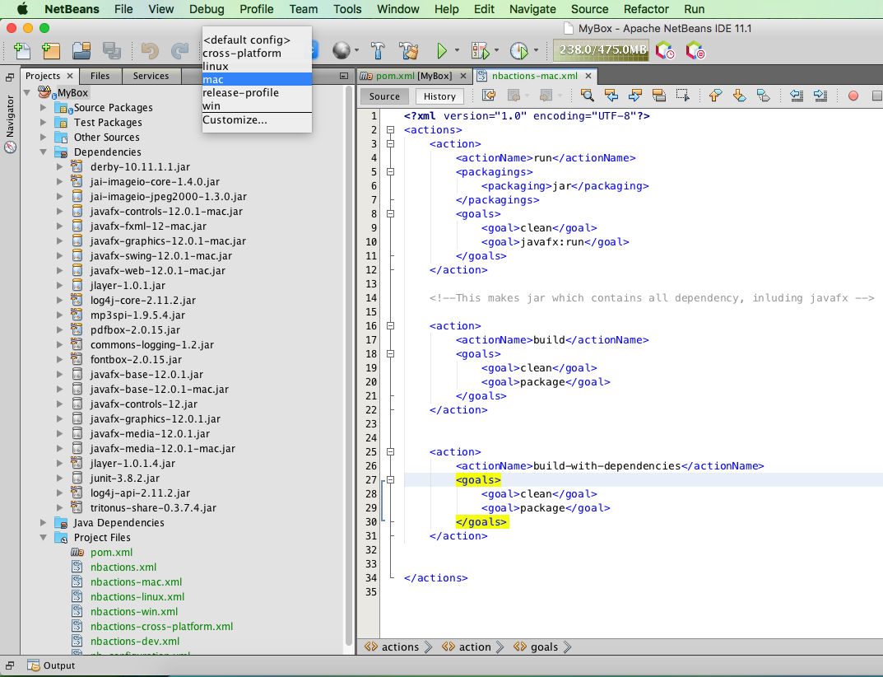

Quick debug
According to guides in offical network, action “run” is defined as “javafx:run” in files “nbactions*.xml”. Thus when click button “run”, MyBox will run directly in IDE javafx env and no jar package is generated. Time is saved much.

Build package with all dependencies
All “nbactions*.xml” define action “build” as “package”, so jar with all dependencies against selected profile(platform) will be generated when execute action “build”. More time is need compared with quick debug.

Find and download codes
Generally, it is easy and direct to search and down latest source codes by Maven in NetBeans. But sometimes some versions may be older or download is slow by IDE(Example in my env), then following address may be useful to find codes more directly:
https://mvnrepository.com/

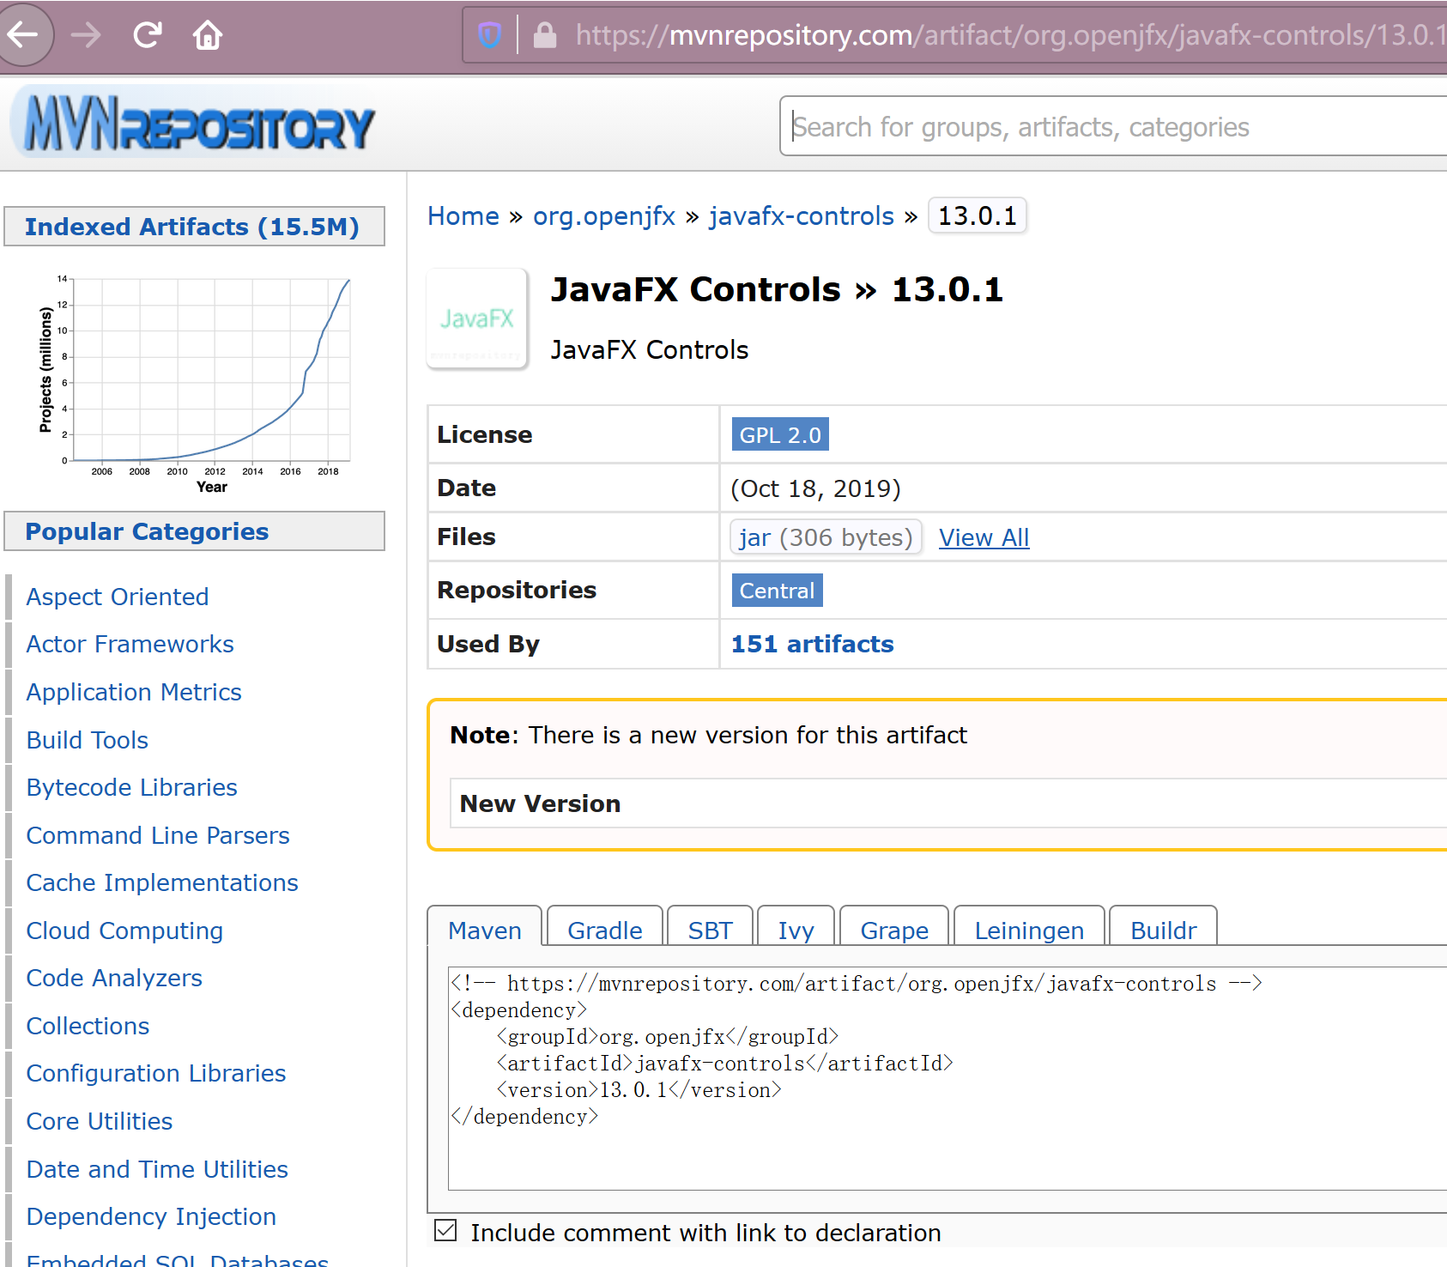

Click “View All” to enter maven library:

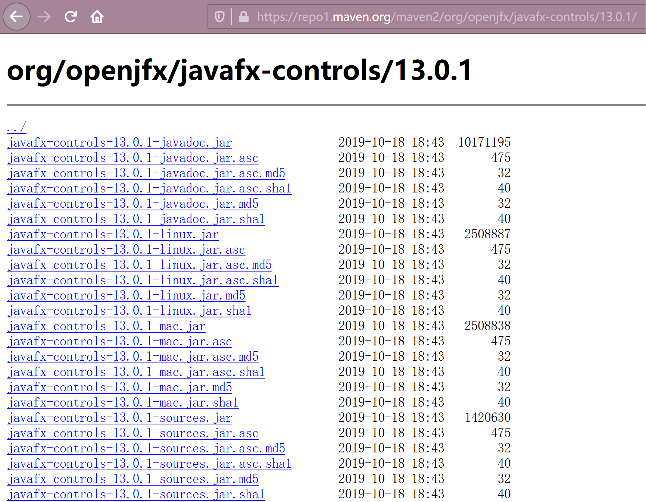

Exceptions

Remove modules
Problem: Add module decriptor “module-info.java” to some project, then remove it. Then all source files are in wrong status in NetBeans.
Solution: Delete NetBeans caches like “C:\Users\mara\AppData\Local\NetBeans\Cache\11.1”.

OS broken
Problem: When system is down suddenly, some data in memory have not been updated to cache and may cause NetBeans abnormal. Example, left project tree can never be shown in my env once time.
Solution: Delete Configure data, like “C:\Users\mara\AppData\Roaming\NetBeans\11.1”. Reinstall NetBeans may be another way.

Editor instead of JavaFX Scene Builder is opened when double click fxml
Check “Tools” - “Options” - “Java” - “JavaFX”, and make sure path of JavaFX Scene Builder is there.
This option may become empty after quit and re-enter NetBeans.
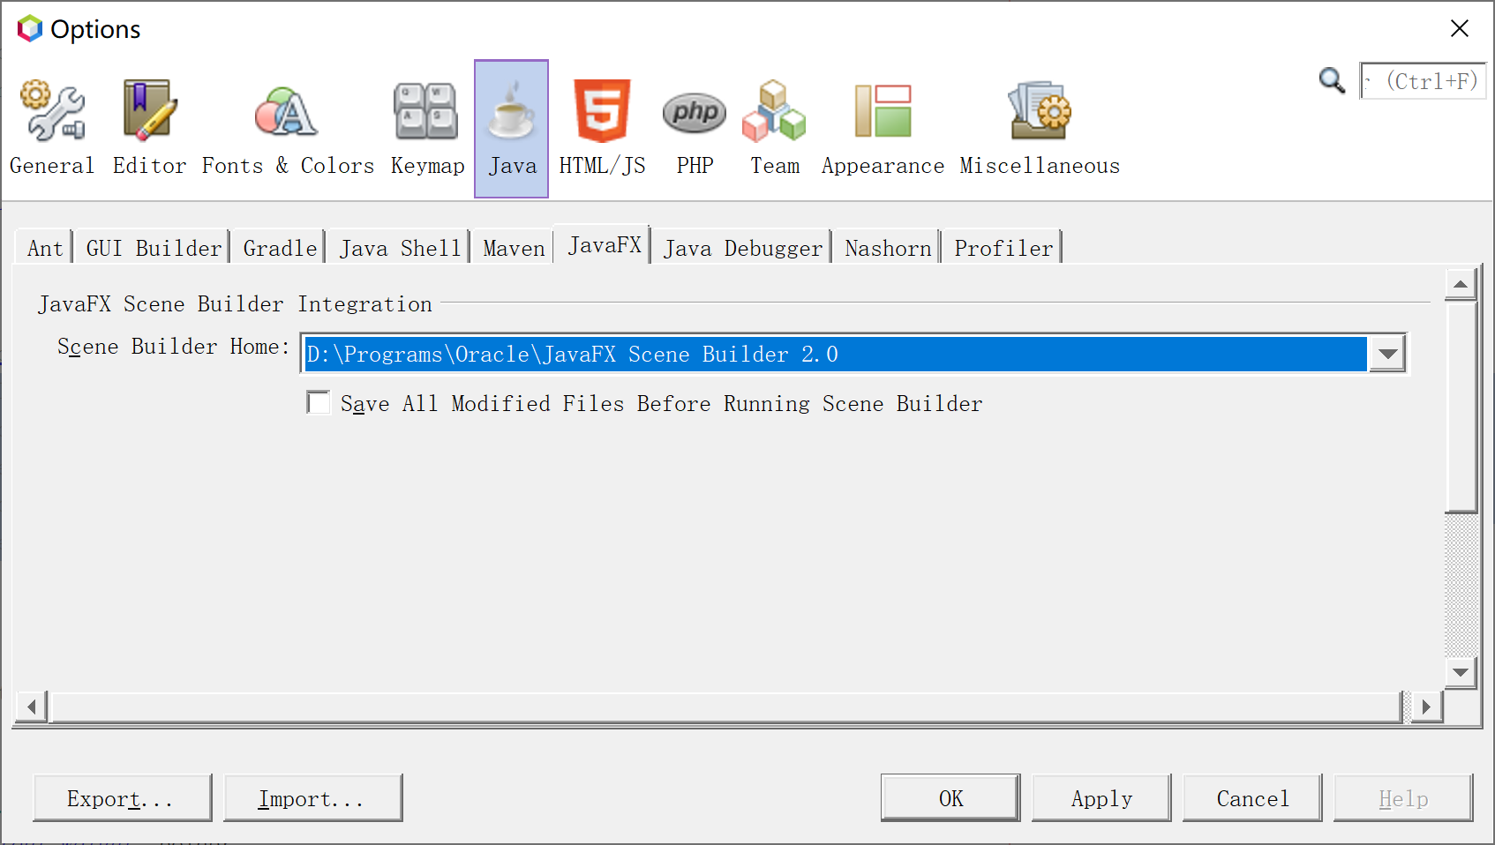

Coding JavaFx

Offical Guides
https://docs.oracle.com/javafx/2/

Configure of latest JavaFx
https://openjfx.io/openjfx-docs/

Interface in CSS style
Offical guides of JavaFX CSS:
https://docs.oracle.com/javafx/2/api/javafx/scene/doc-files/cssref.html
Development guides:
https://docs.oracle.com/javafx/2/get_started/css.htm
https://docs.oracle.com/javafx/2/css_tutorial/jfxpub-css_tutorial.htm

Javafx Experts
https://jonathangiles.net/
http://fxexperience.com/
https://github.com/fxexperience/code
https://github.com/FXDocs/docs
http://tutorials.jenkov.com/javafx/index.html

Exchange data between interfaces
https://stackoverflow.com/questions/14187963/passing-parameters-javafx-fxml

Limit text field
http://fxexperience.com/2012/02/restricting-input-on-a-textfield/
https://stackoverflow.com/questions/7555564/what-is-the-recommended-way-to-make-a-numeric-textfield-in-javafx

Enable/Disable HiDPI
JavaFX has implemented dpi-aware since Java 9. It is enabled by default.
Following setting can enbale/disable hidpi:
System.setProperty("prism.allowhidpi", "false");
Notice: It must be run before JavaFx is lanuched.

Resolution of Control' snapshot
Method snapshot() can be used to make snapshot of control's current status. Snapshot in Java 8 is always WYSIWYG, while snapshot since Java 9 is in low resolution.
Following article explains this problem:
http://news.kynosarges.org/2017/02/01/javafx-snapshot-scaling/
In my env:
“Toolkit.getDefaultToolkit().getScreenResolution()" returns 216
"Screen.getPrimary().getDpi()" returns 72
"Screen.getPrimary().getOutputScaleX()" returns 2.25

72 * 2.25 = 162
96 * 2.25 = 216
216 / 72 = 3
In order to get clear snapshots, MyBox takes the way mentioned in above article: scale control in 3 times and then make snapshot. The bad thing is that the result is in very large size.
Following is an example:

Bounds bounds = webView.getLayoutBounds();
double scale = Toolkit.getDefaultToolkit().getScreenResolution()
/ Screen.getPrimary().getDpi();
if (scale < 1) scale = 1;
int imageWidth = (int) Math.round(bounds.getWidth() * scale);
int imageHeight = (int) Math.round(bounds.getHeight() * scale);
SnapshotParameters snapPara = new SnapshotParameters();
snapPara.setFill(Color.TRANSPARENT);
snapPara.setTransform(javafx.scene.transform.Transform.scale(scale, scale));
WritableImage snapshot = new WritableImage(imageWidth, imageHeight);
snapshot = webView.snapshot(snapPara, snapshot);
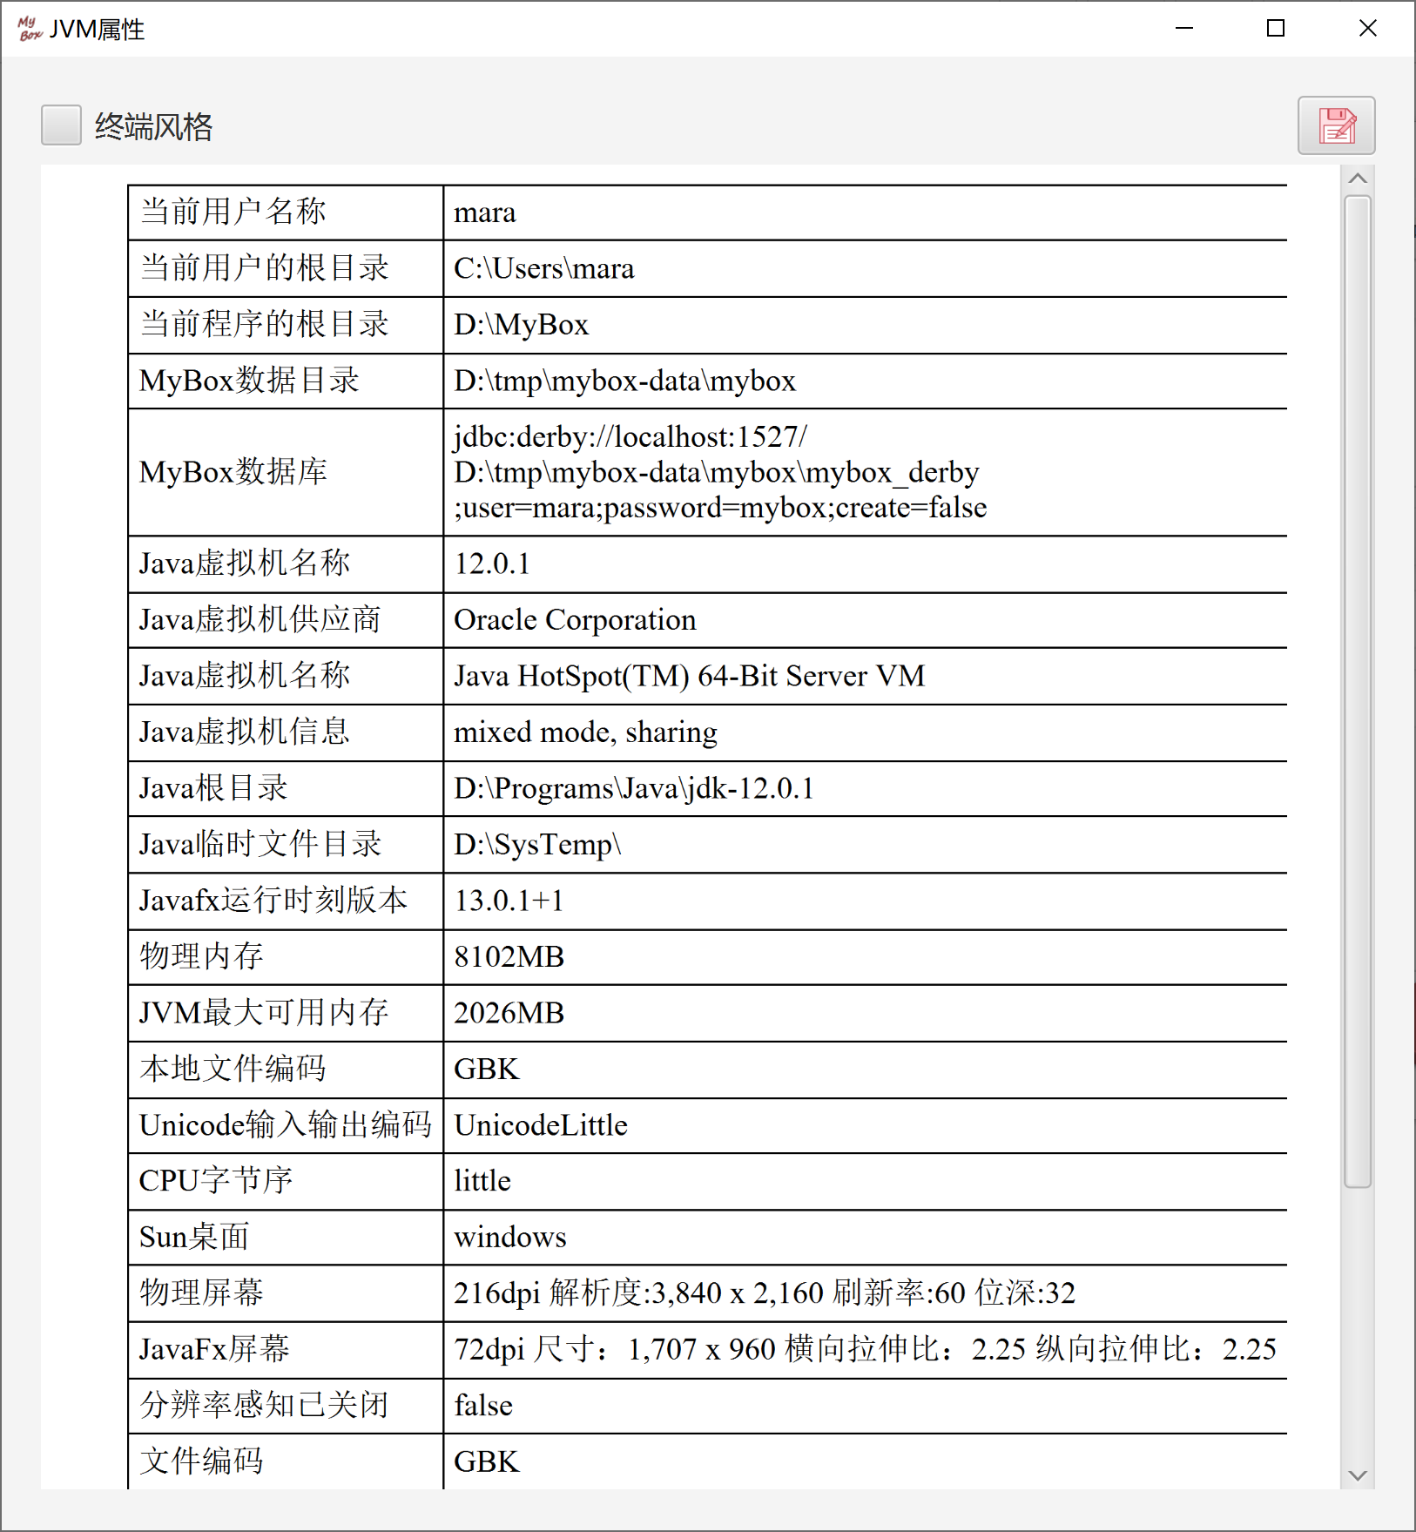

Set controller for fxml dynamically
Refers to:
https://stackoverflow.com/questions/23132302/invocationtargetexception-when-running-a-javafx-program/53129147?r=SearchResults#53129147
Example:
FXMLLoader loader = new FXMLLoader(getClass().getResource("main.fxml"));
loader.setController(new MainController(path));
Pane mainPane = loader.load();
By this way parameters can be set for the controller.
But actions of all controls in this fxml can not be defined directlly.

Update legend in chart dynamically
Refers to:
https://stackoverflow.com/questions/37634769/dynamically-change-chart-colors-using-colorpicker/37646943?r=SearchResults#37646943
Example in MyBox:
Set<Node> legendItems = histogramChart.lookupAll("Label.chart-legend-item");
if (legendItems.isEmpty()) {
return;
}
for (Node legendItem : legendItems) {
Label legendLabel = (Label) legendItem;
Node legend = legendLabel.getGraphic();
if (legend != null) {
String colorString = FxmlColor.rgb2Hex(colorTable.get(legendLabel.getText()));
legend.setStyle("-fx-background-color: " + colorString);
}
}

Danger of “setAlwaysOnTop”
Consider following scenario:
1) Stage A is set as "setAlwaysOnTop(true)".
2) Stage B pops an Alert to have user select some buttons.
3) Stage A is on top and covering buttons of the Alert.
Then app is blocking: Stage A can not get focus before user click buttons on Alert but Alert is unavaliable before stage A is moved away from top of it.

The way to avoid this confliction referred to following article: program should always bring alert in front
https://stackoverflow.com/questions/38799220/javafx-how-to-bring-dialog-alert-to-the-front-of-the-screen?r=SearchResults
Stage stage = (Stage) alert.getDialogPane().getScene().getWindow();
stage.setAlwaysOnTop(true);
stage.toFront(); <----- This is key point
Following report has been submitted to jdk dev team:
https://bugs.java.com/bugdatabase/view_bug.do?bug_id=JDK-8230127

Ghost data in TableView/ListView
Method “UpdateItem” is often changed when define Cell of TableView/ListView, and ghost data, which are non-existed rows shown in bottom, will appear if not handle condition of “empty”
https://stackoverflow.com/questions/26821319/javafx-listview-and-treeview-controls-are-not-repainted-correctly
Solution is always writing codes for empty data:
@Override
protected void updateItem(final T persistentObject, final boolean empty) {
super.updateItem(persistentObject, empty);
if (empty) { <---- Must have this part
setText(null);
setGraphic(null);
} else {
// ... rest of your code.
}
}

Listen events in embedded page
The special thing of listening events in embedded page is that the page can not receive events' notice when focus is not in it and both it and its parent will receive events' notice when focus is in it.
This will make 2 types of toubles: 1) The events can be handled twice if embedded page and its parent are inherited by same class and have same logic to handle and listen events. 2) Embedded page will miss some events when focus is not in it.
One solution is to put all logic in main page and causes it very complex. Better solution is embedded page does not listen events directly anymore and main page dispatchs events information.

Refresh ListView
ListView always refreshs itself when data is added or deleted. But it may be unaware of data updates and can not refresh itself when data attributes have been changed.
Program need refresh ListView.
https://stackoverflow.com/questions/13906139/javafx-update-of-listview-if-an-element-of-observablelist-changes?r=SearchResults
for (int i = 0; i < listView.getItems().size(); i++) {
listView.getItems().set(i, listView.getItems().get(i));
}

Submit updates when lose focus for Editable Cell
No conclusion since 2011:
https://bugs.openjdk.java.net/browse/JDK-8089514
https://bugs.openjdk.java.net/browse/JDK-8089311
https://stackoverflow.com/search?q=TextFieldTableCell+integer
https://stackoverflow.com/questions/29576577/tableview-doesnt-commit-values-on-focus-lost-event
https://blog.csdn.net/xfwangqiang/article/details/61195451

Items in one sentence
  - Always assume user knows nothing about programming.
  - Do not expect user will open user guide. Someone, including me, even will not look at or think about prompts on the screen.
  - Necessary prompts can help user understand intention of the program.
  - Ambiguous prompt is worse than no prompt.
  - Always response for user, like pop information, make sound, or update interface.
  - Provide most options and set default choice.
  - Remember user's inputs or seletions and fill in or set values automatically in next time.
  - Less inputs or selections meanwhile keep interfaces clean.
  - Use radio or check buttons instead of drop-down list if there is enough place in interface.
  - No more than 3 levels to select.
  - When too many controls in interface, consider popular layout: Left-right areas like curtain, vertical accordion menus, tabs to switch targets
  - User' screen resolution may be from 1k to 4k, so the design size of most MyBox interfaces is smaller than 1100 * 720.
  - Make use of auto-wrap container like FlowPane, to work for both small screen and large screen.
  - Controls can be updated only in JavaFx thread. Use Platform.runLater to change control when handle event in its listener.
  - Progress should be shown when operation costs much time.
  - Time-consume operation should not be run in JavaFx thread to avoid blocking interface.
  - Backgournd task should always check whether task is canceled, especially in loop or before/after long-run statements.
  - When listen mouse events, event.getX() and event.getY() return the coordinate of event.getSource() which is the control owns the events. Example, when listen on ImageView, the coordinate is related to the image.
  - Iterative calls may happen when listen both onMouseEntered and onMouseExited and change focus in handling of the events(like pop menu) or change control's size.
  - When double click mouse, single-click event is tiggerred at first and then double-click event is triggerred. So need avoid duplicated or conflicted handlings against same event.

Image Manufacture

Java Image I/O Technology
Please refer following:
https://docs.oracle.com/javase/8/docs/technotes/guides/imageio/
https://docs.oracle.com/javase/8/docs/technotes/guides/imageio/spec/imageio_guideTOC.fm.html
https://docs.oracle.com/javase/tutorial/2d/index.html
https://www.javaworld.com/article/2076764/java-se/image-processing-with-java-2d.html

Image Meta Data
Please refer following:
https://docs.oracle.com/javase/10/docs/api/javax/imageio/metadata/doc-files/standard_metadata.html
https://docs.oracle.com/javase/10/docs/api/javax/imageio/metadata/doc-files/gif_metadata.html
https://docs.oracle.com/javase/10/docs/api/javax/imageio/metadata/doc-files/jpeg_metadata.html
https://docs.oracle.com/javase/10/docs/api/javax/imageio/metadata/doc-files/png_metadata.html
https://docs.oracle.com/javase/10/docs/api/javax/imageio/metadata/doc-files/tiff_metadata.html

Multiple Frames Image File
It is a file which includes multiple independant images.
Currently MyBox supports multiple frames image files in formats of animated gif and tiff/tif.

Tiff/Tif file
Please refer following:
https://en.wikipedia.org/wiki/TIFF
https://en.wikipedia.org/wiki/GeoTIFF
https://www.adobe.io/open/standards/TIFF.html

Animated Gif
Please refer following:
http://giflib.sourceforge.net/whatsinagif/index.html
https://www.jianshu.com/p/df52f1511cf8
https://stackoverflow.com/questions/22259714/arrayindexoutofboundsexception-4096-while-reading-gif-file
https://github.com/DhyanB/Open-Imaging
https://programtalk.com/python-examples/com.sun.media.imageioimpl.plugins.gif.GIFImageWriterSpi/

Big Image
Big image is a picture that includes too many pixels to be loaded and displayed under limitation of current memory usage. For all operations which use image as input, big image should be concerned.
The pressure agianst memory is the pixels number of the image, instead of the bytes number of image file.
Example, a jpg file of 42M includes 65500x4504 pixels. Each pixel occupies 3 bytes, so the image data requires 844M bytes memory. If need load and display the whole image in interface of JavaFx, data will be tranferred between file, BufferedImage, and WritableImage, and at least 2.6G memory will be occupied. In my practice, at least 5G should be defined in "-Xmx" to display this image although about 2.3G is shown as the memory usage.
Another example, a png file of 52M includes 8101x4557 pixels, and it needs only 750M memory to load and display whole image in memory.

The principles of handling big images by MyBox are following:
  - Evaluate the required memory for whole image, and judge whether load all data in memory. (About 5 times of pixels data plus 200M)
  - If enough memory is available to load whole image, read all data for next operations. Try best to operate in memory and avoid file I/O.
  - If memory may be out, subsample the image for next operations.
  - The sample ratio is determined by following rule: Make sure the sampled image is good enough while the sampled data occupy limited memory.
  - The sampled image is mainly to display the image, and not suitable for operations against whole image and images merging.
  - Some operations, like splitting and subsampling, can be done by reading part of image data and writing-while-reading, so they are suitable for big images.
  - Image which can not be loaded wholely may be suitable to be handled batchly. Example, an image of 500M pixels can not be displayed under limitation of 1.8G, thus can not be cropped, zoomed, or color-adjusted interactively. But when crop, zoom, or color-adjust the image in batch way, the operations may be successful under same memory limitation, since the data need not transferred as interface pixels.

Continually handling images may affect memory usage. Example, memory occupied by previous operation has not been collected by GC and then less memory can be required by current operation. So it is better to restart MyBox to handle big image because it can occupy most of available memory.

In order to handle big image interactively, user can extend the maximum memory for JVM.

Image Sampling
There are 2 types of image sampling: Downsampling(Also called Subsampling) and Upsampling(Also called interpolating).
When the pixels number of image is very big, subsampling is helpful to load and display the image under limited memory.
The rule of subsampling is very simple: given the sampling ratio, the image pixels are selected to read. Example, when ratio is 3, only one pixel is read in adjacent matrix of width 3 and height 3.
Image subsampling is mainly used to handle big image. When sample ratio is 1, it acts same as "Crop". The difference between subsmapling and functions of "Crop"/"Size" in tool "Image Manufacture" is that subsampling only reads the required part of data in memroy and is writing while reading for big image. For small image, subsampling does same things as tool "Image Manufacture" and they both load all data and do operations in memory.

Image Grayscale
Please refer following:
https://en.wikipedia.org/wiki/HSL_and_HSV
https://en.wikipedia.org/wiki/Grayscale

Color Distance
Please refer following:
https://en.wikipedia.org/wiki/Color_difference

How to get sepia image
Please refer following:
https://stackoverflow.com/questions/21899824/java-convert-a-greyscale-and-sepia-version-of-an-image-with-bufferedimage/21900125#21900125

Image Blending
Please refer following:
https://en.wikipedia.org/wiki/Blend_modes
https://baike.baidu.com/item/混合模式/6700481?fr=aladdin
https://blog.csdn.net/bravebean/article/details/51392440
https://www.cnblogs.com/bigdream6/p/8385886.html

Convolution
Please refer following:
https://en.wikipedia.org/wiki/Convolution
https://en.wikipedia.org/wiki/Kernel_(image_processing)
http://colah.github.io/posts/2014-07-Understanding-Convolutions/

Flood-Fill
https://en.wikipedia.org/wiki/Flood_fill

Image Size
The following concepts are different:
“Orginal Size”: pixels number saved in image file.
“Loaded Size”: pixels number in memory which can be changed by Load/Crop/Transform.
“Display Size”: pixels number in screen after user zooms image in interface.
“Selected Size”: screen area selected by user, which will be mapped to memory area and calculated according to scale ratio of orginal size.

Example, an image has original size 1000x500, loaded size 800x400, display size 600x300, and selected size 700x200.

By setting loaded size, large image can be read in memory while small image can be scaled to view.
Loaded size is different from zooming in interface. Loaded pixels determine memory usage, while interface zooming only affect pixels in screen.

Image quantization
Technique of reducing distinct colors in image is called "Color Quantization". "Dithering" is to optimize the result of Color Quantization.

Different algorithms can be selected for different purposes:
RGB Uniform is fastest and good enough for 256 colors quantization of most images.
K-Means Clustering is good for calculating mostly different colors in image.
Popularity is good for calculating mostly occurred colors in image.

For some quantization algorithms, color space will be divided into some regions to reduce the data set.
Parameter "Regions Bit Depth" determines the size of data scope to be used for preprocessing.
Example, 4 bit depth means total 16*16*16 color values mapped from 256*256*256 color space.
After image pixels are mapped into new regions, quantization runs against this smaller values collection.
So actually twice quantization happens cause regions mapping is also a quantization.

Notice: Larger bit depth does not mean better results. It always cost much longer running time and may give worse outputs. Result quality depends on image attributes, algorithm, and parameters. Example, when image includes less different colors, small bit depth is better.

Refer：
http://web.cs.wpi.edu/~matt/courses/cs563/talks/color_quant/CQindex.html
http://tpgit.github.io/UnOfficialLeptDocs/leptonica/color-quantization.html
https://www.researchgate.net/publication/220502178_On_spatial_quantization_of_color_images
http://rosettacode.org/wiki/Color_quantization
http://www.imagemagick.org/Usage/quantize/

Filters
Refer:
http://www.jhlabs.com/ip/index.html

Media

ffmpeg
Address:
http://ffmpeg.org/
java wrapper for ffmpeg:
https://github.com/kokorin/Jaffree
https://github.com/bramp/ffmpeg-cli-wrapper
Concepts:
https://blog.csdn.net/xiaojun111111/article/details/52135557

Coding in Java

Data precision
About whether use BigDecimal to keep precision, following link is useful:
https://stackoverflow.com/questions/322749/retain-precision-with-double-in-java
"Do not waste your efford using BigDecimal. In 99.99999% cases you don't need it"
"BigDecimal is much slower than double"
"The solution depends on what exactly your problem is:
- If it's that you just don't like seeing all those noise digits, then fix your string formatting.
Don't display more than 15 significant digits (or 7 for float).
- If it's that the inexactness of your numbers is breaking things like "if" statements,
then you should write if (abs(x - 7.3) < TOLERANCE) instead of if (x == 7.3).
- If you're working with money, then what you probably really want is decimal fixed point.
Store an integer number of cents or whatever the smallest unit of your currency is.
- (VERY UNLIKELY) If you need more than 53 significant bits (15-16 significant digits) of precision, then use a high-precision floating-point type, like BigDecimal."

Charset and encoding
Charset is the mapping between characters(for printing and displaying) and bytes(in memory or files). Encoding is the way about how to save bytes in memory or file.
https://en.wikipedia.org/wiki/UTF-8
https://www.cnblogs.com/ChurchYim/p/8427373.html
https://www.cnblogs.com/maohuidong/p/8044568.html

Problems

“cannot access class … because module ... does not export ...”
I met following error under netbean11.1 + openjdk 12.0.1 + openjfx12.0.1:
Exception in thread "JavaFX Application Thread" java.lang.IllegalAccessError: class mara.mybox.controller.ImageViewerController (in unnamed module @0x1ec2591a) cannot access class com.sun.javafx.charts.Legend (in module javafx.controls) because module javafx.controls does not export com.sun.javafx.charts to unnamed module @0x1ec2591a
This happened due to a reference of internal API.
Java codes are packed in different modules since Java 9 and env need configured when they refer to each other:
https://github.com/javafxports/openjdk-jfx/issues/236
http://mail.openjdk.java.net/pipermail/openjfx-dev/2018-June/021977.html
https://stackoverflow.com/questions/53237287/module-error-when-running-javafx-media-application
https://github.com/openjfx/javafx-maven-plugin
https://openjfx.io/openjfx-docs/#modular
https://community.oracle.com/blogs/vincentvauban/2018/07

Some classes are public but they are not in the export list of module, so module can not visit it without confiration.
Following article mentioned this problem and its solution:
https://stackoverflow.com/questions/56459093/openjfx-custom-runtime-image-using-maven-and-jlink-module-exports-or-command-l/56467911?r=SearchResults#56467911

MyBox is not moduled. Its solution was adding following lines in pom.xml:
<plugin>
<groupId>org.openjfx</groupId>
<artifactId>javafx-maven-plugin</artifactId>
<version>0.0.3</version>
<configuration>
<mainClass>mara.mybox.MyBox</mainClass>
<options>
<option>--add-opens</option>
<option>javafx.controls/com.sun.javafx.charts=ALL-UNNAMED</option>
</options>
</configuration>
</plugin>
And the final solution is only using public API.

“xxx uses unchecked or unsafe operations.”
Refer:
https://stackoverflow.com/questions/8215781/how-do-i-compile-with-xlintunchecked
https://stackoverflow.com/questions/262367/type-safety-unchecked-cast?r=SearchResults
Example, codes in problem：
List<String> names = new ArrayList();
Map<String, ImageInformation> oldList = new HashMap();
Change it as:
List<String> names = new ArrayList<>();
Map<String, ImageInformation> oldList = new HashMap<>();
Replacement in batch can solve this problem very easily.

Add compile option to check invalid lines:
<artifactId>maven-compiler-plugin</artifactId>
<configuration>
<compilerArgument>-Xlint:unchecked</compilerArgument>
</configuration>

Supress this checking by add annotation:
@SuppressWarnings("unchecked")
public Object getValue() {
return value;
}

Items in one sentence
- Always assume most extreme inputs and most weird operations.
- Assume user' hardware configuration(CPU/memory/disk) is lower than average level.
- Use BufferedInputStream and BufferedOutputStream for file I/O.
- Use try-with-resource for file I/O.
- Notice charset when read/write text file.
- Notice charset when convert between bytes and string.
- When class has many parameters, do not write many constructors to initialized different sets of parameters. Better coding is static creator and chain assignment by return “this” in all “set” methods.
- Anonymous class is very useful for scenario like lots of duplicated codes with only difference that several methods have difference implements.
- Generic is very useful for scenario like lots of duplicated codes with only differernce of data type.
- As less float-point calculations as possible in loop. If can, change float-point calculations as integer calculations.
- When listen data changing, need judge whether change trully happens, and avoid too frequently manufactures by setting minimum threshold of changing.
- Reboot application when change JVM parameters or need clean env in simple way.
- Notice whether the index is 0-based or 1-based, especially for thrid-party codes. 0-based is default. If 1-based, should write comment for it.
- Double.MIN_VALUE is the minimum positive double(almost zero). -Double.MAX_VALUE is the minimum double.
<End of Document>

