TS-BMTP-lab_9_2-Talmazan

Ід-р тест-кейса / Test Case ID | Вхід / Input | Очікуваний  результат /  Expected Result
TC - 01 | arr_tem[7] = {1, 3, 4, 2, 6, 5, 5} | celsius = 3.57  farengates = 38.43
TC - 02 | arr_tem[7] = {1, 4, 6, 2, 3, 5, 7} | celsius = 4  farengates = 39.2
TC - 03 | arr_tem[7] = {5, 4, 7, 9, 8, 10, 9} | celsius = 7.43  farengates = 45.37
TC - 04 | arr_tem[7] = {10, 12, 9, 11, 13, 15, 14} | celsius = 12  farengates = 53.6
TC - 05 | arr_tem[7] = {20, 22, 19, 23, 21, 24, 22} | celsius = 21.57  farengates = 70.83
TC - 06 | arr_tem[7] = {-1, 0, -2, -3, -1, -4, -6} | celsius = -2.42  farengates = 27.63
TC - 07 | arr_tem[7] = {3, 1, 0, -2, -1, -3, -5} | celsius = -0.99  farengates = 30.2
TC - 08 | arr_tem[7] = {-10, -9, -11, -13, -15, -14, -16} | celsius = -12.56  farengates = 9.37
TC - 09 | arr_tem[7] = {29, 30, 32, 30, 31, 34, 38} | celsius = 32  farengates = 89.6
TC - 10 | arr_tem[7] = {-20, -23, -25, -21, -21, -19, -20} | celsius = -21.28  farengates = -6.3

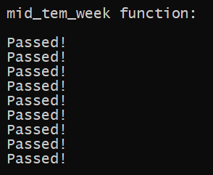

Рисунок 1 — Результати тестування функції mid_tem_week

