LOOK AND FEEL – DESIGN ACTIVITY
OSCAR PEREIRA - DAW 7K

FILIPIDES TRAINING CENTER
“The FASTest way to reach our goals”

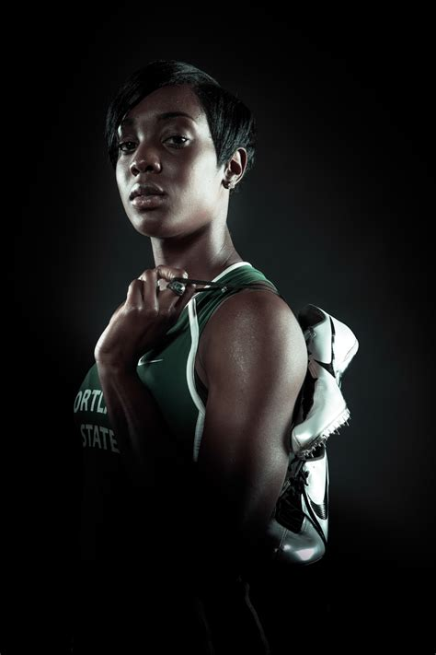

FILIPIDES TEAM

This name was chosen based on the ancient greek tale of Filipides, who ran from Marathon back to the city in a single day to deliver an urgent message, this name was chosen because it honors the first “Marathon” runner.

ABOUT US

The idea behind this website is that of a training facility, fully equipped and supervised by specialists in the conditioning and training of high-performance athletes, designed for aspiring professionals in the track and field disciplines that want to take a step further in their careers.



Impact was chosen for its boldness and sportive look

Color Palette











