The theme of our game is “bring your kid to work day”, which also the working title. The player/ main character will be a child that is accompanying their parent to their office job and the goal is to destroy as many objects in the office as possible. The game will have a time limit and the player should try to get as many points as possible by destroying objects before the time runs out.

Currently we do have something to show in terms of the games but it is still is very early stages. The player character and a few objects with collision appear at random locations on the stage. All images are placeholders until the functions and physics are working in the ways we want them to. In the end they will be replaced with proper sprites.

Over the next week or so we plan to add the following:

New objects

Different collision groups based on specific objects  
 Ex. Moveable and non-moveable objects

Larger World Size and a Camera that follows the player

Current Issues:

When objects randomly spawn their bounds can be set outside the bounds of the game   
and the objects are launched immediately instead of sitting stationary.

Game Stage upon Startup:  
 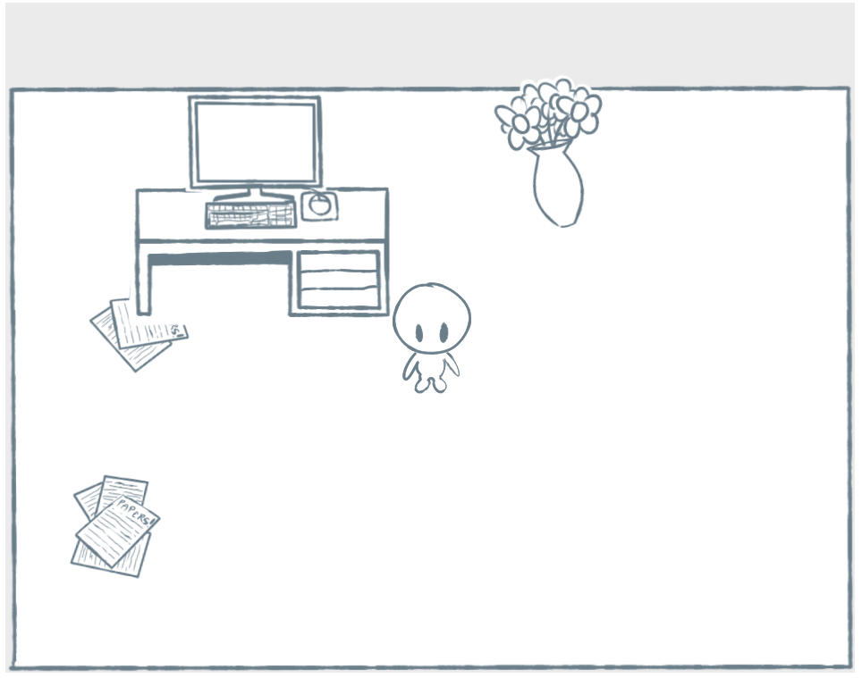

After Interacting with Objects:

