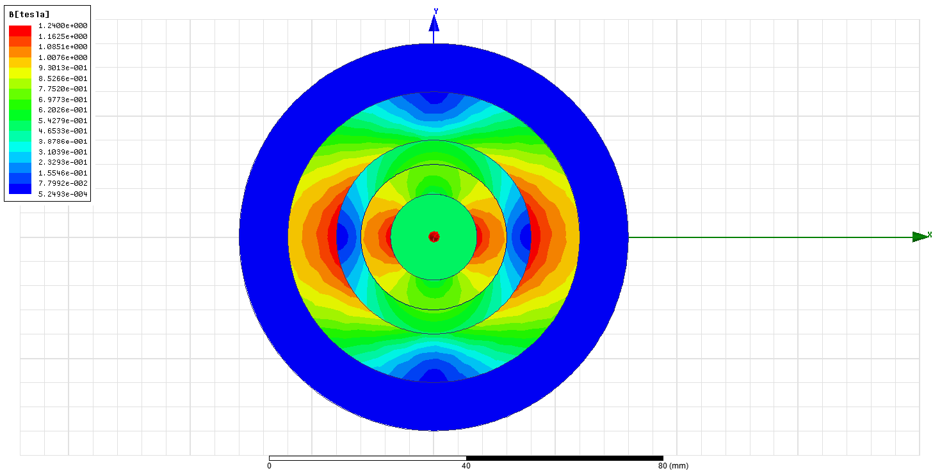



Max airgap flux density = 0.6T

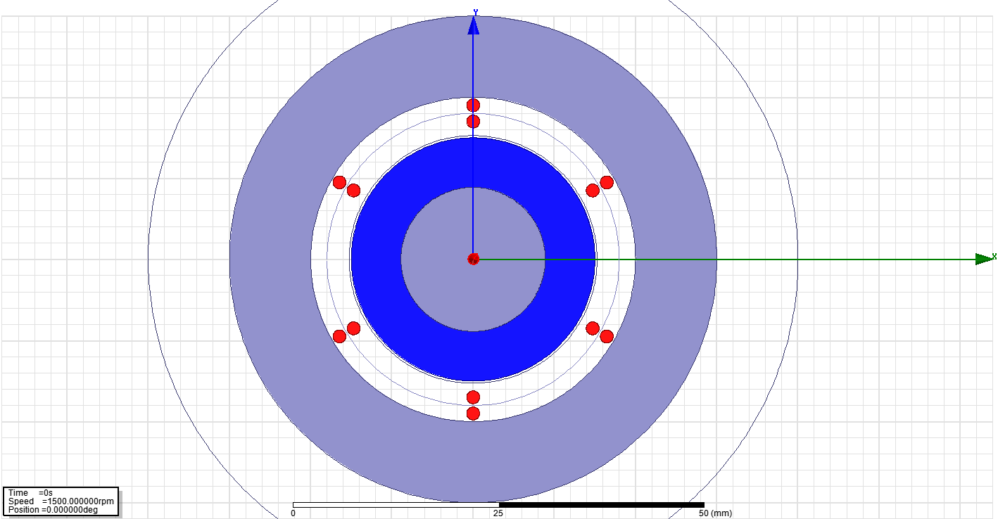

Simple model to find number of turns roughly





Induced voltage @1500 rpm 1turn





Induced voltage @1500 rpm 29 turns

More realistic model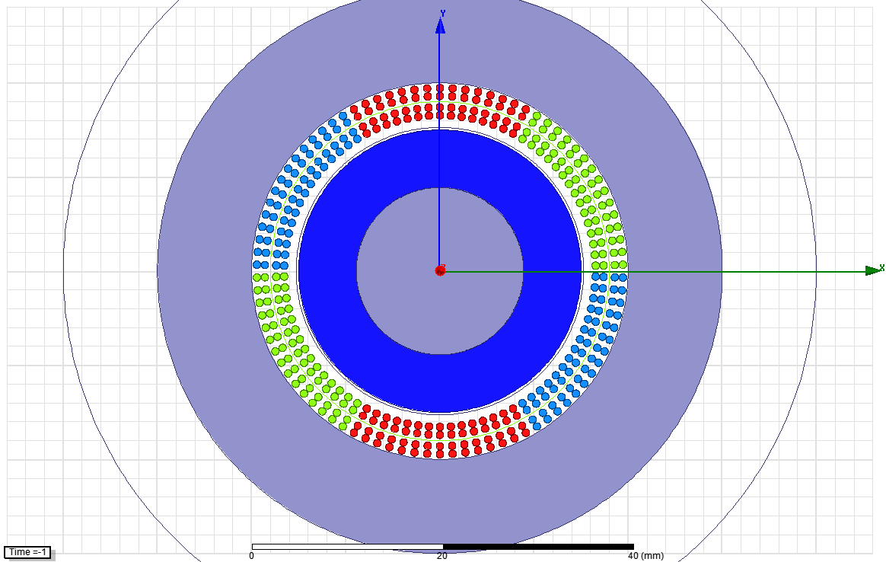

30 turns

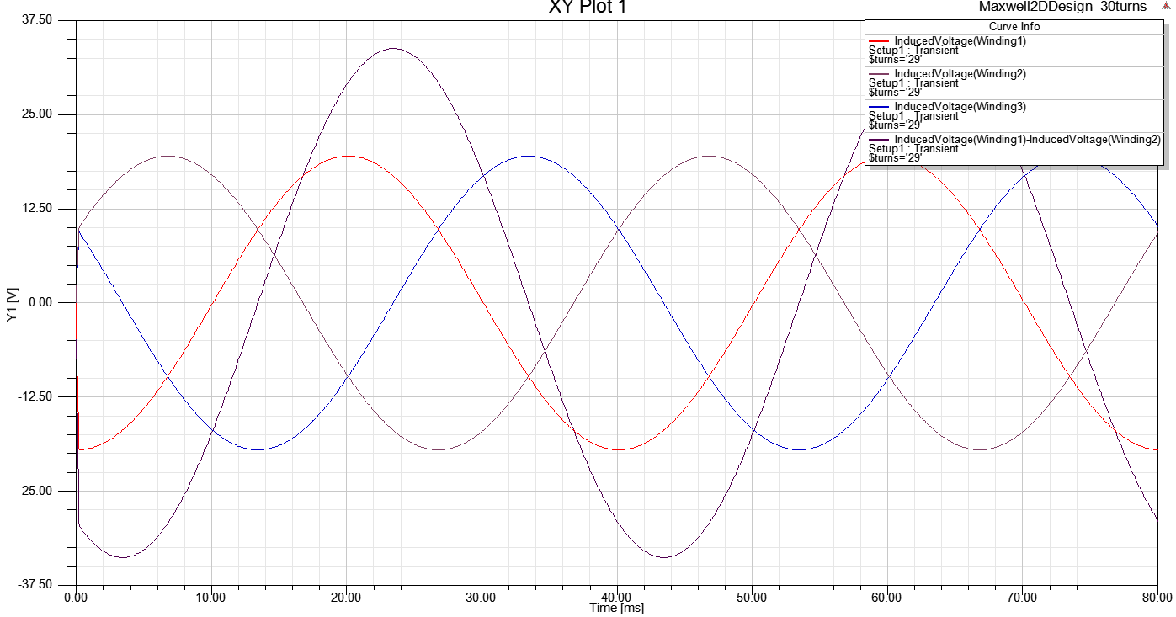

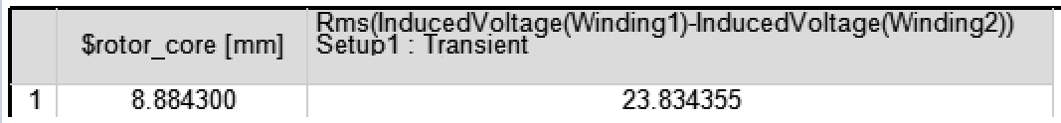

Induced voltage @1500 rpm 30 turns

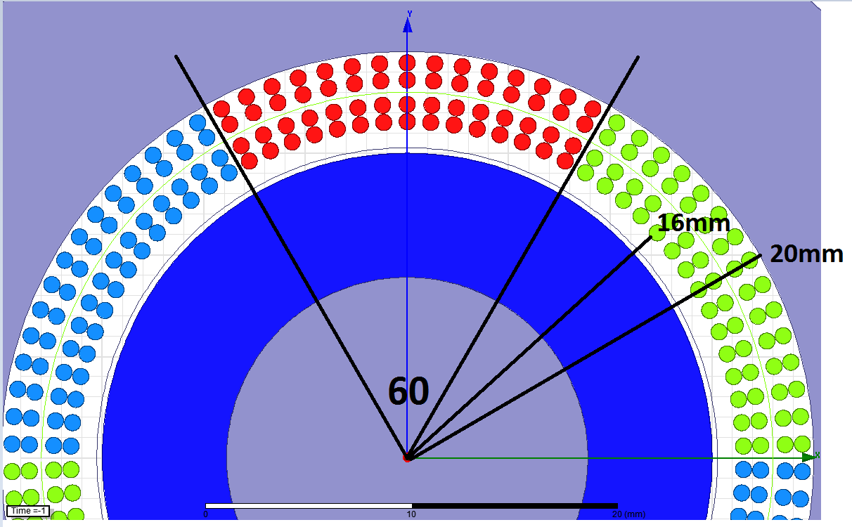

Area*fill factor=total copper area

Total copper area / number of conductors = copper area

Pi*(20^2-16^2)*(60/360)*0.7/60 = **0.88 mm^2 copper area**

Since 4 A/mm^2

**3.52 Arms**

**Max input power: 3^0.5 * 3.52 * 23.83 = 145.29 VA**

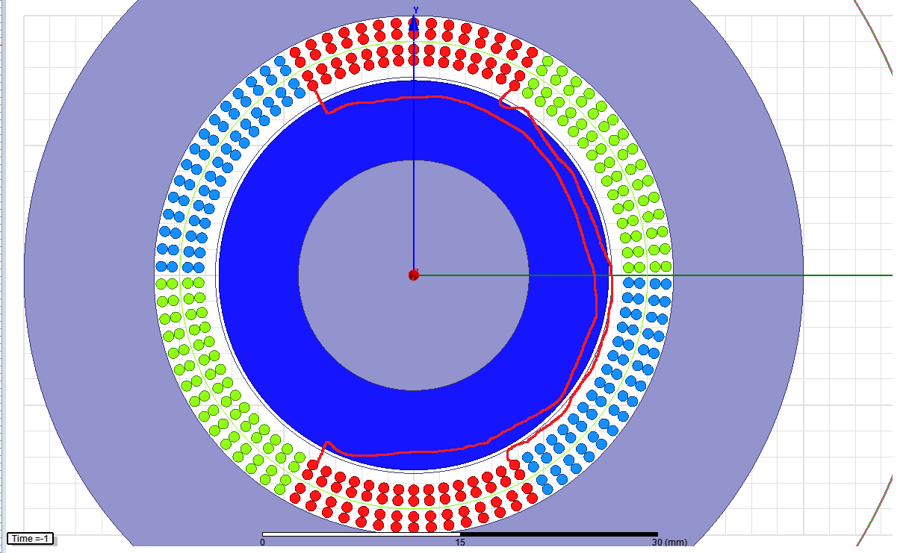

Max end winding angle: 240

Min end winding angle: 120

Average tangent length for end winding: 2*pi*18mm*(180/360)

Take avg axial length: 10mm

For each turn (2*100mm)+(2*(2*pi*18mm*(180/360)))+4*10mm

Motor length tangent length axial end length

=350mm per turn

30turns and two layer

350mm*30*2=**21 meter conductor per phase**

**0.88mm^2 copper**

**Phase resistance: 0.4 ohm**

**Ploss = 3* 3.52^2* 0.4 = 14.87 watt**