**MIDDLE EAST TECHNICAL UNIVERSITY**



**ELECTRICAL AND ELECTRONICS ENGINEERING**

**DEPARTMENT**

**EE 462**

**UTILIZATION OF ELECTRIC ENERGY**

**PROJECT-0**

**SIMULATING DC MOTOR USING SIMULINK**

**Mustafa Murat SEZER**

**1852102**

1. **Short Information About the Motor**

The DC Motor information that I choose is as following:

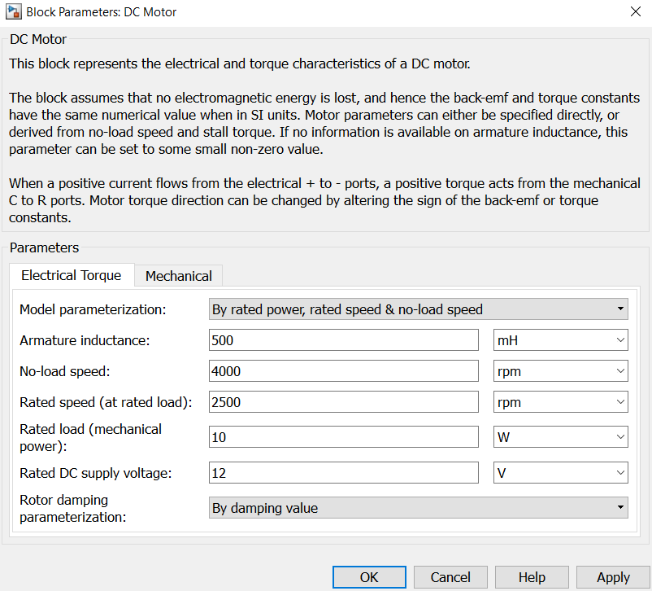

Figure 1 DC Motor Properties

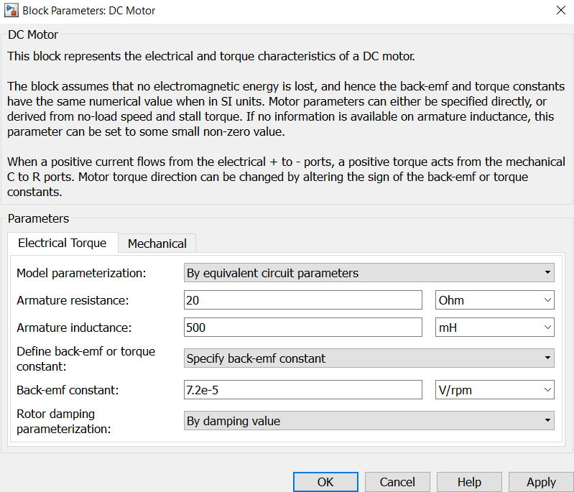

Figure 2 DC Motor Properties

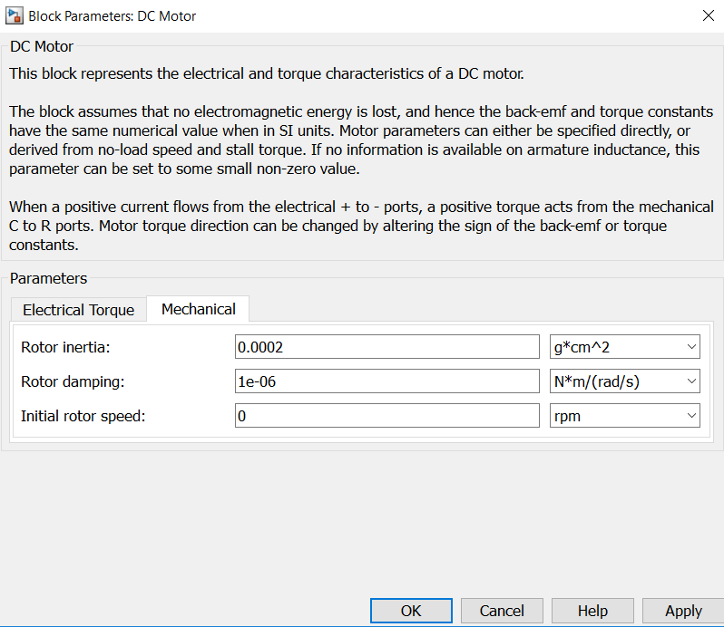

Figure 3 DC Motor Properties

At first by default values its armature resistance was 3.9 ohm and armature inductance was 12 µH, but these values caused stability problem in my design. Thus, I changed my motor parameters as above.

1. **Information About Power Source and Control System**

In my design, I have used a simple DC Voltage Source. The ideal voltage source maintains a constant voltage across its output terminals.

As a controller I have used controlled PWM Voltage to control my motor speed. Pulse-Width Modulated (PWM) voltage source across its PWM and REF ports that depends on the reference voltage Vref across its +ref and -ref ports. The duty cycle in percent is given by 100*(Vref-Vmin)/(Vmax-Vmin) where Vmin and Vmax are the minimum and maximum values for Vref. The output voltage is zero when the pulse is low, and is set equal to the Output voltage amplitude parameter when high. By increasing or decreasing PWM, I control my motor speed. I determine my PWM frequency as 1kHz since it keeps ripple less.

1. **Graphs showing acceleration curve from stationary to rated speed**

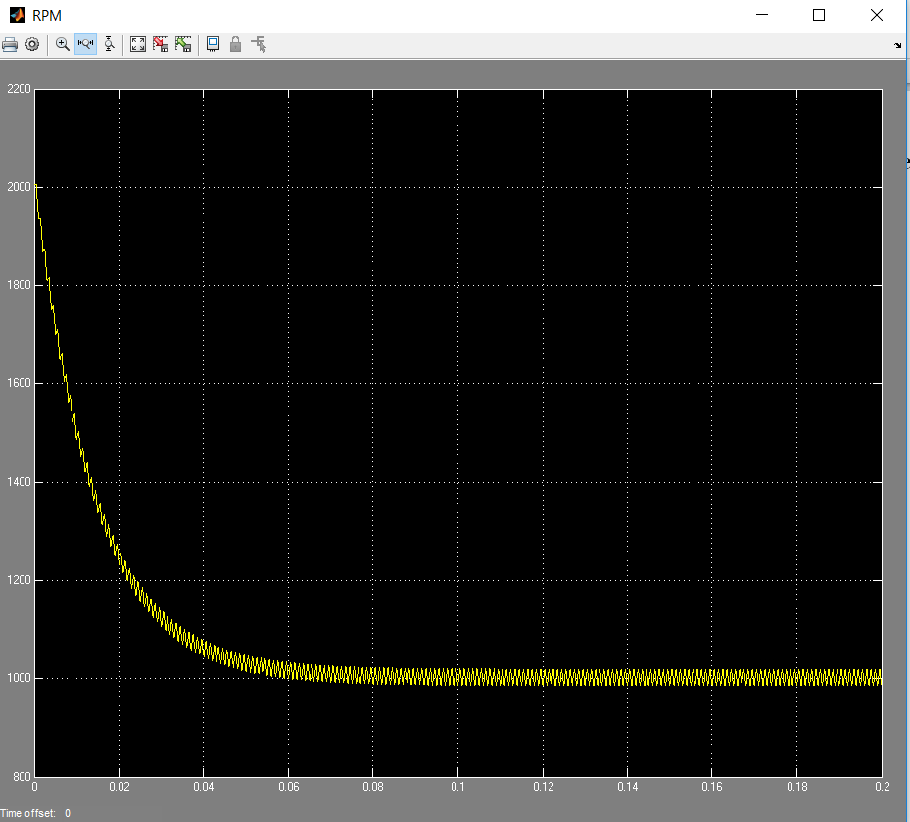

Figure 4 Accelarion Curve of Motor

At first speed is increases instantaneously to 2000 RPM, and in a short time it keeps its steady state behavior and falls its speed to 1000 RPM.

1. **Start-up current graphs**

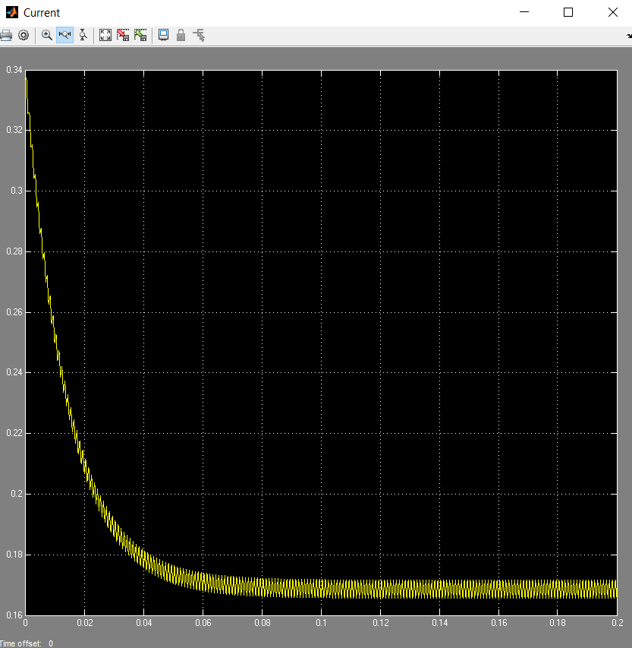

Figure 5 Current Graph

At first motor draws 0.35 A approximately, and it reachs its steady state behavior in a short time. Its ripple is as following :

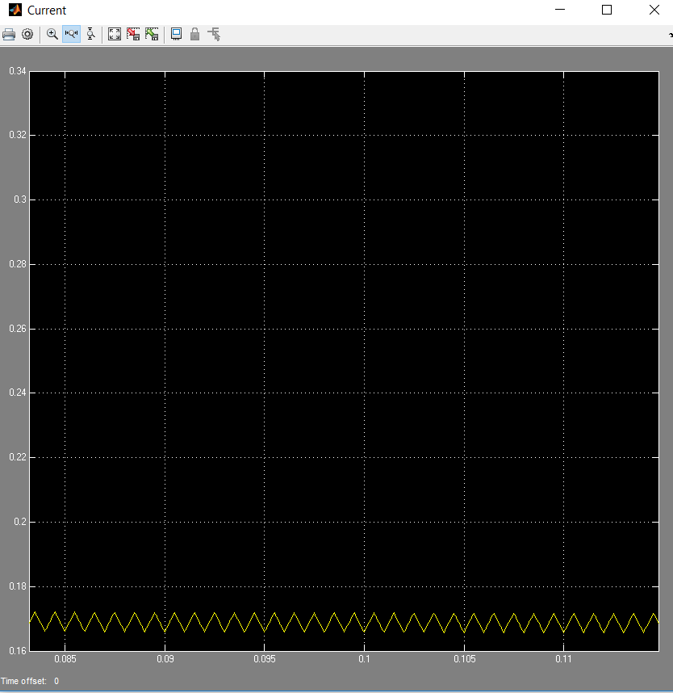

Figure 6 Current Ripple

As can be seen ripple is low, and motor draws 0.17 A.

1. **Produced torque during startup**

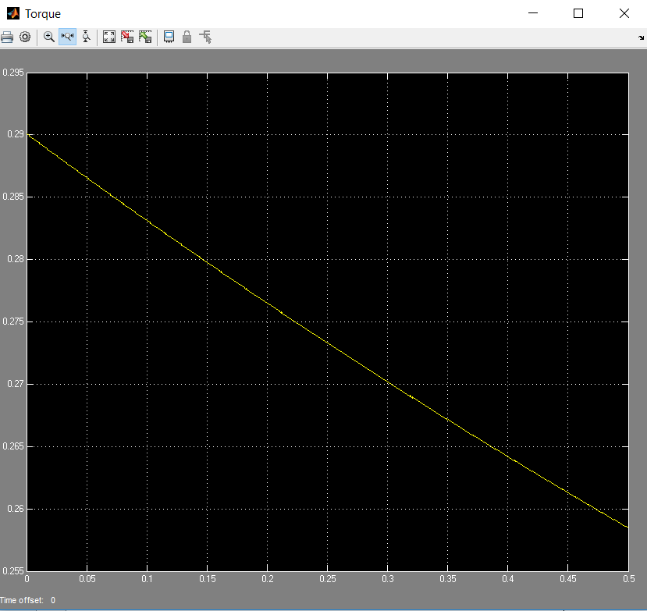

Figure 7 Produced Torque

I do not understand why torque decreased. I expect torque increased since speed is decreased. When I run program I get RPM 0. Maybe I may make a mistake somewhere in the program.

1. **Working Principle of Model**

This model shows how to use the Controlled PWM Voltage and H-Bridge blocks to control a motor. The DC Motor block uses my own parameters that I designed, which specify the motor as delivering 10W mechanical power at 2500 rpm and no-load speed as 4000 rpm when run from a 12V DC supply. Hence if the DC Voltage Source is set to +5V, then the motor should run at 4000 rpm. If it is set to +2.5V, then it should run at approximately 2000 rpm. The Simulation model parameter is set to Averaged for both the Controlled PWM Voltage and H-Bridge blocks, resulting in fast simulation.