Project 0

DC Motor Starter Application

Furkan Karakaya

Project 0: DC Motor Starter Application

by Furkan Karakaya

Published 06-Mar-2017 22:50:20

All rights reserved.

Abstract

This report is created for learning purposes.

Table of Contents

Chapter 1. Model - DCMotor 1

Chapter 1. Model - DCMotor

This is a report created for learning process.

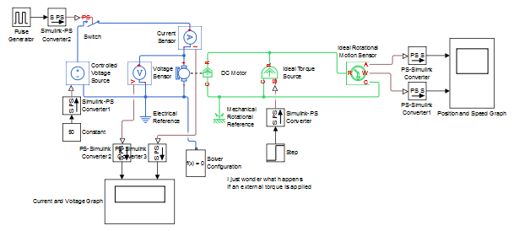

Figure 1.1. Current and Voltage Graph

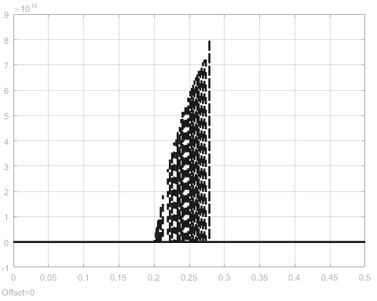

Figure 1.2. Position and Speed Graph

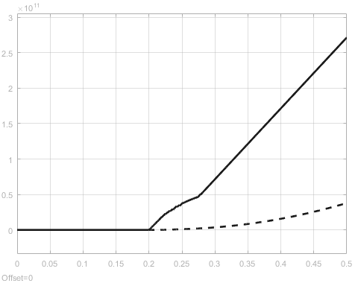

At the end.**I have no enough time to complete whole model or report. However, I gained information about the procedure, usage of SourceTree & GitHub and Simulink environment. I also gained experience on Simulink Report Generator but it seems more detailed thing, so a tutorial about report generation might be very helpful.**