EE462 UTILIZATION OF ELECTRICAL ENERGY

Project-0 Report



Gökhan ÇAKAL

EE462 UTILIZATION OF ELECTRICAL ENERGY: Project-0

by Gökhan ÇAKAL

Published 05-Mar-2017 12:26:56

Abstract

This report is prepared to show a permanent magnet dc motor characteristics through an equivalent model in Matlab/Simulink. In the report, block diagrams, waveforms and explanations of blocks are included.

Table of Contents

Chapter 1. Selection Of Dc Motor 1

Chapter 2. Simulink Model 2

Chapter 3. Waveforms 3

References 5

Chapter 1. Selection Of Dc Motor

Dc motors are two types, which are permanent magnet dc motors and wound type dc motors. In wound type ones, field winding is excited with external dc source so that magnetic field inside dc motor is generated. However, permanent magnet dc motors have magnets inside the motor that creates magnetic field itself so that they do not need to be excited with external source, which makes things easier. In this project, I used permanent magnet dc motor to be simulated. To simulate, I chose Kollmorgen's permanent magnet dc motor with manufacturer model number SRF3756-4996-84-5-56BC-CU. The characteristics and ratings of this PMDC motor can be seen in Table 1 [1].

|  |  |
| --- | --- |
| Characteristics | Value |
| Rated Current | 14 A |
| Rated Voltage | 180 V |
| Rated Torque | 12.2 N.m |
| Rated Power | 2.24 kW |
| Max. Speed | 183.26 rad/s |
| Peak Current | 78 A |
| Torque Constant | 1.05 N.m/A |
| Armature Resistance | 0.6 Ω |
| Armature Inductance | 7.2 mH |
| Inertia of rotor | 0.0117 kg. $m^{2}$ |
| Length | 0.5 m |
| Weight | 39.46 kg |

Tablo 1: Characteristics of PMDC Motor

Chapter 2. Simulink Model

After selection of the motor, I modeled dc motor in Simulink environment with Simscape power toolbox. After that, I modeled whole system including feedback topology, load, source and scope blocks. Simulink model of whole system can be seen in Figure 1[2].

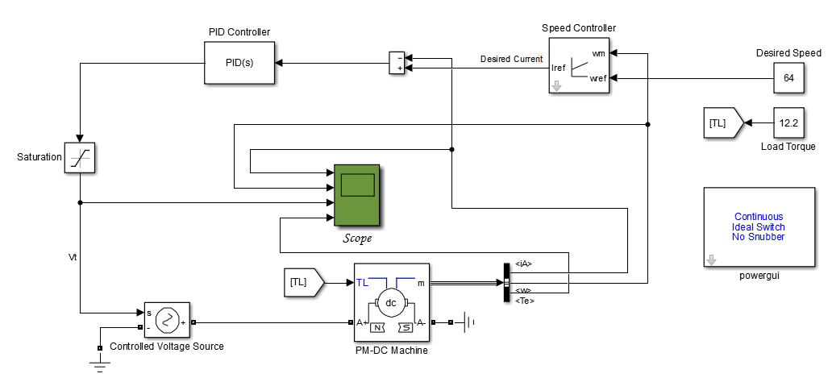

Figure 1: Simulink Model of Whole System

As can be seen in Figure 1, I used feedback by measuring speed. First, I check the desired speed and actual speed of the motor and takes difference to create desired current. After that, again we measure current and subtract from desired current and put the difference into PID controller. Output of this block determines input voltage that should be given to the system. By saturation block, we prevent our motor by limiting input voltage. As can be seen above, I give load torque input of 12.2 N.m to motor. With the scope block, we can see the armature current, motor speed, input voltage and generated torque.

Chapter 3. Waveforms

In our simulink model, I used variable step with ode23tb solver. As desired speed, we give to the system 64 rad/s. We also specify load torque as 12.2 N.m which is rated torque of the PMDC motor. The waveforms of this system can be seen in Figure 2.

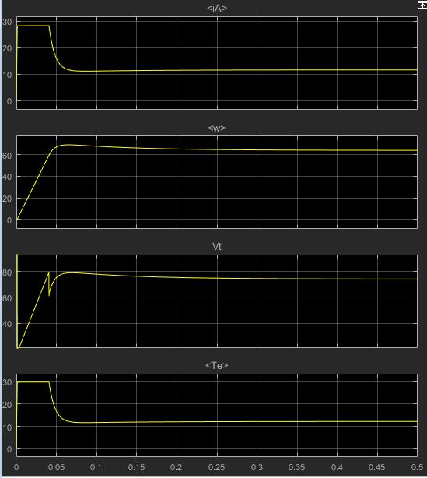

Figure 2: Waveforms of Given System

In Figure 2.1, we see the armature current of dc motor. At the beginning, our rotor was stationary and thus back emf was zero. Therefore, at the beginning, we see high armature current. As current flows, our motor start to rotate and generates back emf and thus armature current decreases with time. After some time, our motor gets steady state situation and have constant current of around 12 A. This steady-state current is determined by load torque, which is 12.2 N.m.

In Figure 2.2, we see velocity of motor in rad/s. As can be seen, our motor starts from zero initial speed and speeds up with time and gets desired speed, which is 64 rad/s, after some time.

In following graphs, we see the terminal voltage and generated torque. We know that generated torque is proportional with armature current and thus we get similar graphs with armature current. Terminal voltage increases with time due to feedback control.

References

[1] PMDC Selection Guide, Kollmorgen Company

<http://www.kollmorgen.com/en-us/products/motors/brush-dc/permanent-magnet-dc-pmdc/>

[2] Chopper-Fed DC Motor Drive, MathWorks Documents

<https://www.mathworks.com/help/physmod/sps/examples/chopper-fed-dc-motor-drive-continuous.html>