

EE 462 PROJECT 0

İBRAHİM GÜNGEN
1936939

Motor Features
I have chosen a motor which model is C42-L90 dc bruch motor(wiring code 10) from moog components.
Nominal terminal voltage:48V
Rated terminal voltage:24-60V
Rated output power:317W
Rated torque: 2.37Nm
Rated current: 8.5A
Friction torque:0.17Nm
No-load speed:1273rpm
Rated speed(at full load):811rpm
Rotor inertia:21890.7 g*cm^2
Coil inductance:2 mH
Electrical time constant: 3.33
Mechanical time constant: 10.526
Weight: 7.428kg
Source and control system
-> Controlled voltege source
In order to feed the motor I used controlled voltage source which takes a reference signal from output of the pid controller according to desired speed. In real life applications, we can design pwm generator with conroller and appropriate transfer function.
-> Sensors
In simulink simscape library there are many sensor to get values like speed and torque, also there are voltmeter, ampermeter etc. I have used these.
-> Pid cortoller
I have used a pid controller for getting desired voltage value from desired speed value.
Pid can arranged with tuned application of matlab simulink. Also, I take a feedback from motor speed and find an error of the system.
How the model work?

In this model, desired speed is arranged the adding error on this then desired voltage is get with PID controller, also it works no-load conditition then I have took a needed values and graphs with sensor. Zero order hold block are using for discretization purpuses.

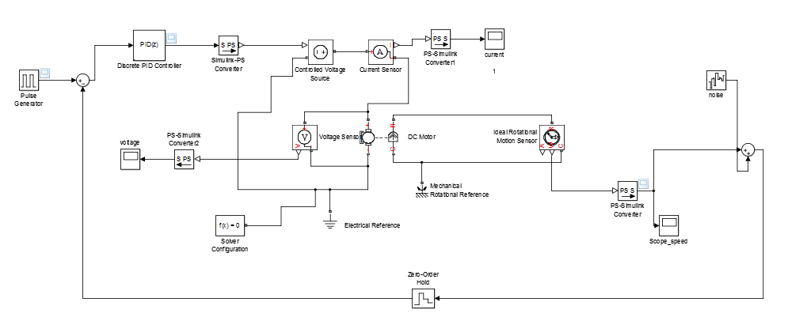
Figure 1: Overall diagram of the circuit

Graphs

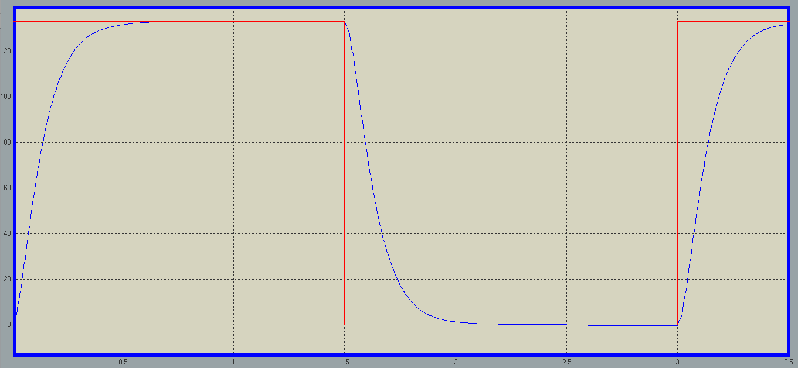
Figure 2: Angular speed of motor, blue line shows real speed of motor and red one shows desired speed of motor

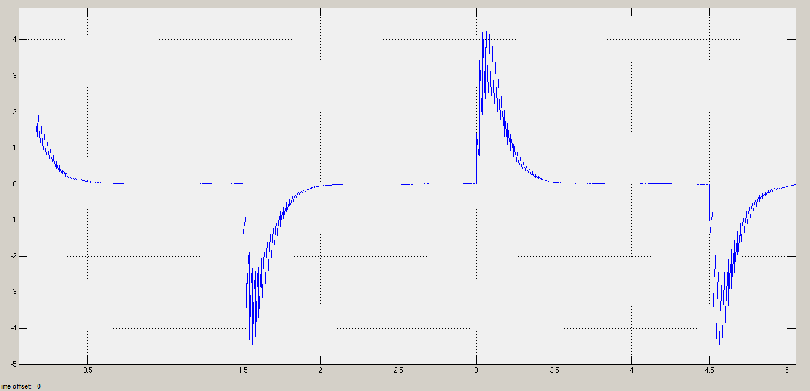
Figure 3: Current graph of motor

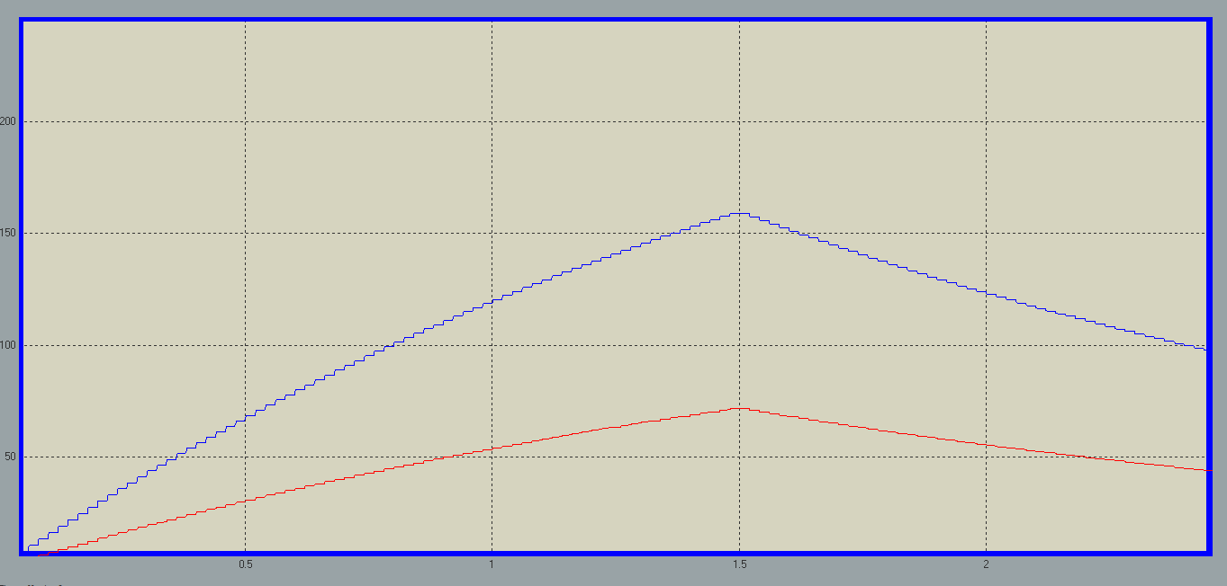
Figure 4: (current and torque) vs time graph

There is a problem to use torque sensor and speed sensor there are not work together and also I connected only torque sensor values are not applicable for example current is nearly 10 times of rated current value ı could not solve this problem.

In this design I follow up [1] link at the bibliograpy.

Bibliography

[1] https://www.mathworks.com/videos/pid-controller-design-for-a-dc-motor-68881.html

