**DC Motor Model**

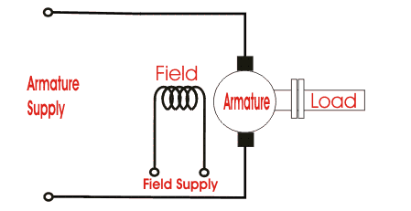

Figure 1: Simplified Model of DC Motor

* Voltage Rating: Machine’s rated operation voltage has an impact on the operation speed. For high rotational velocities high rated voltage may be more useful. Having high voltage rating gives the advantage of decreasing the armature voltage that reduces the resistive losses.
* Current Rating: Current rating has an effect on the output torque. To obtain high torque values choosing high current rating can be useful.
* Power Rating: Electrically, power rating is the multiplication of the voltage and the current ratings if we neglect the electrical losses in the machine. Mechanically, power rating is the multiplication of the torque and the angular velocity. Hence, power rating is decided according to the needs of the operation. The maximum power generated by the machine is the function of its volume.

**Power Source and Controller**

* In the Simulink Model, GTO thyristor is used to generate a PWM voltage source on the armature of the DC machine. Armature is supplied by the 240 V to 0 V and PWM duty cycle is arranged by the feedback control for the rated output power.
* To make the machine work in the rated operation conditions such as torque and the angular velocity, measurements are taken from the machine measurement pin and they are compared with the reference values.
* Employing PI controller output of the error amplifier generates a reference current which will be compared with armature current of the machine in a hysteresis comparator.
* Reference current is limited as 30 A thus in the start-up of the machine, sinking too much current from the source is inhibited.
* By arranging hysteresis band, the armature current ripple value is limited.
* Filter is used for eliminating the high frequency components of the armature current hence a saw-tooth waveform is obtained and it is used as reference value in the current hysteresis comparator.
* An inductor is placed between cathode of the thyristor and the armature of the machine to smooth the armature current and keep it continuously flowing to diminish the torque ripple of the machine.

**Simulation Results**

* Acceleration of the DC machine: Machine starts accelerating from rest and the angular velocity is increased to the rated 120 rad/s. There is an overshoot due to the integral component of the controller. In 0.5s, machine reaches the rated conditions and starts working in steady state.

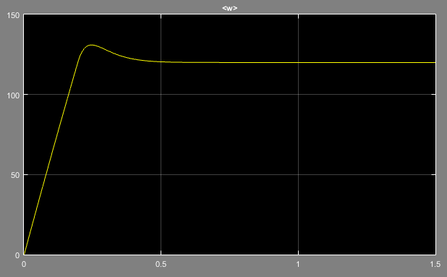

Figure 2: Angular velocity of the DC machine during start-up

* Start-up current: In start-up, machine sinks excessive amounts of currents due to its highly inductive structure. Controller circuit limits the start-up current as 30 A. After reaching the rated angular velocity, the current starts to diminish and at 0.5s, it reaches its rated value.

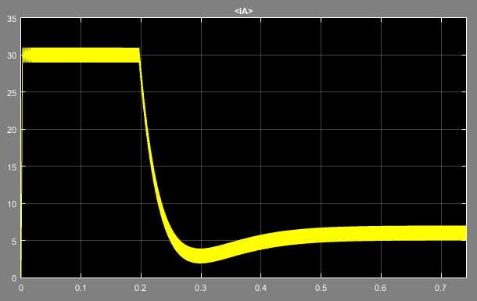

Figure 3: Armature current of the DC machine during start-up

* Produced torque: To accelerate from stationary position, excessive amount of torque is produced by the machine and it starts to diminish as the angular velocity increases. During the overshoot of the angular velocity, the torque is lower than the rated value. After 0.5s, the machine generates rated torque with some ripple on it.

Comparing the Figure 3 and Figure 4, it can be understood that armature current is proportional to the torque generation in the machine.

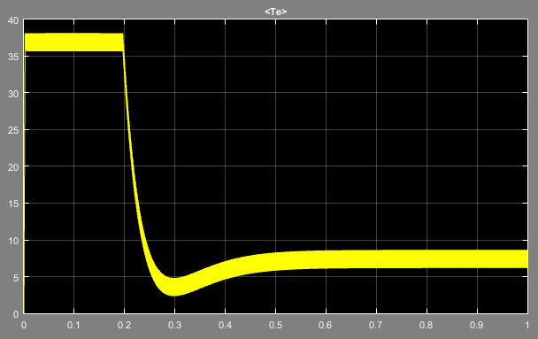

Figure 4: Produced torque of the DC machine during start-up

**References**

* Chopper Fed Dc Motor Drive, Mathworks Documentation, https://www.mathworks.com/help/physmod/sps/examples/chopper-fed-dc-motor-drive-continuous.html