Analysis of DC Motor During Startup

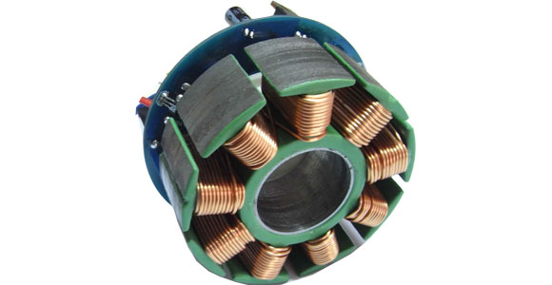

Analysis of DC Motor During Startup:

by

Published 06-Mar-2017 00:22:33

Table of Contents

No table of contents entries found.

Chapter 1. Information about the DC Motor

In this report, starting torque of a DC motor will be analyzed. The ratings of the motor that is used in the simulation are shown in the table below.

|  |  |
| --- | --- |
| Head 1 | Head 2 |
| Entry 21 | Entry 22 |
| Entry 21 | Entry 22 |
|  |  |
| Entry 21 | Entry 22 |