Analysis of DC Motor During Startup

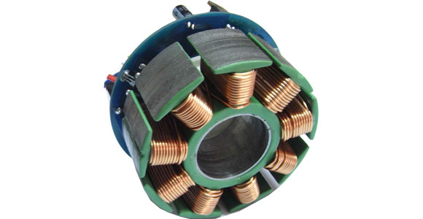

Analysis of DC Motor During Startup:

by

Published 06-Mar-2017 21:33:56

Table of Contents

Chapter 1. Information about the DC Motor 1

Chapter 2. Theoretical Results 2

Chapter 3. Overview of the Circuit Diagram 3

Chapter 4. Analysis Results 4

Chapter 5. Conclusion 5

Chapter 6. References 6

Chapter 1. Information about the DC Motor

In this report, starting torque of a DC motor will be analyzed. The ratings of the motor that is used in the simulation are shown in the table 1.

Table 1 - Parameters of the DC Motor

|  |  |
| --- | --- |
| **Parameters** | **Values** |
| Power (HP) | 20 |
| Armature Voltage (V) | 240 |
| Field Voltage (V) | 300 |
| Speed (rpm) | 1750 |
| Armature resistance (ohm) | 0.4114 |
| Armature Inductance (H) | 0.004895 |
| Field Resistance (ohm) | 105.9 |
| Field Inductance (H) | 27.65 |
| Field-Armature Mutual Inductance (H) | 0.4038 |

Chapter 2. Theoretical Analysis

DC Motor Equations

Following equations will be used theoretical analysis of the DC Motor.

$$T_{em}=k_{T}.I_{a}$$

$$k_{E}=L_{af}.I_{f}$$

$$E_{a}=k_{E}.w_{m}$$

$$k_{E}=k_{T}$$

$$V_{t}={E_{a}+R}_{a}.I_{a}$$

$$w_{m}={\frac{1}{k_{E}}.(V}_{t}-\frac{R_{a}}{k_{T}}.T_{em})$$

$$T_{em}=J{\frac{dw_{m}}{dt}+Bw}_{m}+T_{WL}(t)$$

$$V_{t}=e_{a}+R_{a}.i_{a}+L_{a}.\frac{di_{a}}{dt}$$

Results

By using the given paramaters in the first chapter and equations given above, we can find the following values.

$$k_{E}=1.1439 (Nm/A)$$

$$E_{a}=209.63 V$$

$$T_{em}=686.34 Nm$$

$$w_{m}=193.259 rad/sec$$

$$I_{a}=583.3738 A$$

$$I_{f}=2.83 A$$

Chapter 3. Overview of the Circuit Diagram

In this section, we will examine the following circuit used in the analysis.

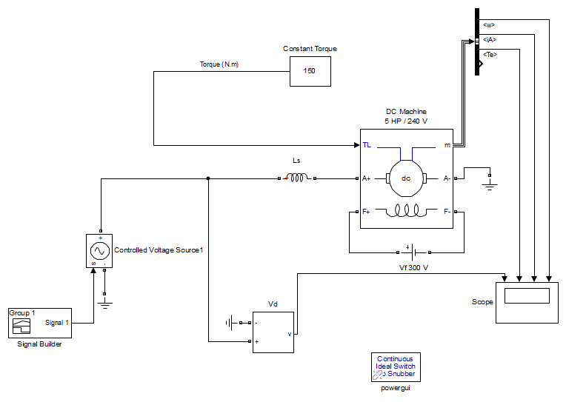

Figure 1 - Simulation Circuit Diagram

Circuit shown in Figure 1 is used for analysis of the DC Motor during the startup. Under the constant torque which is 150 Nm, the voltage given to the armature terminals of the DC motor was started from 0, then it went to 240 V after that it stayed constant. Graphical results will be given in the next chapter. During this process, field winding are excited by 300V.

Chapter 4. Analysis Results

Analysis results are shown in Figure 2..

Figure 4.1. Scope

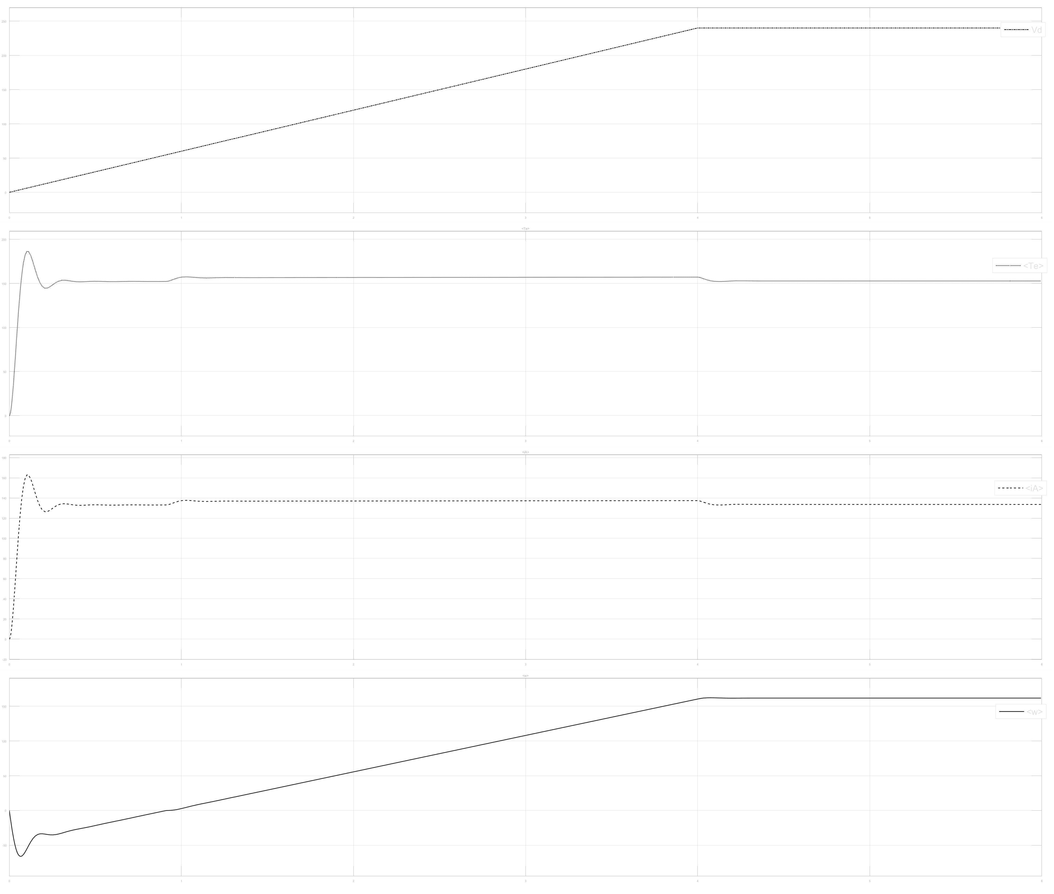

Figure 2 - Armature Voltage, Electrical Torque, Armature Current,Speed vs. Time Graph During the Cosntant Torque and Increasing Armature Voltage

According to graphical results shown in Figure 2, we got the following values from the simulink analysis,

$$T_{em}=700.1 Nm$$

$$w_{m}=186.2 rad/sec$$

$$I_{a}=591.4 A$$

$$I_{f}=2.70 A$$

Chapter 5. Conclusion

When we compare the results taken from Simulink and results calculated by hand, it can be said that results are nearly the same.

Chapter 6. References

ttp://ro-01-ici.ici.ro/brosuri/MathWorks_Simulink-Rpt-gen.pdf

Chopper-Fed DC Motor Drive Example,

(<https://www.mathworks.com/help/physmod/sps/examples/chopper-fed-dc-motor-drive-continuous.html>

Power Electronics: Converters, Applications, and Design by Ned Mohan Hardcover