Analysis of DC Motor During Startup
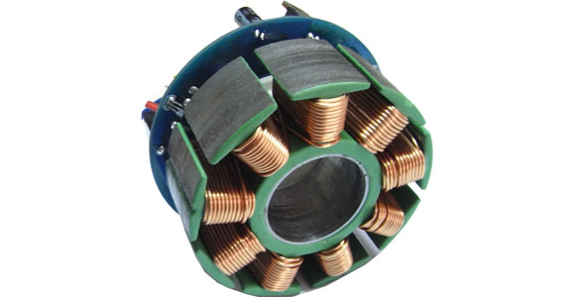

Analysis of DC Motor During Startup:
Published 06-Mar-2017 00:19:31

Table of Contents
1. Information about the DC Motor 1

Chapter 1. Information about the DC Motor
In this report, starting torque of a DC motor will be analyzed. The ratings of the motor that is used in the simulation are shown in the table below.
Parameters | Values
Power (HP) | 20
Armature Voltage, (Va) | 240
Shaft Speed, (RPM) | 1750
Field Voltage, (V) | 300

