Circuit Studio Study Guide
  - Student handbook for Chapters 2 to 7
Use Circuit Studio to connect a circuit drawing to its equations, test device assumptions, and explain the result in your own words. This guide accompanies Sedra and Smith, Microelectronic Circuits, 8th edition, Chapters 2–7. Use your instructor’s assigned reading and device models alongside it.
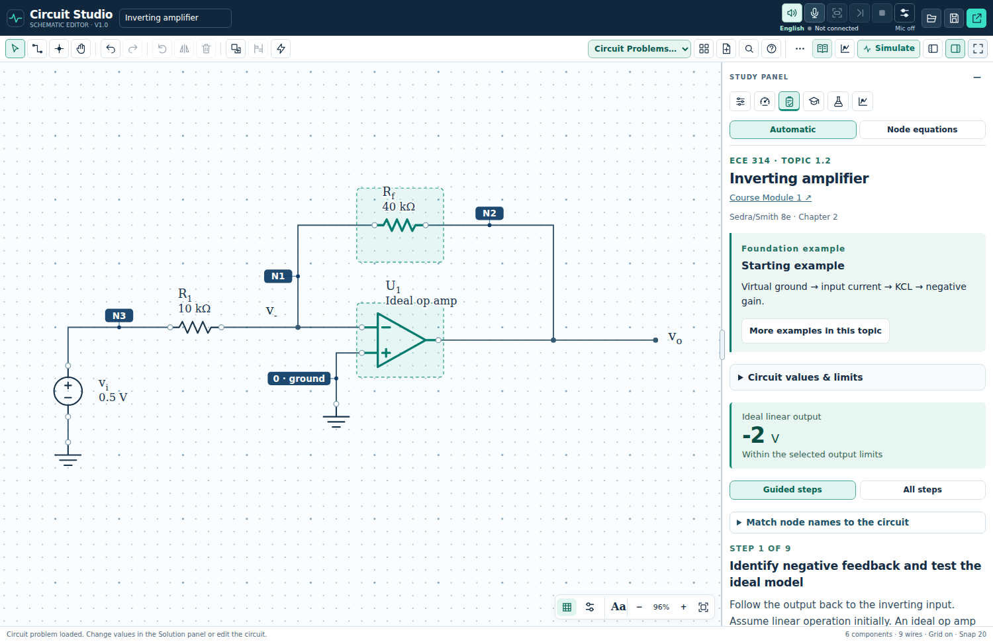
Figure 1. The circuit canvas and Solution panel in the current Circuit Studio.

Your first study session
1. Open Circuit Studio and choose an example from Circuit Problems or the Examples control. Start with a diode or an ideal op amp circuit.
2. Press F to fit the circuit. Collapse Components or Study when you need more canvas space.
3. Predict the output and device state before solving. Write the relevant assumption and equation.
4. Click Solve DC to display values. Click the same button again to hide them; another click shows them again.
5. Open Solution for the derivation, then Tutor to answer practice questions. Compare each result with your prediction.
The editor, calculations, Tutor, chapter lessons, and built-in DC/AC/transient simulation do not require a Gemini API key. Gemini adds optional spoken and conversational guidance.
Study route: controls → worked reasoning → Tutor → chapter lessons → device checks → models → simulation → bias investigation → optional voice → troubleshooting → practice.

Use the circuit workspace
Keep the canvas large. Open a panel only when you need it, and hover over unfamiliar icons to read their tooltips. A dotted outline identifies a selected component name or value.
Task | What to do
Choose a circuit | Open Circuit Problems or Examples. Choose the device family, topic, and an example level.
Fit the drawing | Press F or use Fit. After manual zooming or panning, press F again to restore the full view.
Hide or restore panels | Use the Components and Study panel controls. Focus canvas hides side panels for a larger drawing area.
Select and edit | Click a component, name, or value. Double click a value to edit it. Drag labels separately when they overlap.
Connect components | Use Wire and connect pins. Use a junction dot for an intended connection; crossing wires without a dot are not connected.
Show solution values | Click Solve DC or press D. Click again to hide numeric overlays. Node labels may remain to support the explanation.
Read the explanation | Open Study, then Solution. Use Back and Next for guided steps, or show all steps.
Check DC results | Open the DC tab to run and inspect calculated operating point results. The DC tab is separate from the overlay toggle.
Save your circuit | Use Save project to download an editable JSON project. Export an image only when you need a figure.

Useful keyboard shortcuts
V select • H pan • W wire • J junction • R rotate • M mirror • G grid • F fit • D show or hide solution values • + and − zoom • Esc finish or cancel a tool • Ctrl or Cmd + Z undo.

Read component values carefully
Check the displayed unit after every edit. For example, 1 kΩ = 1000 Ω and 1 mA = 0.001 A. Use the value editor’s supported notation, then verify the label on the canvas. In Tutor, a bare number uses the unit displayed beside the answer field.
Loading a different example replaces the current drawing. Save your project first if you want to keep it. Undo can restore a recent change during the same session.

Match the circuit to the equations
A node is an electrically continuous connection. N1 and N2 are node identities; ground is node 0 and is the voltage reference. The voltage at N2 means its potential relative to ground. An output label may name that same node.
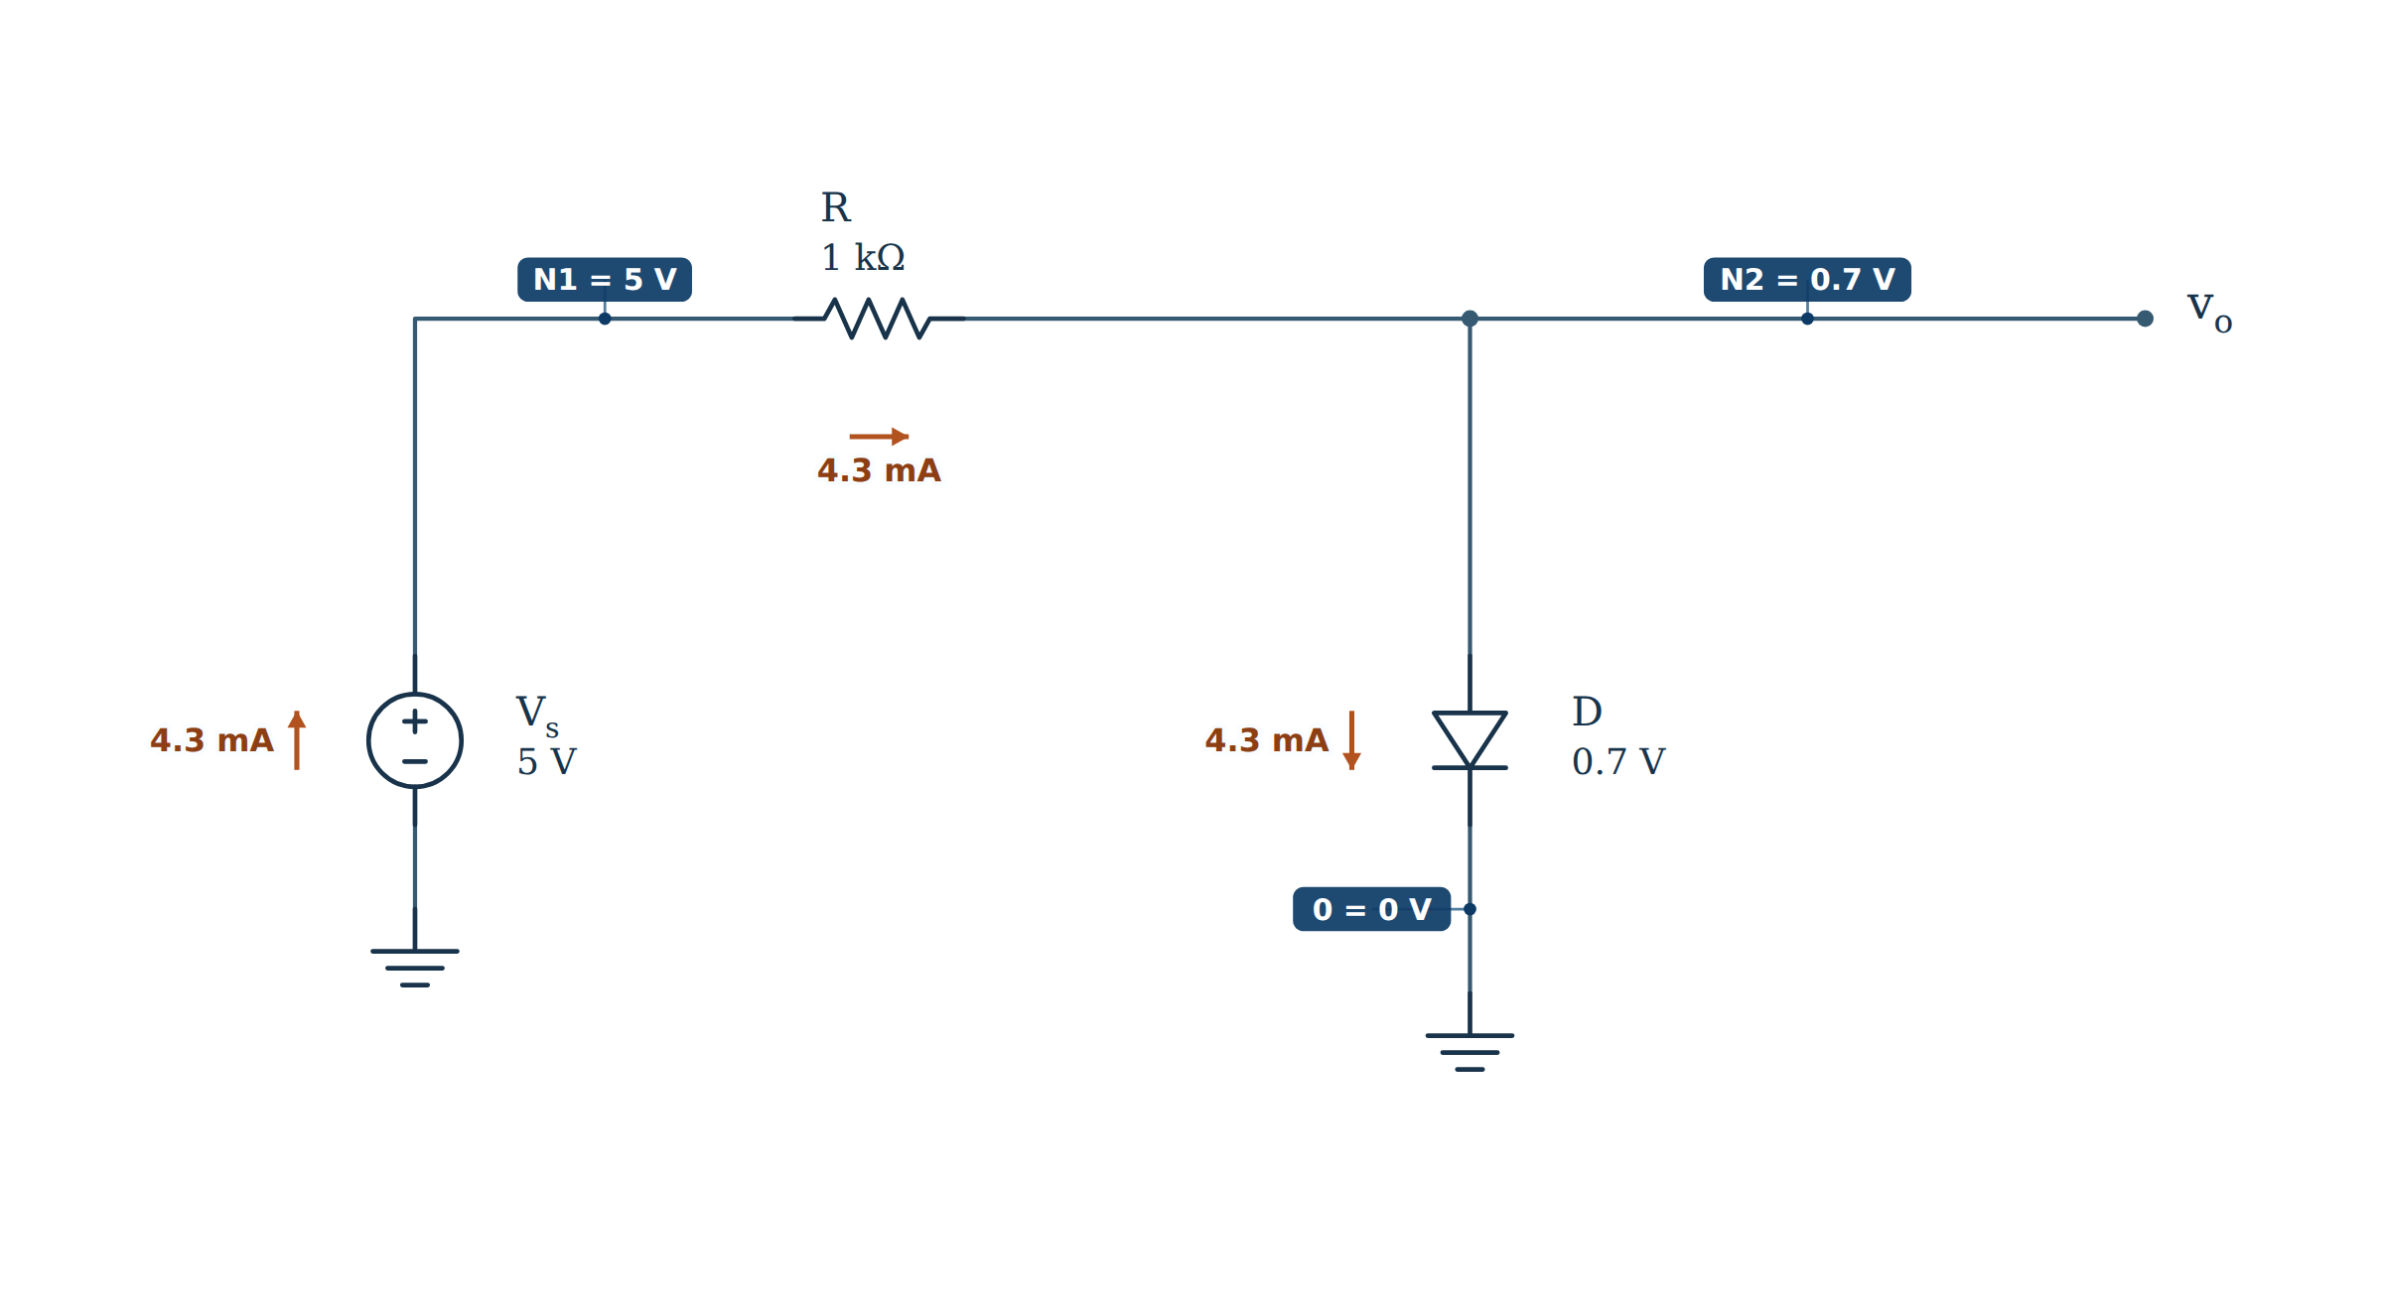
Figure 2. Series diode circuit with matching node names and calculated values.

Work from symbols to numbers
Assume the constant voltage drop diode model with the diode ON. The anode is at N2 and the cathode is grounded. Take current from the source through the resistor and diode.
$v_{N1} = V_{S} = 5 V, v_{N2} = v_{D} = 0.7 V$
$i_{R} = \frac{v_{N1} − v_{N2}}{R} = \frac{V_{S} − v_{D}}{R}$
$i_{R} = \frac{5 V − 0.7 V}{1 kΩ} = 4.3 mA$
Check: the current is positive in the assumed forward direction. Kirchhoff’s voltage law gives 5 V = (4.3 mA)(1 kΩ) + 0.7 V. The ON assumption is consistent.

Test the assumption when the source changes
With the same circuit and a 0.5 V source, an ON trial gives (0.5 − 0.7) V / 1 kΩ = −0.2 mA. Reject that trial for this diode model. With the diode OFF, current is zero, the resistor drop is zero, and the diode voltage is 0.5 V, below the assumed 0.7 V turn on value.
Open “Match node names to the circuit” in Solution when an equation uses an alias such as the output voltage. Read its node and pin mapping before substituting values.

Study with Solution and Tutor
Solution explains how a result is obtained. Tutor asks you to predict, calculate, and explain it. Try Tutor with the numeric overlays hidden so the circuit remains a problem you can solve.
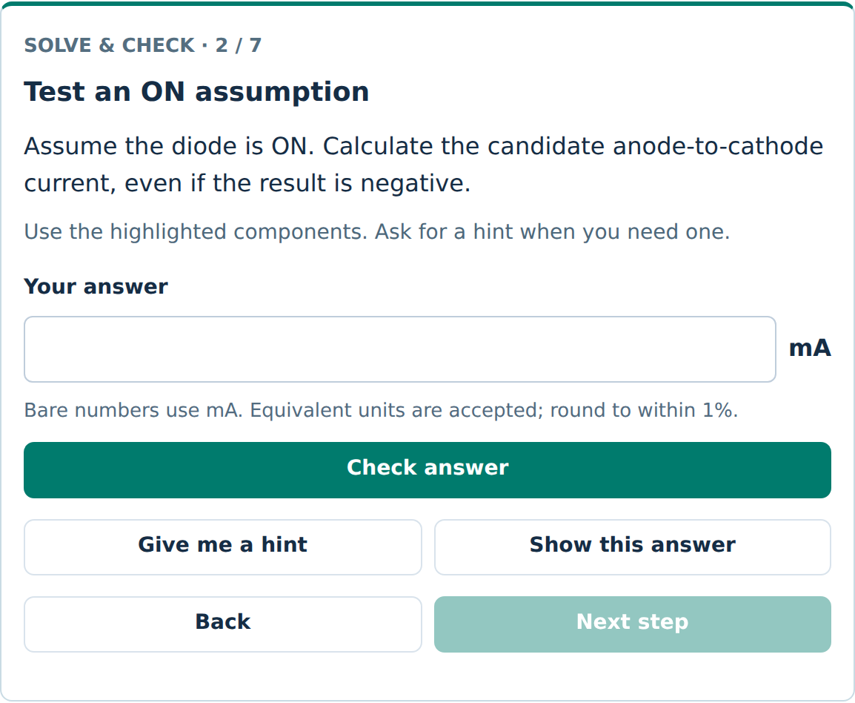
Figure 3. Tutor asks for a candidate current and shows the expected unit.

A productive practice cycle
1. Predict. State the expected sign, size, and device region. Explain which circuit feature supports your prediction.
2. Solve. Write the symbolic equation, substitute the actual circuit values with units, then calculate.
3. Check. Enter the answer using the displayed unit. Use a hint if stuck; Show this answer records that you viewed it.
4. Explain. Describe why the result makes physical sense. Identify the assumption you tested.
5. Explore. After completing the practice prompts, change one slider or component at a time. Predict the effect before checking again.

Use the explanation that fits your drawing
Automatic solutions use the lesson associated with an intact example. Node equations analyze the actual circuit connections. After changing wiring, use the generated node equations and DC results rather than assuming the original example’s derivation still applies.
Notebook record: circuit and values; assumptions; predicted result; symbolic equation; numerical substitution; final answer with units; a validity check; one change to investigate.

Explore the chapter visual lessons
Open the book icon for Chapters 2–7, select a chapter, and choose a visual lesson. Change a control, watch the diagram, and use Back and Next to follow the explanation. Finish with Check your understanding, then return to the canvas.
Textbook chapter | Visual lessons and study focus
2 Operational amplifiers | Integrator, differentiator, gain bandwidth and slew rate, offset and bias currents, instrumentation amplifier.
3 Semiconductors | Electrons and holes, energy bands, doping, drift and diffusion, depletion region, forward injection.
4 Diodes | Full wave rectification and PIV, capacitor filtering and ripple, Zener regulation and power.
5 MOSFETs | Channel formation and operating regions. Connect gate overdrive and drain voltage to the region test.
6 BJTs | Carrier transport and comparison of hand approximations with nonlinear bias calculations.
7 Transistor amplifiers | Common source and common emitter design. Relate bias, gain, and available output swing.

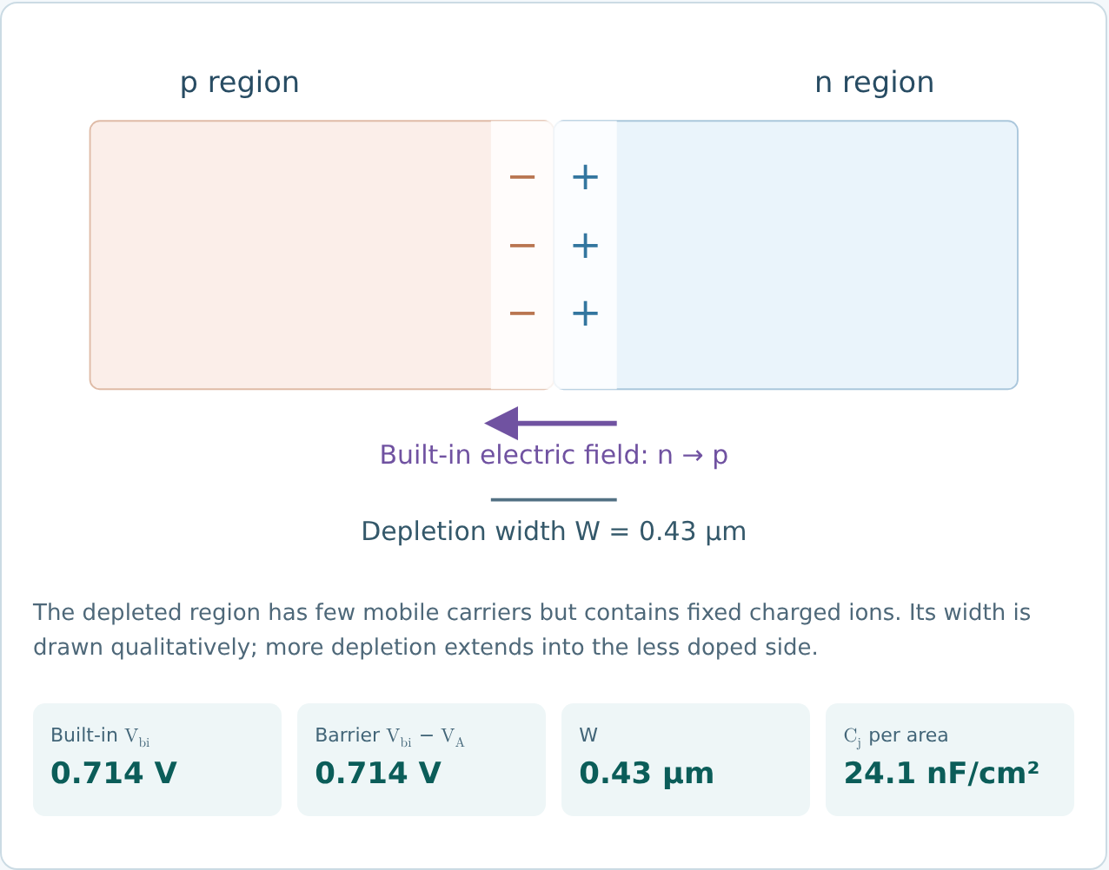
Figure 4. The PN junction lesson visualizes the depletion region and barrier.
Try this: predict what reverse bias does to depletion width. Increase reverse bias and explain why the junction capacitance decreases as the depletion region widens.
The chapter workspace has its own lesson controls. Its displayed values are not automatically the component values of the circuit behind it. These 18 labs support selected topics; use the textbook for the complete chapter treatment.

Check the device physics

Electrons holes and the junction
An electron is a negatively charged carrier. A hole is a missing valence electron that behaves as a positive mobile carrier; it is not a proton moving through the crystal. Conventional electron current points opposite electron drift. Hole current points with hole motion.
Donor doping produces n type material with electrons as majority carriers. Acceptor doping produces p type material with holes as majority carriers. Ionized dopants remain fixed in the lattice. The depletion region contains exposed ionized dopants and few mobile carriers.
Drift is driven by an electric field. Diffusion is driven by a carrier concentration gradient. In an unbiased junction at thermal equilibrium, opposing drift and diffusion currents balance; “no net current” does not mean every carrier stops moving.

Assumptions to check before accepting an answer
Device or model | Validity check
Ideal op amp | Use equal input voltages only when negative feedback supports linear operation. Ideal input currents are zero. Check whether the predicted output fits within the supply rails.
Constant drop diode | Assume ON or OFF, solve, and verify the assumed direction and voltage. The 0.7 V value is a model choice, not a universal physical constant.
NMOS long channel model | Use gate to source voltage for turn on. With positive gate overdrive, saturation requires drain to source voltage at least equal to that overdrive. Otherwise test triode operation.
PMOS long channel model | Gate overdrive is source to gate voltage minus the threshold magnitude. With positive overdrive, saturation requires source to drain voltage at least equal to that overdrive.
BJT amplifier | Check forward active operation: base emitter junction forward biased and base collector junction reverse biased. A fixed 0.7 V estimate can differ from a nonlinear device calculation.
PNP transistor | Use emitter referenced voltages and a consistent current direction. Do not copy NPN signs without changing the reference directions.

MOSFET saturation and BJT saturation are different operating conditions. A MOSFET often operates in saturation for linear amplification. A BJT usually operates in forward active mode for that purpose.
After every solve, check the device region, current direction, units, and supply limits. A number alone does not establish a valid operating point.

Compare DC and small signal models
First find the DC operating point. Then linearize the transistor around that bias point to analyze a sufficiently small AC signal. DC bias voltages and AC increments are different quantities, even when they refer to the same physical node.
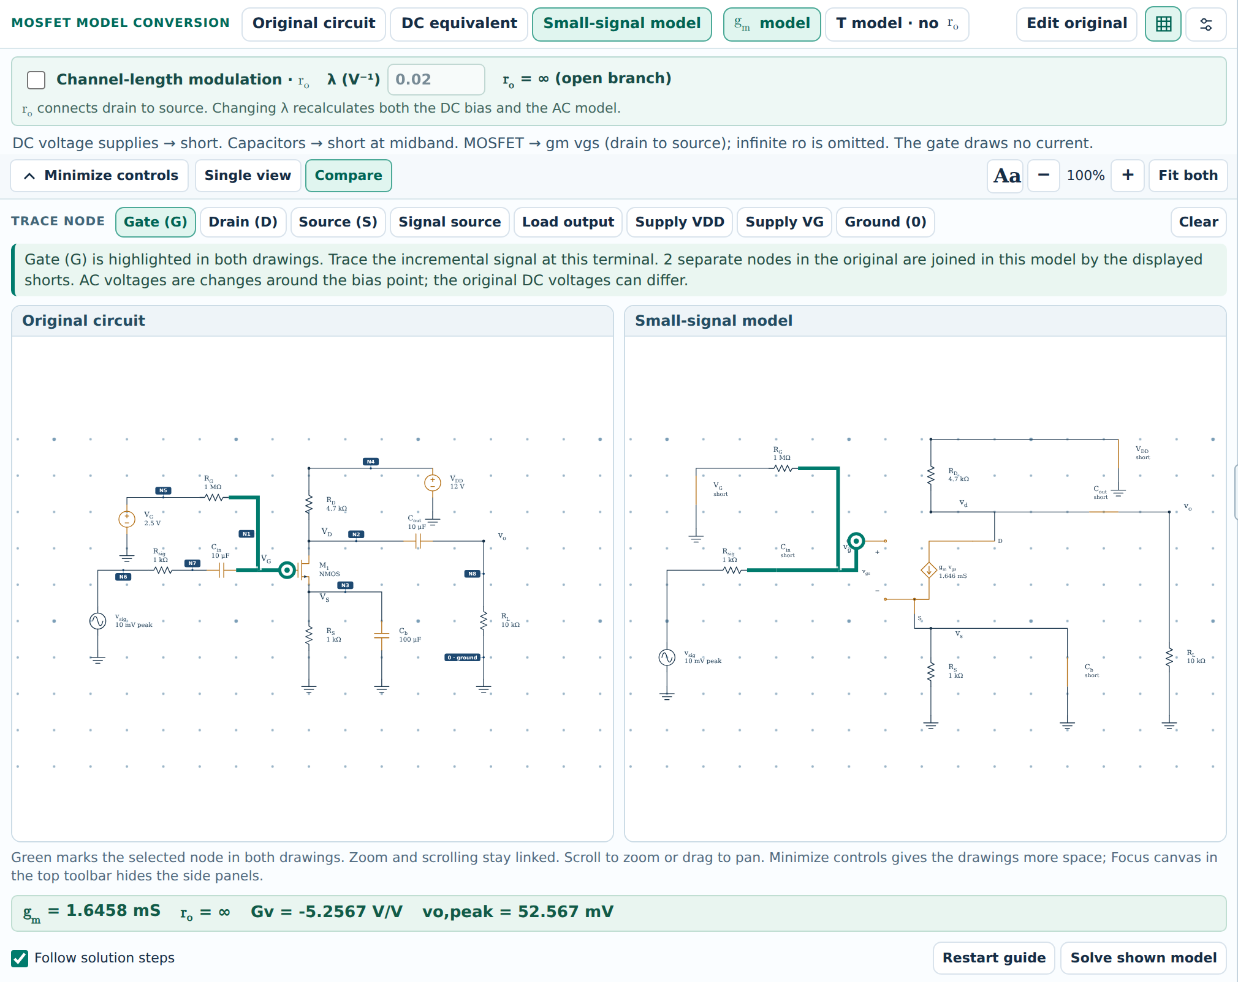
Figure 5. Compare keeps the original and derived MOSFET circuits together.
1. Select the original, DC, or small signal model offered for the example. Use Compare to inspect both circuits and Trace node to follow a connection.
2. For DC, treat capacitors as open circuits. Set a zero mean AC voltage source to its DC value of zero.
3. For the midband small signal model, short ideal DC voltage supplies to AC ground and open ideal DC current sources. Treat coupling and bypass capacitors as shorts only when the midband approximation applies.
4. Keep dependent sources active. Compare gain with the same bias point and output resistance assumptions. The available T models omit transistor output resistance.
Solve DC and Lab analyze operating points. The separate Simulate workspace runs DC, AC frequency, and transient analyses of supported drawn circuits. Read its model notes before comparing with a guided small-signal or waveform lesson.

Simulate the drawn circuit
Open Simulate in the toolbar to run ngspice locally in the browser. The simulation uses the editable circuit, its connections, and supported device parameters. It does not require a Gemini API key. Save the current project before loading a Course example.
Analysis | Use it to answer
DC operating point | What are the steady node voltages and branch currents? Capacitors are open and inductors are short at DC.
DC sweep | How does the operating point change as one selected voltage source is swept?
AC frequency sweep | What is the linearized frequency response around the DC bias? The selected source is 1 V AC; other AC excitations are zero.
Transient | How do voltages and currents change with time under a sine or pulse excitation?

Check an RC low pass response
Choose Course examples → RC low-pass. The example uses R = 1 kΩ and C = 1 µF, with VOUT across the capacitor. Select AC frequency sweep from 1 Hz to 100 kHz with 40 points per decade, then press Run.
$τ = RC = (1 kΩ)(1 µF) = 1 ms$
$f_{c} = \frac{1}{2πRC} = 159.15 Hz$
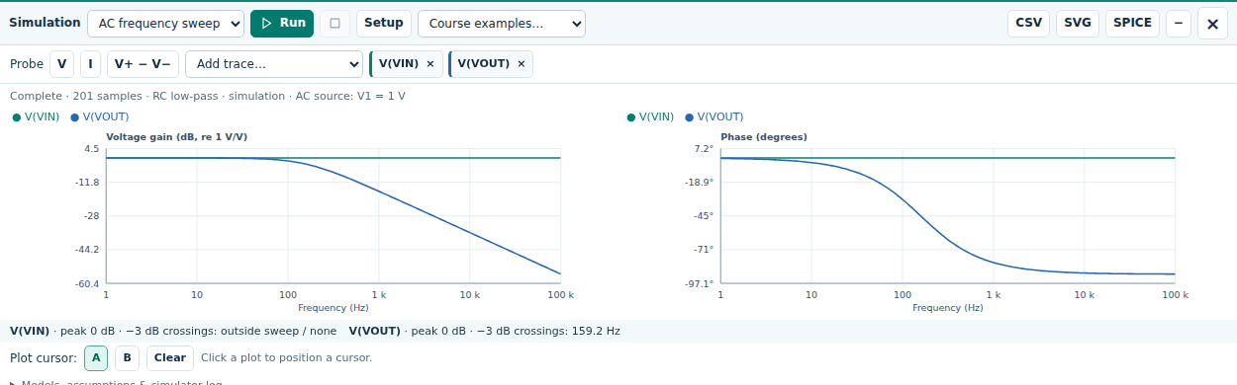
Figure 6. RC AC results. The sampled cutoff is about 159.2 Hz.
At the cutoff, the ideal voltage ratio is 1/√2 ≈ 0.707 (−3.01 dB) and its phase is −45°. The plot reports 20 log₁₀ of a voltage magnitude; with a 1 V input, its output magnitude also equals the numerical input-to-output gain. For a different reference node, form the appropriate voltage ratio.

Measure a transient and report the model
Keep the RC example. Choose Transient and set Waveform to Pulse, Amplitude to 1 V, Offset / low to 0 V, Frequency to 100 Hz, Stop time to 4 ms, and Max. step to 2 µs. Press Run. The pulse rises at 0.5 ms in this setup.
$v_{out}(t) = 1 V [1 − exp(−(t − t₀)/τ)], t ≥ t₀$
At one time constant after the rising edge, t = 1.5 ms, expect about 0.632 V. The small finite rise time and sample spacing can shift the cursor reading slightly. This pulse run begins from its low-level operating point; the simulator does not force every capacitor to start at zero in all circuits.
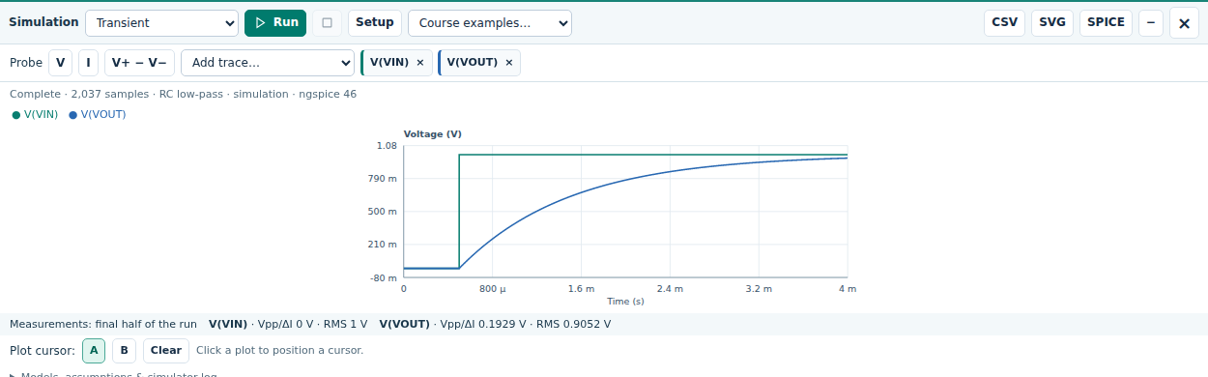
Figure 7. RC transient with a 0 to 1 V pulse and a 1 ms time constant.

Use probes and exports
Use V and click a wire or terminal for voltage to ground. Use I and click a component for branch current. For V+ − V−, select the positive node first and the negative node second. Add trace also lists the available quantities. Choose cursor A or B, then click the plot to compare samples.
CSV downloads plotted data; SVG exports the plots; SPICE exports the generated simulation netlist. Save project separately for the editable circuit. After a circuit or setup change, press Run again; previous results are invalidated.

Read the assumptions before comparing
Open Models, assumptions & simulator log. The MOSFET model is level 1 with its body tied to source and no intrinsic capacitances. The BJT simulation omits Early effect and charge storage. The op amp has large finite DC gain and output limits, but no internal bandwidth or slew-rate model. Drawn capacitors are included.
Consequently, an AC sweep can show external RC effects without predicting a real transistor’s upper cutoff. A BJT simulation may differ from a hybrid-π lesson with finite output resistance. Generic transformer and dependent-source symbols require explicit supported simulation models; inspect any diagnostic instead of accepting an incomplete result.

Explore bias and annotate your reasoning
Explore & Explain provides a separate linked investigation for NPN and NMOS divider bias. Choose the device, inspect the physical circuit or Thevenin view, follow the six derivation steps, and change one parameter in the linked sweep. Use the displayed node names in your written calculation.
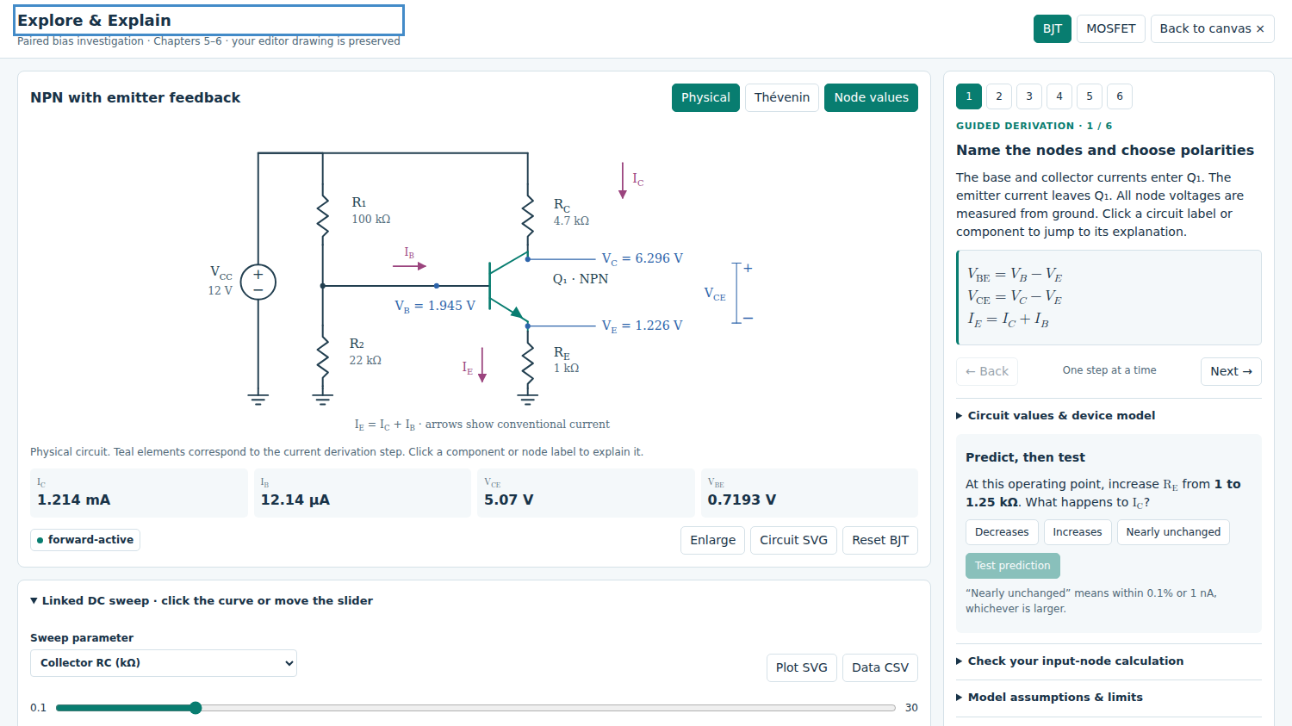
Figure 8. Explore & Explain links the bias circuit, derivation, prediction, and sweep.

Compare MOSFET and BJT divider loading
For the ideal MOSFET gate, zero DC gate current leaves the gate voltage at the unloaded divider value. For the BJT, base current produces a drop across the Thevenin resistance, so the loaded base voltage is lower. Predict which bias will change more when both divider resistances increase while their ratio is fixed.
The investigation and chapter visual lessons have their own parameters. They do not automatically replace or edit the schematic behind them. Return to the canvas before saving or simulating that schematic. Export the investigation CSV separately when you need its sweep data.

Add readable text and equations
Use the text and equation tools to add assumptions, reference directions, and calculations. Double-click an existing text or equation object to edit it in place. Use the formatting controls for text and the equation controls for fractions, subscripts, and mathematical notation. Select an object to move, resize, or delete it; press Esc to leave the active tool.
Keep labels away from wires and terminal names. Press F after arranging the drawing, and check the exported figure at reading size. State the symbolic relation, substitute values with units, and finish with a device-region or consistency check.

Set up optional Gemini voice guidance
You can complete the core study activities without Gemini. To ask spoken questions or hear conversational explanations, use a Google AI Studio API key with access to a supported Live model, or use the classroom connection supplied by your instructor.

Get and save an API key
1. Open aistudio.google.com/apikey and sign in with the Google account you will use for study. Complete any required account or terms steps.
2. Create an API key in an available Google Cloud project. If your existing project is not listed, import it through the AI Studio Projects page. New accounts may receive a default project and key after setup. [1]
3. Return to Circuit Studio. Open the sliders icon for voice settings and choose Google AI Studio API key as the connection method.
4. Paste the key into the API key field. On your own computer, enable Remember API key and choose Save API key & settings.
5. Keep the instructor approved Live model and connection settings unless instructed to change them. Select a voice and pace, then use Listen or Connect Gemini to start.
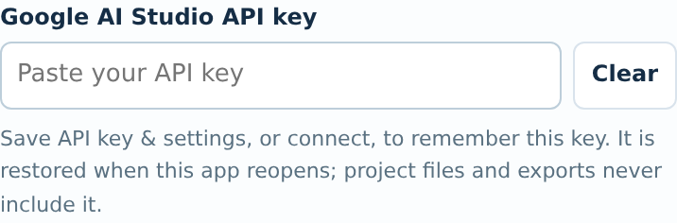
Figure 9. Enter the key in voice settings, then use the save control.

Free and paid access
Google determines which models are available to your project and what limits apply. Free access varies by model; a paid project still has usage limits and may incur charges. Check AI Studio and the current pricing page before enabling billing. [2, 3]
Use short questions about one step, and replay an existing response when you need to hear it again. If a quota error appears, stop repeated connection attempts and check the project limits. Limits apply to the project, so another key in the same project does not provide a fresh quota. [2]

Remembering settings and protecting your key
Saved settings belong to the browser and the app address or local file context. Use the same browser and app location. Private browsing, cleared site data, or a different copy of the app can prevent restoration. On a shared computer, leave Remember API key off and use Forget when finished.
Treat the key like a password. Do not include it in screenshots, reports, or messages. Project files and circuit exports exclude the key. Gemini receives the circuit and learning context needed for guidance; Talk also sends your recorded question.

Use the voice tools one step at a time
The compact voice controls are in the top toolbar. Hover over an icon for its action. The row below is shown in the same order as the app.

Figure 10. Listen, Talk, Explain selection, Next step, Stop, and Settings.
Control | How to use it
Listen | Hear guidance for the current step. It does not automatically advance through the full lesson. If an interruption is detected, Finish can request the rest.
Talk | Start the microphone, ask one question, then choose Send voice. Grant microphone permission when the browser requests it.
Explain selection | Select a component, its name, or its value on the canvas first. Check the selection outline, then ask for an explanation. This action is unavailable within a chapter lab.
Next step | Move to the next learning step when you are ready. Connect through Listen or Talk first.
Stop | Stop voice guidance or recording. Use Disconnect or Release microphone to end the corresponding session or device access.
Settings and captions | Open the panel for captions, typed questions, voice and pace, Pause or Resume, Replay, and Repeat in English.

Ask questions tied to the circuit
• “Explain the selected resistor and identify its two nodes.”
• “Why can we use equal op amp input voltages in this circuit?”
• “Give me a hint for this step without giving the final answer.”
• “Substitute the actual circuit values into this equation.”
• “Check whether this transistor region assumption is consistent.”
Gemini can explain the selected circuit, current solution step, Tutor question, or chapter visual lesson. It may highlight relevant components or prepare a draft answer, but you should review and submit your own Tutor response. Check AI explanations against the circuit, equations, and device assumptions.

Keep playback clear and economical
Short replies are prepared before speaking to reduce stop-and-go playback; a brief initial wait is normal. Replay reuses stored audio. Use Finish when offered for an incomplete response. For a connection error, read its details and choose Reconnect or Try Simple voice. Simple voice omits automatic highlighting and answer drafting.
Device narration reads visible guidance with an available English browser or operating system voice. It does not require a Gemini key and does not answer new questions. Gemini voice choices include Charon, Sulafat, Iapetus, Kore, Puck, and Aoede; availability depends on the selected model. [4]

Save your work and resolve common problems

Choose the right file for the task
Save project downloads the editable circuit as JSON; reopen it to continue. Export SVG or PNG for a circuit figure. In Simulate, CSV saves plot data, SVG saves plots, and SPICE saves the generated netlist. Save analysis settings and assumptions in your report; keep project backups.
What you notice | What to check or do
Circuit is too large or partly hidden | Press F. Collapse Components and Study, or enable Focus canvas. Fit again after changing the window size.
Solution values obscure the circuit | Click the active Solve DC button again or press D. This hides numeric overlays without deleting the calculated result.
An equation uses an unclear node | Open Match node names to the circuit in Solution. Find the named node, connected pins, and any output alias.
The answer differs after editing | Check units, wire connections, polarity, model assumptions, and device region. Use Node equations for the current topology.
Explain selection is unavailable | Select the component, name, or value and look for its outline. Return from a chapter lab to the canvas. Wait for an active voice request to finish.
API key is requested again | Use the same browser and app location. Enable Remember API key and save. Check whether private mode or clearing site data removed the stored setup.
Microphone permission repeats | API key storage and browser microphone permission are separate. Review the site permission in the same browser. A stable HTTPS app address is generally more consistent than changing local file copies.
No audio or a partial sentence | Allow the short reply to finish preparing. Check volume and captions; use Replay or Finish if offered. Stop and reconnect if unresponsive. Device narration is available without Gemini.
Connection or quota error | Read Connection details. Try Reconnect or Try Simple voice. Check the project and Live model. A 1011 server close alone does not prove a quota or billing issue; use AI Studio to check a stated quota limit.

Before you submit a circuit solution
Include the circuit and values, ground reference, node labels, device assumptions, symbolic equation, numerical substitution, result with units, and a validity check. Describe any difference between a hand approximation and the simulator model rather than hiding it.

Practice and check your understanding
Work these problems on paper first. Recreate or edit the matching circuit in Circuit Studio, check your result, and explain any difference. Use the stated ideal or approximate models.
Task | Question
1 Diode ON | For the series circuit on page 3, set the source to 5 V and resistance to 2.2 kΩ. Use a 0.7 V diode drop. Find the current and verify the state.
2 Diode OFF | Use the same circuit with a 0.5 V source. Test an ON assumption, then find the valid current and diode voltage.
3 Inverting op amp | Ground the positive input of an ideal op amp. Use negative feedback, input 0.5 V, input resistor 10 kΩ, feedback resistor 40 kΩ, and supplies ±12 V. Find gain and output.
4 Noninverting op amp | Apply 0.5 V to the positive input. Use 10 kΩ from the negative input to ground and 40 kΩ from output to negative input. Supplies are ±12 V. Find gain and output.
5 PN junction | Increase reverse bias in the junction lesson. Predict and explain the change in depletion width and junction capacitance.
6 Model comparison | Compare transistor models at the same bias. Why must output resistance assumptions match before comparing voltage gain?

Answer checks
$1. i_{D} = \frac{5 − 0.7}{2.2} mA ≈ 1.95 mA ON$
2. The ON trial is −0.0909 mA, so reject it. The valid OFF result is 0 mA with diode voltage 0.5 V.
$3. A_{v} = −\frac{40 kΩ}{10 kΩ} = −4; v_{o} = (−4)(0.5 V) = −2 V$
$4. A_{v} = 1 + \frac{40 kΩ}{10 kΩ} = 5; v_{o} = 5(0.5 V) = 2.5 V$
For 3 and 4, the outputs lie within the stated rails, consistent with the assumed ideal linear operation. For 5, the depletion region widens and junction capacitance decreases. For 6, finite output resistance changes the effective load and gain; the app’s T model comparisons omit it.

Further reading and setup links
Read the corresponding sections of Sedra and Smith, Microelectronic Circuits, 8th edition, Chapters 2–7. Instructions updated September 28, 2026 for Circuit_Studio.html. The Student Manual provides fuller worked examples and control references.
[1] Google AI Studio API keys and project setup
[2] Gemini API rate limits and project quotas
[3] Gemini API pricing and model availability
[4] Gemini Live API documentation

