Circuit Studio Student Manual
  - Engineering circuit analysis and guided practice
Application version V1.0 • ECE 314 • Revised September 28 2026
Use Circuit Studio to draw a circuit, predict its behavior, solve its operating point, and explain the result. This manual connects the software controls to the circuit equations, then develops worked examples for op amps, diodes, MOSFETs, and BJTs.
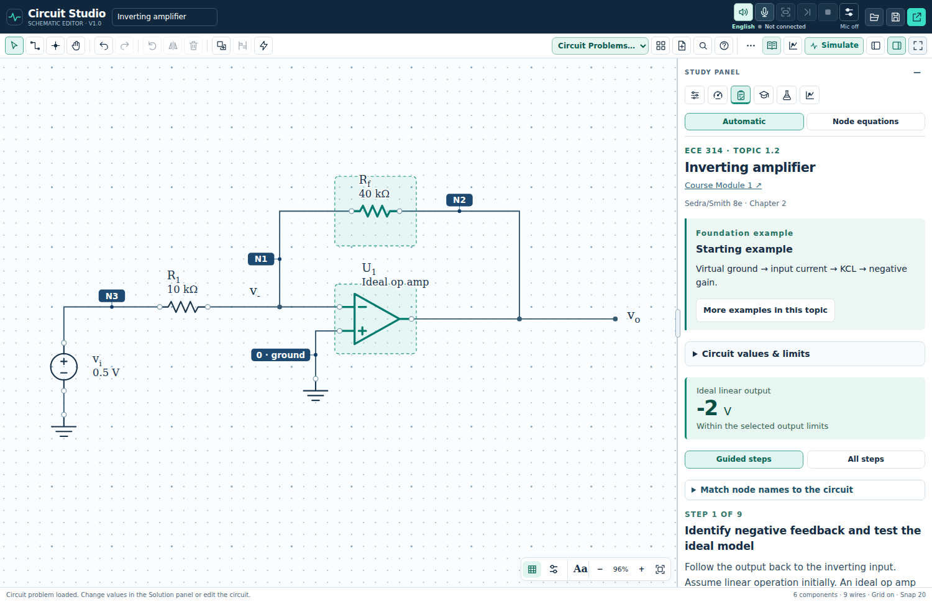
Figure 1. Circuit Studio with an inverting-amplifier problem. The schematic and Solution panel share the workspace; collapsed panels leave room for the drawing.

What you should be able to do
- Build and edit a connected schematic, check signs and units, and save an editable project.
- Find a DC bias point, verify device regions, and convert supported problems into appropriate small-signal models.
- Use Tutor questions and Lab sweeps to test a prediction, then document the model assumptions and evidence.
Prerequisites: Ohm’s law, Kirchhoff’s laws, reference directions, and basic device models. Word equations are editable. This revision adds built-in simulation, linked bias investigations, current voice controls, and clarified model limits.

How to use this manual
Start with Sections 1–6 for the software workflow. Sections 7–14 develop device analysis; 15–20 cover sweeps and reference material. Sections 21–23 add simulation, linked bias investigations, annotation, and voice guidance.
1 Find circuit problems
2 Navigate the workspace
3 Draw a voltage divider
4 Solve and check the DC circuit
5 Learn with Tutor
6 Convert and compare circuits
7 Work through an op amp
8 Analyze diode states and waveforms
9 Build the diode small signal model
10 Solve MOSFET DC bias
11 Solve a MOSFET amplifier
12 Reduce a BJT bias network
13 Solve a BJT amplifier
14 Use hybrid pi and T models
15 Explore with the Lab bench
16 Save print and submit
17 Diagnose common problems
18 Practice and record results
19 Equation and shortcut reference
20 Topic catalog and further study
21 Simulate the drawn circuit
22 Explore bias and annotate your reasoning
23 Use optional voice guidance

Your first ten minutes
1. Open Circuit Studio from the ECE 314 homepage or open Circuit_Studio.html in a desktop browser.
2. Select Examples, choose Op Amp, open Inverting amplifier, and load Starting example.
3. Read the circuit values. Predict the output sign before looking at a calculation.
4. Open Tutor and answer the first question; use a hint if needed.
5. Open Solution to follow the derivation. Change one value under Circuit values & limits and compare with your prediction.
6. Use Save project to download the editable circuit as JSON. Reopen that JSON with Open to continue later.
A useful habit: write the prediction and its reason before changing a value. A result that disagrees with the prediction is an opportunity to check an assumption, polarity, connection, or model.

1 Find circuit problems
Open Circuit Problems or Examples to choose a device family. Compact toolbar controls may use icons; hover to read their names. The topic browser lists Op Amp, Diode, MOSFET, and BJT.
Figure 2. The compact toolbar provides circuit examples, chapter lessons, simulation, and drawing controls.
1. Open Circuit Problems or Examples and choose Op Amp, Diode, MOSFET, or BJT. Use Find when a control is difficult to locate.
2. Choose a topic card, read the example’s goal, and open Starting values & model or Changes from the starting example.
3. Select Load example. Browsing keeps the current sheet; loading replaces it. Undo restores the previous circuit.
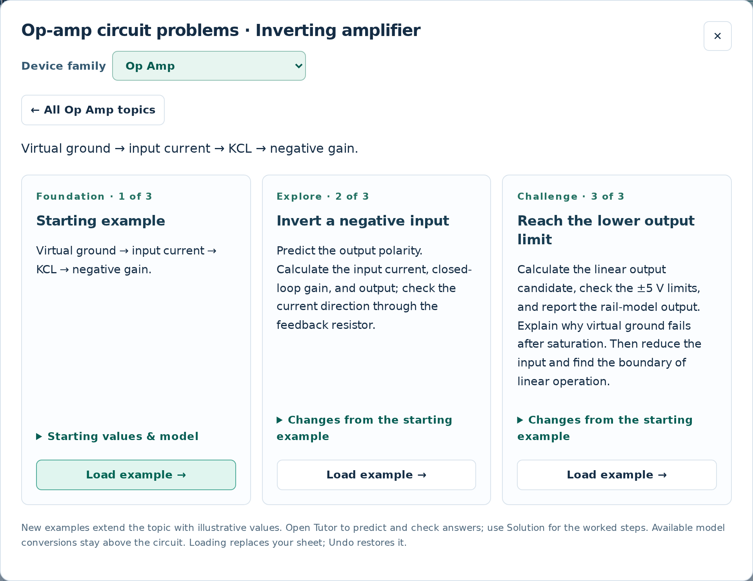
Figure 3. A topic offers three examples. The middle and right cards introduce focused changes to the starting circuit.
Device family | Topics | Worked examples
Op Amp | 6 | 18
Diode | 12 | 36
MOSFET | 9 | 27
BJT | 8 | 24
Total | 35 | 105

The two additional examples per topic use the same circuit topology with purposeful changes in values or model settings. The separate Circuit basics area contains a voltage divider and an RC drawing. Use Find to search for a topic or a named example.

2 Navigate the workspace
Area or control | What you do there
Left component palette | Search for a component, select it, and place it on the sheet.
Center drawing | Place, wire, select, move, and inspect the circuit.
Properties | Edit the selected component, its value, and drawing properties.
DC | Inspect node voltages, branch currents, and operating-point notes.
Solution | Follow a worked derivation or generated node equations.
Tutor | Predict, answer, request hints, and explore after practice.
Lab | Sweep a component value, plot DC quantities, probe nodes, and inspect power.

Make the drawing and equations readable
1. Drag the vertical divider at the left edge of the right panel to change its width. Double-click it to reset; its arrow-key controls also adjust the width when focused.
2. Use Fit, the zoom buttons, or the mouse wheel to frame the drawing. Hold Space and drag to pan, or choose Pan.
3. Toggle Grid on / Grid off beside the zoom controls, or press G. Open the adjacent settings button to choose dots, lines, or higher contrast. Grid visibility does not turn off the 20-unit placement snap.
4. During conversion, use Minimize controls, Show controls, Single view, Compare, and Focus drawing. Use Restore view or Esc to return. Section 6 explains the conversion zoom controls.
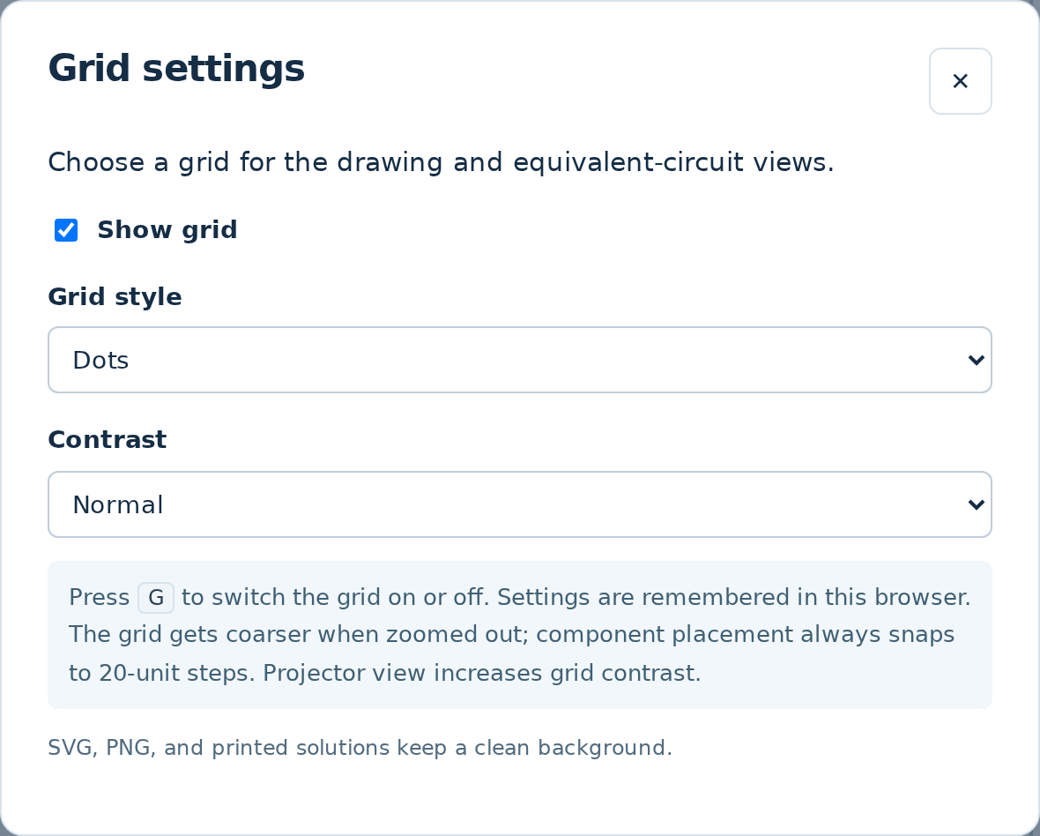
Figure 4. Grid settings control visibility and appearance; the snap spacing remains unchanged.
Focus canvas hides the side panels; Projector view strengthens the drawing for classroom use. Use Find to discover commands. Components and Study restore the corresponding panels.

3 Draw a voltage divider
For a first circuit, choose Examples → Circuit basics → Voltage divider. The starting drawing uses a 10 V source and two 10 kΩ resistors. Rebuild it on a new sheet when you are comfortable with the connections.
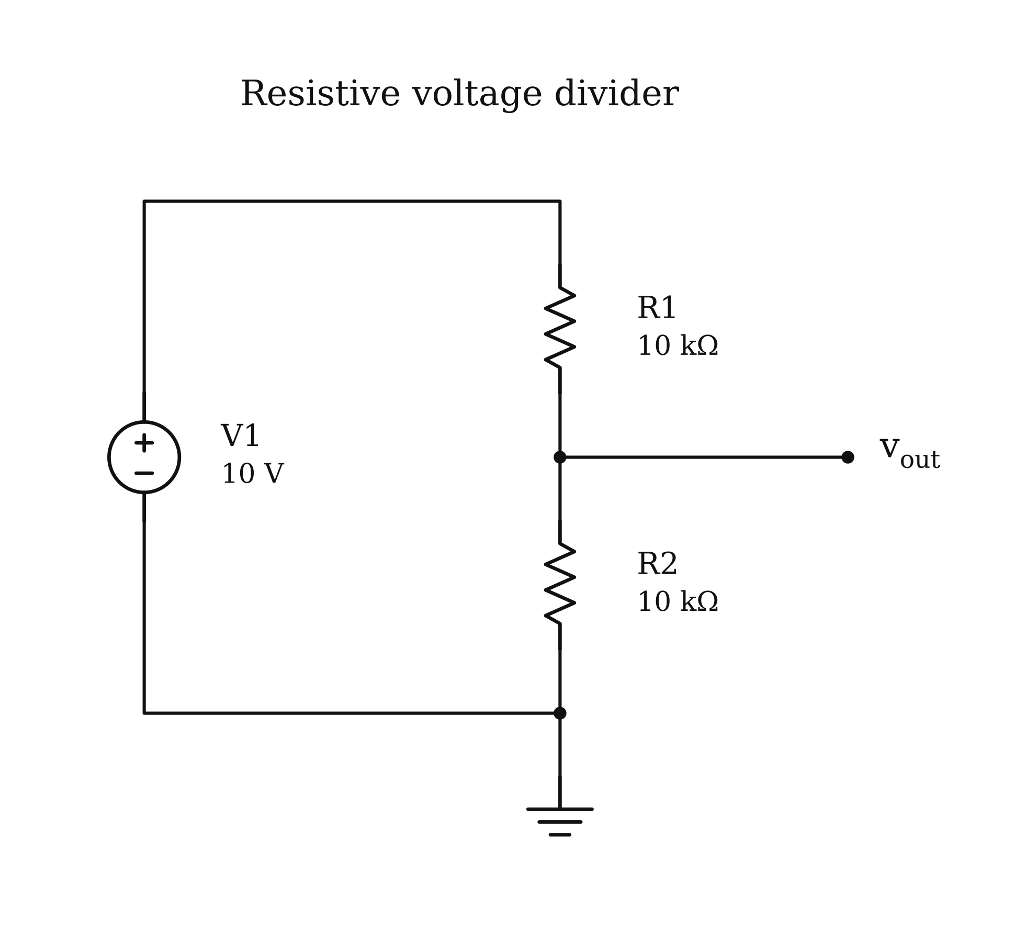
Figure 5. The voltage-divider circuit exported directly from Circuit Studio.
1. Choose New, place a voltage source, two resistors, and ground, then press Esc to stop placing parts.
2. Select each part and enter its value in Properties. Use explicit engineering units such as 10 V, 10 kΩ, and 100 nF.
3. Choose Wire or press W. Click a component pin, click intermediate bends, and finish on another pin or an existing wire.
4. Connect the lower resistor and source return to ground. Add a junction where a branch must connect. A crossing alone is not a connection; use Junction when you intend to join crossing wires.
5. Press D or choose Solve DC. Check the divider output and the direction of resistor current.
$I\text{=}\frac{V_{s}}{R_{1}\text{+}R_{2}}\text{=}\frac{10 \text{V}}{20 \text{kΩ}}\text{=}0.5 \text{mA}$
$V_{o}\text{=}V_{s}\frac{R_{2}}{R_{1}\text{+}R_{2}}\text{=}5 \text{V}$
Displayed resistance prefixes are chosen for readability. For example, 20.653 Ω = 0.020653 kΩ and 4 MΩ = 4000 kΩ. This changes the display scale, not the underlying resistance or the calculated circuit result.
Check your reasoning. The output is measured from the resistor junction to ground. The division ratio depends on which resistor is below that junction.

4 Solve and check the DC circuit
Solve DC computes the circuit’s operating point and toggles its numeric overlays. Click again or press D to hide the values; the DC tab remains available for inspection. Capacitors open, inductors short, and zero-mean AC sources become zero at DC. For AC frequency sweeps and transient analysis, use Simulate in Section 21.
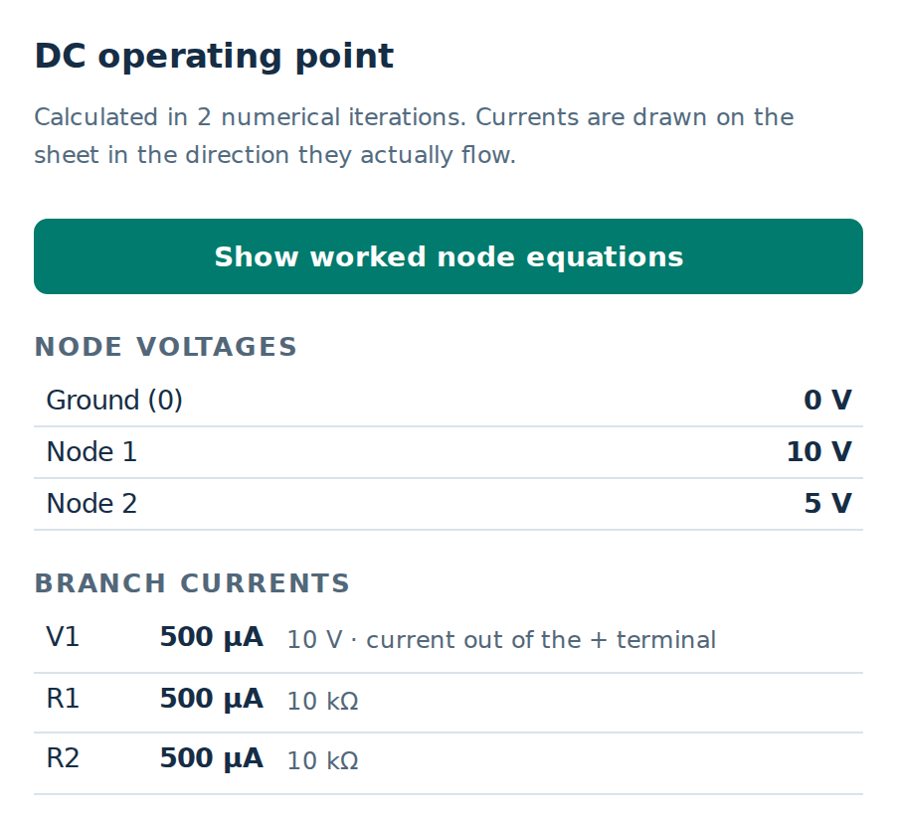
Figure 6. DC results for the 10 V divider. Read node names and current directions together with the drawing.

Check the equations independently
At the divider junction, KCL can be written with both resistor currents directed away from the node:
$\frac{V_{o}\text{−}V_{s}}{R_{1}}\text{+}\frac{V_{o}}{R_{2}}\text{=}0$
Change the lower resistor from 10 kΩ to 20 kΩ. Predict the output before editing, then calculate:
$V_{o}\text{=}10 \text{V}\frac{20 \text{kΩ}}{10 \text{kΩ}\text{+}20 \text{kΩ}}\text{≈}6.667 \text{V}$
Use Solution → Node equations to see equations generated from the current connections. In Automatic mode, a supported problem keeps its specialized derivation when the connections still match; a wiring change can switch to generated DC equations.
- A negative reported current means the actual current is opposite the stated reference direction.
- A successful numerical solve still needs checks on units, signs, device region, and model assumptions.
- Changing values updates results. Adding wires or components can change which guided conversions remain available.

5 Learn with Tutor
Use Tutor when you want to solve before seeing the worked answer. The questions are generated from the current circuit values, and the relevant components are highlighted on the drawing.
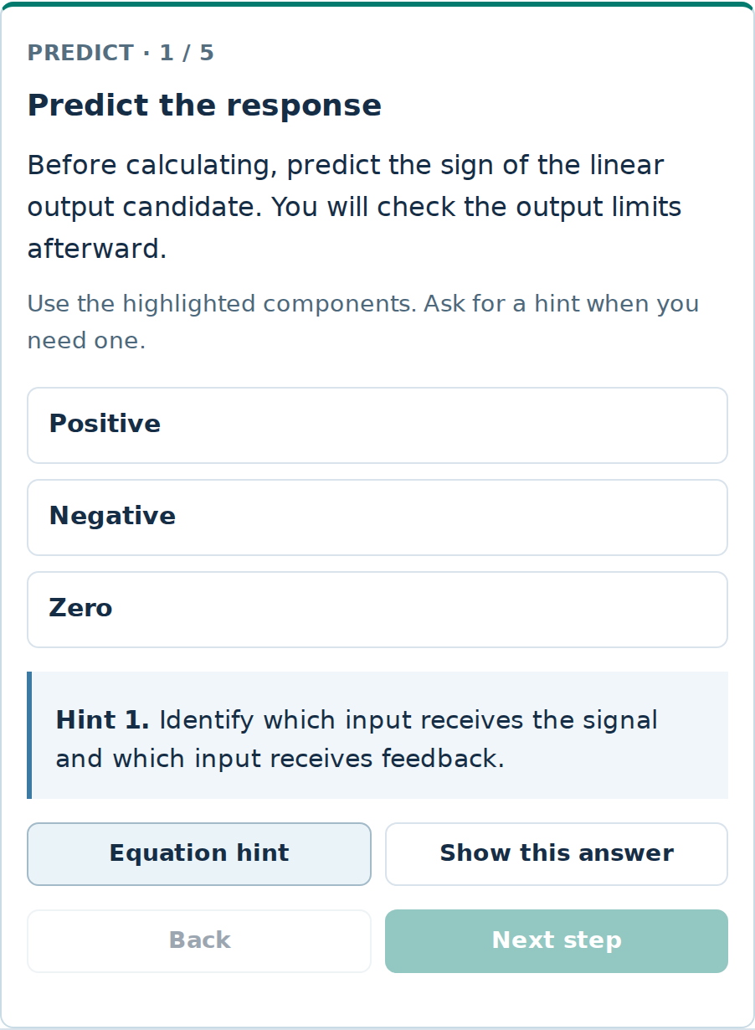
Figure 7. A prediction question with its first hint open. A second hint can supply an equation, and revealing an answer is recorded separately from solving it.
1. Choose Guided practice for intermediate checks or Independent practice for fewer supplied steps.
2. Make a prediction, then enter or choose an answer. Read the displayed unit; equivalent engineering prefixes are accepted. For example, 4 MΩ and 4000 kΩ represent the same resistance.
3. Use Give me a hint, then Equation hint, before selecting Show this answer. Read the explanation and connect it to the highlighted components.
4. After the questions, use the exploration sliders to change one value. Compare the observed result with a written prediction. Reset sliders returns to their starting values; New practice values begins another variation.
Practice progress is stored in this browser. Value or connection changes can start a fresh practice state. The saved circuit JSON preserves the circuit and chosen example; treat browser practice history as separate from your submitted work.

6 Convert and compare circuits
Conversion controls appear above the drawing when the selected problem supports them. A conversion is a view of an equivalent model; it does not replace your editable original circuit.
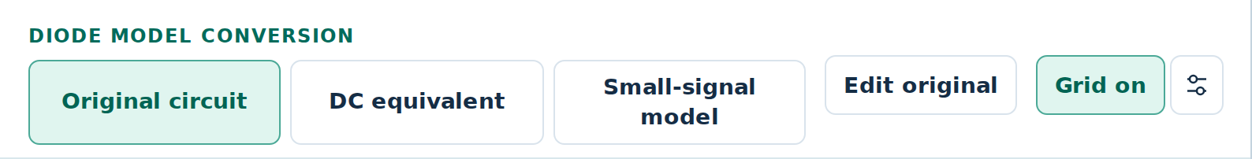
Figure 8. A biased-diode problem provides Original circuit, DC equivalent, and Small-signal model buttons.
Element or quantity | DC operating point | Incremental AC model
Independent DC voltage source | Keep its DC value. | Set its small-signal value to zero; use a short.
Zero-mean AC voltage source | Set it to zero; use a short. | Keep the signal.
Coupling or bypass capacitor | Open circuit. | Use a short only when its reactance is sufficiently small.
Nonlinear device | Solve its bias point and region. | Use the tangent resistance or transistor model, including its controlled source.

$v\left(t\right)\text{=}V_{Q}\text{+}v_{ac}\left(t\right)\text{,} i\left(t\right)\text{=}I_{Q}\text{+}i_{ac}\left(t\right)$
An AC-grounded node can have a nonzero DC voltage. “Ground” in the small-signal model means zero incremental voltage, not that every DC voltage is zero.
1. Select DC equivalent first, then identify the Q-point and confirm the device region.
2. Choose Thevenin equivalent where offered to reduce a supported bias divider. Choose Small-signal model to see the linearized circuit.
3. Use Compare and Trace node to identify corresponding nodes. A shorted supply or capacitor may merge several original nodes in the AC view.
4. Enable Follow solution steps to link the drawing to the derivation. Use Solve shown model or Restart guide as needed. Edit original returns to the editable drawing.
The biased-diode lesson supports its resistor small-signal model. MOSFET and BJT lessons provide their supported equivalents; Thevenin buttons are offered for the implemented divider-bias problems. Arbitrary wiring edits do not create a general automatic AC conversion.

Focus and zoom the conversion drawing
Use this workflow when the conversion explanations take space away from the circuit. The control row stays available in both Single view and Compare.
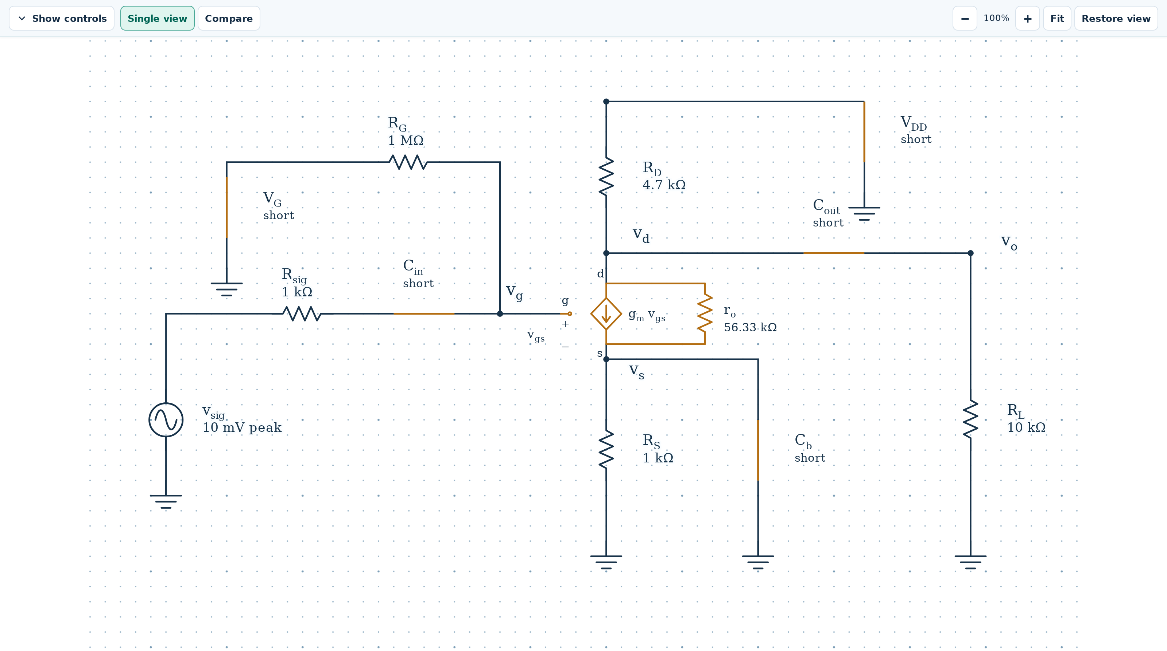
Figure 9. A small-signal MOSFET model in Focus drawing. Show controls, comparison, zoom, Fit, and Restore view remain available.
1. Select the required conversion, then choose Minimize controls. This hides the conversion settings, captions, and node-tracing explanation. Show controls brings them back.
2. Choose Focus drawing to hide the side panels as well. Use Restore view or Esc to return; the previous minimized or expanded control state is restored.
3. Use + / − or the mouse wheel over the circuit to zoom from 50% to 400%. The percentage is relative to the fitted view. Fit resets a single drawing; Fit both resets a comparison.
4. Drag the drawing to pan. With the drawing focused, use the arrow keys to pan and F to fit. Comparison drawings keep zoom and scrolling linked.
Changing the view leaves the circuit values, connections, and bias calculations intact. The minimized-controls preference is remembered in this browser. To change a device parameter, restore the controls first.

7 Work through an op amp
Load Op Amp → Inverting amplifier → Starting example. The input is 0.5 V, the input resistance is 10 kΩ, the feedback resistance is 40 kΩ, and the selected output range is −12 V to +12 V.
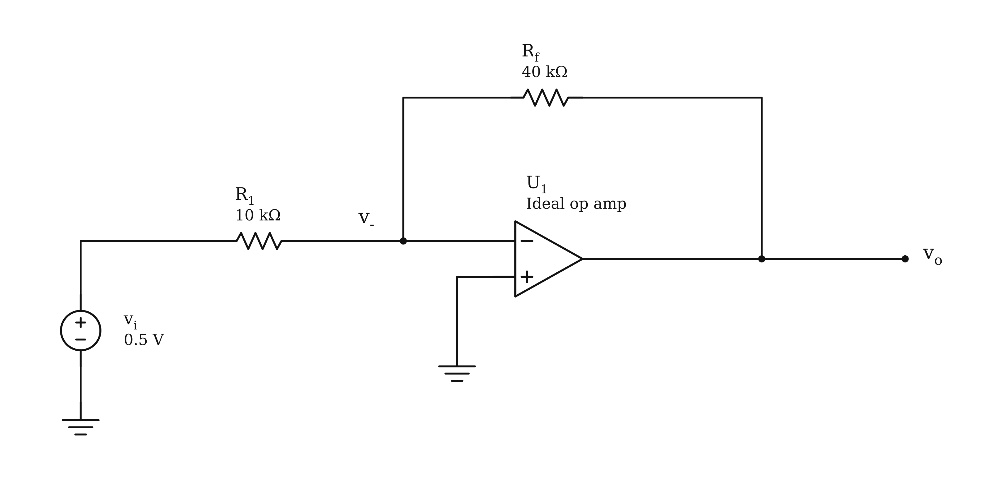
Figure 10. Inverting-amplifier circuit exported from the loaded problem.
Assume ideal input currents and linear negative feedback, then verify the output limits. The grounded noninverting input places the inverting node near zero volts; this is a virtual ground, not a physical wire to ground.
$i_{\text{+}}\text{=}i_{\text{−}}\text{=}0\text{,} v_{\text{−}}\text{≈}v_{\text{+}}\text{=}0$
$\frac{v_{i}\text{−}v_{\text{−}}}{R_{1}}\text{=}\frac{v_{\text{−}}\text{−}v_{o}}{R_{f}}$
$A_{v}\text{=}\text{−}\frac{R_{f}}{R_{1}}\text{=}\text{−}4\text{,} v_{o}\text{=}A_{v}v_{i}\text{=}\text{−}2 \text{V}$
$i_{1}\text{=}\frac{0.5 \text{V}}{10 \text{kΩ}}\text{=}50 \text{μA}$
The calculated −2 V output lies inside the selected range, so the linear assumption is consistent. Circuit values & limits lets you change the inputs, resistor values, and output limits; the limit settings are not drawn supply wires.
Check your reasoning. Load Invert a negative input: −0.25 V with 20 kΩ feedback gives +0.5 V. The step wording follows the input sign. Reach the lower output limit starts beyond the linear range; use the following limit checks before accepting a gain equation.

Check op amp output limits
The guided solution first derives a linear candidate, then checks the selected limits. Automatic keeps that derivation visible for these standard circuits. The result card reports the simple rail-model output when the candidate exceeds the allowed range.
Topic and challenge | Linear candidate | Rail-model output
Inverting • Reach the lower output limit | −7.5 V | −5 V
Noninverting • Reach the 5 V output limit | +6 V | +5 V
Follower • A buffer beyond its output limit | +5.5 V | +5 V
Integrator • Evaluate the integrator after its first output limit | −4 V at 12 ms | −2.5 V

For the integrator, the initial output is +2 V and the slope is −0.5 V/ms. It first reaches the lower limit at 9 ms; the 12 ms evaluation therefore tests the limited branch.
$v_{o\text{,}\text{linear}}\left(t\right)\text{=}2 \text{V}\text{−}\left(0.5 \text{V}\text{/}\text{ms}\right)t\text{,} t_{\text{limit}}\text{=}\frac{2\text{−}\left(\text{−}2.5\right)}{0.5} \text{ms}\text{=}9 \text{ms}$
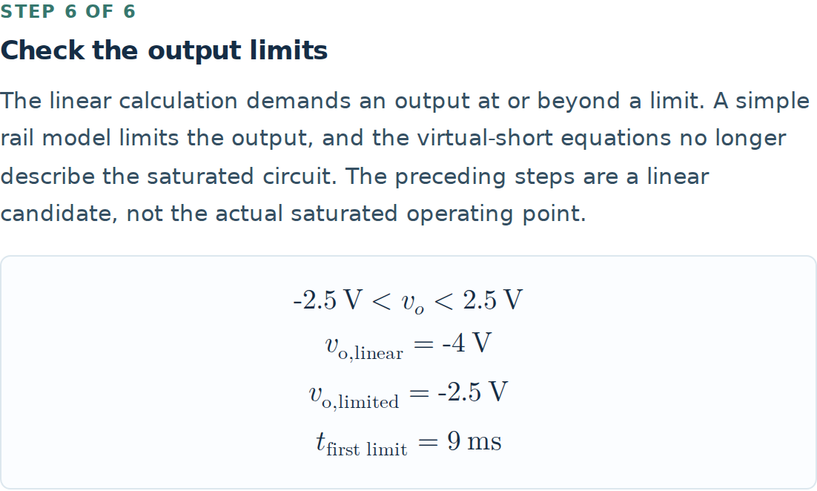
Figure 11. The integrator limit check separates the linear candidate from the limited output.
For the three static amplifiers, choose Node equations to solve the network with the output fixed at its limit. The input voltages are no longer forced equal. For the inverting case, the solved inverting node is about +0.22727 V. A DC solve does not reproduce the integrator time response.

8 Analyze diode states and waveforms
Load Diode → Series diode · state & current → Starting example. Identify anode and cathode before selecting a model. The constant-drop example uses a 5 V supply, 1 kΩ series resistor, and 0.7 V forward drop.
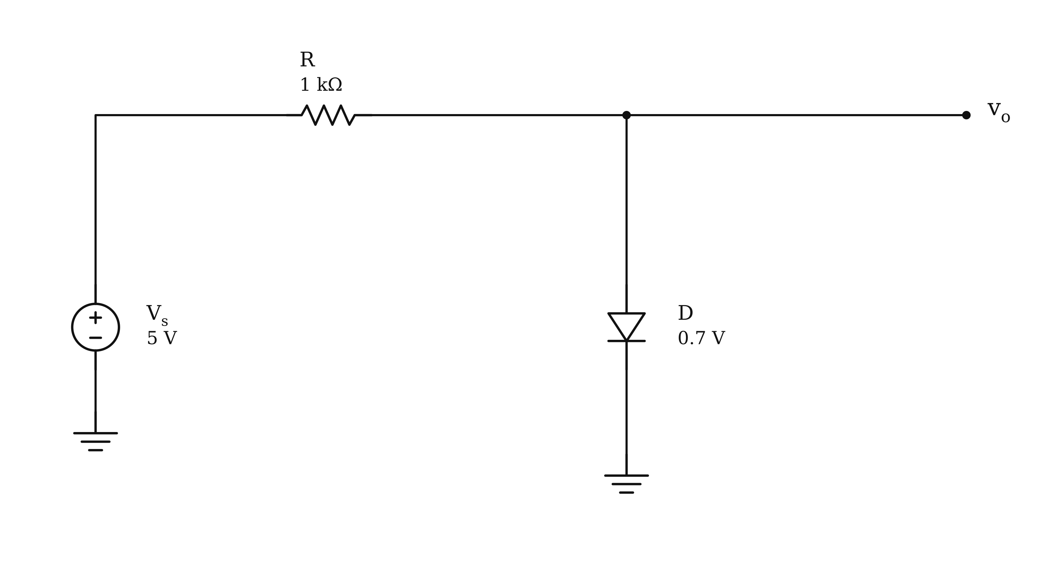
Figure 12. A series diode circuit. Positive diode current is referenced from anode to cathode.
$I_{D\text{,}\text{trial}}\text{=}\frac{V_{s}\text{−}V_{γ}}{R}\text{=}\frac{5\text{−}0.7}{1000} \text{A}\text{=}4.3 \text{mA}$
The trial current is positive, so the ON assumption is consistent. For an OFF candidate, set diode current to zero and verify that the anode-to-cathode voltage does not exceed the chosen forward drop.
$\text{ON}\text{:} V_{D}\text{=}V_{γ}\text{,} I_{D}\text{≥}0$
$\text{OFF}\text{:} I_{D}\text{=}0\text{,} V_{D}\text{≤}V_{γ}$
Load Test a reverse-biased diode. With the source at −3 V, the ON trial gives a negative current, so the valid solution is OFF with zero current and a diode voltage of −3 V. Reverse breakdown is outside this model.

Choose the appropriate diode lesson
- Two diodes: test all state combinations and reject candidates with inconsistent current or voltage inequalities.
- Shockley load line: solve the resistor equation and exponential current law together; do not force a 0.7 V drop.
- Half-wave rectifier and limiters: identify conduction intervals, output peaks, and diode currents from the waveform.
- Clampers: compare RC with the period. Finite capacitor discharge can make the ideal level-shift estimate inaccurate.
Waveform lessons use their specific implemented models. The general Solve DC button still reports an operating point, even when the circuit contains an AC source.

Measure exact diode conduction
Load Diode → Positive limiter → Starting example. The sinusoidal input has 5 V peak amplitude and the conducting threshold is 2.7 V. The diode conducts when the input exceeds that threshold.
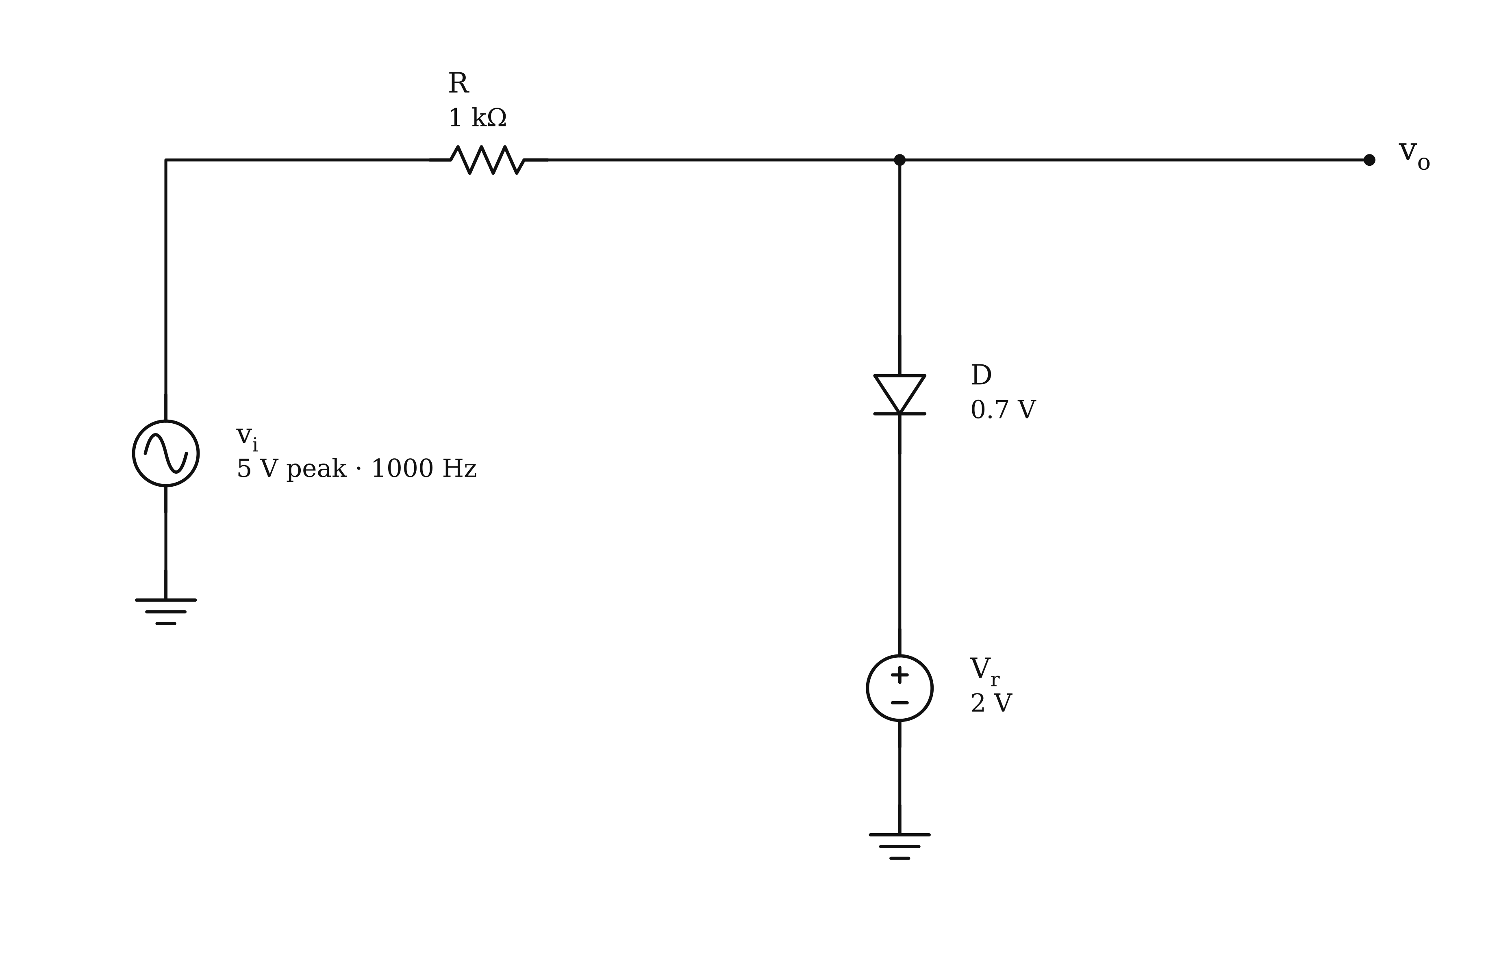
Figure 13. Positive-limiter circuit from the starting example. The reference source and diode drop set the upper output level.
$v_{i}\text{=}V_{\text{peak}}\text{sin}θ\text{,} α\text{=}\text{arcsin}\left(\frac{V_{\text{limit}}}{V_{\text{peak}}}\right)$
$D_{\text{ON}}\text{=}\frac{1}{2}\text{−}\frac{α}{π}\text{=}\frac{1}{2}\text{−}\frac{\text{arcsin}\left(2.7\text{/}5\right)}{π}\text{≈}31.842\text{\%}$
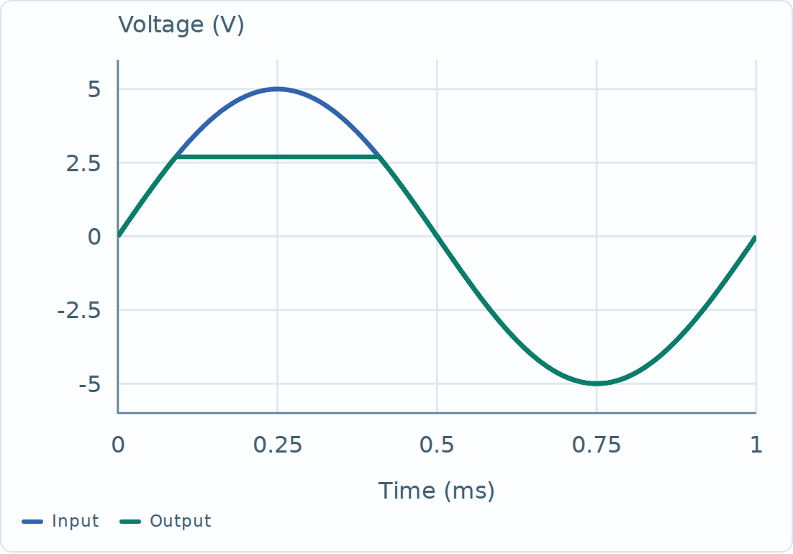
Figure 14. The displayed waveform is sampled for plotting; the conduction percentage is calculated analytically.
For conduction below a signed threshold, as in the negative limiter, use $D_{\text{ON}}\text{=}1\text{/}2\text{+}α\text{/}π$. These expressions assume $|V_{\text{limit}}|\text{<}V_{\text{peak}}$. Outside that range, test for no conduction or full-cycle conduction; zero-amplitude input requires a constant-voltage comparison.
The half-wave rectifier uses its forward drop as the threshold in the same above-threshold formula. Isolated zero-current boundary instants have zero duration. Conduction (exact) labels rectifiers and limiters; Conduction (sampled) remains appropriate for the RC clamper calculation.

Apply and verify a diode regulator design
In Four-diode regulator design, a new target changes the proposed design. Calculated outputs continue to use the drawn resistor and diode saturation currents until you choose Apply calculated design to drawing.
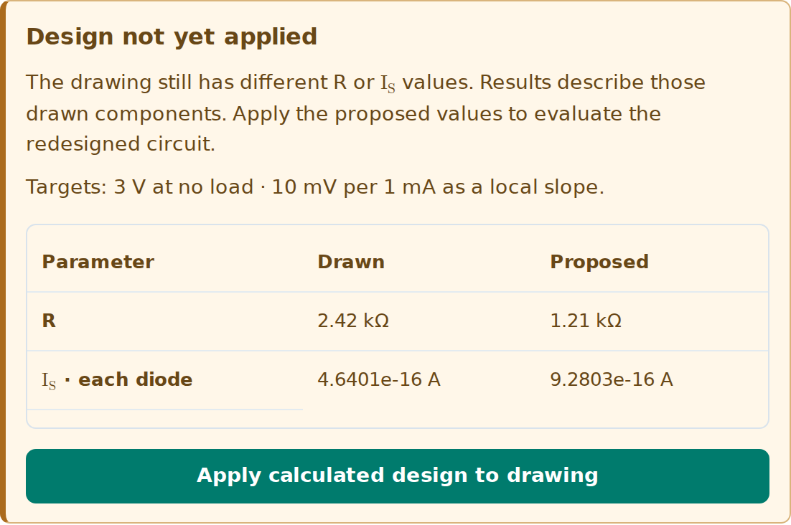
Figure 15. The tighter-regulation example starts with the old drawing. Compare the Drawn and Proposed columns, then apply the calculated values.
1. Read Design not yet applied and compare the target with the existing component values. This applies to Design for tighter load regulation and Design a different output voltage.
2. Choose Apply calculated design to drawing. It updates the series resistor and all four diode saturation currents together. The status then reads Drawing matches calculated design.
3. Read Local slope and finite load step. Matching the proposed components does not guarantee that a finite load change meets a strict maximum-drop requirement.
$R_{\text{out}\text{,}Q}\text{=}\frac{20 \text{mV}}{1 \text{mA}}\text{=}20 Ω\text{,} ΔV_{\text{linear}}\text{=}R_{\text{out}\text{,}Q}ΔI_{L}$
Starting design check | Drop for a 1 mA load step
Local tangent prediction | 20.00 mV
Nonlinear loaded solution | 22.29 mV

The 20 mV per mA specification is used as a local slope at the unloaded Q-point. The nonlinear diode curve produces a larger finite change. If the assignment requires no more than 20 mV for the full 1 mA step, redesign is necessary and the final nonlinear load case must be checked.

9 Build the diode small signal model
Load Diode → Biased diode · small signal → Starting example. Use a 10 V DC supply, 20 mV peak signal, 10 kΩ resistor, saturation current 1.23 nA, ideality factor 2, and thermal voltage 25.85 mV.
First set the AC source to zero and solve the exponential diode law with the resistor load line:
$I_{DQ}\text{=}I_{S}\left(e^{V_{DQ}\text{/}\left(nV_{T}\right)}\text{−}1\right)\text{=}\frac{V_{s}\text{−}V_{DQ}}{R}$
$V_{DQ}\text{≈}0.69981 \text{V}\text{,} I_{DQ}\text{≈}0.93002 \text{mA}$
Differentiate at the Q-point to obtain the incremental resistance. The exact Shockley derivative retains the saturation current; the familiar approximation applies in strong forward bias.
$r_{d}\text{=}\frac{nV_{T}}{I_{DQ}\text{+}I_{S}}\text{≈}\frac{nV_{T}}{I_{DQ}}\text{=}55.590 Ω$
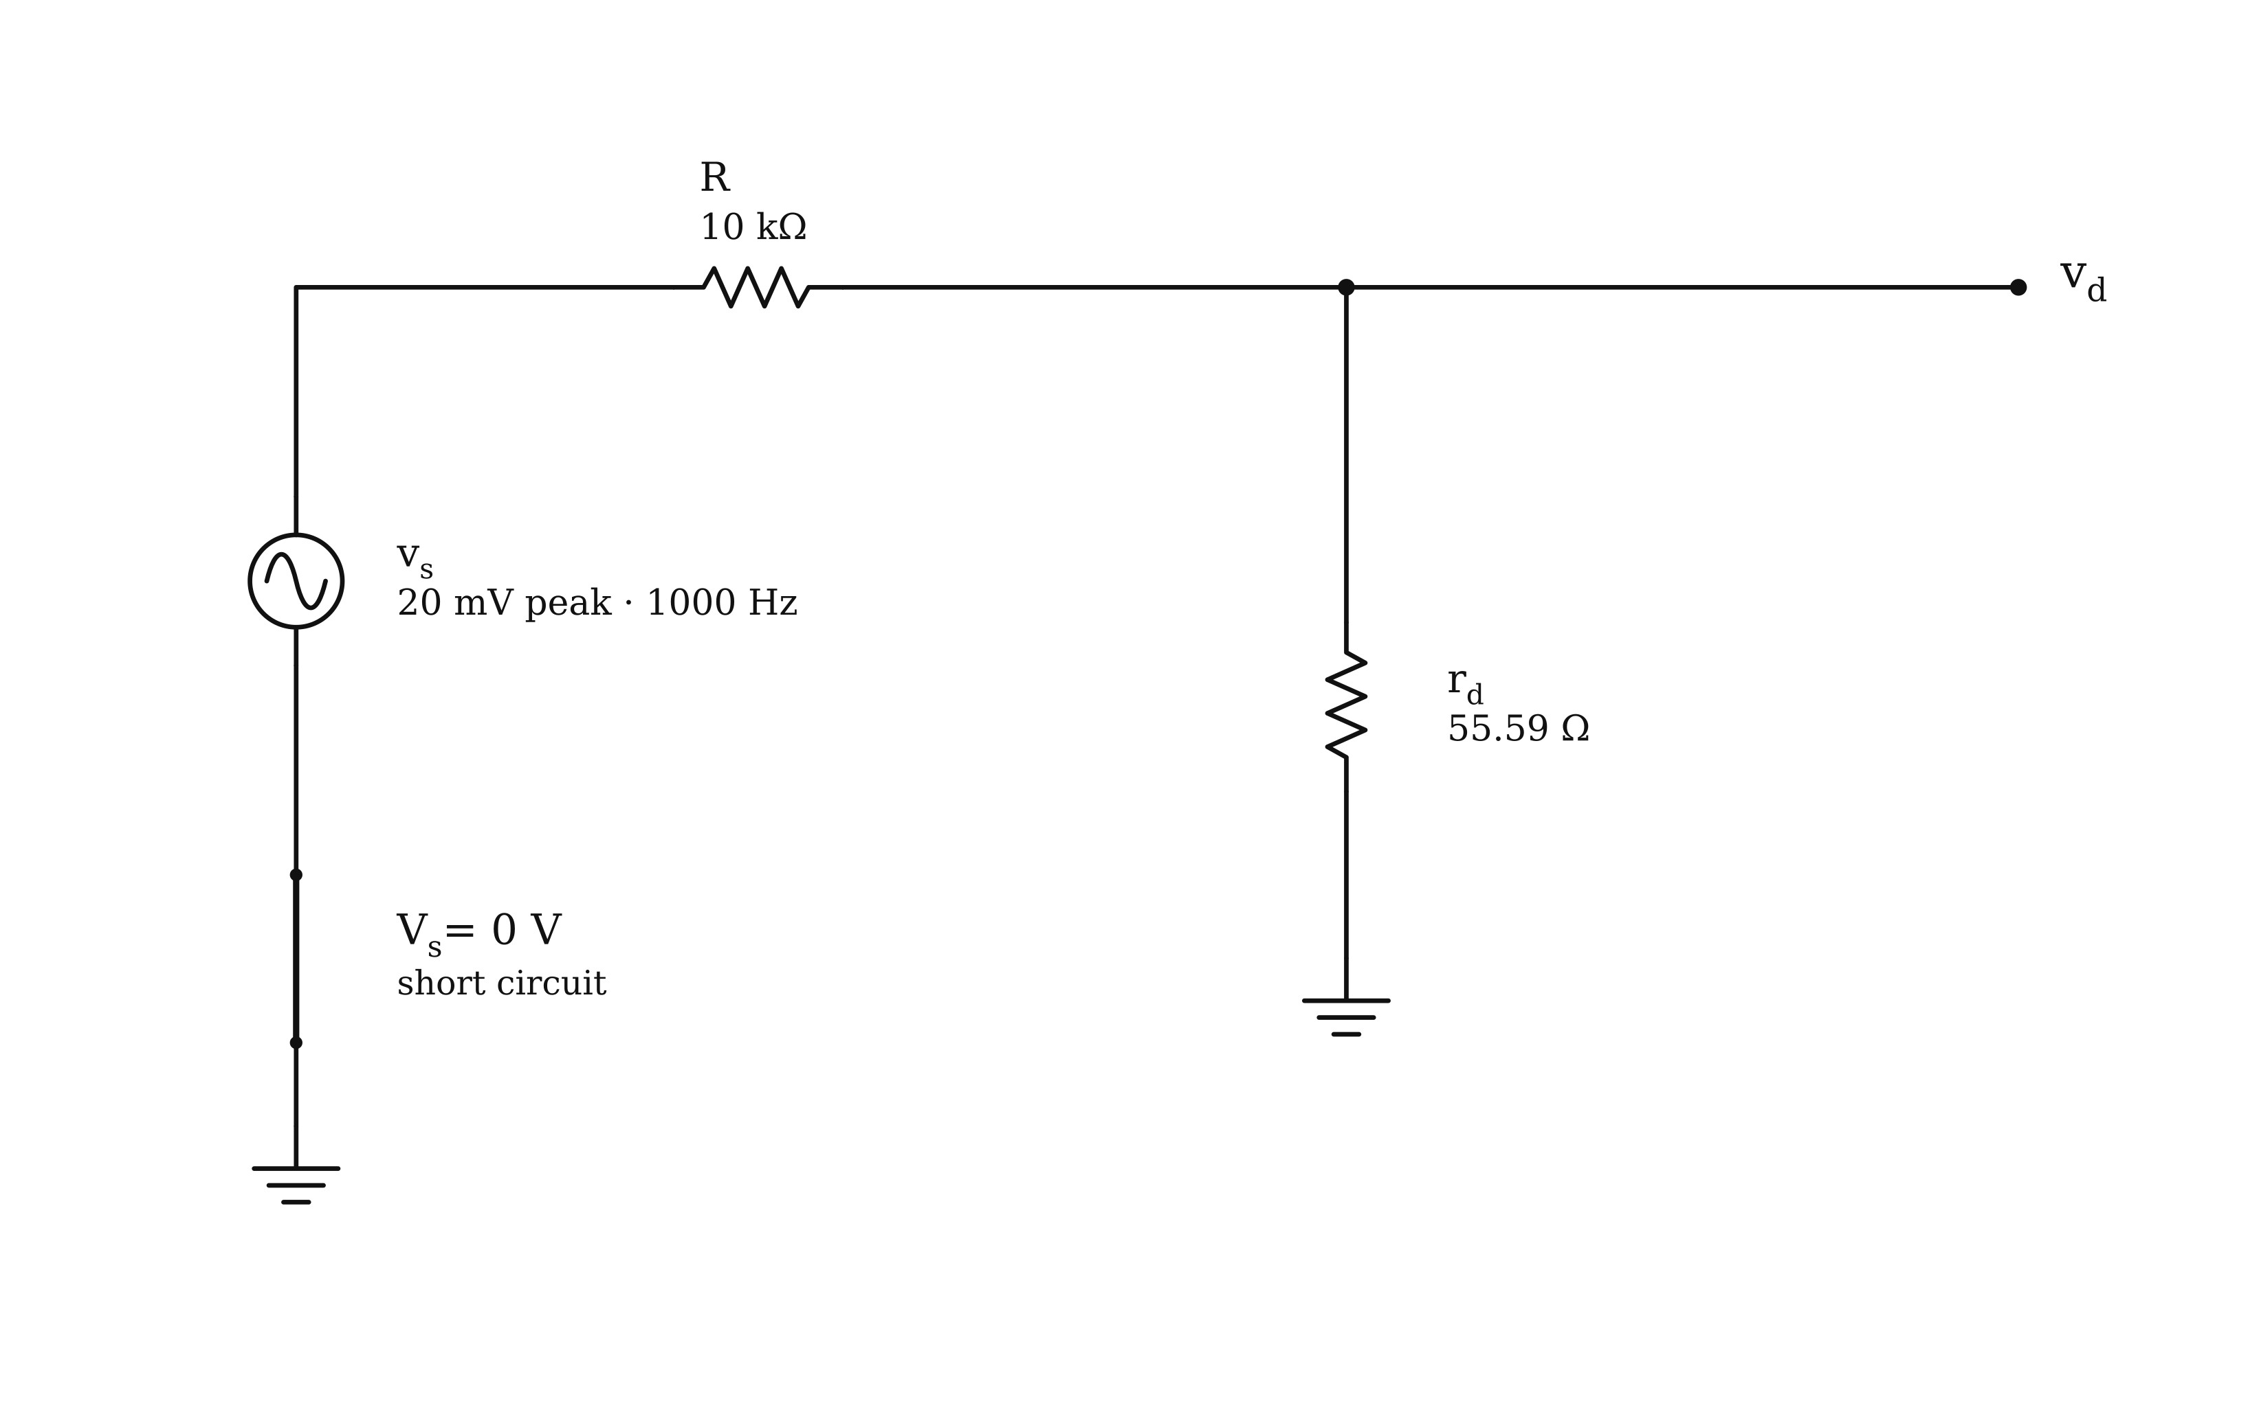
Figure 16. The diode AC equivalent: the DC supply becomes a short and the diode becomes its tangent resistance.
$v_{d\text{,}\text{peak}}\text{=}\frac{r_{d}}{R\text{+}r_{d}}v_{s\text{,}\text{peak}}\text{≈}0.11057 \text{mV}$
Choose Compare to trace the diode terminals between the original and AC drawings. The AC output is the small variation around the bias voltage, not the total diode voltage.
$v_{D}\left(t\right)\text{≈}0.69981 \text{V}\text{+}\left(0.11057 \text{mV}\right)\text{sin}\left(2π\text{⋅}1000t\right)$
Check your reasoning. Load Challenge the small-signal approximation. Compare the predicted ripple with the thermal-voltage scale and inspect the nonlinear curve. The app’s 10% check is a teaching guideline, not a universal accuracy guarantee.

10 Solve MOSFET DC bias
Load MOSFET → NMOS · divider bias & source feedback → Starting example. The supply is 12 V; both gate resistors are 8 MΩ; drain and source resistors are 4 kΩ. The threshold is 1 V and the app uses $k\text{=}1 \text{mA}\text{/}{\text{V}}^{\text{2}}$ with the one-half factor shown below.
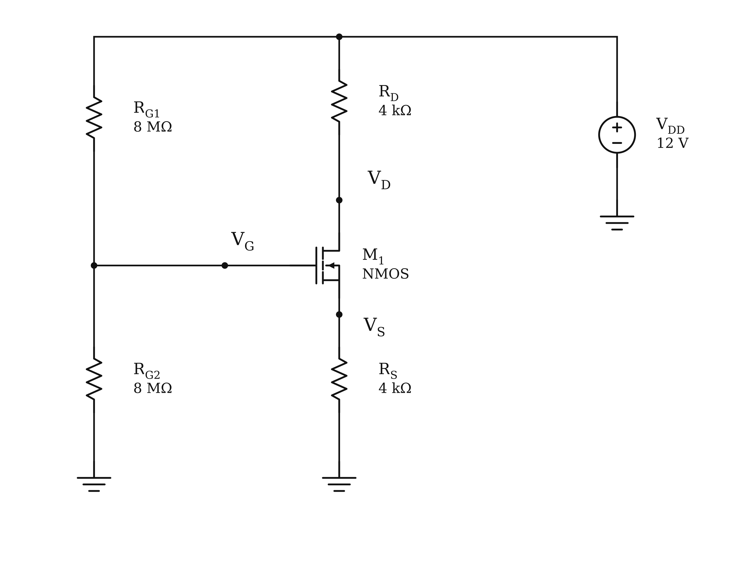
Figure 17. Divider-biased NMOS circuit. Source resistance makes the bias equation implicit in drain current.
$V_{G}\text{=}V_{DD}\frac{R_{G2}}{R_{G1}\text{+}R_{G2}}\text{=}6 \text{V}\text{,} V_{GS}\text{=}V_{G}\text{−}I_{D}R_{S}$
$I_{D}\text{=}\frac{k}{2}{\left(V_{GS}\text{−}V_{TH}\right)}^{2} \left(λ\text{=}0\text{,} \text{saturation}\right)$
Substitute the source-resistor voltage into the current equation, solve the quadratic, and reject any root that violates the assumed region or gives nonphysical overdrive. The accepted result is:
$I_{D}\text{≈}0.91230 \text{mA}\text{,} V_{S}\text{≈}3.6492 \text{V}\text{,} V_{D}\text{≈}8.3508 \text{V}$
$V_{OV}\text{=}V_{GS}\text{−}V_{TH}\text{≈}1.3508 \text{V}\text{,} V_{DS}\text{≈}4.7016 \text{V}$
Because the overdrive is positive and the drain-to-source voltage exceeds it, saturation is consistent. Thevenin equivalent reduces the gate divider to 6 V in series with 4 MΩ. The ideal MOS gate draws no DC current, so there is no DC drop across that Thevenin resistance.
For PMOS: use $V_{SG}\text{=}V_{S}\text{−}V_{G}$ and $V_{SD}\text{=}V_{S}\text{−}V_{D}$ with positive source-to-drain current magnitude. In triode, the effective resistance is $R_{SD\text{,}\text{eff}}\text{=}V_{SD}\text{/}I_{D}$; the local slope resistance is $r_{o}\text{=}1\text{/}g_{ds}$. They describe different measurements. Here $V_{TH}$ means MOS threshold, not Thevenin voltage.

11 Solve a MOSFET amplifier
Load MOSFET → Common-source · bypassed source → Starting example. Find the Q-point before switching to AC. The source resistor establishes DC feedback; its bypass capacitor removes that feedback from the stated midband AC model.
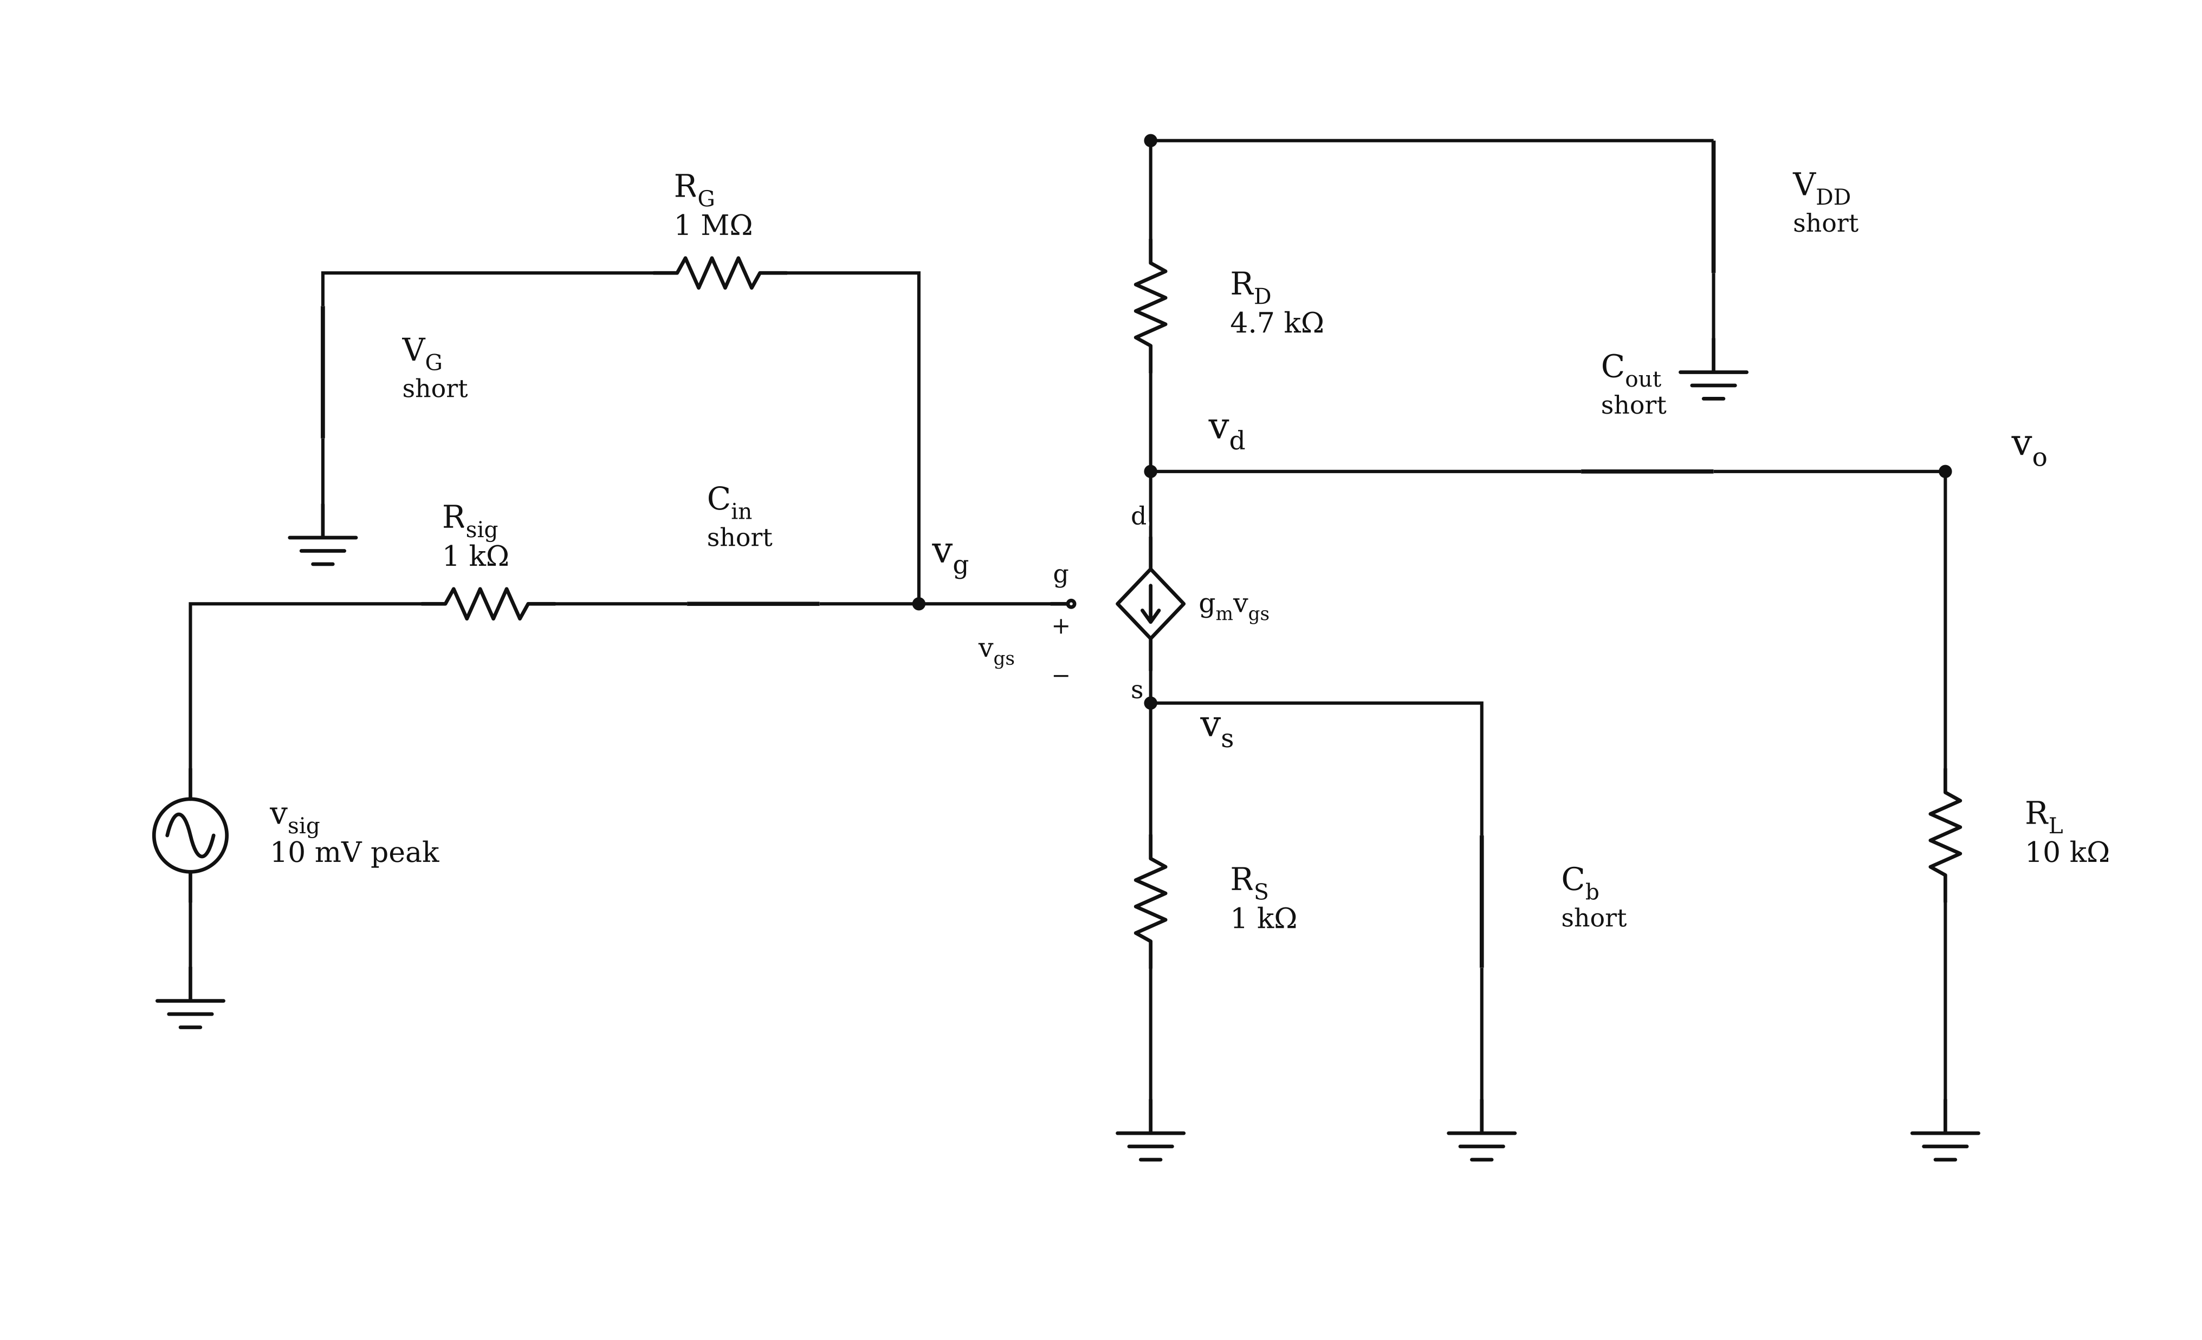
Figure 18. Common-source AC equivalent. The bias supply is shorted, coupling and bypass capacitors are represented as shorts, and the controlled current source remains.
$I_{DQ}\text{≈}0.67712 \text{mA}\text{,} V_{OV}\text{≈}0.82288 \text{V}$
$g_{m}\text{=}kV_{OV}\text{=}\frac{2I_{DQ}}{V_{OV}}\text{≈}1.6458 \text{mS}$
With zero channel-length modulation, the model has infinite transistor output resistance. Include the load at the drain and the signal-source attenuation at the gate:
$R_{D}\text{∥}R_{L}\text{=}\frac{R_{D}R_{L}}{R_{D}\text{+}R_{L}}\text{≈}3.1973 \text{kΩ}$
$\frac{v_{o}}{v_{g}}\text{=}\text{−}g_{m}\left(R_{D}\text{∥}R_{L}\right)\text{≈}\text{−}5.2619$
$\frac{v_{g}}{v_{sig}}\text{=}\frac{R_{G}}{R_{sig}\text{+}R_{G}}\text{≈}0.99900\text{,} G_{v}\text{=}\frac{v_{o}}{v_{sig}}\text{≈}\text{−}5.2567$
A 10 mV peak input therefore gives about 52.57 mV peak output with inversion. These are AC amplitudes around the DC bias. Read the capacitor-reactance and signal-margin checks before accepting the midband prediction.
Check your reasoning. Try Load the common-source output and Include channel-length modulation. A coupled output load leaves the DC bias unchanged, while a nonzero channel-length modulation parameter changes this app’s DC and AC device calculations.

Include MOSFET output resistance
Load Common-source · bypassed source → Include channel-length modulation and select Small-signal model. This example sets λ to 0.03 V⁻¹. The Channel-length modulation · rₒ checkbox and λ field appear above the drawing; use Show controls if they are hidden.
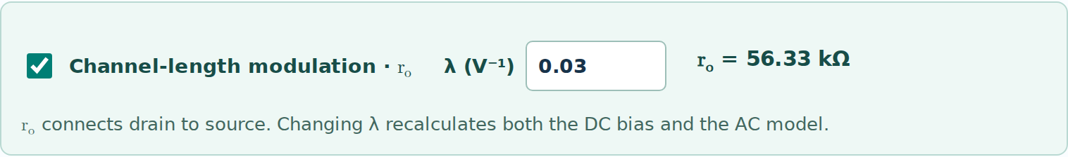
Figure 19. The MOSFET control reports the derived output resistance. Changing λ recomputes both DC bias and the AC model.
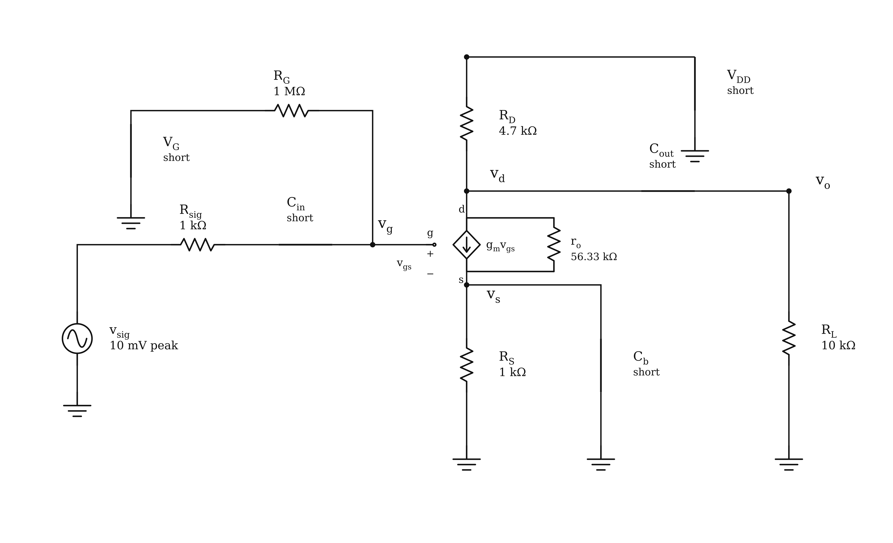
Figure 20. Finite rₒ connects drain to source in parallel with the controlled source. The bypassed source is at AC ground in this example.
$g_{m}\text{=}\frac{2I_{DQ}}{V_{OV}}\text{,} g_{ds}\text{=}\frac{λI_{DQ}}{1\text{+}λV_{DSQ}}\text{,} r_{o}\text{=}\frac{1}{g_{ds}}\text{=}\frac{1\text{+}λV_{DSQ}}{λI_{DQ}}$
$\frac{v_{o}}{v_{g}}\text{=}\text{−}g_{m}\left(R_{D}\text{∥}R_{L}\text{∥}r_{o}\right)$
$I_{DQ}\text{≈}0.73078 \text{mA}\text{,} r_{o}\text{≈}56.334 \text{kΩ}\text{,} G_{v}\text{=}\frac{v_{o}}{v_{sig}}\text{≈}\text{−}5.7429$
The Q-point and $g_{m}$ change with λ. Here the gain magnitude rises from 5.2567 to 5.7429 because the larger $g_{m}$ outweighs the added output loading. At fixed $g_{m}$, finite $r_{o}$ reduces gain magnitude. The estimate $r_{o}\text{≈}1\text{/}\left(λI_{DQ}\right)$ requires $λV_{DSQ}\text{≪}1$; PMOS uses $V_{SDQ}$ and positive current magnitude.
With λ = 0 in saturation, the output-resistance branch is open. In triode, channel slope already gives finite output resistance even when λ = 0. With source degeneration, keep rₒ between drain and source in KCL; it is not simply a resistor from the drain to ground.

12 Reduce a BJT bias network
Load BJT → NPN · voltage-divider bias → Starting example. The base draws current, so the unloaded divider voltage alone is not the loaded base voltage. Use the Thevenin conversion to retain that loading.
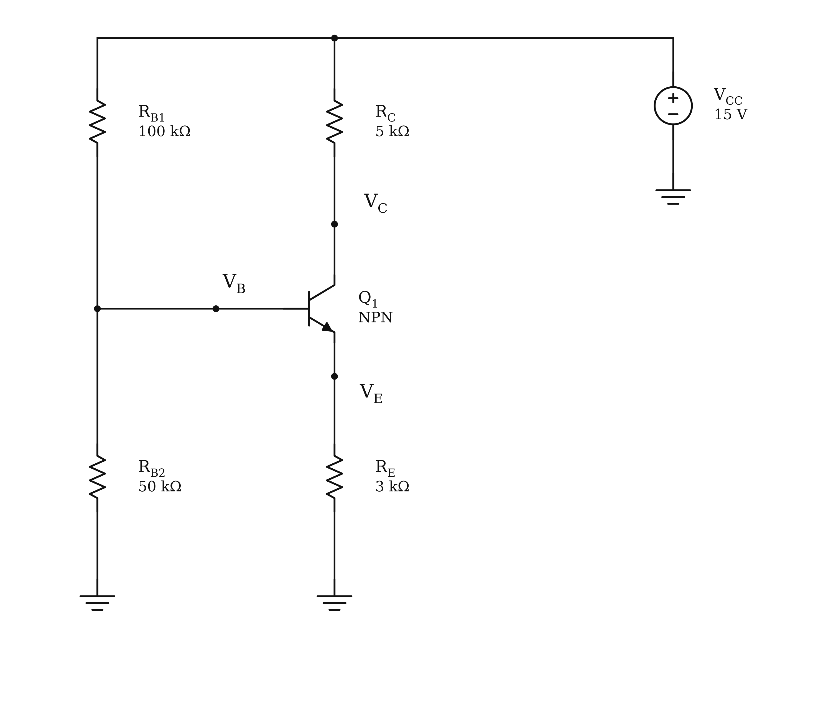
Figure 21. NPN divider-bias circuit with emitter feedback. The two base resistors can be replaced by a Thevenin source and resistance.
$V_{\text{Th}}\text{=}V_{CC}\frac{R_{B2}}{R_{B1}\text{+}R_{B2}}\text{=}5 \text{V}$
$R_{\text{Th}}\text{=}R_{B1}\text{∥}R_{B2}\text{=}33.333 \text{kΩ}$
For a first hand estimate, take the base-emitter voltage as 0.7 V and the forward current gain as 30. Include both base-resistance drop and emitter feedback:
$I_{B}\text{≈}\frac{V_{\text{Th}}\text{−}0.7 \text{V}}{R_{\text{Th}}\text{+}\left(β\text{+}1\right)R_{E}}\text{≈}34.037 \text{μA}$
$I_{C}\text{≈}βI_{B}\text{≈}1.0211 \text{mA}\text{,} I_{E}\text{≈}\left(β\text{+}1\right)I_{B}$
Circuit Studio’s exponential BJT model gives a slightly different, self-consistent bias: collector current 1.0176 mA, base-emitter voltage 0.71471 V, and collector-emitter voltage 6.7573 V. The base and collector voltages are approximately 3.8693 V and 9.9119 V.
$V_{BC}\text{=}V_{B}\text{−}V_{C}\text{≈}\text{−}6.0426 \text{V}\text{<}0$
Check your reasoning. The collector-base junction is reverse biased. Compare the stiffer and loaded divider examples. For the PNP lesson, use $V_{EB}\text{=}V_{E}\text{−}V_{B}\text{≈}0.7 \text{V}$ in the hand estimate and $V_{EC}\text{=}V_{E}\text{−}V_{C}$; the positive current references reverse from the NPN case.

13 Solve a BJT amplifier
Load BJT → Common-emitter · bypassed emitter → Starting example. Select DC equivalent, then Small-signal model → Hybrid-π. The results below use a 1 mV peak source with Early effect off; Section 14 adds finite output resistance.
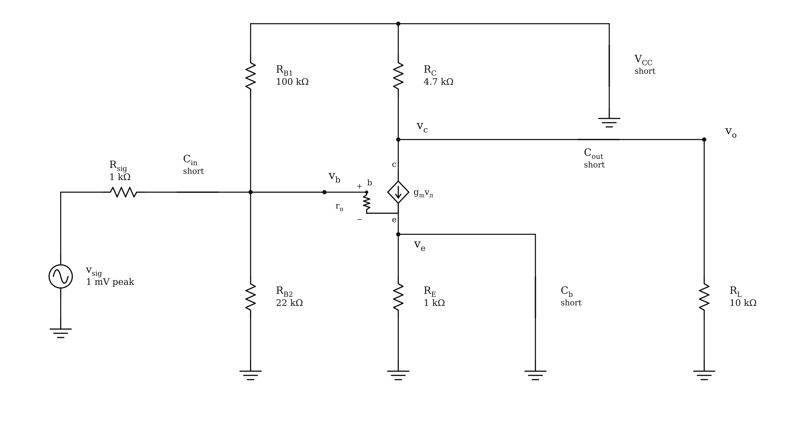
Figure 22. Hybrid-π common-emitter equivalent. The bypassed emitter is at AC ground, while the bias divider loads the input.
$I_{CQ}\text{≈}1.2137 \text{mA}\text{,} g_{m}\text{=}\frac{I_{CQ}}{V_{T}}\text{≈}46.951 \text{mS}$
$r_{π}\text{=}\frac{β}{g_{m}}\text{≈}2.1299 \text{kΩ}$
$R_{in}\text{=}R_{B1}\text{∥}R_{B2}\text{∥}r_{π}\text{≈}1.9049 \text{kΩ}$
$\frac{v_{o}}{v_{b}}\text{=}\text{−}g_{m}\left(R_{C}\text{∥}R_{L}\right)\text{≈}\text{−}150.11$
$G_{v}\text{=}\frac{v_{o}}{v_{sig}}\text{=}\frac{v_{o}}{v_{b}}\frac{R_{in}}{R_{sig}\text{+}R_{in}}\text{≈}\text{−}98.438$
The source-to-output gain is smaller in magnitude than the base-to-output gain because the source resistance attenuates the input. The predicted output is about 98.44 mV peak and is inverted.
Check your reasoning. Confirm a conducting base-emitter junction, a reverse-biased collector-base junction, and a small incremental base-emitter voltage. BJT saturation is not the forward-active amplifier region. The app disables the corresponding conversion when the required bias is absent.

14 Use hybrid pi and T models
The Hybrid-π and T model buttons offer supported BJT small-signal representations. The teaching T model omits Early effect and output resistance. Compare it with hybrid-π at the same bias with Early effect off; those gains should agree.
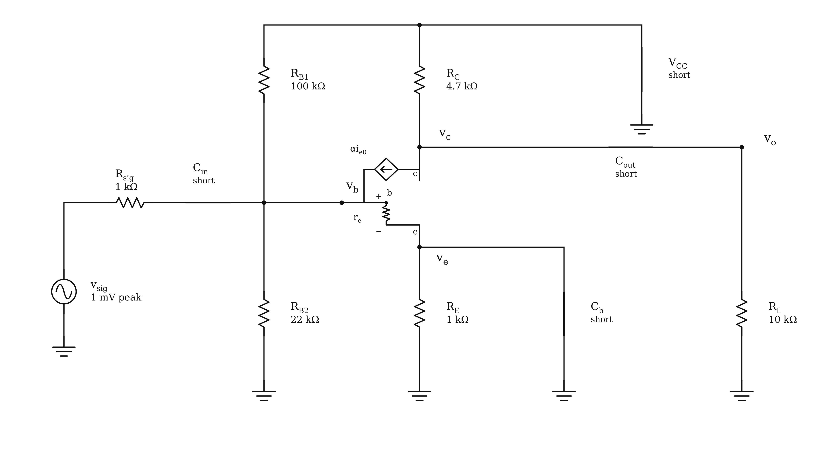
Figure 23. T-model representation of the same common-emitter amplifier. The emitter-current reference matters when using the small resistance.
$α\text{=}\frac{β}{β\text{+}1}\text{,} r_{e}\text{=}\frac{V_{T}}{I_{E}}\text{=}\frac{α}{g_{m}}\text{=}\frac{r_{π}}{β\text{+}1}$
$β\text{=}100\text{,} α\text{≈}0.99010\text{,} r_{e}\text{≈}21.088 Ω$
The controlled source and resistor belong to a complete transistor model; the small resistance alone cannot replace the transistor. Use the T representation when emitter degeneration makes emitter-current relationships easier to follow.
Figure 24. Trace node controls link the selected terminal between the original and equivalent drawings.
1. Choose Compare, select Base (B) or the corresponding control-terminal button, and trace the highlighted node in both drawings.
2. Explain which original nodes become AC ground and which remain distinct. A coupling capacitor short joins nodes only in the chosen AC model.
3. Use Minimize controls or Focus drawing, then zoom with + / − if labels are too small. Choose Show controls to recover the model switches. Unanswered Tutor practice keeps numerical parameters hidden.
The Early effect · rₒ switch adds collector-to-emitter resistance in the hybrid-π representation. The T model omits that branch. The following page explains the setting and its limits. The DC bias remains unchanged in this BJT teaching model.

Include BJT Early effect
Load Common-emitter · bypassed emitter → Include finite AC output resistance. Choose Small-signal model → Hybrid-π. The Early effect · rₒ switch is on with $V_{A}\text{=}50 \text{V}$; changing the value updates the AC model.

Figure 25. Early voltage controls the finite AC output resistance. In this teaching model the DC bias remains unchanged.
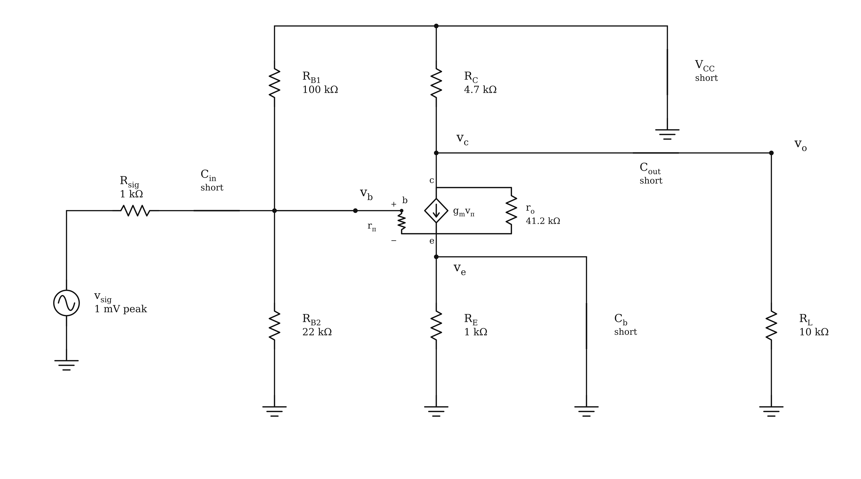
Figure 26. The hybrid-π model includes rₒ from collector to emitter. The teaching T model omits that branch.
$r_{o}\text{≈}\frac{V_{A}}{I_{CQ}}\text{≈}41.197 \text{kΩ}\text{,} G_{v}\text{=}\frac{v_{o}}{v_{sig}}\text{≈}\text{−}91.349$
$\frac{v_{o}}{v_{b}}\text{=}\text{−}g_{m}\left(R_{C}\text{∥}R_{L}\text{∥}r_{o}\right)\text{,} i_{r_{o}}\text{=}\frac{v_{c}\text{−}v_{e}}{r_{o}}$
With Early effect off, compare Hybrid-π and T and verify the same gain. With finite output resistance in Hybrid-π, their gains can differ. The settings use $V_{A}\text{=}0$ as the off flag; it represents infinite output resistance, not a physical zero Early voltage.
This is the app’s first-order AC approximation $r_{o}\text{≈}V_{A}\text{/}I_{C}$. Its Ebers–Moll DC calculation does not include Early effect. With an unbypassed emitter, rₒ still connects collector to emitter; include its current in both node equations instead of placing it directly in parallel with the collector load.

15 Explore with the Lab bench
The Lab tab performs a DC parameter sweep. It repeatedly solves operating points while changing one supported source voltage, source current, resistance, or potentiometer position. Its horizontal axis is the swept value, not time or AC frequency.
1. Load Examples → Circuit basics → Voltage divider, then open Lab.
2. Under Change this value, select the voltage source. Enter From 0 V, To 10 V, and Steps 21.
3. Under Plot these, select the output node. Component tags help identify the node when its name is generated. Select a branch current as a second trace if useful.
4. Choose Run sweep. The drawing’s original component value is restored when the sweep finishes.
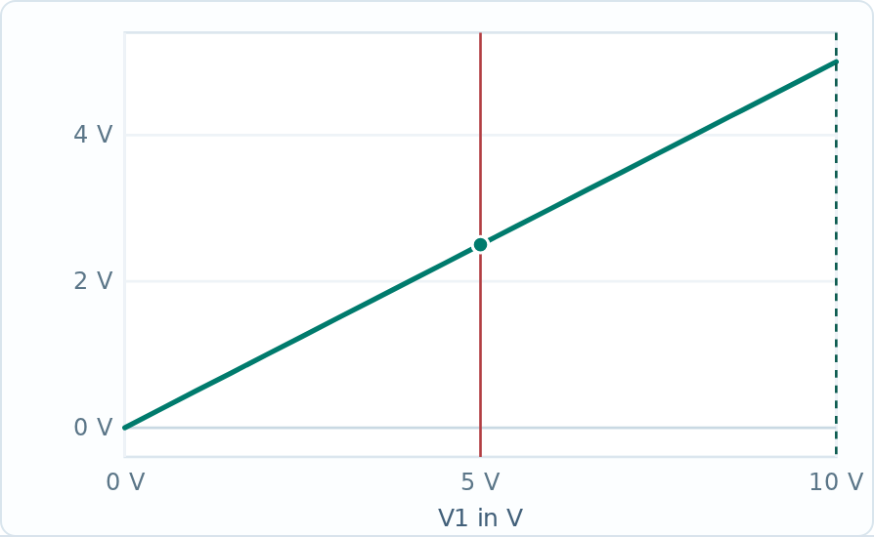
Figure 27. DC sweep of the equal-resistor divider. The output varies linearly from 0 V to 5 V as the source varies from 0 V to 10 V.
$\frac{ΔV_{o}}{ΔV_{s}}\text{=}\frac{R_{2}}{R_{1}\text{+}R_{2}}\text{=}\frac{1}{2}$
Move over the plot to inspect a sample. The scrubber can apply a sampled value to the actual circuit; use Put V1 back to restore the value recorded before the sweep. The exact button label follows the swept component reference.
- Probe between two nodes reports red-lead voltage minus black-lead voltage. Selecting a component also makes its branch current available.
- Power budget and part ratings reports the modeled power. Treat built-in rating flags as teaching defaults, not a selected component’s datasheet rating.
- Copy the data as CSV transfers sweep data for your report. Use consistent units and identify the selected traces.
Missing points or an early stop indicate a solver or time-limit issue. Narrow the range, check the DC circuit, and report any missing samples instead of drawing an unsupported conclusion across them.

16 Save print and submit
Name the circuit in the top bar before saving. Use a name that identifies the device, exercise, and revision, such as BJT_CE_Load_Study. Local autosave is convenient, but a downloaded project is the file you can reliably reopen or submit.
Action | Output and purpose
Save project | Editable JSON containing the current drawing, values, settings, and selected example.
Open | Restore a saved Circuit Studio JSON project.
Export SVG or PNG | A drawing image for a report or presentation. It is not an editable project.
Print in Solution | Circuit, model conversions where available, and worked derivation. Use the browser print dialog to print or save a PDF.
Export printable drawing | The schematic itself, with the chosen export options.
Export SPICE netlist | Text for an external simulator. Review model definitions and syntax for the intended simulator.
Download offline app | A standalone copy of Circuit Studio. Save your circuit separately as JSON.


Figure 28. Drawing and print options in the export dialog. Netlist and offline-app options appear below these controls.
A useful submission: the JSON project; an exported drawing or screen capture with legible values; your hand derivation; calculated and simulated results; and a short explanation of assumptions, discrepancies, and one parameter change. Include the app version and the example name.
Reopen the downloaded JSON before submitting it. Confirm the values, selected example, and output, then check that your figures show the same final circuit as your written calculation.

17 Diagnose common problems
Symptom | What to check or do
I cannot find Device family | Open Circuit Problems or Examples. Compact controls use icons; hover for the name or use Find.
The circuit has no DC solution | Check for missing ground, floating nodes, open connections, incompatible ideal sources, and invalid numerical values. Read the DC error and inspect highlighted parts.
A wire crossing did not connect | Use Junction to join the crossing intentionally. Verify connection dots and component pin endpoints.
A value is rejected | Use a numerical value with the correct units and prefix. A source labeled v_in still needs a numeric value before DC analysis.
Only node equations are available | Select Automatic for an unchanged supported problem. Wiring edits can require generated DC equations. Standard op-amp output limiting now keeps its guided limit check available.
A small-signal model is unavailable | Check that the problem supports conversion and that its device has a valid bias region. Return to Automatic mode and a supported topology.
A gain disagrees with a simple formula | Check the source resistance, input loading, output load, unbypassed resistance, finite output resistance, and the exact input/output reference nodes.
A linear waveform exceeds a region limit | Treat it as a linear prediction. Reduce the signal or change the bias; do not interpret the curve as a nonlinear clipping simulation.
The conversion drawing cannot be edited | Choose Edit original. The equivalent view is derived from the original circuit.
The grid or side panel is hard to see | Use G and Grid settings; drag the right-panel divider. During conversion, use Minimize controls, Focus drawing, zoom, and Fit. Show controls restores the settings.

Know the model boundary
Solve DC and Lab serve operating-point analysis; Simulate adds ngspice DC, source sweep, AC, and transient analyses. Guided waveform and small-signal lessons retain their stated teaching assumptions. Read the simulation model notes before comparing results; intrinsic transistor capacitances and op-amp internal bandwidth and slew rate are omitted.

18 Practice and record results
Use these short investigations after following the worked examples. Keep the same topology unless the exercise explicitly asks for a wiring change. Record a prediction first and change one parameter at a time.
Investigation | Task and evidence
Divider loading | Change the lower resistor from 10 kΩ to 20 kΩ. Predict and verify the new output. Repeat the source sweep and compare its slope.
Op-amp headroom | Load Reach the lower output limit. Compare the −7.5 V linear candidate with the −5 V limit. Reduce the input below 0.5 V and verify linear operation.
Diode linearization | Compare Lower bias, different dynamic resistance with Challenge the small-signal approximation. Explain the change in tangent resistance and waveform error.
MOSFET load effect | Compare the common-source starting example with Load the common-source output. Show why the DC bias stays the same but the AC gain changes.
BJT base loading | Compare the starting, stiffer, and loaded divider examples. Keep the unloaded voltage ratio in view while explaining the different loaded base voltages.
Equivalent BJT models | Compare hybrid-π and T with Early effect off. Then set VA = 50 V in hybrid-π and explain the gain change. The teaching T model omits output resistance.

Use a repeatable record
1. Identify: family, topic, example, app version, and project filename.
2. Predict: direction of change, expected sign, and the equation or physical reason.
3. Model: DC state or region, output limits, capacitor assumptions, and included device parameters.
4. Calculate: symbolic equations, numerical substitution with units, and the physical-root or region check.
5. Compare: app result, hand result, the difference, and a labeled figure.
6. Explain: what changed, why it changed, and the range over which the conclusion is valid.
For a nonzero reference result, report a relative difference; when the reference is zero, report an absolute difference with units instead.
$ε\text{=}\frac{|x_{\text{app}}\text{−}x_{\text{hand}}|}{|x_{\text{hand}}|}\text{×}100\text{\%}$

19 Equation and shortcut reference
These equations are starting points for the supported ideal or midband models. Apply them only after checking the topology and assumptions. Define all voltage and current references before substitution.
Circuit or relation | Equation and condition
Noninverting op amp | $v_{o}\text{=}\left(1\text{+}R_{f}\text{/}R_{1}\right)v_{i}$ in linear negative feedback.
Voltage follower | $v_{o}\text{=}v_{i}$ while the required output is inside its limits.
Difference amplifier | $v_{o}\text{=}\left(R_{2}\text{/}R_{1}\right)\left(V_{2}\text{−}V_{1}\right)$ only for matched resistor ratios.
Weighted summer | vo=−Rfj​Vj/Rj for ideal linear feedback.
Constant-input integrator | $v_{o}\left(t\right)\text{=}v_{o}\left(0\right)\text{−}v_{i}t\text{/}\left(RC\right)$ before reaching an output limit.
MOS saturation with modulation | $I_{D}\text{=}\left(k\text{/}2\right)V_{OV}^{2}\left(1\text{+}λV_{DS}\right)$ for the stated NMOS region.
Capacitor reactance | $|X_{C}|\text{=}1\text{/}\left(2πfC\right)$; compare with the relevant surrounding resistance.
BJT small-signal resistance | $r_{π}\text{=}β\text{/}g_{m}$ and $r_{e}\text{=}V_{T}\text{/}I_{E}$ in forward-active operation.

Shortcut | Action | Shortcut | Action
V | Select | W | Wire
J | Junction | H or Space drag | Pan
R | Rotate | M | Mirror
F | Fit | G | Grid on or off
D | Toggle DC values | L | Open Lab
Ctrl or ⌘ S | Save project | Ctrl or ⌘ O | Open project
Ctrl or ⌘ Z | Undo | Ctrl or ⌘ K | Find
Shift F | Focus view | P | Projector view

Shortcuts normally act on the drawing when you are not typing or using a dialog. In a focused conversion drawing, + / − zoom, F fits, and arrow keys pan. Esc or Restore view exits Focus drawing.

20 Topic catalog and further study
Each topic below contains its starting example and two additional practice cases. Use the topic browser to see the current example names, learning goals, and changed values.

Op Amp 6 topics and 18 examples
Inverting amplifier; noninverting amplifier; voltage follower; difference amplifier; weighted summing amplifier; inverting integrator.

Diode 12 topics and 36 examples
Series diode state and current; two ideal diodes; two constant-drop diodes; Shockley load-line Q-point; biased-diode small signal; three-diode regulator; four-diode regulator design; half-wave rectifier; positive and negative limiters; positive and negative clampers.

MOSFET 9 topics and 27 examples
NMOS operating regions; fixed-gate triode bias; divider bias with source feedback; diode-connected NMOS; PMOS source-referenced bias; bypassed common source; common source with degeneration; common gate; source follower.

BJT 8 topics and 24 examples
NPN junction biases and operating regions; two-supply bias; voltage-divider bias; PNP bias and current directions; bypassed common emitter; common emitter with degeneration; common base; emitter follower.

Read a result as an engineering argument
A convincing solution links a model to a prediction, a calculation, and a verification. A correct numerical value without its reference directions or validity check is incomplete. When an edited circuit requires a different method, use the generated equations to explain that change rather than forcing a familiar formula onto a new topology.

Course and software references
Circuit Studio V1.0, revised September 28 2026. Worked examples, equations, and controls accompany Circuit_Studio.html. The Study Guide provides a shorter route through the current study workflow.
ECE 314 Microelectronic Circuits course: https://oduececlass.github.io/ECE314/ . Use the course links in the app for the relevant op-amp, diode, MOSFET, and BJT modules. The additional examples use illustrative values and should not be assumed to reproduce every course walkthrough exactly.
For built-in or external SPICE analysis, record the device model, analysis settings, excitation, and reference nodes. Differences from a guided hand model can reflect different assumptions. Review Section 21 before interpreting a frequency or time response.

21 Simulate the drawn circuit
Open Simulate in the toolbar to run ngspice locally in the browser. The simulation uses the editable circuit, its connections, and supported device parameters. It does not require a Gemini API key. Save the current project before loading a Course example.
Analysis | Use it to answer
DC operating point | What are the steady node voltages and branch currents? Capacitors are open and inductors are short at DC.
DC sweep | How does the operating point change as one selected voltage source is swept?
AC frequency sweep | What is the linearized frequency response around the DC bias? The selected source is 1 V AC; other AC excitations are zero.
Transient | How do voltages and currents change with time under a sine or pulse excitation?

Check an RC low pass response
Choose Course examples → RC low-pass. The example uses R = 1 kΩ and C = 1 µF, with VOUT across the capacitor. Select AC frequency sweep from 1 Hz to 100 kHz with 40 points per decade, then press Run.
$τ = RC = (1 kΩ)(1 µF) = 1 ms$
$f_{c} = \frac{1}{2πRC} = 159.15 Hz$
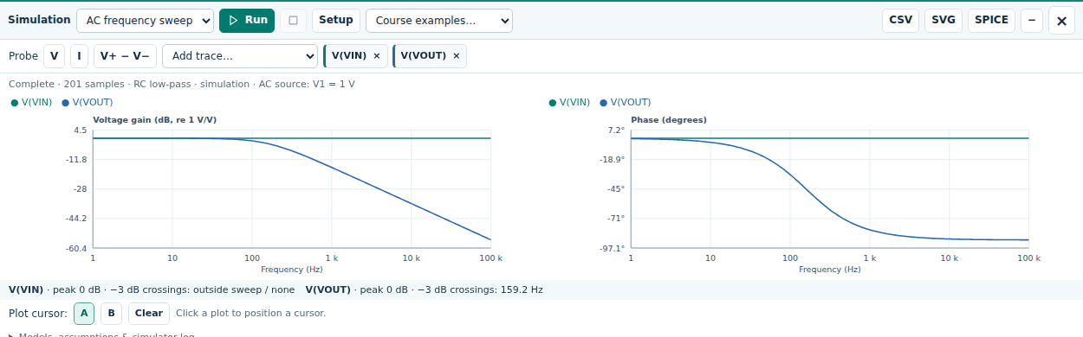
Figure 29. RC AC results. The sampled cutoff is about 159.2 Hz.
At the cutoff, the ideal voltage ratio is 1/√2 ≈ 0.707 (−3.01 dB) and its phase is −45°. The plot reports 20 log₁₀ of a voltage magnitude; with a 1 V input, its output magnitude also equals the numerical input-to-output gain. For a different reference node, form the appropriate voltage ratio.

Measure a transient and report the model
Keep the RC example. Choose Transient and set Waveform to Pulse, Amplitude to 1 V, Offset / low to 0 V, Frequency to 100 Hz, Stop time to 4 ms, and Max. step to 2 µs. Press Run. The pulse rises at 0.5 ms in this setup.
$v_{out}(t) = 1 V [1 − exp(−(t − t₀)/τ)], t ≥ t₀$
At one time constant after the rising edge, t = 1.5 ms, expect about 0.632 V. The small finite rise time and sample spacing can shift the cursor reading slightly. This pulse run begins from its low-level operating point; the simulator does not force every capacitor to start at zero in all circuits.
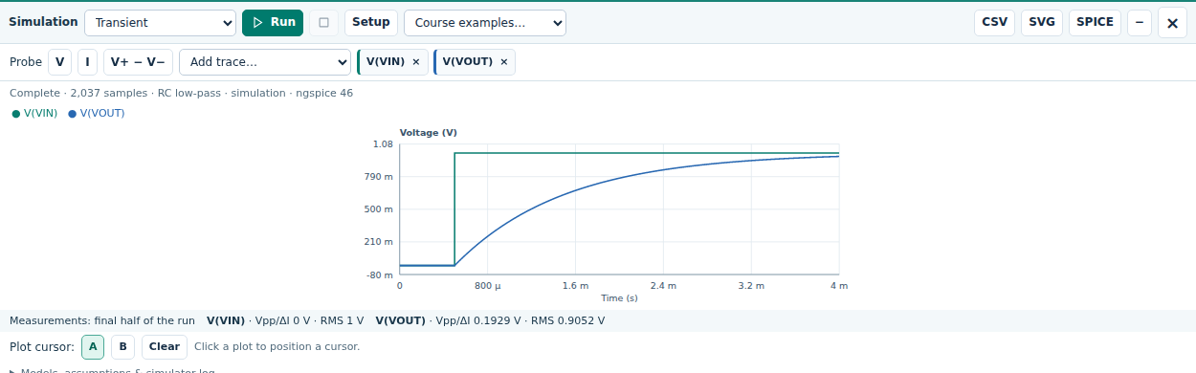
Figure 30. RC transient with a 0 to 1 V pulse and a 1 ms time constant.

Use probes and exports
Use V and click a wire or terminal for voltage to ground. Use I and click a component for branch current. For V+ − V−, select the positive node first and the negative node second. Add trace also lists the available quantities. Choose cursor A or B, then click the plot to compare samples.
CSV downloads plotted data; SVG exports the plots; SPICE exports the generated simulation netlist. Save project separately for the editable circuit. After a circuit or setup change, press Run again; previous results are invalidated.

Read the assumptions before comparing
Open Models, assumptions & simulator log. The MOSFET model is level 1 with its body tied to source and no intrinsic capacitances. The BJT simulation omits Early effect and charge storage. The op amp has large finite DC gain and output limits, but no internal bandwidth or slew-rate model. Drawn capacitors are included.
Consequently, an AC sweep can show external RC effects without predicting a real transistor’s upper cutoff. A BJT simulation may differ from a hybrid-π lesson with finite output resistance. Generic transformer and dependent-source symbols require explicit supported simulation models; inspect any diagnostic instead of accepting an incomplete result.

22 Explore bias and annotate your reasoning
Explore & Explain provides a separate linked investigation for NPN and NMOS divider bias. Choose the device, inspect the physical circuit or Thevenin view, follow the six derivation steps, and change one parameter in the linked sweep. Use the displayed node names in your written calculation.
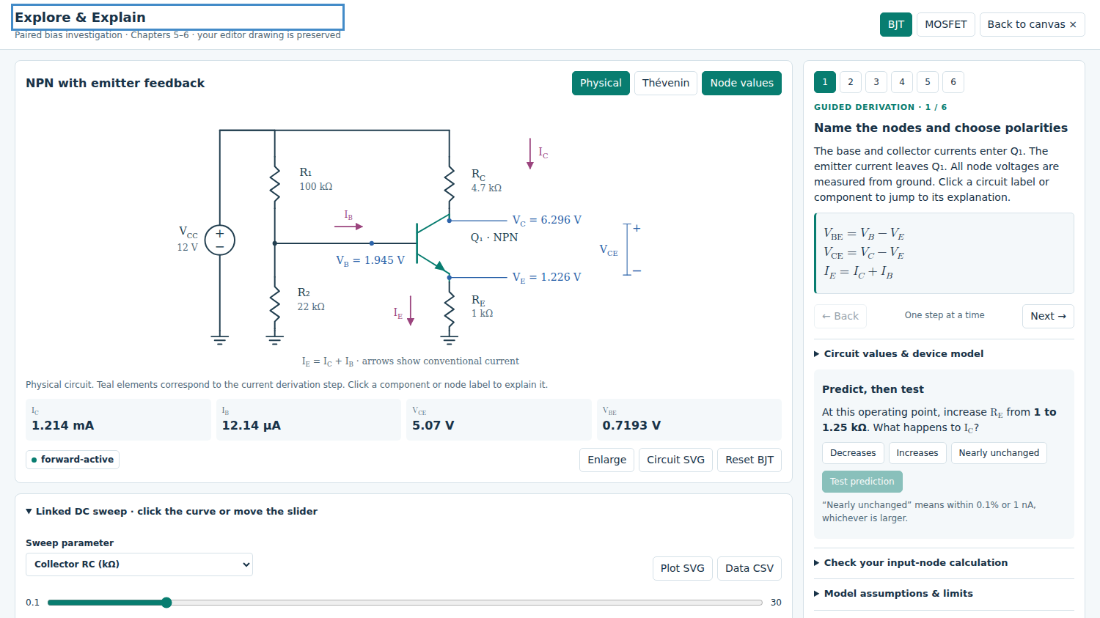
Figure 31. Explore & Explain links the bias circuit, derivation, prediction, and sweep.

Compare MOSFET and BJT divider loading
For the ideal MOSFET gate, zero DC gate current leaves the gate voltage at the unloaded divider value. For the BJT, base current produces a drop across the Thevenin resistance, so the loaded base voltage is lower. Predict which bias will change more when both divider resistances increase while their ratio is fixed.
The investigation and chapter visual lessons have their own parameters. They do not automatically replace or edit the schematic behind them. Return to the canvas before saving or simulating that schematic. Export the investigation CSV separately when you need its sweep data.

Add readable text and equations
Use the text and equation tools to add assumptions, reference directions, and calculations. Double-click an existing text or equation object to edit it in place. Use the formatting controls for text and the equation controls for fractions, subscripts, and mathematical notation. Select an object to move, resize, or delete it; press Esc to leave the active tool.
Keep labels away from wires and terminal names. Press F after arranging the drawing, and check the exported figure at reading size. State the symbolic relation, substitute values with units, and finish with a device-region or consistency check.

23 Use optional voice guidance
The editor, worked solutions, Tutor, chapter lessons, and simulation run without a Gemini key. Gemini adds spoken questions and conversational explanations of the current circuit or lesson. Device narration reads visible guidance without connecting to Gemini.

Set up your connection
Open voice settings. Choose Google AI Studio API key, create or select a key at aistudio.google.com/apikey, and paste it into the key field. On your own device, use Remember API key and Save API key & settings. On a shared computer, clear that checkbox and use Forget saved connection when finished. Your instructor may instead provide a classroom connection.
Use a Live model enabled for your Google project. Free and paid projects can differ in access and quota; check your current limits before enabling billing. Keep credentials out of screenshots and submitted files. Connecting sends circuit and learning context to Google; Talk also sends the recorded question.
Control | Student action
Listen | Hear an explanation of the current learning step. A short reply is prepared before it begins playing.
Talk and Send voice | Start recording, ask one question, and choose Send voice. Grant microphone permission when asked.
Explain selection | Select a component or its label on the circuit canvas, then request its explanation.
Next step | Advance when ready; the assistant should not complete the whole lesson for you.
Replay and Stop | Replay the stored audio without a new request, or stop the current narration or recording.

Respond to a connection error
Read Connection details, then use Reconnect or Try Simple voice. Simple voice retains spoken questions, captions, and explanations but omits automatic circuit highlighting and answer drafting. A 1011 server close alone does not prove a quota or billing problem. For a quota message, check the project limits; repeated retries or another key in the same project do not create extra quota.
A brief preparation delay before speech is normal. Use Replay for a complete stored response or Finish when offered for an incomplete response. Check the captions and use device narration while the service is unavailable. Verify AI explanations against the circuit and your own calculations.
Current setup references: ai.google.dev/gemini-api/docs/api-key; ai.google.dev/gemini-api/docs/rate-limits; ai.google.dev/gemini-api/docs/live-api. Model access and service limits are controlled by Google.

