Circuit Problem-Solving Workspace — Quick Guide
Worked example: Homework #1, Problem 2 (inverting amplifier: R₁ = 10 kΩ, R_{f} = 100 kΩ, v_{i} = 0.15 V).

1. Open your homework file
- Open the ECE314-HWn_student_workspace.html file in Chrome or Edge. No installation or internet account is needed.
- Click Student info and enter your name and student ID. Pick a problem with the ← / → arrows or the problem list on the left.
- Your work saves automatically in this browser (use one browser and do not clear its site data). To move to another computer, click Save progress (downloads a progress file) and load it there with Open assignment / progress.

2. Work on the circuit
Click the Edit circuit tab. The starting circuit is already loaded. Double-click a label to change a value, drag parts from Components, and use Wire to connect them. Restore starting circuit (left panel) undoes all changes.
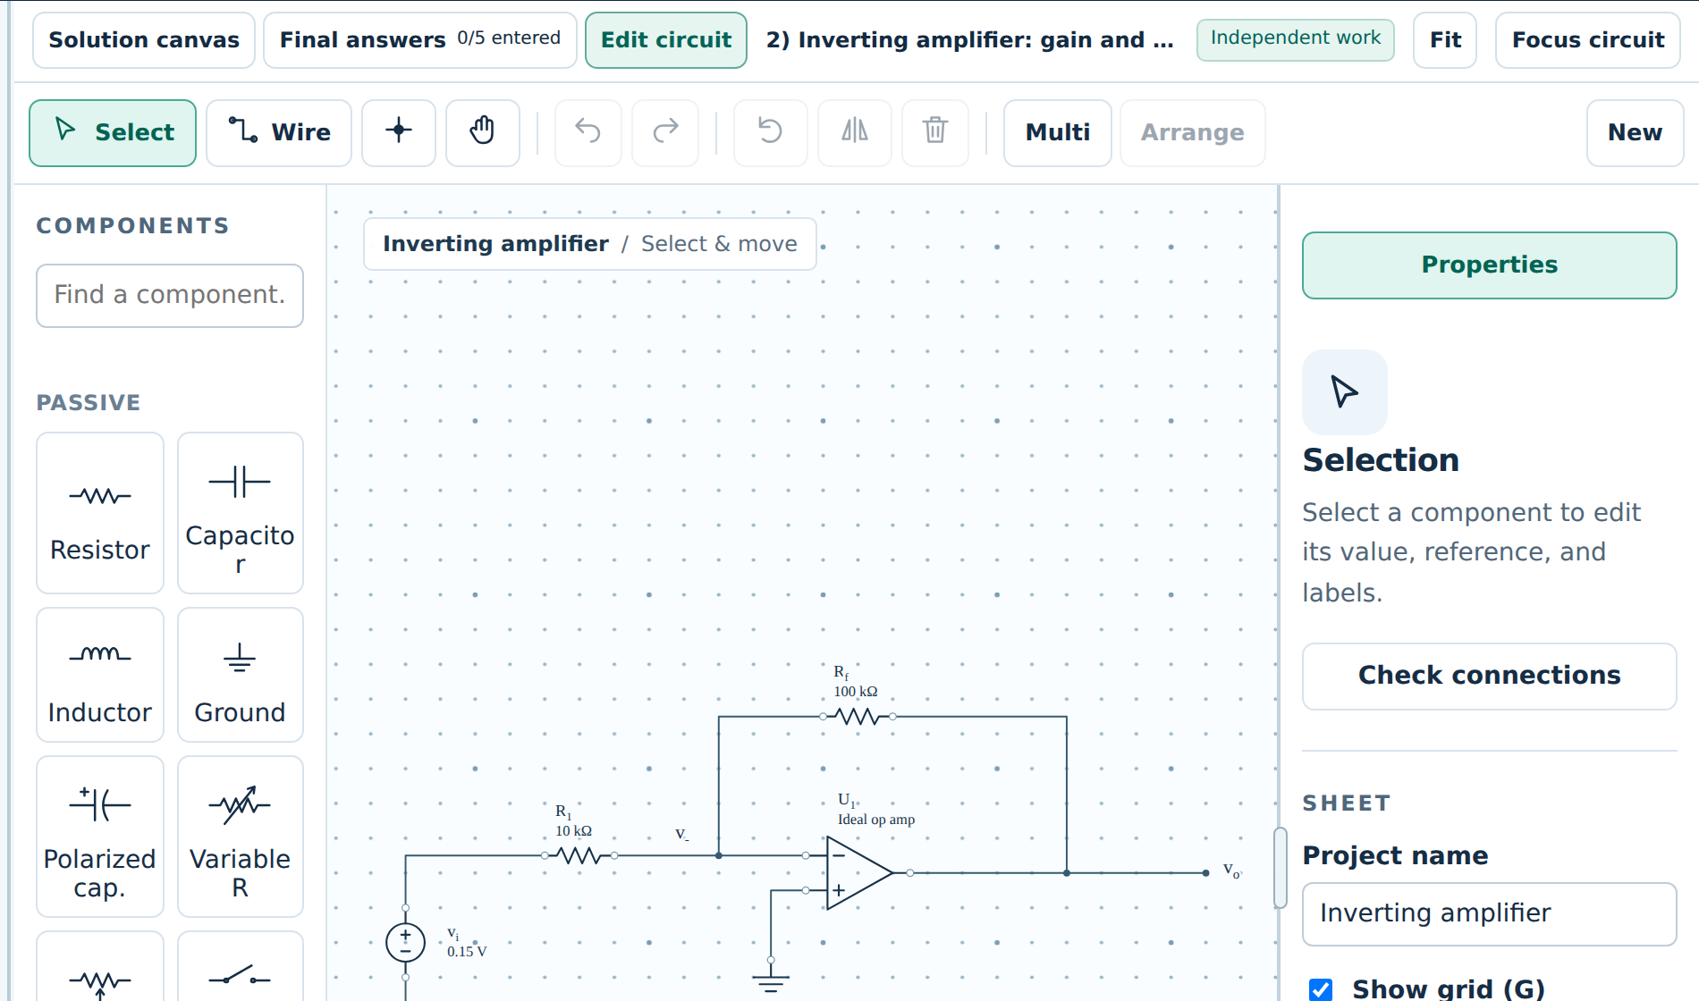
Figure 1. Edit circuit tab with the starting circuit.

3. Insert the circuit into your solution
Go back to Solution canvas and choose Insert ▾ → Current circuit snapshot. The drawing is placed on the page, where you can move, resize, or annotate it. A snapshot does not update by itself — insert it again after you change the circuit.
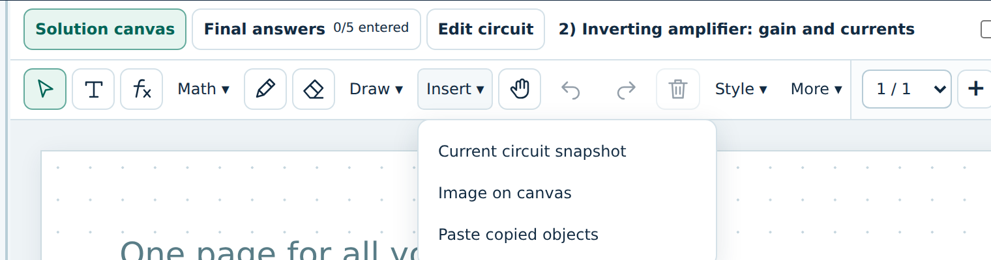
Figure 2. Insert menu on the solution canvas.

4. Add text and LaTeX equations
- Text: choose T, click on the page, and type. Double-click a text box later to edit it.
- Equation: choose ƒx, click on the page, then type or paste LaTeX. Press Enter for a new line; click Done (or Esc) to finish. Math ▾ offers fractions, roots, Greek letters, and circuit symbols without typing LaTeX.
- When typing directly, _ and ^ start a subscript or superscript; press → to leave it. Pasting a full LaTeX line is usually fastest.
What you want | Type or paste (LaTeX)
i₁ = vᵢ / R₁ = 15 μA | i_1=\frac{v_i}{R_1}=15\,\mu\text{A}
vₒ = −(R_f / R₁)·vᵢ = −1.5 V | v_o=-\frac{R_f}{R_1}v_i=-1.5\,\text{V}
Parallel, ≈, square root | R_D\parallel r_o,\ \approx,\ \sqrt{2I_D/k_n}
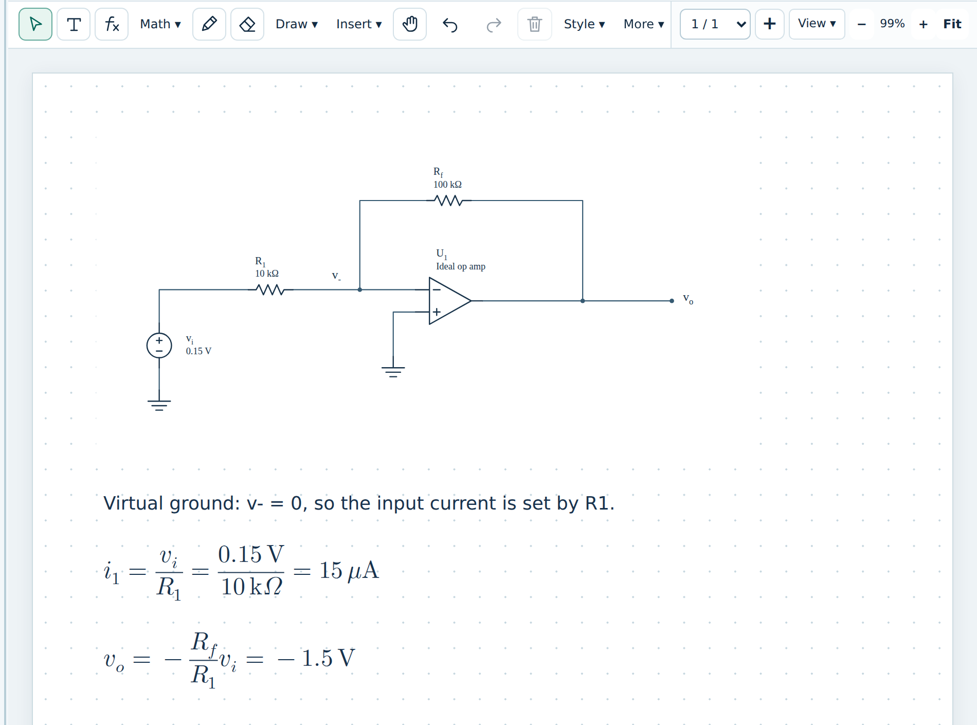
Figure 3. Finished solution canvas: circuit snapshot, explanation text, and equations.

5. Worked on paper? Insert a photo of it
- Take a clear, well-lit photo or scan of the page, one page per problem. Write the problem number at the top.  - Save it as JPEG or PNG under 4 MB. iPhone HEIC photos must be exported as JPEG (or send a “medium” size to yourself).  - In the problem’s Solution canvas, choose Insert ▾ → Image on canvas and pick the file. You can also copy the image and press Ctrl + V on the canvas.  - Drag the corner handle to resize it; add more pages with + if the work continues. Still type the key results in Final answers. | 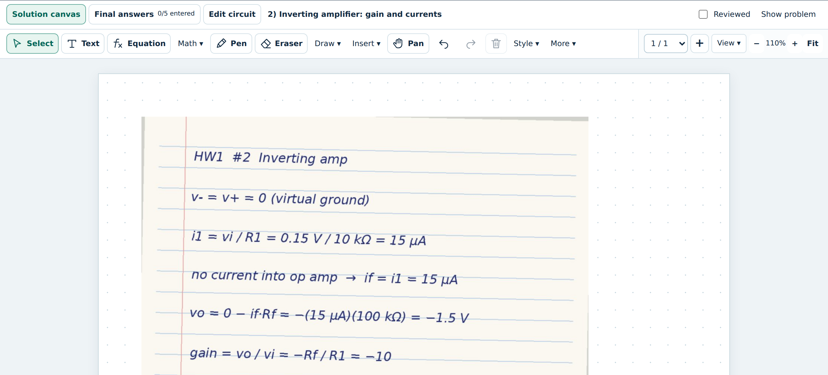  Figure 4. A photo of paper work placed on the canvas.

6. Enter your final answers
- Open Final answers. Type numbers only, in the unit shown next to each box (for example -1.5 in V, 15 in μA). Scientific notation such as 2.93e-6 is accepted.
- Choice boxes (ON/OFF, operating region) use the drop-down; explanation boxes take a short sentence or two.
- When a problem is complete, tick Reviewed. The progress bar on the left shows answers entered and problems reviewed.
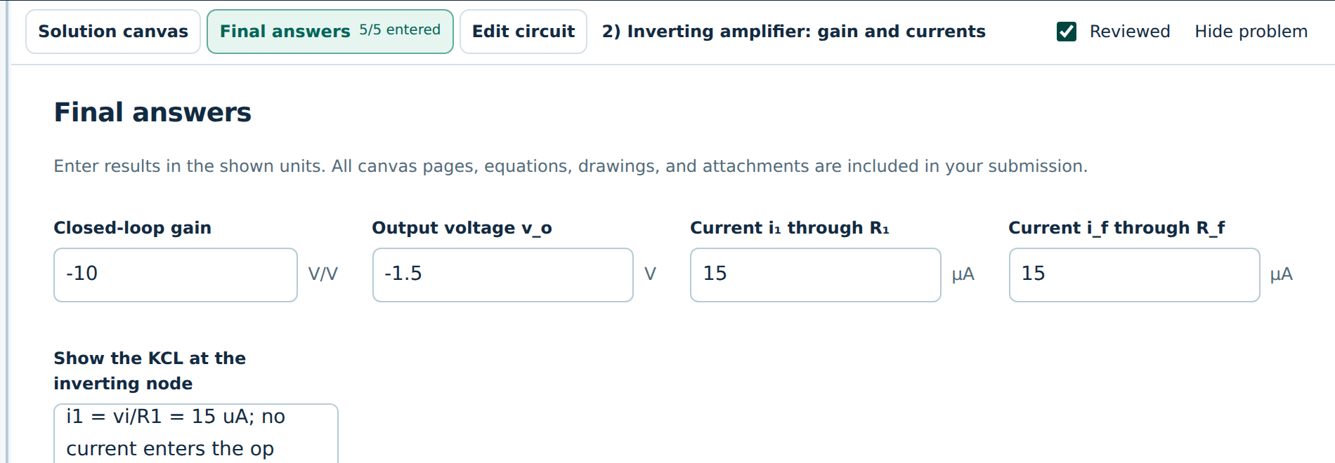
Figure 5. Final answers for Problem 2, marked Reviewed.

7. Submit your final homework as a JSON file
- Finish every problem. The left panel shows your progress (for example 33/33 answers entered · 10/10 reviewed). Blank answers can still be submitted but earn no credit.
- Click Download submission in the top bar. If your name or ID is missing, the Student information window opens first: enter Full name and Student ID (section and email optional) and click Save information. The download then starts.
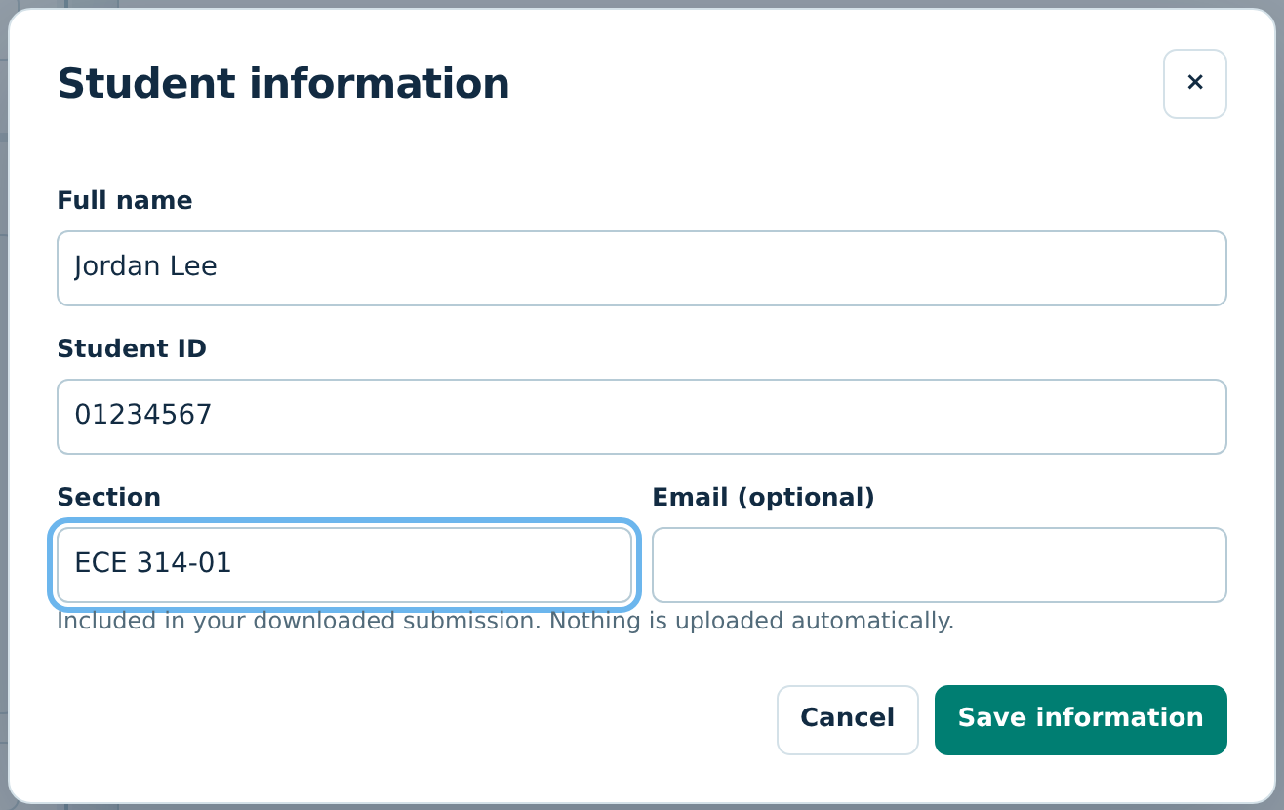
Figure 6. Student information window (asked only once).
- Your browser saves one file to your Downloads folder, named ECE314-HW1_<your ID>_submission.json (for example ECE314-HW1_01234567_submission.json). It contains every canvas page, circuit, equation, and final answer.
- Upload that .json file to the homework assignment in the course LMS before the deadline. Do not rename, edit, or zip it, and do not upload the HTML file or a _progress.json file instead.
- To change something after submitting, fix it in the workspace, click Download submission again, and replace your earlier upload with the new file.
- Optional check: Open assignment / progress → choose your submission file. If your work reopens, the file is good.

