Circuit Studio Study Guide
  - Student handbook for Chapters 2 to 7 • Revised October 17 2026
Use Circuit Studio to connect a circuit drawing to its equations, test device assumptions, and explain the result in your own words. This guide accompanies Sedra and Smith, Microelectronic Circuits, 8th edition, Chapters 2–7. Use your instructor’s assigned reading and device models alongside it.
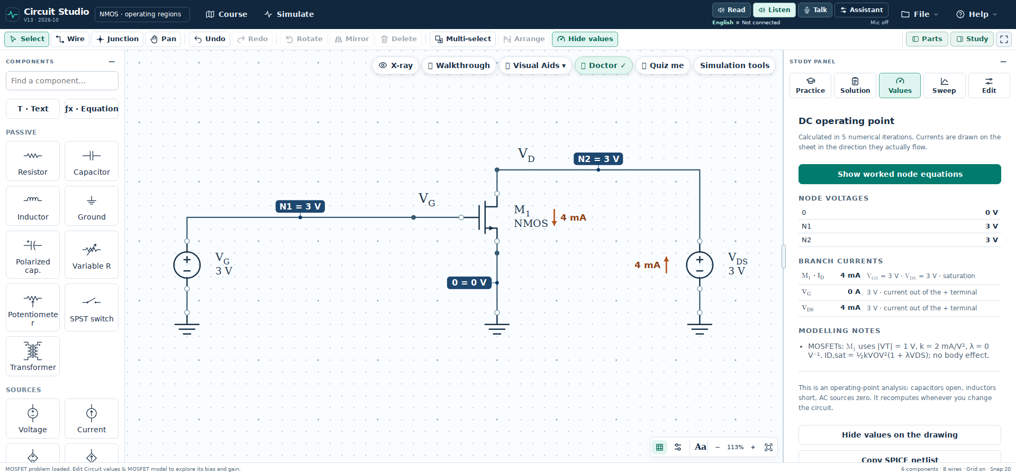
Figure 1. Full workspace with Parts on the left, Study on the right, voice controls in the header, and visual tools above the circuit.

Your first study session
1. Open Course, select a module, and choose Learn, Practice, or Explore. Begin with a prepared diode or ideal op amp circuit.
2. Use Fit or press F. Parts opens the component library; Study opens the learning panel. Hide either panel when you need more drawing space.
3. Predict the output and device state before solving. Write the relevant assumption and equation.
4. Use Show values to reveal DC annotations and Hide values to remove them. Open Study → Values for the operating point table.
5. Try Study → Practice before opening Solution. Compare the worked steps with your prediction, then change one value and explain the result.
The editor, worked problems, visual aids, and built-in simulation do not require Gemini. Read uses Kokoro narration; Listen and Talk use configured Gemini guidance.
Study route: workspace → Practice and Solution → visual aids → device checks → model conversions → simulation → voice guidance → troubleshooting → practice.

Use the circuit workspace
Keep the canvas large. Open a panel only when you need it, and hover over unfamiliar icons to read their tooltips. A dotted outline identifies a selected component name or value.
Task | What to do
Choose a circuit | Open Course, choose a module, and select Learn, Practice, or Explore.
Fit the drawing | Press F or use Fit. After manual zooming or panning, press F again to restore the full view.
Hide or restore panels | Use Parts and Study. Fit the circuit again after changing the available canvas area.
Select and edit | Click a component, name, or value. Double click a value to edit it. Drag labels separately when they overlap.
Connect components | Use Wire and connect pins. Use a junction dot for an intended connection; crossing wires without a dot are not connected.
Show solution values | Use Show values or Hide values to toggle DC annotations without changing the circuit.
Read the explanation | Open Study → Solution. Use guided steps or the complete explanation.
Check DC results | Open Study → Values to inspect node voltages and branch currents.
Save your circuit | Use Save project to download an editable JSON project. Export an image only when you need a figure.

Useful keyboard shortcuts
V select • H pan • W wire • J junction • R rotate • M mirror • G grid • F fit • D show or hide solution values • + and − zoom • Esc finish or cancel a tool • Ctrl or Cmd + Z undo.

Read component values carefully
Check the displayed unit after every edit. For example, 1 kΩ = 1000 Ω and 1 mA = 0.001 A. In Practice, use the unit shown beside the answer field. Edit changes the selected component; Sweep varies one parameter across a range.
Loading a different example replaces the current drawing. Save your project first if you want to keep it. Undo can restore a recent change during the same session.

Match the circuit to the equations
A node is an electrically continuous connection. N1 and N2 are node identities; ground is node 0 and is the voltage reference. The voltage at N2 means its potential relative to ground. An output label may name that same node.
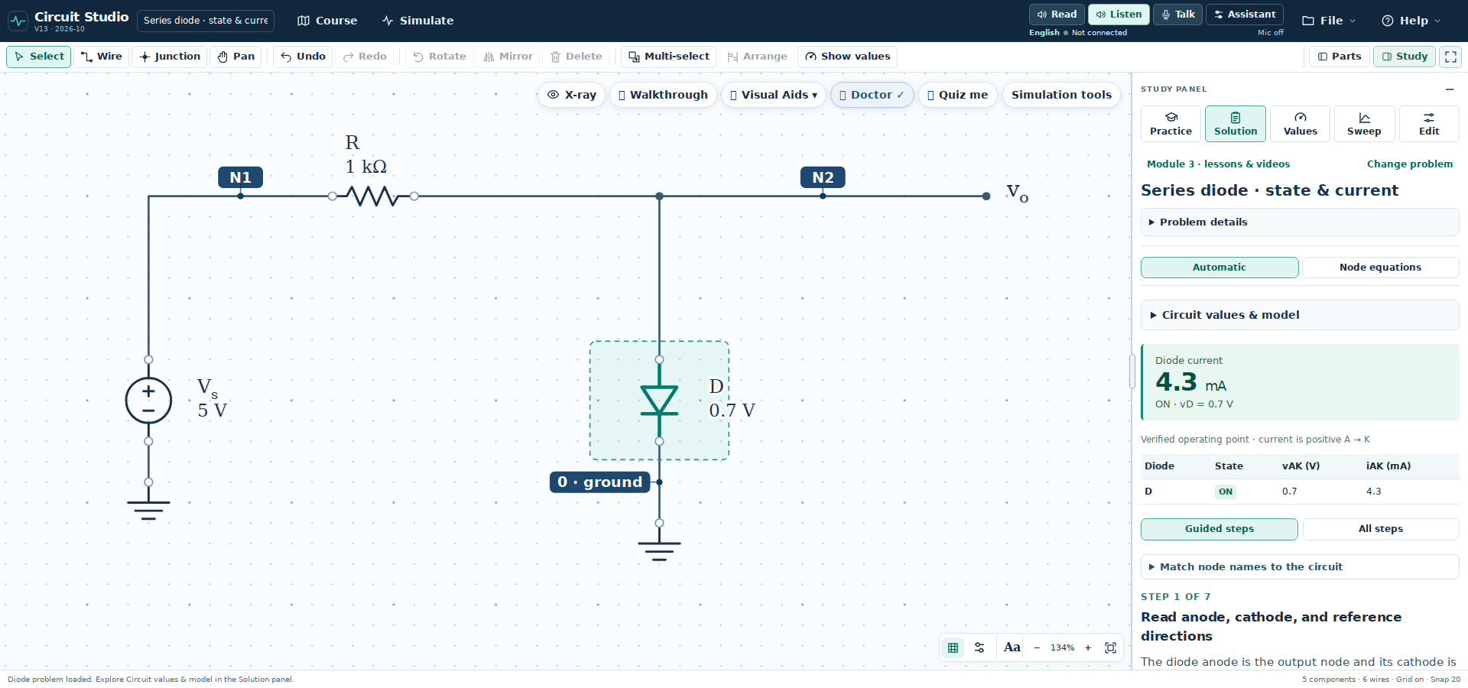
Figure 2. Series diode circuit with matching node names and calculated values.

Work from symbols to numbers
Assume the constant voltage drop diode model with the diode ON. The anode is at N2 and the cathode is grounded. Take current from the source through the resistor and diode.
$v_{N1} = V_{S} = 5 V, v_{N2} = v_{D} = 0.7 V$
$i_{R} = \frac{v_{N1} − v_{N2}}{R} = \frac{V_{S} − v_{D}}{R}$
$i_{R} = \frac{5 V − 0.7 V}{1 kΩ} = 4.3 mA$
Check: the current is positive in the assumed forward direction. Kirchhoff’s voltage law gives 5 V = (4.3 mA)(1 kΩ) + 0.7 V. The ON assumption is consistent.

Test the assumption when the source changes
With the same circuit and a 0.5 V source, an ON trial gives (0.5 − 0.7) V / 1 kΩ = −0.2 mA. Reject that trial for this diode model. With the diode OFF, current is zero, the resistor drop is zero, and the diode voltage is 0.5 V, below the assumed 0.7 V turn on value.
Open “Match node names to the circuit” in Solution when an equation uses an alias such as the output voltage. Read its node and pin mapping before substituting values.

Study with Practice and Solution
The Study panel has five tabs: Practice, Solution, Values, Sweep, and Edit. Practice asks you to reason; Solution shows the worked steps; Values lists DC results; Sweep reveals trends; Edit changes the selected component.
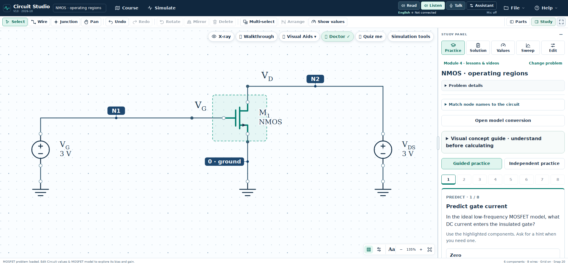
Figure 3. Practice keeps the prediction and questions beside the current circuit.

A productive practice cycle
1. Predict. State the expected sign, size, and device region. Explain which circuit feature supports your prediction.
2. Solve. Write the symbolic equation, substitute the actual circuit values with units, then calculate.
3. Check. Enter your answer using the displayed unit. Use a hint when stuck, and inspect the feedback before revealing a worked answer.
4. Explain. Describe why the result makes physical sense. Identify the assumption you tested.
5. Explore. After completing the practice prompts, change one slider or component at a time. Predict the effect before checking again.

Use the explanation that fits your drawing
Automatic solutions use the lesson associated with an intact example. Node equations analyze the actual circuit connections. After changing wiring, use the generated node equations and DC results rather than assuming the original example’s derivation still applies.
Notebook record: circuit and values; assumptions; predicted result; symbolic equation; numerical substitution; final answer with units; a validity check; one change to investigate.

Use Course and visual aids
Course organizes modules and their Learn, Practice, and Explore activities. Learn introduces a topic; Practice opens problems; Explore offers investigations. The Visual Aids menu above the canvas provides views of the current circuit.
Textbook chapter | Visual lessons and study focus
2 Operational amplifiers | Integrator, differentiator, gain bandwidth and slew rate, offset and bias currents, instrumentation amplifier.
3 Semiconductors | Electrons and holes, energy bands, doping, drift and diffusion, depletion region, forward injection.
4 Diodes | Full wave rectification and PIV, capacitor filtering and ripple, Zener regulation and power.
5 MOSFETs | Channel formation and operating regions. Connect gate overdrive and drain voltage to the region test.
6 BJTs | Carrier transport and comparison of hand approximations with nonlinear bias calculations.
7 Transistor amplifiers | Common source and common emitter design. Relate bias, gain, and available output swing.

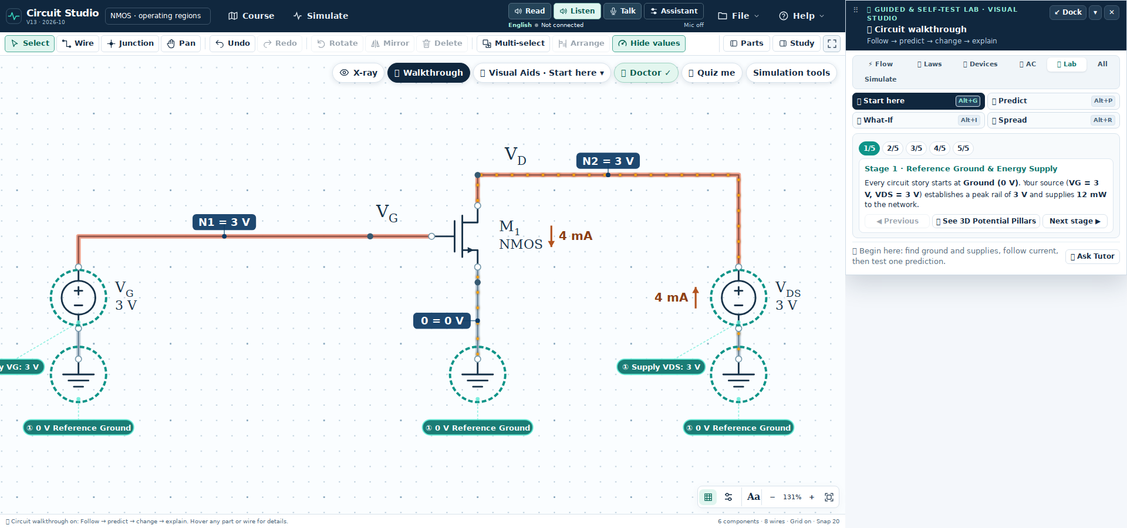
Figure 4. Visual Aids groups circuit views into Flow, Laws, Devices, AC, and Lab.
Try one tool for one question. X-ray shows voltage colors and conventional current motion. Walkthrough guides observation and prediction. Doctor checks connections; Quiz me provides a self-test. Moving markers are a current visualization, not individual electron speeds.
Under Visual Aids, use Q-Point or Silicon to connect terminal voltages with device state. Use DC to AC and Thevenin for stepwise conversions. A separate chapter activity may have its own parameters; check which circuit or lesson is active before interpreting a result.

Check the device physics

Electrons holes and the junction
An electron is a negatively charged carrier. A hole is a missing valence electron that behaves as a positive mobile carrier; it is not a proton moving through the crystal. Conventional electron current points opposite electron drift. Hole current points with hole motion.
Donor doping produces n type material with electrons as majority carriers. Acceptor doping produces p type material with holes as majority carriers. Ionized dopants remain fixed in the lattice. The depletion region contains exposed ionized dopants and few mobile carriers.
Drift is driven by an electric field. Diffusion is driven by a carrier concentration gradient. In an unbiased junction at thermal equilibrium, opposing drift and diffusion currents balance; “no net current” does not mean every carrier stops moving.

Assumptions to check before accepting an answer
Device or model | Validity check
Ideal op amp | Use equal input voltages only when negative feedback supports linear operation. Ideal input currents are zero. Check whether the predicted output fits within the supply rails.
Constant drop diode | Assume ON or OFF, solve, and verify the assumed direction and voltage. The 0.7 V value is a model choice, not a universal physical constant.
NMOS long channel model | Use gate to source voltage for turn on. With positive gate overdrive, saturation requires drain to source voltage at least equal to that overdrive. Otherwise test triode operation.
PMOS long channel model | Gate overdrive is source to gate voltage minus the threshold magnitude. With positive overdrive, saturation requires source to drain voltage at least equal to that overdrive.
BJT amplifier | Check forward active operation: base emitter junction forward biased and base collector junction reverse biased. A fixed 0.7 V estimate can differ from a nonlinear device calculation.
PNP transistor | Use emitter referenced voltages and a consistent current direction. Do not copy NPN signs without changing the reference directions.

MOSFET saturation and BJT saturation are different operating conditions. A MOSFET often operates in saturation for linear amplification. A BJT usually operates in forward active mode for that purpose.
After every solve, check the device region, current direction, units, and supply limits. A number alone does not establish a valid operating point.

Compare DC and small signal models
First find the DC operating point. Then linearize the transistor around that bias point to analyze a sufficiently small AC signal. DC bias voltages and AC increments are different quantities, even when they refer to the same physical node.
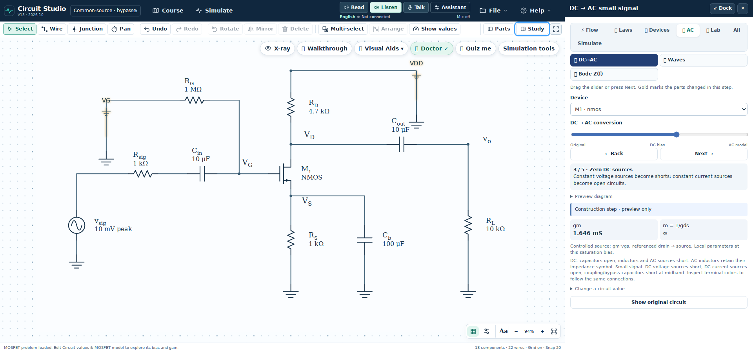
Figure 5. The DC to AC slider changes the circuit one step at a time.
1. Open Visual Aids → AC → DC to AC. Move the slider through Original, DC bias, restored signal path, zeroed DC sources, midband capacitors, and the small-signal model. Watch the highlighted change before advancing.
2. For DC, treat capacitors as open circuits. Set a zero mean AC voltage source to its DC value of zero.
3. For the midband small signal model, short ideal DC voltage supplies to AC ground and open ideal DC current sources. Treat coupling and bypass capacitors as shorts only when the midband approximation applies.
4. Keep dependent sources active. Small-signal parameters come from the DC bias point. Compare gains using the same bias and output-resistance assumptions; the model is valid only for sufficiently small signal excursions.
The slider explains a model transformation. Simulation tests the drawn circuit with its supported numerical models. Keep the two sets of assumptions consistent before comparing results.

Simulate the drawn circuit
Open Simulation tools above the canvas. One panel contains Instruments and Analysis tools, with shared Run, Live, and Dock controls. Simulation does not require a Gemini key. Allow the popup when prompted, or use Dock to keep the panel inside Circuit Studio.
Analysis | Use it to answer
DC operating point | What are the steady node voltages and branch currents? Capacitors are open and inductors are short at DC.
Sweep | How does the operating point change across a chosen parameter range? Use Study → Sweep or the appropriate simulation curve.
Bode plot | What is the small-signal frequency response around the DC operating point? Check the selected input and output references.
Oscilloscope | How do signals change with time? Check generator settings and each channel’s vertical scale.

Set the generator and run an amplifier
Load the inverting op amp example with input resistance 10 kΩ and feedback resistance 40 kΩ. In Instruments, select the input source to replace. Set Sine, amplitude 100 mV peak, offset 0 V, and frequency 1 kHz. Select input and output signals, then press Run.
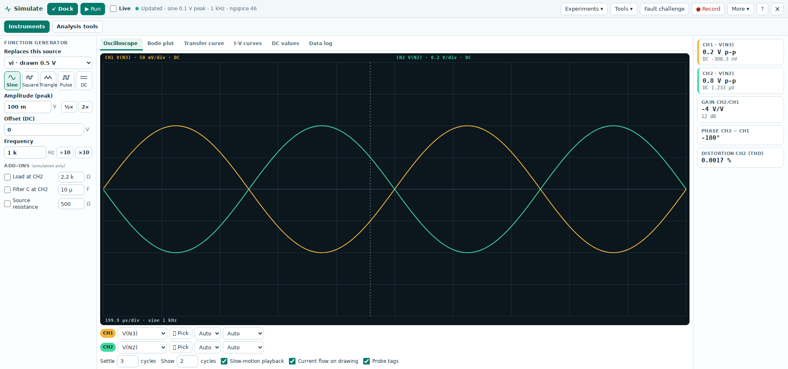
Figure 6. Instruments shows the generator, oscilloscope, and measured gain.
For this ideal inverting amplifier, expect gain −4: a 0.2 V peak-to-peak input produces about 0.8 V peak-to-peak output with opposite polarity. Check each channel’s volts per division; equal trace heights can represent different amplitudes.

Read plots and analysis tools
Use Oscilloscope for time signals, Bode plot for frequency response, Transfer curve and I–V curves for device or circuit trends, DC values for operating points, and Data log for recorded measurements. Select the view that answers your question.
Analysis tools includes AC signal, Node equations, Sensitivity, and Real circuit. Use Node equations to connect measurements to Kirchhoff’s laws. Sensitivity helps identify influential parameters. Class report is intended for instructor review.
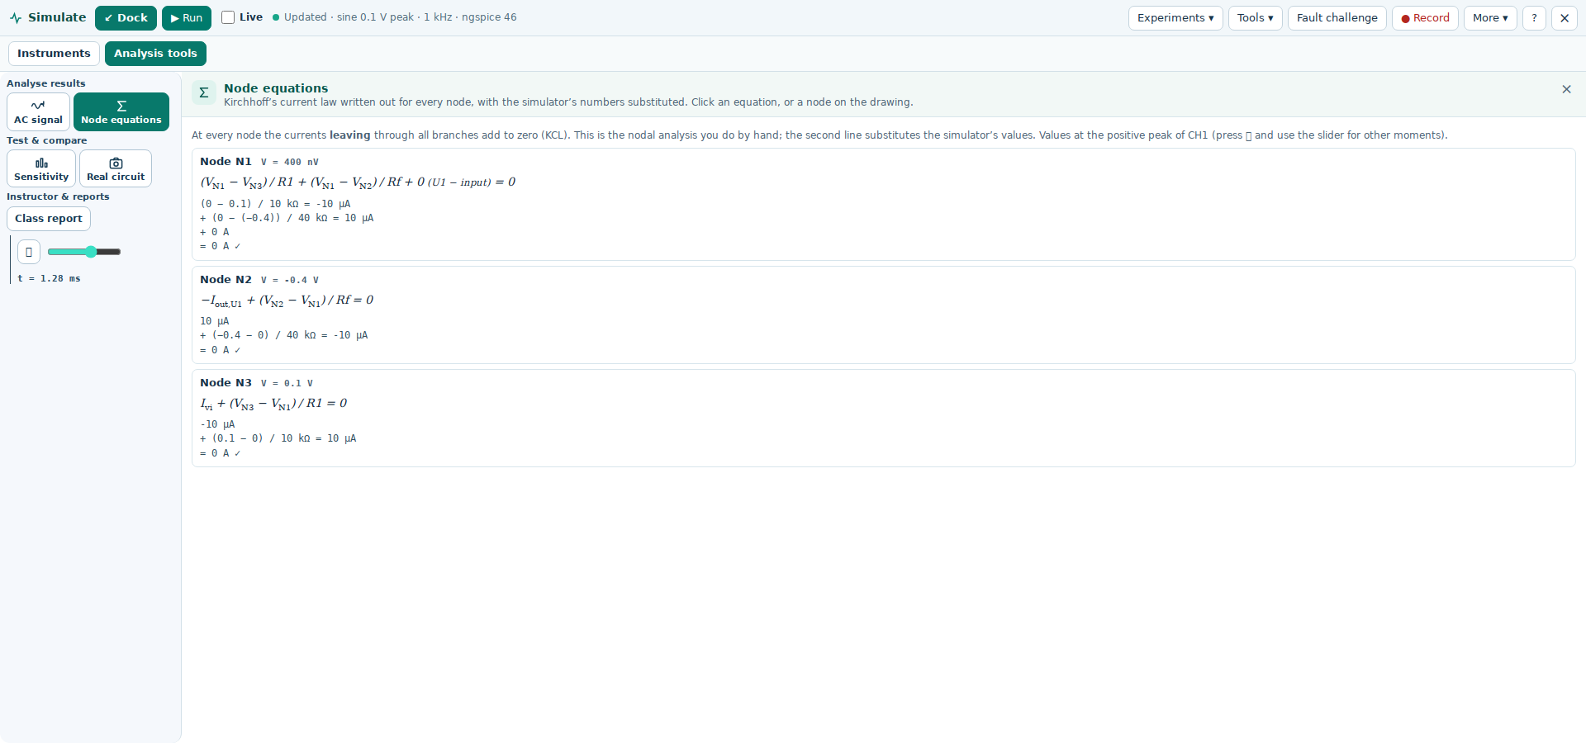
Figure 7. Analysis tools shares the simulation panel with Instruments.

Move resize and record
Move the popup using its window title bar, including to another monitor. Dock returns it to the main workspace. Drag the docked panel’s upper divider to resize it; Pop out detaches it again. Open one tool at a time to keep the circuit visible.
Use Record to keep a measurement in Data log. Save the editable circuit separately through File. After changing the circuit or generator, press Run again or enable Live. Turn Live off when you want deliberate updates or fewer repeated calculations.

Read the assumptions before comparing
Inspect the selected device and simulation model before comparing plots with hand calculations. An ideal op amp does not automatically represent a real device’s bandwidth or slew rate. Device capacitance, output resistance, and source assumptions affect the result.
For an RC check, use 1 kΩ and 1 µF. The ideal cutoff is about 159 Hz and the time constant is 1 ms. A rising step reaches about 63.2% of its final change after one time constant. Measure time from the actual input edge, not from the start of the plot.

Convert a bias network with Thevenin
Open Visual Aids → Laws → Thevenin. Start at Identify: the highlight should mark the supply and the two divider resistors. The rest of the circuit is the load. Move through Open, VTH, RTH, Equivalent, and Load, checking the drawing at each step.
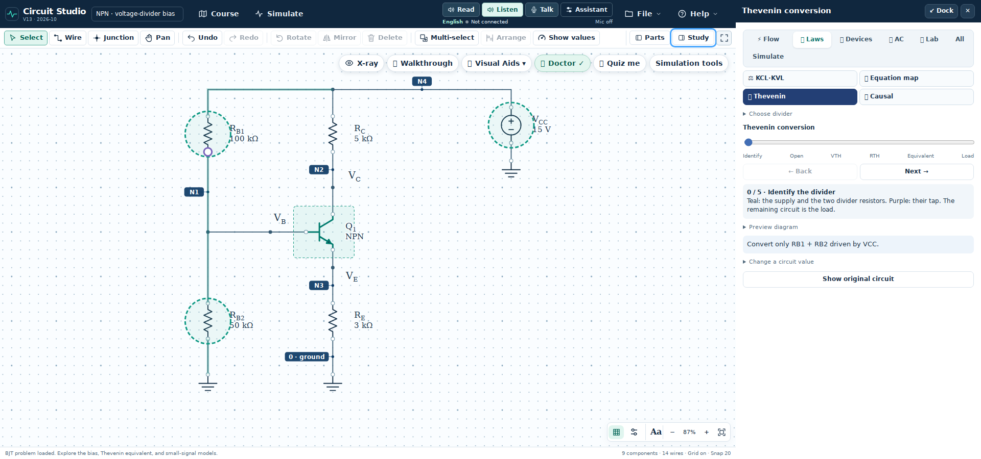
Figure 8. Thevenin identifies the divider before replacing it with an equivalent.

Compare MOSFET and BJT divider loading
For the ideal MOSFET gate, zero DC gate current leaves the gate voltage at the unloaded divider value. For the BJT, base current produces a drop across the Thevenin resistance, so the loaded base voltage is lower. Predict which bias will change more when both divider resistances increase while their ratio is fixed.
Find open-circuit voltage with the load disconnected. Zero the independent voltage supply to find resistance looking into the port. Reconnect the load only after building the equivalent. Use Back whenever a transformation is unclear.

Add readable text and equations
Use the text and equation tools to add assumptions, reference directions, and calculations. Double-click an existing text or equation object to edit it in place. Use the formatting controls for text and the equation controls for fractions, subscripts, and mathematical notation. Select an object to move, resize, or delete it; press Esc to leave the active tool.
Keep labels away from wires and terminal names. Press F after arranging the drawing, and check the exported figure at reading size. State the symbolic relation, substitute values with units, and finish with a device-region or consistency check.

Set up voice guidance
Use Read for narration of the current guidance. It starts directly with Kokoro; a second Read guidance button is not needed. Listen requests Gemini guidance, and Talk lets you ask a spoken question. Assistant opens the compact control panel.

Prepare the voice connection
1. Open Assistant. For Kokoro, check the available local voice setup and use Test Kokoro when needed. The initial model load may take longer than later playback.
2. For Gemini, open the AI setup controls and enter the connection information supplied by your instructor or your own Google AI Studio API key.
3. Save the AI settings on your own computer. Keep the instructor-approved model and voice unless you have a reason to change them.
4. Return to the circuit or lesson step. Press Read for narration, Listen for Gemini guidance, or Talk to ask a question.
5. Grant microphone permission when using Talk. If Kokoro fails, automatic Gemini fallback requires a configured and available Gemini connection.
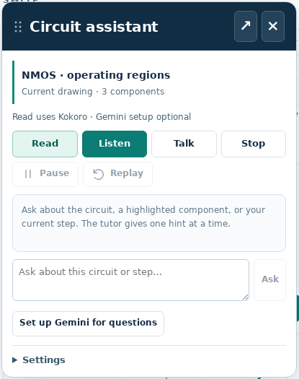
Figure 9. Assistant provides reading, listening, speaking, and playback controls.

Free and paid access
Kokoro runs locally once its required resources are available. It does not consume Gemini API quota. Gemini access and limits depend on the configured project and model; check your account before enabling paid use.
Ask one focused question at a time. If the app reports a connection or quota error, read the message and check the configured service rather than repeatedly pressing Listen.

Remembering settings and protecting your key
Saved settings belong to the browser and the app address or local file context. Use the same browser and app location. Private browsing, cleared site data, or a different copy of the app can prevent restoration. On a shared computer, leave Remember API key off and use Forget when finished.
Keep API keys out of screenshots, submitted work, and shared files. Gemini guidance uses the relevant circuit or learning context; spoken questions require microphone input. Check the app settings before using a shared computer.

Use the voice tools one step at a time
The header exposes Read, Listen, Talk, and Assistant. Use the active circuit or lesson step as context, then choose the control that matches your task.

Figure 10. The current voice controls in the top header.
Control | How to use it
Read | Read the current guidance directly with Kokoro. Configured Gemini is the fallback if local narration fails.
Listen | Request Gemini guidance for the current circuit or lesson step. Requires AI setup.
Talk | Ask one spoken question. Grant microphone permission and use the displayed send control.
Assistant | Open the compact guidance panel, typed questions, connection status, and playback controls.
Stop | Stop narration or an active voice response using the panel controls.
Setup and tests | Use setup when changing the connection. Test Kokoro or Test Gemini if troubleshooting is needed.

Ask questions tied to the circuit
• “Explain the selected resistor and identify its two nodes.”
• “Why can we use equal op amp input voltages in this circuit?”
• “Give me a hint for this step without giving the final answer.”
• “Substitute the actual circuit values into this equation.”
• “Check whether this transistor region assumption is consistent.”
Ask about the selected circuit, current Solution step, or Practice question. Verify the response against the connections, equations, and operating-region assumptions. Submit your own reasoning.

Keep playback clear and economical
Read the current step once, pause to work, and then request help with a specific uncertainty. Use the Stop and playback controls in Assistant when needed. Check volume, browser audio permissions, and connection status if nothing is heard.
Kokoro reads prepared guidance; it does not answer new questions by itself. Gemini provides conversational guidance. If local narration fails and Gemini is unavailable, resolve the reported setup issue before trying again.

Save your work and resolve common problems

Choose the right file for the task
Use File to save the editable circuit project and reopen it later. Export a circuit figure when required. Record simulation measurements in Data log, and use the available data export for your report. Course → My progress provides progress downloads.
What you notice | What to check or do
Circuit is too large or partly hidden | Use Fit. Hide Parts or Study, or move the simulation popup aside. Fit again after resizing.
Solution values obscure the circuit | Use Hide values. Leave annotations hidden while predicting, then reveal them to check.
An equation uses an unclear node | Open Match node names to the circuit in Solution. Find the named node, connected pins, and any output alias.
The answer differs after editing | Check units, wire connections, polarity, model assumptions, and device region. Use Node equations for the current topology.
Guidance is about the wrong part | Select the intended component or learning step, then use Read or ask Assistant a specific question.
API key is requested again | Use the same browser and app location. Enable Remember API key and save. Check whether private mode or clearing site data removed the stored setup.
Microphone permission repeats | API key storage and browser microphone permission are separate. Review the site permission in the same browser. A stable HTTPS app address is generally more consistent than changing local file copies.
No audio or a partial sentence | Check volume and browser audio permissions. Open Assistant to inspect Kokoro status. Gemini fallback needs a configured connection.
Connection or quota error | Read the reported error and check the configured model and account. Use local reading when available.

Before you submit a circuit solution
Include the circuit and values, ground reference, node labels, device assumptions, symbolic equation, numerical substitution, result with units, and a validity check. Describe any difference between a hand approximation and the simulator model rather than hiding it.

Practice and check your understanding
Work these problems on paper first. Recreate or edit the matching circuit in Circuit Studio, check your result, and explain any difference. Use the stated ideal or approximate models.
Task | Question
1 Diode ON | For the series circuit in the worked diode example, set the source to 5 V and resistance to 2.2 kΩ. Use a 0.7 V diode drop. Find the current and verify the state.
2 Diode OFF | Use the same circuit with a 0.5 V source. Test an ON assumption, then find the valid current and diode voltage.
3 Inverting op amp | Ground the positive input of an ideal op amp. Use negative feedback, input 0.5 V, input resistor 10 kΩ, feedback resistor 40 kΩ, and supplies ±12 V. Find gain and output.
4 Noninverting op amp | Apply 0.5 V to the positive input. Use 10 kΩ from the negative input to ground and 40 kΩ from output to negative input. Supplies are ±12 V. Find gain and output.
5 PN junction | Increase reverse bias in the junction lesson. Predict and explain the change in depletion width and junction capacitance.
6 Model comparison | Compare transistor models at the same bias. Why must output resistance assumptions match before comparing voltage gain?

Answer checks
$1. i_{D} = \frac{5 − 0.7}{2.2} mA ≈ 1.95 mA ON$
2. The ON trial is −0.0909 mA, so reject it. The valid OFF result is 0 mA with diode voltage 0.5 V.
$3. A_{v} = −\frac{40 kΩ}{10 kΩ} = −4; v_{o} = (−4)(0.5 V) = −2 V$
$4. A_{v} = 1 + \frac{40 kΩ}{10 kΩ} = 5; v_{o} = 5(0.5 V) = 2.5 V$
For 3 and 4, the outputs lie within the stated rails, consistent with ideal linear operation. For 5, the depletion region widens and junction capacitance decreases. For 6, finite output resistance changes the effective load and gain; compare models with consistent assumptions.

Further reading and setup links
Read Sedra and Smith, Microelectronic Circuits, 8th edition, Chapters 2–7. Updated October 17, 2026 for the revised Circuit Studio interface. The companion seven-minute video follows the full GUI, Study, voice, visual aids, components, conversions, and simulation.
[1] Google AI Studio API keys and project setup
[2] Gemini API rate limits and project quotas
[3] Gemini API pricing and model availability
[4] Gemini Live API documentation

