TECHBLEAT MASTERCLASS
MINI PROJECT

Task: To deploy a website for an organization on the cloud.
Cloud Model: AWS
Tool: AWS Amplify

GitHub link: https://github.com/odufuwabusola/school-portal

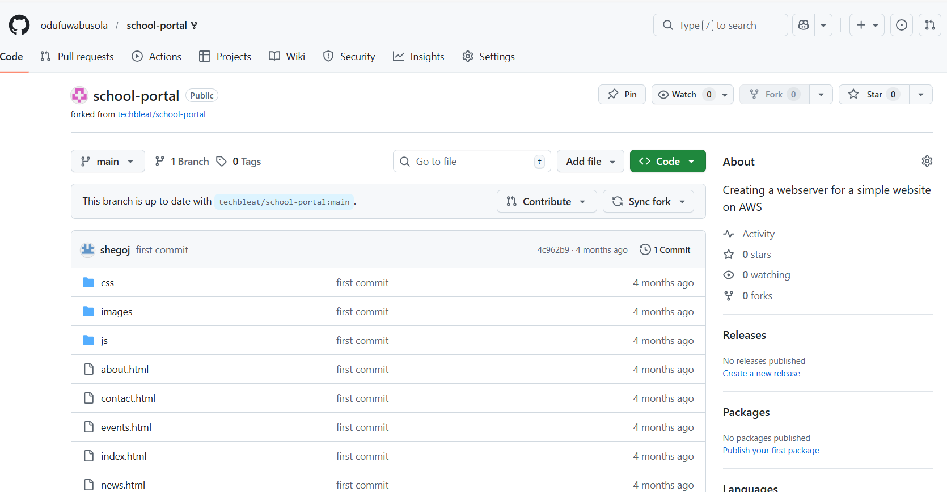

The following are the screenshots of the processes
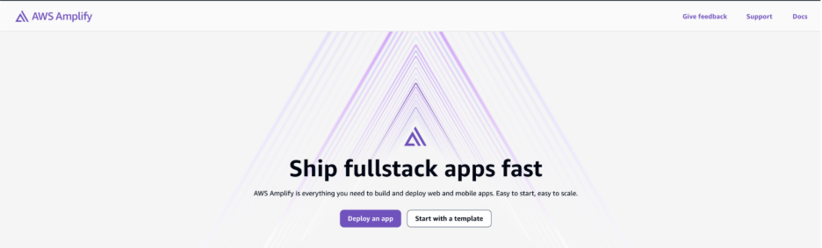

Location of the file on GitHub- https://github.com/odufuwabusola/school-portal
