Name: Busola Odufuwa
Task: AWS Console Task: Launch Two Amazon Linux Instances
Date: 22/10/2025
Part 1 - Use the AWS Management Console to provision two Amazon Linux EC2 instances (t2.micro or t3.micro) within the Free Tier

Connection established
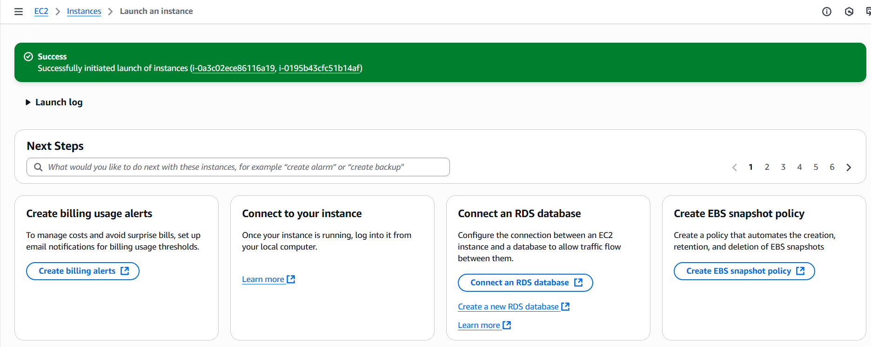

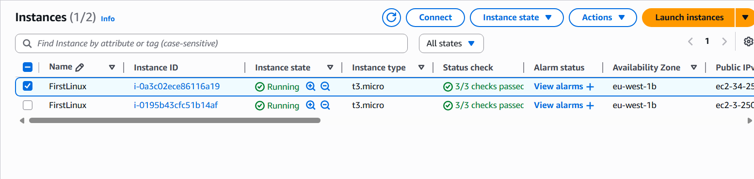

Linux Machine created
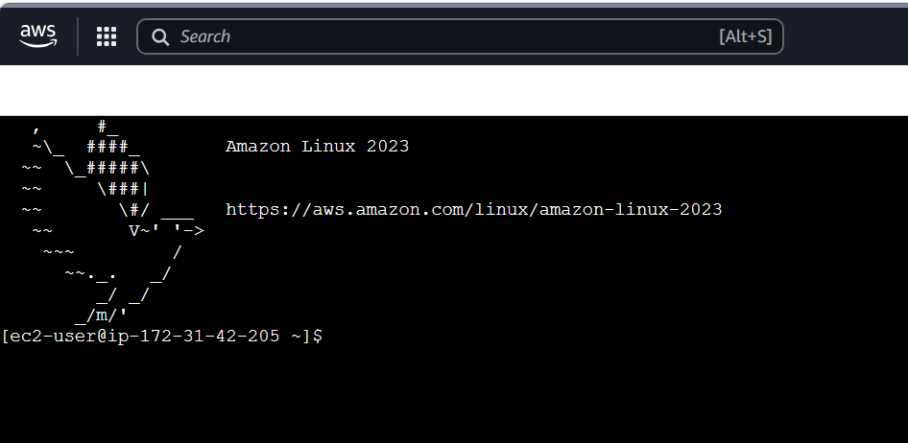
Part 2 - Linux Commands
Task 1- Find the current working directory you are in
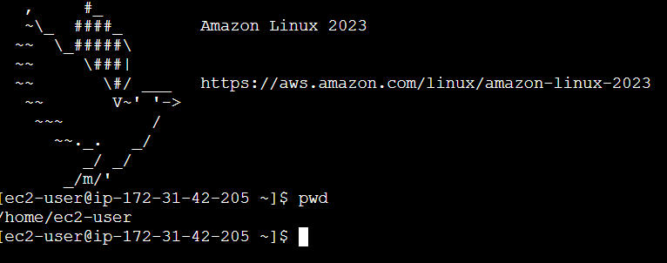

Task 2- List all the files and directories in your current location, including hidden files
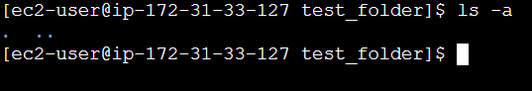

Task 3- Create a new folder called test_folder, move inside it, confirm your location, and then delete the folder
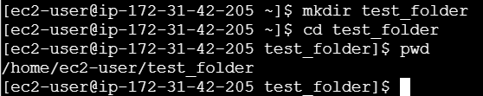

Folder deleted
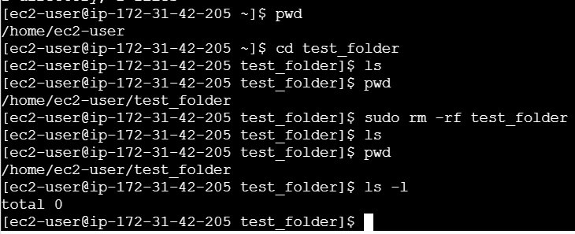
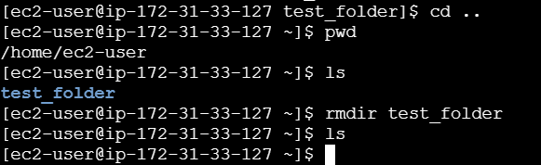

Task 4- Create a text file named hello.txt containing he line “Hello Amazon Linux”; then display its contents on the screen
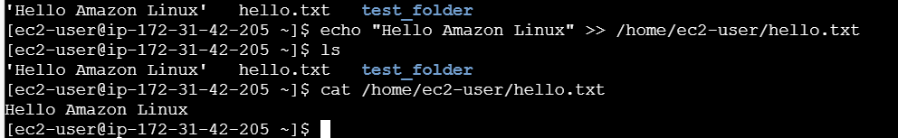

Task 5- Check how much disk space is being used and how much is available on your system
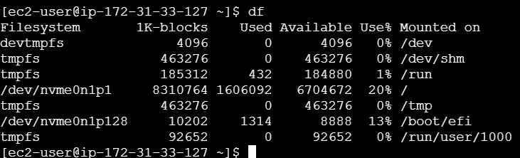

Task 6- Find out how much memory (RAM) is available and currently being used
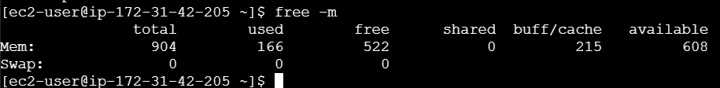

Task 7- Display detailed CPU information – such as model, cores, and architecture
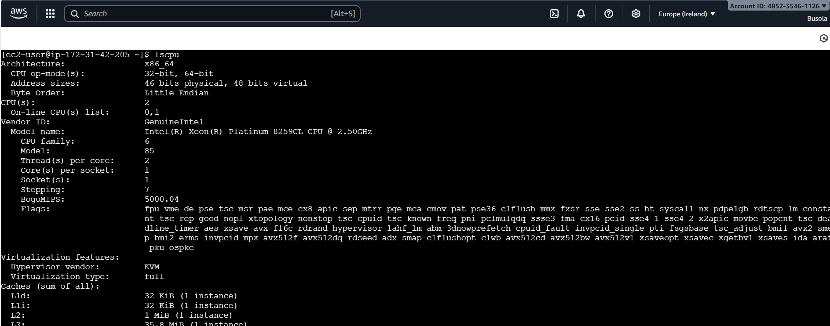
Task 8- Check the list of running processes on your system and identify which one uses the most CPU.
These are the list of running processes but there is no count for the CPU
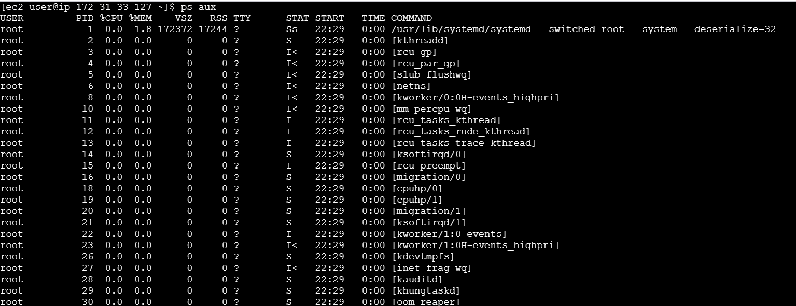

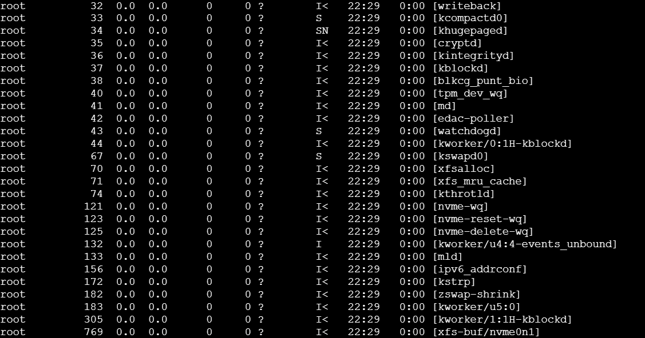

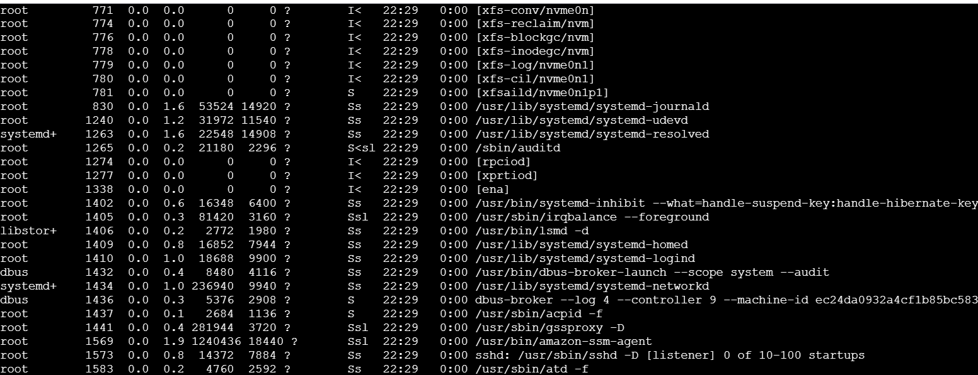
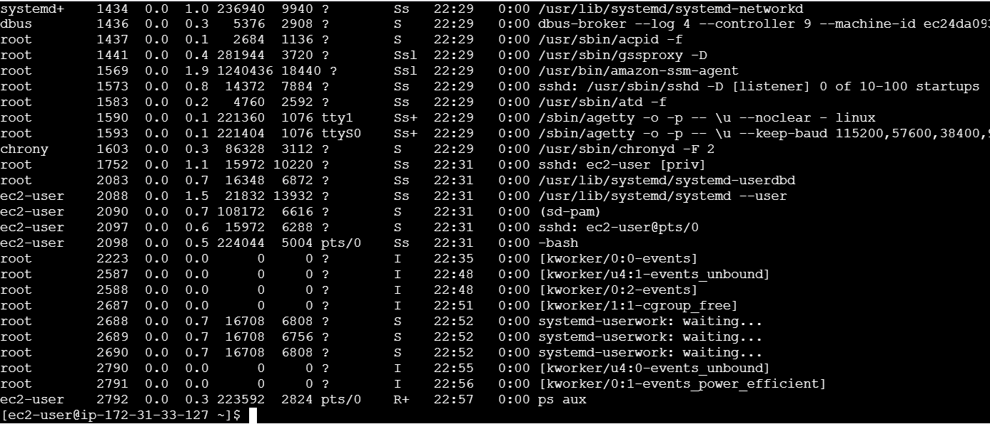

Task 9- Find out how long the system has been running since last reboot, along with the average load.

Task 10- View the latest entries in the system log to observe recent activity or errors.
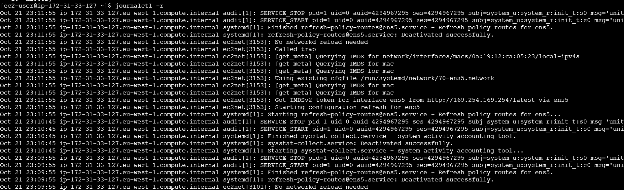

Part 3- Create a GitHub Account
Objective: Set up a free account on GitHub to store, manage, and share your code repositories.
Steps:
1. Go to https://github.com/
2. Click Sign Up (top-right corner).
3. Enter:
o Your email address
o A secure password
o Your username
4. Verify your email address when prompted. ✅ Expected Outcome: You have an active GitHub account and can sign in to your dashboard.
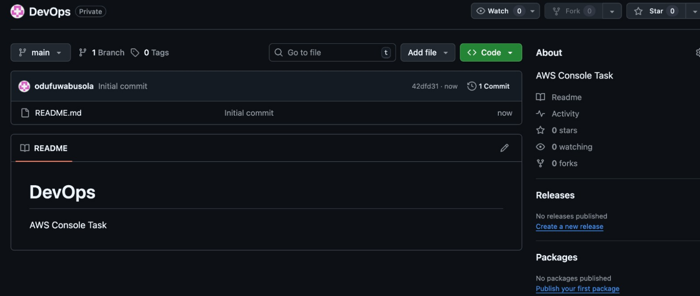

Part 5 – Install Git on Your Machine
Objective: Install Git, the version-control tool used to interact with GitHub.
Windows Users
1. Visit https://git-scm.com/download/win
2. Download and run the Git for Windows installer.
3. Accept default settings unless you have specific needs.
4. Installation provides:
o Git (the tool)
o Git Bash — a Linux-like terminal required for Git commands on Windows.
5. Verify installation: open Git Bash → run
git --version

