|  |  |  |  |
| --- | --- | --- | --- |
| **S.no** | **War/Battle** | **Year** | **Result** |
| *1.* | ***Battle of Hydaspas*** | ***326 B.C.*** | ***Alexander defeated Porus*** |
| *2.* | ***Kalinga War*** | ***261 B.C.*** | ***Asoka won the war but after the war he  adapts Buddhism*** |
| *3.* | ***Invasion of Sind*** | ***712 A.D.*** | ***Mohammed-bin-Qasim invades from the west*** |
| *4.* | ***First Battle of Tarain*** | ***1191 A.D.*** | ***Prithviraj Chauhan defeated Mohammed Ghori*** |
| *5.* | ***Second Battle of Tarain*** | ***1192 A.D.*** | ***Ghori defeated Prithviraj Chauhan*** |
| *6.* | ***Battle of Chhandwar*** | ***1194 A.D.*** | ***Ghori defeated Jaichandra of Kannauj*** |
| *7.* | ***First Battle of Panipat*** | ***1526 A.D.*** | ***Babar defeated Ibrahim Lodhi*** |
| *8.* | ***Battle of Khanua*** | ***1527 A.D.*** | ***Babar defeated Rana Sanga*** |
| *9.* | ***Battle of Ghaghara*** | ***1529 A.D.*** | ***Babar defeated the Afghans*** |
| *10.* | ***Battle of Chausa*** | ***1539 A.D.*** | ***Sher Shah Suri d defeated Humayun*** |
| *11.* | ***Battle of Kannauj (or Bilgram)*** | ***1540 A.D.*** | ***Sher Shah Suri defeated Humayun*** |
| *12.* | ***Second Battle of Panipat*** | ***1556 A.D.*** | ***Bairam Khan (representing Akbar) defeated Hemu*** |
| *13.* | ***Battle of Talikota (or Banihatti)*** | ***1565 A.D.*** | ***Vijaynagar empire (represented by Sadasiva) lost against an alliance formed by Ahmednagar, Bijapur, Golkonda and Bidar*** |
|  | | | |

**1) The Slave Dynasty**

**2) Khalji Dynasty**

**3) Tughlaq Dynasty**

**4) The SaiyyidDynasty**

**5) Lodhi Dynasty**

**1. The Slave Dynasty**

***Qutubbudin Aibakbegan his reign with the modest title Malik and Siphasalar that had been conferred upon him by Muhammad Ghori.The rise of Qutubuddin roused jealousy of Yildoz of Ghazni.Aibak charged him with exercising undue influence on Mahmud of FerozKhoh and marched against him. In 1208 he even occupied Ghazni and also won over Sultan Mahmud to his own side. During his brief reign of 4 years he did not make any fresh conquests because his entire attention was devoted to the establishment of law and order and strengthening of his army of occupation. Aibak died in 1210 AD.He earned the title of Lakh Baksh.***

* The defeat of Prithviraj Chauhan in the second battle of Tarain in 1192 by Muhammad Ghori laid the foundation of Muslim rule in India. After the death of Muhammed Ghori, his slave QutubuddinAibak took the charge and became the first sultan of Delhi.
* For his generosity, he earned the sobriquet Lakh-Bakhsh (giver of Lakhs.).
* He built two mosques-Quwat-ul-Islam at Delhi and Adhai din kaJhonpra at Ajmer.
* He started the construction of QutubMinar which was dedicated to famous Sufi Saint KhwajaQutubuddinBakhityar Kaki.
* He died while playing Polo in the year 1210.

***Iltutmish was the greatest of the slave kings. He was the real founder of the Sultanate. At the time of Qutubbudin's death he was the governor of Badaun.He made Delhi the capital of his empire. The reign of Iltutmish saw the decline of Lahore and the rise of Delhi. Delhi gradually became the greatest centre of learning and culture in India. The Delhi Sultanate owes the outlines of its administrative system to Iltutmish.He organized the Revenue and Finance depts. Although Iltutmish had many sons but all of them were incompetent. He appointed his daughter Raziya as his successor.***

* He divided his empire into Iqtas, known as Iqtadari system under which land were assigned to nobles and officers in lieu of salary.
* He introduced the silver tanka and the copper jital - the two basic coins of the Sultanate period.
* He built the Hauz-i-Shamsi reservoir in Mehrauli in 1230.
* He completed the QutubMinarin the year 1231-32.
* He formed Turkan-i-Chahalgani or Chalisa (a group of 40 powerful Turkish nobles).
* He saved Delhi Sultanate from the wrath of Chengiz Khan, the Mongol leader.

***Raziya is the first and the last woman ruler of medieval India. She assumed the title of sultan and did her best to play the part of a man. Her reign lasted for 3 years and six months. She aimed at removing the uncalled for interference and influence of Turkish chiefs on administration. She discarded Purdah and began to adorn the attire of the male. Raziya tried to concentrate power in her own hands and succeeded. This provoked serious opposition that took the shape of a protest against her.***

* She succeeded her father Iltutmish in 1236.
* She was the first lady to sit on the throne of Delhi.
* She was the first and the last Muslim lady who ever ruled India'.
* Her promotion of Jalaluddin Yakut, an Abyssinian, to the important offices provoked the Turkish officers.
* She was killed along with her husband Altunia by Bahram Shah, a son of Iltutmish.

***Alauddin Masud Shah also met the same fate of Bahram Shah who succeeded Raziya's successor. Bahram Shah was weak and incompetent ruler and was overthrown by the nobles after a brief reign of 2 years.***

***Balban sat on the throne of Delhi in 1266 AD and adopted the name of GhiyasuddinBalban. With his accession the line of rulers of the family of Iltutmish ended. He started the era of strong centralized government. He increased the power and position of sultan.Balban ascended the throne in 1266. He introduced Persian ceremonies and etiquettes in his court and allowed no manner of levity here. He suppressed the revolts in the Doab and Oudh and tracked down elements in Rohilkhand.The Mongols invaded again in 1279 and 1285 but were defeated and driven away. In 1286 the Mongols reappeared and this time Prince Muhammad was killed. Balban could not recover from this tragedy and died in 1286 AD.***

* His real name was Baharuddin.
* He crushed the power of Turkan-i-Chahalgani or Chalisa which stabilized the Sultanate rule.
* He established the military department Diwani-i-Arz.
* For defeating the Mongols he got the sobriquet Ulagh Khan

***He was succeeded by his grandson Kaikubad.He was inefficient and incapable. JalaluddinKhilji placed himself at the head of a powerful faction and routed the Turkish amirs. He eventually murdered Kaikubad and seized the throne***

Study Notes Gupta Period One Liners Part 2

[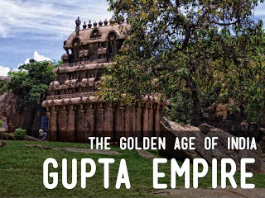](https://1.bp.blogspot.com/-vPGMPMBPydY/VsWrMgdfGnI/AAAAAAAACNY/XT4wWrjfs6k/s1600/GUPTA+PERIOD.jpg)

***21. Who was the galaxy of scholars in the court of Chandragupta Vikramaditya?***

***Ans. Aryabhatta, Kalidasa, Varahmihira, Dhanvantri, Amar Singh and Brahmagupta.***

***22. Who was Kalidasa?***

***Ans. Kalidasa was a great poet of Sanskrit.***

***23. Which are the important books written by Kalidasa?***

***Ans. Meghdoot, Raghuvansham, Kumarasambhavam.***

***24. Who was Varahamihira?***

***Ans He was as a great astrologer.***

***25. Who wrote the famous book Vrihat Sanhita'?***

***Ans. Varahamihira, it deals with astrology and physical geography.***

***26.Who was Dhanavantri?***

***Ans. He was a great Physician in the court of Chandragupta Vikramaditya.***

***27.Who was Aryabhatta?***

***Ans. He was a great Mathematician and Astrologer in the court of Chandragupta Vikramaditya. He invented the Decimal system.***

***28. Who wrote the famous book 'Aryabhatta'?***

***Ans. Aryabhatta.***

***29. Which was the second capital of Chandragupta Vikramaditya?***

***Ans. Ujjain***

***30.Who wrote the famous book 'Surya Siddhanta'?***

***Ans. Aryabhatta.***

***31. What was the main contribution of Aryabhatta in this field of science?***

***Ans. He was the first astrologer who explained that the earth rotates on its own axis but revolves round the sun***

***32. Who established Nalanda University?***

***Ans. Kumargupta.***

***33.To which period cave paintings of Ajanta belonged?***

***Ans. Gupta period.***

***34.Where was the centre of higher education during Gupta period?***

***Ans. Nalanda University.***

***35. Why Nagarjuna was famous during Gupta period?***

***Ans. He was a renowned chemist.***

***36.What was the main occupation of people during Gupta period?***

***Ans. Agriculture.***

***37. What was the land revenue during Gupta period?***

***Ans. It was from 1/6 to 1/4 th of the total produce of the land.***

***38.When did the art of making temples started?***

***Ans. During Gupta period.***

***39.During which period the iron pillar at Mehrauli built?***

***Ans. Gupta period.***

***40.Which ruler of the Gupta period is associated with pillar at Mehrauli?***

***Ans. Chandragupta Vikramaditya.***

***41. During which period the great epics the Ramayan and the Mahabharat were given the final form?***

***Ans. During Gupta period.***

***42. During which period the famous Sanskrit book "Panchtantra" a collection of tales had been written?***

***Ans. Gupta period.***

***43. Which period is known as 'golden age of Indian history'?***

***Ans. Gupta period.***

***44. Which were the famous trade centers during Gupta period?***

***Ans. Ujjain, Patliputra, Banaras and Mathura.***

***45. Which was the famous sea-port on the east coast of India during Gupta period?***

***Ans. Tamralipti.***

***46. Which was the famous sea-port on the west coast of India during Gupta Period?***

***Ans. Broach.***

***47.Of which religion the rulers of Gupta dynasty were followers?***

***Ans. Hindu religion.***

***48. What was the official language during Gupta period?***

***Ans. Sanskri***

Ancient History Notes: Mauryan Dynasty for SSC CGL 2016, SSC CPO, SSC CHSL

**Mauryan Empire**

**[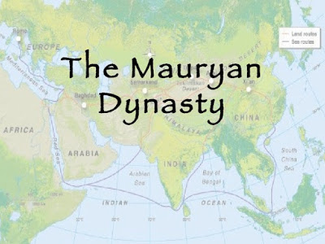](https://3.bp.blogspot.com/-8r9ioD5YtU4/VsL4bAsfgoI/AAAAAAAACVk/x66xxbFwb8E/s1600/unit-4-mauryan-dynasty-1-728.jpg)**

a) The Mauryan Empire was one of the largest empires to rule India.

b) It was established in 321 BC by ***Chandragupta Maurya*** and dissolved in 185 BC with the death of the last Maurayan king ***Bhrihadrata Maurya.***

c) The capital of the Mauryan Empire was **Pataliputra.**

d) The Mauryan Empire is known for the ***Arthasastra by Kautilya (Chanakya)***, the ***Rock Edicts of Asoka***, and the ***Lion Capital of Asoka***at Sarnath which today serves as the emblem of India.

**Some of the rulers of Mauryan Dynasty**

**Chandragupta Maurya**

***a)****He was the founder of the Mauryan Empire.*

***b)****He was known in Greek and Latin accounts as Sandrokyptos, Sandrokottos or Androcottus.*

***c)****He established the empire by overthrowing the Nanda dynasty of Magadha under Dhana Nanda.*

***d)****Chanakya was the Prime Minister of Chandragupta while Rakhshasa was his chief advisor.*

***e)****After his conquests, the Empire stretched from Assam to Afghanistan, from Kashmir to the Deccan*

***f)****Chandragupta defeated the Seleucus I Nicator, the successor of Alexander in Macedonia. As part of the agreement reached later, Chandragupta married a daughter of Seleucus and in return gifted 500 war elephants.*

***g)****Seleucus sent an ambassador to Chandragupta’s court called Megasthenes.*

***h)****Towards the end of his life, Chandragupta embraced Jainism and migrated south with Acharya Bhadrabahu to Shravanabelgola in Karnataka.*

**Bindusara**

**a)** He was the successor to Chandragupta.

**b)** He was the son of Chandragupta and the father of Asoka.

**c)** He was also known as Amitraghata or Ajathasetru

**d)** He expanded the Mauryan Empire south beyond the Deccan, as far south as Mysore

**e)** During his reign, the Empire included all of India except Kalinga and the southern kingdoms of Cheras, Cholas and Pandyas.

**f)** The Seleucid ambassador to Bindusara’s court was Deimakos

**Asoka the Great**

**a)** Successor to Bindusara

**b)** Also known as Devanampriya and Priyadarshin

**c)**Conquered Kalinga and added it to the Mauryan Empire.

**d)** Was initially an Ajivaka but later embraced Buddhism after the conquest of Kalinga.

**e)** Asoka organized the Third Buddhist Council at Pataliputra in 250 BCE. It was conducted by the monk Mogaliputta-Tissa, who was also the spiritual teacher of Asoka.

**f)** He is known for the Asoka Chakra, the Asoka Pillars and the Lion Capital at Sarnath

**g)**The Ptolemaic dynasty of Egypt under king Philadelphus sent the ambassador Dionysius to the court of Asoka

***Chanakya***

**a)**Also known as Kautilya, Vishnugupta.

**b)**He was the advisor and trainer of Chandragupta.

**c)**He later served as the Prime Minister of the Mauryan Empire under Chandragupta and his son Bindusara.

**d)**Author of the Arthasastra and the Nitishastra. The Arthashastra discusses monetary policies, warfare and international relations while the Nitishastra is a treatise on the ideal way of life and philosophy.

***Ending of the Dynasty***

The Mauryan Empire was dissolved in c. 185 BC with the assassination of the last ruler Brihadrata by his commander-in-chief Pushyamitra Sunga.

***1. Where was the capital of Srigupta?***

*Ans. Patliputra.*

***2. To whom Chandragupta I was married?***

*Ans. He married a princess Kurnaridevi of Lichhavi republic of Vaishali.*

***3. Which city Chandragupta I got in dowry by marryin, Lichhavi princess?***

*Ans. Patliputra.*

***4. Who started the Gupta era?***

*Ans. Chandragupta 1 in 320 AD.*

***5.Mcghavarman, the king of Cylone sent an ambassador which Gupta ruler and sought permission to build Buddhist Monastry at Bodh Gaya?***

*Ans. Samudragupta.*

***6. In Indian history who is known as 'Napolean of India?***

*Ans. Samudragupta.*

***7. Which Gupta ruler was a great musician and an exper player on Veena?***

*Ans. Samudragupta,*

***8. Who was shown in some of the gold coins as seated 01 a couch and playing on the Veena?***

*Ans. Samudragupta.*

***9.What is the main source of information of the conquests of Samudragupta?***

*Ans. Inscriptions engraved on a pillar at Allahabad.*

***10. Where has been this engraved pillar kept?***

*Ans. The engraved inscriptions on a pillar of Ashoka has be& kept in Allahabad fort.*

***11.Who authored the inscriptions engraved on the pillar at Allahabad?***

*Ans. Harisena.*

***12. Who was Harisena?***

*Ans A court poet of Samudragupta.*

***13. In which language the inscriptions are engraved on Allahabad pillar?***

*Ans. Sanskrit.*

***14. Who was the galaxy of scholars in the court of Samudragupta?***

*Ans. Harisena, Vasubandhu and Asanga.*

***15. Samudragupta was the follower of which religion?***

*Ans. He was a staunch Hindu and worshiper of Vishnu.*

***16. Who was the most famous ruler of Gupta dynasty?***

*Ans. Chandragupta Vikramaditya.*

***17. Which Gupta ruler is known as Sakari and why?***

*Ans. Chandragupta Vikramaditya, because he conquered the Saka.*

***18. Which city was the most important city for trade during the reign of Samudragupta?***

*Ans. Ujjain.*

***19. Which was the second capital of Chandragupta Vikramaditya?***

*Ans. Ujjain*

***20. A Chinese pilgrim, 'Fahyan' visited India during the reign of which Gupta ruler?***

*Ans. Chandragupta Vikramaditya.*

IMPORTANT BATTLES AND WARS IN INDIA

**1. Battle of Chausa: 1539 A.D.** - The battle of Chausa was fought between Mughal emperor Humayun and Sher Shah Suh. In this battle Humayun was defeated. It facilitated Sher Khan to march on to Delhi at Agra.

[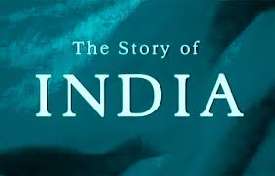](http://3.bp.blogspot.com/-Jays1Qx3gss/VlWxEtQUjaI/AAAAAAAAAmg/ARSvf6KIrEw/s1600/images.jpg)

**2. Battle of Hydaspes 326 B.C.**—Alexander the Great, defeated Porus, the Paurava king.

**3. Battle of Kannauj (1540 A.D.)** – Sher Shah Suri defeated Humayun. After this battle, Humayun fled to Iran and Sher Shah Suri occupied Delhi.

**4. Battle of Kalinga 261 B.C**.— Ashoka defeated the king of Kalinga. Ashoka embraced Buddhism and preached r during the rest of his life after this war.

**5. First Battle of Tarain or Thaneswar A.D. 1191 -** Prithvi Raj Chauhan defeated Mohammed Ghori.

**6. Second Battle of Tarain A.D. 1192** - Mohammed Ghori defeated Prithvi Raj Chauhan. Ghori's victory paved the way for the establishment of Muslim rule in India

**7. First Battle of Panipat 1526**— Babur defeated Ibrahim Lodhi. This laid the foundation of the Mughal rule in India.

**8. Second Battle of Panipat 1556**—Bairam Khan (Akbar's General) defeated Hemu (the Hindu General and right-hand man of Mohd. Adil Shah). It also ended the Afghan Rule and Mughal Rule began instead.

**9. Third Battle of Panipat 1761**—Ahmed Shah Abdali defeated Marathas. It gave a terrible blow to the Maratha power. It made the field clear for the English.

**10. Battle of Khanwah 1527**— Babar defeated Rana Sanga of Mewar. This battle resulted in the defeat of the powerful Rajput confederacy.

**11. Battle of Talikota 1564- 65**—United alliance between Bijapur, Bidar, Ahmednagar and Golkonda under Hussain Nizam Shah defeated Ram Raja of Vijayanagar. It destroyed the Hindu Kingdom of Vijayanagar.

**12. Battle of Haldighati 1576**—Akbar's forces headed by Raja Man Singh defeated Rana Pratap, the brave Rajput king. Though defeated, Rana Pratap refused to accept Mughal authority and carried on warfare till his death.

**13. Battle of Plassey 1757—** The English under Lord Clive defeated Siraj-ud-Daulah. It brought Muslim Rule in Benga to an end and laid foundations of the British Rule in India.

**14. Battle of Wandiwash 1760—**The English defeated the French. The battle sealed the fate of the French in India and paved the way for English rule in India.

**15. Battle of Buxar 1764—** Fought in 1764 between the forces of the English and the combined forces of Mir Qasim, Shuja-ud-Daulah (Nawab of Oudh) and the Mughal Emperor Shah Alam. The English victory at Buxar finally riveted the shackles of the Company's rule upon Bengal.

**16. First Mysore War (1767- 68)—**In 1768, Haider All was defeated by the English relinquishing all his rights over Mysore in favour of the English.

**17. Second Mysore War 1780**— A grand alliance between Haider Ali, the Nizam and the Marathas was formed and Haider Ali. He defeated the English and took possession of Arcot and became the undisputed master of the Carnatic.

**18. Third Mysore War 1790- 92**—Fought between the English and Tipu Sultan. Tipu Sultan had to submit and was compelled to sign the Treaty of Seringapattam stripped him of half his territory.

**19. Fourth Mysore War 1799**— The British forces under Arthur Wellesley defeated Tipu Sultan, which brought the end of the Tipu Sultan.

**20. First Anglo-Maratha War (1775-1782)-**was the first of three Anglo-Maratha wars fought between the British East India Company and Maratha Empire in India. The war began with theTreaty of Surat and ended with the Treaty of Salbai.

**21. Second Anglo Maratha War 1803-05**—It weakened the Maratha power. The English annexed Tanjore, Surat and Carnatic.

**22. Third Anglo Maratha War 1817- 18—**The British forces defeated Marathas and this campaign finally extinguished the Maratha Empire.

**23. Battle of Cheelianwala 1849**—Forces of the East India Company under Lord Hugh Gough defeated the Sikhs under Sher Singh.

**24. Burmese War 1885—**As a result of this War, the whole of Burma was occupied by the English and made a part of India.

**25. Afghan War III 1919—**As a result of this War, Treaty of Rawalpindi was signed by which Afghanistan was recognised as an independent State.

Major Harappan Sites and their Excavators Part-1

**Dear Reader’s**

As the Exam will start soon and the focus of the student not only be on**Math and Reasoning but also on General Knowledge**. This post is exclusively for all the aspirants who are preparing for Railway's and SSC. This  notes were based on ancient history and we highlighted all the important things from Exam point of view. So friends, read the below topics this will definitely help you. We will post this notes of different subject on daily basis, so please keep reading...

[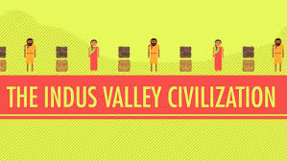](http://4.bp.blogspot.com/-MiR8-SVzWMw/Vo-sLv9w0dI/AAAAAAAABDw/jePGeg1K_Aw/s1600/images.jpg)

[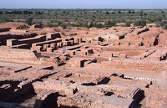](http://2.bp.blogspot.com/-XzY3OporQhA/Vo-YY86XBZI/AAAAAAAABCY/pzQAz7hxDlM/s1600/Rakhigarhi-mound-india.jpg)**Name of site- Harappa**   
Year of Excavation-**1921**   
Excavator**-Daya Ram Sahni**  
Montgomery district of **Punjab (Now in Pakistan) on the left bank of Ravi river**   
•City followed**grid planning**.   
•Two rows of **six granaries**.   
•Dancing **Natraja** (stone)   
•Only place having evidences of coffin burial.   
•no. of Cemetery H and cemetery R - 37.    
  
  
  
  
Name of site -**Mohenjo-Daro**   
Year of Excavation -**1922**   
[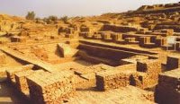](http://4.bp.blogspot.com/-uOgrLhU8tWI/Vo-ZRgQf8VI/AAAAAAAABCg/4mBU2E2y89s/s1600/download.jpg)Excavator -**RD Banerjee**   
**Larkana district in Sindh on the right bank of Indus (Now in Pakistan)**  
•City followed grid planning.   
•A large**granary, great bath and a collage.**  
•Human skeletons showing**invasion** and **massacre.**  
•Evidence of **horse** comes **iron superficial level.**  
•A piece of **woven cotton** along with spindle whorls and needles.   
•A bearded man in steatite and a bronze dancing girl are found.   
•Town was flooded more than **seven times**.   
•A seal representing Mother Goddess with a plant growing from her wombe and a woman to be sacrificed by a man with a knife.   
  
  
  
Name of site -**Sutkagendor**   
[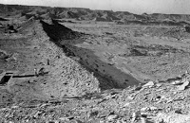](http://4.bp.blogspot.com/-jN-QRblWEg8/Vo-ZzL1hmFI/AAAAAAAABCo/SLOBTiPASk0/s1600/Aachen_1987_Abb_102_web.jpg)Year of Excavation -**1927**   
Excavator **-RL. Stein**   
Situated in **Baluchistan on Dask river**   
•Trade point between Harappa and Babylon, to mature phase.   
•Citadel was fortified, Evidence of horse   
  
  
  
  
Name of site -**Chanhudaro**   
Year of Excavation -**1931**   
[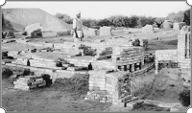](http://1.bp.blogspot.com/-7JqaMBIo2tY/Vo-aOWnCLUI/AAAAAAAABCw/BnrGMMZZPk8/s1600/kiln-Chanhu-daro.png)Excavator -**N Gopal Majumdar, Mackey**    
Situated in **Sindh on the bank of left Indus**    
•The city has **no citadel**.  
•Famous for bead makers shop.   
•A small pot, possibly an inkpot.   
•Foot prints of a dog chasing a cat.   
•Evidence of copper or bronze tools of carts with seated drivers.   
•Three different cultural layers-**Indus, Jhukar and Jhangar.** 

[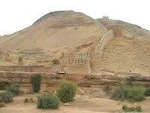](http://1.bp.blogspot.com/-1oiUt2mFt2k/Vo-at1EtITI/AAAAAAAABC8/KgwKvL2Mlfw/s1600/hqdefault.jpg)

Name of site -**Amri**   
Year of Excavation -**1935**   
Excavator -**NG Majumdar**   
Situated in Sindh on the bank of Indus   
•**Evidence of antelope.**   
  
  
  
  
  
Name of site -**Kalibangan**    
Year of Excavation -**1953**   
Excavator -**A Ghosh**   
[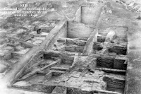](http://4.bp.blogspot.com/-CSXYafWt2Mc/Vo-bImsYV4I/AAAAAAAABDE/pIphX0pyvGA/s1600/Untitled-24.jpg)Situated in **Rajasthan**on the left bank of **Ghaggar**   
•Shows both Pre-Harappan and Harappan phase.   
•Evidence of Furrowed land.   
•Evidence of seven fire altars and camel bones.   
•Many houses had their own well.  
•Kalibangan stands for **black bangles.**   
•Evidence of **wooden furrow.**   
•Evidence of **two types of burials** (i) Burials in a rectangular grave and (ii) Burials in a circular grave.   
  
  
  
Name of site -**Kot Diji**   
[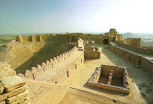](http://1.bp.blogspot.com/-SMmwNZxaaUQ/Vo-bc8RNcVI/AAAAAAAABDM/qVyH3KdCOV4/s1600/pic_kotdiji-fort-2.jpg)Year of Excavation -**1953**   
Excavator -**Razal Ahmed**   
Situated on the left bank of**Indus**   
•Wheel made painted pottery.   
•Trace of a defensive wall and well aligned streets.   
•Knowledge of **metallurgy, artistic toys etc.**  
•Five figurines of mother Goddess discovered.   
  
  
  
  
  
[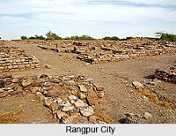](http://1.bp.blogspot.com/-ycWCTjalaz4/Vo-b5P1VNPI/AAAAAAAABDU/ZzEX7jODtjU/s1600/Rangpur_Harappan_Cit.jpg)Name of site -**Rangpur**   
Year of Excavation -**1953**   
Excavator -**MS Vats, BB Lal and SR Rao**   
Situated on the left bank of **Mahar river (Gujarat)**   
•Rice was cultivated   
  
  
  
  
  
  
Name of site **-Ropar**   
Year of Excavation -**1953**   
[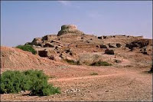](http://1.bp.blogspot.com/-aetpMczNWaw/Vo-dAc9lQDI/AAAAAAAABDg/KYMy1eeV4JM/s1600/download+%281%29.jpg)Excavator -**YD Sharma**   
Situated in **Punjab on the banks of Sutlej**   
•Evidence of burying a dog below the human burial.   
•One example of rectangular mud rick chamber was noticed.   
•**Fivefold culture**–Harappan, PGW, NBP, Kushana-Gupta and Medieval.

Major Harappan Sites and their Excavators Part-2

**Dear Reader’s**

As the Exam will start soon and the focus of the student not only be on **Math and Reasoning but also on General Knowledge**. This post is exclusively for all the aspirants who are preparing for Railway's and SSC. This  notes were based on ancient history and we highlighted all the important things from Exam point of view. So friends, read the below topics this will definitely help you. We will post this notes of different subject on daily basis, so please keep reading..

[](http://4.bp.blogspot.com/-FPC073Xg900/VpIlWGn2jdI/AAAAAAAAAGI/JmIAGN0uFes/s1600/images+%286%29.jpg)

**Lothal**   
  
1953   
SR Rao   
•A tiled floor which bears intersecting design of circles.   
•Remains of rice husk (other than Rangpur).   
•Evidence of horse from a terracotta figurine.   
[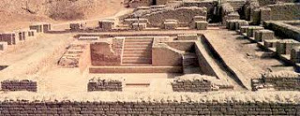](https://2.bp.blogspot.com/-nDIXpx800ZI/VpDUoaljFOI/AAAAAAAAAFQ/lLkFB4glyck/s1600/download+%283%29.jpg)•A ship designed on a seal.   
•Beads and trade ports. A Terracotta ship.   
•An instrument for measuring angles, pointing to modern days compass.   
•Houses with entrances on the main street a unique feature as the houses of all other Harappan cities had side entries.   
•First man-made port in the world and a dock.   
•Evidence of joint burial.   
•A jar depicting scene from the story ‘cunning fox’ of Panchatantra.   
   
  
   
**Alamgirpur**   
  
[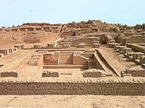](https://1.bp.blogspot.com/-mMwUxJFEgw8/VpDWFIWb3YI/AAAAAAAAAFc/oZoka9suInA/s1600/images+%284%29.jpg)1958    
YD Sharma    
Situated in Meerut on the bank of Hindon River   
•The impression of cloth on a trough is discovered.   
•Usually considered to be Eastern boundary of the Indus culture.     
 **Surkotada**   
[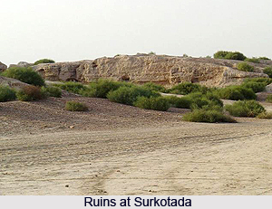](https://images-blogger-opensocial.googleusercontent.com/gadgets/proxy?url=http://www.indianetzone.com/photos_gallery/77/1_Ruins_at_Surkotada.jpg&container=blogger&gadget=a&rewriteMime=image/*)1964   
  
  
JP Joshi    
Situated in Kutch (Bhuj) (Gujarat)    
•Bones of horse, bead making shops.   
  
  
  
  
  
**Banawali**   
  
[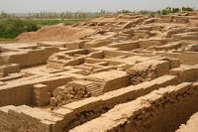](http://2.bp.blogspot.com/-jFfiqeXxQsI/VpIk6EqNM0I/AAAAAAAAAGA/rQ-e6dVZQZI/s1600/images+%285%29.jpg)1974   
RS Bisht    
Situated in Hissar (Haryana)    
•A jar depicting scene from the story cunning fox of panchatantra.   
•Show both Pre-Harappan and Harappan phase.   
•Good quantity of barley found here.   
•Pottery.   
  
**Balakot**   
1963 - 76   
George F Dales  Situated in the Arabian Sea    
•Remain of Pre-Harappan and Harappan Civilisation.   
•The mounds rise to the height of about 9.7 m and are spread 2.8 sq. hectare of area. Beads manufactures and shale’s industry.  
  
 **Dholavira**   
[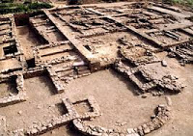](http://4.bp.blogspot.com/-1hk64JrA73k/VpIj966glCI/AAAAAAAAAF0/2cxKbP6b58s/s1600/DHOLVIRA.jpg)1985-90   
RS Bisht    
Situated in Rann of Kutch (Gujarat)   
•Seven cultural stages. Latest site to be discovered   
•Remains of horse.   
•Largest site.   
•Three parts of city are citadel, middle twon and Lenten town   
•Unique water management.    
  
**Rakhigarhi**   
[](http://2.bp.blogspot.com/-fhns3PHT3jE/VpIjXhPixEI/AAAAAAAAAFs/YbQW6WAVwhE/s1600/Rakhigarhi-mound-india.jpg)  
1963    
Prof Surajbhan    
Drishdavati (Hissar district Haryana) on Ghaggar river     
•Two distinct cultures i.e, early Harappan and mature Harappan.   
•One of the largest Harappan site provincial capital.   
  
**Smart Facts**  
 **.**Until 1920s. Indian History began with the advent of Aryans, as no information was available to reconstruct the history of India before that.    
**.**The efforts of the Indian Archaeologist of the first half of the 20th Century have pushed back the starting point of the study of Indian History.   
**.**The earliest recorded reference to the civilisaiton is given by Charles Masson, who visited the site Harappa in 1826 and wrote about a running brick castle but its significance was not realized until much later.   
**.**In 1857, the British Authorities used Harappan bricks in the construction of East Indian Railway line connecting Karachi and Lahore.   
. In 1912, Harappan seals with then unknown symbols were discovered by J Fleet which trigged an excavation campaign under Sir John Marshall in (1921-22), resulting in the discovery of a hitherto unknown civilization by Dayaram Sahni. By 1931, much of Mohenjo-Daro was excavated, but minor campaigns continued, such as that led by Mortimer Wheeler in 1950.

**Ancient India**  
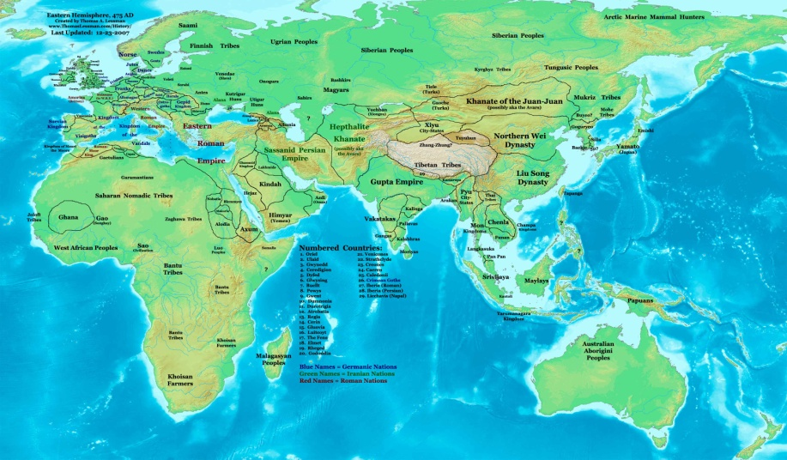

Ancient India can be studied under other heads  like Paleolithic, Mesolithic, Neolithic and Chalcolithic period – based on the type of stone/ metal tools people used.There were activities of proto humans (Homo erectus) in the Indian subcontinent 20 lakh years (2 million years) ago, and of Homo sapiens since 70,000 BC. But they were gathers/hunters.The first inhabitants of Indian subcontinent might have been tribals like Nagas (North-East), Santhals (East-India), Bhils (Central India), Gonds (Central India), Todas (South India) etc. Most of them are speakers of the Austric, pre-Dravidian languages, such as Munda and Gondvi. Dravidians and Aryans are believed to be immigrants who came later to the sub-continent.

**Paleolithic Period (2 million BC – 10,000 BC)**

Fire,

Tools made up of lime stone,

Ostrich Eggs,

Important Paleolithic sites : Bhimbetka (M.P), Hunsgi, Kurnool Caves, Narmada Valley (Hathnora, M.P), Kaladgi Basin

**Mesolithic Period (10,000 BC – 8,000 BC)**  
 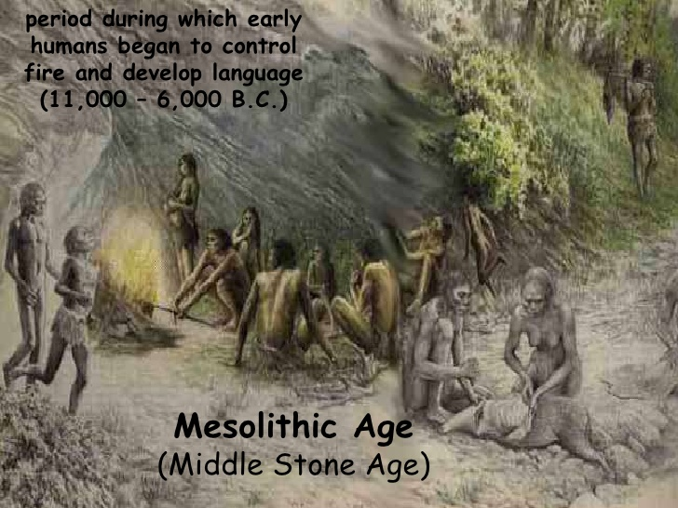

Major Climatic Change happened

Domestication of animals ie Cattle rearing started

Microliths found at Brahmagiri (Mysore), Narmada, Vindya, Gujarat

**Neolithic Period (8000 BC – 4,000 BC)**

Agriculture Started,

Wheel discovered,

Inamgaon = An early village,

Important Neolithic Sites : Burzahom(Kashmir), Gufkral(Kashmir), Mehrgarh(Pakistan), Chirand(Bihar), Daojali Hading(Tripura/Assam), Koldihwa(UP), Mahagara(UP), Hallur(AP), Paiyampalli(AP), Maski, Kodekal, Sangana Kaller, Utnur, Takkala Kota.

NB: Megalithic Sites: Brahmagiri, Adichanallur

**Chalcolithic Period (4000 BC – 1,500 BC)**  
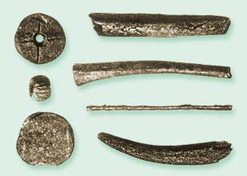

Copper Age, can be considered part of Bronze Age. (Bronze = Copper + Tin)

Indus Valley Civilization (BC 2700 – BC 1900).

Also cultures at Brahmagiri, Navada Toli (Narmada region), Mahishadal (W.Bengal), Chirand (Ganga region)

**Iron Age (BC 1500 – BC 200)**  
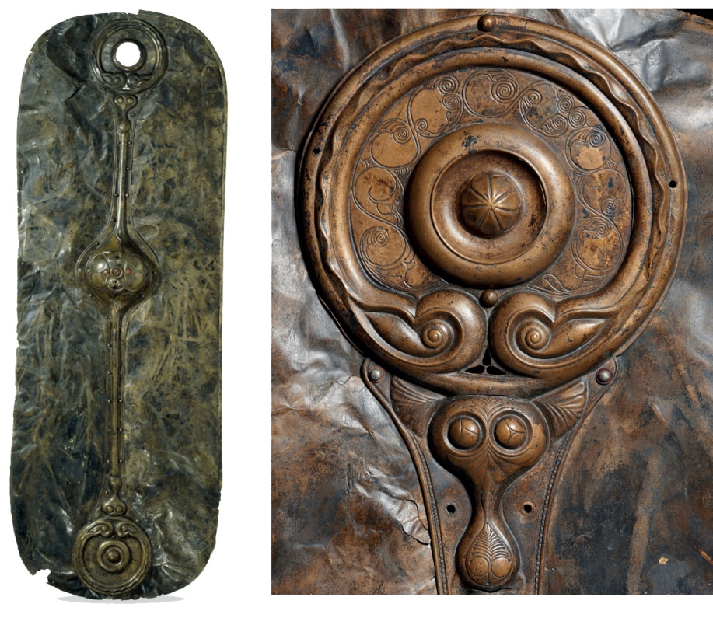

Vedic Period (Arrival of Aryans ie. BC 1600 – BC 600) – Nearly 1000 years (Basic books of Hinduism, ie Vedas were composed, might have written down later.)

**Later Vedic Age ( 1000-600 BC)**  
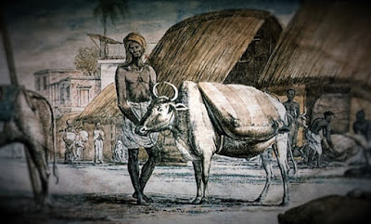

- Later Vedic Age- Also known as PGW (Painted Grey Ware)- Iron Age

- They knew two seas- The Arabian and the Indian Ocean

- Gandak was known as 'Sadanira'

- Position of Women Declined

- Earliest reference to four ashrams or four stages of life- found in 'Jabala Upanishad'

**Society**

Eight Types of Marriages

1. Brahma: Marriage of a duly dowried girl to a man of the same verna.

2. Daiva: Father gives the daughter to the priest as a part of his fee.

3. Arsa: A Token bride price of a cow and a bull is given as dowry.

4. Prajapati: Marriage- without dowry and bride price.

5. Gandharva: By consent of two parties analogous to modern love marriage.

6. Asura: Marriage by Purchase

7. Rakshsa: Marriage by Capture

8. Paishacha: Seduction of a girl while asleep, mentally deranged or drunk.

Marriage on the Basis of Varna

1. Anuloma: Marriage of a man in his verna or below his verna

2. Pratiloma: Marriage of a girl or woman in lower rank than his own verna.

**Polity**

The term 'Rastra' First appeared in this period.

Economy: Rice is called 'Vrihi'

- Niksha, Satmana, Krsnala-were used as convenient units of values, but were not coins.

Four Types of Pottery

- Black and Red ware

- Black and Slipped ware

- Painted grey ware

- Red ware

**Religion:**

Prajapati ( the creator) comes to occupy supreme position.

- Rudra and Vishnu gained their position

**Vedas:** First three vedas are called "Trayi"-three fold knowledge.  
  
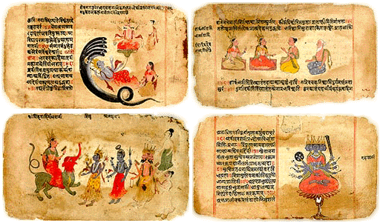

**Rigveda:** Recited by Priest 'Hotri'-1028 Hyms (10 Mandals) -Atraya and Kaushitak Brahamns are attached to it.

**Samveda:** Receited by Priest 'Udgatri'- All the verses except 75 taken from Rigveda- Tandayam and Janmejaya Brahamns are attached to it.

**Yajur Veda**: Receited by 'Ardhyawahu'- Procedure for performance of sacrifice. Shatpath and Taitriya Brahamns are attached to it.

**Athrva Veda**: Magical Formulae and sacrifices

**Brahamnas**: Science of Sacrifice

**Aranyaks**: Forest Books: Meant for forest dwelling hermits

**Upanishads:** Upanishad means the inner or mystic teaching. The term Upanishad is derived from upa (near), ni (down) and s(h)ad (to sit), i.e., sitting down near. Groups of pupils sit near the teacher to learn from him the secret doctrine. In the quietude of the forest hermitages

**Vedangas**

- Shiksha ( Phonetics)

- Kalpa ( Ritualistic Science)

- Jyotish ( Astronomy)

- Vyakarana ( Grammar)

- Nirukta ( Etymology)

- Chhanda (Metrics)

(Nirukta from Yaksha is the oldest Indian Linguistic Text)

**Sutra:**

Shranta Sutra: Large public sacrifices

Guhya Sutra: Birth, Naming, Marriages

Salva Sutra: Measurement

**Upaveda:**

- Aurveda

- Dhaurveda

- Gandharvaveda

- Shilpaveda

**Rituals and Sacrifices**

Rajasuya: Royal consecration, conferred supreme powers on him

Ashwamedha:Horse Sacrifice' that King Dasharath is supposed to have performed.

Vajpaye: Race of horces (chariots)

Vritasyoma: to convert a Nishd into Arya

Important Places During India's Freedom Struggle Part 1

**Dear Readers,**

[](https://2.bp.blogspot.com/-QFGcOHczGic/Vt1wvN6e8mI/AAAAAAAACu8/r4-xoEElGPo/s1600/GeneralAwareness+ssc+adda.jpg)

**1. ChauriChaura**

**Importance**

**The place in Uttar Pradesh, near Gorakhpur which came into news when a frenzied mob set fire to a police station killing 23 people inside. Gandhiji had given a call for non-cooperation movement in 1920. Since the movement was to be non-violent, Gandhiji was deeply hurt by the violence of the people and hastily called off the non-cooperation movement. The incident occurred on 04 Feb 1922.**

**2. Kakori**

**Importance**

**The place in Lucknow district of Uttar Pradesh. The famous Kakori Train Dacoity took place on 09 Aug 1925. Revolutionaries led by Ram Prasad Bismil, Ashfaqulla Khan, Chandrasekhar Azad and others stopped a train carrying British government money. The train was looted of the treasury by the revolutionaries who needed the money to run the freedom struggle.**

**3. Chittagong**

**Importance**

**Located in present day Bangladesh, the place is well-known for Chittagong Armoury Raid. The raid was led by revolutionary Surya Sen. Surya Sen had organised a group of young revolutionaries and together they planned to lay a siege to police armouries in Chittagong. On 18 April 1930, Surya Sen alongwith his troop captured the police armoury, cut off telegraph lines and hoisted the National Flag.**

**4. Champaran**

**Importance**

**In the year 1917, Gandhiji began his active involvement in India's politics from this place in Bihar. At Champaran, the farmers were being forced to grow unremunerative indigo plant which yielded blue dye. Gandhiji was called upon by some activists to solve the problem of the cultivators. Gandhiji for the first time used the tool of non-violence. He toured the villages and compelled the government to pass the ChamparanAgraria Law in 1918.**

**5. Dandi**

**Important Points to Remember**

**A small village on the coast of Gulf of Khambhat, Arabian Sea. The place shot to world fame when Gandhiji led the famous Dandi March from Sabarmati Ashram near Ahmedabad on 12 March 1930. On the 24th day, i.e. 06 April 1930, Gandhiji reached Dandi and made salt as a protest against the tax imposed on salt by the British. The incident also marked the beginning of the Civil Disobedience Movement. Recently Time magazine listed the Salt Satyagraha in its list of Top 10 Most Influential Protests of all time.**

**6. Port Blair**

**Important Points to Remember**

**The present capital of Andaman and Nicobar Islands, Port Blair played an important role during the freedom struggle. Firstly, the British had constructed the huge Cellular Jail on the island. Indian prisoners, especially political ones, were sent to the jail, the punishment being popularly known as Kala Pani. SachindranathSanyal, the author of Bandi Jeevan, and VinayakDamodarSavarkar were such freedom fighters who were sent to the Cellular Jail. Secondly, Netaji Subhash Chandra Bose hoisted the National Flag on 30 Dec 1943 and declared it to be the headquarters of the Provisional Government of India. The Airport at Port Blair is named Veer Savarkar International Airport.**

**7. Bardoli**

**Important Points to Remember**

**In 1925, the taluka of Bardoli in Gujarat suffered from floods and famine, causing crop production to suffer and leaving farmers facing great financial troubles. However, the Government had raised the tax rate by 30% that year. The farmers protested in vain. SardarVallabhbhai Patel in consultation organised the Bardoli Satyagraha in which the farmers refused to pay the taxes despite the threat of confiscation of property. In the end the Government relented and enhanced taxes were withdrawn. Vallabhbhai Patel earned the title of Sardar from this Satyagraha.**

**8. Amritsar**

**Important Points to Remember**

**JallianwalaBagh in Amritsar, well known for the massacre of innocent and peaceful gathering of people who had gathered in the park for a public meeting. On 13 April 1919 (Baisakhi Day), a crowd of about 20,000 people had gathered in the small park, when troops surrounding the park were ordered by Brig Gen REH Dyer to open fire. The official figures put the casualty at 379, but unofficial figures have been much higher. Michael O'Dyer the Lt. Governor of Punjab was shot dead by Udham Singh 21 years later. In protest against the incident Rabindranath Tagore renounced his knighthood bestowed upon him by the British in 1915.**

Study Notes Based On : The Tughlaq Dynasty

[](https://2.bp.blogspot.com/--zjdw2YwC8E/VuaDHlZ-atI/AAAAAAAACy8/ASkdwTom9YwC8aoC6-Enb2pkDq78N6hXQ/s1600/STUDY+NOTES.jpg)

**GhiyasuddinTughlaq 1320-24 AD**

**Muhammad Tughlaq 1324-51 AD**

**Firoz Shah Tughlaq 1351-88 AD**

**Mohammad Khan 1388 AD**

**GhiyassuddinTughlaq Shah II 1388 AD**

**Abu Baqr         1389-90 AD**

**Nasiruddin Muhammad 1390-94 AD**

**Humayun         1394-95 AD**

**Nasiruddin Mahmud 1395-1412 AD**

**GhiyasuddinTughlaq (1320-1325 AD)**

* **Ghazni Malik the last king of the Khilji dynasty, Khusrau Khan and assumed the title     GhiyasuddinTughlaq.**
* **He founded the city Tughlaqabad.**
* **Khusrau Khan, the last king of the Khilji dynasty was killed by Ghazni Malik, and Ghazni Malik ascended the throne assuming the title GhiyasuddinTughlaq.**
* **He died in an accident and his soneJauna (Ulugh Khan) succeeded him under the title Mohammad-bin-Tughlaq.**
* **Reintroduced the food laws of Ala-ud-Din**
* **Supressed the rebellions in the distant provinces with strong hand and resorted the peace and order**
* **Organised better postal system**
* **Encouraged agriculture**

**In 1323, he defeated the ruler of Warrangal and annexed his territory. A war of succession was going on in Bengal. Ghiyas-ud-din took an advantage of such a situtation and invaded Bengal. He suppressed the rebels and in this way Bengal also became a part of his empire.**

**Mohammad-bin Tughlaq (1325-1351 AD)**

**Mohammad bin Tughlaq is best remembered as a ruler who undertake a number of bold experiments, and showed a keen interest in agriculture. He was deeply read in religion and philosophy and had a critical and open mind. He had deep interest in philosophy, astronomy, logic and mathematics. He conversed not only with the muslim mystics, but also with the Hindu yogis and Jain saints such as Junaprabha Suri.**

* **Taxation in the Doab: The Sultan made an ill-advised financial experiment in the Doab between the Ganges and Jamuna. He not only increased the rate of taxation but also revived and created some additional Abwabs or cessess. Although the share of the state remained half as in the time of Alauddin, it was fixed arbitrarily and not on the basis of actual produce.**
* **Transfer of Capital (1327): It appears that the Sultan wanted to make Deogir second capital so that he might be able to control south India better. Deogir was named Daulatabad. However, after a couple of years, Muhammad Tughlaq decided to abandon Daulatabad largely because he soon found that just as he could not control south India from Delhi, he could not control North from Daulatabad.**
* **Introduction of Token Currency (1330): Muhammad Tughlaq decided to introduce bronze coins, which were to have the same value as the silver coins. Muhammad Tughlaq might have been successful if he could prevent people from forging the new coins. He was not able to to do so and so on the new coins began to be greatly devalued in markets.**
* **Transfer of the capital from Daultabad, earlier known as Devagiri.**
* **Introduction of token copper currency to replace gold and silver coins.**
* **Unsuccessful expedition to subjugate Quarajal-the region identified as the modern Kulu in Kangra district of Himachal Pradesh.**
* **Futile plan to conquer Khurasan and Iraq.**
* **Creation of Diwan-i-Kohi**
* **Independence of dinar (a gold coin) and adl(a silver coin).**
* **Establishment of city of Jahanpanah.**
* **Arrival of an envoy from the Chinese ruler, ToghanTimur(1341)**
* **The famous Moroccon traveller Ibn Batuta visited India during his reign.**

**Firoz Shah Tughlaq(1351-1388 AD)**

* **He was a cousin of Mohammad-bin-Tughlaq. After his death the nobles and the theologians of the court selected Firoz Shah as the next Sultan.**
* **Established of Diwan-i-Khairat (department for poor and needy people) and Diwan-l-Bundagan (department of slaves)**
* **Making Iqtadari system hereditary.**
* **Construction of canals for irrigation from**
* **Yamuna to the city of Hissar**
* **From the Sutlej to the Ghaggar**
* **From the Ghaggar to Firuzabad**
* **From Mandvi and Sirmour Hills to Hansi in Haryana.**
* **Establishment of four new towns, Firuzabad, Fatebabad, Jaunpur and Hissar.**
* **He rebuilt two storeys of QutubMinar which were damaged by lightening in 1368 AD.**

**After Firoz Shah Tughlaq(1388-1414 AD**

* **The Tughlaq dynasty would not survive much after Firoz Shah's death. The Malwa, Gujarat and Sharqi (Jaunpur) Kingdoms broke away from the Sultanate.**
* **TimurInvasion: (1398-99)Timur, a Turk, invaded India in 1398 during the reign of Muhammad Shah Tughlaq , the last ruler of Tughlaq dynasty. His army mercilessely sacked and plundered Dellhi. Timur returned to Central Asia, leaving a nominee to rule to Punjab which ended the Tughlaq dynasty.**

Study Notes : The Sayyid Dynasty (1414-50 AD)

[](https://2.bp.blogspot.com/-jnvrjIjMOEM/VuvoobYZCGI/AAAAAAAAC6g/Xqb_9FXnXyUmNAuchzd63mDVs3X5JMZ8w/s1600/STUDY+NOTES.jpg)

**The Sayyid Dynasty (1414-50 AD)**

Khizr-Khan, a lieutenant of Timur, was a Sayyid and so his dynasty is called Sayyid Dynasty. Khizr Khan ruled till 1421, but his whole reign was marked by utter chaos and disorder. He was succeeded, after his death, by his son Mubarak Shah (1421-1434). During his reign the subedars of Punjab, bhatinda and Doab broke out in revolt and the whole of his period was spent in trying to supress them. He died in 1434 and was succeeded by his son Mohammad Shat (1434-1443). During his reign, the ruler of Malwa invaded Delhi, which was however, saved by the valiant Subedar of Lahore, Bahlol Lodhi

Sayyid Dynasty Rulers

Khizr Khan         1414-21 AD

Mubarak Shah         1421-33 AD

Muhammad Shah         1421-43 AD

AlauddinAlam Shah 1443-51 AD

**Khizr Khan(1414-1421):**Timur's nominee captured Delhi and was proclaimed the new Sultan and the first of the Sayyid Dynasty. They ruled over Delhi and surroundings districts.

He was a lieutenant of Timur.

He was a Sayyid and so his dynasty is called Sayyid Dynasty.

**Mubarak Shah(1421-1434)**:He succeeded Khizr at the throne after his successful expeditions against Mewatis, Katehars and the Gangetic Doab area. He was killed by the nobles in his own court.

**Muhammad Shah(1434-1443):**The nobles put Muhammad Shah on the throne, but could not survive the in-fighting among the nobles in the court. He was authorized to rule a meagre area of around 30 miles and rest of the Sultnate was ruled by the nobles.

Alam Shah (1443-1451):The last Sayyid king descended in favour of Bahlol Lodhi and himself retired. Thus began the Lodhi dynasty, which confined to Delhi and a few surrounding areas.

**Lodhi or Pathans Sultans**

**Bahlol Lodhi (1451-88 AD)**

* Bahlol Lodhi was one of the Afghan sardars who established himself in Punjab afer invasion of Timur
* He founded the Lodhi dynasty. He founded the rule of the Lodhi dynasty by usurping the throne from the last of the Sayyid rulers.
* Bahlol belonged to the Shahu Khel clan of the Lodhi Pashtun tribe.
* He was a strong and brave ruler. He tried to restore the glory of Delhi by conquering territories around Delhi and after continuous war for 26 years, he succeeded in extending his authority over Jaunpur, Rewail, Itawah, Mewar, Sambhal, and Gwalior etc.
* He was a kind and generous ruler. He was always prepared to help his subjects. Though he was himself illiterate, he extended his patronage to art and learning. He died in 1488.

**Sikandar Lodhi (1489-1517 AD)**

* Sikandar Lodhi was the son of Bahlol Lodhi who conquered Bihar and Western Bengal.
* He shifted his capital from Delhi to Agra in 1504, a city founded by him.
* Sikandar was a fanatical Muslim and he broke the sacred images of the Jwalamukhi Temple at Naga Kot and ordered the temples of Mathura to be destroyed.
* He took a keen interest in the development of agriculture. He introduced the Gaz-i-Sikandari (Sikandar's yard) of 32 digits for measuring cultivated fields.
* He was a staunch Sunni and a Muslim fanatic. He lacked religious tolerance. In the name of religion, he perpetuated untold cruelties on the Hindus.

**Ibrahim Lodhi (1517-26 AD)**

* He was the last king of Lodhi dynasty and the last Sultan of Delhi
* He was the son of Sikandar Lodhi
* The Afghan nobility was brave and freedom-loving people but it was because of its fissiparous and individualistic tendencies that the Afghan monarchy was weakened. Moreover, Ibrahim Lodhi asserted the absolute power of the Sultan.
* At last DaulatKan Lodhi, the governor of Punab invited Babur to poverthrow Ibrahim Lodhi, Babur accepted the offer and inflicated a crushing defeat on Ibrahim Lodhi in the first battle of Panipat in 1526.
* No Sultan of India except Sultan Ibrahim had been killed on the battle field.
* Causes of Decline of Delhi Sultanate:
* The main causes were:-
* Deposite and military type of government which did not have the confidence of the people
* Degeneration of Delhi Sultans (esp. the wild projects of Muhammad-bin-Tughlaq,Incompetence of FirozTughlaq)
* War of succession as there was no fixed law of it
* Greed and incompetency of nobles
* Defective military organisation
* Vastness of empire and poor means of communication
* Finanical instability
* Number of slaves increased to 1,80,000 in FirozTughlaq's time which was a burden on the treasury
* Invasion of Timur