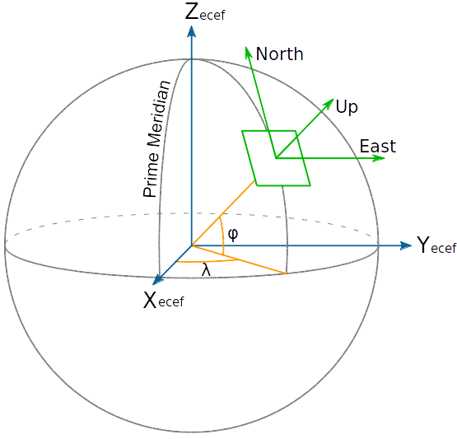
xyzcamera
z
xyzcenter
y
x
lon, lat = 0°, 0°
x, y, z = 0, 0, R
lon, lat = 90°, 0°
x, y, z = R, 0, 0

r

lon, lat = 0°, -90°
x, y, z = 0, -R, 0

r = R•cos(φ)
xthree = r •sin(λ)
ythree = R•sin(φ)
zthree = r • cos(λ) = R • cos(φ) • cos(λ)

