### 

## Computer Science Department

## Database Systems 333

Software Requirements for MG Motor Palestine Database System

Donia Yasin #1201831

Abdelrahman Abed #1193191

Ody Shbayeh #1201462

Group No: 12

## Summary

The database system project for MG Motor Palestine is developed to streamline and enhance the operational efficiency of the dealership, which has recently acquired an agency from MG Motors through Hyundai Palestine. This initiative aims to establish a separate, dedicated database to manage the burgeoning requirements of MG Motor's sales and service operations within Palestine. MG Motors, a renowned entity in the automotive industry, is celebrated for its exceptional vehicles, stellar customer service, and operational excellence. The proposed database will encompass several key areas including customer management, vehicle inventory, employee performance, sales transactions, and after-sales services. By introducing a structured database system with tables specifically designed for Customers, Cars, Employees, Services, and Sales, MG Motor Palestine intends to optimize inventory management, improve employee performance tracking, elevate customer service standards, and streamline sales processes. This project represents a strategic enhancement in MG Motor Palestine's capability to deliver a superior automotive purchase and service experience, thereby setting a new benchmark in the industry.

## Introduction

MG Motors is a well-known company in car industrials was originally based in England and have multiple branches all over the world and they are known for powerful and reliable production cars that are competing with other world-known production cars companies. MG Motors is also known for its commitment to excellence in customer service and operations and for a very effective management and reliable services for their cars and a smooth interaction with clients. Recently Hyundai Palestine managed to have an agency from MG motors to sell their cars in Palestine and also service them in the country however Hyundai does not have a separated database for their new agency so they connected it to their original one. To experience the full journey with MG Motor Palestine we are developing a new database system to the company this system will enhance customer service optimize inventory management and improve employee performance tracking along with their sales. The upcoming database system will revolutionize MG Motor Palestine's operations, ensuring a full experience for clients and setting new standards in the automotive industry.

## Data Requirements

The database system designed for MG Motor Palestine encompasses a comprehensive structure aimed at capturing and managing all crucial information related to its operations. This system is structured into several key tables: Customer, Cars, Employees, Services, and Sales, each serving a specific purpose and interconnected through well-defined relationships to support the dealership's multifaceted business processes.

* Each Customer has personal and contact information such as customerID (a unique identifier for each customer), Cname (customer's full name), email, phoneNumber, address, and National_Identification_Number (NIN), facilitating precise identification and communication with customers.
* Each Car has many specifications that distinguish it such as carID (a unique car identifier), type (the vehicle category or segment), model, color, and status (indicating whether the car is equipped with full options or is a standard model), and price.
* Customers can purchase multiple cars, and each purchase is made through the sales department.
* Each Employee has essential information including employeeID, name, date of employment and salary.
* Employees are categorized into Managers, Salesman, and Advertisers, based on their job roles. The Manager has Monthly Report, The Salesman has employee_target, while the Advertisers have points that increase based on the agency's increased sales through them. So, allowing for detailed management of different operational roles.
* The Sales department details transactions involving car sales, comprising saleID, customerID, carID, and description (Details of the sale), thereby encapsulating the sales operations.
* Sales are further categorized by payment method into Cash and Installment Payment. The Cash includes bank cash, direct cash, and discounts, accommodating different cash payment modalities and incentives. The Installment Payment includes taxes, first payment, total cost, months number, and monthly installment, detailing the terms of sales made on an installment basis.
* The Services records after-sales services provided to customers, linking serviceID, customerID, and carID to detail the service transactions, complemented by notes for any additional information. This setup ensures a thorough tracking of customer service engagements.
* Each sale must have exactly one customer, but a customer can have zero or many sales.
* Each sale must be linked to exactly one car, but a car can be sold zero or multiple times (considering multiple instances of the same model).
* Each service record must have exactly one customer, but a customer can have zero or many service records.
* Each service record must be linked to exactly one car, but a car can have zero or many service records.
* One Salesman can be responsible for many Sales and each Sale is handled by exactly one Salesman.

## ER Diagram

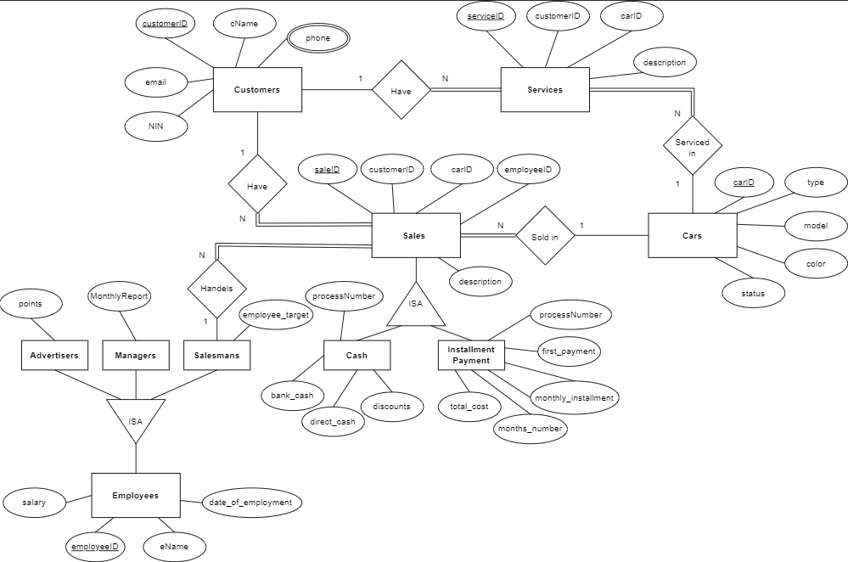

* **To view the ER Diagram, you can find the link in appendix.**

## Technology

The hardware: MSI GF63s thin --- with a capacity for the database of a 1TB

The Operating system: windows 11 pro

The Database system: Mysql server 8.0.23

The programming language: Eclipse IDE "java" with a version—2024-03 (4.31).

## Partners work

|  |  |  |  |
| --- | --- | --- | --- |
|  | Donia | Ody | Abdelrahman |
| Summary | Done |  |  |
| Introduction |  | Done |  |
| Data Requirements | Done | Done | Done |
| ER Diagram | Done | Done | Done |
| Technology |  |  | Done |
| SQL Scripts | Done |  | Done |

* **Work was done equally on the Data Requirements and ER Diagram sections.**

The complete works of car.java, CarController.java, customer.java, CustomerPhone.java, CustomerController.java, Service.java, ServiceController.java and fxml files for these was done by Abdelrahman.

The complete works of Employee .java, Employee Controller.java, Advertisers.java, AdvertisersController.java, Manager.java, ManagerController.java, Salesman.java, SalesmanController.java, AdminController.java and fxml files for these was done by Ody.

The complete works of Sale.java, SaleController.java, Cash.java, CashController.java, InstallmentPayment.java, InstallmentPaymentController.java, Salesman.java, UserController.java and fxml files for these was done by Donia.

# GitHub Repository

<https://github.com/Doniayasin-CE/MG-Database-System/tree/main>

## Appendix

<https://tinyurl.com/4fdbamay>